Ralph M. Tsong, Esq.
Xuelan Fang, Esq.
Tsong Law Group, A.P.C
10900 183rd St., Suite 270,
Cerritos, CA 90703
(562) 274-7807

Attorney for CHENGFANG SHI

In re the matter of:  infant CHILD SHI  to be born to parent CHENGFANG SHI | )  )  )  )  )  )  )  )  )  ) | SPECIAL POWER OF ATTORNEY OF CHILD AND AUTHORIZATION TO CONSENT TO HEALTH CARE FOR MINOR

- I, CHENGFANG SHI, am the Intended Father of the Infant CHILD SHI, born to me via gestational surrogate SELENA MARIA AISPURO. My People’s Republic of China Passport No. is ED3297013. A photocopy of my passport is attached to this declaration.
- My child, infant CHILD SHI is expected to be born anytime from now to the original anticipated due date, on or before December 4, 2025, at Loma Linda University Medical Center, in Loma Linda, California via gestational surrogate SELENA MARIA AISPURO, whose date of birth is May 22, 1996.
- I hereby consent to giving special powers of attorney to JIAJIA GAO, date of birth 02/24/1986 and People’s Republic of China Passport No. EJ4979964 (a copy of JIAJIA GAO’s passport is attached to this declaration).
- I understand and agree that JIAJIA GAO to be provided a wristband, allowing her access to the nursery (including the Neo-Natal Intensive Care Unit “NICU”) by any physician and/or medical facility and/or medical personnel providing post-natal or well care to the child born to me by my gestational surrogate.
- I hereby consent that the child born to me by SELENA MARIA AISPURO shall be released upon discharge to that JIAJIA GAO without my presence. This is due to the fact I am not able to arrive the United States before Child’s delivery.
- I hereby consent for JIAJIA GAO, and/or any agent designated by my attorney Xuelan Fang to complete the Birth Certificate Application and sign the birth certificate for my child so that no paperwork is delayed in having the Certified Birth Certificate available. I give permission for JIAJIA GAO and/or any agent designated by my attorney Xuelan Fang to provide the full name that I wish to give my child.
- I hereby consent for JIAJIA GAO to act as true and lawful representative, agent, and Attorney-In-Fact for me and in her name to sign documents on my behalf and to act on my behalf as needed for the hospital and further pediatric well care. I consent and authorize JIAJIA GAO to be able to speak with the hospital staff regarding the health status and to receive medical information. JIAJIA GAO is authorized to make decisions for the benefit of and best interest of my child after birth. I understand that additional documents may be required in order to effectuate such powers due to requirements of third parties.
- I hereby authorize JIAJIA GAO to obtain a passport for Infant CHILD SHI and to travel with the Infant CHILD SHI including to any state or outside of the United States.
- I hereby authorize JIAJIA GAO to obtain Infant CHILD SHI’s birth certificate, travel documents, and to request an apostille from any applicable agency on my behalf.
- The rights, power and authority herein granted shall remain in full force from the date of signing, until one of the following events occurs: six (6) months from the date of signing occurs or termination by a written Revocation of Power of Attorney signed by me, whichever happens first. This Power of Attorney shall not be affected by my disability or incapacity. The authority herein granted to my Attorney-in-Fact, is exercisable by me, notwithstanding my later disability or incapacity or later uncertainty as to whether I am dead or alive.
- I hereby release from liability any individual, business, or health care provider providing medical care in reliance on this document from liability relating to acceptance of this form and the Attorney-in-Fact’s consent.
IN WITNESS WHEREOF, I, CHENGFANG SHI, have executed this Power of Attorney on ______________.

CHENGFANG SHI

NOTARY ACKNOWLEDGMENT
A Notary Public or other officer completing this certificate verifies only the identity of the individual who signed the document to which this certificate is attached, and not the truthfulness, accuracy, or validity of that document.

STATE OF )
)
COUNTY OF ____________ )

On ______________________, before me, ______________________________, a Notary Public, remotely appeared , who proved to me on the basis of satisfactory evidence to be the person(s) whose name(s) is/are subscribed to the within instrument and acknowledged to me that he/she/they executed the same in his/her/their authorized capacity(ies), and that by his/her/their signature on the instrument the person(s), or the entity on behalf of which the person(s) acted, executed the instrument.

I certify under PENALTY OF PERJURY under the law of the State of that the foregoing paragraph is true and correct.

WITNESS my hand and official seal.

_______________________________________
Notary Public

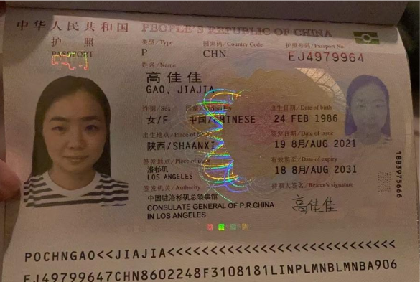

Power of Attorney

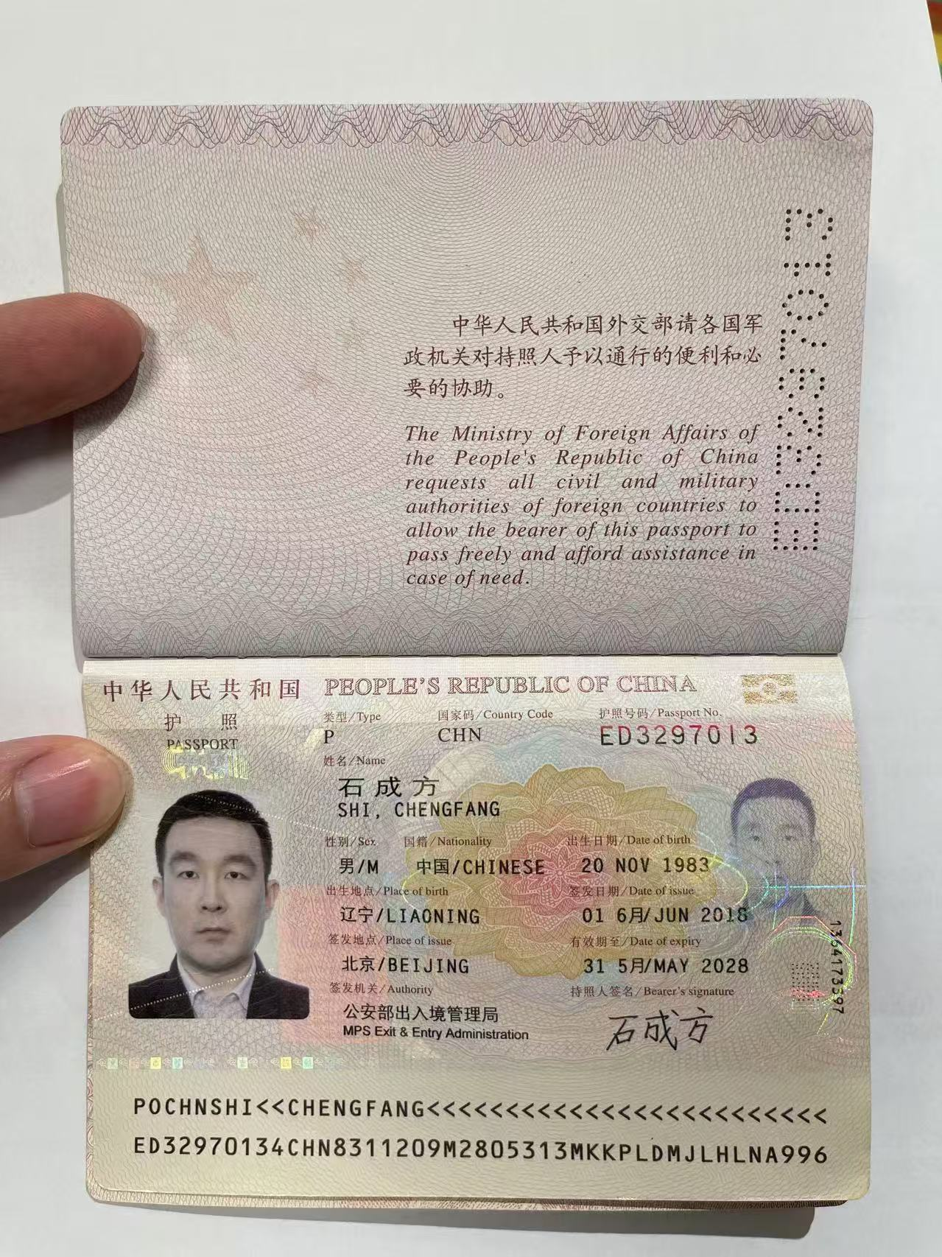

Intended Father

