Ralph M. Tsong, Esq.
Xuelan Fang, Esq.
Tsong Law Group, A.P.C
10900 183rd St., Suite 270,
Cerritos, CA 90703
(562) 274-7807

DAOQING ZHOUAttorney for IP1NAME

In re the matter of:  CHILD ZHOU infant CHILDNAME  DAOQING ZHOUto be born to parent IP1NAME | )  )  )  )  )  )  )  )  )  )  ) | SPECIAL POWER OF ATTORNEY OF CHILD AND AUTHORIZATION TO CONSENT TO HEALTH CARE FOR MINOR

- DAOQING ZHOUCHILD ZHOUTIFFANY LEE BRUMMETTEF5878181I, IP1NAME, am the IP1ROLE of the Infant CHILDNAME, born to me via gestational surrogate SURROGATENAME. My IP1COUNTRY Passport No. is IP1PASSPORT. A photocopy of my passport is attached to this declaration.
- CHILD ZHOUwas born on or around April 5, 2026Doctors Medical CenterModestoTIFFANY LEE BRUMMETTSeptember 16, 1988My child, Infant CHILDNAME is expected to be born anytime from now to the original anticipated due date, on or before DUEDATE, at HOSPITALNAME, in HOSPITALCITY, HOSPITALSTATE via gestational surrogate SURROGATENAME, whose date of birth is SURROGATEDOB.
- and )I hereby consent to giving special powers of attorney to AGENT1NAME, date of birth AGENT1DOB and AGENT1ID (a copy of AGENT1NAME’s identification is attached to this declaration), and AGENT2NAME, date of birth AGENT2DOB and AGENT2ID (a copy of AGENT2NAME’s identification is attached to this declaration).
- and/or I understand and agree that AGENT1NAME and/or AGENT2NAME are to be provided a wristband, allowing their access to the nursery (including the Neo-Natal Intensive Care Unit “NICU”) by any physician and/or medical facility and/or medical personnel providing post-natal or well care to the child born to me by my gestational surrogate.
- TIFFANY LEE BRUMMETT and/or I hereby consent that the child born to me by SURROGATENAME shall be released upon discharge to AGENT1NAME or AGENT2NAME without my presence. This is due to the fact I am not able to arrive the United States before Child’s delivery.
- and/or and/or I hereby consent for AGENT1NAME, AGENT2NAME and/or any agent designated by my attorney ATTORNEYNAME to complete the Birth Certificate Application and sign the birth certificate for my child so that no paperwork is delayed in having the Certified Birth Certificate available. I give permission for AGENT1NAME, AGENT2NAME and/or any agent designated by my attorney ATTORNEYNAME to provide the full name that i wish to give my child.
- and/or and/or and/or I hereby consent for AGENT1NAME and/or AGENT2NAME to act as true and lawful representative, agent, and Attorney-In-Fact for me and in their name to sign documents on my behalf and to act on my behalf as needed for the hospital and further pediatric well care. I consent and authorize for AGENT1NAME and/or AGENT2NAME to be able to speak with the hospital staff regarding the health status and to receive medical information. AGENT1NAME and/or AGENT2NAME are authorized to make decisions for the benefit of and best interest of my child after birth. I understand that additional documents may be required in order to effectuate such powers due to the requirements of third parties.
- and/orCHILD ZHOUCHILD ZHOUI hereby authorize AGENT1NAME and/or AGENT2NAME to obtain a passport for Infant CHILDNAME and to travel with the Infant CHILDNAME including to any state or outside of the United States.
- and/orCHILD ZHOUI hereby authorize AGENT1NAME and/or AGENT2NAME to obtain Infant CHILDNAME’s birth certificate, travel documents, and to request an apostille from any applicable agency on my behalf.
- The rights, power and authority herein granted shall remain in full force from the date of signing, until one of the following events occurs: six (6) months from the date of signing occurs or termination by a written Revocation of Power of Attorney signed by me, whichever happens first. This Power of Attorney shall not be affected by my disability or incapacity. The authority herein granted to my Attorney-in-Fact, is exercisable by me, notwithstanding my later disability or incapacity or later uncertainty as to whether I am dead or alive.
- I hereby release from liability any individual, business, or health care provider providing medical care in reliance on this document from liability relating to acceptance of this form and the Attorney-in-Fact’s consent.
DAOQING ZHOUIN WITNESS WHEREOF, I, IP1NAME, have executed this Power of Attorney on ______________.

DAOQING ZHOUIP1NAME

NOTARY ACKNOWLEDGMENT
A Notary Public or other officer completing this certificate verifies only the identity of the individual who signed the document to which this certificate is attached, and not the truthfulness, accuracy, or validity of that document.

STATE OF )
)
COUNTY OF ____________ )

On ______________________, before me, ______________________________, a Notary Public, remotely appeared , who proved to me on the basis of satisfactory evidence to be the person(s) whose name(s) is/are subscribed to the within instrument and acknowledged to me that he/she/they executed the same in his/her/their authorized capacity(ies), and that by his/her/their signature on the instrument the person(s), or the entity on behalf of which the person(s) acted, executed the instrument.

I certify under PENALTY OF PERJURY under the law of the State of that the foregoing paragraph is true and correct.

WITNESS my hand and official seal.

_______________________________________
Notary Public

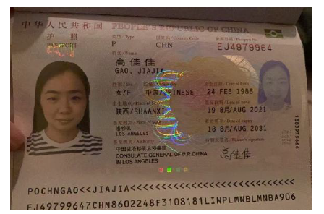

Power of Attorney 1

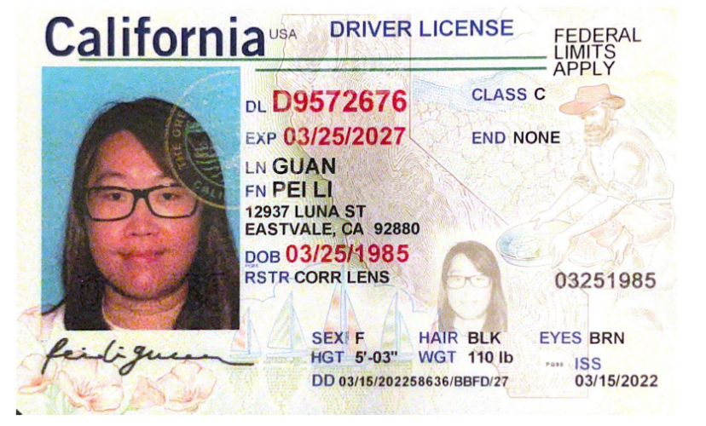

Power of Attorney 2

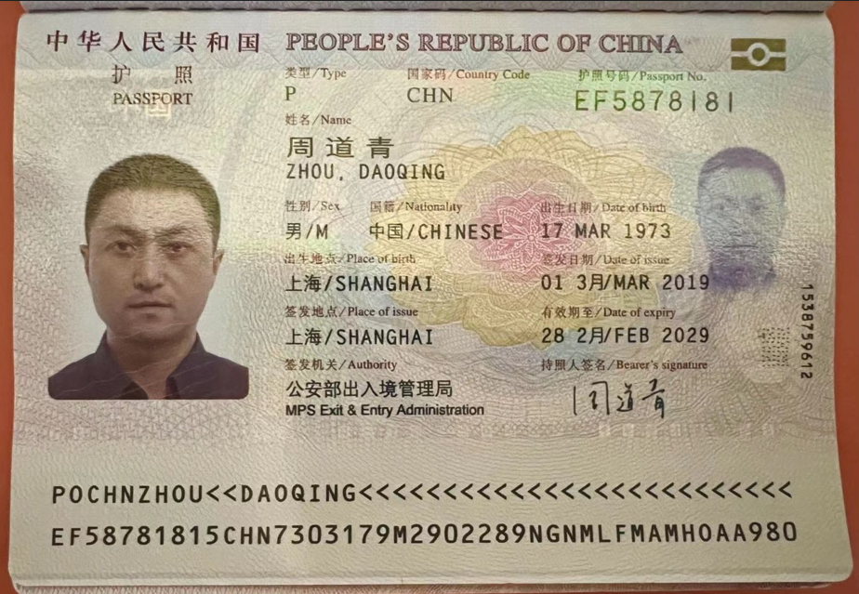 Intended Father

