Ralph M. Tsong, Esq.
Xuelan Fang, Esq.
Tsong Law Group, A.P.C
10900 183rd St., Suite 270,
Cerritos, CA 90703
(562) 274-7807

XINMIAO JIAZHEN WANGAttorney for IP1NAME and IP2NAME

In re the matter of:  CHILD WANG infant CHILDNAME  XINMIAO JIAZHEN WANGto be born to parentS IP1NAME AND IP2NAME | )  )  )  )  )  )  )  )  )  )  ) | SPECIAL POWER OF ATTORNEY OF CHILD AND AUTHORIZATION TO CONSENT TO HEALTH CARE FOR MINOR

- XINMIAO JIAZHEN WANGCHILD WANGJESSICA TATIANA LAMASXINMIAO JIAER0468095ZHEN WANGE56419622We, IP1NAME AND IP2NAME, are the Intended Parents of the Infant CHILDNAME, born to us via gestational surrogate SURROGATENAME. IP1NAME’s IP1COUNTRY Passport No. is IP1PASSPORT, and IP2NAME’s IP2COUNTRY Passport No. is IP2PASSPORT. Photocopies of our passports are attached to this declaration.
- CHILD WANGApril 8, 2026Riverside Community HospitalRiversideCaliforniaJESSICA TATIANA LAMASJanuary 06, 1993Our child, Infant CHILDNAME is expected to be born anytime from now to the original anticipated due date, on or before DUEDATE, at HOSPITALNAME, in HOSPITALCITY, HOSPITALSTATE via gestational surrogate SURROGATENAME, whose date of birth is SURROGATEDOB.
- JIA XIAODecember 26, 1983Y8938647 JIA XIAOXIAOLING WANGOctober 1581Y2780081 XIAOLING WANGWe hereby consent to giving special powers of attorney to AGENT1NAME, date of birth AGENT1DOB and AGENT1ID (a copy of AGENT1NAME’s identification is attached to this declaration), and AGENT2NAME, date of birth AGENT2DOB and AGENT2ID (a copy of AGENT2NAME’s identification is attached to this declaration).
- JIA XIAOXIAOLING WANGWe understand and agree that AGENT1NAME and/or AGENT2NAME are to be provided a wristband, allowing their access to the nursery (including the Neo-Natal Intensive Care Unit “NICU”) by any physician and/or medical facility and/or medical personnel providing post-natal or well care to the child born to us by our gestational surrogate.
- JESSICA TATIANA LAMASJIA XIAOXIAOLING WANGWe hereby consent that the child born to us by SURROGATENAME shall be released upon discharge to AGENT1NAME or AGENT2NAME without our presence. This is due to the fact we are not able to arrive the United States before Child’s delivery.
- JIA XIAOXIAOLING WANGJIA XIAOXIAOLING WANGWe hereby consent for AGENT1NAME, AGENT2NAME and/or any agent designated by our attorney ATTORNEYNAME to complete the Birth Certificate Application and sign the birth certificate for our child so that no paperwork is delayed in having the Certified Birth Certificate available. We give permission for AGENT1NAME, AGENT2NAME and/or any agent designated by our attorney ATTORNEYNAME to provide the full name that we wish to give our child.
- JIA XIAOXIAOLING WANGJIA XIAOXIAOLING WANGJIA XIAOXIAOLING WANGWe hereby consent for AGENT1NAME and/or AGENT2NAME to act as true and lawful representative, agent, and Attorney-In-Fact for us and in their name to sign documents on our behalf and to act on our behalf as needed for the hospital and further pediatric well care. We consent and authorize for AGENT1NAME and/or AGENT2NAME to be able to speak with the hospital staff regarding the health status and to receive medical information. AGENT1NAME and/or AGENT2NAME are authorized to make decisions for the benefit of and best interest of our child after birth. We understand that additional documents may be required in order to effectuate such powers due to the requirements of third parties.
- JIA XIAOXIAOLING WANGCHILD WANGCHILD WANGWe hereby authorize AGENT1NAME and/or AGENT2NAME to obtain a passport for Infant CHILDNAME and to travel with the Infant CHILDNAME including to any state or outside of the United States.
- JIA XIAOXIAOLING WANGCHILD WANGWe hereby authorize AGENT1NAME and/or AGENT2NAME to obtain Infant CHILDNAME’s birth certificate, travel documents, and to request an apostille from any applicable agency on our behalf.
- The rights, power and authority herein granted shall remain in full force from the date of signing, until one of the following events occurs: six (6) months from the date of signing occurs or termination by a written Revocation of Power of Attorney signed by us, whichever happens first. This Power of Attorney shall not be affected by our disability or incapacity. The authority herein granted to our Attorney-in-Fact, is exercisable by us, notwithstanding our later disability or incapacity or later uncertainty as to whether we are dead or alive.
- We hereby release from liability any individual, business, or health care provider providing medical care in reliance on this document from liability relating to acceptance of this form and the Attorney-in-Fact’s consent.
XINMIAO JIAZHEN WANGIN WITNESS WHEREOF, We, IP1NAME AND IP2NAME, have executed this Power of Attorney on ______________.

IP1NAME AND IP2NAME
XINMIAO JIA

ZHEN WANG

NOTARY ACKNOWLEDGMENT
A Notary Public or other officer completing this certificate verifies only the identity of the individual who signed the document to which this certificate is attached, and not the truthfulness, accuracy, or validity of that document.

STATE OF )
)
COUNTY OF ____________ )

On ______________________, before me, ______________________________, a Notary Public, remotely appeared , who proved to me on the basis of satisfactory evidence to be the person(s) whose name(s) is/are subscribed to the within instrument and acknowledged to me that he/she/they executed the same in his/her/their authorized capacity(ies), and that by his/her/their signature on the instrument the person(s), or the entity on behalf of which the person(s) acted, executed the instrument.

I certify under PENALTY OF PERJURY under the law of the State of that the foregoing paragraph is true and correct.

WITNESS my hand and official seal.

_______________________________________
Notary Public

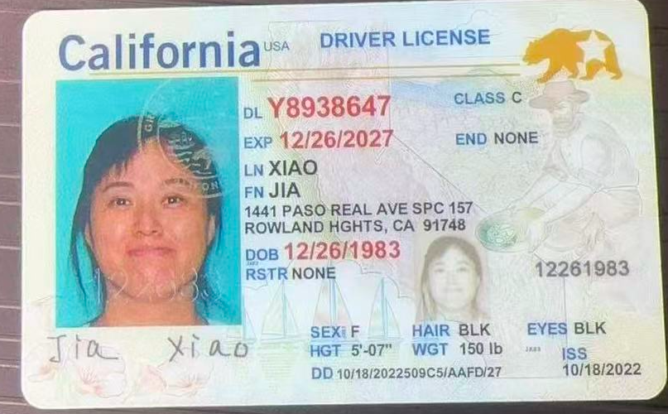

Power of Attorney 1
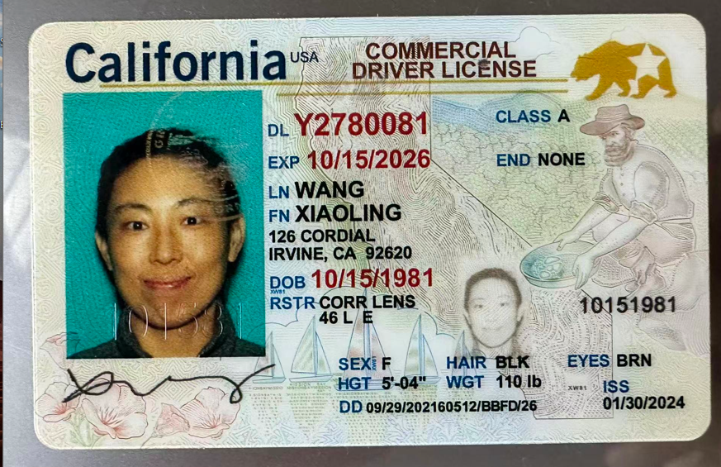

Power of Attorney 2

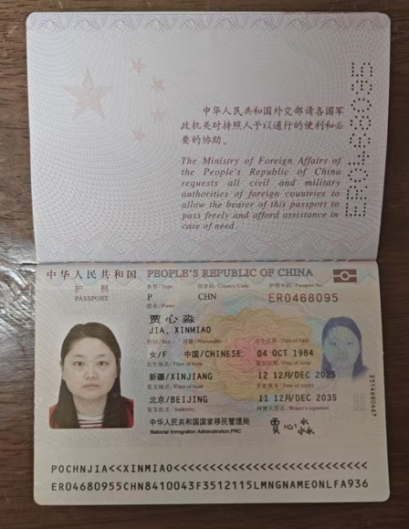

Intended Mother

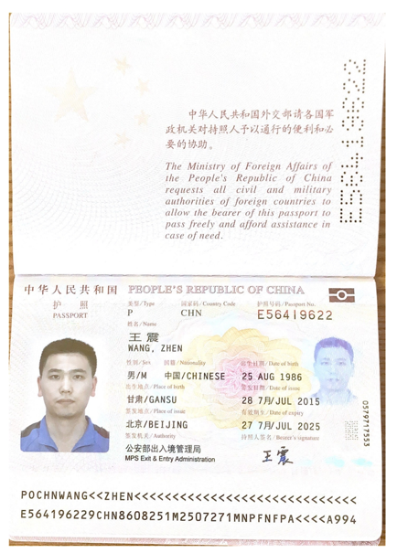

Intended Father

