Listening for the Main Ideas: SMART Goals
Unit 1: Personality | Skills focus: Listening

Before you watch
Match each word with its definition.
Word |  |  |  | Definition
1. vague |  | a. |  | a promise to yourself to do something
2. milestone |  | b. |  | possible to achieve with effort
3. attainable |  | c. |  | not clear or specific
4. commit |  | d. |  | limited to a specific period of time
5. time-bound |  | e. |  | an important step that shows progress toward a goal

* You will hear both “attainable” and “achievable” in the video — they mean the same thing.

How to watch
https://www.youtube.com/watch?v=PCRSVRD2EAk
▶ Watch once — Just listen. Try to understand the main ideas. Do not turn on captions and do not translate. Don’t write anything yet.
▶ Watch again — Fill in the sections below. Still no captions.
▶ If you feel like you didn’t understand anything — watch a third time with captions on. If you find the speaker hard to follow, you can also slow the video to 0.8 speed in the YouTube settings.

Video Link: https://www.youtube.com/watch?v=PCRSVRD2EAk
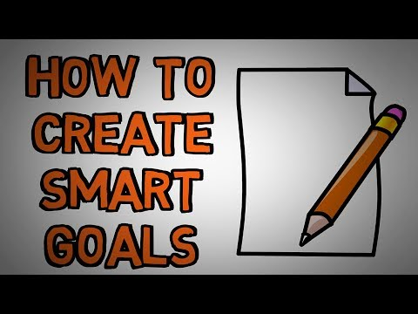

As you watch the second time
Write what each letter means and an example you heard.
S — Specific
What does it mean?
It’s a clarify goal, no general, its much better if is with details.

An example from the video:
I go to the gym three times a week for 45 minutes

M — Measurable
What does it mean?
It’s an amount that you can measure with numbers.
An example from the video:
I want to lose 10 pounds

A — Attainable
What does it mean?
Does mean about the possibility of research a goal.

An example from the video:
earn a million dollars a month
more achievable would be to earn 100 dollars more monthly

R — Relevant
What does it mean?
It’s a meaningful, important gal by myself.

An example from the video:
I learned French because I liked the way it sounded

T — Time-bound
What does it mean?
It’s a deadline, no a project without end date.

An example from the video:
at school they gave you a month to write an essay

