Read Me

This file is intended to show and explain the purpose of the project, what it does, and what capabilities it gives to those who use it.

This project based on infrastructure for the representation of geographic information.

The ability of this project are:

**A basic coordinate system converter**

like: 1. find the 3D vector between two lat,lon, alt points 2. Adding a 3D vector in meters to a global point. 3. convert a 3D vector from meters to polar coordinates. This method are implemented in the coord package .

**Convert a csv file to a kml file**

In the class Csv2kml there is method writeFileKML that gets the name of a csv file and creates a kml file that based on the information in the csv.   
In the conversion process creates a project object that contains one layer and several elements according to the number of rows in the file.

**Convert a** **folder** **to a kml file**

In the class MultiCsv there is option to give location of folder which we are scanning and any csv file which is converted to be a layers in the project object with some elements.

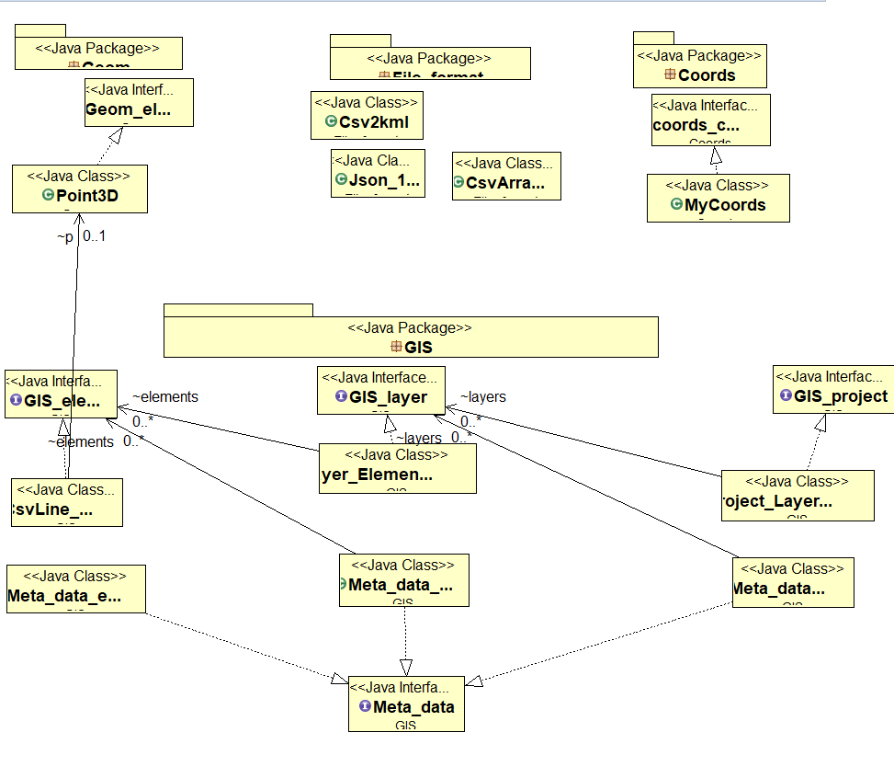

In converting from Java to kml we used Jak library: https://labs.micromata.de/projects/jak.html