Banksy: Who Owns an Anonymous Voice?
Teacher's guide · Seconde bac pro · A2 and B1
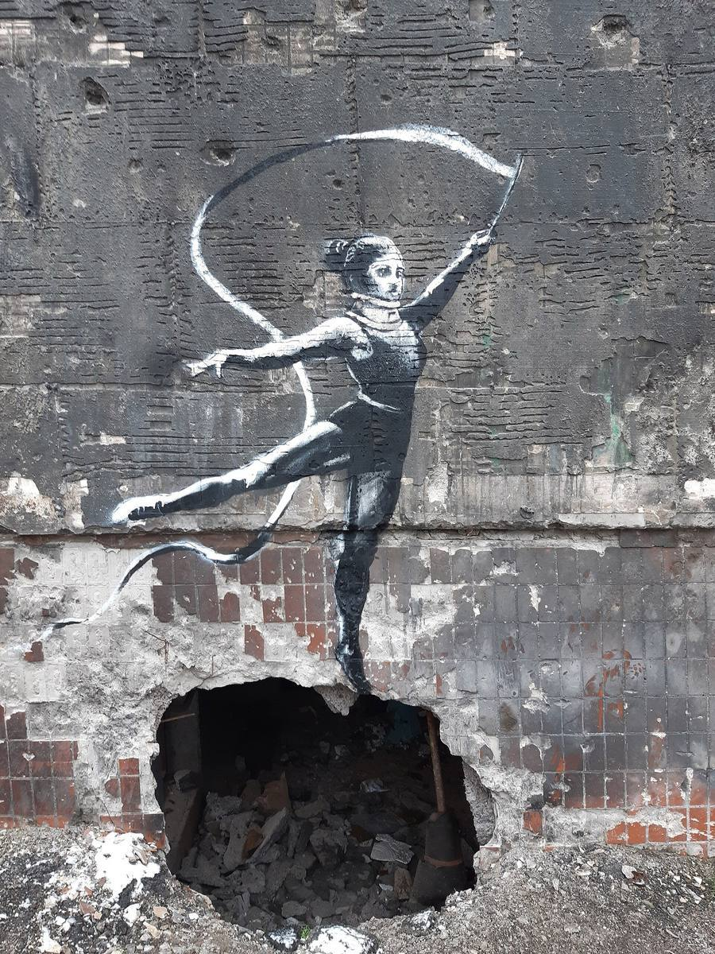
Cover photograph: a mural widely attributed to Banksy, Gymnast with a Ribbon, Irpin, Ukraine, 2022. Photograph by Rasal Hague, 18 November 2022, Wikimedia Commons, CC BY-SA 4.0. The photograph is shared under that licence. The artwork itself remains protected.
Designed by Madame Carole Paoli Pompougnac
BO spécial n° 5 du 11 avril 2019 · Six lessons of 55 minutes
https://itineraires-destinations.fr/banksy-who-owns-an-anonymous-voice/
conçu par Madame Carole Paoli Pompougnac, mis en page par Grok
© 2026 Madame Carole Paoli Pompougnac · CC BY-NC-SA 4.0
Anglais · Seconde bac pro · A2 and B1 · Teacher's guide

Teacher's guide
This guide is for the teacher. Students use the lesson pages, the student pack and, if they need it, the dys version. The sequence was designed by Madame Carole Paoli Pompougnac and laid out for the site by Grok.

1. What this sequence will not do
- It will not present Robin Gunningham, or the later name David Jones, as a confirmed civil identity. Both names are press claims. The accurate classroom sentence is on the presentation page and in Lesson 2.
- It will not ask students to find a private address, to identify relatives, to contact a private person, or to "solve" the artist's identity.
- It will not flatten a documented Reuters investigation, published on 13 March 2026, into "just a rumour". Students learn to say according to, and to keep a well-supported claim in the category of a claim.
- It will not treat a High Court decision about one physical wall, in 2015, as a universal rule about every mural.
- It will not treat a sale price as proof of the artist's intention.
The original request for this sequence mentioned a Reuters investigation in 2025. The investigation located for the sequence was filed on 13 March 2026. The date is corrected throughout.

2. Photographs and rights
A Creative Commons or public-domain licence for a photograph does not remove rights in the artwork that was photographed. Pest Control is Banksy's official contact and the body that issues certificates of authenticity for eligible works. It does not, according to its own FAQ, certify illegally executed works, and it does not treat the removal of a street mural as a normal way to obtain a certificate.
Every photograph on the site is credited in its caption (photographer, licence, Wikimedia Commons page). The photographs were downloaded into the page folder. No photograph already used elsewhere on itineraires-destinations.fr was reused here. Dismaland was a multi-artist project: captions warn teachers and students not to attribute every object to Banksy. The Girl with Balloon photograph is a reconstructed mural in a Brussels exhibition, not the original 2002 London wall; the caption says so. The Irpin gymnast is not the Borodianka handstand gymnast. Interpretations of the judo mural that name a political leader remain interpretations.
Pest Control is Banksy's official contact and the body that authenticates eligible works. Its FAQ states that it does not issue certificates for illegally executed works, and reporting about the organisation describes a policy against authenticating street pieces removed from their intended locations. Mention this gently, as a fact about authentication, not as a moral lecture.

3. The two pathways
Every lesson uses the same images, the same videos and the same questions. The A2 pathway offers frames, shorter outputs and more explicit support. The B1 pathway asks for connected explanation, attribution, qualification and a response to an opposing view. The diagnostic in Lesson 1 is not marked; it is used to place students. A student can move from one pathway to the other later. Première classes can take the B1 pathway as the main track, and still use the A2 frames as a help box.
The 2019 programme identifies B1+ as the examination expectation for LVA in the vocational baccalaureate, A2+ for LVB, and A2 for the relevant CAP assessment. The two pathways are teaching pathways, not a claim about every student's final examination target.

4. Timing
Each lesson lasts 55 minutes and is planned over 52 minutes, with three minutes for arrival and transitions. A checkpoint at minute 44 tells you what every student must already have done. The eight-minute essential closing route replaces the last eight minutes when the class needs more time. It does not add eight minutes. Every lesson ends with a written record, an oral contribution from every student, and homework.

5. Videos and listening
- Dismaland trailer, banksyfilm, 25 August 2015: youtube.com/watch?v=V2NG-MgHqEk, 00:00 to 02:07, shown twice at most.
- Shredding film, banksyfilm: youtube.com/watch?v=vxkwRNIZgdY, 00:00 to 02:00, shown twice at most. Preview it, and check local access. It is the artist's presentation of the event, not an independent investigation.
Teacher-written listening texts are original teaching materials. Tell students so, and do not present them as quotations from Banksy, Reuters or Pest Control. They are based on the referenced issues.

6. Assessments
Diagnostic, Lesson 1: not marked. Mid-point oral, Lesson 3: paired speaking on ownership, A2 and B1 grids, coefficient 1. Summative, Lesson 6: written label and recommendation, plus oral continuous speaking and interaction, A2 and B1 grids, coefficient 2. Every grid has a language criterion. After the oral, each student notes what was missed and writes an improved version. For Lesson 6, record pairs simultaneously if you cannot hear thirty presentations live.
Do not require public social-media accounts or public posting. School-approved recording only, submitted privately.

7. Legal and civic caution, in brief
The Creative Foundation v Dreamland Leisure Ltd, 11 September 2015, concerned a physical section of wall bearing Art Buff. The EUIPO decision of 25 October 2022 (case R 1246/2021-5), about a trademark in a monkey image, addresses trademark law and rejects the idea that a pseudonym necessarily makes copyright unenforceable. It does not settle every copyright question, and it does not say that all Banksy trademarks are valid. Mention it only if a confident B1 group asks; do not turn it into a general rule.

8. Homework and flashcards
Homework is given at the end of every lesson. For more fragile groups, prefer short oral tasks (a recorded sentence, a rehearsed turn) and flashcard revision. Students make their own cards in every lesson. Colour code, if you use one: navy for theme vocabulary, gold for words to argue, a third mark (for example a simple box) for grammar structures. Avoid a green code if you are working on a navy English sequence and want the page to stay consistent.

9. The dys version
The dys version can be used alone, including after an absence, without an AESH. Texts are shorter, consignes go step by step, a worked example precedes each exercise, and corrigés are there for self-assessment. The ambition of the questions is the same. Italics are avoided; important words are in bold.

10. What was hedged or corrected from the raw research
- The Reuters date is 13 March 2026, not 2025.
- The Irpin gymnast with a ribbon is not the Borodianka handstand gymnast. Some summaries confuse the two.
- The judo figure is not identified as a named political leader in this sequence.
- The 2021 sale of Love is in the Bin is given as a reported price of about 18.6 million pounds, as a market event, not as a window into intention.
- Girl with Balloon, on this page, is an exhibition reconstruction. The original London mural of 2002 is described, not passed off as the photograph.
Further sources are listed on the sources page.

Anglais · Seconde bac pro (all streams) · A2 and B1 (CEFR)

Banksy: Who Owns an Anonymous Voice?
Six lessons of 55 minutes, designed by Madame Carole Paoli Pompougnac. Programme de langues vivantes, BO spécial n° 5 du 11 avril 2019. Two clear pathways in every lesson, A2 and B1, on the same works and the same questions.
A mural widely attributed to Banksy, Gymnast with a Ribbon, painted in 2022 on a damaged building in Irpin, Ukraine (Severynivska Street). Photograph by Rasal Hague, 18 November 2022, Wikimedia Commons, CC BY-SA 4.0. The photograph is shared under that licence. The artwork itself remains protected. This is not the handstand gymnast in Borodianka, a different mural that Banksy posted on Instagram.

Why this sequence?
Banksy paints on walls, in streets, on hotels and in temporary parks. A work on a wall often has no civil name beside it. The public meets the image first, and the author only as a signature, a rumour or a newspaper claim. That mystery has made the work famous. It has also made it easy to copy, to cut out, to sell, and to discuss in class, because so many original images can be shown.
This sequence starts from the works themselves. It then asks two questions that do not have a single schoolbook answer. First: does it matter who the artist is in private life, or only what the work does in public? Second: when a painting is on a wall, who should decide what happens to it, the artist, the owner of the wall, the city, or the people who walk past?
The big question of the sequence. Does an artist's identity matter more than the work, and who should control art painted in a public space?
This is an open question. You can argue that a mural already has a public author, the name Banksy, without a civil identity. You can argue that a wall belongs to its owner, or that a work made for the street should stay in the street. At the end of the sequence, you will defend your own answer, with evidence, and you will keep claims in their right category: fact, attributed claim, rumour, or interpretation.
A necessary caution about identity. Banksy's civil identity is not a confirmed fact in this sequence. In July 2008, the Mail on Sunday put forward the name Robin Gunningham. On 13 March 2026, a Reuters investigation reported that Banksy was born Robin Gunningham and later used the name David Jones. Reuters presents this as the conclusion of its own enquiry, based on documents and interviews. Banksy did not confirm that identification in the sources examined for this sequence. Pest Control, the artist's official contact, told Reuters that the artist had decided not to comment. A lawyer, Mark Stephens, challenged the accuracy of many details without confirming or denying the proposed name. On 22 March 2026, NPR stated that it had not independently confirmed Reuters' findings. In class, we therefore say: According to Reuters, in March 2026, Banksy was born Robin Gunningham. We never say: Banksy's real name is Robin Gunningham.

Fiche d'identité
Title | Banksy: Who Owns an Anonymous Voice?
Class | Seconde bac pro, all streams (production and services). Première classes can follow the B1 pathway as the main track.
Level | A2 and B1 (CEFR), as two clear pathways in every lesson. Same supports, different expected language and length.
Programme | BO spécial n° 5 du 11 avril 2019, langues vivantes des classes préparant au CAP et au baccalauréat professionnel
Length | Six lessons of 55 minutes, each planned over 52 minutes, with a checkpoint at minute 44 and an eight-minute essential closing route
Differentiation | Two pathways, A2 and B1, visible in every lesson. Students work on the same images and the same questions.
Final task | A cultural mediation team advises a local exhibition entitled Banksy: Public Walls, Private Names.

Programme and five objectives
Programme de langues vivantes des classes préparant au CAP et au baccalauréat professionnel (arrêté du 3 avril 2019). Source: education.gouv.fr.
The programme does not use the numbered cultural axes of the lycée général et technologique. It organises teaching around two contexts of communication. This sequence works in both. The five objectives below are the programme themes that the sequence actually serves.
Context 1. Everyday, personal, social and civic life
Objective from the programme | Where in the sequence
1. Grandes œuvres célèbres (peinture, sculpture, cinéma, photographie) | Every lesson: describing and interpreting murals, a temporary park, a hotel and an auction film
2. Personnages historiques et personnalités célèbres | Lessons 1, 2 and 6: a public artistic name, without treating a civil identity as established
3. Médias, réseaux sociaux et internet: pratiques et enjeux | Lesson 2: Reuters reporting, an earlier press claim from 2008, a fact-check, and the ethics of publication
4. Grands enjeux contemporains, droits de l'homme et migrations | Lessons 4 and 5: public space, conflict, displacement, and who may see a work
5. Événements culturels, lieux symboliques et tourisme | Lessons 4 and 6: Dismaland, The Walled Off Hotel, and a mediation task for visitors

Context 2. Professional life
Professional skill named by the programme | Where in the sequence
Identifying different viewpoints and taking part in a debate | Lessons 2, 3 and 5: a newsroom, a rights dispute, a public-art committee
Providing explanations adapted to a client or a visitor | Lesson 6: acting as a cultural mediator
Producing a short professional report and proposing solutions | Lesson 6: a written exhibition recommendation and an ethical label

The six lessons
Lesson | Question of the day | Language focus
1. Can an image speak without a name? | Can we understand an artwork before we know who made it? | there is / there are; present continuous; may
2. Should the public know who Banksy is? | When does reporting an identity serve the public, and when does it intrude on a private life? | according to; reported that; may / might; did not confirm is not denied
3. If you own the wall, do you own the art? | Can someone own the object without owning every right connected to it? | was painted / was removed / was returned; should; however
4. Can anti-commercial art escape the market? | Does selling criticism weaken it, spread it, or change it? | comparatives; more... than; whereas; although
5. Does a mural lose its voice when it leaves its wall? | Is a street artwork an image alone, or an image in a particular place? | if + present, will / may; because of; in order to
6. Exhibiting Banksy without owning the name | How can a mediator inform the public without overstating evidence or erasing the street? | review: should, may, although, if, accurate attribution

Final task
Banksy: Public Walls, Private Names. Your class is a cultural mediation team. The organisers want to exhibit photographs of murals and to discuss a fictional proposal: should a mural be removed from a privately owned building and shown indoors? Each student presents one artwork, explains why its location matters, distinguishes a documented event from an identity claim, recommends what should happen to the fictional mural, answers a visitor's question, and writes a short ethical exhibition label. Nobody is asked to discover a private address, to identify relatives, or to investigate a private person.

Assessments

Assessment calendar
Assessment | When | What | Weight
Diagnostic | Lesson 1, first 12 minutes | Observe a mural, speak and write without researching the artist | Not marked: used to place students on the A2 or B1 pathway
Mid-point oral | Lesson 3, minutes 28 to 44 | Paired speaking on ownership, with A2 and B1 grids, then self-correction | /20, coefficient 1
Summative | Lesson 6 | Final oral task (continuous speaking and interaction) and a written label and recommendation, with A2 and B1 grids | /20, coefficient 2

Every grid includes a language criterion: vocabulary from the sequence, and accurate syntax. After oral work, each student notes what was missed, using the teacher's grid, and produces an improved version.

Downloads
Student pack, teacher's guide and dys version, each in pdf, docx and odt.
- Student pack
pdf
docx
odt
- Teacher's guide
pdf
docx
odt
- Dys version
pdf
docx
odt
On the site: dys version · teacher's guide · sources.

Photographs used in the sequence
The images are photographs from Wikimedia Commons, downloaded for this page, with the photographer and the licence in each caption. A Creative Commons or public-domain licence for a photograph does not remove rights in the artwork that was photographed. Pest Control is Banksy's official contact and the body that issues certificates of authenticity for eligible works. It does not, according to its own FAQ, certify illegally executed works, and it does not treat the removal of a street mural as a normal way to obtain a certificate.

Anglais · Seconde bac pro · A2 and B1 · Lesson 1 of 6

Lesson 1. Can an image speak without a name?
Question of the day: Can we understand an artwork before we know who made it?

For the teacher: timing (52 minutes)
Time | Activity
00 to 05 | Silent observation of Girl with Balloon: individual diagnostic notes, no research yet
05 to 12 | Diagnostic paired speaking and a short written response
12 to 19 | Expanding your vocabulary: description or interpretation
19 to 26 | Grammar: there is / there are, present continuous, may
26 to 34 | A second mural, One Nation Under CCTV, and a short listening reconstruction
34 to 40 | Paired interpretation exchange, A2 and B1 pathways
40 to 44 | Three flashcards
44 to 49 | Written record
49 to 52 | Exit sentence and homework

Checkpoint at minute 44. Every student has named three visible details, used one description structure, and spoken to a partner.
Eight-minute essential closing route (replaces the last eight minutes if the class needs more time; it does not add time): 44 to 46: complete There is... / The girl is... / It may... 46 to 49: each partner reads one sentence and gives a reason. 49 to 51: one vocabulary card and one structure card. 51 to 52: record homework.

A2 outcome
Describe visible details and give a simple interpretation with a reason.

B1 outcome
Distinguish description from interpretation and compare two plausible readings of the same image.

Step 1 and 2. Diagnostic assessment
Look at the image in silence. Do not search for the artist's name yet. The photograph shows the famous motif of Girl with Balloon. The original mural appeared in London in 2002. The photograph below is a reconstructed mural in an exhibition in Brussels, not the original wall. We can still study the image itself.
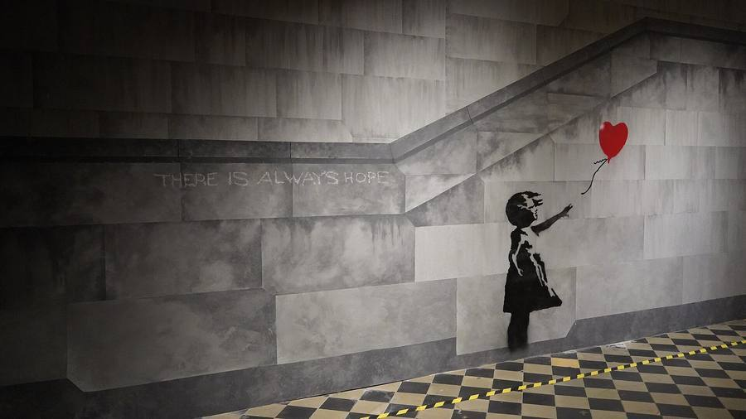
The motif of Banksy's Girl with Balloon (the original mural appeared in London in 2002). This photograph shows a reconstructed mural in the exhibition The World of Banksy, Brussels, 2022, not the original wall in London. Photograph by Miguel Discart, Wikimedia Commons, CC BY-SA 2.0. The photograph is shared under that licence. The artwork itself remains protected.

Student sheet
Task A. Observe. Write: 1. Three things you can actually see. 2. One thing you think the image means. 3. One question about the image.

A2 pathway
Task B. Speak for 30 seconds. Use: There is... The girl is... I think... because...
Task C. Write three connected sentences.

B1 pathway
Task B. Speak for 60 seconds. Include visible evidence, two possible interpretations, and one question the image cannot answer. Then ask your partner one question.
Task C. Write five or six sentences, keeping description and interpretation apart.
The teacher uses this first speaking turn to place students on the A2 or the B1 pathway. It is not marked.

Teacher's positioning grid (not marked)
Criterion | Towards A2 | Towards B1
Observation | Lists objects, sometimes mixes them with opinions | Separates what is visible from what is guessed
Speaking | Short sentences, with support from the frames | Connected speech, a reason, a second possibility
Language | there is, present continuous, a simple because | may, whereas, a question the image cannot answer

Step 3. The question of the day
A mural on a wall often has no civil name next to it. Some works carry a painted tag; others are attributed later. The public still meets an author of a kind: a style, a stencil, a repeated motif. The question is not "is there no author at all?" The question is: can the image already speak, before a private identity is known?

Step 4. Expanding your vocabulary

A. Words for looking at a mural
Word or phrase | Meaning | Example
mural | a painting made directly on a wall | The mural is on the side of a building.
stencil | a cut-out shape used to paint a repeated image | The girl is painted with a stencil.
foreground | the part of the image that appears closest to us | In the foreground, the girl is reaching out.
background | the part that appears further away | In the background, the wall is almost empty.
to reach (towards) | to stretch a hand in the direction of something | The girl is reaching towards the balloon.
anonymous | with a name that is not publicly known | The artist is anonymous as a private person.
author | the person who created the work | A mural can have an author without a civil identity.
public space | a place that people can enter or see in ordinary life | The original mural was in a public space.

B. Words to analyse and give an opinion
Word or phrase | Meaning | Example
description | saying what you can actually see | A description stays with visible evidence.
interpretation | a possible meaning, not a proof | My interpretation is that the balloon is being lost.
to suggest | to point towards a meaning, without proving it | The empty wall may suggest loneliness.
evidence | what you can point to in the image or in a source | The evidence is the girl's raised hand.
plausible | possible and reasonable | Both readings are plausible.
I would argue that | a phrase to introduce a reasoned opinion | I would argue that the image already speaks.

Exercises on vocabulary
Exercise 1. Match. 1. mural 2. stencil 3. foreground 4. interpretation 5. evidence
a. a possible meaning b. what you can point to c. a painting on a wall d. a cut-out used to paint e. the nearest part of the image
Corrigé
1c, 2d, 3e, 4a, 5b.
Exercise 2. Description or interpretation? Write D or I.
- The balloon is red and heart-shaped.
- The girl is sad because she has lost her balloon.
- The girl is reaching towards the balloon with her left hand.
- The image is about lost love.
- The wall behind the figure is almost empty.
Corrigé
1 D (visible colour and shape). 2 I (sadness and loss are not proven). 3 D (a visible action). 4 I (a general meaning). 5 D (what the photograph shows of the wall).
Exercise 3. Fill in the gaps with: mural · stencil · foreground · may · evidence
In the _______ we can see a girl and a balloon. The figure looks as if it was made with a _______. This _______ is famous, but the photograph here is a reconstruction, not the original wall. The red balloon _______ suggest a heart. That is an interpretation, not _______ we can prove from the image alone.
Corrigé
foreground; stencil; mural; may; evidence.

Flashcards of the lesson
Each student makes three cards: one theme word, one word for arguing, one grammar structure. On the front: the word or structure. On the back: a short meaning, and one example sentence about today's mural. Model:
Front | Back
interpretation | A possible meaning, not a proof. Example: One interpretation is that the balloon is escaping.
may + verb | A possibility, not a certainty. Example: The girl may be letting the balloon go.
public space | A place people can see in ordinary life. Example: The original mural was in a public space in London.

Keep the cards for the next lessons. You will reuse them.

Step 5. A second mural, and a grammar point
Now look at a work that is still (or was) on a real street wall: One Nation Under CCTV, on Newman Street in London. A child is painting huge letters. A uniformed figure and a dog seem to watch. A camera is part of the scene. What can you actually see, and what can you only suggest?
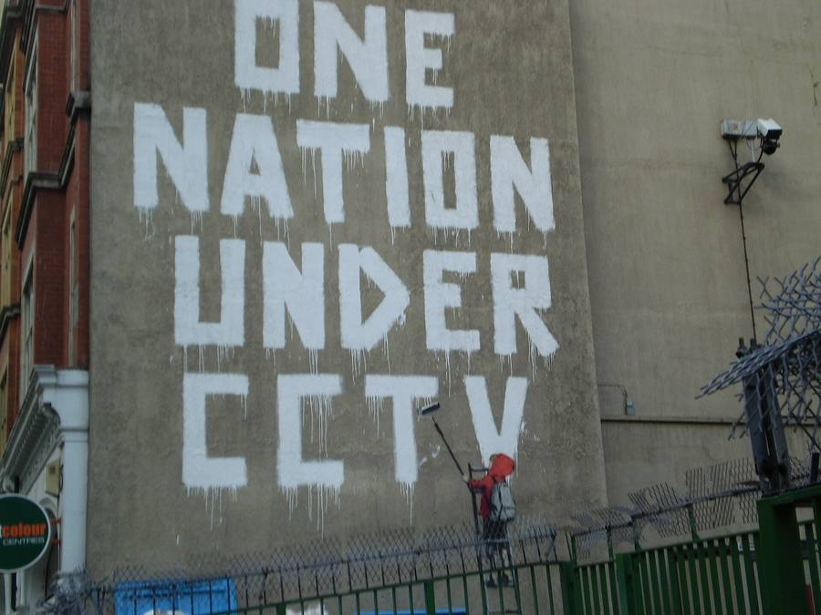
A mural attributed to Banksy, One Nation Under CCTV, Newman Street, London. A child on a ladder paints large white letters on a wall, while a uniformed figure and a dog look on. Photograph by VirtuallyLondonBecky, Wikimedia Commons, CC BY-SA 4.0. The photograph is shared under that licence. The artwork itself remains protected.

Grammar of the lesson
- there is / there are for what exists in the picture: There is a child on a ladder. There are large white letters.
- present continuous for a visible action now: The child is painting. The figure is watching.
- may for a possible reading: The child may be criticising surveillance. We do not know the painter's exact intention from the image alone.
Exercise 4. Choose the correct form.
- There is / There are a dog in the picture.
- The child is paint / is painting the last letter.
- The letters may / are meaning "the nation is watched". (Careful: may is followed by the infinitive without to.)
- There is / There are large letters on the wall.
- The uniformed figure may watch / may be watching the child.
Corrigé
1 There is. 2 is painting. 3 may mean (may + infinitive: The letters may mean...). 4 There are. 5 may be watching (a possible action we see as ongoing).
Exercise 5. Rewrite. Turn each note into a full sentence, using the grammar of the lesson.
- child / ladder / paint / letters
- possible meaning: the camera / watch / everyone
- visible fact: huge white words / on / wall
Corrigé
Example answers. Other correct sentences are possible. 1. The child is on a ladder and is painting the letters. / There is a child on a ladder, painting the letters. 2. The camera may watch everyone. / This may suggest that everyone is being watched. 3. There are huge white words on the wall.

Step 6. Speaking task

A2 pathway
In pairs, present Girl with Balloon in 30 to 40 seconds. Use at least two of these frames: There is... The girl is... I think... because... It may... Your partner then asks you one simple question.

B1 pathway
In pairs, compare the two murals in about one minute. Distinguish what you can see from what you interpret. Use may, whereas and I would argue that. End with a question the photographs cannot answer: for example, who owns the wall, or what the artist intended.

Step 7. Written record

A2 pathway
Copy and complete: There is a girl and a balloon. The girl is... The balloon may... I think this image can / cannot speak without a name because...

B1 pathway
Write six to eight sentences. First describe. Then give two interpretations. Then answer the question of the day, with a reason, without inventing a civil identity for the artist.

Step 8. Homework
Complete an observation card for The Mild Mild West, a mural in Stokes Croft, Bristol, or for Well Hung Lover at the bottom of Park Street, Bristol (photographs on this page, below). Write what you can see, what you think it may suggest, and one thing you cannot establish from the image alone. A2: six short sentences, using there is and may. B1: a short paragraph that keeps description and interpretation apart. Bring your card to Lesson 2. Do not search for a private name.
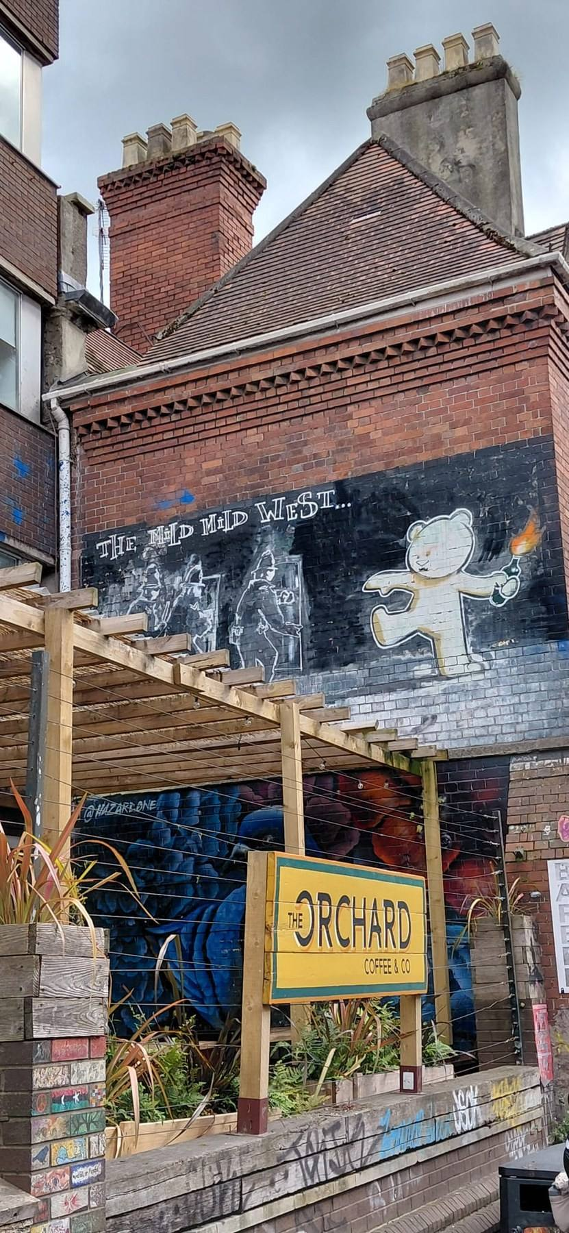
A mural attributed to Banksy, The Mild Mild West, Stokes Croft, Bristol: a teddy bear throws a molotov cocktail towards three riot police. Photograph by Earthkingfather, Wikimedia Commons, CC BY-SA 4.0. The photograph is shared under that licence. The artwork itself remains protected.
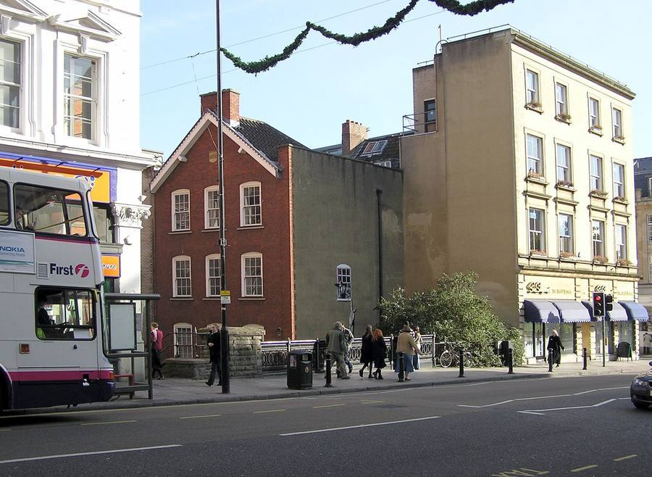
A mural attributed to Banksy, often called Well Hung Lover or The Naked Man, at the bottom of Park Street, Bristol. A naked man hangs from a window while a jealous husband and a woman look out. Photograph by Adrian Pingstone (public domain), Wikimedia Commons. The photograph is in the public domain. The artwork itself remains protected. The city council chose not to remove it.
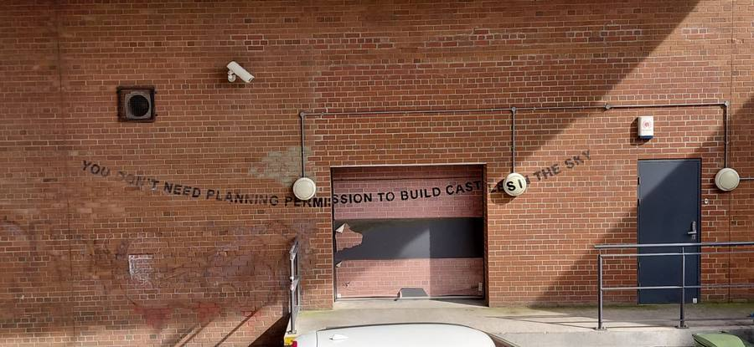
A stencil attributed to Banksy in Bristol: You don't need planning permission to build castles in the sky. Photograph by Earthkingfather, 20 March 2026, Wikimedia Commons, CC BY-SA 4.0, showing the work as it stood in 2026. The photograph is shared under that licence. The artwork itself remains protected.
The third photograph, a stencil in Bristol, will be useful again when we talk about walls, cities and permission, in Lesson 3.

Anglais · Seconde bac pro · A2 and B1 · Lesson 2 of 6

Lesson 2. Should the public know who Banksy is?
Question of the day: When does reporting an identity serve the public, and when does it intrude on a private life?

For the teacher: timing (52 minutes)
Time | Activity
00 to 05 | Flashcard retrieval from Lesson 1
05 to 12 | Read the source cards, silently and then in pairs
12 to 20 | Fact, claim, rumour and interpretation: sorting
20 to 28 | Attribution grammar and exercises
28 to 37 | Newsroom ethics role-play, A2 and B1 pathways
37 to 42 | Paired oral verdict
42 to 44 | Two new flashcards
44 to 49 | Written record: a corrected headline
49 to 52 | Exit question and homework

Checkpoint at minute 44. Every student can say who made the identity claim, and can avoid presenting it as Banksy's own confirmation.
Eight-minute essential closing route (replaces the last eight minutes if the class needs more time; it does not add time): 44 to 46: correct an overconfident headline. 46 to 49: each student gives a 20-second ethical judgement. 49 to 51: copy the accurate reporting sentence. 51 to 52: note homework.

A2 outcome
Identify the source of a statement and distinguish a press report from a personal confirmation.

B1 outcome
Evaluate evidence, keep attribution accurate, and defend a position on the ethics of publication.

Step 1. Retrieval
In pairs, use yesterday's cards. One student says a word or a structure; the other gives the example sentence. Then swap.

Step 2. Source cards
These cards are educational paraphrases, not copied articles. They exist so that you can practise a distinction. Read them carefully. Then, for each card, write: is this a documented fact, an attributed claim, a rumour, or an interpretation?

Card A. Reuters, 13 March 2026
Reuters published an investigation by Simon Gardner, James Pearson and Blake Morrison. The investigation reports that Banksy was born Robin Gunningham and later used the name David Jones. Reuters presents this as the conclusion of its own enquiry, and says it used police and court documents, interviews and travel information. Reuters is a named source, making a strong claim. It is not the same thing as a confirmation by the artist.
Source: reuters.com/investigates/special-report/global-art-banksy/, filed 13 March 2026, 10 a.m. GMT.

Card B. What Banksy and those around the artist said, as reported by Reuters
According to Reuters, Pest Control, the artist's official contact, said the artist had decided not to comment. A lawyer, Mark Stephens, challenged the accuracy of many details. He did not, in the reporting consulted for this sequence, confirm or deny the proposed identity. An absence of confirmation is not a denial. A challenge to details is not a confirmation either.

Card C. NPR, 22 March 2026
NPR interviewed Simon Gardner about the investigation. The presenter stated clearly that NPR had not independently confirmed Reuters' findings. This is useful: a second organisation can report that a first organisation has made a claim, without adopting the claim as its own established fact.
Source: NPR, 22 March 2026.

Card D. The Mail on Sunday, July 2008
Eighteen years earlier, the Mail on Sunday had already put forward the name Robin Gunningham, after what it described as a long investigation. The paper itself hedged: it presented a photograph of a man "believed to be Banksy". Banksy did not confirm the identification. In class, this is an earlier attributed claim, not a proof that Reuters must be right, and not a proof that Reuters must be wrong.

Card E. A genuine case of misidentification, 19 March 2026
After the Reuters investigation, some outlets and social-media posts circulated photographs of a London resident, George Georgiou, as if he were Banksy. Reuters published a fact-check: those photographs were not of the person Reuters had written about, and Georgiou is not Robin Gunningham. This shows how a story about identity can create a new error. We do not reproduce that person's photograph in this sequence.
Source: Reuters Fact Check, 19 March 2026.

Step 3. Four useful categories
Category | Working meaning | Example from this lesson
Documented fact | An event or a publication supported by the source under examination | Reuters published its investigation on 13 March 2026.
Attributed claim | A conclusion clearly assigned to a named source | According to Reuters, Banksy was born Robin Gunningham.
Rumour | An allegation circulating without adequate supporting evidence in the material available | An unnamed account on social media says a local stranger is Banksy.
Interpretation or opinion | A judgement about meaning, value, or what should happen | Banksy's anonymity makes the work more powerful.

A claim can be well supported. Calling something a claim does not mean it is false. Reuters presents documentary evidence; students may discuss how strong that evidence seems, without turning the name into a classroom fact, and without flattening a documented investigation into "just a rumour".
Exercise 1. Sort these statements. Write F (documented fact), C (attributed claim), R (rumour) or I (interpretation).
- Reuters published an investigation on 13 March 2026.
- Banksy's real name is Robin Gunningham.
- According to Reuters, Banksy later used the name David Jones.
- NPR said it had not independently confirmed the findings.
- Anonymity is the only reason Banksy is famous.
- A classmate heard that a teacher in Bristol is Banksy, but has no source.
- The Mail on Sunday put the name Gunningham forward in 2008.
- Pest Control confirmed the Reuters identification. (Careful.)
Corrigé
1 F (the publication and its date are documented). 2 This sentence is not acceptable in this sequence: it turns a claim into a fact, with no attribution. The accurate form is a C: According to Reuters, Banksy was born Robin Gunningham. 3 C. 4 F (what NPR stated, on a dated broadcast). 5 I (a judgement, and a risky one: fame has more than one cause). 6 R (no adequate source). 7 F (the paper did publish that claim in 2008; the identity itself remains a claim). 8 This is false, and it is not a fair claim either. According to Reuters, Pest Control said the artist had decided not to comment. An absence of comment is not a confirmation.

Step 4. Expanding your vocabulary
Word or phrase | Meaning | Example
according to | used to show the source of a piece of information | According to Reuters, the artist later used another name.
to report that | to give information as news, as a journalist does | Reuters reported that it had examined court documents.
to confirm | to say officially that something is true | Banksy did not confirm the identification.
to deny | to say that something is not true | A refusal to comment is not a denial.
to allege | to say that something is true, without proving it | The paper alleged that it had identified the artist.
investigation | a careful enquiry that looks for evidence | The investigation was published in March 2026.
privacy | the right to keep some parts of life out of public view | Some people argue that a private name should stay private.
public interest | a reason for publishing something because society may need to know it | The newsroom must decide whether publication is in the public interest.
to attribute | to assign a statement or a work to a source or a person | We attribute the claim to Reuters, not to Banksy.
to qualify (a claim) | to limit a statement so that it stays accurate | You can qualify a headline by adding according to.

Grammar of the lesson
- according to + source: According to Reuters, the artist was born Robin Gunningham.
- X reported that + clause: Reuters reported that it had used court documents.
- may / might for a possibility we do not treat as certain: The documents may support the claim. They might still be incomplete.
- A useful contrast: did not confirm is not the same as denied. The artist did not confirm the name. The artist did not deny it either, in the sources we have.
Exercise 2. Correct the headlines. Each headline is too sure of itself. Rewrite it so that it is accurate.
- BANKSY'S REAL NAME REVEALED: ROBIN GUNNINGHAM.
- PEST CONTROL CONFIRMS THE STORY.
- NPR PROVES REUTERS RIGHT.
- BANKSY DENIES EVERYTHING.
Corrigé
Example rewrites. Other accurate versions are possible. 1. Reuters reports that Banksy was born Robin Gunningham. / According to a Reuters investigation, Banksy was born Robin Gunningham. 2. Pest Control said the artist had decided not to comment. 3. NPR said it had not independently confirmed Reuters' findings. 4. In the sources examined for this sequence, Banksy did not confirm the identification, and did not issue a personal denial either. A lawyer challenged many details without confirming or denying the name.
Exercise 3. Complete with according to, reported that, may, did not confirm, or denied.
- _______ Reuters, the artist later used the name David Jones.
- The Mail on Sunday _______ a man in its photographs was "believed to be Banksy".
- NPR _______ it had not independently confirmed the findings.
- Banksy _______ the identification in the sources we have.
- A well-supported claim _______ still be debated. It is not automatically a classroom fact.
Corrigé
1 According to. 2 reported that (or alleged that). 3 reported that / stated that. 4 did not confirm. 5 may.

Step 5. Newsroom role-play
You work on the news desk of a school magazine. A major agency has just published an investigation into Banksy's civil identity. You must decide what to print, and how to print it. You are not asked to find a private address or to contact a private person.

A2 pathway
In pairs: one student is a reporter, the other is the editor. The reporter has 40 seconds to say what the agency reported, using according to. The editor has 40 seconds to decide: print the name with a cautious headline, print the story without the civil name, or wait. Use I think we should... because...

B1 pathway
In groups of three: reporter, editor, and a lawyer for the magazine. In three minutes, reach a decision. You must: attribute the claim; mention that Banksy did not confirm it; mention NPR's caution; and answer this objection: 'The public has a right to know everything about a famous person.' Use although, may and public interest.

Step 6. Oral verdict

A2 pathway
Give a 20-second answer to the question of the day. Frame: I think the public should / should not know, because... According to... Banksy did not confirm...

B1 pathway
Give a 45-second answer. Include one argument for publication, one argument for privacy, and your own qualified decision. Do not present the civil name as a fact.

Step 7. Written record and flashcards
Write the accurate classroom sentence in your exercise book:
Reuters reported in March 2026 that Banksy was born Robin Gunningham and later took the name David Jones. Banksy did not confirm that identification in the sources examined for this sequence.
Then write two flashcards: according to and did not confirm. Homework will reuse them.

A2 pathway
Copy the classroom sentence. Then rewrite headline 1 from exercise 2 in your own words.

B1 pathway
Copy the classroom sentence. Then write a six-sentence news brief for the school magazine, with accurate attribution and a final ethical judgement.

Step 8. Homework
A2: record yourself (on a school-approved device, or read aloud at home) reading your corrected headline and one reason, in about 20 seconds. B1: write a short comment (80 to 100 words) on this statement: "If you choose to be famous, you lose the right to privacy." Use according to, although and may. Do not try to discover a private address.

Anglais · Seconde bac pro · A2 and B1 · Lesson 3 of 6

Lesson 3. If you own the wall, do you own the art?
Question of the day: Can someone own the object without owning every right connected to it?

For the teacher: timing (52 minutes)
Time | Activity
00 to 05 | Retrieval: author, source, confirmation
05 to 12 | Read the Art Buff case and sequence the events
12 to 20 | Three kinds of rights, with No Ball Games and Season's Greetings
20 to 28 | Passive-form workshop and Pest Control
28 to 38 | Mid-point paired oral assessment
38 to 44 | Teacher feedback and student self-correction
44 to 49 | Written record and flashcards
49 to 52 | Exit recommendation and homework

Checkpoint at minute 44. Every student distinguishes the physical wall from rights in the image, and from public access.
Eight-minute essential closing route (replaces the last eight minutes if the class needs more time; it does not add time): 44 to 46: complete the three-rights chart. 46 to 49: each student gives one recommendation. 49 to 51: copy the legal distinction. 51 to 52: note homework.

A2 outcome
Explain, in simple terms, the difference between a wall, an image and public access.

B1 outcome
Apply these distinctions to a real dispute, without inventing a universal legal rule.

Step 1. Retrieval
Without looking at your notes: who published an identity claim in March 2026? Did Banksy confirm it? How do we say that in one accurate sentence?

Step 2. The Art Buff case (Folkestone, 2014 to 2015)
We do not have a clear open-licence photograph of this mural for the page, so we work from a short educational paraphrase of a court case. The case is useful because it is documented, and because it is limited: it answers one question, not every question.
In September 2014, a mural known as Art Buff appeared on a building in Folkestone. It showed a woman wearing headphones, facing an empty plinth. The business using the building was a tenant, not the freehold owner of the wall. The tenant arranged for a section of wall to be cut out and removed, without the landlord's permission. The landlord later transferred its title and its legal claim to a charity, the Creative Foundation. On 11 September 2015, the High Court decided that the Foundation was entitled to the return of the removed section of wall. The dispute was about the physical object. It did not decide that the public owns every Banksy, and it did not decide that buying a wall automatically buys the copyright in the image.
Source: The Creative Foundation v Dreamland Leisure Ltd, High Court, 11 September 2015.
Exercise 1. Put the events in order.
a. The High Court orders the return of the section of wall. b. A mural appears on a building in Folkestone. c. The landlord's claim is transferred to the Creative Foundation. d. The tenant has the wall cut out, without permission.
Corrigé
b, d, c, a. The mural appears; the tenant removes it; the claim is transferred; the court orders the return of the physical wall.
Exercise 2. True, false, or we cannot say from this case?
- The tenant owned the freehold of the building.
- The court decided that every Banksy mural belongs to the public.
- The dispute was about a physical section of wall.
- The court decided that the charity now owns the copyright in the image.
- The mural was removed without the landlord's permission.
Corrigé
1 False (the tenant was not the freehold owner). 2 False (the case is particular, not a universal rule). 3 True. 4 We cannot say that: the judgement was about the physical object, not about a transfer of copyright. 5 True.

Step 3. Three different questions about ownership
For classroom purposes, keep these three questions apart:
Question | What it is about | A first example
Physical ownership | Who owns the wall, or the piece of wall that has been cut out? | In the Art Buff case, the court treated the removed section as part of the landlord's property.
Copyright | Who has rights in the artistic image, and who may reproduce it? | A Creative Commons licence for a photograph does not automatically cancel rights in the artwork.
Public access | Who can still encounter the work, in the street or elsewhere? | If a mural is removed and sold, passers-by may lose it, even if someone now "owns" the object.

Look at two photographs that show these questions in a different way. The first shows No Ball Games on a wall in Tottenham, in 2009. The mural was later removed and sold in sections. The second shows Season's Greetings, first painted on a garage in Port Talbot in 2018, and later displayed behind glass, away from its original wall.
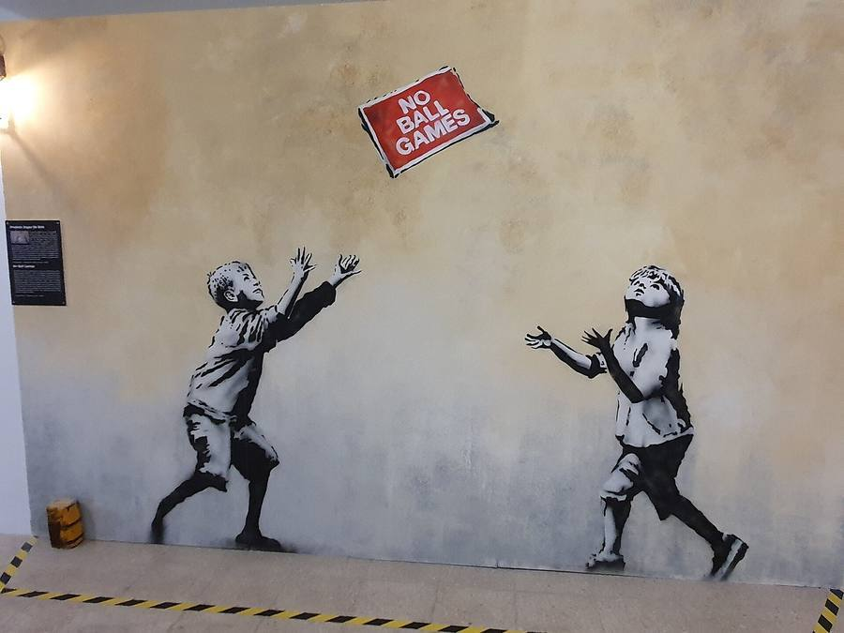
A mural attributed to Banksy, No Ball Games, Tottenham, London, 2009. Two children throw a red sign that reads No Ball Games, instead of a ball. Photograph by GualdimG, Wikimedia Commons, CC BY-SA 4.0. The photograph is shared under that licence. The artwork itself remains protected. The mural was later removed from its wall and sold in sections.
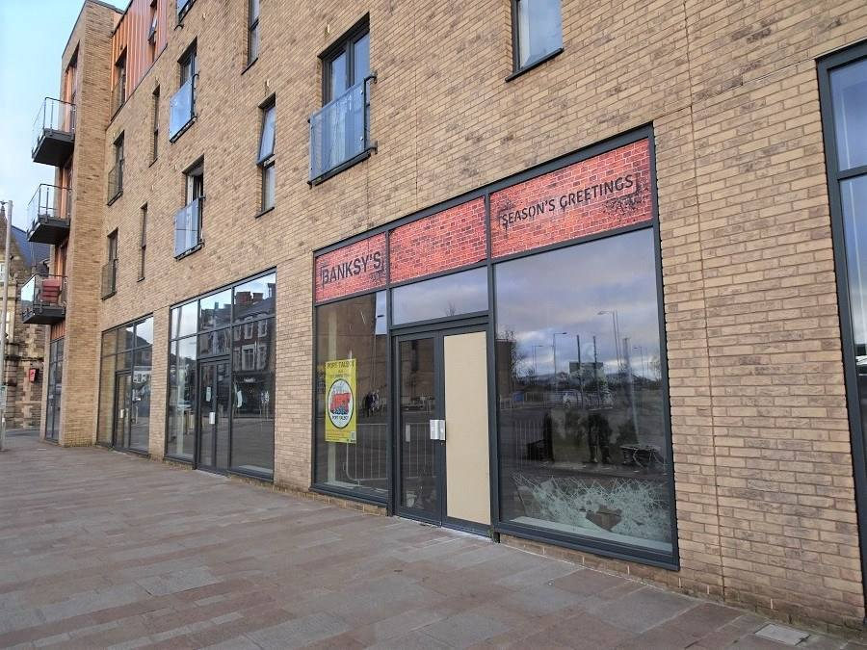
A mural attributed to Banksy, Season's Greetings, first painted on a garage in Port Talbot, Wales, in 2018. This photograph shows the work on display behind glass, no longer on its original wall. Photograph by Sionk, Wikimedia Commons, CC BY-SA 4.0. The photograph is shared under that licence. The artwork itself remains protected.
A third photograph shows what "removing a mural" can look like. In May 2023, the section of wall that carried the Irpin gymnast was cut out. The figure left the building. The mural was later moved to another site on the same street. Protection and loss can be close to each other.
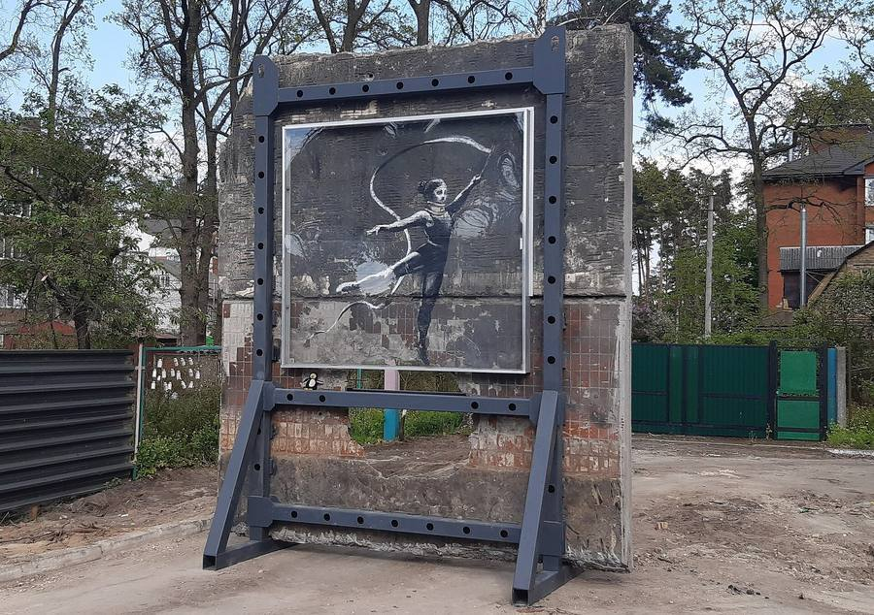
The Irpin mural of the gymnast with a ribbon after the section of wall was cut out, 14 May 2023. The figure has left the building. Photograph by Rasal Hague, Wikimedia Commons, CC BY-SA 4.0. The photograph is shared under that licence. The artwork itself remains protected. The mural was later moved to another site on the same street.

Step 4. Expanding your vocabulary
Word or phrase | Meaning | Example
landlord | the owner of a building, who may rent it to a tenant | The landlord had not given permission.
tenant | the person or business that rents a building | The tenant had the wall cut out.
to remove | to take something away from its place | The mural was removed from the wall.
to return | to give something back | The court ordered the return of the wall section.
copyright | the legal rights in an original artistic work | Owning a wall is not the same as owning the copyright.
to authenticate | to confirm that a work is by a particular artist | Pest Control authenticates eligible works.
certificate | an official document that states something is genuine | A certificate is not a permission to cut out a street mural.
public access | the possibility for people to see a work in ordinary life | Removal can reduce public access.
however | used to introduce a contrast | The charity obtained the wall. However, that did not settle copyright.

Grammar of the lesson
The past simple passive is useful for events when the object is more important than the person: The mural was painted in 2014. It was removed without permission. It was returned after a court decision. Form: was / were + past participle.
To give a recommendation: It should stay on the wall. It should not be sold without a public debate.
Exercise 3. Rewrite in the passive.
- Someone painted the mural on a garage in Port Talbot.
- Someone later displayed the work behind glass.
- Someone cut the Irpin gymnast out of the building.
- The High Court ordered the return of the Folkestone wall.
- People sold No Ball Games in sections. (Use was sold.)
Corrigé
1 The mural was painted on a garage in Port Talbot. 2 The work was later displayed behind glass. 3 The Irpin gymnast was cut out of the building. 4 The return of the Folkestone wall was ordered by the High Court. / The Folkestone wall was ordered to be returned by the High Court. The most natural form: The High Court ordered that the wall should be returned (this one can stay active). Accept: The section of wall was ordered to be returned. 5 No Ball Games was sold in sections.
Exercise 4. Wall, image, or access? For each sentence, say which question is at stake.
- Passers-by can no longer see the mural on their way to work.
- A collector buys the cut-out section of brick.
- A website reproduces the image without permission.
- The landlord wants the piece of wall back.
Corrigé
1 Public access. 2 Physical ownership (and, later, perhaps access). 3 Copyright. 4 Physical ownership.

Pest Control, a short teacher-written listening
The teacher reads the following text twice, at a measured pace. Students are told that this is an educational text based on Pest Control's published position, not a quotation. They take notes, then reconstruct.
Pest Control presents itself as Banksy's official contact, and as the source of certificates of authenticity for eligible works. Its public FAQ distinguishes works that can receive a certificate from items it will not certify. It states that it does not issue certificates for illegally executed works. Reporting about the organisation also explains a policy against authenticating street pieces that have been removed from their intended locations. A certificate and an official photograph of a mural in the street are not the same thing. Authentication is not a permission to take a wall down.

A2 pathway
Listen and complete: Pest Control is Banksy's official _______. It can issue a _______ of authenticity for some works. It does not certify illegally executed works. Authentication is not a _______ to remove a mural.

B1 pathway
Listen and write four notes: what Pest Control is; what a certificate does; what it does not certify; why this matters for a removed mural. Then tell your partner, using the passive at least once.
Corrigé
A2: contact; certificate; permission. B1, example reconstruction: Pest Control is the official contact. A certificate can authenticate an eligible work. Illegally executed works, and street pieces removed from their intended place, are not treated as ordinary candidates for a certificate. A mural can be photographed and still not be a saleable, certified object.

Step 5. Mid-point oral assessment
In pairs, you have three minutes. A fictional local café has a mural attributed to Banksy on its side wall. The owner wants to cut it out and sell it. A residents' association wants it to stay. You take sides, then you try to agree on a recommendation. You will be recorded on a school-approved device, or assessed live if recording is not possible. After the assessment, you use the grid to note what you missed, and you write an improved sentence.

A2 pathway
A2, about 45 seconds each, then one minute of interaction. Say: what the owner wants; what the residents want; the difference between the wall and the image; your recommendation, with should and because.

B1 pathway
B1, about one minute each, then one minute of interaction. Use the three-rights distinction, mention the Art Buff case without treating it as a universal rule, mention Pest Control, and answer your partner's objection. Use however, was removed and should.

A2 oral grid (mid-point) /20
Criterion | 0 to 2 | 3 to 4 | 5
Task: positions and a recommendation | The task is incomplete | Positions are stated, with a simple recommendation | Clear positions, a recommendation and a reason
Ownership distinction | Wall, image and access are mixed | At least two of the three questions are kept apart | The three questions are used simply and correctly
Language: vocabulary and syntax | Little language from the sequence | should, because, some passive attempts | Vocabulary reused; was painted / was removed used intelligibly
Interaction | Little response to the partner | A question or a short reaction | A real exchange, with a joint or reasoned conclusion

B1 oral grid (mid-point) /20
Criterion | 0 to 2 | 3 to 4 | 5
Task and argument | The task is incomplete | A position is defended, with one limitation | A clear recommendation, an opposing view, a reasoned conclusion
Use of the case and of Pest Control | No source, or a universal rule invented | The case or Pest Control is mentioned, with some accuracy | The case is used as a particular example, not as a general law
Language: vocabulary and syntax | Limited control | Passive forms and however attempted | Accurate attribution, passive forms, however, sequence vocabulary
Interaction | Little response | A relevant reaction | The partner's objection is taken up and answered

Self-correction: look at the criterion you missed, write what went wrong, and write a better version of one sentence. The improved sentence is part of the work.

Step 6. Written record and homework

A2 pathway
Complete: The wall was... The image is not the same as... The public should / should not... because...

B1 pathway
Write a short professional note (90 to 110 words) to the café owner, explaining the three questions and giving a recommendation. Do not invent a legal rule that the Art Buff case did not decide.
Homework. A2: make two flashcards, was removed and copyright, and learn them. B1: read your professional note aloud and record it, or rehearse it for a partner. Both pathways: look again at the Bristol stencil You don't need planning permission to build castles in the sky. Write two sentences: who might "own" that wall, and who can still see the work.

Anglais · Seconde bac pro · A2 and B1 · Lesson 4 of 6

Lesson 4. Can anti-commercial art escape the market?
Question of the day: Does selling criticism weaken it, spread it, or change it?

For the teacher: timing (52 minutes)
Time | Activity
00 to 05 | Retrieval: ownership and reproduction
05 to 12 | Shredding video, two viewings, brief notes
12 to 20 | Dismaland trailer, two viewings, brief notes
20 to 27 | Vocabulary and comparison exercises
27 to 34 | The Walled Off Hotel: image study
34 to 41 | Paired mini-debate
41 to 44 | Flashcards
44 to 49 | Written record
49 to 52 | Oral exit and homework

Checkpoint at minute 44. Students can name an observed event and an interpretation separately, and can describe a contrast between a promise and what is shown.
Eight-minute essential closing route (replaces the last eight minutes if the class needs more time; it does not add time): 44 to 46: complete one comparison with more... than or whereas. 46 to 49: each student explains a contradiction in 20 seconds. 49 to 51: write the two-sentence record. 51 to 52: set homework.
Video exposure stays below ten minutes: the shredding extract is shown twice (about four minutes in total); the Dismaland extract is shown twice (about four minutes and fourteen seconds in total).

A2 outcome
Describe contrasts and compare two ways of encountering a work.

B1 outcome
Explain a contradiction without reducing it to a simple accusation of hypocrisy.

Step 1 and 2. The shredding, from the artist's film
In October 2018, a framed version of Girl with Balloon was sold at Sotheby's in London. As the sale ended, the work passed through a mechanism in the frame and part of it was shredded. The transformed work was later given the title Love is in the Bin. It was sold again in 2021, for a reported price of about 18.6 million pounds. The price is a documented market event. It does not, by itself, prove the artist's exact intention.
We do not have an open-licence photograph of the shredded work. We watch a short extract from the film published by the artist, on the channel banksyfilm. The film is the artist's presentation of the event, not an independent investigation. The teacher previews it before class and checks that it can be shown.
Exact link: youtube.com/watch?v=vxkwRNIZgdY. Extract: 00:00 to 02:00. Source: banksyfilm, Shredding the Girl and Balloon: The Director's Half Cut.
First viewing. Number these elements in the order you see them: preparation, the auction, the audience reaction. Do not explain them yet.
Second viewing. Note one visible event, and one question the footage cannot answer.
Corrigé
Order: students should follow what the extract actually shows. Typically: preparation around the frame and the room; the auction itself; then the audience reaction as the paper moves through the frame. Visible event (examples): the lower part of the work passes through the frame and hangs in strips; people in the room react. Questions the footage cannot answer (examples): whether every bidder knew; what the artist exactly intended; whether the gesture criticises the market or becomes part of it. The film is the artist's own presentation, so it cannot be treated as a neutral enquiry.
Exercise 1. Visible or unproven? Write V or U.
- The work passes partly through a mechanism in the frame.
- Every person in the room knew what would happen.
- The event takes place in an auction room.
- The artist wanted to destroy the market for the work.
- The transformed work later sold for a very high price. (This is not in the two-minute extract: it comes from later reporting.)
Corrigé
1 V (in the film). 2 U (we cannot see what people knew). 3 V. 4 U (intention is not proven by the film). 5 This is a reported market fact from 2021, not something the two-minute extract shows. In the exercise, it is unproven from the footage. It can be used later as a documented report, with attribution.

Step 3. Dismaland, a temporary park
In 2015, Banksy created Dismaland, a temporary "bemusement park" in Weston-super-Mare. Many other artists took part. Do not attribute every object in a photograph to Banksy. The trailer is again from the channel banksyfilm, published on 25 August 2015.
Exact link: youtube.com/watch?v=V2NG-MgHqEk. Extract: 00:00 to 02:07. Source: banksyfilm, published 25 August 2015.
First viewing. Record three things you can see. Do not explain them yet.
Second viewing. Identify two contrasts between the promise of a theme park and what the trailer actually shows.
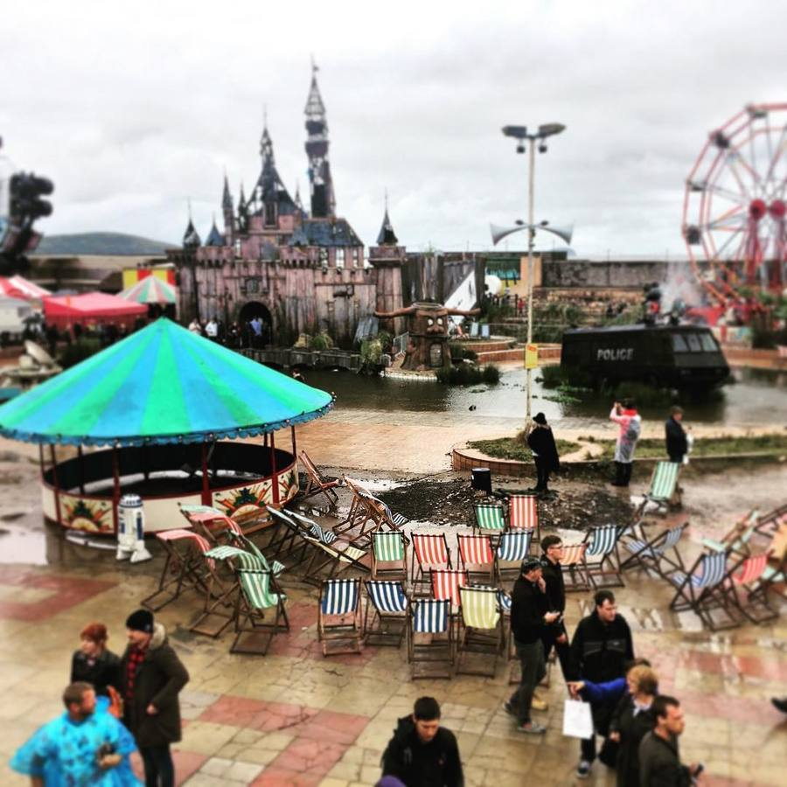
An overview of Dismaland, Weston-super-Mare, 2015, with deckchairs, a pond, a distant castle and a big wheel. Dismaland was a multi-artist project created by Banksy. Photograph by Florent Darrault, Wikimedia Commons, CC BY-SA 2.0. The photograph is shared under that licence. The artworks themselves remain protected.
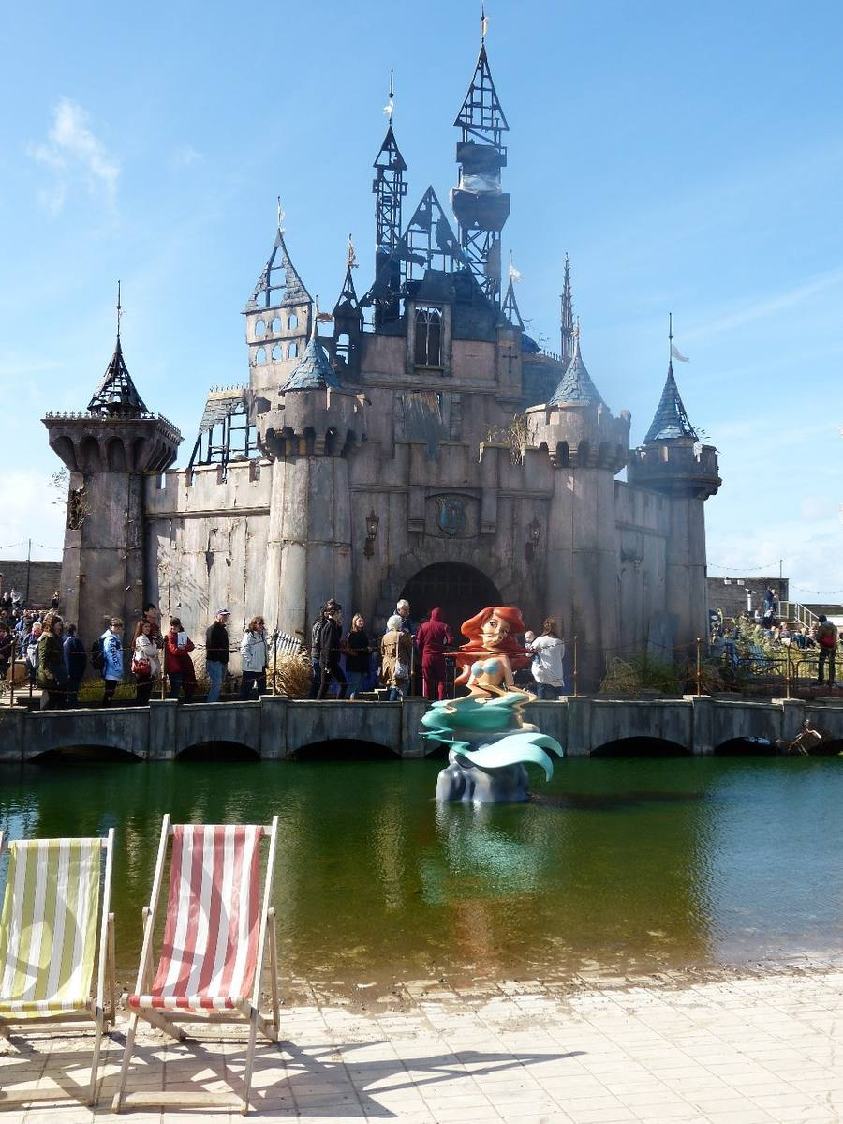
Dismaland, Weston-super-Mare, 2015: the crooked castle and a twisted mermaid figure in a moat. Banksy created the temporary park and invited many other artists. Do not attribute every object in the photograph to Banksy. Photograph by Rob Farrow, 24 September 2015, Geograph Britain and Ireland, Wikimedia Commons, CC BY-SA 2.0. The photograph is shared under that licence. The artworks themselves remain protected.
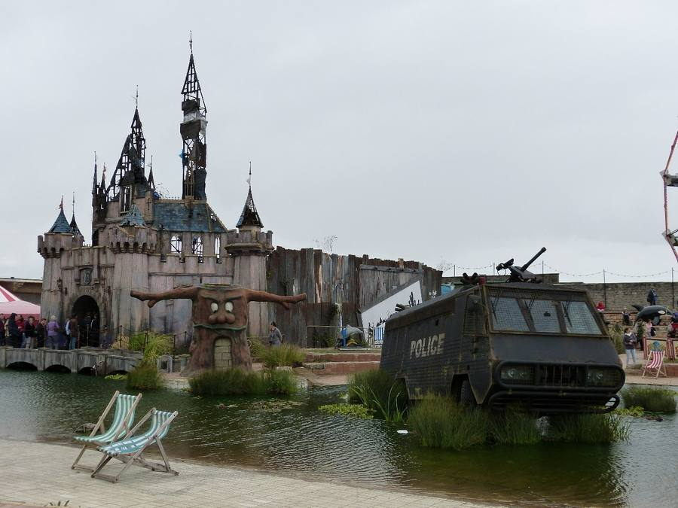
Dismaland, 2015: a stranded police vehicle in the water in front of the crooked castle. Multi-artist project. Photograph by Rob Farrow, 24 September 2015, Geograph Britain and Ireland, Wikimedia Commons, CC BY-SA 2.0. The photograph is shared under that licence. The artworks themselves remain protected.
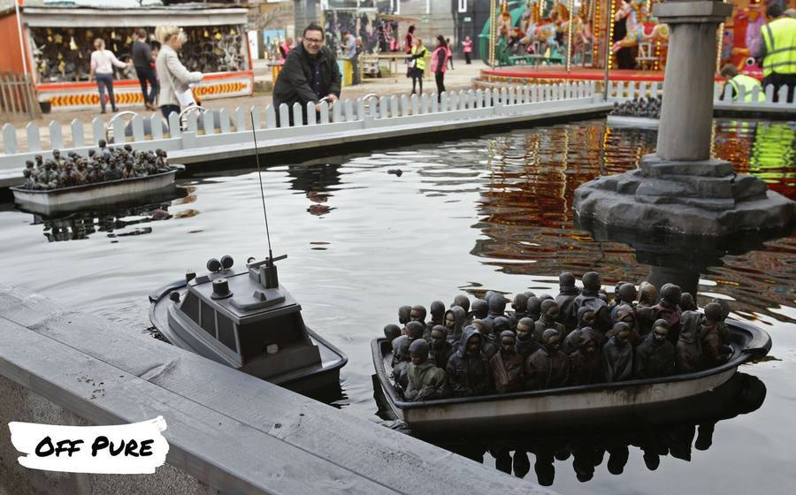
A stand at Dismaland, 2015: visitors could steer small remote-controlled boats filled with figurines of migrants. This attraction is widely attributed to Banksy. Photograph by Off Pure, 29 August 2015, Wikimedia Commons, CC BY-SA 4.0. The photograph is shared under that licence. The artwork itself remains protected.
Corrigé
Visible elements (examples): a crooked castle; a distorted mermaid; a police vehicle in the water; deckchairs; queues; a boat crowded with figurines. Contrasts (examples): a theme park promises fun, brightness and safety, whereas Dismaland shows decay, awkward humour and political images; a castle should look magical, whereas this one looks damaged; boats in a park are usually a pleasant ride, whereas these boats carry figurines of migrants. Accept other contrasts that are grounded in what is shown.

Step 4. Expanding your vocabulary and grammar
Word or phrase | Meaning | Example
auction | a public sale in which the highest bidder wins | The work was sold at an auction in London.
to shred | to cut into strips | Part of the work was shredded in the frame.
commodity | something treated as an object of trade | A critical artwork can become a valuable commodity.
contrast | a clear difference between two things | There is a contrast between the park's promise and its appearance.
whereas | used to set two facts against each other | A theme park promises delight, whereas Dismaland looks disappointing on purpose.
although | used to admit one fact and then add a contrasting one | Although the gesture seemed to attack the sale, the work later sold for more.
to criticise | to point out what is wrong, in your view | The park seems to criticise entertainment and consumer culture.
hypocrisy | pretending to have principles that your actions contradict | A simple accusation of hypocrisy may be too thin for this case.

Grammar: comparatives (more disappointing than, less magical than, far more expensive than), whereas and although.
Exercise 4. Combine the two facts, using the word in brackets.
- A theme park is supposed to be cheerful. Dismaland looks grim. (whereas)
- The shredding looked like an attack on the auction. The work became even more valuable. (although)
- The original mural was in the street. The auctioned work was in a framed sale. (more... than / whereas)
- The castle should look fairytale-like. This castle looks crooked. (less... than)
Corrigé
Example answers. 1. A theme park is supposed to be cheerful, whereas Dismaland looks grim. 2. Although the shredding looked like an attack on the auction, the work became even more valuable. 3. The original mural was in the street, whereas the auctioned work was in a framed sale. / The auctioned work was treated as a more saleable object than the mural on the wall. 4. This castle looks less fairytale-like than a traditional park castle. / This castle is less magical than visitors might expect.

Step 5. The Walled Off Hotel
In 2017, a hotel associated with Banksy opened in Bethlehem, beside the West Bank barrier. The name plays on the Waldorf hotels. The place is at once a hotel, a viewpoint, and a political statement. Guests pay to stay next to a wall that limits movement. That is already a contradiction worth describing carefully, without rushing to a single moral verdict.
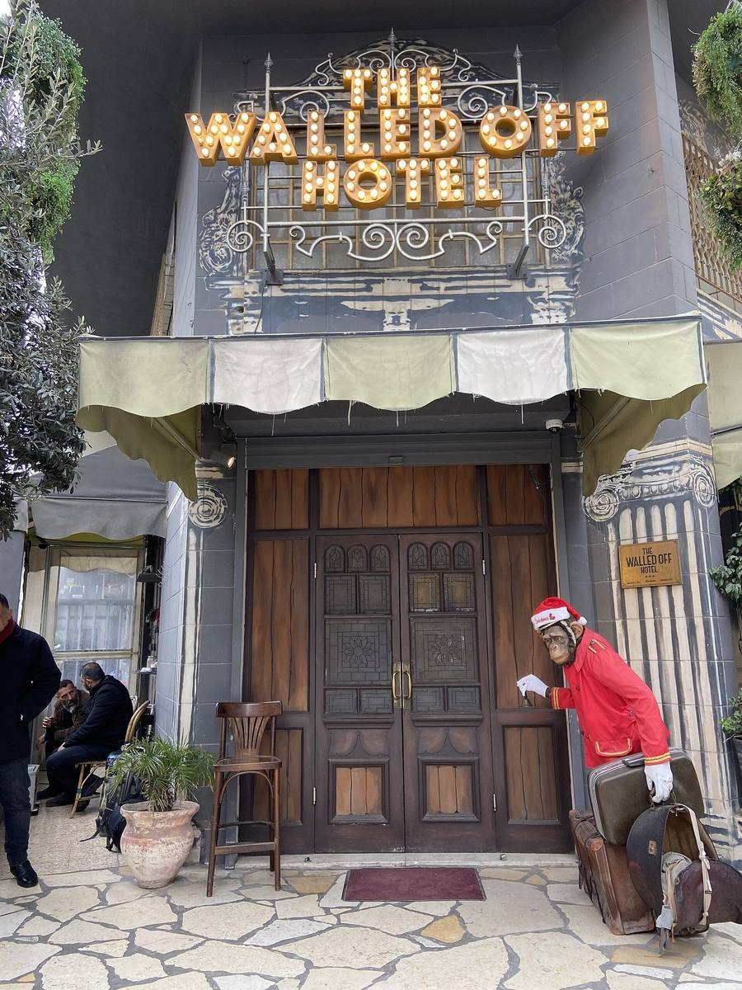
The Walled Off Hotel, Bethlehem, opened in 2017, a project associated with Banksy, standing beside the West Bank barrier. The name plays on the Waldorf hotel chain. Photograph by YellowFratello, Wikimedia Commons, CC0. The photograph is in the public domain as a photograph. The building, the decorations and any artworks remain protected.
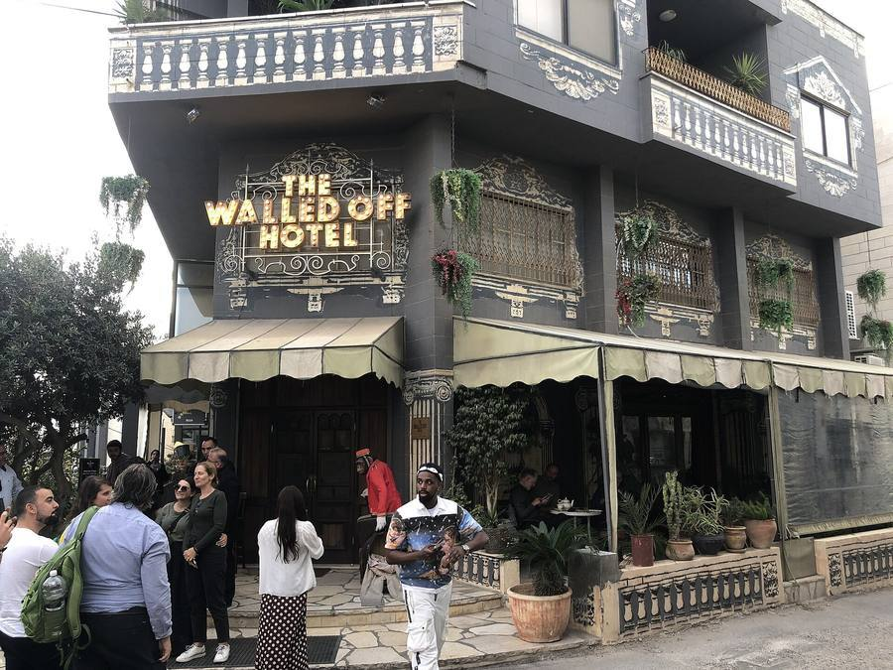
The entrance of The Walled Off Hotel, Bethlehem. Photograph by Davide Mauro, Wikimedia Commons, CC BY-SA 4.0. The photograph is shared under that licence. The building and its decorations remain protected.
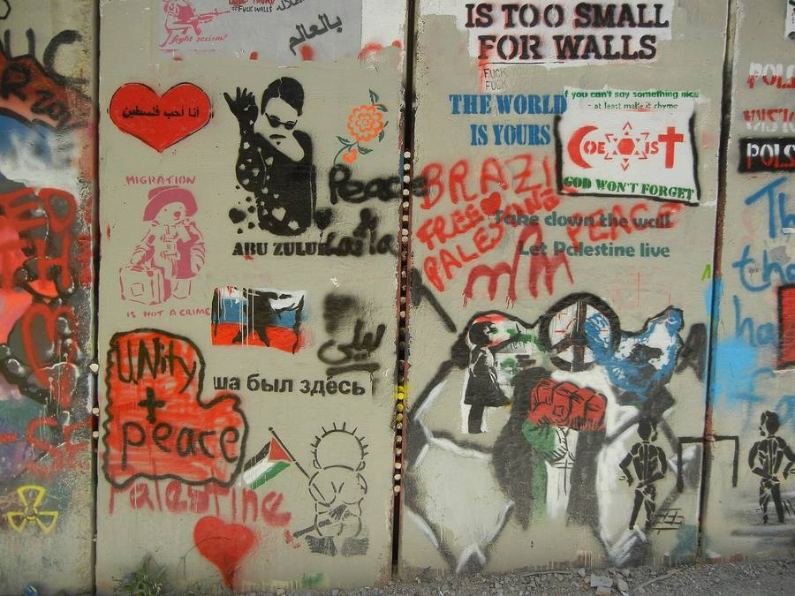
The barrier in front of The Walled Off Hotel, covered with many paintings and messages by different people. Do not attribute every image on the wall to Banksy. Photograph by Wikimedia Commons user シャター, Wikimedia Commons, CC BY-SA 4.0. The photograph is shared under that licence. The paintings themselves remain protected.
The barrier photograph shows many paintings and messages by different people. Do not attribute every image on that wall to Banksy.

A2 pathway
Write four sentences: where the hotel is; what you can see on the entrance photograph; one contrast with an ordinary luxury hotel; one question you would ask a visitor.

B1 pathway
Write a short comparison (eight to ten lines) of three encounters with Banksy's world: a street mural, an auction room, and this hotel. Use whereas and although. End with a qualified judgement, not a slogan.

Step 6. Mini-debate
Motion: "When critical art sells for millions, the criticism dies."

A2 pathway
A2: 30 seconds for, 30 seconds against, then a 20-second personal decision. Frames: I agree / I do not agree, because... Although..., the work still...

B1 pathway
B1: one minute for, one minute against, then a 30-second qualified conclusion. You must refuse a simple accusation of hypocrisy, and explain at least two possible effects of the sale: it may weaken the critique, spread the image, or change its meaning.

Step 7. Written record and homework

A2 pathway
Complete: At the auction, I can see... Dismaland looks... than a usual park, because... I think selling the work may... because...

B1 pathway
Write a 100-word commentary on the question of the day, using although, whereas and one attributed fact (the 2021 sale, or the opening of the hotel in 2017).
Homework. A2: make flashcards for whereas, auction and contrast. B1: prepare a 45-second oral presentation of one photograph from today's lesson, for a visitor who has never heard of Dismaland or of the hotel. Both: do not treat the artist's intention as something the price can prove.

Anglais · Seconde bac pro · A2 and B1 · Lesson 5 of 6

Lesson 5. Does a mural lose its voice when it leaves its wall?
Question of the day: Is a street artwork an image alone, or an image in a particular place?

For the teacher: timing (52 minutes)
Time | Activity
00 to 05 | Flashcard retrieval
05 to 13 | Ukraine image study: the gymnast in place, then dismantled
13 to 20 | Two more Ukrainian works, and a caution about interpretation
20 to 27 | London animal works, 2024: goat and pelicans
27 to 34 | Vocabulary, conditionals, and a short listening
34 to 41 | Public-art committee
41 to 44 | Flashcards
44 to 49 | Written record and a recommendation
49 to 52 | Exit statement and homework

Checkpoint at minute 44. Every student explains at least one connection between an image and its site.
Eight-minute essential closing route (replaces the last eight minutes if the class needs more time; it does not add time): 44 to 46: finish If the mural is removed... 46 to 49: each student gives a recommendation. 49 to 51: record one benefit and one risk. 51 to 52: note homework.

A2 outcome
Explain a visible connection between an image and its surroundings.

B1 outcome
Compare conservation, public access and contextual meaning, and make a qualified recommendation.

Step 1 and 2. A gymnast on a ruined wall, in Irpin
In November 2022, several murals appeared in the Kyiv region. One of them, in Irpin, shows a rhythmic gymnast with a ribbon, as if she were balancing on a hole in a damaged building. This is not the handstand gymnast in Borodianka, a different mural, which Banksy posted on Instagram. The Irpin work is widely attributed to Banksy. Look first at the mural in its original place, then at what happened when the wall was cut.
A mural widely attributed to Banksy, Gymnast with a Ribbon, painted in 2022 on a damaged building in Irpin, Ukraine (Severynivska Street). Photograph by Rasal Hague, 18 November 2022, Wikimedia Commons, CC BY-SA 4.0. The photograph is shared under that licence. The artwork itself remains protected. This is not the handstand gymnast in Borodianka, a different mural that Banksy posted on Instagram.
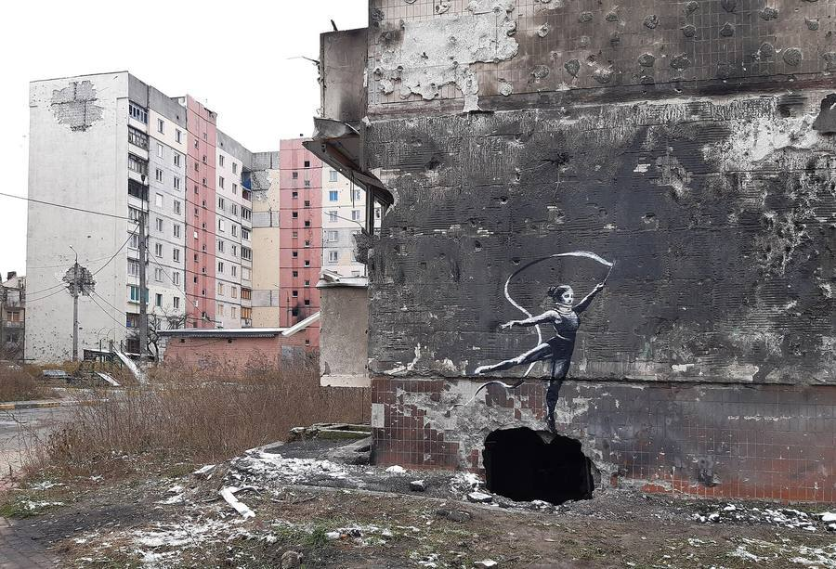
The same Irpin mural in its original setting: the gymnast appears to balance on a shell hole in a ruined building, with damaged blocks behind. Photograph by Rasal Hague, 18 November 2022, Wikimedia Commons, CC BY-SA 4.0. The photograph is shared under that licence. The artwork itself remains protected.
The Irpin mural of the gymnast with a ribbon after the section of wall was cut out, 14 May 2023. The figure has left the building. Photograph by Rasal Hague, Wikimedia Commons, CC BY-SA 4.0. The photograph is shared under that licence. The artwork itself remains protected. The mural was later moved to another site on the same street.
In May 2023 the section of wall was dismantled, so that the image could be saved. It was later moved to another site on the same street. Saving a work and taking it away from the hole that gave it meaning can be the same gesture, seen from two sides.
Exercise 1. Observation before interpretation. For each statement, write V (visible), I (interpretation) or N (cannot be established from the photographs alone).
- The gymnast is painted above a dark hole in the wall.
- The hole was made by a shell.
- The figure seems to balance as if the hole were a ball.
- The section of wall was later cut out.
- The people who removed it wanted to sell the work.
Corrigé
1 V. 2 N from the photograph alone (local and news reports describe a shell hole, but the image itself shows a hole, not its cause). Students may add: 'Reports say it was a shell hole,' which is an attributed claim. 3 I (a reading of the pose, a plausible one). 4 V, in the later photograph, and documented in reporting about May 2023. 5 N (intention is not shown; the stated aim in local reporting was to save the mural).

Step 3. Two more works from the same period
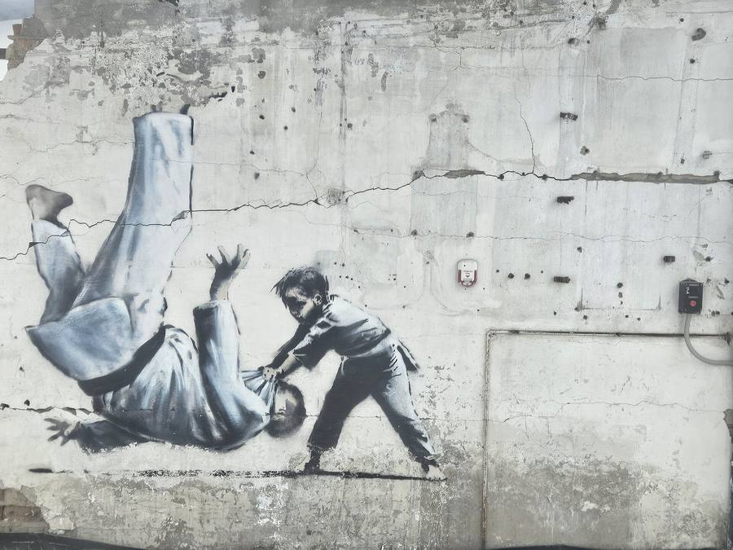
A mural widely attributed to Banksy: a child in a judogi throws a much larger adult. The work first appeared in Borodianka, Ukraine, in November 2022. Banksy did not identify the adult figure; readings that name a political leader remain interpretations. Photograph by Simon Höger, 19 February 2025, Wikimedia Commons, CC BY 4.0. The photograph is shared under that licence. The artwork itself remains protected. The 2025 photograph shows the mural after the period of its first appearance; it may have been protected or moved.
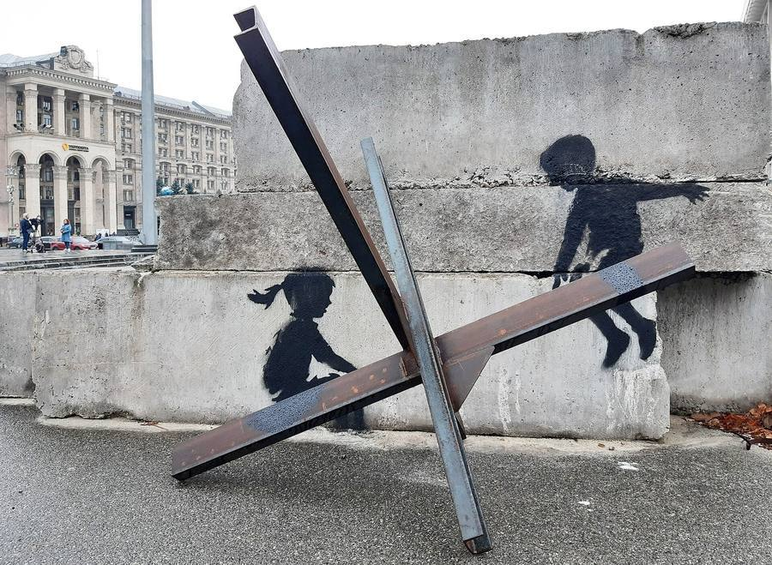
A mural widely attributed to Banksy: two children play on an anti-tank obstacle as if it were a seesaw, Maidan Nezalezhnosti (Independence Square), Kyiv, 2022. Photograph by Rasal Hague, 6 November 2022, Wikimedia Commons, CC BY-SA 4.0. The photograph is shared under that licence. The artwork itself remains protected.
The judo mural first appeared in Borodianka. A child throws a much larger adult. Some viewers have identified the adult with a political leader. That reading must remain an interpretation: Banksy did not name the figure, and this sequence will not present the identification as a fact. The Kyiv photograph shows two children on a real anti-tank obstacle, used as a seesaw, on Independence Square. In both cases, the place is part of what the image does.
Exercise 2. Match the work and the role of the site.
1. Gymnast in Irpin. 2. Pelicans in Walthamstow (next step). 3. Children in Kyiv. 4. Judo mural, first seen in Borodianka.
a. A military object becomes a piece of play. b. A hole in a ruined wall becomes a point of balance. c. A shop sign becomes part of the scene. d. A damaged place is the background for a smaller figure overcoming a larger one.
Corrigé
1b, 2c, 3a, 4d.

Step 4. London, August 2024: animals on ordinary walls
In August 2024, a series of animal murals appeared across London. The artist posted the works on the official Banksy Instagram, which is a public attribution of the series, not a civil identity. Two photographs are enough to see the point: the goat in Richmond stands on a real architectural ledge; the pelicans in Walthamstow interact with a real fish-and-chip shop sign. If you move only the painted animal, you lose the ledge, or you lose the sign.
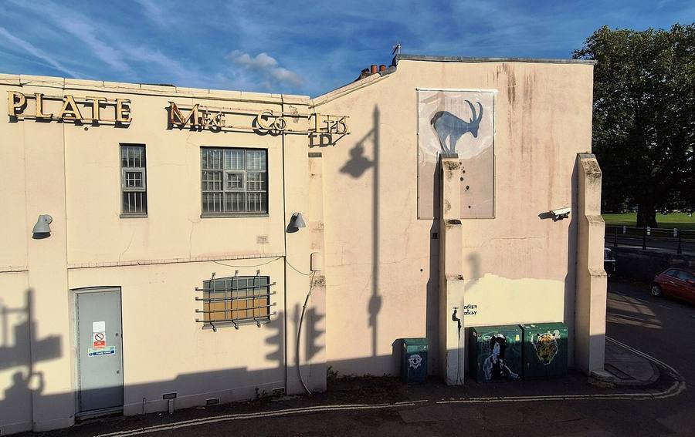
A mural attributed to Banksy and posted on the artist's official Instagram: a goat on a narrow ledge, Richmond, London, August 2024, part of a series of animal works that appeared across the city. Photograph by Anthony Parkes, 14 September 2024, Geograph Britain and Ireland, Wikimedia Commons, CC BY-SA 2.0. The photograph is shared under that licence. The artwork itself remains protected.
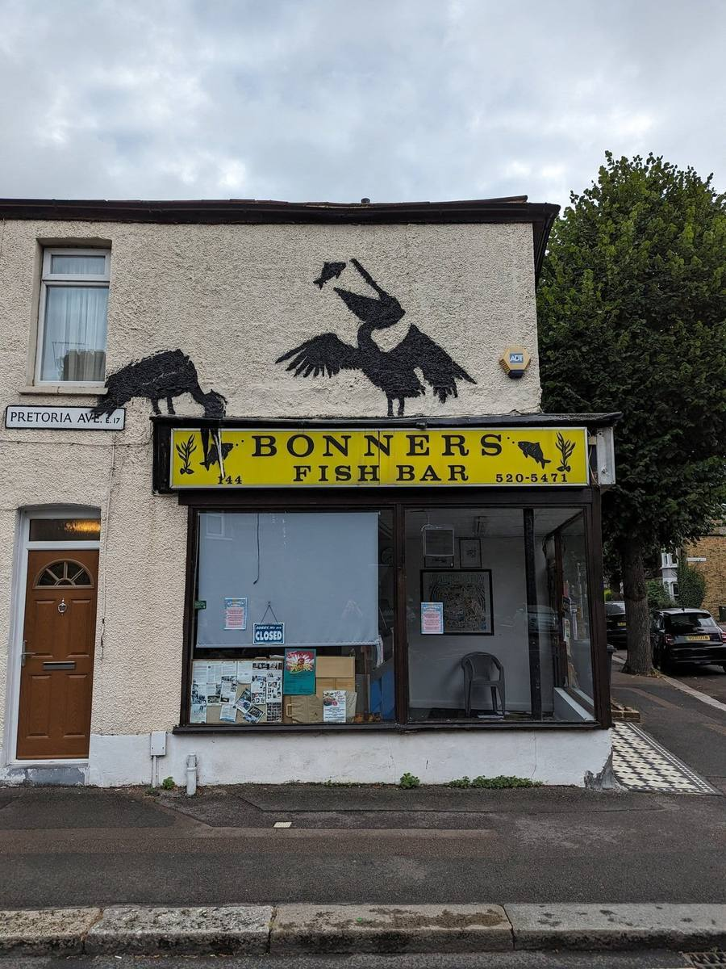
A mural attributed to Banksy and posted on the artist's official Instagram: pelicans interacting with a fish-and-chip shop sign, Walthamstow, London, August 2024. Photograph by Panicshouter, Wikimedia Commons, CC0. The photograph is in the public domain as a photograph. The artwork itself remains protected.

Step 5. Expanding your vocabulary and grammar
Word or phrase | Meaning | Example
site | the particular place where a work stands | The site is part of the meaning.
surroundings | what is around the work | The surroundings include rubble, a sign, or a ledge.
to conserve | to protect a work so that it lasts | The city may want to conserve the mural.
context | the situation that gives a work its meaning | If you remove the context, the image may say something else.
in order to | used to express a purpose | The wall was cut in order to save the painting.
because of | used to give a cause | The gymnast is striking because of the hole beneath her.
if + present, will / may | a possible future result | If the mural is removed, passers-by will no longer see it.
to relocate | to move something to a new place | The gymnast was later relocated on the same street.

Grammar: first conditional. If the mural is removed, it may be safer. If it is removed, it will lose its hole, its ledge, or its shop sign. Purpose: in order to save it. Cause: because of the surroundings.
Exercise 3. Complete with if, will, may, because of, or in order to.
- _______ the pelicans are taken off the shop, they _______ lose the fish on the sign.
- The gymnast was cut out _______ protect her from demolition.
- The children are striking _______ the real metal obstacle they sit on.
- _______ the goat is sold as a cut-out, visitors _______ see a goat, but not a goat on that ledge.
Corrigé
1 If; will / may. 2 in order to. 3 because of. 4 If; may / will.
Exercise 4. Rewrite, keeping the same idea.
- People removed the mural. They wanted to save it. (in order to)
- The image is powerful. It stands on a ruined building. (because of)
- We take the goat away. We lose the ledge. (If...)
Corrigé
1 The mural was removed in order to save it. / People removed the mural in order to save it. 2 The image is powerful because of the ruined building. 3 If we take the goat away, we will (or may) lose the ledge.

Teacher-written listening (read twice)
A local committee is discussing a fictional mural on a privately owned warehouse. The image is a child looking at a closed shutter. Some members want to cut the shutter out and show it in a museum, in order to protect it from the rain and from theft. Other members say that if the shutter leaves the street, the work will lose the place it was made for. A third group suggests a photograph in the museum and a protective screen on the original wall. Nobody in the room has the right to invent a legal rule for every city. They must recommend, and they must give reasons.

A2 pathway
Note two options the committee discusses, and complete: If the mural is removed, it may... If it stays, it may...

B1 pathway
Restitute the three positions in connected sentences, then add your own recommendation, with in order to and a conditional.

Step 6. Public-art committee
Your class is the committee. The fictional warehouse mural can stay, move to a museum, or be photographed and protected in place. You must make a recommendation for Lesson 6's exhibition file.

A2 pathway
In pairs, 45 seconds each: give your recommendation with should and If... will / may. Then agree on one sentence to report to the class.

B1 pathway
In groups of three, three minutes: one student defends removal in order to conserve the work; one defends keeping it in place; one must propose a third way and write the group's final sentence. Use although, because of and a conditional.

Step 7. Written record and homework

A2 pathway
Complete: The gymnast is striking because of... If the mural is removed, it may... I think it should... in order to...

B1 pathway
Write a 100-word recommendation for the committee, comparing the Irpin gymnast (saved and moved) with the London pelicans (still tied to a shop sign). Keep interpretations and facts apart.
Homework. Choose one work from the sequence. Complete a full observation card: title or description, place, date, photographer, what you can see, what the place adds, what you cannot establish, and (B1) what would change if the work left its wall. Bring the card to Lesson 6. You will use it in the final task.

Anglais · Seconde bac pro · A2 and B1 · Lesson 6 of 6

Lesson 6. Exhibiting Banksy without owning the name
Question of the day: How can a cultural mediator inform the public without overstating evidence or erasing the street?

For the teacher: timing (52 minutes)
Time | Activity
00 to 05 | Vocabulary retrieval and a quick language correction
05 to 10 | Read the final brief and the criteria
10 to 25 | Individual written assessment: label and recommendation
25 to 40 | Paired oral assessment, recorded when possible
40 to 44 | Self-assessment and an improved sentence
44 to 49 | Written record of the ethical principle, and flashcards
49 to 52 | Individual oral exit and homework for revision

Checkpoint at minute 44. Every student has completed a written response and both oral components (continuous speaking and interaction).
Eight-minute essential closing route (replaces the last eight minutes if the class needs more time; it does not add time): 44 to 46: identify one error from the grid. 46 to 49: produce and say an improved version. 49 to 51: record the final ethical principle. 51 to 52: note revision homework.
If thirty individual presentations cannot be assessed live in fifteen minutes, students record in pairs on school-approved equipment and submit the recording privately. The teacher assesses the recordings after class. If recording is unavailable, written work is collected in this lesson and additional oral time is scheduled. Do not pretend that a single teacher can hear thirty full performances in a quarter of an hour.

The final brief
Your class is a cultural mediation team advising a local exhibition entitled Banksy: Public Walls, Private Names. The organisers want to show photographs of murals, and to discuss a fictional proposal: a mural on a privately owned warehouse would be removed and shown indoors. Each student must:
- Present one artwork from the sequence (place, date, what is visible, why the location matters).
- Distinguish a documented event from an attributed identity claim. The civil name, if you mention it, stays a claim, with its source.
- Recommend what should happen to the fictional warehouse mural, with a reason.
- Answer a visitor's question (your partner asks it).
- Write a short ethical exhibition label, and a short recommendation.
Nobody is asked to discover a private address, to identify relatives, to contact a suspected artist, or to investigate a private person.

Step 1. Expanding your vocabulary, last review
Word or phrase | Meaning | Example
exhibition label | a short text that helps a visitor understand a displayed work | The label must be accurate and modest.
to acknowledge | to recognise or to state something openly | The label should acknowledge that the name is a press claim.
to qualify | to limit a claim so that it stays accurate | Qualify the headline with according to.
to recommend | to propose a course of action | We recommend keeping a photograph in the street and a copy in the room.
to consult | to ask for another person's view or for a source | The organisers should consult the wall's owner and the neighbourhood.
mediator | a person who helps the public meet a work or an idea | A mediator explains, and does not overstate.
ethical | concerned with what is right to do | An ethical label does not pretend we know more than we do.

Exercise 1. Repair these labels. They are too sure, or they mix categories. Rewrite each one.
- "This mural was painted by Robin Gunningham in 2022."
- "Banksy wants all his works to stay in the street, so selling them is illegal."
- "This photograph is free to use because it is on the internet, and so is the artwork."
- "The High Court decided that the public owns every Banksy mural."
Corrigé
Example rewrites. 1. A mural widely attributed to Banksy, 2022. Reuters reported in March 2026 that Banksy was born Robin Gunningham. Banksy has not confirmed that identification in the sources used for this exhibition. (Better: do not put the civil name in the visitor's first sentence at all.) 2. We do not know a single intention for every work. Some street pieces have been removed and sold; Pest Control does not treat that as a normal way to obtain a certificate. The law depends on the case. 3. A photograph may have a Creative Commons licence. The artwork itself remains protected. 4. In 2015, in a particular case about Art Buff, the High Court ordered the return of a physical section of wall. It did not decide that the public owns every mural.

Step 2. Written assessment (15 minutes)
You work alone. You may use your observation card from Lesson 5, and the classroom sentence about Reuters from Lesson 2. You may not search the web for a private name.

A2 pathway
A2 written task /20.
- Write an exhibition label of four to six short sentences for one work: what we can see, where it was, why the place matters, and one accurate sentence about identity (you may write that the artist's civil name is not confirmed).
- Write three sentences recommending what should happen to the fictional warehouse mural, with should and because.

B1 pathway
B1 written task /20.
- Write an exhibition label of eight to ten sentences: description, location, one documented event, one attributed claim clearly marked as a claim, and a sentence about photographic licences and remaining rights in the artwork.
- Write a short professional recommendation (90 to 120 words) on the fictional warehouse mural, using the three-rights distinction and a conditional. Qualify anything that is not a fact.

A2 written grid /20
Criterion | 0 to 3 | 4 to 6 | 7
Label: work, place, what is visible | Incomplete or confused | The work and the place are identified, with some description | Clear description, and the place is given a simple role
Identity and accuracy | A civil name is presented as a fact, or the issue is ignored in a misleading way | The text avoids a false certainty | An accurate cautious sentence, with or without a named source
Recommendation | No clear advice | A recommendation with a simple reason | A clear should, with because, that a visitor can follow

Plus 0 to 6 for language (vocabulary from the sequence, and intelligible syntax), adjusted so that the total is /20. The teacher records the language mark in the same spirit as the oral grids: 0 to 2 limited, 3 to 4 adequate reuse, 5 to 6 secure reuse of there is, may, should, according to.

B1 written grid /20
Criterion | 0 to 3 | 4 to 6 | 7
Label: description, place, rights | Incomplete, or categories mixed | Solid description and location, some caution | Description, location, and a clear note on photographs and remaining rights
Attribution and identity | A claim is treated as a fact | A source is named, with a small slip | Documented events and claims are kept apart; no civil name as fact
Recommendation | No usable advice | A reasoned recommendation | Three rights, a conditional, a qualified professional tone

Plus 0 to 6 for language, as above, with expected control of although, whereas, the passive, and accurate attribution.

Step 3. Oral assessment (about 15 minutes, in simultaneous pairs)

A2 pathway
A2 oral, /20. Continuous speaking, 40 to 50 seconds: present your work (what you can see, where it is, why the place matters). Interaction, about 40 seconds: your partner is a visitor and asks one of these questions: "Who is Banksy, really?" or "Can we just cut this wall and show it here?" You answer without presenting a civil name as a fact, and you give a simple recommendation.

B1 pathway
B1 oral, /20. Continuous speaking, about 90 seconds: present your work, explain the role of the site, and include one documented fact and one attributed claim, clearly distinguished. Interaction, about one minute: your partner plays a visitor who wants a sure name and a sure legal answer. You qualify, you attribute, and you recommend. You respond to a follow-up objection.

A2 oral grid, summative /20
Criterion | 0 to 2 | 3 to 4 | 5
Continuous speaking: the work and the place | Too little, or the work is not identified | A description, with a simple mention of place | Visible details, the place, and a reason why the place matters
Identity and honesty | A civil name is given as a fact | The student avoids a false certainty | A clear cautious formulation, if the question arises
Language | Little language from the sequence | Frames are used, with some errors that do not block meaning | Vocabulary reused; there is, may, should, according to used intelligibly
Interaction | The question is not really answered | A relevant short answer | A clear answer to the visitor, with a recommendation

B1 oral grid, summative /20
Criterion | 0 to 2 | 3 to 4 | 5
Continuous speaking: work, site, evidence | Incomplete | A connected presentation, with some distinction of categories | A clear presentation; fact and claim are kept apart; the site has a role
Ethics of the name and of the wall | Overstatement, or no recommendation | A cautious position, with a reason | Accurate attribution, a qualified recommendation, no investigation of a private person
Language | Limited control | Sequence language attempted, with slips | Secure reuse; qualification (according to, may, although); intelligible syntax
Interaction | Little response to the visitor | A relevant reply | The objection is taken up; the answer stays accurate and professional

Step 4. Self-correction
Using the teacher's grid (A2 or B1), write:
- The criterion I missed, or the one I only partly reached.
- What went wrong, in my own words.
- An improved version of one spoken sentence and one written sentence, following that criterion.
The improved version is part of the assessment, not an optional extra.

Step 5. Final written record
Copy and keep this principle, then complete it in your own words:
A mural on a wall can have an author without a confirmed civil identity. A press investigation can be serious and still remain a claim until it is confirmed. Owning a wall is not the same as owning every right in the image, and it is not the same as public access. As a mediator, I should... I should not...

Step 6. Homework
Revise your flashcards from the six lessons. A2: be ready to present your work again in 40 seconds, with the improved sentence included. B1: polish your exhibition label and be ready to read it aloud. This work can be used later in a CCF or in an oral practice, if the teacher so decides. It is not, by itself, the examination.

Anglais · Seconde bac pro · A2 and B1 · Sources

Sources
Only short educational paraphrases and teacher-written texts are used as classroom reading. Protected texts are not copied in full. Links below are the references.

Programme
- Programme de langues vivantes des classes préparant au CAP et au baccalauréat professionnel, arrêté du 3 avril 2019, BO spécial n° 5 du 11 avril 2019. education.gouv.fr.

Identity, reporting and fact-checking
- Simon Gardner, James Pearson and Blake Morrison, "In search of Banksy", Reuters, 13 March 2026, 10 a.m. GMT. reuters.com/investigates/special-report/global-art-banksy/. This is the source of the attributed identity claim used in Lesson 2. It is not treated as a confirmation by the artist.
- NPR interview with Simon Gardner, 22 March 2026. NPR stated that it had not independently confirmed Reuters' findings. npr.org.
- Reuters Fact Check, "London man misidentified as street artist Banksy", 19 March 2026, about photographs of George Georgiou. The person's photograph is not used on this site. reuters.com/fact-check.
- Mail on Sunday, July 2008: an earlier press claim putting forward the name Robin Gunningham, already hedged at the time. Consulted through later reporting, including the Reuters investigation itself.

Ownership, authentication and related law
- The Creative Foundation v Dreamland Leisure Ltd, High Court, 11 September 2015, about a section of wall bearing Art Buff.
- Pest Control official site and FAQ, on certificates of authenticity and on works it does not certify. pestcontroloffice.com.
- EUIPO Fifth Board of Appeal, 25 October 2022, case R 1246/2021-5, on a trademark concerning a monkey image. Trademark law only; not a general rule for this sequence.

Audiovisual
- banksyfilm, Dismaland trailer, 25 August 2015, extract 00:00 to 02:07. youtube.com/watch?v=V2NG-MgHqEk.
- banksyfilm, Shredding the Girl and Balloon: The Director's Half Cut, extract 00:00 to 02:00. youtube.com/watch?v=vxkwRNIZgdY.

Photographs (Wikimedia Commons)
A Creative Commons or public-domain licence for a photograph does not remove rights in the artwork that was photographed. Pest Control is Banksy's official contact and the body that issues certificates of authenticity for eligible works. It does not, according to its own FAQ, certify illegally executed works, and it does not treat the removal of a street mural as a normal way to obtain a certificate. Full credits are in each caption on the lesson pages. The list below is the complete set used on this sequence.
- Gymnast with a Ribbon, Irpin, 2022. Photograph: Rasal Hague, 18 November 2022. File:Banksy_Irpin.jpg and File:Banksy_in_Irpin.jpg. CC BY-SA 4.0.
- The same mural after dismantling, 14 May 2023. Photograph: Rasal Hague. File:Демонтований_Бенксі_20230514.jpg. CC BY-SA 4.0.
- Girl with Balloon motif, reconstructed mural in The World of Banksy, Brussels, 2022 (not the 2002 London original). Photograph: Miguel Discart. File:The_World_of_Banksy_2022,_Brussels.jpg. CC BY-SA 2.0.
- One Nation Under CCTV, Newman Street, London. Photograph: VirtuallyLondonBecky. File:Banksy_graffiti_on_Newman_Street_-_One_Nation_Under_CCTV.jpg. CC BY-SA 4.0.
- The Mild Mild West, Stokes Croft, Bristol. Photograph: Earthkingfather. File:The_Mild_Mild_West.jpg. CC BY-SA 4.0.
- Well Hung Lover, Park Street, Bristol. Photograph: Adrian Pingstone. File:Banksy.in.bristols.park.street.longshot.arp.jpg. Public domain photograph.
- You don't need planning permission to build castles in the sky, Bristol. Photograph: Earthkingfather, 20 March 2026. File:You_don't_need_planning_permission.jpg. CC BY-SA 4.0.
- No Ball Games, Tottenham, 2009. Photograph: GualdimG. File:Proibido_Jogos_de_Bola_2009_Banksy_Tottenham_01.jpg. CC BY-SA 4.0.
- Season's Greetings, Port Talbot, on display away from the original garage. Photograph: Sionk. File:Banksy_on_display,_Port_Talbot.jpg. CC BY-SA 4.0.
- Dismaland overview, Weston-super-Mare, 2015. Photograph: Florent Darrault. File:Dismaland_1.jpg. CC BY-SA 2.0. Multi-artist project.
- Dismaland castle and mermaid. Photograph: Rob Farrow, 24 September 2015, Geograph. File:Dismaland_-_The_Dismal_Castle_-_and_weird_Little_Mermaid_-_geograph.org.uk_-_4679419.jpg. CC BY-SA 2.0.
- Dismaland police vehicle. Photograph: Rob Farrow, same day, Geograph. File:Dismaland_-_Dismal_Castle_and_Police_vehicle_(stranded)_-_geograph.org.uk_-_4679411.jpg. CC BY-SA 2.0.
- Dismaland boats. Photograph: Off Pure, 29 August 2015. File:Bateaux-migrants-banksy-dismaland.jpg. CC BY-SA 4.0.
- The Walled Off Hotel, Bethlehem. Photograph: YellowFratello. File:The_Walledoff_Hotel_Bethlehem.jpg. CC0 as a photograph.
- Hotel entrance. Photograph: Davide Mauro. File:The_Walled_Off_Hotel_entrance_02.jpg. CC BY-SA 4.0.
- The barrier in front of the hotel (many hands, not all Banksy). Photograph: Wikimedia Commons user シャター. File:The_segregation_wall_in_front_of_the_walled_off_hotel_1.jpg. CC BY-SA 4.0.
- Goat, Richmond, August 2024. Photograph: Anthony Parkes, 14 September 2024, Geograph. File:Banksy's_Goat_Mural_on_Caxton_Name_Plate_Works_-_geograph.org.uk_-_7878741.jpg. CC BY-SA 2.0.
- Pelicans, Walthamstow, August 2024. Photograph: Panicshouter. File:Image_of_Banksy_street_art_in_Walthamstow,_London.jpg. CC0 as a photograph.
- Judo mural, first appeared in Borodianka, 2022. Photograph: Simon Höger, 19 February 2025. File:Banksy_judo.jpg. CC BY 4.0.
- Children on an anti-tank obstacle, Maidan, Kyiv, 2022. Photograph: Rasal Hague, 6 November 2022. File:Children_of_War,_Maidan.jpg. CC BY-SA 4.0.
Official Instagram posts by the artist are the public source for the 2024 London animal series, and for some of the 2022 Ukraine works (in particular the Borodianka handstand gymnast, which is not the cover of this sequence). Instagram itself is not copied here; teachers may show a post if the school network allows it, with the usual preview.

