Version accessible
Passing the Flame. Othello: ten autonomous fiches, one for each lesson, usable on their own.
Madame Carole Paoli Pompougnac
Tle spécialité LLCER · lycée général et technologique · Level C1
Programme of BO spécial n° 8 of 25 July 2019: thematic areas « Arts et débats d’idées » and « Expression et construction de soi » (axis « Mise en scène de soi »). Level C1.
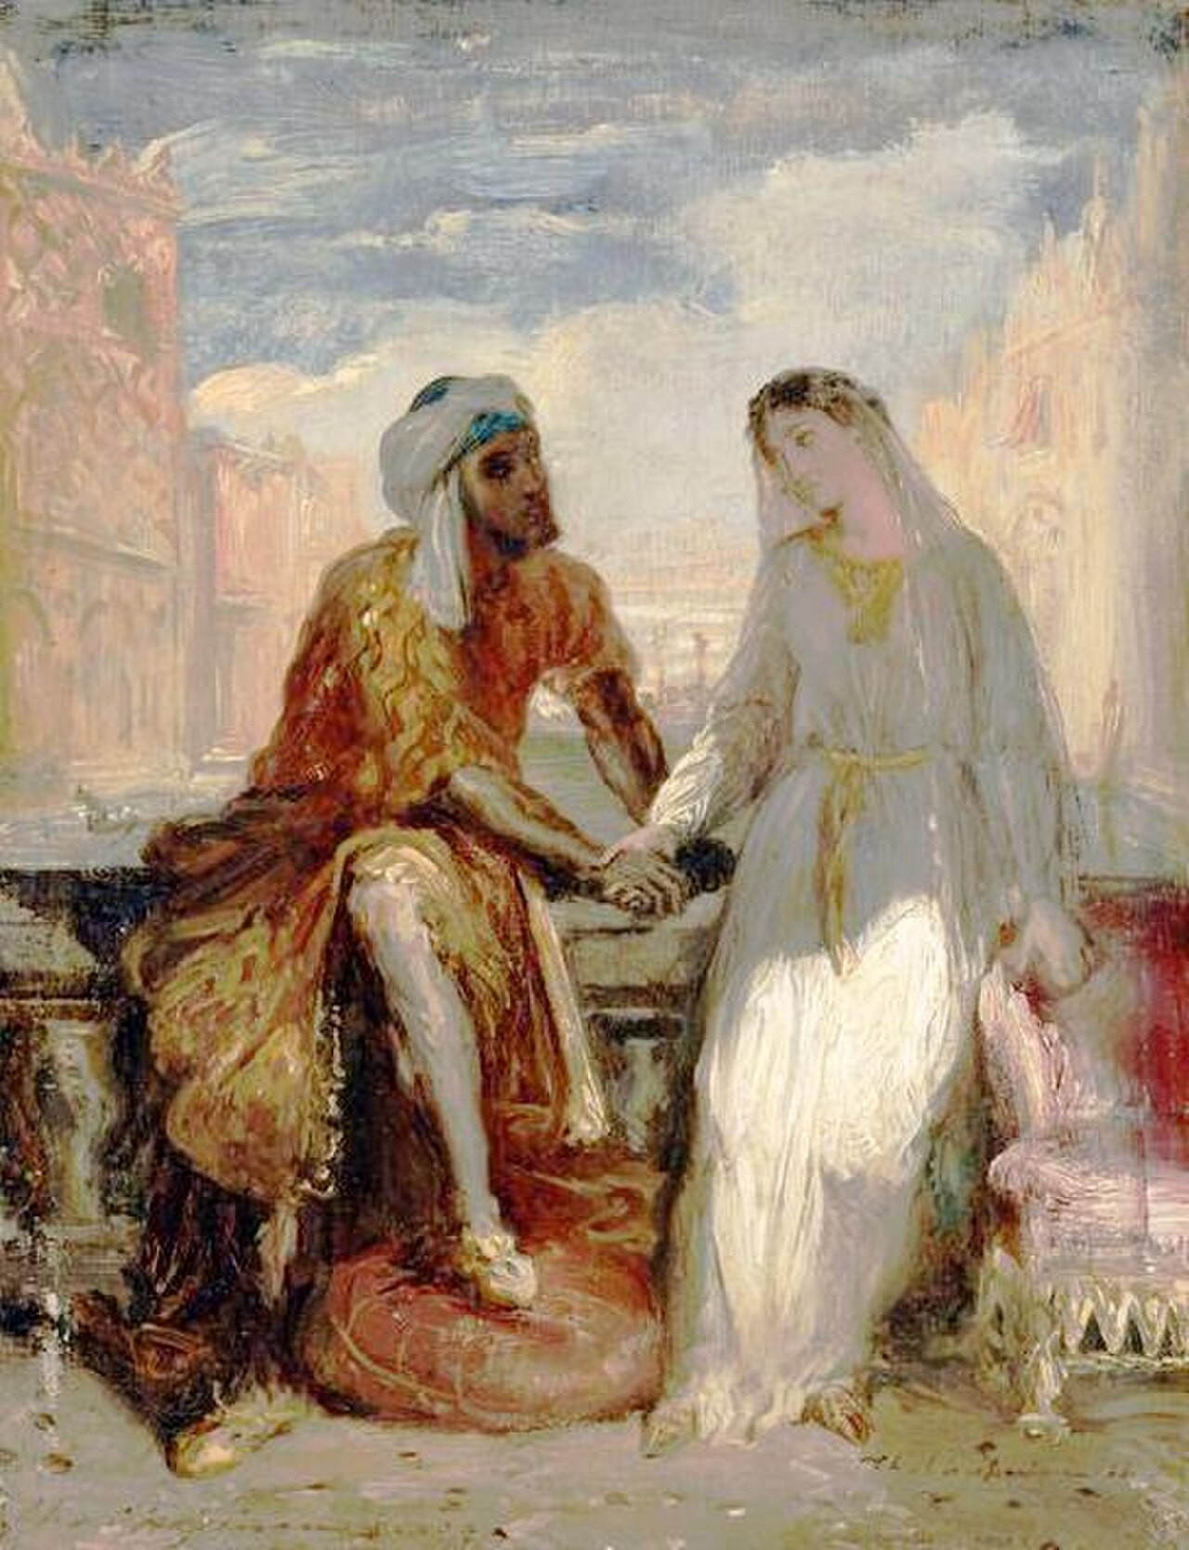
Théodore Chassériau, Othello et Desdémone à Venise, 1849-1850, oil on wood, Musée du Louvre, Paris, RF 3897, public domain.
Guiding question
How does Shakespeare turn theatre itself into a trap of perception in Othello, and what does that trap still teach us about language, jealousy and the courage to read between the lines?

conçu par Madame Carole Paoli Pompougnac, mis en page par Grok
© 2026 Madame Carole Paoli Pompougnac · CC BY-NC-SA 4.0
Accessible version, in English, for the C1 sequence Passing the Flame. Ten autonomous fiches, one for each lesson, usable after an absence.
The demand remains C1. The page is airier. Instructions are short and numbered. The Shakespeare extracts are the same complete speeches as in the student booklet, with a few extra glosses.
Guiding question. How does Shakespeare turn theatre itself into a trap of perception in Othello, and what does that trap still teach us about language, jealousy and the courage to read between the lines?
Line numbers follow Project Gutenberg ebook 1531. Madame Carole Paoli Pompougnac. Tle spécialité LLCER, lycée général et technologique.

Fiche autonome 1. Inheriting a way of reading
Today’s aim. Look carefully first. Then interpret. Do not invent a story the picture does not give.
The painting is Théodore Chassériau, Othello et Desdémone à Venise, 1849-1850, Musée du Louvre, RF 3897, public domain. If you have the booklet, look at it there. If not, use a museum reproduction of that exact work only.
Before you look for a story. What do you actually see?

Your tasks
1. Write four short sentences:
- In the foreground I can see... - The two figures are... - The light falls... - This painting cannot prove...
1. In two sentences, say what « passing the flame » might mean for a reader of a difficult play.
2. Copy the guiding question. Underline the words trap, perception, language.
Emergency exit. Complete only the four sentences of task 1.
Homework. Fair copy of the four sentences, plus one on the guiding question.

Fiche autonome 2. « I am not what I am »
Today’s aim. Read Iago’s speech as a whole. Say what the last line does to the audience.
Before you read. Why tell us, so early, that he is not what he is?

I.1, Iago. (Gutenberg 1531, lines 133-157.)

O, sir, content you.
I follow him to serve my turn upon him:
We cannot all be masters, nor all masters
Cannot be truly follow’d. You shall mark
Many a duteous and knee-crooking knave
That, doting on his own obsequious bondage,
Wears out his time, much like his master’s ass,
For nought but provender, and when he’s old, cashier’d.
Whip me such honest knaves. Others there are
Who, trimm’d in forms, and visages of duty,
Keep yet their hearts attending on themselves,
And throwing but shows of service on their lords,
Do well thrive by them, and when they have lin’d their coats,
Do themselves homage. These fellows have some soul,
And such a one do I profess myself. For, sir,
It is as sure as you are Roderigo,
Were I the Moor, I would not be Iago:
In following him, I follow but myself.
Heaven is my judge, not I for love and duty,
But seeming so for my peculiar end.
For when my outward action doth demonstrate
The native act and figure of my heart
In complement extern, ’tis not long after
But I will wear my heart upon my sleeve
For daws to peck at: I am not what I am.

Glosses. serve my turn: use him; knee-crooking: bowing; cashier’d: dismissed; visages of duty: masks of loyalty; daws: jackdaws.

Your tasks
1. Draw a line under the sentence that starts the « other sort » of servant.
2. Copy the last five lines accurately.
3. In four short sentences:
- what honest servants are, for Iago; - what the other sort are; - which sort he joins; - what the last clause does to us, as an audience.
Emergency exit. Copy the last line, then complete: Iago tells the audience... This is a trap because...
Homework. A fair copy of task 3, then ten more lines: « What contract does Iago offer the spectator? »

Fiche autonome 3. The Senate
Today’s aim. See how a story wins a hearing, and how a warning plants a future doubt.
Before you read. What, in a public tale, is already theatre?

I.3, Othello, the close of the tale. (Gutenberg 1531, lines 831-840.)

She swore, in faith, ’twas strange, ’twas passing strange;
’Twas pitiful, ’twas wondrous pitiful.
She wish’d she had not heard it, yet she wish’d
That heaven had made her such a man: she thank’d me,
And bade me, if I had a friend that lov’d her,
I should but teach him how to tell my story,
And that would woo her. Upon this hint I spake:
She lov’d me for the dangers I had pass’d,
And I lov’d her that she did pity them.
This only is the witchcraft I have us’d.

Read also, in your edition or in the student booklet, the whole tale from « Her father lov’d me » (line 799). The full speech is printed there.
I.3, the warning and the pledge. (lines 1017-1025.)

BRABANTIO.
Look to her, Moor, if thou hast eyes to see:
She has deceiv’d her father, and may thee.

OTHELLO.
My life upon her faith! Honest Iago,
My Desdemona must I leave to thee.

Glosses. witchcraft: the charge against him; Look to her: watch her; My life upon her faith: I stake my life on her loyalty.

Your tasks
1. Copy the two lines of the chiasmus (« She lov’d me... / And I lov’d her... »).
2. In two sentences, say how this balance is made to explain the marriage.
3. In four sentences: what Brabantio plants, and what Othello answers, next to the name « Honest Iago ».
Emergency exit. Copy the chiasmus, Brabantio’s two lines, and « My life upon her faith ».
Homework. 180 words: how the tale wins a hearing, and what the close plants.

Fiche autonome 4. The desire for proof
Today’s aim. Mark the shift from wanting to know to wanting a doubt closed.
Before you read. Wanting to know is not the same as wanting to be confirmed.

III.3. (lines 2815-2823, then 3156-3160.)

IAGO.
O, beware, my lord, of jealousy;
It is the green-ey’d monster which doth mock
The meat it feeds on. That cuckold lives in bliss
Who, certain of his fate, loves not his wronger;
But O, what damned minutes tells he o’er
Who dotes, yet doubts, suspects, yet strongly loves!

OTHELLO.
O misery!

[...]

OTHELLO.
Villain, be sure thou prove my love a whore;
Be sure of it. Give me the ocular proof,
Or, by the worth of man’s eternal soul,
Thou hadst been better have been born a dog
Than answer my wak’d wrath.

Glosses. green-ey’d monster: jealousy, a body that feeds on what it looks at; to dote: to love too fondly; ocular proof: proof that can be seen.
The dots mark a later moment in the same scene, not a cut inside a speech. Each of the two speeches is complete.

Your tasks
1. Copy the sentence that names the monster.
2. In three lines, say what the metaphor does.
3. Copy « Give me the ocular proof ». Then complete: Othello no longer only wants to know. He wants...
Emergency exit. Tasks 1 and 3 only.
Homework. 150 words on the shift from « I’ll know thy thoughts » (look it up in your edition) to « ocular proof ».

Fiche autonome 5. The handkerchief and the test of trust
Today’s aim. Read the main speeches of III.4 whole. Track three kinds of trust.
Before you read. The audience already knows Emilia has taken the handkerchief. What does that do to our listening?

III.4, Emilia’s answer, and the moist hand. (lines 3410-3467.)

DESDEMONA.
Where should I lose that handkerchief, Emilia?

EMILIA.
I know not, madam.

DESDEMONA.
Believe me, I had rather have lost my purse
Full of crusadoes. And but my noble Moor
Is true of mind and made of no such baseness
As jealous creatures are, it were enough
To put him to ill thinking.

EMILIA.
Is he not jealous?

DESDEMONA.
Who, he? I think the sun where he was born
Drew all such humours from him.

Enter Othello.

OTHELLO.
Well, my good lady. [Aside.] O, hardness to dissemble!
How do you, Desdemona?

DESDEMONA.
Well, my good lord.

OTHELLO.
Give me your hand. This hand is moist, my lady.

DESDEMONA.
It yet hath felt no age nor known no sorrow.

OTHELLO.
This argues fruitfulness and liberal heart.
Hot, hot, and moist. This hand of yours requires
A sequester from liberty, fasting and prayer,
Much castigation, exercise devout;
For here’s a young and sweating devil here
That commonly rebels. ’Tis a good hand,
A frank one.

DESDEMONA.
You may indeed say so,
For ’twas that hand that gave away my heart.

OTHELLO.
A liberal hand. The hearts of old gave hands,
But our new heraldry is hands, not hearts.

Glosses. crusadoes: gold coins; aside: a private line; moist / liberal: in old medicine, signs of desire, and also « unrestrained »; heraldry: coats of arms; signs of honour.
The hypothetical. (line 3550.)

DESDEMONA.
It is not lost, but what and if it were?

Emilia, later. (lines 3695-3698.)

They are not ever jealous for the cause,
But jealous for they are jealous: ’tis a monster
Begot upon itself, born on itself.

Read the Egyptian tale (lines 3498-3523) in the student booklet: it is printed there whole, with glosses (charmer, sibyl, mummy, perdition).

Your tasks
1. What does the audience know, when Emilia says « I know not, madam »?
2. In four sentences: how does Othello turn a moist hand into a verdict? Use one humoral word and one moral word.
3. Why is Desdemona’s « what and if it were? » grammatically innocent, and dangerous here?
4. In two sentences, what does Emilia see, and what does she still not say?
Emergency exit. Tasks 1 and 3, plus one concluding sentence on trust.
Homework. 200 words: three kinds of trust in III.4. Prepare the midpoint question in the student booklet.

Fiche autonome 6. Directing the spectator
Today’s aim. IV.1: a man watches a scene whose meaning has already been prepared.
Before you read. What is the difference between watching a conversation and watching a conversation that someone has already explained to you?

Open the complete extract in the student booklet (Gutenberg 1531, lines 4076-4121). If you do not have it, use your edition of IV.1 from « Iago beckons me » to Bianca’s exit.
Glosses. beckons: signals him to watch; bauble: a contemptuous word for Bianca; imports: is taken to mean; take out the work: copy the embroidery.

Your tasks
1. Make a table with three columns: Cassio is talking about / Iago has prepared Othello to hear / Othello says.
2. Copy « By heaven, that should be my handkerchief! » In two sentences, say what is true, and what is misread, in that cry.
3. In three lines: Bianca treats the handkerchief as... Othello treats it as...
Emergency exit. Complete: Cassio speaks of... Othello thinks he hears... The handkerchief is...
Homework. 180 words: « How does Shakespeare make Othello a spectator of his own deception? »

Fiche autonome 7. One conversation, two meanings
Today’s aim. Map the same exchange more slowly. Use the words referent and assigned story once each, accurately.
Referent: what a speech is actually about. Assigned story: the meaning another hearer attaches to it.

Your tasks
1. Choose one of Cassio’s sentences about Bianca. Copy it.
2. In two columns, write: What Cassio means / What Othello attaches to it.
3. In five short sentences, answer: can two people share a conversation and not share its meaning?
Emergency exit. Three facts and the quotation you copied: Cassio is speaking of... Iago has told Othello... So the same words...
Homework. Fair copy of the two columns, plus the five sentences.

Fiche autonome 8. The language of justification
Today’s aim. Read two complete speeches in V.2: the light, then « Speak of me as I am ».
Before you read. What work is the rhetoric doing, if a man speaks of justice just before a killing?

V.2, the turned word. (lines 5479-5484.)

Put out the light, and then put out the light:
If I quench thee, thou flaming minister,
I can again thy former light restore,
Should I repent me. But once put out thy light,
Thou cunning’st pattern of excelling nature,
I know not where is that Promethean heat
That can thy light relume.

The whole bed soliloquy and the last speech are printed in the student booklet. Read them whole there (lines 5472-5497 and 6233-6254).
Glosses. flaming minister: the lamp; to relume: to light again; to extenuate: to soften the facts; being wrought: having been worked upon.

Your tasks
1. In the six lines above, which light is the lamp, and which light is a life? Write two short arrows.
2. Copy « Speak of me as I am ». Then list, in four bullets, the portraits Othello offers in the last speech (loved not wisely...).
3. In four sentences: is this lucidity, a last self-portrait, or both? Use one quotation.
Emergency exit. Tasks 1 and 2 only.
Homework. 180 words on how V.2 makes murder sound like justice.

Fiche autonome 9. What can literature teach?
Today’s aim. Answer one public-domain critic with a line from the play.
Thomas Rymer (1693) mocks the weight placed on the handkerchief and treats the play, in substance, as a « Bloody Farce ».
What he has seen: a piece of cloth, and a murder. The disproportion shocks him.
What he may have refused to see: the cloth is not the cause. It is the object onto which a method of reading has been forced. (Lesson 5.)

Your tasks
1. In three lines, paraphrase Rymer fairly. Do not insult him.
2. In three lines, resist him, with one quotation from III.4.
3. Optional: choose Johnson’s word credulous, or Coleridge’s « motiveless malignity », and test it against one line from I.1 or I.3.
Emergency exit. Tasks 1 and 2 only.
Homework. Prepare Lesson 10. Revise IV.1 and III.4. No new reading.

Fiche autonome 10. Explaining the trap
Today’s written task. « How does Shakespeare make Othello a spectator of his own deception, and what does that trap still teach us about language, jealousy and the courage to read between the lines? »

A short shape, if you need one
1. Open with a precise thesis (not the plot).
2. Look back at I.1 or I.3 (the pact, or the pledge).
3. Centre on IV.1, with two quotations. You may also use III.4.
4. Close on the guiding question, without a slogan.
Emergency exit, at minute 44. A shorter commentary on IV.1 only: a three-sentence opening, two quotations, a three-sentence close.
Oral task, if asked. Two minutes as a director of IV.1 or III.4: one choice of space, one choice of silence or address, one thing you refuse to add for the eye. Each choice from the verse.

