American Superheroes: images of a nation
Correction sheet. Short model answers for the six lessons, the escape game and the final task.
Madame Carole Paoli Pompougnac
Anglais · 2nde and 1re of the baccalauréat professionnel
Programme: Bulletin officiel spécial n° 5 of 11 April 2019. Two levels: A2/B1 in 2nde, B1 in 1re. Examination from session 2027; CCF still in force.
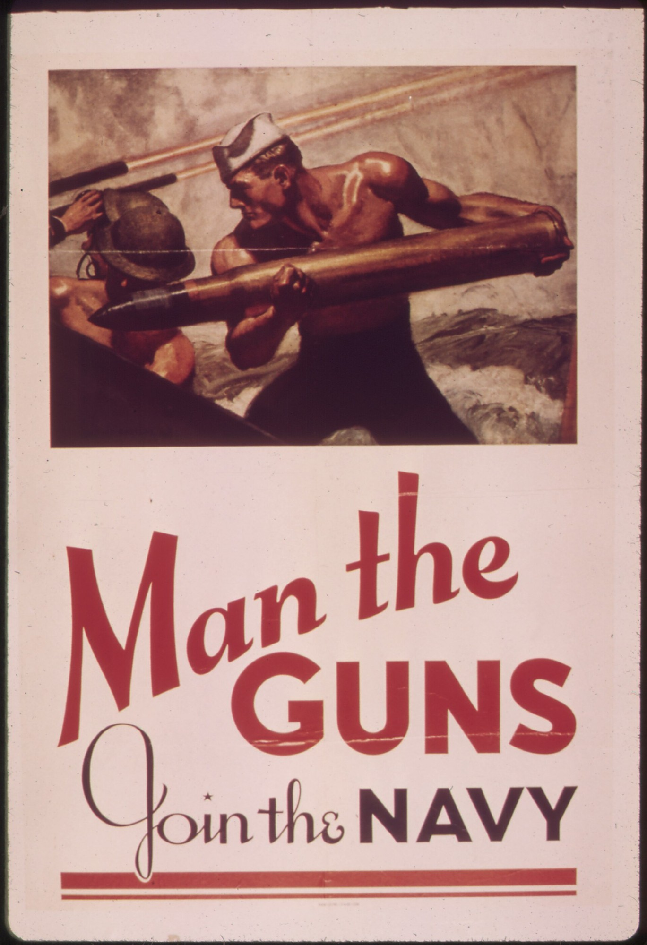
McClelland Barclay, Man the Guns, Join the Navy, 1942, United States Navy recruiting poster. National Archives (NARA) 513519; Library of Congress, Prints and Photographs Division, reproduction number LC-USZC4-2009. Public domain (United States government work). Image via Wikimedia Commons.
conçu par Madame Carole Paoli Pompougnac, mis en page par Grok
© 2026 Madame Carole Paoli Pompougnac · CC BY-NC-SA 4.0

American Superheroes: images of a nation
Short model answers and grids. Two levels when useful: 2nde (A2/B1) and 1re (B1).

Lesson 1
A. Seven panels, along the reading path: left to right, then down.
B. Examples:
▪ A gutter: the space between the first and the second panel, at the top.
▪ A speech balloon: “WHAT’S UP?” at the top right.
▪ A caption: the yellow box at the top, “IN BOB BENTON’S DRUGSTORE...”
C. Listen. The student points to the balloon or caption that was read, and repeats a few words.
D. Model sentences (2nde, short):
1. In the first panel, on the left, I can see a boy in a red shirt.
2. The boy in the red shirt is sitting, with a paper in his hands.
3. In a later panel, a woman in a red coat is walking on the right.
4. The caption at the top of the page says “IN BOB BENTON’S DRUGSTORE...”
E. 1re adds: This page cannot prove what every American did in 1945. It shows how one comic pictured a scene.

Lesson 2
A. The splash.
▪ The plane is behind the hero, near the top.
▪ The hero is in the centre. He is punching a man.
▪ The circular lines around the propeller are motion lines. They show that the propeller is turning.
▪ The yellow caption at the bottom narrates the action.
B. Page 6. Onomatopoeias include:
▪ WHIRRR / WHIRRR-RRR-RR, around the plane, at the top.
▪ RAT-A-TAT-TAT, near the plane, at the top right.
▪ OOF!, in the bottom right, near the falling body.
▪ OW!, in the bottom left.
▪ WUMP!, in the bottom right.
▪ PUFF! may also appear.
A body is falling diagonally in the bottom-right panel. A face or a still pose can look more static.
D. 1re: The page looks dynamic because figures move on a diagonal, and because sounds are written as words. A still pose would look quieter and more static.

Lesson 3
C. F, I or U.
1. F (fact). The comic is from July 1941. The United States entered the war in December 1941.
2. U (unsupported). We cannot say what every American wanted.
3. I (interpretation, with may). The splash may want the reader to see a clear enemy and a fast, powerful hero.
D. A careful 2nde close:
▪ On the splash I can see a shocked figure in the centre.
▪ A hero in red is running on the left.
▪ Another figure is flying in from the top right.
▪ This page may want us to see a clear enemy.
▪ It cannot prove that every American thought in this way.

Lesson 4
A. Colour. Name colours and places first (yellow captions, a red coat, a black costume, a pink wall). Then may, then I cannot reduce the whole page to one colour meaning, because several colours are at work.
B. Lichtenstein. Students write from the MoMA page, not from a printed image. Accept any accurate short description: a woman, water, a balloon with words if they see one, dots, strong colours. Then: close to a comic panel (balloon, crop, dots), but no longer a comic page (a painting, in a museum, one image).
C. Visible: mostly white male heroes, a woman in a red coat, a boy. Left out: many other Americans, the cost of war, ordinary courage without a costume. Use may. No slogan.

Lesson 5. Escape: solutions
▪ Envelope 1. Code: 7 (seven panels).
▪ Envelope 2. A correct label names Daredevil Comics no. 1, July 1941, Lev Gleason, public domain, not Marvel, not the 1938 Superman cover. Code word: july.
▪ Envelope 3. Code: WUMP (bottom right).
▪ Final statement. Option B, or a careful rewrite with the same limits (may / cannot prove).

Lesson 6. Grid (20 points, class level)
This is class work, not the official examination.
Criterion | Points | 2nde, short | 1re, a little more
Description of the page (panels or splash, places, movement, balloons, sounds, colour) | 8 | Four to six accurate sentences | A fuller, ordered description
Careful reading (may / cannot prove) | 4 | One may and one cannot prove | Two of each, clearly distinct
Guiding question and the tip | 4 | Two dates, a link to fears or ideals | Three dates, and one path (existential, political, or civilisational)
Language (prepositions, verbs, vocabulary) | 4 | Intelligible A2/B1 | Firmer B1, more precise terms

Compressed 2nde model (about 160 words).
I am going to describe a public-domain page from The Black Terror no. 11, August 1945.
On this splash, the hero is in the centre. He is punching a man. A plane is behind him. Circular motion lines go around the propeller.
On page 6, a body is falling diagonally. I can see the words WUMP! in the bottom right, and OOF! near the body. The page looks dynamic because the figures move, and because sounds are written as words.
This may want the reader to feel speed and danger. It cannot prove what every American believed in 1945. It cannot prove that a hero on a page is the same as ordinary courage.
These images may reveal a country’s fears and ideals. They also leave people out of the picture.

