American Superheroes: images of a nation
Teacher’s sheet. Six short lessons around genuine public-domain comic pages.
Madame Carole Paoli Pompougnac
Anglais · 2nde and 1re of the baccalauréat professionnel
Programme: Bulletin officiel spécial n° 5 of 11 April 2019. Two levels: A2/B1 in 2nde, B1 in 1re. Examination from session 2027; CCF still in force.
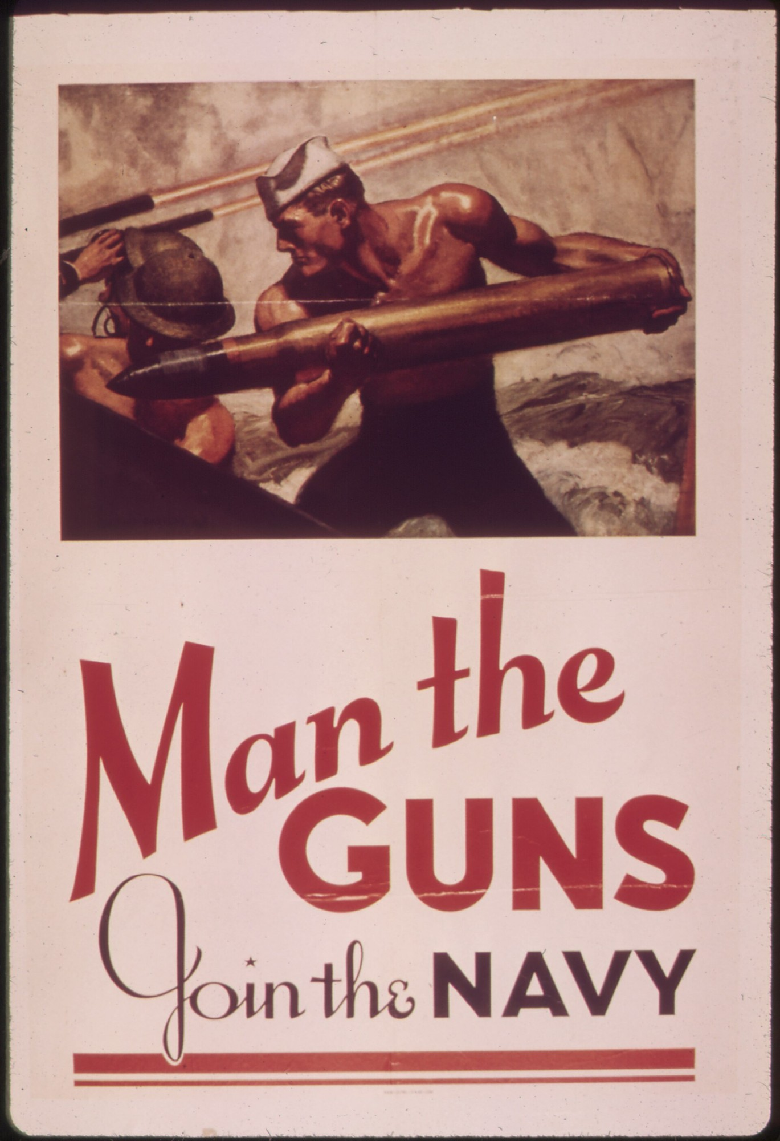
McClelland Barclay, Man the Guns, Join the Navy, 1942, United States Navy recruiting poster. National Archives (NARA) 513519; Library of Congress, Prints and Photographs Division, reproduction number LC-USZC4-2009. Public domain (United States government work). Image via Wikimedia Commons.
conçu par Madame Carole Paoli Pompougnac, mis en page par Grok
© 2026 Madame Carole Paoli Pompougnac · CC BY-NC-SA 4.0

American Superheroes: images of a nation
Teacher’s sheet. British English.
Six short lessons, built around genuine public-domain comic pages.
Conçu par Madame Carole Paoli Pompougnac, mis en page par Grok.

Official frame (brief)
Rubrique | Contenu
Programme | Arrêté du 3 avril 2019, BO spécial n° 5 of 11 April 2019
Thèmes | Grands événements historiques; grandes œuvres; médias; personnalités
Levels | A2/B1 in 2nde, B1 in 1re, two levels in one sequence
Session 2027 | B1+ (LVA), A2+ (LVB)
CCF | Still in force (arrêté du 17 juin 2020, as amended): Situation A, one hour; Situation B, a ten-minute oral
This sequence | Six short lessons, not a year’s work. Lesson 6 trains towards the CCF at class level. It is not the examination.

Intention
▪ The heart of the work is real comic pages, and description before interpretation.
▪ Name: panels, gutters, balloons, captions, onomatopoeia, motion lines, prepositions, verbs of movement, colour.
▪ The guiding question stays serious: what these images reveal, and what they cannot prove.
▪ Adapt access, never ambition. Do not talk down.
▪ Student instructions are short, in simple English, with many images and little running text.
▪ No original diagrams or stick figures. Use only the real pages and the cropped details already in the booklet.
▪ The website presents the same course in tabs, one lesson per tab.
Méthode de la spirale de Gorse conçue par Madame Carole Paoli Pompougnac. Six turns. The tip is in the student sequence.
Each lesson: 55 minutes, timed on 52; stopping point at minute 44; eight-minute emergency exit; short homework; sentence starters; self-correction.

Cover and presentation
The cover is a public-domain United States Navy recruiting poster, in the same layout as the other published sequences:
McClelland Barclay, Man the Guns, Join the Navy, 1942, United States Navy recruiting poster. National Archives (NARA) 513519; Library of Congress, Prints and Photographs Division, reproduction number LC-USZC4-2009. Public domain (United States government work). Image via Wikimedia Commons.
Page 2 is the presentation: aim, fiche d’identité, and the five official activités langagières (short bullets). A listening task in Lessons 1 and 2 gives a clear objective for compréhension de l’oral.

The comics we print (all public domain)
*1. The Black Terror no. 11, August 1945*, Nedor / Better Publications (Standard).
▪ Interior art: Ed Moritz. Cover (not required in the booklet): Alex Schomburg.
▪ Pages used: 3 (splash), 4 (seven-panel grid), 6 (action and onomatopoeia), plus cropped details from those pages.
▪ The solo Black Terror title was not renewed. Do not use early appearances in Exciting Comics (those were renewed).
*2. Daredevil Comics no. 1, July 1941 (Daredevil Battles Hitler*), Lev Gleason / Your Guide Publications.
▪ Lev Gleason’s line was not renewed.
▪ This is not Marvel’s Daredevil (1964, protected).
▪ Interior splash and a panel page. Source: Internet Archive and Wikimedia Commons.
▪ The 1941 cover is not reprinted: it includes a racist caricature of the villain called the Claw. If a student finds it online, name the problem and return to the interior pages.
Do not print Marvel or DC pages, or any MCU still. Describe only, as in Lesson 3.
Do not print Lichtenstein. Use the MoMA page: https://www.moma.org/collection/works/80249. The placeholder is ready to swap if the Estate grants permission.

Vigilance
▪ 1941-1945 pages show punches, guns and Nazi figures. They are historical documents, not a model to celebrate uncritically.
▪ The “enemy” on the 1941 page is drawn as a clear, almost cartoon target. That is part of the work of Lesson 3.
▪ On Black Terror page 6, a fallen body and gunfire: describe the form (onomatopoeia, diagonal). Do not linger on the violence.
▪ Test the MoMA link before Lesson 4.

Material and timing
▪ Print, in colour if you can, the pages already in the student booklet. Credits travel with every copy.
▪ Timer for the stopping point.
▪ Lesson 4: classroom access to the MoMA page.
▪ Lesson 5: three envelopes per team, hint slips, Option A/B/C. Codes: 7, july, WUMP. Final statement: Option B.
▪ Lesson 6: one printed page per student, oral prompt, grid from the correction sheet.

Differentiation
▪ The same pages, the same question.
▪ 2nde: shorter production; four to six accurate sentences can be a complete performance on many tasks.
▪ 1re: a little more length, and a firmer use of may / cannot prove.
▪ The accessible version is six short fiches, usable alone after an absence.

If permission arrives (Lichtenstein)
Replace `lichtenstein-placeholder.png` with `lichtenstein-drowning-girl.jpg`, with the credit required by the Estate and by MoMA.
Keep the museum link. Do not change the task. If permission is refused, leave the placeholder.

Standing orders
▪ Madame Carole Paoli Pompougnac.
▪ Footer: © 2026 Madame Carole Paoli Pompougnac · CC BY-NC-SA 4.0.
▪ Credit: conçu par Madame Carole Paoli Pompougnac, mis en page par Grok.
▪ Date ranges with a hyphen (1938-1941).
▪ If the general pathway is named: « lycée général et technologique ».
▪ The phrase « spirale de Gorse » is kept in French.
▪ British English throughout this sheet.
▪ Homework is always a precise task.

