American Superheroes: images of a nation
Six short lessons, built around genuine public-domain Golden Age comic pages, for 2nde and 1re of the baccalauréat professionnel.
Madame Carole Paoli Pompougnac
Anglais · 2nde and 1re of the baccalauréat professionnel
Programme: Bulletin officiel spécial n° 5 of 11 April 2019. Two levels: A2/B1 in 2nde, B1 in 1re. Examination from session 2027; CCF still in force.
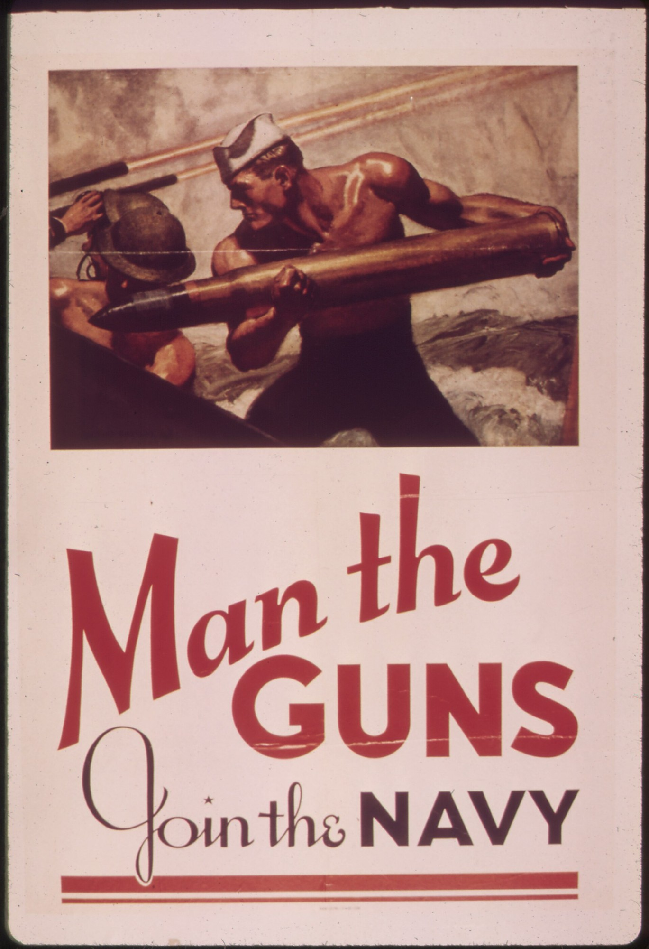
McClelland Barclay, Man the Guns, Join the Navy, 1942, United States Navy recruiting poster. National Archives (NARA) 513519; Library of Congress, Prints and Photographs Division, reproduction number LC-USZC4-2009. Public domain (United States government work). Image via Wikimedia Commons.
Guiding question
What do American superheroes reveal about the United States, its fears, its ideals and the images it makes of itself?

conçu par Madame Carole Paoli Pompougnac, mis en page par Grok
© 2026 Madame Carole Paoli Pompougnac · CC BY-NC-SA 4.0

I. Presentation of the sequence

Aim of the sequence
▪ Look at real public-domain Golden Age comic pages.
▪ Describe what we see, before we interpret.
▪ Ask what these images reveal about the United States, and what they cannot prove.

Fiche d’identité
Rubrique | Contenu
Title | American Superheroes: images of a nation
Level | 2nde (A2/B1) and 1re (B1), baccalauréat professionnel
Thématique | Grands événements historiques; grandes œuvres; médias; personnalités (BO spécial n° 5, 11 April 2019)
Duration | Six lessons of 55 minutes, timed on 52
Method | Spirale de Gorse, six turns
Final task | Lesson 6: a careful description and a two-minute oral, towards the CCF at class level
Rights | Public-domain Golden Age pages only. No Marvel or DC. Lev Gleason’s Daredevil (1941) is not Marvel’s. Lichtenstein is not printed: we use the MoMA page.

Objectives: the five activités langagières
1. Compréhension de l’écrit. Read a real comic page. Find panels, gutters, balloons and captions, and follow the reading path. (Lessons 1 to 3.)
2. Compréhension de l’oral. Listen to a short description, or a balloon read aloud. Point to the right place on the page. (Lessons 1, 2 and 5.)
3. Expression écrite. Write short sentences, then a careful paragraph, with prepositions, movement verbs, may and cannot prove. (Lessons 1 to 4 and 6.)
4. Expression orale en continu. Speak for about two minutes: describe one page, then say what it may reveal and what it cannot prove. (Lesson 6.)
5. Interaction orale. Work in a small team: ask, answer, and restore a careful label in the escape game. (Lesson 5.)

 The spirale de Gorse
Méthode de la spirale de Gorse conçue par Madame Carole Paoli Pompougnac.
1. What do we see on this page?
2. How does the page show movement?
3. What kind of hero does a country invent in wartime?
4. Who is in the picture, and who is left out?
5. Can we restore a careful description?
6. What do these images reveal, and what can they not prove?
The tip. When a society tells its story through images of invincible heroes, what happens to ordinary courage, to the enemy it invents, and to those it leaves out of the picture?

Lesson 1. What do we see on this page?
Look first. Do not interpret yet.
This is a real comic page from 1945. We may print it. It is in the public domain.
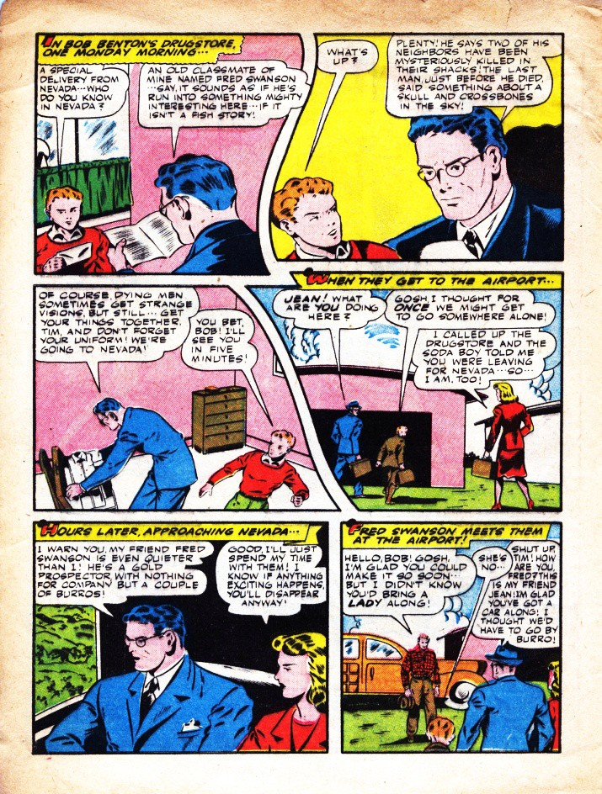
The Black Terror no. 11, August 1945, page 4. Nedor / Better Publications. Art: Ed Moritz. Public domain (published in the United States in 1945; copyright not renewed). Wikimedia Commons, File: BlackTerror1104.jpg.
Credit. The Black Terror no. 11, August 1945, page 4. Nedor / Better Publications (Standard). Art: Ed Moritz. Public domain (United States, 1945; copyright not renewed). Wikimedia Commons.

Building your vocabulary
Word | Meaning
panel (or frame) | one picture on the page, in a box
gutter | the space between two panels
speech balloon | what a character says
caption | a box of narration (often yellow here)
reading path | the order we read: usually left to right, then down
in the first panel / on the left / on the right / in the foreground | prepositions of place

Look closer (real details)
These are crops from the same 1945 page, not drawings.
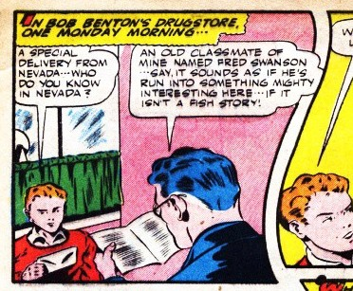
In the first panel, on the left: a boy in a red shirt. Detail from The Black Terror no. 11, August 1945, page 4. Nedor / Better Publications. Art: Ed Moritz. Public domain.
On the left. In the first panel, a boy in a red shirt is sitting.
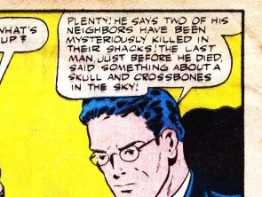
Speech balloons at the top right. Detail from The Black Terror no. 11, August 1945, page 4. Public domain.
A speech balloon. At the top right, a character is speaking.
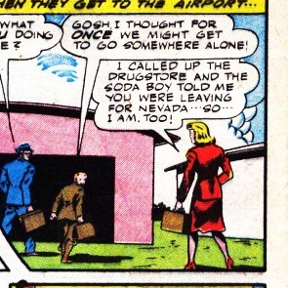
On the right: a woman in a red coat. Detail from The Black Terror no. 11, August 1945, page 4. Public domain.
On the right. A woman in a red coat is walking.

Your tasks (short)
A. The page. How many panels do you count? Number them, 1, 2, 3..., along the reading path.
B. Find and point.
▪ a gutter;
▪ a speech balloon;
▪ a caption.
Say where each one is (at the top, in the middle, on the left...).
C. Listen. The teacher reads one balloon, or one caption. Point to it on the page. Say what you heard.
D. Describe, with prepositions. Complete:
1. In the first panel, on the left, I can see...
2. The boy in the red shirt is...
3. In a later panel, a woman in a red coat is...
4. The caption at the top of the page says... (copy a few words).
E. Two levels.
▪ 2nde. Six short sentences. Use four prepositions and three words from the table.
▪ 1re. Eight sentences, then one more: This page cannot prove...
Sentence starters.
▪ In the first panel...
▪ On the right...
▪ Between the two panels (in the gutter)...
▪ The balloon in the top right says...

Stopping point (minute 44) · Emergency exit (8 minutes)
Complete only:
▪ On this page I can see ... panels.
▪ In the first panel...
▪ A speech balloon is...
▪ A caption is...
▪ The reading path is...

Homework
Five sentences about this page, from memory if you can.
Do not search for a Marvel or DC image.

Lesson 2. How does the page show movement?
Two more real pages from the same issue. Describe the movement.
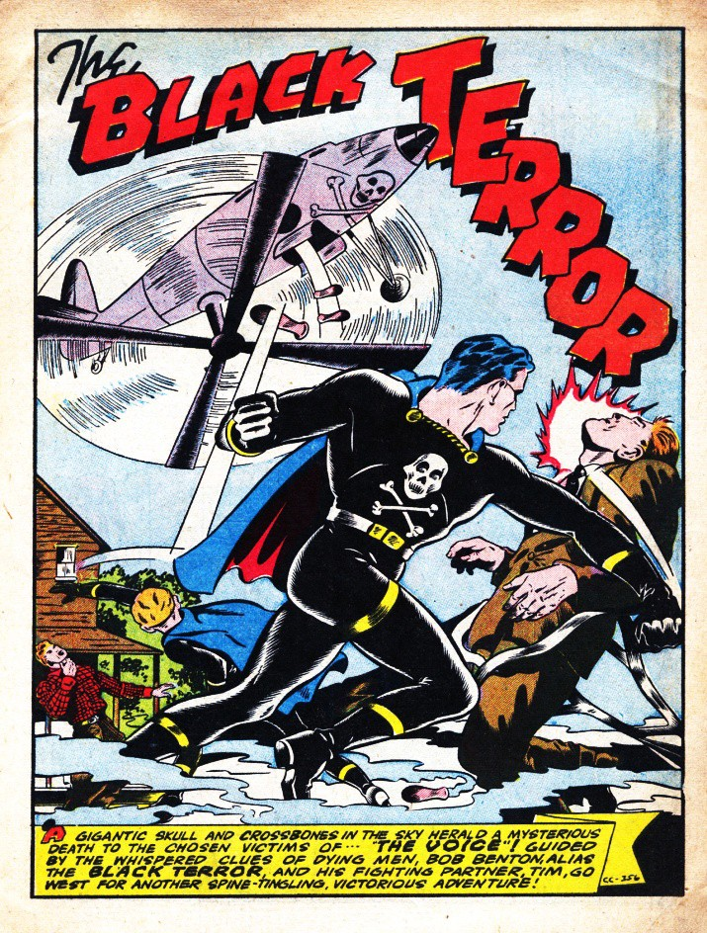
The Black Terror no. 11, August 1945, page 3 (splash page). Nedor / Better Publications. Art: Ed Moritz. Public domain. Wikimedia Commons, File: BlackTerror1103.jpg.
Credit. The Black Terror no. 11, August 1945, page 3. A splash: one large image on the page. Nedor / Better Publications. Art: Ed Moritz. Public domain. Wikimedia Commons.
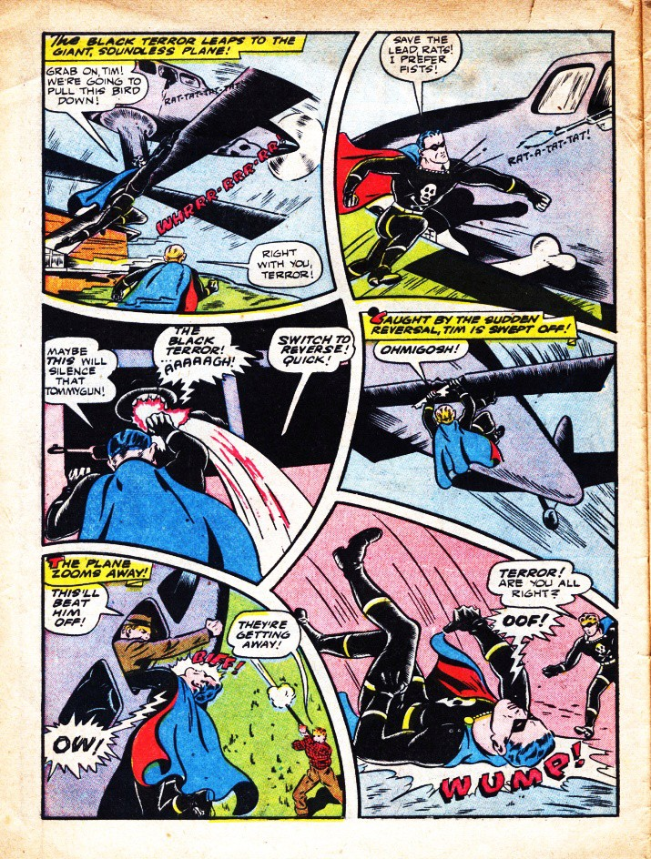
The Black Terror no. 11, August 1945, page 6. Nedor / Better Publications. Art: Ed Moritz. Public domain. Wikimedia Commons, File: BlackTerror1106.jpg.
Credit. The Black Terror no. 11, August 1945, page 6. Nedor / Better Publications. Art: Ed Moritz. Public domain. Wikimedia Commons.

Expanding your vocabulary
Word | Meaning | Example on these pages
splash page | a page with one large image | Page 3 is a splash.
motion lines | lines that show speed | Around the propeller; around the plane.
onomatopoeia | a sound written as a word | WUMP!, OOF!, OW!, RAT-A-TAT-TAT, WHIRRR
to leap / to fall / to zoom / to punch / to grab | verbs of movement | The hero leaps. A body is falling.
diagonally | in a slanted line | A body falls diagonally across the panel.
dynamic | full of movement | Page 6 looks dynamic.
static | still | A face that does not move is more static.

Look closer (real details)
Crops from pages 3 and 6 of the same issue. No drawings.
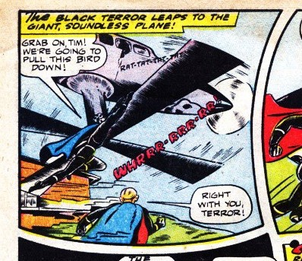
The hero is leaping onto a plane. Motion lines and the onomatopoeia WHIRRR. Detail from The Black Terror no. 11, August 1945, page 6. Art: Ed Moritz. Public domain.
Movement. The hero is leaping. The plane is turning. The letters WHIRRR give the sound.
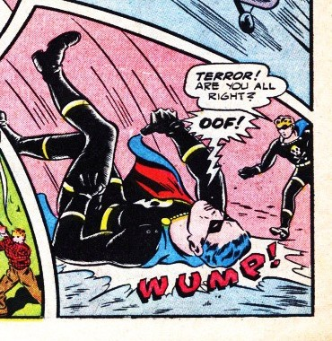
A body is falling diagonally. The word WUMP is in the bottom right. Detail from The Black Terror no. 11, August 1945, page 6. Public domain.
Onomatopoeia, bottom right. A body is falling diagonally. The word WUMP! is in the bottom right. OOF! is a sound of impact.

Your tasks
A. The splash (page 3). Answer in short sentences:
1. Where is the plane?
2. Where is the hero? What is he doing?
3. What are the circular lines around the propeller?
4. What does the yellow caption at the bottom do?
B. The action page (page 6).
1. Find at least four onomatopoeias.
2. For each one, say where it is and what sound it gives.
3. Find a body in the air.
4. Find a panel that looks almost still.
C. Listen. The teacher describes one panel, without showing it. Point to that panel. Then say one verb of movement you heard.
D. Verbs. Write five sentences in the present continuous:
▪ The hero is leaping...
▪ The plane is zooming...
▪ A man is falling...
E. Two levels.
▪ 2nde. Eight short sentences: four on the splash, four on page 6. Use two onomatopoeias and three verbs of movement.
▪ 1re. Ten sentences, then: The page looks dynamic because... A still pose would look...

Stopping point · Emergency exit
▪ On the splash, the hero is...
▪ The plane is...
▪ On page 6 I can see the words ... and ...
▪ A body is (verb+ing)...
▪ The page looks dynamic because...

Homework
Six sentences:
▪ three with an onomatopoeia and a preposition (WUMP! is in the bottom right);
▪ three with a verb of movement.

Lesson 3. What kind of hero in wartime?
This is a real comic from July 1941. We may print it.
It is Lev Gleason’s Daredevil (1941), not Marvel’s Daredevil.
The United States entered the Second World War in December 1941. This comic appeared before that.
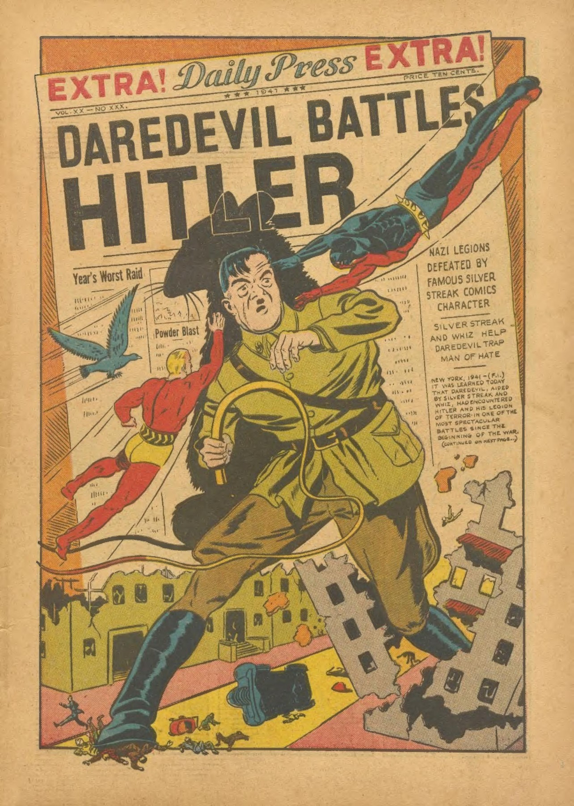
Splash page from Daredevil Comics no. 1, July 1941 (Daredevil Battles Hitler), Lev Gleason / Your Guide Publications. Public domain (published in the United States in 1941; copyright not renewed). Scan via the Internet Archive, item daredevilcomics01c2clevgleason1941julytitanfan, and Wikimedia Commons.
Credit. Daredevil Comics no. 1, July 1941 (Daredevil Battles Hitler), splash page. Lev Gleason / Your Guide Publications. Public domain (United States, 1941; copyright not renewed). Internet Archive and Wikimedia Commons. Not the Marvel character.
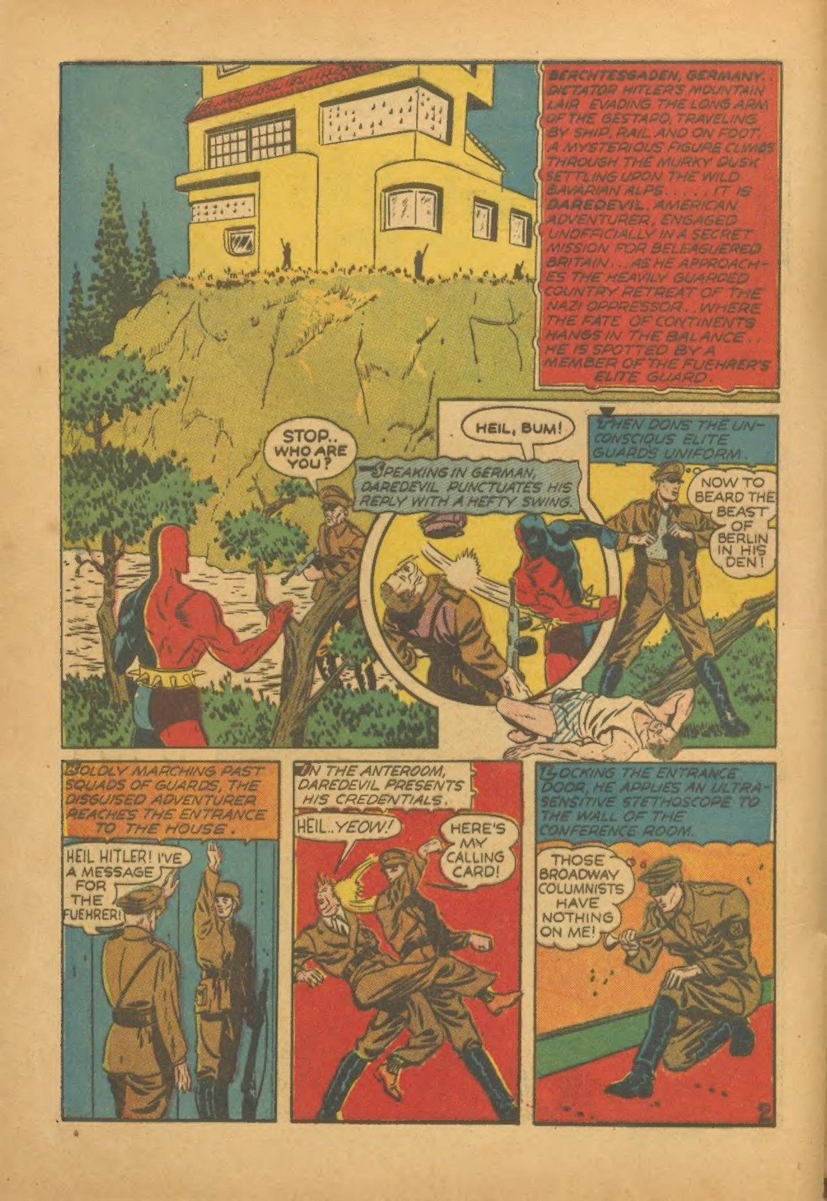
Interior page from Daredevil Comics no. 1, July 1941. Lev Gleason / Your Guide Publications. Public domain. Internet Archive and Wikimedia Commons.
Credit. Daredevil Comics no. 1, July 1941, an interior page (establishing panel, then smaller panels). Lev Gleason / Your Guide Publications. Public domain. Internet Archive and Wikimedia Commons.

Look closer (a real detail)
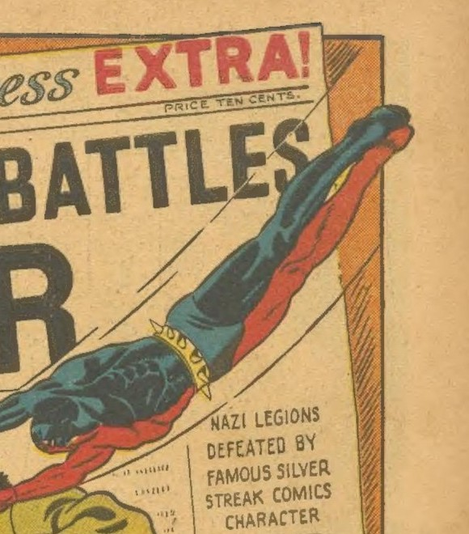
A figure is flying in from the top right. Detail from Daredevil Comics no. 1, July 1941, splash page. Lev Gleason / Your Guide Publications. Public domain. Not the Marvel character.
In the air, at the top right. A costumed figure is flying into the page.

A short timeline (facts)
Date | Fact
June 1938 | Superman first appears in Action Comics no. 1. The cover is protected. We do not print it.
March 1941 | Captain America first appears. The cover (a punch at Hitler) is protected. We do not print it. We describe it only.
July 1941 | This comic: Daredevil Comics no. 1. We may print it.
December 1941 | The United States enters the war. Wonder Woman appears in All Star Comics no. 8.

Your tasks
A. The splash. Short answers:
1. What is in the centre?
2. Who is in the air, and where?
3. What is in the background?
4. What words are at the top?
Use prepositions, and at least one verb of movement (to fly, to run, to strike).
B. The panel page.
1. In the large panel at the top: where is the house?
2. Where is the red figure?
3. What is happening in the middle panel?
4. Follow the reading path down to the three small panels.
C. Fact, interpretation, or unsupported? Write F, I or U:
1. This comic appeared in July 1941, before the United States entered the war.
2. Every American wanted this hero to punch the enemy.
3. The splash may want the reader to see a clear enemy and a fast, powerful hero.
D. Two levels.
▪ 2nde. Eight sentences: description of the splash, then one may and one cannot prove.
▪ 1re. A short paragraph (about 120 words). Description first. Then: what enemy does this 1941 page invent? What does it not show?

Stopping point · Emergency exit
▪ This comic is from July 1941.
▪ On the splash I can see...
▪ In the air...
▪ This page may...
▪ It cannot prove...

Homework
The four dates in the timeline: for each, one fact.
Then two sentences about the splash, with prepositions.

Lesson 4. Colour, and who is left out
A. Colour. Look again at a Black Terror page from Lesson 1 or 2.
1. Name the main colours.
2. Say where each colour is. Do not jump to a symbol yet.
3. Then complete: The yellow captions may... but I cannot reduce the whole page to one colour meaning, because...

B. Pop Art: a painting we do not print
Roy Lichtenstein, Drowning Girl, 1963.
The Museum of Modern Art, New York, object number 80249.
The work is still protected. Madame Carole Paoli Pompougnac has asked the Estate for permission, and is awaiting a reply.
Open the official page and describe what you see there:
https://www.moma.org/collection/works/80249
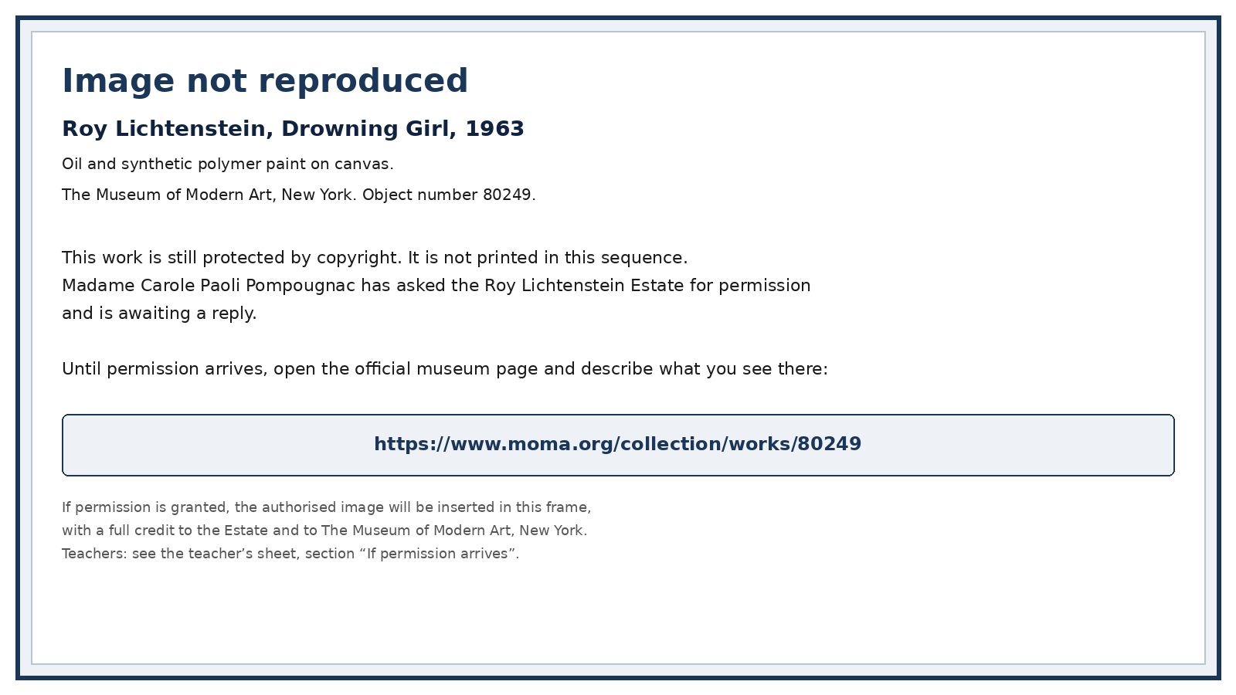
Image not reproduced. Roy Lichtenstein, Drowning Girl, 1963, MoMA 80249. Open the official museum page to describe the work.
Credit. Roy Lichtenstein, Drowning Girl, 1963, MoMA 80249. The image is not reproduced. If permission is granted, the authorised image will be inserted in this frame.
Write, in short lines:
1. Title, date, museum, object number 80249.
2. Six short sentences: who; how much of the body; posture; water; words if you see a balloon; colours and dots.
3. Then: This may... It is close to a comic panel because... It is no longer a comic page because...
C. Who is left out? On the 1941 and 1945 pages:
▪ Who is visible?
▪ Who is not?
Four careful sentences, with may. No slogan.
▪ 2nde: tasks A and B.
▪ 1re: tasks A, B and C.

Homework
A museum label of 8 short lines, with the MoMA link.

Lesson 5. Escape game: The Museum of Unfinished Heroes
A short, serious game. Teams of three or four.
If you miss a clue, ask for a hint. You can still finish.
The aim: restore accurate labels. Do not mislead the visitor.

Envelope 1. The page
Look at The Black Terror no. 11, page 4 (Lesson 1).
▪ How many panels?
▪ What is in the gutter?
▪ What is in the first caption?
The code is the number of panels.

Envelope 2. The damaged label
A visitor has written:
“This is the 1938 Superman cover, a Marvel still from 2011, in the public domain. Lev Gleason’s Daredevil is the same character as Marvel’s Daredevil.”
Rewrite a correct label for Daredevil Comics no. 1, July 1941.
The code word is the month of publication, in English, in lower case.

Envelope 3. Sounds
On The Black Terror no. 11, page 6:
▪ find three onomatopoeias;
▪ for each, write the word and where it is.
The code is the onomatopoeia in the bottom right.

Final statement
Choose the careful option, or rewrite it carefully:
▪ A. “These comics prove that the United States was always united and fair to everyone.”
▪ B. “These public-domain pages show how a 1940s comic pictured heroes, enemies and movement. They may reveal fears and ideals. They cannot prove what every American believed, or that a hero on a page is the same as ordinary courage.”
▪ C. “Comics are only for children, so they have nothing to say.”
Write six to eight short lines. Use two dates and four terms from the vocabulary.
Solutions are on the correction sheet.

Homework
Eight short lines:
▪ what you can now describe;
▪ one date;
▪ one protected work you will not copy.

Lesson 6. Final task: images of a nation
This hour trains towards the CCF (Situation A and Situation B) at class level.
It is not the official examination.
1. Describe. The teacher gives you one printed page from this sequence.
Write a full description:
▪ panels or splash;
▪ reading path;
▪ places;
▪ movement;
▪ balloons, captions, onomatopoeia;
▪ colour.
2. A careful reading.
▪ What may this page want the reader to feel? Use may.
▪ Then two things it cannot prove.
3. The guiding question.
What do American superheroes reveal about the United States, its fears, its ideals and the images it makes of itself?
End at the tip of the spiral: ordinary courage, the enemy a society invents, those it leaves out.
▪ 2nde (A2/B1). About 140-180 words. At least two dates.
▪ 1re (B1). About 180-220 words. At least three dates. A last short paragraph on one path: existential, political, or civilisational.
4. Short oral (about two minutes).
1. Choose one printed page.
2. Describe it.
3. Then: This may reveal... It cannot prove...
Sentence starters.
▪ I am going to describe a public-domain page from...
▪ In the first panel / On this splash...
▪ The hero is (verb+ing)...
▪ This may...
▪ I would not say “every American”, because...
Self-correction (after the work comes back).
▪ What went wrong: ...
▪ My improved sentence: ...
▪ One word I now use more precisely: ...

Emergency exit
Twelve short sentences:
▪ a description (eight sentences);
▪ two may;
▪ two cannot prove.
That is a finished thought.

Credits
All comic pages reproduced here are in the public domain (United States publication, 1941 or 1945; copyright not renewed).
1. The Black Terror no. 11, August 1945, Nedor / Better Publications (Standard). Cover: Alex Schomburg. Interior art: Ed Moritz. Pages used: page 3 (splash); page 4 (panel grid); page 6 (action and onomatopoeia). Wikimedia Commons (Files: BlackTerror1103.jpg, BlackTerror1104.jpg, BlackTerror1106.jpg). Public domain.
2. Daredevil Comics no. 1, July 1941 (Daredevil Battles Hitler), Lev Gleason / Your Guide Publications. Interior splash and panel pages. Public domain. Scans via the Internet Archive (item daredevilcomics01c2clevgleason1941julytitanfan) and Wikimedia Commons (Daredevil Battles Hitler.djvu). This is Lev Gleason’s character, not Marvel’s Daredevil. The original 1941 cover includes a racist caricature (the villain called the Claw); that cover is not reprinted in this sequence.
Cover: McClelland Barclay, Man the Guns, Join the Navy, 1942, United States Navy recruiting poster. National Archives (NARA) 513519; Library of Congress, Prints and Photographs Division, reproduction number LC-USZC4-2009. Public domain (United States government work). Image via Wikimedia Commons.
Marvel and DC images are not reproduced.
Lichtenstein, Drowning Girl, 1963, MoMA 80249, is not reproduced: https://www.moma.org/collection/works/80249.

