American Superheroes: images of a nation
Accessible version. Six short autonomous fiches, one for each lesson.
Madame Carole Paoli Pompougnac
Anglais · 2nde and 1re of the baccalauréat professionnel
Programme: Bulletin officiel spécial n° 5 of 11 April 2019. Two levels: A2/B1 in 2nde, B1 in 1re. Examination from session 2027; CCF still in force.
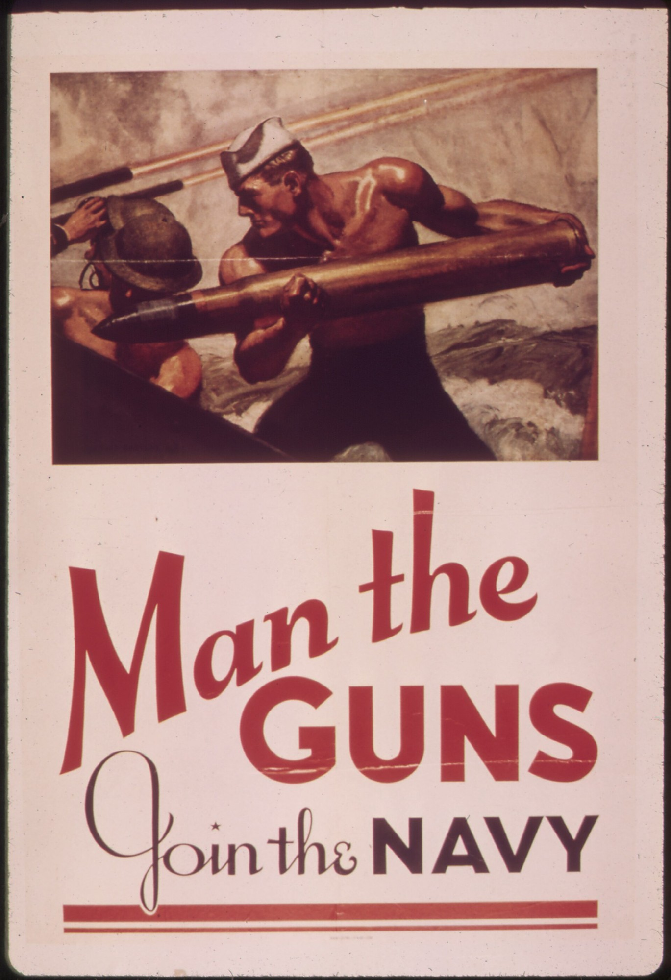
McClelland Barclay, Man the Guns, Join the Navy, 1942, United States Navy recruiting poster. National Archives (NARA) 513519; Library of Congress, Prints and Photographs Division, reproduction number LC-USZC4-2009. Public domain (United States government work). Image via Wikimedia Commons.
Guiding question
What do American superheroes reveal about the United States, its fears, its ideals and the images it makes of itself?

conçu par Madame Carole Paoli Pompougnac, mis en page par Grok
© 2026 Madame Carole Paoli Pompougnac · CC BY-NC-SA 4.0

I. Presentation of the sequence

Aim of the sequence
▪ Look at real public-domain Golden Age comic pages.
▪ Describe what we see, before we interpret.
▪ Ask what these images reveal, and what they cannot prove.

Objectives: the five activités langagières
1. Compréhension de l’écrit. Read a real comic page. Find panels, gutters, balloons and captions. (Lessons 1 to 3.)
2. Compréhension de l’oral. Listen. Point to the right place on the page. (Lessons 1, 2 and 5.)
3. Expression écrite. Write short sentences, with prepositions, movement verbs, may and cannot prove. (Lessons 1 to 4 and 6.)
4. Expression orale en continu. Speak for about two minutes about one page. (Lesson 6.)
5. Interaction orale. Work in a team in the escape game. (Lesson 5.)
Levels. 2nde (A2/B1) and 1re (B1).
Final task. Lesson 6: a careful description and a two-minute oral.

Fiche autonome. Lesson 1. What do we see on this page?
Look first. Do not interpret yet.
This is a real comic page from 1945. We may print it.
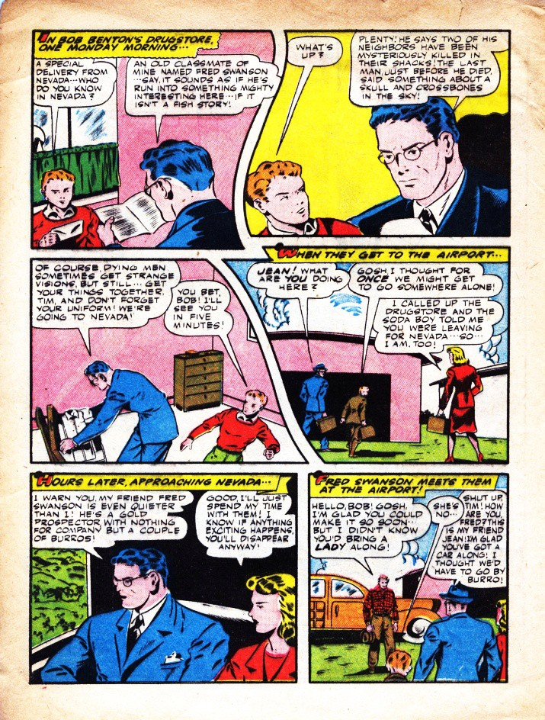
The Black Terror no. 11, August 1945, page 4. Nedor / Better Publications. Art: Ed Moritz. Public domain.
Credit. The Black Terror no. 11, August 1945, page 4. Public domain.

Look closer
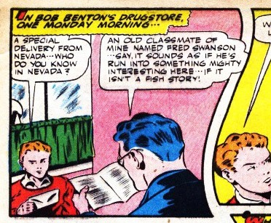
On the left, a boy in a red shirt. Detail from the same page. Public domain.
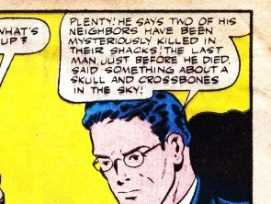
A speech balloon at the top right. Detail from the same page. Public domain.

Words
▪ panel: one picture, in a box
▪ gutter: the space between two panels
▪ speech balloon: what a character says
▪ caption: a box of narration (often yellow)
▪ on the left / on the right: prepositions of place

Tasks
A. How many panels? Number them 1, 2, 3...
B. Point to: a gutter; a speech balloon; a caption. Say where each one is.
C. Listen. The teacher reads one balloon. Point to it. Say what you heard.
D. Complete:
1. In the first panel, on the left, I can see...
2. The boy in the red shirt is...
3. On the right, a woman in a red coat is...
4. The caption at the top says...
2nde: six short sentences. 1re: eight sentences, then: This page cannot prove...

Homework
Five sentences about this page. Do not search for a Marvel or DC image.

Fiche autonome. Lesson 2. How does the page show movement?
Two real pages from the same issue.
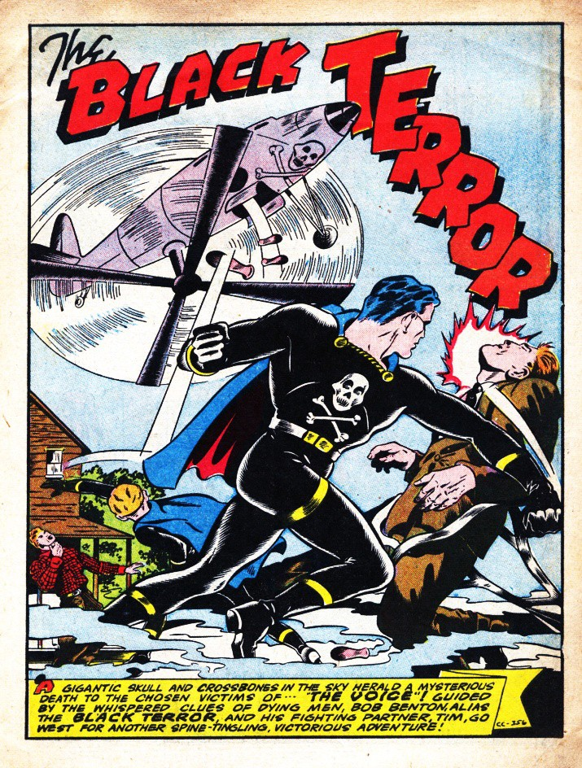
The Black Terror no. 11, August 1945, page 3, splash. Public domain.
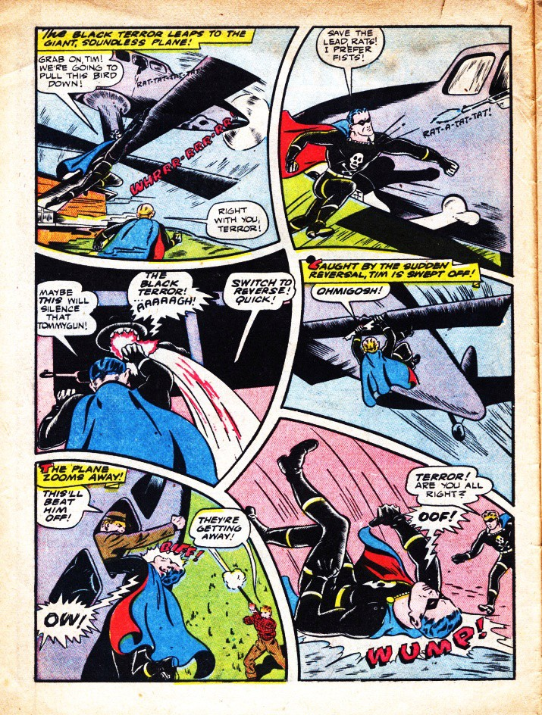
The Black Terror no. 11, August 1945, page 6. Public domain.

Look closer
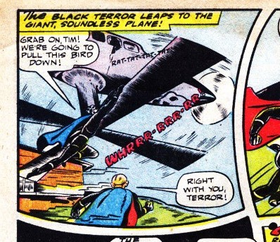
The hero is leaping. The word WHIRRR. Detail, page 6. Public domain.
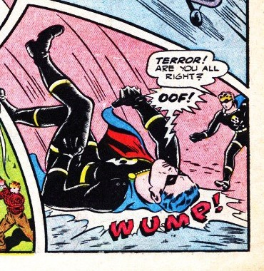
A body is falling. The word WUMP is in the bottom right. Detail, page 6. Public domain.

Words
▪ splash page: one large image
▪ motion lines: lines that show speed
▪ onomatopoeia: a sound written as a word (WUMP!, OOF!, OW!, RAT-A-TAT-TAT, WHIRRR)
▪ to leap / to fall / to zoom: verbs of movement
▪ diagonally: in a slanted line

Tasks
A. On the splash: where is the plane? Where is the hero? What is he doing?
B. On page 6: find four onomatopoeias. For each, say where it is.
C. Write five sentences: The hero is leaping... The plane is zooming... A man is falling...
2nde: eight short sentences. 1re: ten sentences, then: The page looks dynamic because...

Homework
Six sentences: three with an onomatopoeia and a preposition, three with a verb of movement.

Fiche autonome. Lesson 3. What kind of hero in wartime?
A real comic from July 1941. We may print it.
Lev Gleason’s Daredevil (1941), not Marvel’s Daredevil.
The United States entered the war in December 1941. This comic appeared before that.
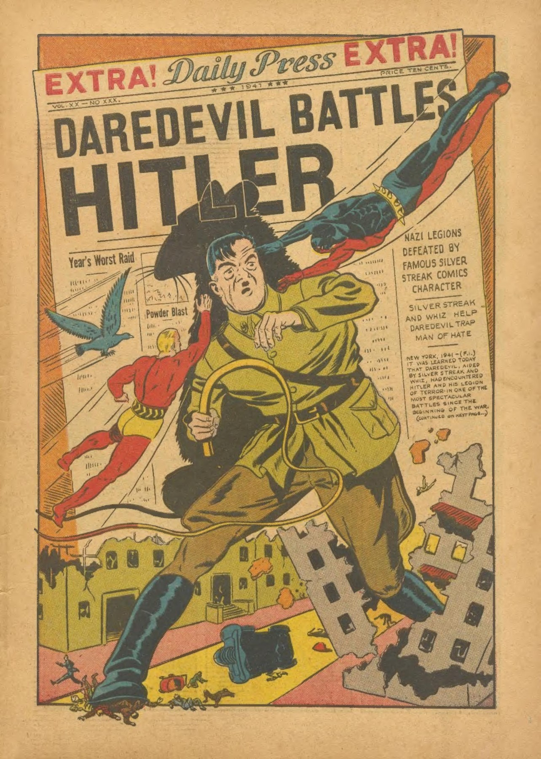
Daredevil Comics no. 1, July 1941, splash page. Lev Gleason. Public domain. Not the Marvel character.
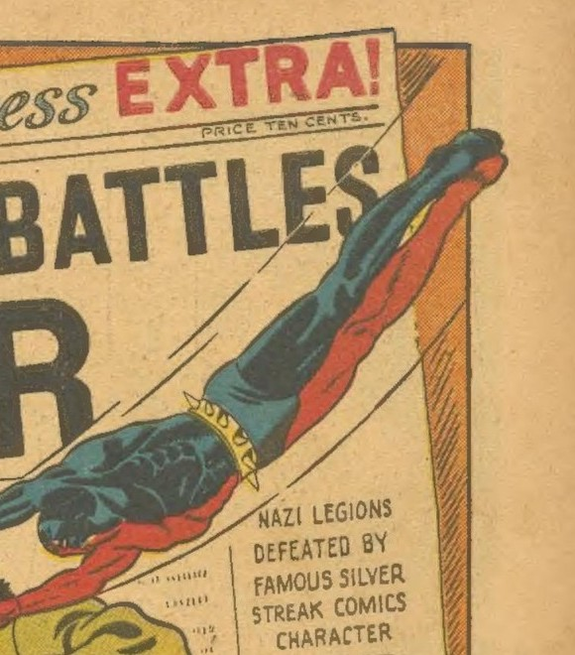
In the air, at the top right. Detail from the same splash. Public domain.
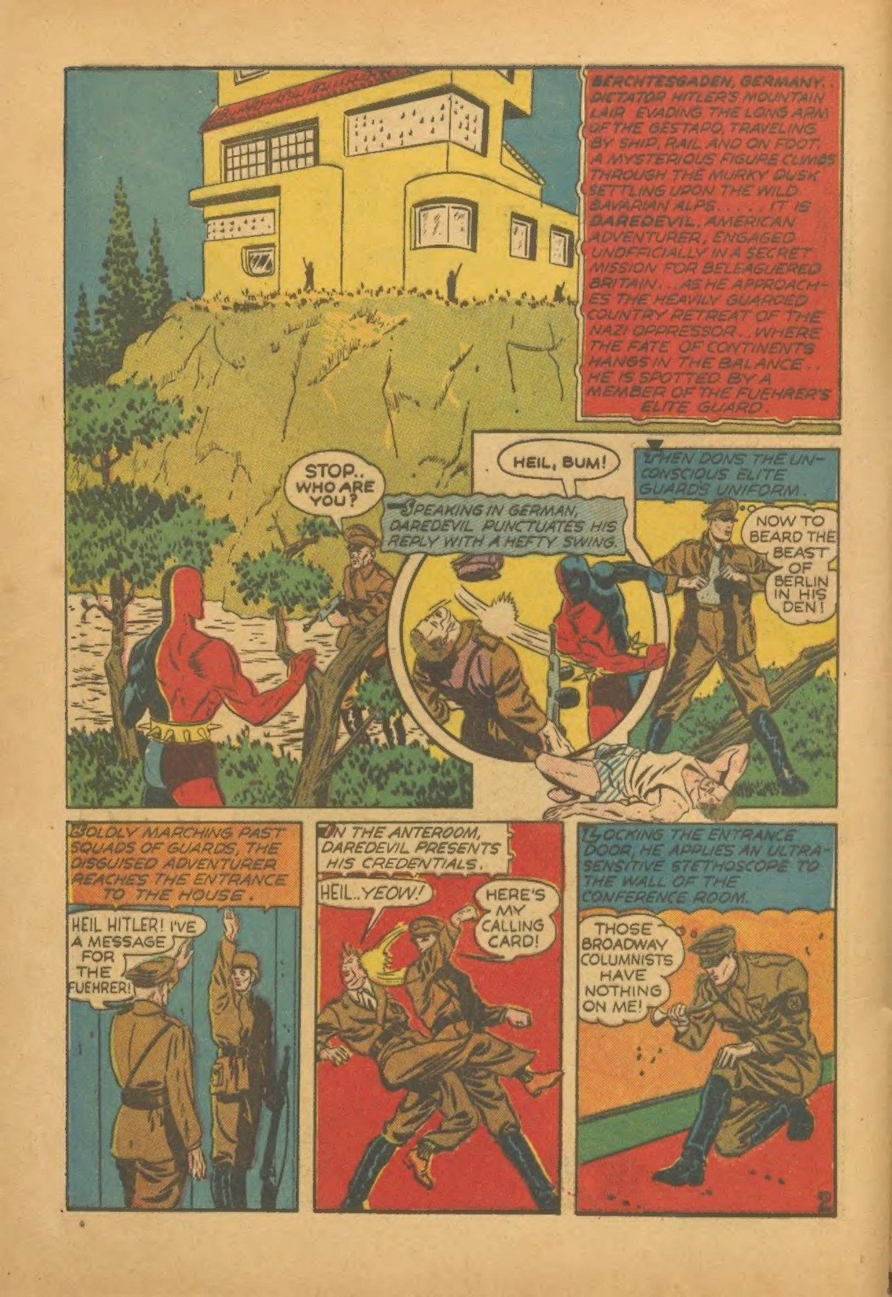
Daredevil Comics no. 1, July 1941, interior page. Public domain.

Dates
▪ June 1938. Superman first appears. The cover is protected. We do not print it.
▪ March 1941. Captain America first appears. The cover is protected. We do not print it.
▪ July 1941. This comic. We may print it.
▪ December 1941. The United States enters the war.

Tasks
A. On the splash: what is in the centre? Who is in the air, and where? What words are at the top?
B. Write F, I or U:
1. This comic appeared in July 1941, before the United States entered the war.
2. Every American wanted this hero to punch the enemy.
3. The splash may want the reader to see a clear enemy and a fast hero.
Answers, on the correction sheet: 1 F; 2 U; 3 I.
2nde: eight sentences, with one may and one cannot prove. 1re: about 120 words.

Homework
The four dates, each with one fact. Two sentences about the splash.

Fiche autonome. Lesson 4. Colour, and who is left out
A. Colour. Look again at a Black Terror page.
1. Name the main colours, and where they are.
2. Then: The yellow captions may... but I cannot reduce the whole page to one colour meaning, because...
B. A painting we do not print.
Roy Lichtenstein, Drowning Girl, 1963. MoMA, New York, 80249.
Open: https://www.moma.org/collection/works/80249
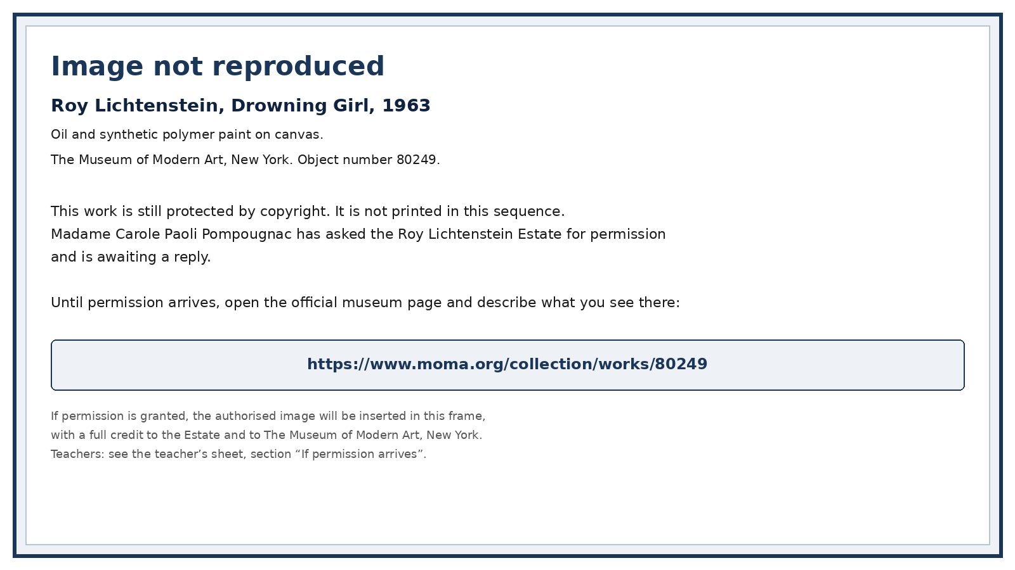
Image not reproduced. Roy Lichtenstein, Drowning Girl, 1963, MoMA 80249.
Write: title, date, museum, 80249. Then six short sentences about what you see on the museum page. Then: This may... It is close to a comic panel because... It is no longer a comic page because...
C. (1re) Who is visible on the 1941 and 1945 pages? Who is not? Four careful sentences, with may.

Homework
A museum label of 8 short lines, with the MoMA link.

Fiche autonome. Lesson 5. The Museum of Unfinished Heroes
A short game. Teams of three or four. If you miss a clue, ask for a hint.
Envelope 1. The Black Terror no. 11, page 4. How many panels? The code is that number.
Envelope 2. Rewrite a correct label for Daredevil Comics no. 1, July 1941. The visitor’s label mixed Marvel and 1938. The code word is the month, in English, in lower case.
Envelope 3. On page 6, find three onomatopoeias and where they are. The code is the word in the bottom right.
Final statement. Choose Option B, or rewrite it carefully:
▪ A. “These comics prove that the United States was always united and fair to everyone.”
▪ B. “These public-domain pages show how a 1940s comic pictured heroes, enemies and movement. They may reveal fears and ideals. They cannot prove what every American believed, or that a hero on a page is the same as ordinary courage.”
▪ C. “Comics are only for children, so they have nothing to say.”
Write six to eight short lines. Use two dates and four vocabulary words.

Homework
Eight short lines: what you can now describe; one date; one protected work you will not copy.

Fiche autonome. Lesson 6. Final task
This is class work, not the official examination.
Describe one printed page: panels or splash, places, movement, balloons, sounds, colour.
Then a careful reading with may, and two cannot prove.
Then the guiding question, in 140-180 words (2nde) or 180-220 words (1re). End at the tip of the spiral.
Oral, two minutes. Describe one printed page. Then: This may reveal... It cannot prove...
Sentence starters.
▪ I am going to describe a public-domain page from...
▪ In the first panel...
▪ On this splash...
▪ The hero is (verb+ing)...
▪ This may...
▪ I would not say “every American”, because...
Self-correction. What went wrong: ... My improved sentence: ...

