Anglais · Première bac pro · B1
Dolly Parton: An American Legacy
Dys version of the student pack · Première bac pro · B1
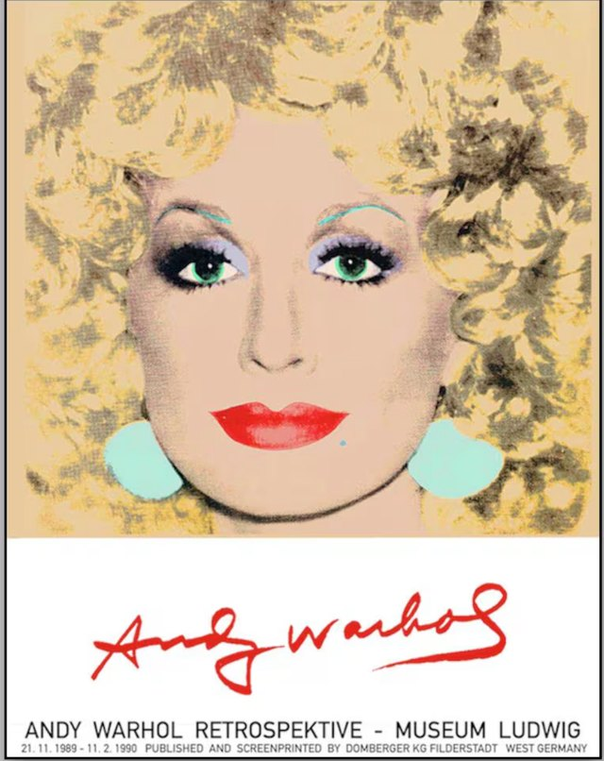
Andy Warhol, Dolly Parton, 1985. Poster of the Andy Warhol retrospective, Museum Ludwig, Cologne, 1989-1990. © The Andy Warhol Foundation for the Visual Arts. Reproduced as a one-off exception for teaching purposes, from Madame Carole Paoli Pompougnac's own copy of the poster.
Designed by Madame Carole Paoli Pompougnac
BO spécial n° 5 du 11 avril 2019 · Nine lessons of 55 minutes
https://itineraires-destinations.fr/dolly-parton-american-legacy/
© 2026 Madame Carole Paoli Pompougnac · CC BY-NC-SA 4.0

Dys version
For students who work alone, without an AESH, even after an absence. Short texts. One step at a time. An example corrected before every exercise. All the answers at the end of each lesson, to check yourself.

How to use this version
- Read the box "What I need to say".
- Read the rule and the example.
- Do the exercise. Cover the answers with a sheet of paper.
- Check with the answers. Count your points.
- Make your flashcards (see section 2.4: front = word; back = meaning + example).
- Do the homework: most of it is oral (record yourself on your phone).
Layout advice for the teacher: sans-serif font (Arial, Verdana or OpenDyslexic), size 14, line spacing 1.5, no italics, no justified text, one exercise per page, key words in bold. Give the audio of the texts (teacher's recording or text-to-speech).

Adaptation by type of class
Class | What changes
lycée général et technologique (Seconde, Première) | Same steps. Add the "Going further" box of each lesson. The final task can include the question of the sequence in 150 words.
Bac pro (2de, 1re, Tle) | This version as it is. Use the Help box frames of the full lessons.
CFA (apprentices) | Work at home between two periods at the CFA: each lesson can be done in 30 minutes alone. Priority: Lessons 1, 2, 3, then Appendix A or B. Record the oral homework and send it to the trainer.
CAP | Same steps. Exercises 1 and 2 of each lesson are enough; exercise 3 is optional. Oral homework only.
SEGPA (collège) | Lessons 1, 2, 3, 6 and 8 only. One exercise per lesson; word bank with pictures drawn by the student; the final task is a 1-minute recorded presentation of Dolly.

Lesson 1. An icon in colour
What I need to say. I describe the Warhol portrait of Dolly.
Rule.
- Always true → present simple: She has green eyes.
- Now, in the picture → present continuous: She is smiling.
- Impression → She looks like a film star.
Word bank: portrait · platinum blonde (very light blonde) · lilac (light purple) · scarlet (bright red) · turquoise (blue-green) · background (behind) · icon (a very famous person)
Exercise 1. Match the detail and the colour. Example: eyes → green ✔
- hair 2. lips 3. earrings → scarlet · turquoise · platinum blonde
Exercise 2. Complete with the present continuous. Example: She (look) at us. → She is looking at us. ✔
- She (smile). 2. She (wear) earrings.
Exercise 3. Complete with looks or looks like. Example: She ... happy. → She looks happy. ✔
- She ... a doll. 2. She ... glamorous.
Homework. Record yourself: three sentences about a famous person.
Answers. Ex 1: hair → platinum blonde; lips → scarlet; earrings → turquoise. Ex 2: She is smiling. She is wearing earrings. Ex 3: looks like; looks.

Lesson 2. Rags to rhinestones
What I need to say. I tell Dolly's childhood and I describe her look.
Short text. Dolly was born in 1946 in Tennessee. Her family was poor. Her mother made her a coat with small pieces of fabric. At school, children laughed at her. In 1971, Dolly wrote a song about this coat.
Listen: https://www.youtube.com/watch?v=KFbYFHaigSk (from 0:00 to 3:04). While you listen, raise your hand or tick each time you hear the word coat.
Rule.
- Past simple: make → made, wear → wore, write → wrote, grow up → grew up.
- Habit in the past: used to + verb → She used to sing with her mother.
- Order of adjectives: opinion → size → colour → noun: a beautiful long pink dress.
Word bank: cabin · coat · patchwork · rags · wig · curls · rhinestones · sequins · false lashes
Exercise 1. Past simple. Example: sing → sang ✔
- make 2. wear 3. write
Exercise 2. Put in order. Example: hair / big / blonde → big blonde hair ✔
- dress / pink / a / long 2. boots / white / high
Exercise 3. used to. Example: She (live) in a cabin. → She used to live in a cabin. ✔
- Her mother (sing) ballads.
Homework. Learn six words of the Dolly look (flashcards). Record one sentence about her look.
Answers. Ex 1: made, wore, wrote. Ex 2: a long pink dress; high white boots. Ex 3: Her mother used to sing ballads.

Lesson 3. Backstage
What I need to say. I ask, I offer, I suggest politely.
Rule.
- Ask: Could you + verb? → Could you make it shorter?
- Offer: Shall I + verb? → Shall I add volume?
- Suggest: What about + noun? → What about the pink suit?
- Prefer: I'd rather + verb → I'd rather wear the white dress.
Word bank: dresser (helps with costumes) · hairdresser · make-up artist · wig · costume · lashes · quick change (very fast change)
Exercise 1. Make it polite. Example: Give me the dress. → Could you give me the dress, please? ✔
- Give me the wig.
Exercise 2. Make an offer. Example: I / help you? → Shall I help you? ✔
- I / add glitter?
Exercise 3. Suggest. Example: the red lipstick → What about the red lipstick? ✔
- the golden wig
Homework. Learn three polite phrases. Say them to someone at home, or record them.
Answers. Ex 1: Could you give me the wig, please? Ex 2: Shall I add glitter? Ex 3: What about the golden wig?

Lesson 4. 9 to 5
What I need to say. I describe a working day and the rules at work.
Short text. In 1980, Dolly played a secretary in the film 9 to 5. The boss was unfair. Dolly wrote the song. It won two Grammy Awards.
Watch: https://www.youtube.com/watch?v=UbxUSsFXYo4 (from 0:00 to 0:33). Tick the actions you see: get up · make coffee · drive · take a shower.
Rule.
- always, often, never → before the verb: She always works late.
- have to = necessary · mustn't = forbidden · don't have to = not necessary · should = advice.
Word bank: boss · office worker · promotion · equal pay · colleague · fair / unfair
Exercise 1. Place the adverb. Example: She arrives late. (never) → She never arrives late. ✔
- The boss says thank you. (never)
Exercise 2. mustn't or don't have to? Example: You ... smoke here (forbidden). → You mustn't smoke here. ✔
- You ... work on Sunday (not necessary).
Homework. Record three rules for a fair workplace.
Answers. Watch: get up, make coffee, take a shower (no driving). Ex 1: The boss never says thank you. Ex 2: don't have to.

Lesson 5. Dollywood
What I need to say. I present a company and its numbers.
Short text. Dollywood is a theme park in Tennessee. It opened in 1986. It has about 4,000 employees. It is the biggest employer in the county.
Rule.
- Date finished → past simple: Dollywood opened in 1986.
- Result today → present perfect: It has created many jobs.
- since + date (since 1986) · for + duration (for forty years).
Word bank: theme park · employer · staff · job · to apply (ask for a job)
Exercise 1. Say the number. Example: 3,000 → three thousand ✔
- 4,000 2. 1986
Exercise 2. opened or has opened? Example: The shop ... in 2020. → The shop opened in 2020. ✔
- Dollywood ... in 1986.
Exercise 3. since or for? Example: ... ten years → for ten years ✔
- ... 1986
Homework. Name three jobs at Dollywood and record them.
Mid-point assessment (dys version). Same parts as the class version, with: Part A = 4 questions; Part B = 4 items; Part C = 40 words with the frame Dolly grew up... Later, she wore... I think...; Part D = 30 seconds. Self-correction: same grid.
Answers. Ex 1: four thousand; nineteen eighty-six. Ex 2: opened. Ex 3: since 1986.

Lesson 6. Aunt Dolly
What I need to say. I report what people said.
Short text. Miley Cyrus is a singer. Dolly was her godmother. They sang the song Jolene together many times.
Listen: https://www.youtube.com/watch?v=wOwblaKmyVw (from 0:00 to 1:32). Complete: please don't take my ...... Listen: https://www.youtube.com/watch?v=GtFw9dEwrbo (from 0:00 to 1:00). Who sings first: Miley or Dolly? Optional, to watch: Dolly and Miley sing Jolene at the Grammy Awards, 10 February 2019 ([Billboard](https://www.billboard.com/video/dolly-parton-jolene-about-2019-billboard-grammy-awards-coverage-on-billboardgn-sourceflv/)).
Rule.
- "I am proud." → She said that she was proud.
- "Be yourself." → She told her to be herself.
Word bank: godmother · goddaughter · role model (a person you admire) · bond (a strong link) · heir · legacy (what you leave)
Exercise 1. Report. Example: "I am happy." → She said that she was happy. ✔
- "I accept." → She said that she ...
Exercise 2. Report the order. Example: "Sing!" → She told her to sing. ✔
- "Be yourself." → She told her ...
Exercise 3. Look at them. Choose one word. Example: They smile. They look happy. ✔
- They hold hands. They look (close / angry).
Homework. Record one piece of advice you received, in reported speech.
Answers. Listen: man; Miley. Ex 1: accepted. Ex 2: to be herself. Ex 3: close.

Lesson 7. True or Tale?
What I need to say. I say if it is a fact, a claim or a fake.
Short text. After Dolly's death, a video said: "Dolly left all her money to Miley." Fact-checkers said the video was made with AI. Nobody knows who inherits: it is private.
Rule.
- must = almost sure: It must be fake.
- might = possible: It might be true.
- can't = impossible: It can't be her real voice.
- There is no evidence that... = nobody can prove it.
Word bank: rumour · fake · AI-generated · fact-check · evidence (proof) · will
The 4 questions: 1. Who posted it? 2. What is the original source? 3. Where else is it reported? 4. What does the official account say?
Exercise 1. Fact, claim or fake? Example: Dolly was Miley's godmother. → fact ✔
- Dolly left Jolene to Miley.
Exercise 2. must, might or can't? Example: Nobody reported it. It ... be fake. → must ✔
- The voice is robotic. It ... be Miley.
Homework. Check one viral post with the 4 questions. Record your verdict (30 seconds).
Answers. Ex 1: claim, not verified. Ex 2: can't.

Lesson 8. Legacy
What I need to say. I pay tribute and I explain Dolly's goals.
Short text. Dolly died on 25 August 2026. She was 80. In 1995, she created the Imagination Library: every month, young children receive a book by post. More than 330 million books have been sent.
Watch: https://www.youtube.com/watch?v=IjxcK1ZZw3c (from 0:52 to 3:58). Tick what happens to the book: chosen · printed · eaten · mailed.
Rule.
- Goal: to + verb / so that + could: She created the library so that children could read.
- Passive: is + past participle: A book is sent every month.
Word bank: tribute · charity · donation · literacy (reading and writing) · research · to live on (to continue)
Exercise 1. Passive. Example: They print the book. → The book is printed. ✔
- They send a book.
Exercise 2. Goal. Example: She worked hard ... succeed. → to ✔
- She gave money ... help research.
Homework. Record a 30-second tribute: who she was, one thing she did, why.
Answers. Watch: chosen, printed, mailed. Ex 1: A book is sent. Ex 2: to.

Lesson 9. Final task
What I need to say. I present Dolly, I play a scene, I check a rumour.
My plan (with key words only).
- Present Dolly: born 1946 · Tennessee · coat · wig · 9 to 5 · Dollywood · library.
- Scene: Could you...? · Shall I...? · What about...?
- True or Tale: The video must be fake. There is no evidence that...
Example. Dolly was born in Tennessee in 1946. Could you add more volume? The video must be fake.
Exercise 1. Name the three backstage jobs. Example: the person who does make-up → make-up artist ✔
Summative assessment (dys version). Part A: 1 minute 30 with the plan. Part B: role-play with the Help starters. Part C: 4 questions, text in size 14. Part D: 60 words with a frame. Same grids; the Language criterion counts only the words of the word banks.
Homework. Self-assessment: record three things I can say now.
Answers. Ex 1: dresser, hairdresser, make-up artist.

