Banksy: Who Owns an Anonymous Voice?
Dys version · Seconde bac pro · A2 and B1
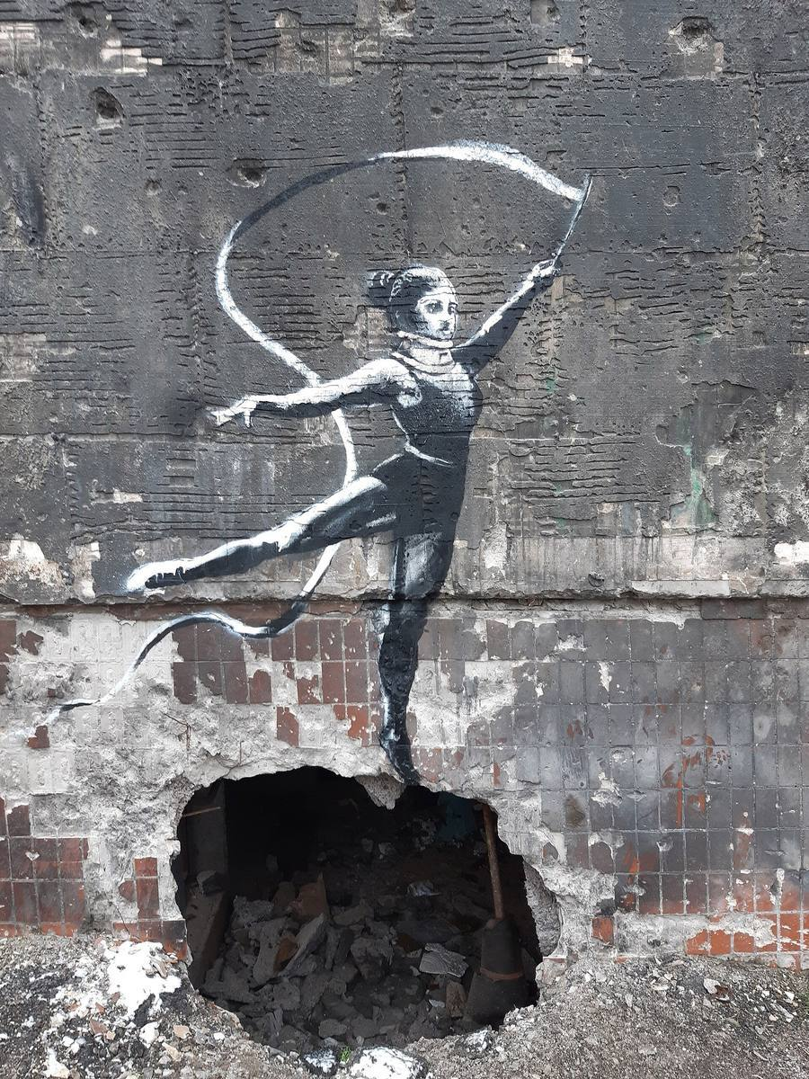
Cover photograph: a mural widely attributed to Banksy, Gymnast with a Ribbon, Irpin, Ukraine, 2022. Photograph by Rasal Hague, 18 November 2022, Wikimedia Commons, CC BY-SA 4.0. The photograph is shared under that licence. The artwork itself remains protected.
Designed by Madame Carole Paoli Pompougnac
BO spécial n° 5 du 11 avril 2019 · Six lessons of 55 minutes
https://itineraires-destinations.fr/banksy-who-owns-an-anonymous-voice/
conçu par Madame Carole Paoli Pompougnac, mis en page par Grok
© 2026 Madame Carole Paoli Pompougnac · CC BY-NC-SA 4.0
Anglais · Seconde bac pro · A2 and B1 · Dys version

Dys version
This version can be used alone, even if you were absent, and without an assistant. The questions are the same as in the main sequence. The texts are shorter. Each exercise starts with a worked example. You can check your work with the button Afficher le corrigé.
The big question. Does an artist's identity matter more than the work, and who should control art painted in a public space?
A necessary caution. We do not say that Banksy's real name is known for certain. Reuters reported a name in March 2026. Banksy did not confirm it in the sources we use. You will practise this sentence: According to Reuters, Banksy was born Robin Gunningham. You will not write: Banksy's real name is Robin Gunningham.

The six lessons
- Lesson 1. Can an image speak without a name?
- Lesson 2. Should the public know who Banksy is?
- Lesson 3. If you own the wall, do you own the art?
- Lesson 4. Can anti-commercial art escape the market?
- Lesson 5. Does a mural lose its voice when it leaves its wall?
- Lesson 6. Exhibiting Banksy without owning the name
If a word is new, look at the vocabulary table first. Then do the example. Then do the exercise. Then open the corrigé and correct your work in a different colour.
Back to the sequence · Downloads (the dys pack is also there, in pdf, docx and odt).

Dys version · Lesson 1 of 6

Lesson 1. Can an image speak without a name?
Activités langagières. Réception écrite, production orale en continu, interaction orale, production écrite.
The question today. Can a picture speak like a slogan, even before we know who made it?
What you will do. 1. Look. 2. Write three things you can see. 3. Write one slogan sentence: what does the image say? 4. Say the tone, and speak for 30 seconds.

Step 1. Look at the picture
This is the famous image called Girl with Balloon. The first mural was in London in 2002. The photograph here is a copy in an exhibition in Brussels, not the original wall. We can still study the image.
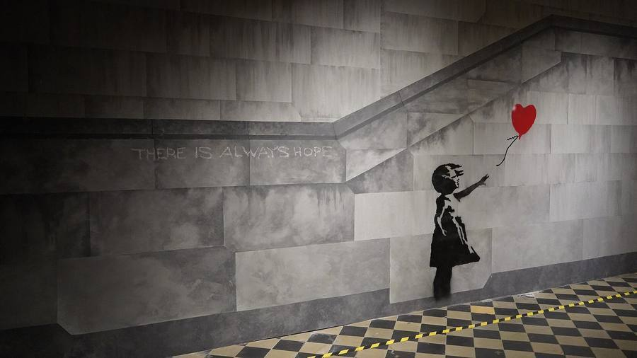
The motif of Banksy's Girl with Balloon (the original mural appeared in London in 2002). This photograph shows a reconstructed mural in the exhibition The World of Banksy, Brussels, 2022, not the original wall in London. Photograph by Miguel Discart, Wikimedia Commons, CC BY-SA 2.0. The photograph is shared under that licence. The artwork itself remains protected.
Worked example. A good observation: "There is a girl in a dress. She is reaching towards a red balloon." That is a description. A slogan sentence: "The image may say: do not let hope fly away." That is an interpretation. It is not a proof. The tone may be sad, or hopeful.
Banksy's pictures are visual slogans: messages spoken by a drawing. For each image, write: what it says, to whom, and in what tone (ironic, sad, angry, playful, warning).

Step 2. Your turn
Write:
- Three things you can actually see.
- One slogan sentence, with may or The image says.
- The tone, and one question.
Corrigé
Example. 1. There is a girl. There is a red heart-shaped balloon. The girl is reaching out with her hand. 2. The balloon may suggest love, or it may be escaping. 3. Is she letting it go, or is she trying to catch it? Other correct answers are possible, if they stay close to the image.

Step 3. Expanding your vocabulary
Word or phrase | Meaning | Example
mural | a painting on a wall | The mural is on a wall.
stencil | a cut-out used to paint a shape | The girl looks as if she was painted with a stencil.
to reach | to stretch a hand towards something | The girl is reaching towards the balloon.
description | what you can actually see | A description stays with visible things.
interpretation | a possible meaning, not a proof | My interpretation may be wrong.
may | used for a possibility | The girl may be letting the balloon go.
visual slogan | a message spoken by a picture | This mural is a visual slogan.
tone | the way the message sounds: ironic, sad, angry, playful | The tone may be ironic.
to denounce | to say publicly that something is wrong | The image denounces rising water.

Worked example. "The balloon is red." This is a description. "The girl is sad." This is an interpretation. We cannot see sadness for certain.
Exercise. Write D (description) or I (interpretation).
- The balloon is heart-shaped.
- The image is about lost love.
- The girl is reaching towards the balloon.
Corrigé
1 D. 2 I. 3 D.

Step 4. Grammar
Use there is / there are for what exists. Use the present continuous for an action you can see: is reaching, is painting. Use may + verb for a possible idea: may suggest, may be losing.
Worked example. There is a girl. The girl is reaching towards the balloon. The balloon may suggest a heart.
Exercise. Complete: There _____ a red balloon. The girl _____ reaching towards it. This _____ suggest a heart.
Corrigé
is; is; may.

Step 5. Two more walls
Look at these two photographs. The first has words next to a real camera: What are you looking at? The second has words in a canal: I don't believe in global warming. The water covers part of the sentence. That is irony: the place contradicts the words.
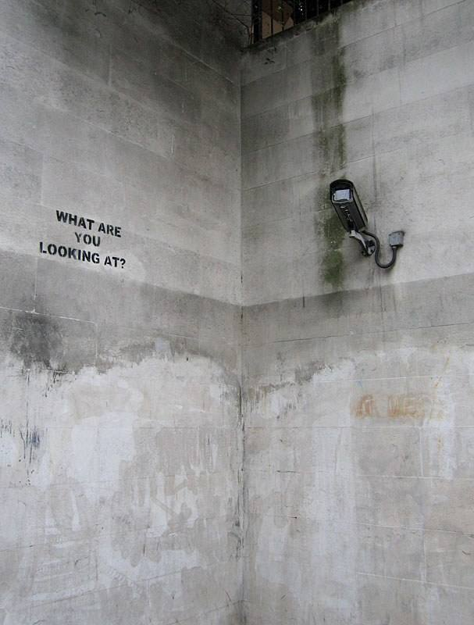
A stencil widely attributed to Banksy in a subway near Hyde Park, London: the words WHAT ARE YOU LOOKING AT?, painted on the wall facing a real surveillance camera. Photograph by Andrew Dunn, April 2006, Wikimedia Commons, CC BY-SA 2.0. The photograph is shared under that licence. The artwork itself remains protected.
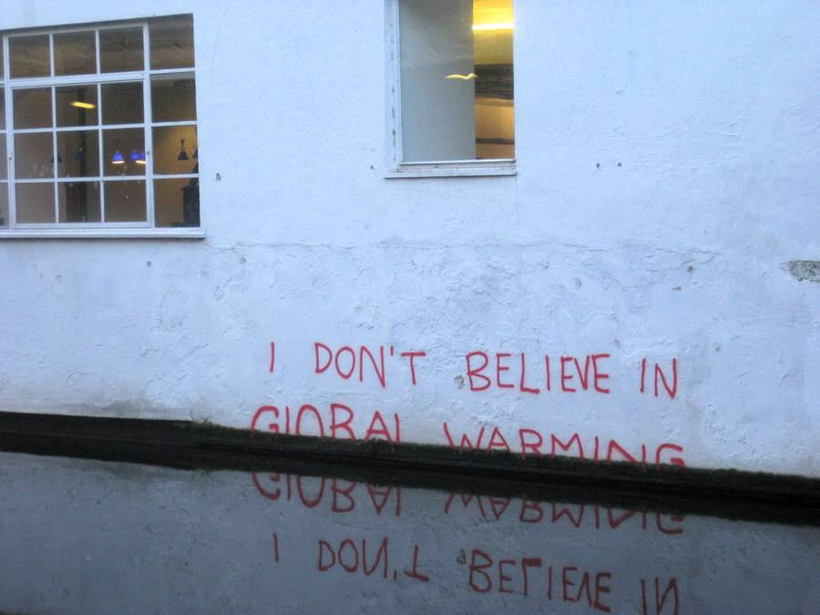
A mural widely attributed to Banksy on the Regent's Canal in Camden, London: the words I DON'T BELIEVE IN GLOBAL WARMING, painted so that the lower line sits in the water. Photograph by Matt Brown, 21 December 2009, Wikimedia Commons, CC BY 2.0. The photograph is shared under that licence. The artwork itself remains protected.
Exercise. For each picture, complete: The words say... The image is speaking to... The tone is... because...
Corrigé
Example. 1. The words say: What are you looking at? They may be speaking to the camera, or to us. The tone may be angry or ironic, because a painted question answers a camera that watches. 2. The words say they do not believe in global warming. The water covers the words. The tone is ironic, because the place contradicts the claim. The image denounces rising water. Other justified answers are possible.

Step 6. Speak
Speak for 30 seconds, with a partner or as a recording. Use this frame:
There is... The image says... The tone is... because... It may...

Step 7. Homework
Make two flashcards. Card 1, front: visual slogan. Back: a message spoken by a picture. Example: This mural is a visual slogan. Card 2, front: may. Back: a possibility. Example: The girl may be losing the balloon. Bring the cards to Lesson 2.

Dys version · Lesson 2 of 6

Lesson 2. Should the public know who Banksy is?
Activités langagières. Réception écrite, médiation (paraphrase a claim accurately), production écrite, interaction orale, production orale en continu.
The question today. When is it right to publish a name, and when is it better to wait?

A public name, without a face
Look first at two images. On a path, the word BANKSY points visitors towards a park. On a museum stone, a famous sentence is carved, Picasso's name is crossed out, and the name Banksy is carved below. The public already meets a name. That name is not a confirmed civil identity.
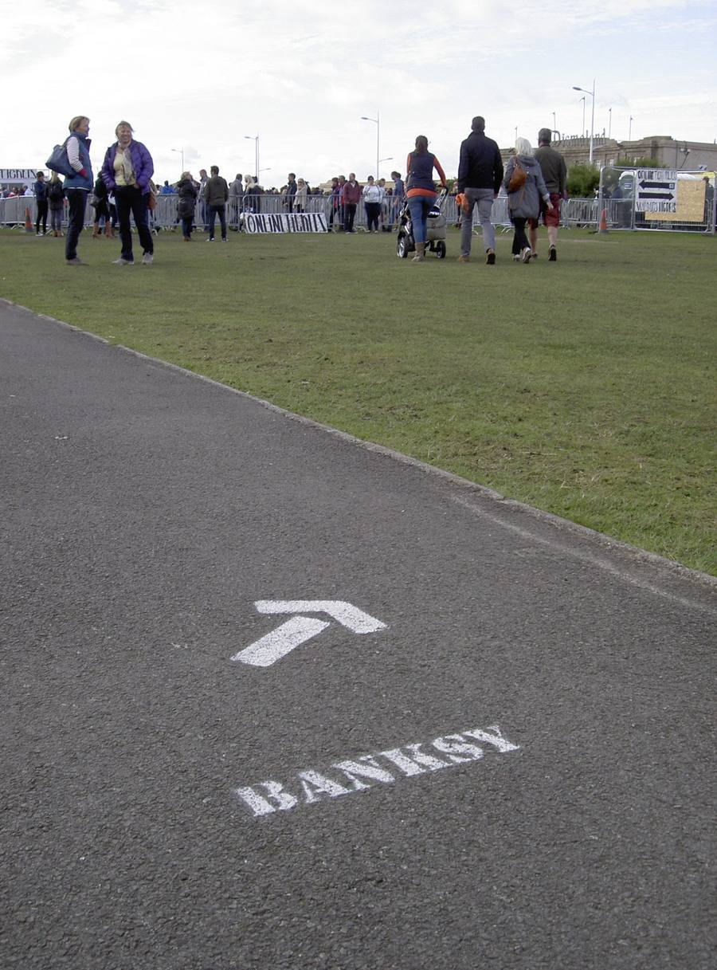
A painted arrow and the name BANKSY on a path leading visitors towards Dismaland, Weston-super-Mare, in 2015. The public name itself becomes a sign: people follow the word, not a face. Photograph by Neil Owen, Geograph, Wikimedia Commons, CC BY-SA 2.0. The photograph is shared under that licence.
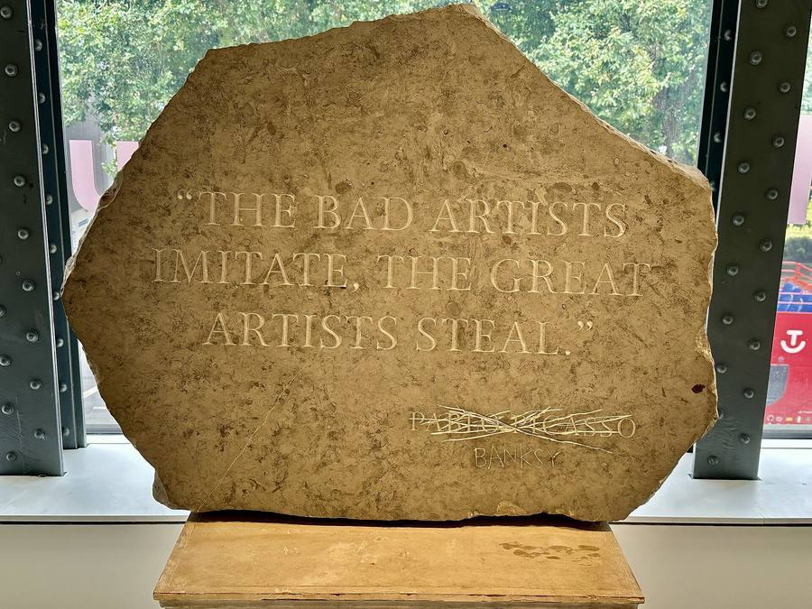
A carved stone exhibited at the Moco Museum, London, photographed by Matt Brown on 14 August 2024. The sentence reads: THE BAD ARTISTS IMITATE, THE GREAT ARTISTS STEAL. The name Pablo Picasso is crossed out, and the name Banksy is carved below. The saying is often attributed to Picasso; the display puts Banksy's name in its place. Wikimedia Commons, CC BY 2.0. The photograph is shared under that licence. The artwork itself remains protected. A museum display is not a certificate from Pest Control.
Exercise. Complete: The path says... People follow... The stone says... I think the public name is / is not enough, because...
Corrigé
Example. The path says BANKSY. People follow a word, not a face. The stone says that great artists steal, and it puts the name Banksy under a crossed-out name. The public name is already a kind of author. A civil name is a different question. A museum display is not a confirmation.

The sentence you must remember
Reuters reported in March 2026 that Banksy was born Robin Gunningham and later took the name David Jones. Banksy did not confirm that identification in the sources examined for this sequence.
Copy this sentence into your exercise book. It is the accurate form. Do not write: "Banksy's real name is Robin Gunningham."

Four categories
Category | Meaning | Example
Documented fact | We can show the event or the publication | Reuters published its investigation on 13 March 2026.
Attributed claim | A named source says this | According to Reuters, Banksy was born Robin Gunningham.
Rumour | A story with no adequate source | Someone on the internet says a stranger is Banksy, with no evidence.
Interpretation | Your judgement | Anonymity makes the work more powerful.

Worked example. "Reuters published a report in March 2026." This is a documented fact. "According to Reuters, the artist later used the name David Jones." This is an attributed claim. A claim can be serious. It is still a claim until it is confirmed.
Exercise 1. Write F, C, R or I.
- Reuters published an investigation on 13 March 2026.
- Banksy's real name is Robin Gunningham.
- According to Reuters, Banksy later used the name David Jones.
- A classmate says, with no source, that a neighbour is Banksy.
Corrigé
1 F. 2 This sentence is not acceptable. The correct form is a C: According to Reuters, Banksy was born Robin Gunningham. 3 C. 4 R.

Expanding your vocabulary
Word or phrase | Meaning | Example
according to | used to give the source | According to Reuters, the artist used another name.
to report | to give information as news | Reuters reported that it had used documents.
to confirm | to say officially that something is true | Banksy did not confirm the name.
to deny | to say that something is not true | Did not confirm is not the same as denied.

Worked example. A bad headline: BANKSY'S REAL NAME REVEALED. A better headline: According to Reuters, Banksy was born Robin Gunningham.
Exercise 2. Rewrite: PEST CONTROL CONFIRMS THE STORY.
Corrigé
Pest Control said the artist had decided not to comment. (That is not a confirmation.)

Speak
20 to 30 seconds. Use this frame:
I think the public should / should not know, because... According to Reuters... Banksy did not confirm...

Homework
Learn the classroom sentence. Record yourself reading it, or read it aloud three times. Make a flashcard for according to.

Dys version · Lesson 3 of 6

Lesson 3. If you own the wall, do you own the art?
Activités langagières. Réception écrite, réception orale, production orale en continu and interaction (mid-point oral, Situation B practice), production écrite.
The question today. Can someone own the wall without owning every right in the painting?

Three questions, not one
- The wall. Who owns the physical wall, or the piece of wall that was cut out?
- The image. Who has rights in the artistic image (copyright)?
- Public access. Who can still see the work?
Worked example. A café owner cuts a mural out of a wall and sells it. The owner may then hold the piece of wall. That does not automatically settle copyright. Passers-by may also lose public access.

A court case, in short
In Folkestone, in 2014, a mural called Art Buff appeared on a building. The tenant had a section of wall cut out, without the landlord's permission. In 2015, the High Court said the section of wall should be returned. The case was about the physical object. It did not say that the public owns every Banksy.
Exercise 1. True or false?
- The tenant was the freehold owner of the building.
- The court case was about a physical section of wall.
- The court decided that the public owns every Banksy mural.
Corrigé
1 False. 2 True. 3 False.

Two photographs
No Ball Games, in Tottenham, was later removed and sold. The Irpin gymnast was cut out of a building in 2023, in order to save it, and later moved.
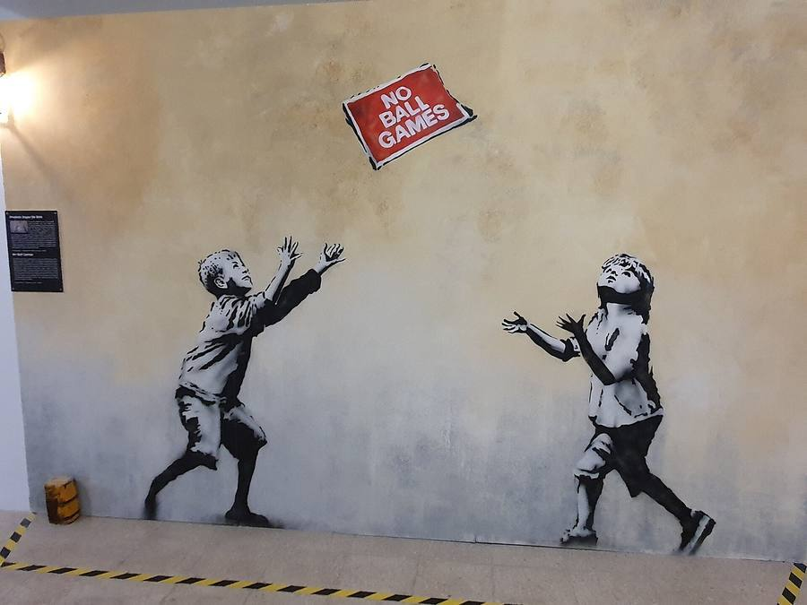
A mural attributed to Banksy, No Ball Games, Tottenham, London, 2009. Two children throw a red sign that reads No Ball Games, instead of a ball. Photograph by GualdimG, Wikimedia Commons, CC BY-SA 4.0. The photograph is shared under that licence. The artwork itself remains protected. The mural was later removed from its wall and sold in sections.
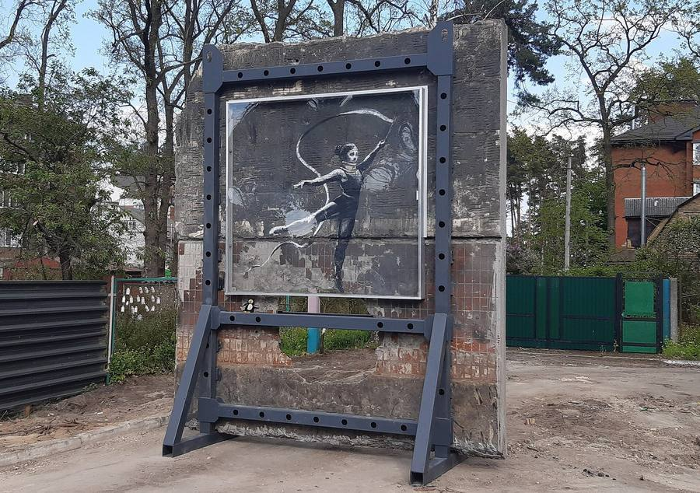
The Irpin mural of the gymnast with a ribbon after the section of wall was cut out, 14 May 2023. The figure has left the building. Photograph by Rasal Hague, Wikimedia Commons, CC BY-SA 4.0. The photograph is shared under that licence. The artwork itself remains protected. The mural was later moved to another site on the same street.

Grammar: the passive
We use was / were + past participle when the object is the focus: The mural was painted in 2009. It was removed later. It was sold in sections.
Worked example. Active: Someone removed the mural. Passive: The mural was removed.
Exercise 2. Rewrite in the passive. 1. Someone painted the mural on a wall. 2. Someone cut the gymnast out of the building.
Corrigé
1 The mural was painted on a wall. 2 The gymnast was cut out of the building.

Speak (mid-point practice)
A café owner wants to cut out a mural and sell it. Residents want it to stay. Use this frame, for 40 seconds:
The owner wants... The residents want... The wall is not the same as the image. I think it should / should not... because...

Homework
Make two flashcards: was removed and copyright. Learn them.

Dys version · Lesson 4 of 6

Lesson 4. Can anti-commercial art escape the market?
Activités langagières. Réception orale, réception écrite, production orale, interaction, production écrite, médiation.
The question today. When a slogan criticises money and then meets a shop or an auction, what happens to its voice?

Two short films
Your teacher will show two short extracts, each twice. First extract: a work is shredded at an auction (00:00 to 02:00). Second extract: the trailer for Dismaland (00:00 to 02:07). For each film:
- Write three things you can see. Do not explain them yet.
- Write one contrast, with whereas or although.
Worked example. I can see a castle that looks damaged. A usual theme park looks cheerful, whereas Dismaland looks grim. Although the shredding looked like an attack on the sale, the work later sold for even more money (this last fact comes from later reporting, not from the two-minute film).
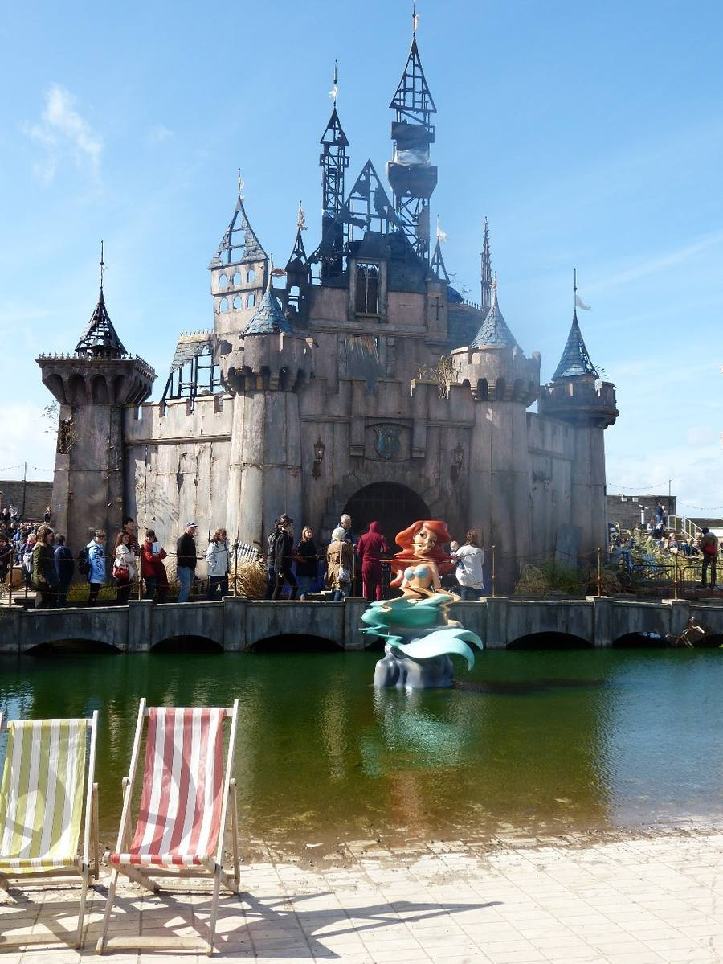
Dismaland, Weston-super-Mare, 2015: the crooked castle and a twisted mermaid figure in a moat. Banksy created the temporary park and invited many other artists. Do not attribute every object in the photograph to Banksy. Photograph by Rob Farrow, 24 September 2015, Geograph Britain and Ireland, Wikimedia Commons, CC BY-SA 2.0. The photograph is shared under that licence. The artworks themselves remain protected.

Expanding your vocabulary
Word or phrase | Meaning | Example
auction | a public sale, the highest bidder wins | The work was sold at an auction.
to shred | to cut into strips | Part of the work was shredded.
contrast | a clear difference | There is a contrast between fun and decay.
whereas | used to set two facts against each other | A park promises fun, whereas this park looks grim.
although | used to admit one fact, then add a contrast | Although the work was shredded, it was sold again.

Exercise. Combine with the word in brackets. 1. A theme park is cheerful. Dismaland looks grim. (whereas) 2. The shredding looked like an attack. The work became more valuable. (although)
Corrigé
1 A theme park is cheerful, whereas Dismaland looks grim. 2 Although the shredding looked like an attack, the work became more valuable.

The Walled Off Hotel
This hotel opened in Bethlehem in 2017, beside a barrier. Guests pay to stay next to a wall that limits movement. That is a contrast worth describing carefully.
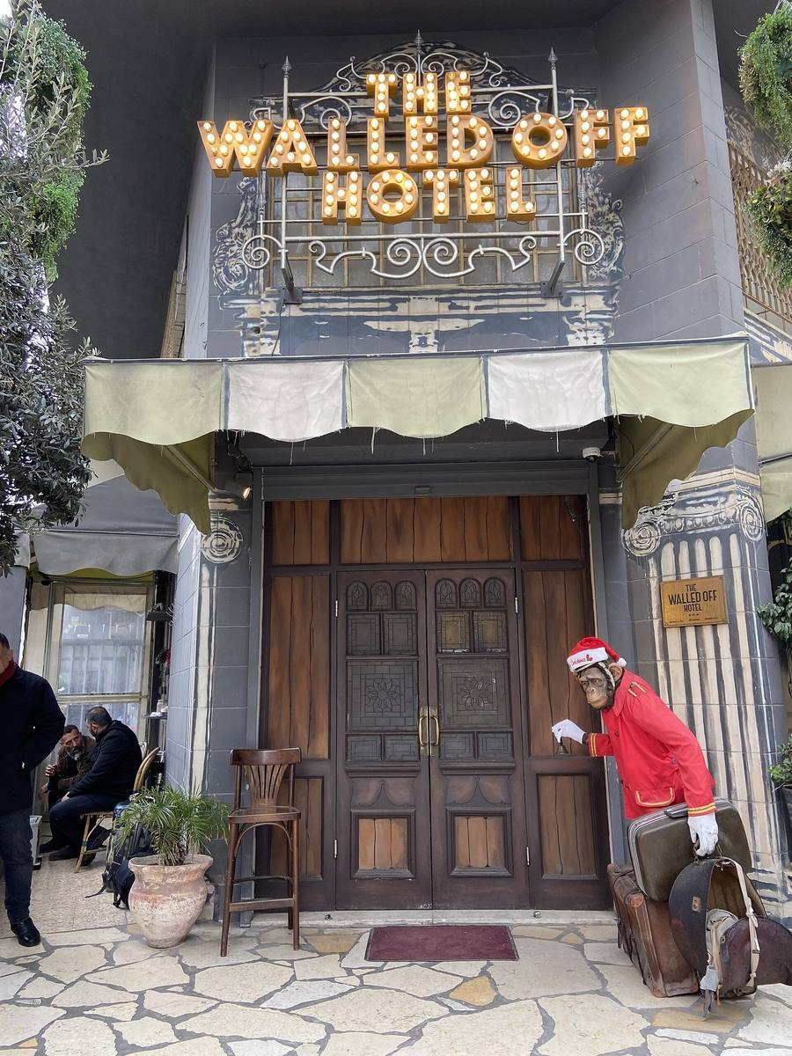
The Walled Off Hotel, Bethlehem, opened in 2017, a project associated with Banksy, standing beside the West Bank barrier. The name plays on the Waldorf hotel chain. Photograph by YellowFratello, Wikimedia Commons, CC0. The photograph is in the public domain as a photograph. The building, the decorations and any artworks remain protected.
Write three sentences: where it is; what you can see; one question you would ask a visitor.

Homework
Make flashcards for whereas and auction. Do not say that a sale price proves the artist's exact intention.

Dys version · Lesson 5 of 6

Lesson 5. Does a mural lose its voice when it leaves its wall?
Activités langagières. Réception écrite, réception orale, médiation, production orale, interaction, production écrite.
The question today. If the place is part of the slogan, what remains when the image moves?

The gymnast in Irpin
Look at the girl with a ribbon. She seems to balance on a hole in a damaged building, in Irpin, in 2022. This is not the other gymnast, in Borodianka. In 2023 the wall was cut, in order to save the painting. The place and the image were then separated.
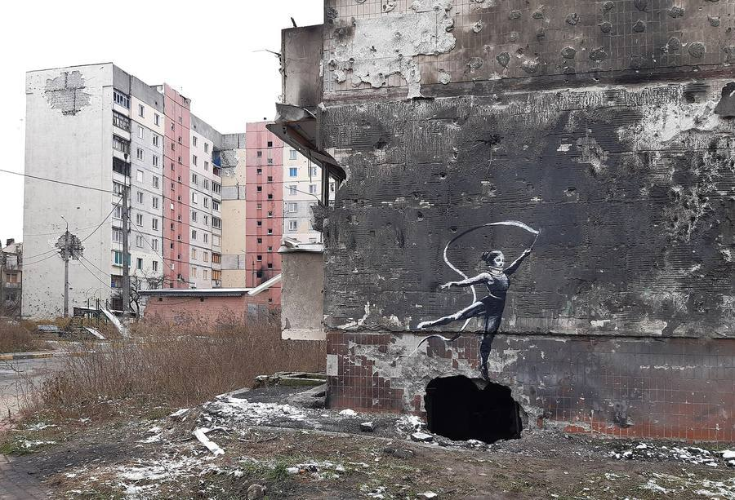
The same Irpin mural in its original setting: the gymnast appears to balance on a shell hole in a ruined building, with damaged blocks behind. Photograph by Rasal Hague, 18 November 2022, Wikimedia Commons, CC BY-SA 4.0. The photograph is shared under that licence. The artwork itself remains protected.
Worked example. Visible: the gymnast is painted above a dark hole. Interpretation: she may be using the hole as a ball. Not proven by the photograph alone: the exact cause of the hole, and the intention of the people who later moved the wall.

London, 2024
A goat stands on a real ledge, in Richmond. Pelicans interact with a real shop sign, in Walthamstow. If you move only the painted animal, you lose the ledge or the sign.
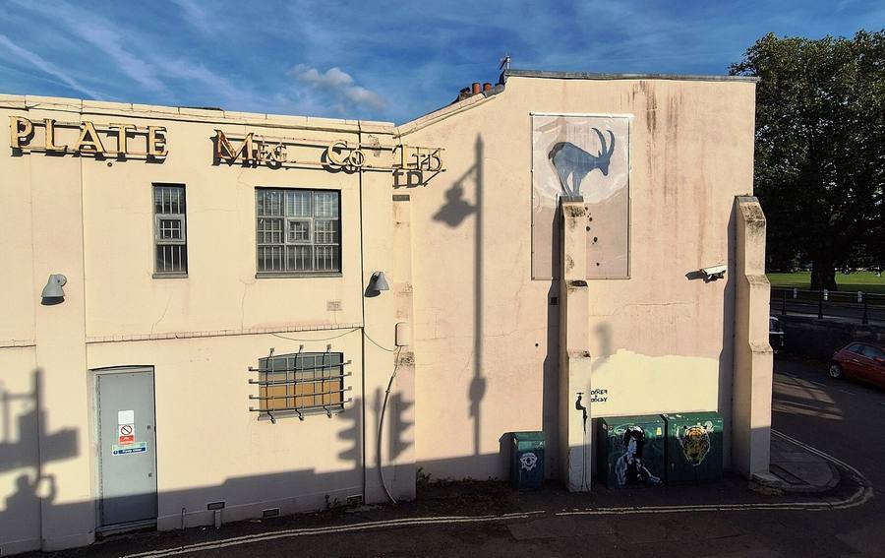
A mural attributed to Banksy and posted on the artist's official Instagram: a goat on a narrow ledge, Richmond, London, August 2024, part of a series of animal works that appeared across the city. Photograph by Anthony Parkes, 14 September 2024, Geograph Britain and Ireland, Wikimedia Commons, CC BY-SA 2.0. The photograph is shared under that licence. The artwork itself remains protected.
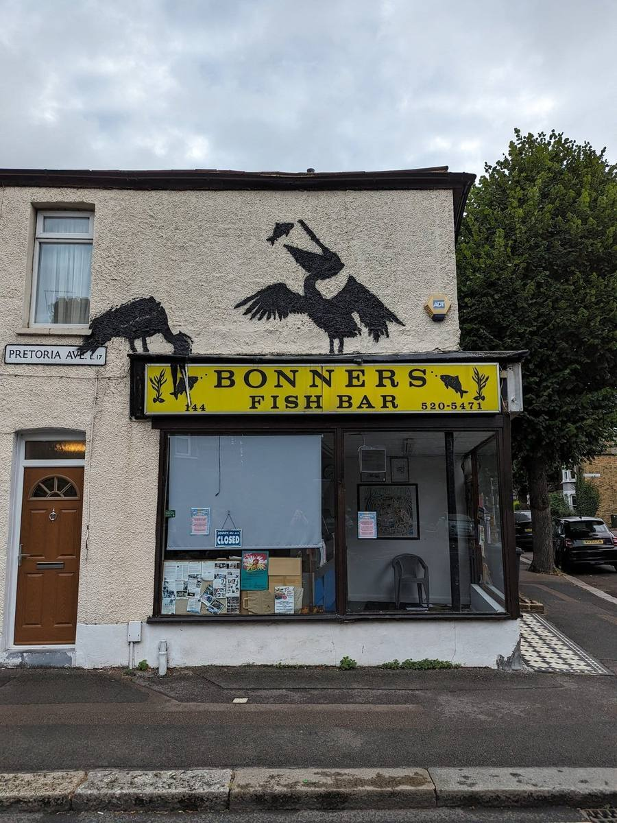
A mural attributed to Banksy and posted on the artist's official Instagram: pelicans interacting with a fish-and-chip shop sign, Walthamstow, London, August 2024. Photograph by Panicshouter, Wikimedia Commons, CC0. The photograph is in the public domain as a photograph. The artwork itself remains protected.
A child in Venice, painted in 2019 on a wall above the water. Later floods marked the work. The water is part of what the image says.
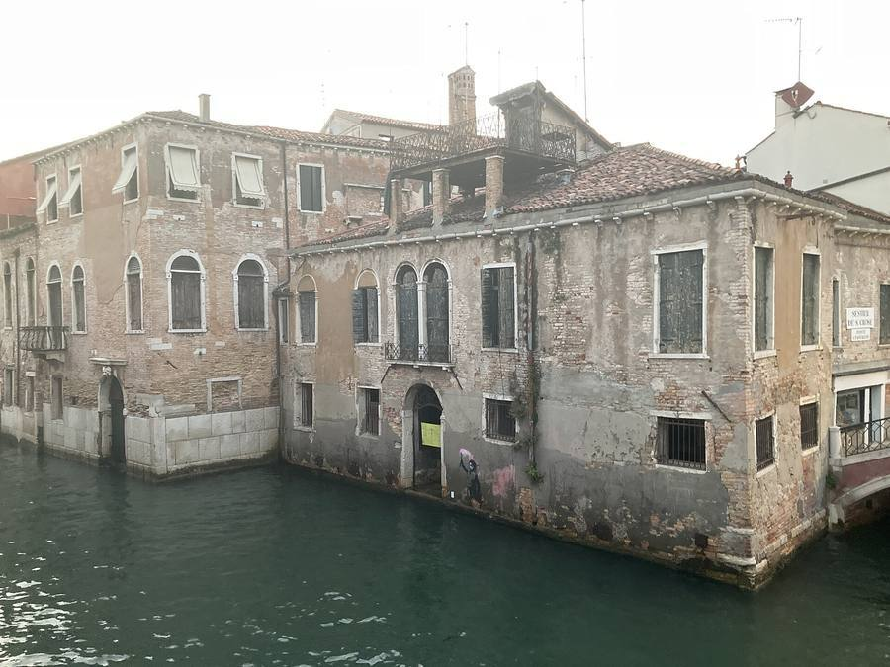
A mural widely attributed to Banksy, Migrant Child, painted in Venice in 2019 on a wall rising from the water. This photograph was taken about three years later, when floods had already marked the work. Photograph by Steve Loughran, Wikimedia Commons, CC BY 4.0. The photograph is shared under that licence. The artwork itself remains protected.

Grammar: if + present, will / may
Worked example. If the mural is removed, it may be safer. If the mural is removed, it will lose its place.
Exercise. Complete. 1. If the pelicans are taken off the shop, they _____ lose the fish on the sign. 2. The gymnast was cut out _____ protect her. (in order to / because of) 3. The image is striking _____ the hole beneath her. (in order to / because of)
Corrigé
1 will / may. 2 in order to. 3 because of.

Speak
Give a recommendation, 30 to 40 seconds:
If the mural is removed, it may... If it stays, it may... I think it should... in order to...

Homework
Choose one work. Complete a short card: place, what you can see, what the place adds, what would change if the work left its wall. Bring it to Lesson 6.

Dys version · Lesson 6 of 6

Lesson 6. Exhibiting Banksy without owning the name
Activités langagières. Médiation, production écrite (Situation A practice), production orale en continu and interaction (Situation B practice). This is classroom assessment, not the CCF itself.
The question today. How can you present a visual slogan to a visitor without saying more than you know?

A slogan in an exhibition, and a slogan about looking
The first photograph is a museum wall: What are you looking at? It is an exhibition display, not the original street work of Lesson 1. The second says: This is not a photo opportunity, near Big Ben. Before you write a label, say what each image says, to whom, and in what tone.
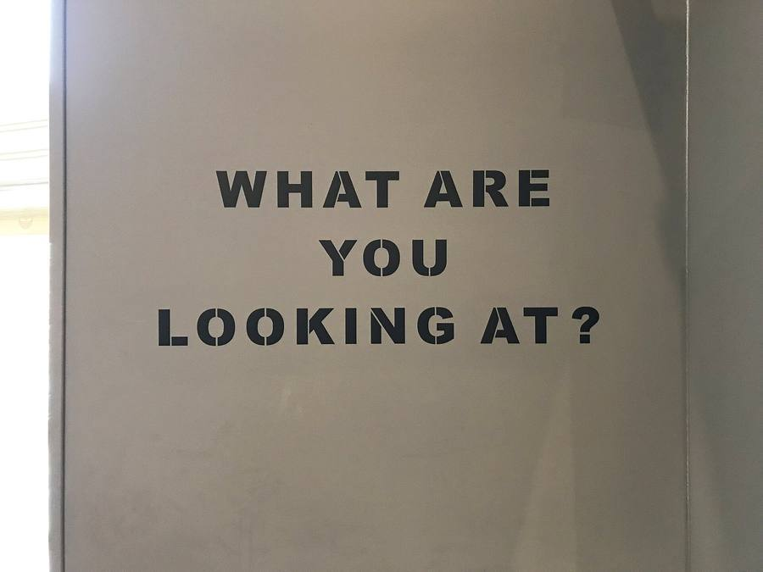
The words WHAT ARE YOU LOOKING AT? displayed on a wall at an exhibition of work associated with Banksy, in Amsterdam, 2018. This is an exhibition presentation of a slogan, not the original street work near Hyde Park (that original is shown in Lesson 1). Photograph by MMLDND, Wikimedia Commons, CC BY-SA 4.0. The photograph is shared under that licence. The artwork itself remains protected.
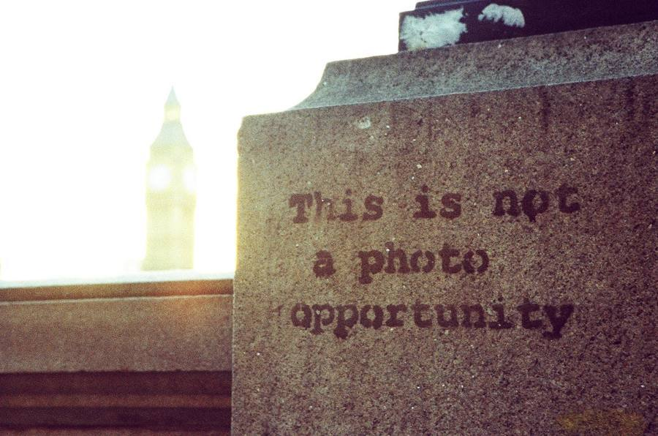
A stencil widely attributed to Banksy, on a stone plinth near the Palace of Westminster: This is not a photo opportunity, with the clock tower of Big Ben out of focus behind it. Photograph by Kris Krug, Wikimedia Commons, CC BY-SA 2.0. The photograph is shared under that licence. The artwork itself remains protected.

Your job
You are a mediator for an exhibition called Banksy: Public Walls, Private Names. You will:
- Present one work as a visual slogan (what it says, to whom, in what tone), then what you can see, where it is, and why the place matters.
- Keep identity as a claim, if you mention it: According to Reuters... You never say: Banksy's real name is...
- Recommend what should happen to a fictional mural on a warehouse.
- Answer a visitor's question.
- Write a short label.
You are not asked to find a private address or to investigate a private person.

Worked example of a label
This photograph shows a gymnast with a ribbon, on a damaged building in Irpin, in 2022. The work is widely attributed to Banksy. The hole in the wall is part of the image. In 2023 the section of wall was moved, in order to save it. The artist's civil identity is not confirmed in the sources used for this exhibition.
Exercise. Repair this bad label: "This mural was painted by Robin Gunningham in 2022."
Corrigé
Example: A mural widely attributed to Banksy, 2022. Reuters reported a civil name in March 2026. Banksy did not confirm it in the sources used here. (You may also leave the civil name out of the label completely.)

Written work
Write a label of four to six short sentences for your work. Then write three sentences: I think the warehouse mural should / should not be removed, because... If it is removed, it may...

Oral work
Speak for 40 to 50 seconds about your work, then answer one visitor question:
- "Who is Banksy, really?"
- "Can we just cut this wall and show it here?"
Frame for the first question: We do not know a confirmed civil name. According to Reuters... Banksy did not confirm this. I think the work can already speak, because...

After the assessment
Look at the grid with your teacher. Write: 1. What you missed. 2. A better version of one sentence. This improved sentence is part of your work.

The principle to keep
A mural can have an author without a confirmed civil identity. A press report can be serious and still remain a claim. Owning a wall is not the same as owning the image, and it is not the same as public access. As a mediator, I should be accurate. I should not overstate.

