Anglais · Première technologique · lycée général et technologique
LVA and LVB · B1-B2
Who Speaks for the Desert?
Correction sheet
Frank Herbert, Dune (1965), the first novel only
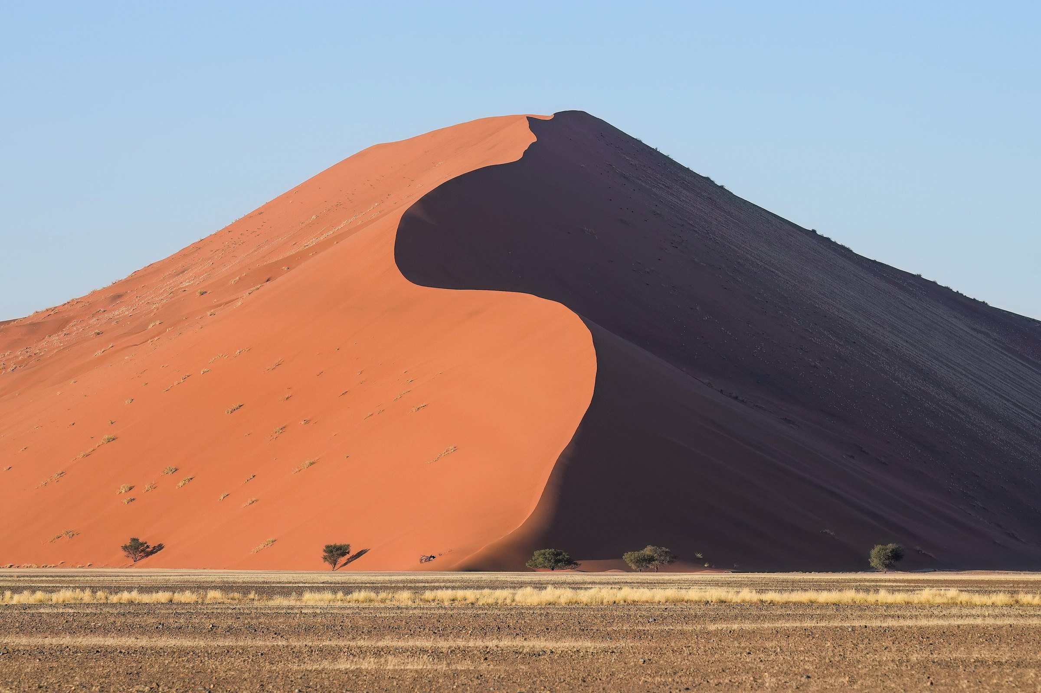
Giles Laurent, Dune 45 in Sossusvlei at sunrise, Namibia. Wikimedia Commons, CC BY-SA 4.0. This photograph belongs to the desert world of the novel. It is not a still from any film.
Madame Carole Paoli Pompougnac
conçu par Madame Carole Paoli Pompougnac, mis en page par Grok
© 2026 Madame Carole Paoli Pompougnac · CC BY-NC-SA 4.0
Problématique
When a desert, a resource and a prophecy make a hero, is the hero the voice of a people or the instrument of those who wrote his legend, and who pays the price?
All keys from the lessons and the assessments are collected here. On the site, the same keys sit in folds.

Lesson 1. A Planet Called Dune
Listening T/F: 1 True. 2 False (journalist). 3 True. 4 True. 5 True. Herbert was a journalist. The idea came from sand dunes near Florence, Oregon, and grasses planted to stop the sand. World of Arrakis: desert planet, recycled water, empire, spice, Paul, Fremen.
Q1 is the author's dedication, to the dry-land ecologists. Q2 is spoken by the Princess Irulan, a historian inside the fiction. "Him" is Paul. Arrakis is the desert planet known as Dune. "Forever his place" suggests a destiny tied to the land. The historian already admires him, so the reader meets a legend, not a neutral report.
Exercise 1. a) People have to / must protect their water. b) Children need to / must learn to walk on sand. c) Nobody can cry in public / You mustn't cry in public. d) Travellers have to wear a special suit. Check mustn't (prohibition) versus don't have to (no obligation).

Teacher's notes (listening texts and checks)
Listening text (written for the sequence; not a quotation from the novel). Read at natural speed, twice:
Frank Herbert was born in 1920 in Tacoma, in the state of Washington. He worked as a journalist. In the late 1950s, he planned an article on sand dunes near Florence, Oregon, where scientists were planting grasses to stop the sand from moving. The article was never finished, but the idea of a world made of sand stayed with him. His novel Dune was published in 1965. It describes a desert planet, Arrakis, where water is so rare that people recycle the water of their own bodies. It also describes an empire, a precious resource called the spice, and a young man, Paul Atreides, whom a people of the desert, the Fremen, come to see as a messiah.
The Florence dunes project and the 1965 publication are widely documented. Do not tell the class that the novel appeared "six years later", or that it followed "several refusals from publishers", until those details have been checked in Brian Herbert's biography.
Diagnostic grid (positioning only). CO: A2 isolated facts; B1 main facts and origin; B2 facts, origin, and a link between the Oregon dunes and the novel. CE: A2 Arrakis is a planet; B1 a princess writes about a man linked to the planet; B2 the writer is a historian inside the fiction who already glorifies the hero.
Check Q1 and Q2 in your edition before the lesson.

Lesson 2. The Spice: One Resource, One System
B1 diagram, a possible completion: producers, the Fremen; extractors, the noble families (sandworms are a danger to the machines); consumers, the Guild navigators; controller, the Emperor (and whoever holds the spice); what it makes possible: life, travel, the empire.
Exercise 2. a) The Fremen are a people who live in the deep desert. b) Arrakis is a planet where water is rare. c) The Guild is an organisation whose navigators need the spice. d) The Harkonnens are a family (that / which) the Emperor gave the planet to / to whom the Emperor gave the planet. Common error: which for people.

Teacher's notes (listening texts and checks)
Listening text (written for the sequence):
In the novel, the spice, also called melange, exists only on Arrakis. It extends life. It allows the navigators of the Spacing Guild to see a safe path through space, so without the spice there is no travel between planets. The Emperor gives the planet to noble families as a fief. They extract the spice with huge machines, which attract the giant sandworms of the desert. The Fremen, who live in the deep desert, are treated by the governors as a problem. Whoever controls the spice controls the empire.
A line often attributed to the novel, "The spice must flow", belongs only to the 1984 film. Do not attribute it to the book.
Two-line summary, for students without the book: In Arrakeen, the Fremen housekeeper Shadout Mapes shows Jessica a crysknife, a sacred blade. Jessica understands that Mapes's words follow a prophecy, and that her own order, the Bene Gesserit, planted such legends long ago. This summary is not a quotation.

Lesson 3. Whose Planet? Empire and the Desert People
B1: 1 Emperor; 2 Duke (or a governor); 3 a Fremen; 4 a Bene Gesserit. B2, a possible direction: although the Fremen have a real faith and a real knowledge of the desert, the legend they wait for was partly planted by the Bene Gesserit, whereas the offworld families claim the planet as a fief.
Exercise 3. a) Although Jessica is a foreigner, the Fremen respect her. b) Even though the legend was invented by her order, it helps Jessica. c) The Duke wants peace, whereas the Emperor wants him dead. Accept however with a new sentence.

Teacher's notes (listening texts and checks)
Key idea: Jessica knows the legend was planted, and she chooses to use it. Quote the exact wording of Q4 from your edition only. Do not invent a sentence and attribute it to Herbert.
Dialogue, written for the lesson (not a quotation from the novel): Mapes: My lady, this blade is sacred to my people. It is a crysknife. Jessica: I know what it is. I have been taught something of the desert. Mapes: Then you know we have been waiting. The legends speak of a mother and a son from the outer world. Jessica (quietly): I know this legend. It was planted here, long ago, so that a woman of my order would be safe. I can use it, and perhaps I must. Mapes: The signs have begun. Will you take the knife?

Lesson 4. Making a Messiah
B1 legend: The prophecy was written long ago. A legend was planted among the people. A mother and a son were sent from the outer world. Their story was told as a sign.
Exercise 4. a) The prophecy was written long ago. b) He will be followed (by the Fremen). c) His story is being told. d) The signs have been seen.

Teacher's notes (listening texts and checks)
Listening text: A prophecy is a story about the future. When people hear the same story for generations, they wait for someone who fits it. On Arrakis, the Fremen wait for a man from outside, the Lisan al-Gaib, the voice from the outer world. When Paul and his mother arrive in the desert, many signs seem to match. Paul knows the legend was planted, and he also sees that he can use it. The question is not whether the signs are true; it is who decided what the signs would be.
"Lisan al-Gaib" and "the voice from the outer world" are terms from the novel; check the spelling in your edition.
Check Q3, and the lines that follow, in your edition.

Lesson 5. Mid-Sequence Assessment
A: 1. That Paul is simply a hero. 2. The danger of charismatic leaders. 3. Courage and unity. 4. The right to speak for them. 5. If a leader talks for everyone, the people lose their own voice.
B: 1. A Bene Gesserit order that plants protective legends on worlds like Arrakis, so that a sister can later use them. 2. Warrior and mystic; ogre and saint; the fox and the innocent; chivalrous and ruthless (also: less than a god, more than a man). 3. Paul's legend is written by others: the Bene Gesserit before him, the Princess Irulan after him.
Expected direction for C. B1: Paul helps the Fremen to win, but the legend was written by others, so the Fremen do not entirely decide; a hero can be dangerous. B2: Paul is both the voice of the Fremen and the instrument of a legend planted by the Bene Gesserit and written by Irulan; the price may be paid by the people who follow him.

Teacher's notes (listening texts and checks)
Listening text (paraphrase, not a quotation; heard three times): Many readers finish Dune and think Paul is simply a hero. Herbert did not agree. In interviews, he said he wanted to show the danger of charismatic leaders. In the novel, the people who believe in Paul gain courage and unity. But they also give him the right to speak for them. When one man speaks for a whole people, the people may stop speaking for themselves.
If you wish to quote Herbert himself, check an interview source first. Do not present this listening text as his wording.

Lesson 6. The Ecologist's Warning
Together, Q5, Q6 and Q9 anticipate the cost of following Paul: a victory that may destroy the slow plan, and a people that may lose its voice.
Exercise 5. a) If the Fremen follow Paul, the empire will / might fall (or: If the Fremen followed Paul, the empire would fall). b) If the planet became green, the sandworms would die. c) If a hero took power, the long plan would stop. Common error: would in the if-clause.

Teacher's notes (listening texts and checks)
Listening text: Liet-Kynes is the Imperial planetologist, a scientist sent to study Arrakis. His father dreamed of changing the planet: catching the water, planting grasses on the dunes, and one day making Arrakis green. The Fremen adopted this dream, and Kynes became one of their leaders. But a plan that takes centuries needs patience, and a hero who promises everything now can destroy it.
Check Q5, Q6 and Q9 in your edition. For Q9, some epigraphs give "understanding consequences" without "the".

Lesson 7. The Hero Trap
Q7 pairs: warrior / mystic; ogre / saint; the fox / the innocent; chivalrous / ruthless; less than a god / more than a man. Which side "wins" is a reasoned choice. Q8: the hero now speaks as a controller of the resource; the liberator uses destruction as a form of ownership.
Exercise 6. a) The Fremen are not as independent as before / less independent than before. b) A legend can be more dangerous than an army. c) Kynes's plan is slower than Paul's war. Accept any reasoned order: the content is debatable, the structure must be correct.

Teacher's notes (listening texts and checks)
Some sources give an earlier formulation of Q8, in Paul's thoughts: "He who can destroy a thing has the real control of it." Check which wording your edition uses. Do not write the film line "The spice must flow" as if it belonged to this chapter: it does not belong to the novel.

Lesson 8. The Council of the Deep Desert
Expected answers. B1: Paul helps the Fremen to win, but the legend was written by others, so the Fremen do not decide. A hero can be dangerous. B2: Paul is both the voice of the Fremen and the instrument of a legend planted by the Bene Gesserit and written by Irulan. His victory gives the Fremen power but takes away their voice and threatens Kynes's long ecological plan; the price is paid by the Fremen and by the desert.
Common errors. "Paul is a good hero, end of story": ask who wrote the prophecy before he arrived (Q4). Confusing the film and the novel ("the spice must flow"): that line is from the 1984 film, not from the book. Which for people; would in the if-clause; more good: point to the grammar box of the relevant lesson. Using the passive without asking who is hidden: ask "by whom?". Turning the council into a summary of the plot: ask "what do you propose?".

Teacher's notes (listening texts and checks)
B2 model statement (to be shown after students have written, or at the teacher's invitation):
Elders of the sietch, I was trained by the planetologist, and I speak for the desert. Muad'Dib has given us victory, and I do not deny it. Our enemies have been defeated, and the spice is in our hands. Yet I ask you: in whose hands, exactly? The legend we sang was planted long ago by strangers, and the man who fulfilled it has learnt to speak our words better than we do. When he told the Guild that "the power to destroy a thing is the absolute control over it", he spoke of our planet as a weapon. Kynes's father warned us that no disaster could be more terrible than to "fall into the hands of a Hero". Although Muad'Dib loves us, a people that hands its voice to one man may never take it back. If we follow him across the stars, our sons will die far from the sand, and the slow plan to bring water to Dune will be forgotten. I propose that we honour him, but that the council, not the prophet, decides the future of the desert. The highest function of ecology is understanding consequences; let it be ours too.
This is a model, not the only right answer.
Optional short bridge at the end: in Orwell, the Party controls the past; in Dune, whoever controls the spice also controls the story of the planet (Q8). Who tells the story of a vital resource? Fictions et réalités remains a Terminale axis; this Première sequence prepares that later work.

Expected answers at two levels (the problématique, the final task)
B1: Paul helps the Fremen to win, but the legend was written by others, so the Fremen do not decide. A hero can be dangerous.
B2: Paul is both the voice of the Fremen and the instrument of a legend planted by the Bene Gesserit and written by Irulan. His victory gives the Fremen power but takes away their voice and threatens Kynes's long ecological plan; the price is paid by the Fremen and by the desert.

