Anglais · Première technologique · lycée général et technologique
LVA and LVB · B1-B2
Who Speaks for the Desert?
Dys version
Frank Herbert, Dune (1965), the first novel only
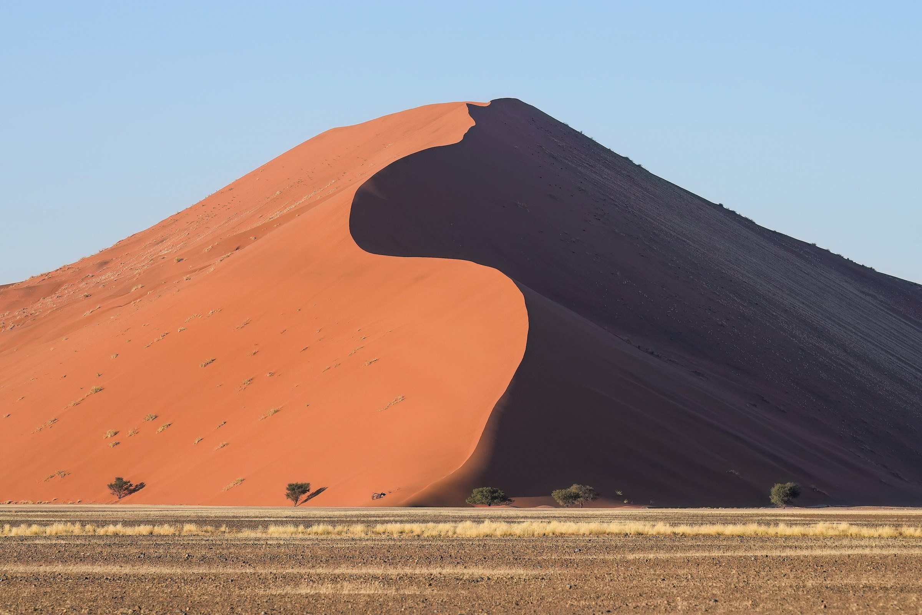
Giles Laurent, Dune 45 in Sossusvlei at sunrise, Namibia. Wikimedia Commons, CC BY-SA 4.0. This photograph belongs to the desert world of the novel. It is not a still from any film.
Madame Carole Paoli Pompougnac
conçu par Madame Carole Paoli Pompougnac, mis en page par Grok
© 2026 Madame Carole Paoli Pompougnac · CC BY-NC-SA 4.0
Problématique
When a desert, a resource and a prophecy make a hero, is the hero the voice of a people or the instrument of those who wrote his legend, and who pays the price?
This version can be used on its own, and after an absence. There is one instruction on each line. Examples come before exercises. Important words are in bold, not in italics.
After an absence: read the written trace of each missed lesson, make the two model flashcards, do the exercise, and check with the key on the correction sheet.

Lesson 1. A Planet Called Dune
Frank Herbert wrote Dune in 1965.
Dune is a desert planet.
Water is very rare.
Step 1. Read the text.
Step 2. Underline the word water.
Step 3. Complete the sentence.
Example: On Arrakis, people must save water.
Exercise: On Arrakis, people must ________ (wear a suit / protect children / recycle water).
Key: any of the three is correct.

Lesson 2. The Spice
The spice is a substance which exists only on Arrakis.
Everybody needs it.
Example: The Fremen are a people who live in the desert.
Exercise: The spice is a resource ________ the empire needs. (who / which)
Key: which.

Lesson 3. Whose Planet?
Strangers put a legend on Arrakis, long ago.
The Fremen believe it.
Example: Although Jessica is a stranger, the Fremen help her.
Exercise: Although the legend is false, ________.
Key: the Fremen believe it / it gives power to Paul.

Lesson 4. Making a Messiah
The prophecy was written by strangers.
Paul fulfils it.
Example: The legend was planted.
Exercise: People told the story. The story ________ told.
Key: was.

Lesson 5. Mid-sequence assessment
Use the student sheet of Lesson 5.
If you need a shorter writing task, answer in 80 words, with one example and one quotation.

Lesson 6. The Ecologist's Warning
Kynes is a scientist.
He wants to make the desert green.
He says a hero is dangerous.
Example: If the spice disappears, the Guild will stop.
Exercise: If the Fremen follow a hero, they ________ (lose / will lose) their voice.
Key: will lose (or might lose).

Lesson 7. The Hero Trap
Paul is "less than a god, more than a man".
Example: Paul is more powerful than the Emperor.
Exercise: A legend is ________ dangerous ________ an army.
Key: more ... than (or as ... as).

Final task, Lesson 8. Seven boxes
Use the seven boxes. Write one sentence in each box. Tick the box when it is done.
- Who are you? ☐
- What is positive? (use a passive) ☐
- Problem one. (use a passive) ☐
- Problem two. (use although) ☐
- One quotation. ☐
- A consequence. (use if) ☐
- Your decision. ☐
Self-assessment. Tick: I said who I am. / I gave one good point. / I gave one problem. / I used one quotation. / I gave my decision.

