Anglais · Première technologique · lycée général et technologique
LVA and LVB · B1-B2
Who Speaks for the Desert?
A Prophet Made of Sand: Power, Belief and a Scarce Resource
Frank Herbert, Dune (1965), the first novel only
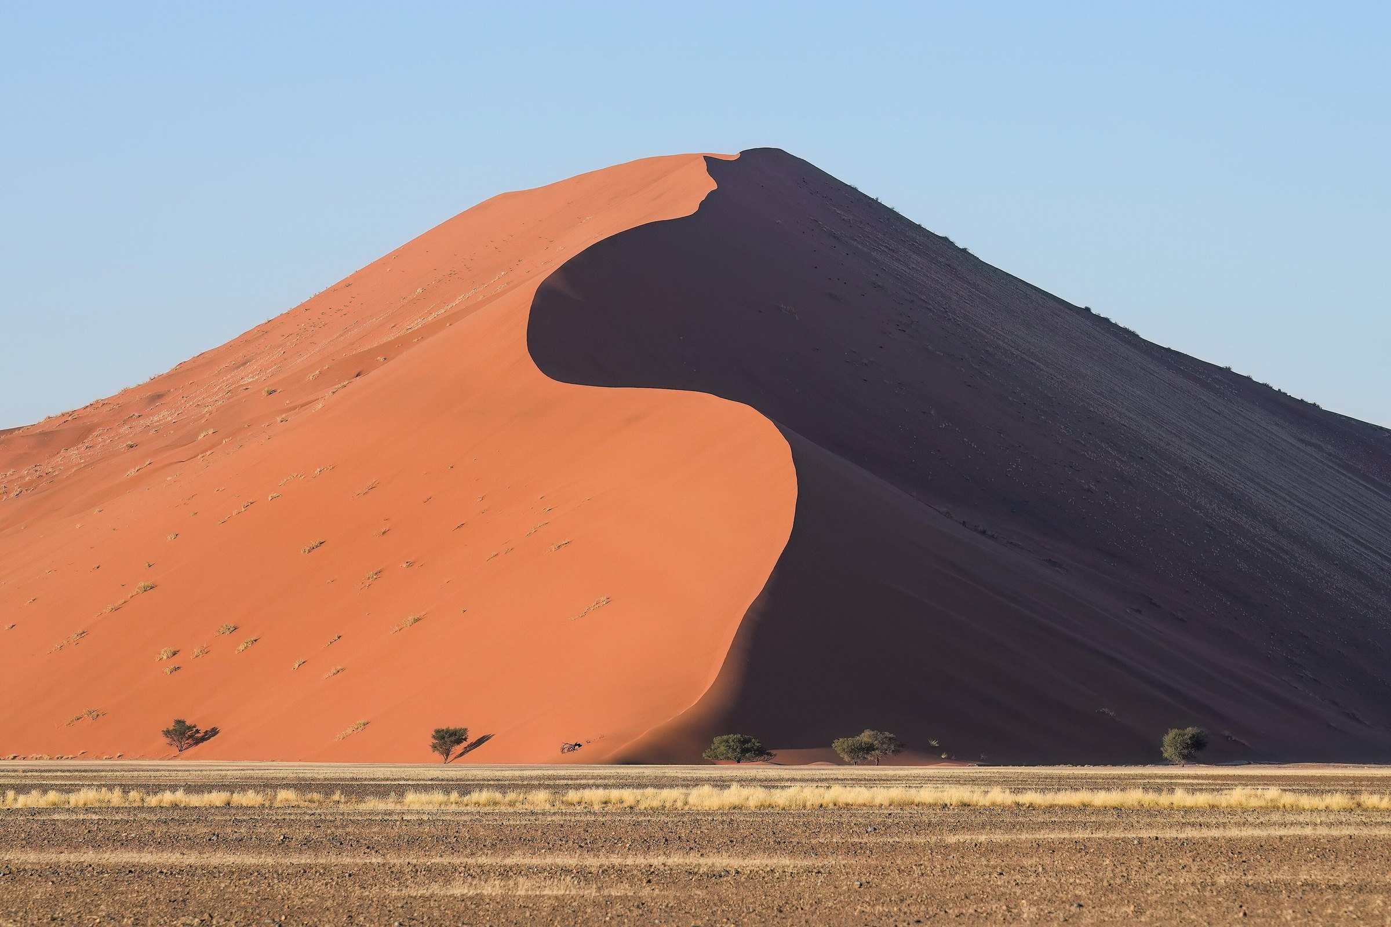
Giles Laurent, Dune 45 in Sossusvlei at sunrise, Namibia. Wikimedia Commons, CC BY-SA 4.0. This photograph belongs to the desert world of the novel. It is not a still from any film.
Madame Carole Paoli Pompougnac
conçu par Madame Carole Paoli Pompougnac, mis en page par Grok
© 2026 Madame Carole Paoli Pompougnac · CC BY-NC-SA 4.0
Problématique
When a desert, a resource and a prophecy make a hero, is the hero the voice of a people or the instrument of those who wrote his legend, and who pays the price?

Fiche d'identité
Title | Who Speaks for the Desert?
Subtitle | A Prophet Made of Sand: Power, Belief and a Scarce Resource in Frank Herbert's Dune (1965)
Author studied | Frank Herbert (1920-1986), American novelist and journalist
Work | Dune (1965), the first novel only
Level | Première technologique, lycée général et technologique, English LVA and LVB, CECRL B1 to B2
Official frame | Programme de langues vivantes, BO n° 22 du 29 mai 2025, classes de Première
Main axis | Axe 3, Art et pouvoir
Secondary axes | Axe 5, L'être humain et la nature; axe 4, Innovations scientifiques et responsabilité. A light, optional link to axe 6 (Gros plan sur une région ou spécificité de l'aire culturelle) through the Oregon Dunes, as biography and context only.
Problématique | When a desert, a resource and a prophecy make a hero, is the hero the voice of a people or the instrument of those who wrote his legend, and who pays the price?
Method | La spirale de Gorse, in five steps: Je remarque, Je repère, Je comprends, J'anticipe, Je trouve le sens.
Length | Eight lessons of 55 minutes, timed on 52, each with a stopping point and an 8-minute emergency exit.
Final task | The Council of the Deep Desert: a briefing (3 to 4 minutes) and a written statement (180 to 250 words; B1, 150 to 180).

Fiche de lecture
Madame Carole Paoli Pompougnac's book-study worksheet (fiche de lecture) will be associated with this sequence, in its latest version, in pdf, docx and odt, once the model has been received.

Official frame
Since the start of the 2026-2027 school year, Première follows the programme published in the Bulletin officiel n° 22 du 29 mai 2025 (arrêté du 5 mai 2025, NOR MENE2504621A). In the voie technologique, at least three axes are to be treated during the year. This sequence treats three in full, and names them from the official list for Première:
- Axe 3. Art et pouvoir (main axis).
- Axe 5. L'être humain et la nature.
- Axe 4. Innovations scientifiques et responsabilité.
A light, optional link to axe 6 (Gros plan sur une région ou spécificité de l'aire culturelle) is made through the Oregon Dunes, as biography and context, not as a second subject. The full official wording of each axis, from the programme annexe, is not quoted here; it should be read in the published text if it is to be cited.
The 2019 cycle-terminal programme, with its eight axes (including Fictions et réalités in Première), no longer governs this class. Fictions et réalités remains an axis of the Terminale programme. The Orwell sequence Big Brother Is Watching · When Fiction Warns Reality, written for Terminale, keeps that label. This Première sequence prepares students for that later work.
The five activités langagières (compréhension de l'oral, compréhension de l'écrit, expression orale en continu, expression orale en interaction, expression écrite), plus médiation, are named in every lesson.

La spirale de Gorse
La spirale de Gorse is the method of Madame Carole Paoli Pompougnac; its name honours her husband's grandmother. It is a real round spiral, airy, drawn in navy. It starts on the outside and turns inwards, ending in a tip, never a centre. On the outer side of each turn, students write the idea. On the inner side, they write the chapter references. Students follow the line, turn by turn; nobody jumps to the tip.
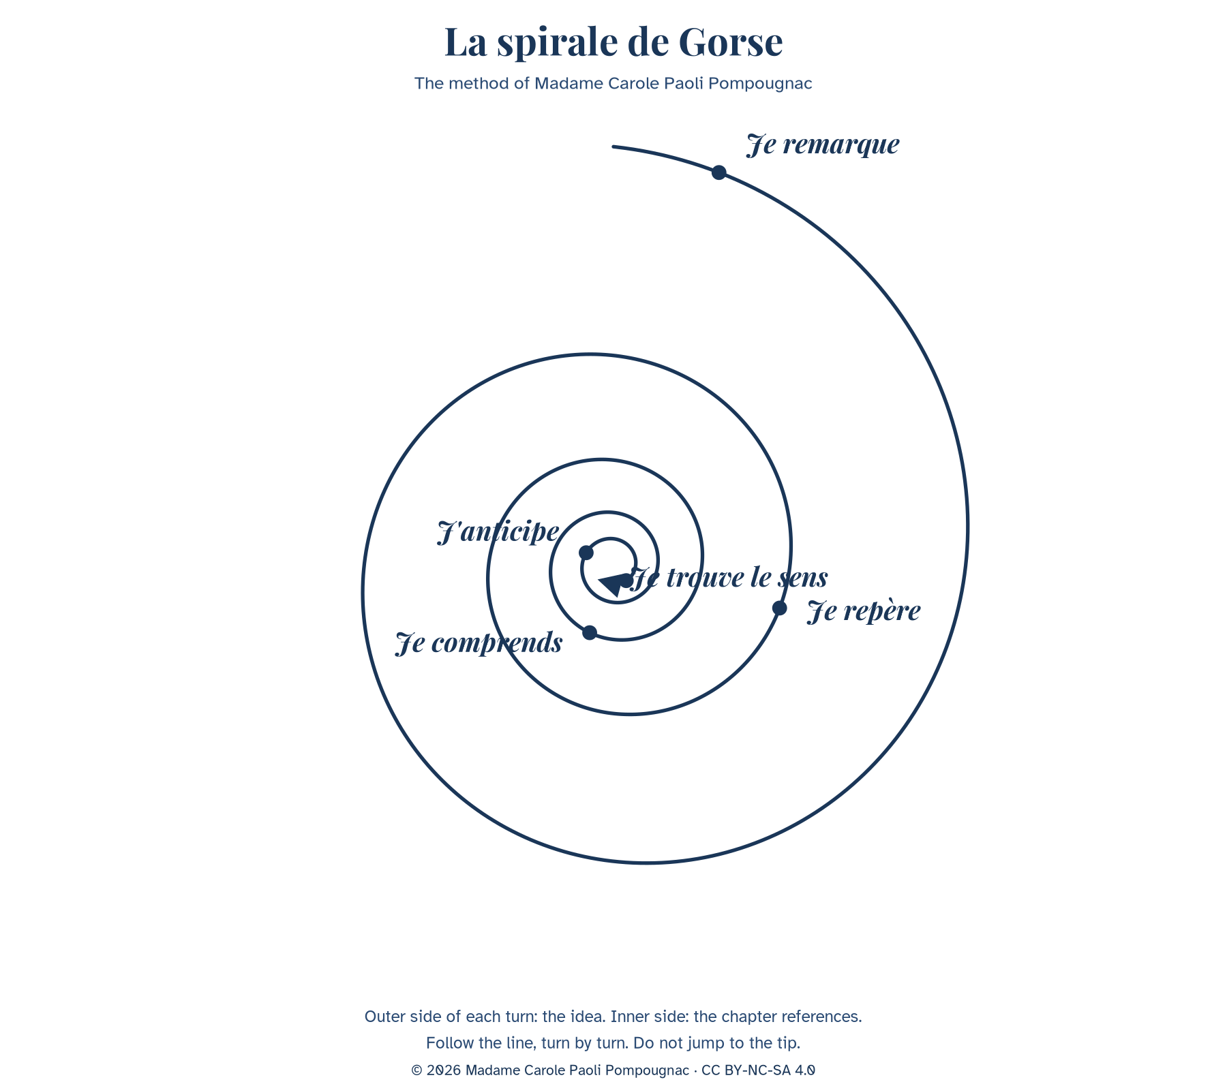
The five steps, always in this order: Je remarque, Je repère, Je comprends, J'anticipe, Je trouve le sens.
Step | What students do | Lesson
Je remarque | First impression, what is visible. | Lesson 1
Je repère | Locate words, voices, places. | Lessons 2 and 3
Je comprends | Explain how it works. | Lessons 3 and 4
J'anticipe | Predict consequences. | Lessons 5 and 6
Je trouve le sens | Reach the problem. | Lessons 7 and 8

The question at the tip is not given in advance. Expected kind of tip: "A people can be saved by the story that enslaves it."

Filled example: the death of Liet-Kynes (Book II)
Turn | Outer side: the idea | Inner side: the reference
Je remarque | A man is dying of thirst; the scene feels like a lesson, not an action scene. | Book II, the chapter in which the Harkonnens leave Kynes in the desert without a stillsuit.
Je repère | Two voices: the dying son and the remembered father. The father's sentence is in direct speech. | "No more terrible disaster could befall your people than for them to fall into the hands of a Hero."
Je comprends | The scientist understands too late that a saviour can destroy the project he served. | The same chapter. Compare Book I, the Missionaria Protectiva.
J'anticipe | Kynes asked the Fremen to protect Paul. The warning predicts the danger of Paul's success. | Book III, final chapter (check the wording of Q8 in your edition).
Je trouve le sens | The hero is the disaster. Freedom given by a saviour is a new dependence. | Appendix I: "the highest function of ecology is the understanding of consequences."

The eight lessons
Lesson | Title | Step | Question of the day
1 | A Planet Called Dune | Je remarque | What do we notice about a world where water is the measure of everything?
2 | The Spice: One Resource, One System | Je repère | Who needs the spice, who extracts it, who controls it?
3 | Whose Planet? Empire and the Desert People | Je repère, then Je comprends | Who owns Arrakis: the Emperor who gives it, the family who rules it, or the people who live on it?
4 | Making a Messiah | Je comprends | How is a legend written, and who writes it?
5 | Mid-Sequence Assessment | J'anticipe | If the Fremen follow the hero, what will they gain and what could they lose?
6 | The Ecologist's Warning | J'anticipe | What does the scientist foresee, and what does he fail to foresee?
7 | The Hero Trap | Je trouve le sens | Is the hero the voice of the people or the voice that replaces them?
8 | The Council of the Deep Desert | the tip | The class answers the problématique.

Lesson 1. A Planet Called Dune
Step of the problématique: Je remarque. What do we notice about a world where water is the measure of everything?
55 minutes, timed on 52.
Stage | Time | Activity | Skill
1 | 5 min | Image without a caption. What do you see? Is it a place to live? One word each. | EOI
2 | 10 min | Diagnostic listening (teacher reads the context text twice). | CO
3 | 10 min | Reading Q1 and Q2: who is speaking? Who is "him"? | CE
4 | 12 min | Pairs: Guess the world. Three rules of life on Arrakis. Each pair presents one rule. | EOI, EOC
5 | 10 min | Spiral, turn 1: Je remarque. | EE, médiation
6 | 5 min | Written trace and homework. | EE

Stopping point: After stage 4.
Emergency exit (8 minutes): Image, one word each, Q2 read aloud, one sentence: "On Arrakis, people must...".
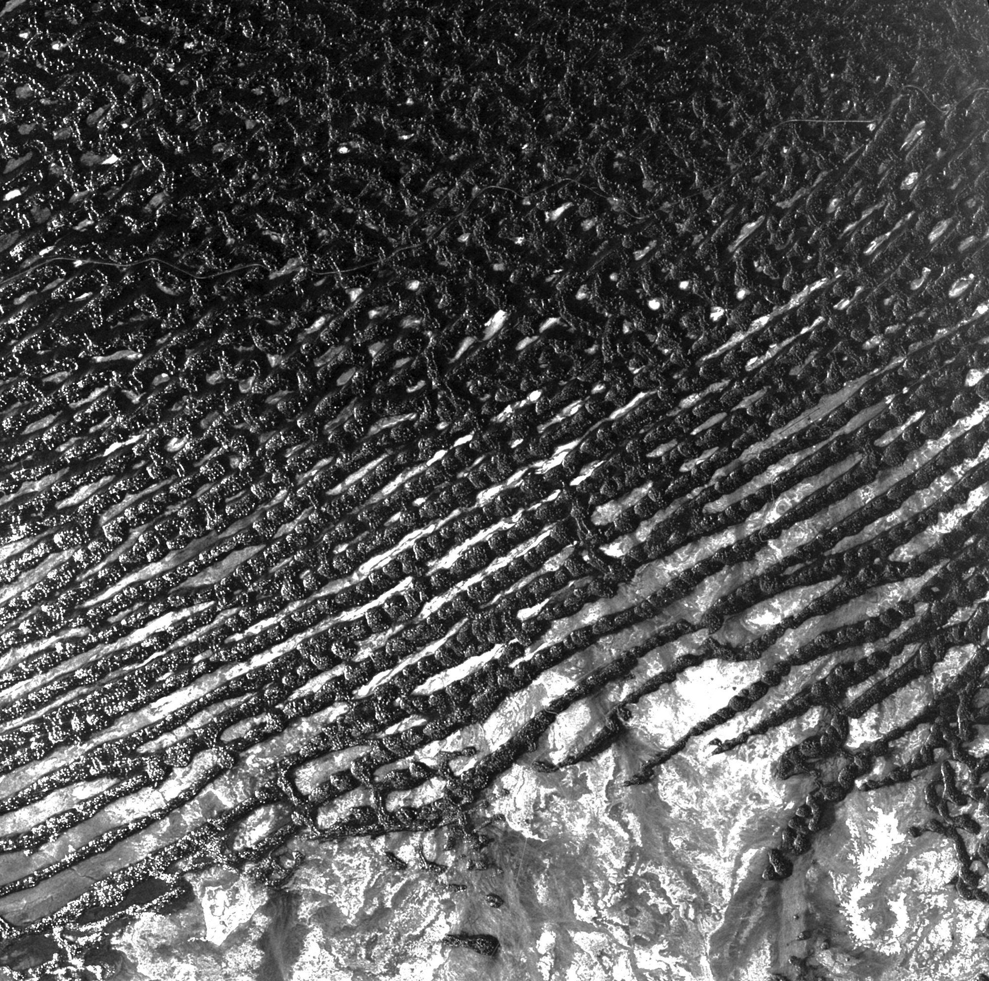
ESA radar image of the Rub' al Khali. CC BY-SA 3.0 IGO. Open the lesson without this caption; reveal it after the first words.
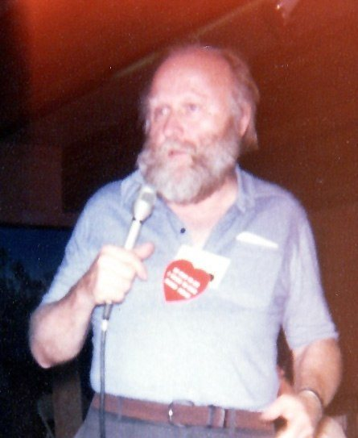
Frank Herbert, Robert E. Nylund, Octocon, October 1978. Public domain.
Look first at a radar image of a sand sea, without a caption, and say one word. Is this a place to live? (On the site, the ESA radar image of the Rub' al Khali opens the lesson; the caption is revealed afterwards.)
Listening, twice: a short context text, written for the sequence, read by the teacher. Students do not read it during the listening.
B1: tick true or false (five statements), then complete: Herbert was a ____. The idea came from ____.
B1 statements: 1. Frank Herbert was born in 1920 in Tacoma, in the state of Washington. 2. He worked as a scientist. 3. In the late 1950s he planned an article on sand dunes near Florence, Oregon. 4. Scientists there were planting grasses to stop the sand from moving. 5. His novel Dune was published in 1965.
B2: notes under three headings (the man, the origin, the world), then a 30-second oral summary.
"To the people whose labors go beyond ideas into the realm of 'real materials' ... to the dry-land ecologists."
Q1. Dedication. The American spelling "labors" is the wording of the book: leave it unchanged when you quote.
"A beginning is the time for taking the most delicate care that the balances are correct." "Arrakis, the planet known as Dune, is forever his place."
Q2. Book I, opening epigraph.
Text intelligence. The opening sentence is not the narrator. It is an extract from a book written later, inside the fiction, by a princess. The novel begins with a historian who already knows that Paul is great. What does it change to read the hero's story through someone who already admires him?
Grammar. Modals of obligation and necessity: must, have to, need to, can't. Example (already corrected): water / not waste → On Arrakis, you must not waste water.
Exercise 1. a) people / protect their water. b) children / learn to walk on sand. c) nobody / cry in public. d) travellers / wear a special suit.
Expanding your vocabulary: arid, barren, scarce, scarcity, a dune, a planet, an empire, a resource, to survive, survival, to recycle, a desert people. Language for analysis: the epigraph, the narrator, the point of view, to introduce, to foreshadow.
Flashcards. Front: scarce. Back: available in small quantities; noun: scarcity. "Water is scarce on Arrakis." Front: epigraph. Back: a short quotation at the beginning of a chapter.
Diagnostic (not graded). CO: When and where was Herbert born? What was his job? What gave him the idea? Name two elements of the world of Arrakis. CE: Who writes Q2? What is Arrakis? What does "forever his place" suggest? EOC, one minute: Would you like to live on Arrakis? Why? EE, 40 words: My first impression of Dune. Self-correction: What I understood / What I missed / My improved answer.
Written trace: "Arrakis is a desert planet where water is scarce. The novel opens with the voice of a historian, the Princess Irulan, who already presents Paul as a great man. On Arrakis, people must..."
Homework. Make four flashcards. Record a 30-second voice note: "Three things I noticed about Arrakis".

Teacher's notes, Lesson 1
Listening text (written for the sequence; not a quotation from the novel). Read at natural speed, twice:
Frank Herbert was born in 1920 in Tacoma, in the state of Washington. He worked as a journalist. In the late 1950s, he planned an article on sand dunes near Florence, Oregon, where scientists were planting grasses to stop the sand from moving. The article was never finished, but the idea of a world made of sand stayed with him. His novel Dune was published in 1965. It describes a desert planet, Arrakis, where water is so rare that people recycle the water of their own bodies. It also describes an empire, a precious resource called the spice, and a young man, Paul Atreides, whom a people of the desert, the Fremen, come to see as a messiah.
The Florence dunes project and the 1965 publication are widely documented. Do not tell the class that the novel appeared "six years later", or that it followed "several refusals from publishers", until those details have been checked in Brian Herbert's biography.
Diagnostic grid (positioning only). CO: A2 isolated facts; B1 main facts and origin; B2 facts, origin, and a link between the Oregon dunes and the novel. CE: A2 Arrakis is a planet; B1 a princess writes about a man linked to the planet; B2 the writer is a historian inside the fiction who already glorifies the hero.
Check Q1 and Q2 in your edition before the lesson.

Key, Lesson 1
Listening T/F: 1 True. 2 False (journalist). 3 True. 4 True. 5 True. Herbert was a journalist. The idea came from sand dunes near Florence, Oregon, and grasses planted to stop the sand. World of Arrakis: desert planet, recycled water, empire, spice, Paul, Fremen.
Q1 is the author's dedication, to the dry-land ecologists. Q2 is spoken by the Princess Irulan, a historian inside the fiction. "Him" is Paul. Arrakis is the desert planet known as Dune. "Forever his place" suggests a destiny tied to the land. The historian already admires him, so the reader meets a legend, not a neutral report.
Exercise 1. a) People have to / must protect their water. b) Children need to / must learn to walk on sand. c) Nobody can cry in public / You mustn't cry in public. d) Travellers have to wear a special suit. Check mustn't (prohibition) versus don't have to (no obligation).

Lesson 2. The Spice: One Resource, One System
Step of the problématique: Je repère. Who needs the spice, who extracts it, who controls it?
55 minutes, timed on 52.
Stage | Time | Activity | Skill
1 | 5 min | Three voice notes heard; the class lists what we noticed. | EOC
2 | 10 min | Historical map of the medieval spice-trade routes. Who travelled? Who became rich? | CE, EOI
3 | 10 min | Listening: The spice, explained. | CO
4 | 15 min | Role play in fours: Emperor's adviser, Guild navigator, Harkonnen governor, Fremen. | EOI
5 | 8 min | A definition paragraph with relative clauses. | EE
6 | 4 min | Spiral turn 2, trace, homework. | EE

Stopping point: After stage 4.
Emergency exit (8 minutes): Listening, then one role per student, in one sentence.
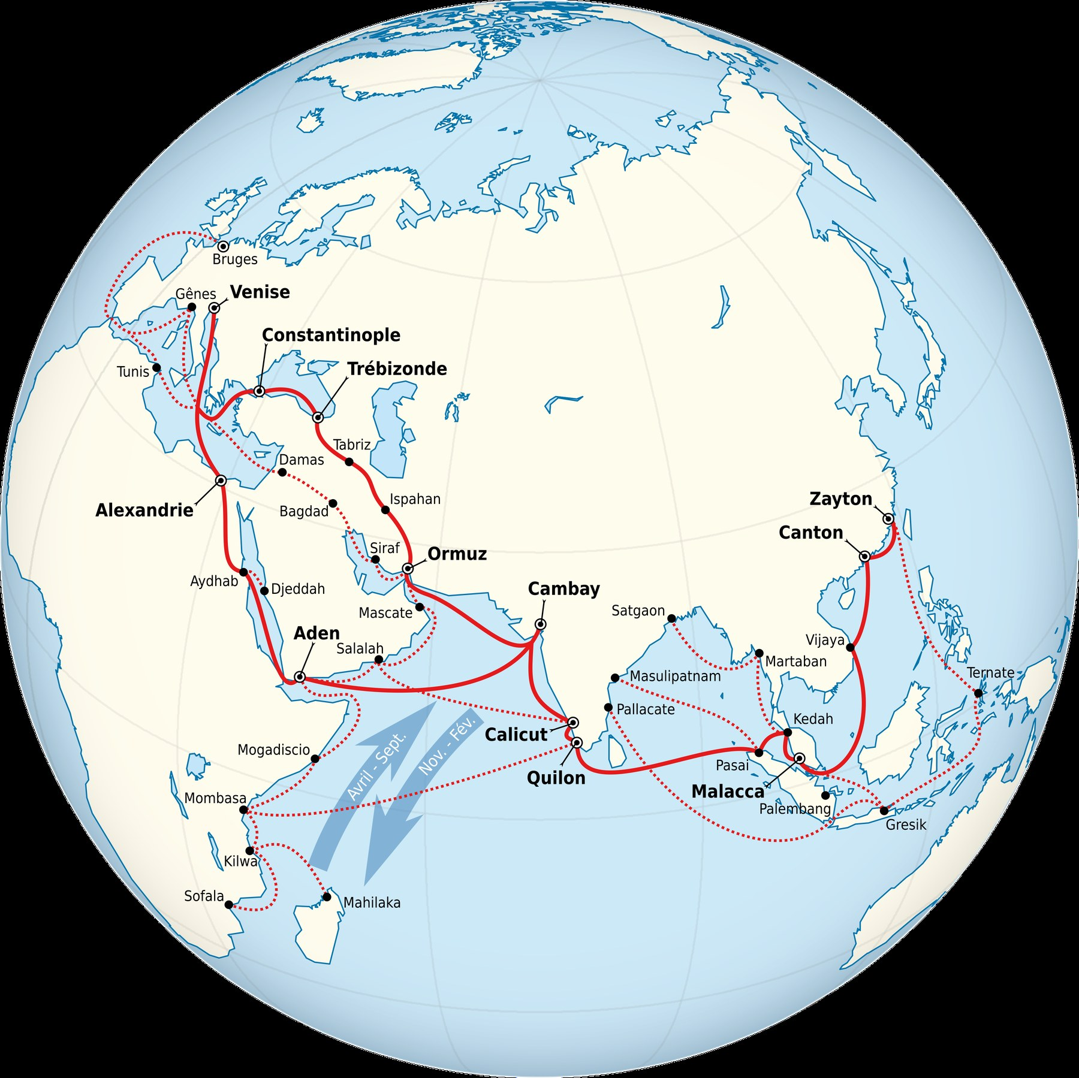
Medieval spice-trade routes. Tricholome, CC BY-SA 4.0. A historical document, not a map of Arrakis.
The map is a historical document about real trade between Asia, Africa and Europe. It is not a picture of Arrakis. Do not say "Arrakis is the Indies". Ask: what does a single, rare and distant resource do to the relations between the people who produce it and the people who consume it?
B1: complete a diagram (producers, extractors, consumers, controller, what the spice makes possible) with words from a box: Fremen, Guild navigators, noble families, the Emperor, sandworms, life, travel, the empire.
B2: in four sentences, explain why control of the spice is control of the empire, using which and so.
Role play starters: Without the spice, I... / For my people, the spice is... / Whoever controls it...
Grammar. Defining relative clauses (who, which, that, whose, where). Example: The spice is a substance. It exists only on Arrakis. → The spice is a substance which exists only on Arrakis.
Exercise 2. a) The Fremen are a people. They live in the deep desert. b) Arrakis is a planet. Water is rare there. c) The Guild is an organisation. Its navigators need the spice. d) The Harkonnens are a family. The Emperor gave them the planet.
Expanding your vocabulary: a resource, to extract, extraction, a supply, to depend on, dependence, a monopoly, a fief, a governor, profit, a trade route. Language for argument: because of, as a result, therefore, whoever controls...
Written trace: a definition paragraph (40 to 70 words) beginning "The spice is a resource which..."
Homework. Read Book I, the chapter of the crysknife (the teacher gives a two-line summary if you do not have the book). Learn six flashcards.

Teacher's notes, Lesson 2
Listening text (written for the sequence):
In the novel, the spice, also called melange, exists only on Arrakis. It extends life. It allows the navigators of the Spacing Guild to see a safe path through space, so without the spice there is no travel between planets. The Emperor gives the planet to noble families as a fief. They extract the spice with huge machines, which attract the giant sandworms of the desert. The Fremen, who live in the deep desert, are treated by the governors as a problem. Whoever controls the spice controls the empire.
A line often attributed to the novel, "The spice must flow", belongs only to the 1984 film. Do not attribute it to the book.
Two-line summary, for students without the book: In Arrakeen, the Fremen housekeeper Shadout Mapes shows Jessica a crysknife, a sacred blade. Jessica understands that Mapes's words follow a prophecy, and that her own order, the Bene Gesserit, planted such legends long ago. This summary is not a quotation.

Key, Lesson 2
B1 diagram, a possible completion: producers, the Fremen; extractors, the noble families (sandworms are a danger to the machines); consumers, the Guild navigators; controller, the Emperor (and whoever holds the spice); what it makes possible: life, travel, the empire.
Exercise 2. a) The Fremen are a people who live in the deep desert. b) Arrakis is a planet where water is rare. c) The Guild is an organisation whose navigators need the spice. d) The Harkonnens are a family (that / which) the Emperor gave the planet to / to whom the Emperor gave the planet. Common error: which for people.

Lesson 3. Whose Planet? Empire and the Desert People
Step of the problématique: Je repère, then Je comprends. Who owns Arrakis: the Emperor who gives it, the family who rules it, or the people who live on it?
55 minutes, timed on 52.
Stage | Time | Activity | Skill
1 | 6 min | Flashcard duel in pairs. | EOI
2 | 10 min | A short dialogue, written for the lesson, Jessica and a Fremen housekeeper. | CO, EOC
3 | 12 min | Reading Q4: the Missionaria Protectiva. | CE
4 | 14 min | Exposés in threes, one minute each: Who owns Arrakis? | EOC
5 | 6 min | A 60-word opinion. | EE
6 | 4 min | Spiral, trace, homework. | EE

Stopping point: After stage 3.
Emergency exit (8 minutes): The dialogue, a short explanation of Q4, one sentence from each student.
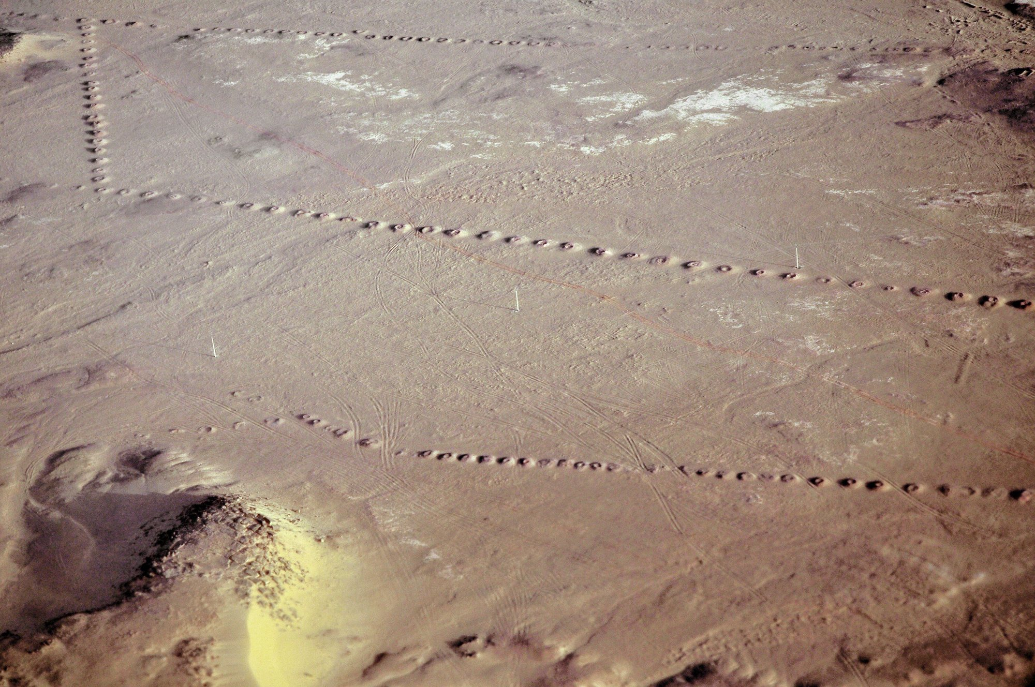
A foggara at Timimoun, Adrar, Algeria. LBM1948, 9 April 2009, CC BY-SA 4.0.
The Missionaria Protectiva is, in the novel, the Bene Gesserit order that plants protective legends on worlds such as Arrakis, so that a sister of the order can later be received and protected. In the Arrakeen scene, Jessica realises that the housekeeper's words echo a prophecy, and she decides to use it. The exact wording is to be read from the teacher's edition. The idea that matters: the religion of the people who live on Arrakis has been partly written by outsiders. This is the core of the problématique.
A historical image of a foggara (a qanat) in Algeria is used here: arid peoples have their own knowledge of water. The Fremen are not "primitive", and the offworlders' view of them is a colonial view. Who calls whom "primitive" in the novel, and why?
B1: match four sentences to four speakers (Emperor, Duke, Fremen, Bene Gesserit). 1. "I give this planet as a fief, and I can give it to someone else." 2. "I am sent to rule this land and to keep the spice moving into the empire's hands." 3. "This is our desert. We have lived here for generations." 4. "We planted a legend here, long ago, so that one of us would be safe."
B2: explain, with although and whereas, why the Fremen both believe and are manipulated.
Grammar. Concession: although, even though, whereas, however. Example: The Fremen are strong. They are used by outsiders. → Although the Fremen are strong, they are used by outsiders.
Exercise 3. a) Jessica is a foreigner. The Fremen respect her. b) The legend helps Jessica. It was invented by her order. c) The Duke wants peace. The Emperor wants him dead.
Expanding your vocabulary: to colonise, a coloniser, the colonised, to own, ownership, to rule, a native people, to exploit, a legend, to plant (an idea), to manipulate. Words for nuance: partly, to some extent, on the one hand, on the other hand.
Written trace: "The Missionaria Protectiva shows that the religion of Arrakis was partly written by outsiders. This means that..."
Homework. Oral recording, 45 seconds: "Who owns Arrakis? My view."

Teacher's notes, Lesson 3
Key idea: Jessica knows the legend was planted, and she chooses to use it. Quote the exact wording of Q4 from your edition only. Do not invent a sentence and attribute it to Herbert.
Dialogue, written for the lesson (not a quotation from the novel): Mapes: My lady, this blade is sacred to my people. It is a crysknife. Jessica: I know what it is. I have been taught something of the desert. Mapes: Then you know we have been waiting. The legends speak of a mother and a son from the outer world. Jessica (quietly): I know this legend. It was planted here, long ago, so that a woman of my order would be safe. I can use it, and perhaps I must. Mapes: The signs have begun. Will you take the knife?

Key, Lesson 3
B1: 1 Emperor; 2 Duke (or a governor); 3 a Fremen; 4 a Bene Gesserit. B2, a possible direction: although the Fremen have a real faith and a real knowledge of the desert, the legend they wait for was partly planted by the Bene Gesserit, whereas the offworld families claim the planet as a fief.
Exercise 3. a) Although Jessica is a foreigner, the Fremen respect her. b) Even though the legend was invented by her order, it helps Jessica. c) The Duke wants peace, whereas the Emperor wants him dead. Accept however with a new sentence.

Lesson 4. Making a Messiah
Step of the problématique: Je comprends. How is a legend written, and who writes it?
55 minutes, timed on 52.
Stage | Time | Activity | Skill
1 | 5 min | Two homework recordings heard; the class reacts. | EOI
2 | 8 min | Reading aloud Q3 (the litany), with stress and pauses; chorus then individual. | EOC
3 | 10 min | Listening: How a prophecy works. | CO
4 | 14 min | Press conference: a Fremen witness and journalists; every student asks or answers once. | EOI
5 | 10 min | Rewriting: turn a plain event into a legend (passive, often without an agent). | EE
6 | 5 min | Spiral turn 3, homework. | EE

Stopping point: After stage 4.
Emergency exit (8 minutes): The litany read aloud, three questions and answers, one legend sentence in the passive.

Dunes and shadows at Sossusvlei. Diego Delso, delso.photo, CC BY-SA 4.0.
Q3 is a ritual sentence, short, repetitive, with a rhythm. Religious language works by repetition. Why is a sentence you repeat stronger than a sentence you understand?
B1: complete a short legend with verbs in the passive (plant, write, send, tell). B2: write a legend of 60 words, then underline every place where the agent is hidden.
Grammar. The passive used to build a myth: "It was written...", "He was sent...". This is different from the Orwell use of the passive to hide responsibility ("Mistakes were made"). Here the passive creates an invisible author. Ask, each time: by whom? Who gains from that disappearance?
Exercise 4. Example: The Bene Gesserit planted the legend. → The legend was planted (by the Bene Gesserit). a) Someone wrote the prophecy long ago. b) The Fremen will follow him. c) People are telling his story. d) They have seen the signs.
Expanding your vocabulary: a prophecy, a prophet, a messiah, a saviour, a sign, to fulfil, a believer, faith, a ritual, a litany, a myth, to worship.
Optional bridge (if the class knows the Orwell sequence, Terminale, axe Fictions et réalités): two ways of controlling language. Orwell's Newspeak reduces words; Herbert's prophecy multiplies sacred words. Is it more dangerous to take words away, or to give people the "right" words? A short question, not a second subject.
Written trace: "A messiah is made, not born. In Dune, the legend was planted by..."
"I must not fear. Fear is the mind-killer."
Q3. Book I, first chapter, the test of the gom jabbar. Read the litany, and the half page before it, in the class edition.
Homework. Revise all the flashcards for the mid-sequence assessment. Prepare a two-minute talk: "Who writes the legend of Paul? Use one quotation."

Teacher's notes, Lesson 4
Listening text: A prophecy is a story about the future. When people hear the same story for generations, they wait for someone who fits it. On Arrakis, the Fremen wait for a man from outside, the Lisan al-Gaib, the voice from the outer world. When Paul and his mother arrive in the desert, many signs seem to match. Paul knows the legend was planted, and he also sees that he can use it. The question is not whether the signs are true; it is who decided what the signs would be.
"Lisan al-Gaib" and "the voice from the outer world" are terms from the novel; check the spelling in your edition.
Check Q3, and the lines that follow, in your edition.

Key, Lesson 4
B1 legend: The prophecy was written long ago. A legend was planted among the people. A mother and a son were sent from the outer world. Their story was told as a sign.
Exercise 4. a) The prophecy was written long ago. b) He will be followed (by the Fremen). c) His story is being told. d) The signs have been seen.

Lesson 5. Mid-Sequence Assessment
Step of the problématique: J'anticipe. If the Fremen follow the hero, what will they gain and what could they lose?
55 minutes, timed on 52.
Stage | Time | Activity | Skill
1 | 3 min | Instructions.
2 | 10 min | Compréhension de l'oral. | CO
3 | 15 min | Compréhension de l'écrit. | CE
4 | 14 min | Expression écrite. | EE
5 | 10 min | Oral: two-minute talks begin (continued in Lessons 6 and 7). | EOC, EOI

Stopping point: After stage 4.
Emergency exit (8 minutes): If time is very short: stages 2 and 4 only. Reading and talks in Lesson 6.
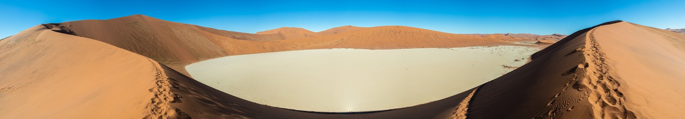
Dead Vlei, Namibia. Diego Delso, delso.photo, CC BY-SA 4.0.
This lesson is the mid-sequence assessment, out of 20 (CO 5, CE 5, EE 5, EO 5).
Part A, CO, 10 minutes. You will hear a short text three times. It was written for this assessment. It paraphrases an idea often reported from Herbert; it does not quote an interview. Questions: 1. What do many readers think? 2. What did Herbert want to show? 3. Name two things the believers gain. 4. What do they give? 5. Explain the last sentence in your own words. (LVB may answer question 5 in French if needed.)
Part B, CE, 15 minutes. Document 1 (scene summary, not a quotation): in Book I, in Arrakeen, Jessica understands that the Bene Gesserit, through the Missionaria Protectiva, planted legends on Arrakis long before her arrival, so that a sister of the order could one day be protected. The housekeeper's words echo a prophecy, and Jessica decides to use it. Document 2 is Q7.
Tasks: 1. Explain the Missionaria Protectiva in two sentences. 2. Find four pairs of opposites in Q7. 3. What do the two documents show about who writes Paul's legend?
Part C, EE, 14 minutes. B1: 80 to 100 words. B2: 120 to 150 words. "Is Paul the voice of the Fremen, or are the Fremen the voice of Paul's legend?"
Part D, EOC, two minutes, and one follow-up question: "Who writes the legend of Paul? Use one quotation." Talks continue in Lessons 6 and 7.
"warrior and mystic, ogre and saint, the fox and the innocent, chivalrous, ruthless, less than a god, more than a man"
Q7. Book III, a late epigraph by the Princess Irulan. The full epigraph is about five lines: check your edition.
Teacher grid, out of 20. CO, B1: main idea and some details; B2: all details and the implicit link between belief and loss of voice. CE, B1: explains the planted legend, finds two pairs; B2: explains the external author of the religion, four pairs, links the documents. EE content, B1: a clear opinion, one example; B2: a nuanced argument, two references, a concession. EE language, B1: modals and relatives mostly correct, five sequence words reused; B2: conditionals, passive and concession accurate, eight words reused. EO, B1: two minutes with pauses, a clear structure, one quotation; B2: fluent, structured, the quotation commented, a natural answer to a question.
Self-correction grid: Criterion / What I did / What I missed / My improved version. Rows: Content; References; Vocabulary reused; Accurate syntax.
Homework. Complete the self-correction grid. Write an improved version of your written answer.

Teacher's notes, Lesson 5
Listening text (paraphrase, not a quotation; heard three times): Many readers finish Dune and think Paul is simply a hero. Herbert did not agree. In interviews, he said he wanted to show the danger of charismatic leaders. In the novel, the people who believe in Paul gain courage and unity. But they also give him the right to speak for them. When one man speaks for a whole people, the people may stop speaking for themselves.
If you wish to quote Herbert himself, check an interview source first. Do not present this listening text as his wording.

Key, Lesson 5
A: 1. That Paul is simply a hero. 2. The danger of charismatic leaders. 3. Courage and unity. 4. The right to speak for them. 5. If a leader talks for everyone, the people lose their own voice.
B: 1. A Bene Gesserit order that plants protective legends on worlds like Arrakis, so that a sister can later use them. 2. Warrior and mystic; ogre and saint; the fox and the innocent; chivalrous and ruthless (also: less than a god, more than a man). 3. Paul's legend is written by others: the Bene Gesserit before him, the Princess Irulan after him.
Expected direction for C. B1: Paul helps the Fremen to win, but the legend was written by others, so the Fremen do not entirely decide; a hero can be dangerous. B2: Paul is both the voice of the Fremen and the instrument of a legend planted by the Bene Gesserit and written by Irulan; the price may be paid by the people who follow him.

Lesson 6. The Ecologist's Warning
Step of the problématique: J'anticipe. What does the scientist foresee, and what does he fail to foresee?
55 minutes, timed on 52.
Stage | Time | Activity | Skill
1 | 6 min | Two mid-sequence talks, continued. | EOC
2 | 8 min | Images: Banshee Hill, Oregon; a Sahel vegetation record (NASA); a satellite view of the Namib. A dune moves. What can people do? | EOI
3 | 10 min | Listening: Kynes's dream. | CO
4 | 12 min | Reading Q5, Q6 and Q9. | CE
5 | 10 min | Dilemma in fours: should the planet be made green, even if the Fremen way of life disappears? | EOI
6 | 6 min | An ecologist's note, spiral turn 4, homework. | EE

Stopping point: After stage 4.
Emergency exit (8 minutes): Listening, Q5, one sentence: "If..., then...".
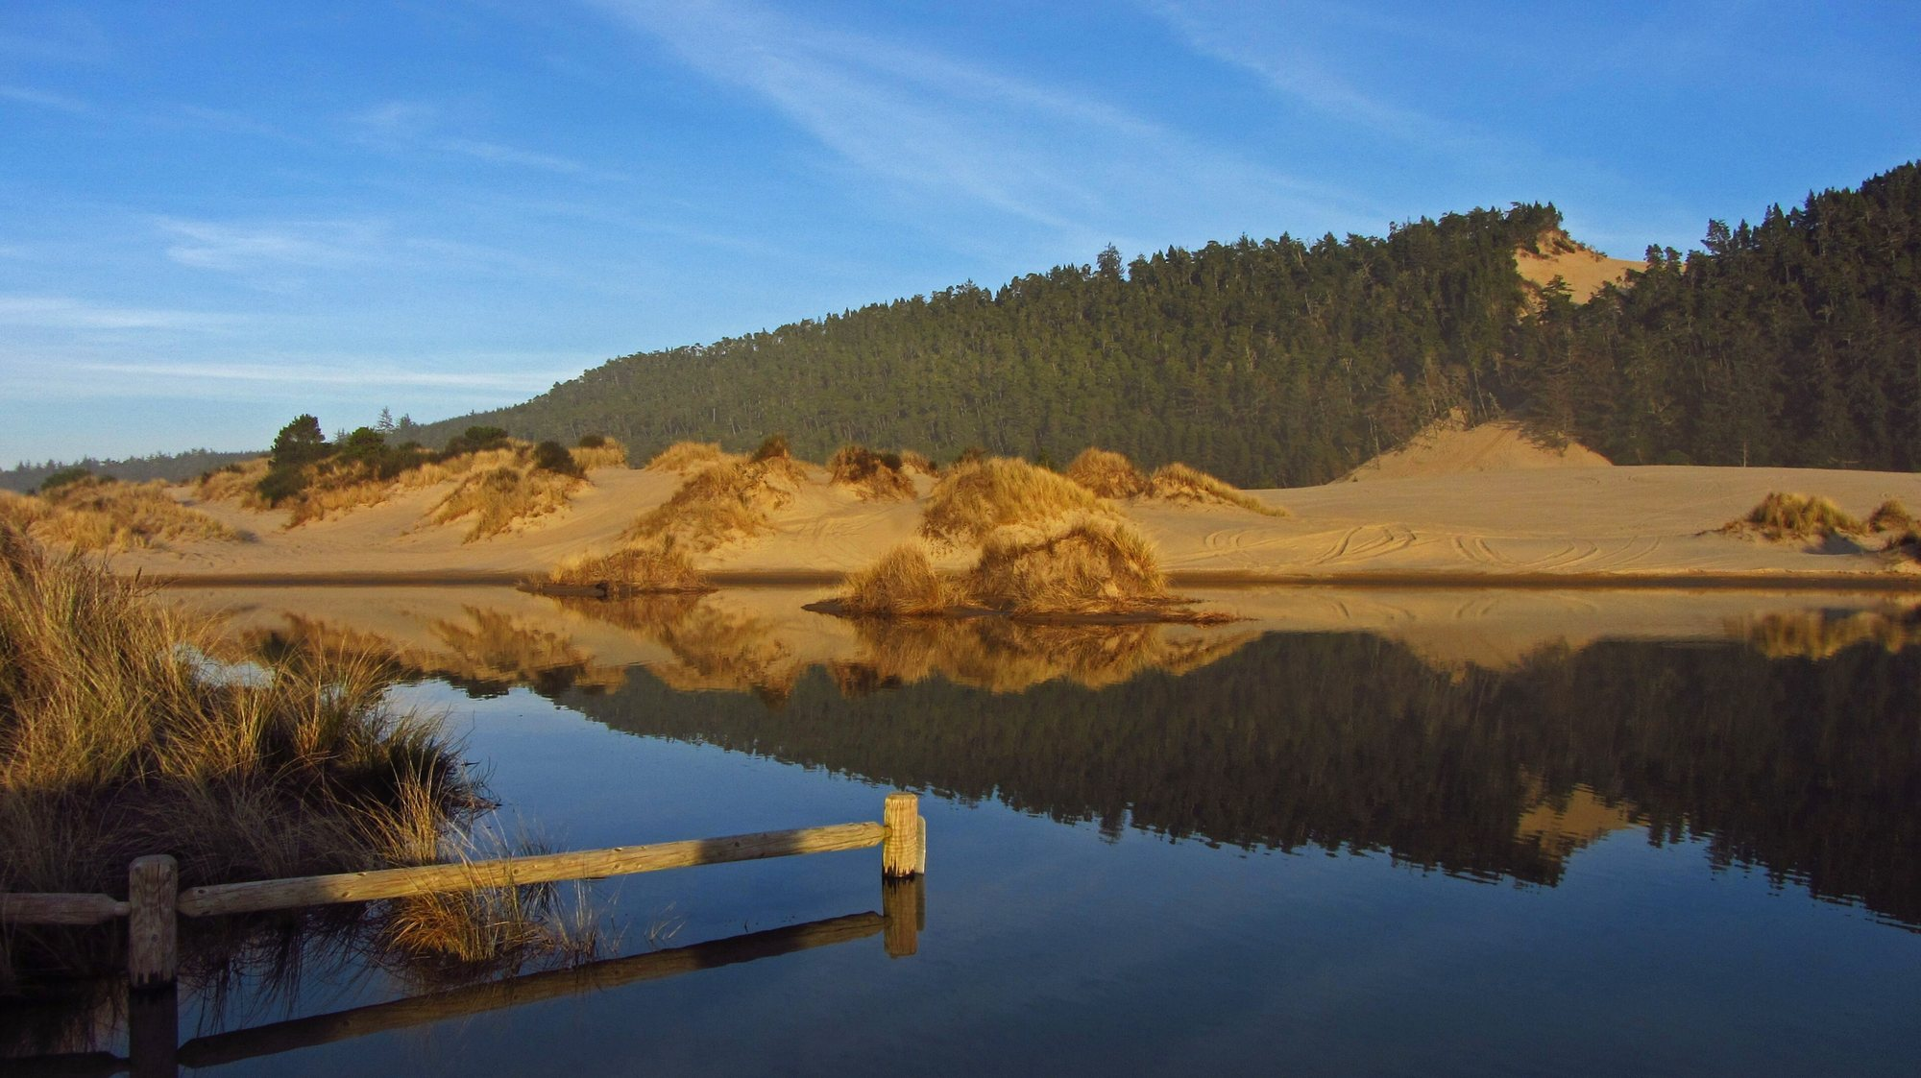
Banshee Hill, Oregon Dunes. Themom51, 21 January 2013, CC BY-SA 3.0.
Banshee Hill, in the Oregon Dunes, is near Florence, where Herbert planned an article. A light optional link to axe 6, used as biography and context, not as a substitute for Arrakis.
B1: complete "If the Fremen follow a hero, they might..." (two endings from a box, plus one personal). B2: a conditional chain of four links, ending with a consequence for the desert.
Text intelligence. Q5 is the father's voice inside the son's dying mind. The warning comes from science, not from religion, at the very moment when the religious story is winning. Q6 closes the chapter on accident and error. Why does Herbert give the strongest warning to a dying man, in what the chapter presents as a remembered lesson?
Grammar. First and second conditional; might, could, will, would. Example: If the spice disappeared, the Guild could not travel.
Exercise 5. a) the Fremen / follow Paul → the empire / fall. b) the planet / become green → the sandworms / die. c) a hero / take power → the long plan / stop.
Expanding your vocabulary: an ecologist, ecology, an ecosystem, a consequence, to foresee, to transform, terraforming, a long-term plan, irreversible, a warning, to warn against.
Written trace, 50 to 80 words: "As an ecologist, I warn that..."
"No more terrible disaster could befall your people than for them to fall into the hands of a Hero."
Q5. Book II, the chapter of Liet-Kynes dying in the desert.
"the most persistent principles of the universe were accident and error"
Q6. The same chapter, final line.
"the highest function of ecology is the understanding of consequences"
Q9. Appendix I, The Ecology of Dune. Some epigraphs give a shorter form: check your edition.
Homework. Oral recording, one minute: "A warning from Kynes to the Fremen". Learn Q5 by heart.

Teacher's notes, Lesson 6
Listening text: Liet-Kynes is the Imperial planetologist, a scientist sent to study Arrakis. His father dreamed of changing the planet: catching the water, planting grasses on the dunes, and one day making Arrakis green. The Fremen adopted this dream, and Kynes became one of their leaders. But a plan that takes centuries needs patience, and a hero who promises everything now can destroy it.
Check Q5, Q6 and Q9 in your edition. For Q9, some epigraphs give "understanding consequences" without "the".

Key, Lesson 6
Together, Q5, Q6 and Q9 anticipate the cost of following Paul: a victory that may destroy the slow plan, and a people that may lose its voice.
Exercise 5. a) If the Fremen follow Paul, the empire will / might fall (or: If the Fremen followed Paul, the empire would fall). b) If the planet became green, the sandworms would die. c) If a hero took power, the long plan would stop. Common error: would in the if-clause.

Lesson 7. The Hero Trap
Step of the problématique: Je trouve le sens. Is the hero the voice of the people or the voice that replaces them?
55 minutes, timed on 52.
Stage | Time | Activity | Skill
1 | 6 min | The last two-minute talks. | EOC
2 | 8 min | Listening: Q7 read aloud twice; students note pairs of opposites. | CO
3 | 10 min | Reading Q8: the threat to destroy the spice. | CE
4 | 12 min | Spiral presentations, from turn 1 to the tip, one minute per student. | EOC
5 | 10 min | Council rehearsal: questions for the final task. | EOI
6 | 6 min | Draft of the final statement, homework. | EE

Stopping point: After stage 4.
Emergency exit (8 minutes): Q7, Q8, and each student says the tip of the spiral in one sentence.
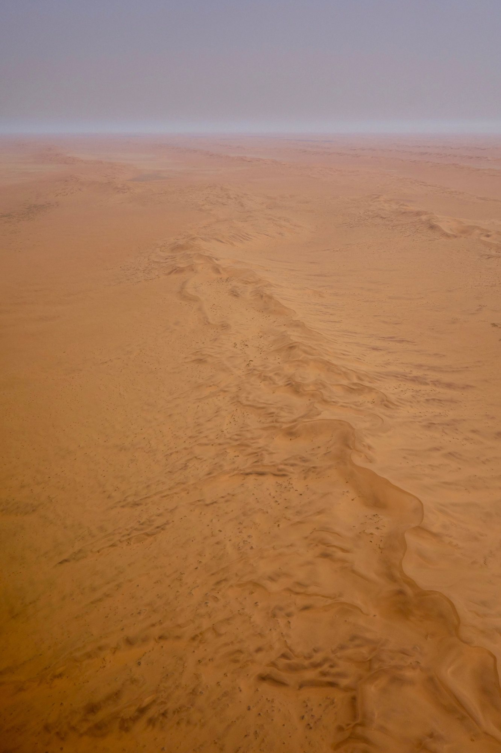
A serpentine ridge in the Namib. Sonse, 20 September 2017, CC BY 2.0.
B1: classify the words of Q7 into "positive" and "negative", then say which side wins for you. B2: comment on the effect of the antitheses in four to five sentences.
Text intelligence. Q7 is a portrait made of opposites: the historian cannot decide what Paul is. Q8 shows the liberator using the language of total control, and of the destruction of the very resource that defined the planet. Has the hero become the new owner of the spice?
The tip is a sentence the group has reached, not a sentence given in advance. A possible kind of tip (for the teacher, not to be written on the board first): "A people can be saved by the story that enslaves it."
Language for speech: Let me begin by... / I would like to stress that... / To put it simply... / I am convinced that... / To conclude...
Optional bridge: the leader as a manufactured figure. Big Brother may not even exist; Paul exists, but his legend was written before him. Does it matter whether the leader is real, if the story is what people follow?
Grammar. Comparison: as ... as, more ... than, the most, less than. Notice Q7: "less than a god, more than a man".
Exercise 6. a) the Fremen / independent / before. b) a legend / dangerous / an army. c) Kynes's plan / slow / Paul's war.
Expanding your vocabulary: a hero, heroism, a trap, to be trapped, an antithesis, to blackmail, a threat, a leader, a follower, to obey, charisma.
Written trace: the class tip, copied and signed by every group.
"warrior and mystic, ogre and saint, the fox and the innocent, chivalrous, ruthless, less than a god, more than a man"
Q7. Book III, a late epigraph by the Princess Irulan.
"The power to destroy a thing is the absolute control over it."
Q8. Book III, final chapter. Check the wording in your edition: some sources give "He who can destroy a thing has the real control of it."
Homework. Finish the draft of the final statement. Rehearse the briefing with a timer (3 to 4 minutes). Record it once.

Teacher's notes, Lesson 7
Some sources give an earlier formulation of Q8, in Paul's thoughts: "He who can destroy a thing has the real control of it." Check which wording your edition uses. Do not write the film line "The spice must flow" as if it belonged to this chapter: it does not belong to the novel.

Key, Lesson 7
Q7 pairs: warrior / mystic; ogre / saint; the fox / the innocent; chivalrous / ruthless; less than a god / more than a man. Which side "wins" is a reasoned choice. Q8: the hero now speaks as a controller of the resource; the liberator uses destruction as a form of ownership.
Exercise 6. a) The Fremen are not as independent as before / less independent than before. b) A legend can be more dangerous than an army. c) Kynes's plan is slower than Paul's war. Accept any reasoned order: the content is debatable, the structure must be correct.

Lesson 8. The Council of the Deep Desert
Step of the problématique: the tip. The class answers the problématique.
55 minutes, timed on 52.
Stage | Time | Activity | Skill
1 | 4 min | Instructions; roles are drawn.
2 | 30 min | The council: briefings (3 to 4 minutes), then one or two questions. | EOC, EOI
3 | 15 min | Written statement, final version. | EE
4 | 3 min | The self-correction grid is begun.

Stopping point: After stage 2.
Emergency exit (8 minutes): The written statement only, today; the briefings in the next lesson.
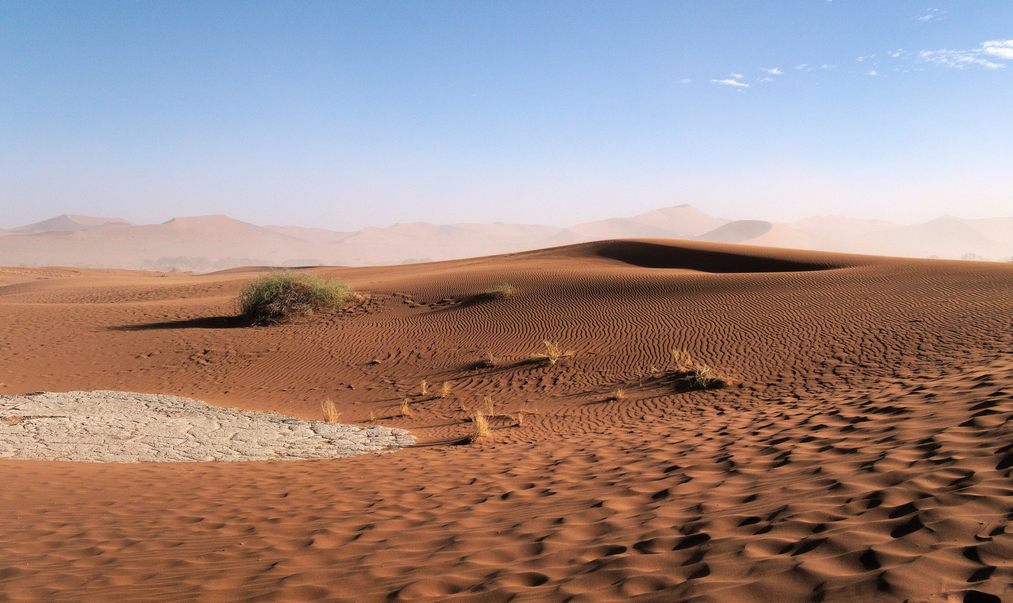
Ripples at Sossusvlei. Daniel Kraft, 21 May 2019, CC BY-SA 3.0.
This lesson is the final task and the summative assessment, out of 20 (briefing EOC 6, interaction EOI 4, written statement EE 6, language 4).
Situation. After the end of the novel, the Fremen elders of a sietch meet. You are an adviser. Choose one role: a Fremen elder; a planetologist trained by Kynes; a Fremen woman who knew Paul as Usul; a sceptical young fighter. You give a briefing: should the Fremen keep following Muad'Dib? Then you write a statement, to be kept in the sietch's records: 180 to 250 words (B1: 150 to 180).
This is not a dystopia opening page, and it is not a warning speech on the Orwell model. It is a council deliberation, inside the fiction, with a decision to take.
Requirements. Answer the problématique. Quote at least two short lines from Q1 to Q9. Use at least one conditional, one passive, and one concession.
Briefing structure (both levels): Introduction (who I am, my question) / Point 1 / Point 2 / Counter-argument (B2) / Decision / Thank you.
Guided B1 model (seven boxes). 1. Elders, I am a Fremen woman. I knew Muad'Dib when he was only Usul. (Who are you?) 2. He helped us to win, and our enemies were defeated. (What is positive? Use a passive.) 3. But the legend was written by strangers before he came. (Problem one. Use a passive.) 4. Although he is brave, he speaks for us, and we do not speak any more. (Problem two. Use a concession.) 5. Kynes's father said we must not "fall into the hands of a Hero". (A quotation.) 6. If we follow him everywhere, many young Fremen will die, and the plan to make water will stop. (A consequence. Use a conditional.) 7. So I think we must thank him, but the council must decide. (Your decision.)
Teacher grid. EOC, B1: three minutes, introduction, two points, conclusion, two quotations; B2: four minutes, a clear thesis, three points including a counter-argument, three quotations commented. EOI, B1: answers a simple question, asks for repetition if needed; B2: defends and nuances, reacts to objections, rephrases. EE, B1: a position stated, reasons, one example; B2: a position nuanced, a concession, two references, a link to today. Language: B1, six to eight sequence words, modals, relatives and conditionals generally correct; B2, ten or more words used precisely, passive, conditionals, concession and comparison accurate.
Three bridges for a later French sequence on René Barjavel's Ravage (1943), not developed here: 1. The dependence of a technical civilisation (spice / electricity). 2. The guide of a people in a hostile world, and what the guide asks in return. 3. The land that remakes its inhabitants. Is the environment a teacher or a tyrant?
Homework. Finish the self-correction grid. Rewrite your conclusion and one paragraph, following the teacher grid.

Teacher's notes, Lesson 8
B2 model statement (to be shown after students have written, or at the teacher's invitation):
Elders of the sietch, I was trained by the planetologist, and I speak for the desert. Muad'Dib has given us victory, and I do not deny it. Our enemies have been defeated, and the spice is in our hands. Yet I ask you: in whose hands, exactly? The legend we sang was planted long ago by strangers, and the man who fulfilled it has learnt to speak our words better than we do. When he told the Guild that "the power to destroy a thing is the absolute control over it", he spoke of our planet as a weapon. Kynes's father warned us that no disaster could be more terrible than to "fall into the hands of a Hero". Although Muad'Dib loves us, a people that hands its voice to one man may never take it back. If we follow him across the stars, our sons will die far from the sand, and the slow plan to bring water to Dune will be forgotten. I propose that we honour him, but that the council, not the prophet, decides the future of the desert. The highest function of ecology is understanding consequences; let it be ours too.
This is a model, not the only right answer.
Optional short bridge at the end: in Orwell, the Party controls the past; in Dune, whoever controls the spice also controls the story of the planet (Q8). Who tells the story of a vital resource? Fictions et réalités remains a Terminale axis; this Première sequence prepares that later work.

Key, Lesson 8
Expected answers. B1: Paul helps the Fremen to win, but the legend was written by others, so the Fremen do not decide. A hero can be dangerous. B2: Paul is both the voice of the Fremen and the instrument of a legend planted by the Bene Gesserit and written by Irulan. His victory gives the Fremen power but takes away their voice and threatens Kynes's long ecological plan; the price is paid by the Fremen and by the desert.
Common errors. "Paul is a good hero, end of story": ask who wrote the prophecy before he arrived (Q4). Confusing the film and the novel ("the spice must flow"): that line is from the 1984 film, not from the book. Which for people; would in the if-clause; more good: point to the grammar box of the relevant lesson. Using the passive without asking who is hidden: ask "by whom?". Turning the council into a summary of the plot: ask "what do you propose?".

Expanding your vocabulary
The desert and nature. arid, barren, scarce, scarcity, a dune, sand, to recycle, an ecosystem, ecology, an ecologist, to transform, terraforming, irreversible.
Resource and power. a resource, to extract, a supply, to depend on, dependence, a monopoly, profit, a fief, a governor, to rule, to own, ownership.
Empire and colonialism. an empire, an emperor, to colonise, a coloniser, the colonised, a native people, to exploit.
Religion and myth. a prophecy, a prophet, a messiah, a saviour, a sign, to fulfil, faith, a believer, a ritual, a litany, a legend, a myth, to worship.
The hero. a hero, heroism, a leader, a follower, charisma, to obey, a trap, a threat, to blackmail.
Analysis. the narrator, the point of view, an epigraph, to foreshadow, an antithesis, an oxymoron, world-building, an invented word, the passive voice, the agent.
Argument and nuance. although, even though, whereas, however, on the one hand, on the other hand, to some extent, partly, as a result, therefore, I am convinced that, I would argue that, it could be said that.

Short quotations to remember
The novel remains protected. These are short lines, with references. Before class, check each line in the class edition.
- 1. "A beginning is the time for taking the most delicate care that the balances are correct." (Book I, opening epigraph)
- 2. "I must not fear. Fear is the mind-killer." (Book I, the gom jabbar)
- 3. "No more terrible disaster could befall your people than for them to fall into the hands of a Hero." (Book II, death of Liet-Kynes)
- 4. "less than a god, more than a man" (Book III, epigraph by the Princess Irulan)
- 5. "The power to destroy a thing is the absolute control over it." (Book III, final chapter)
- 6. "the highest function of ecology is the understanding of consequences" (Appendix I)

Recap
Arrakis is a desert world where water and the spice decide everything. The empire, the noble families and the Guild depend on a resource extracted from the land of the Fremen. The religion that makes Paul a messiah was partly planted by outsiders and is written down by a princess-historian. The scientist Kynes warns that a hero is the worst disaster for a people. At the end, the liberator controls the spice by threatening to destroy it. The problématique: a hero can be the voice of a people and also the voice that replaces it.

Bridges: the Orwell strand
This sequence belongs to the same strand of warning fictions as the English sequence on George Orwell, Big Brother Is Watching · When Fiction Warns Reality, designed for Terminale (axe Fictions et réalités of the Terminale programme, which remains in force). The bridges are optional and secondary. This is a study of Dune, not a comparative commentary on Nineteen Eighty-Four.
- Lesson 4. Two ways of controlling language. Newspeak reduces words; prophecy multiplies sacred words. Is it more dangerous to take words away, or to give people the "right" words?
- Lesson 7. The leader as a manufactured figure. Big Brother may not even exist; Paul exists, but his legend was written before him. Does it matter whether the leader is real, if the story is what people follow?
- Lesson 8. The resource and the story about it. In Orwell, the Party controls the past; in Dune, whoever controls the spice also controls the story of the planet. Who tells the story of a vital resource?

Bridges for a later French sequence on Barjavel (Ravage, 1943)
To be taken up in Lettres; not developed here.
- Dependence of a technical civilisation: the spice, and electricity. A civilisation is as fragile as the resource it cannot live without.
- The guide of a people in a hostile world: Paul, and François. What does the guide ask in return for survival?
- The land that remakes its inhabitants. Is the environment a teacher or a tyrant?

Bibliography
- Frank Herbert, Dune, 1965 (first edition Chilton Books). Use any complete English edition.
- Library record with the epigraph, the dedication and the first words: LibraryThing, Dune (https://www.librarything.com/work/4041453).
- A quotation collection used for cross-checking (always verify in a paper edition): Wikiquote, Dune (https://en.wikiquote.org/wiki/Dune_(novel)).
- Official texts: Bulletin officiel n° 22 du 29 mai 2025 (https://www.education.gouv.fr/bo/2025/Hebdo22/MENE2504621A); Éduscol, programmes de langues vivantes, voie générale et technologique.
- For the teacher only: Brian Herbert, Dreamer of Dune: The Biography of Frank Herbert, 2003.
The novel remains protected (Frank Herbert died in 1986). Only short quotations are used, with precise references. No chapter is reproduced. No film poster or still is hosted.

