La spirale de Gorse · my reading
Who Speaks for the Desert? · Frank Herbert, Dune (1965)
Work: ____________________________ Book _____ opening scene: ____________________
Starting question: ________________________________________________________________
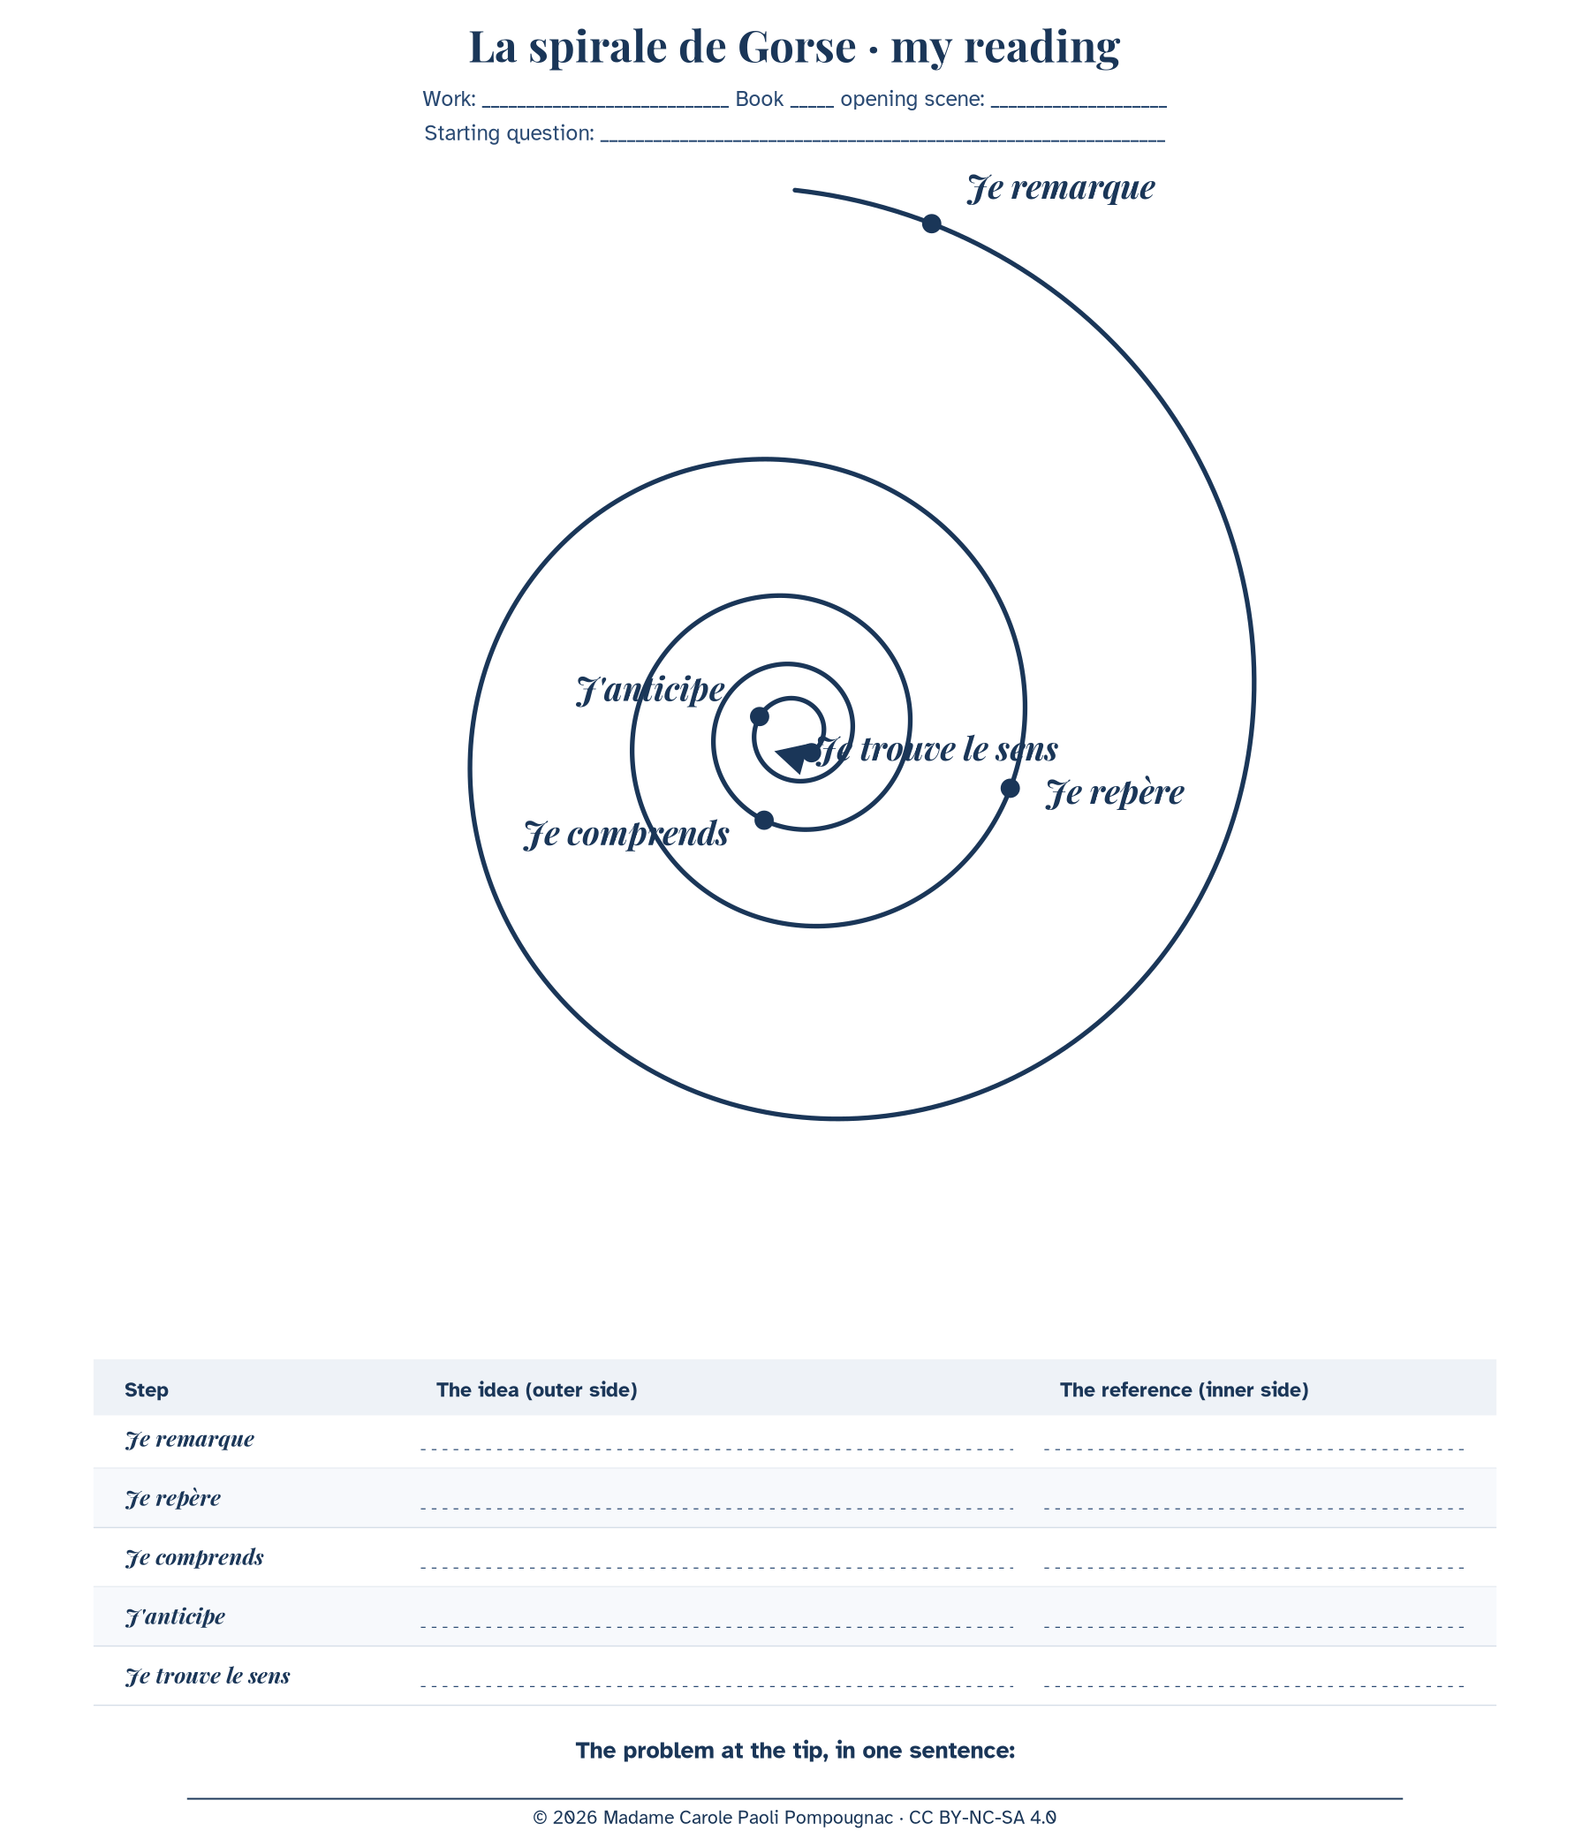
Outer side: the idea. Inner side: the chapter references. Follow the line to the tip.
Step | The idea (outer side) | The reference (inner side)
Je remarque
Je repère
Je comprends
J'anticipe
Je trouve le sens

The problem at the tip, in one sentence:
___________________________________________________________________________
Sentence starters: At first sight, I notice that... / The word "..." appears in... / This shows that... / If ..., then ... might... / The real question is whether...
© 2026 Madame Carole Paoli Pompougnac · CC BY-NC-SA 4.0

