Anglais · Première technologique · lycée général et technologique
LVA and LVB · B1-B2
Who Speaks for the Desert?
Student booklet
Frank Herbert, Dune (1965), the first novel only
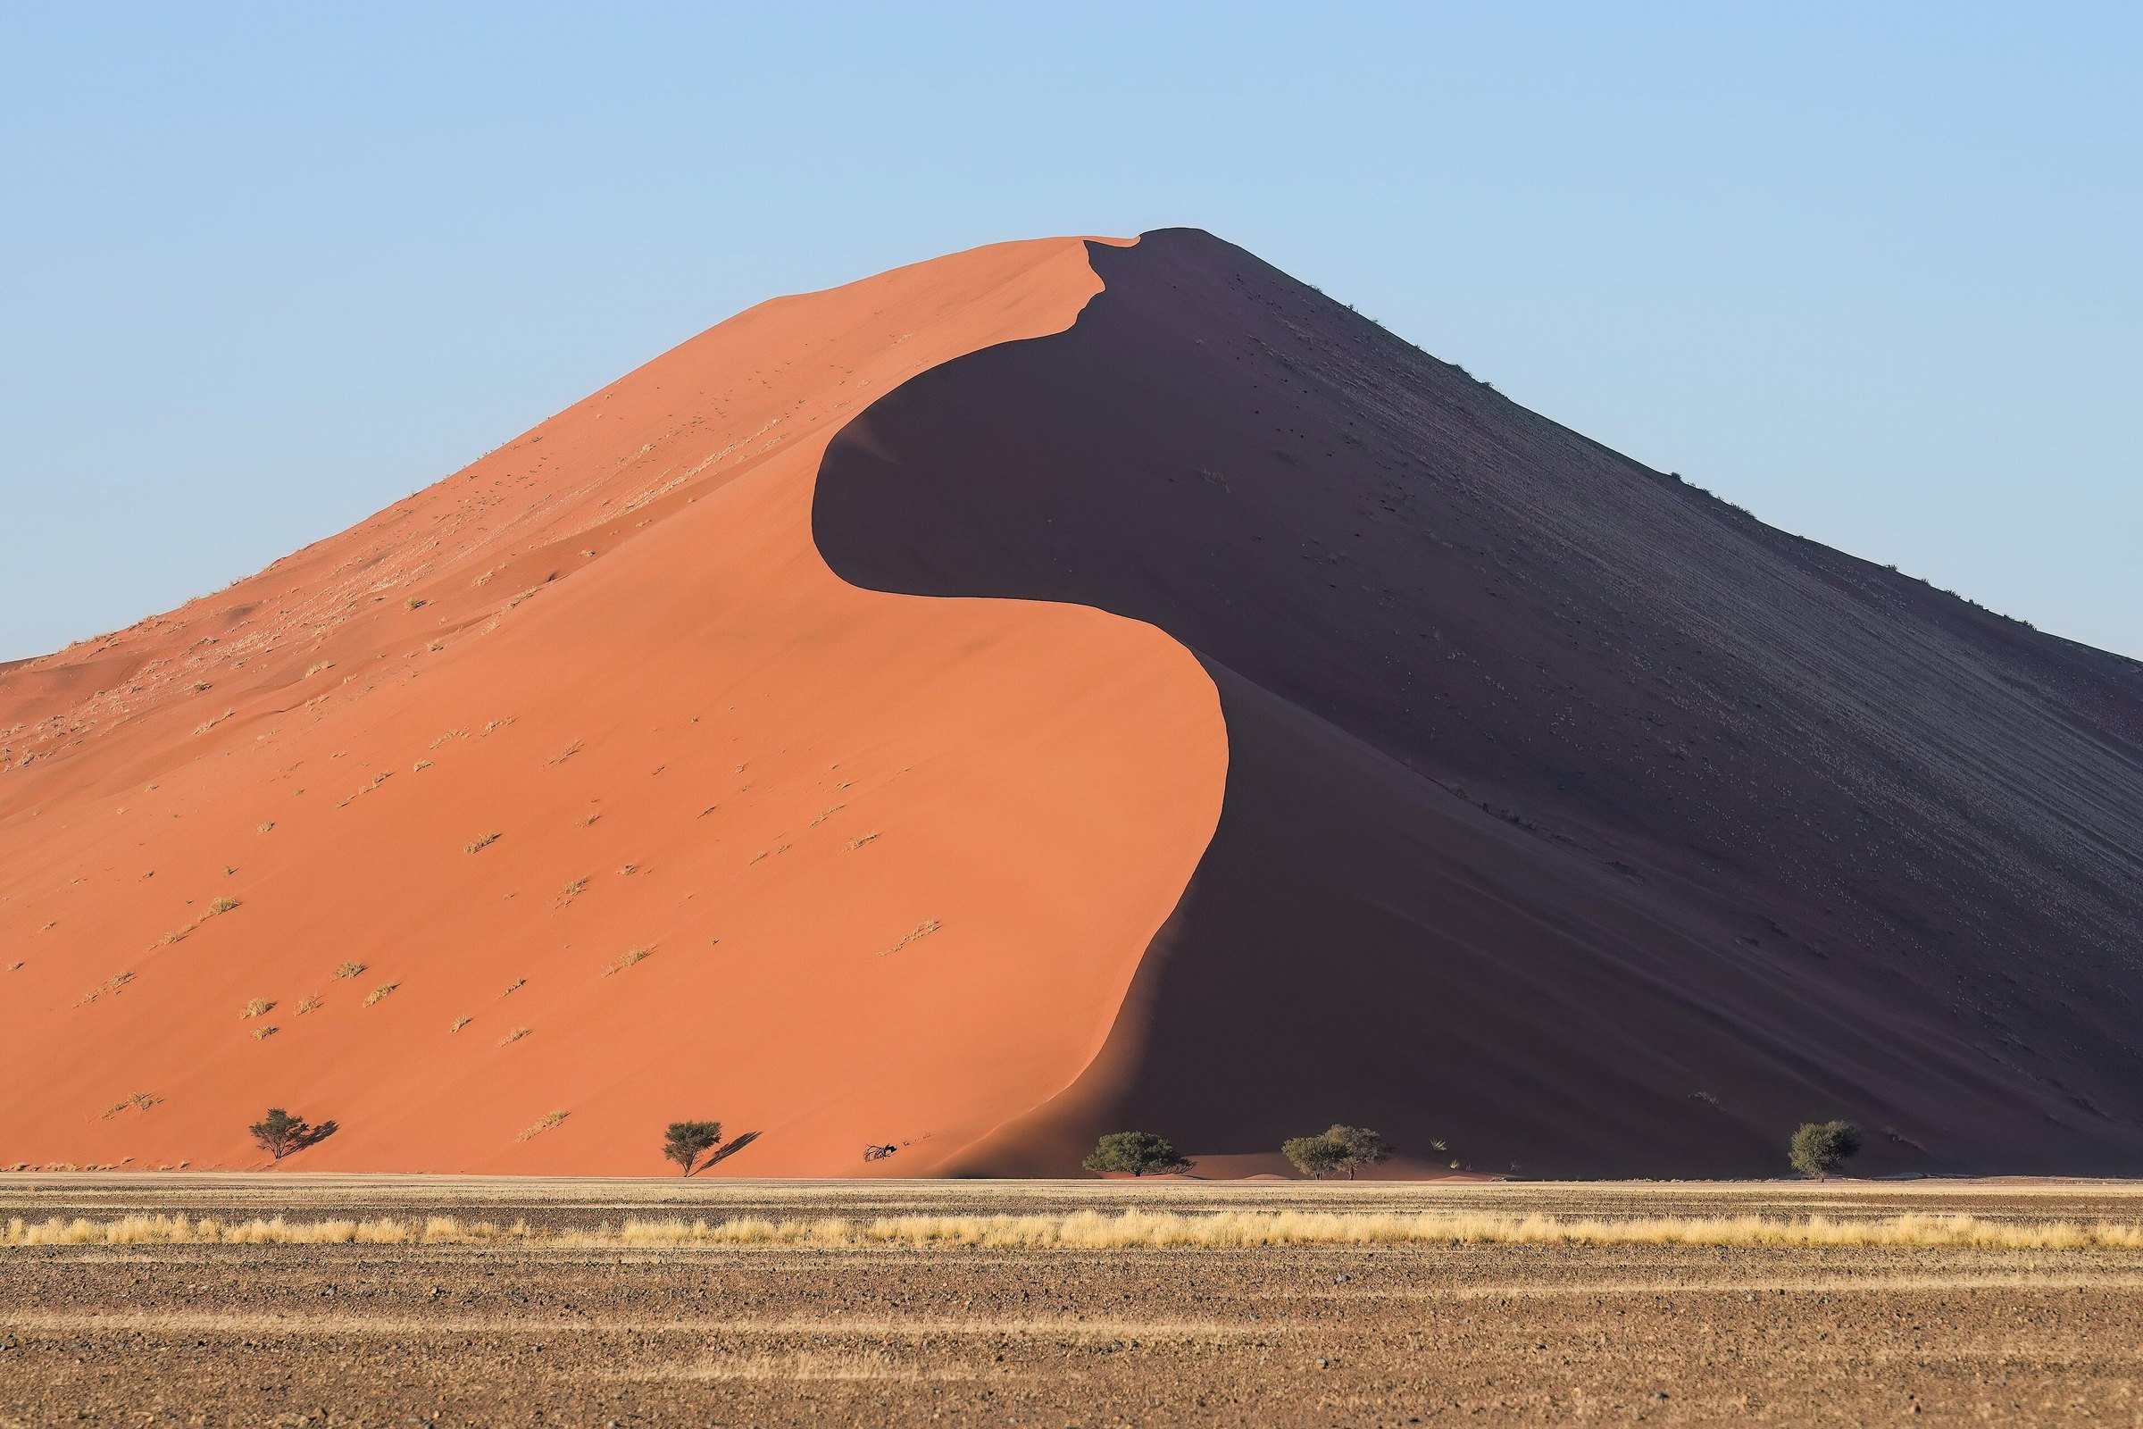
Giles Laurent, Dune 45 in Sossusvlei at sunrise, Namibia. Wikimedia Commons, CC BY-SA 4.0. This photograph belongs to the desert world of the novel. It is not a still from any film.
Madame Carole Paoli Pompougnac
conçu par Madame Carole Paoli Pompougnac, mis en page par Grok
© 2026 Madame Carole Paoli Pompougnac · CC BY-NC-SA 4.0
Problématique
When a desert, a resource and a prophecy make a hero, is the hero the voice of a people or the instrument of those who wrote his legend, and who pays the price?
This booklet is for the student. Listening texts are read by the teacher and are not printed here. Keys are on the correction sheet, and in folds on the site.
Problématique. When a desert, a resource and a prophecy make a hero, is the hero the voice of a people or the instrument of those who wrote his legend, and who pays the price?
Lesson | Title | Step | Question of the day
1 | A Planet Called Dune | Je remarque | What do we notice about a world where water is the measure of everything?
2 | The Spice: One Resource, One System | Je repère | Who needs the spice, who extracts it, who controls it?
3 | Whose Planet? Empire and the Desert People | Je repère, then Je comprends | Who owns Arrakis: the Emperor who gives it, the family who rules it, or the people who live on it?
4 | Making a Messiah | Je comprends | How is a legend written, and who writes it?
5 | Mid-Sequence Assessment | J'anticipe | If the Fremen follow the hero, what will they gain and what could they lose?
6 | The Ecologist's Warning | J'anticipe | What does the scientist foresee, and what does he fail to foresee?
7 | The Hero Trap | Je trouve le sens | Is the hero the voice of the people or the voice that replaces them?
8 | The Council of the Deep Desert | the tip | The class answers the problématique.

La spirale de Gorse
La spirale de Gorse is the method of Madame Carole Paoli Pompougnac; its name honours her husband's grandmother. It is a real round spiral, airy, drawn in navy. It starts on the outside and turns inwards, ending in a tip, never a centre. On the outer side of each turn, students write the idea. On the inner side, they write the chapter references. Students follow the line, turn by turn; nobody jumps to the tip.
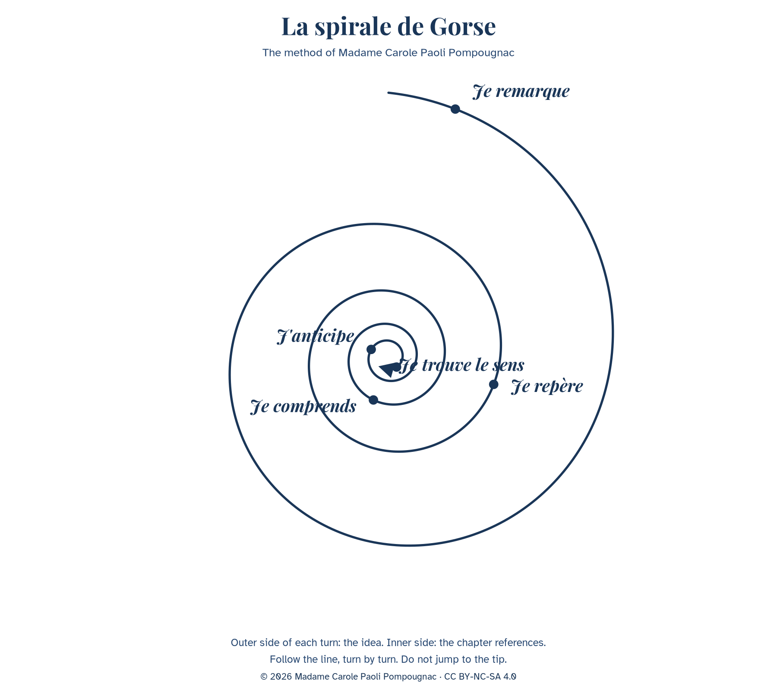
The five steps, always in this order: Je remarque, Je repère, Je comprends, J'anticipe, Je trouve le sens.
Step | What students do | Lesson
Je remarque | First impression, what is visible. | Lesson 1
Je repère | Locate words, voices, places. | Lessons 2 and 3
Je comprends | Explain how it works. | Lessons 3 and 4
J'anticipe | Predict consequences. | Lessons 5 and 6
Je trouve le sens | Reach the problem. | Lessons 7 and 8

The question at the tip is not given in advance. Expected kind of tip: "A people can be saved by the story that enslaves it."

Filled example: the death of Liet-Kynes (Book II)
Turn | Outer side: the idea | Inner side: the reference
Je remarque | A man is dying of thirst; the scene feels like a lesson, not an action scene. | Book II, the chapter in which the Harkonnens leave Kynes in the desert without a stillsuit.
Je repère | Two voices: the dying son and the remembered father. The father's sentence is in direct speech. | "No more terrible disaster could befall your people than for them to fall into the hands of a Hero."
Je comprends | The scientist understands too late that a saviour can destroy the project he served. | The same chapter. Compare Book I, the Missionaria Protectiva.
J'anticipe | Kynes asked the Fremen to protect Paul. The warning predicts the danger of Paul's success. | Book III, final chapter (check the wording of Q8 in your edition).
Je trouve le sens | The hero is the disaster. Freedom given by a saviour is a new dependence. | Appendix I: "the highest function of ecology is the understanding of consequences."

Lesson 1. A Planet Called Dune
Step of the problématique: Je remarque. What do we notice about a world where water is the measure of everything?
55 minutes, timed on 52.
Stage | Time | Activity | Skill
1 | 5 min | Image without a caption. What do you see? Is it a place to live? One word each. | EOI
2 | 10 min | Diagnostic listening (teacher reads the context text twice). | CO
3 | 10 min | Reading Q1 and Q2: who is speaking? Who is "him"? | CE
4 | 12 min | Pairs: Guess the world. Three rules of life on Arrakis. Each pair presents one rule. | EOI, EOC
5 | 10 min | Spiral, turn 1: Je remarque. | EE, médiation
6 | 5 min | Written trace and homework. | EE

Stopping point: After stage 4.
Emergency exit (8 minutes): Image, one word each, Q2 read aloud, one sentence: "On Arrakis, people must...".
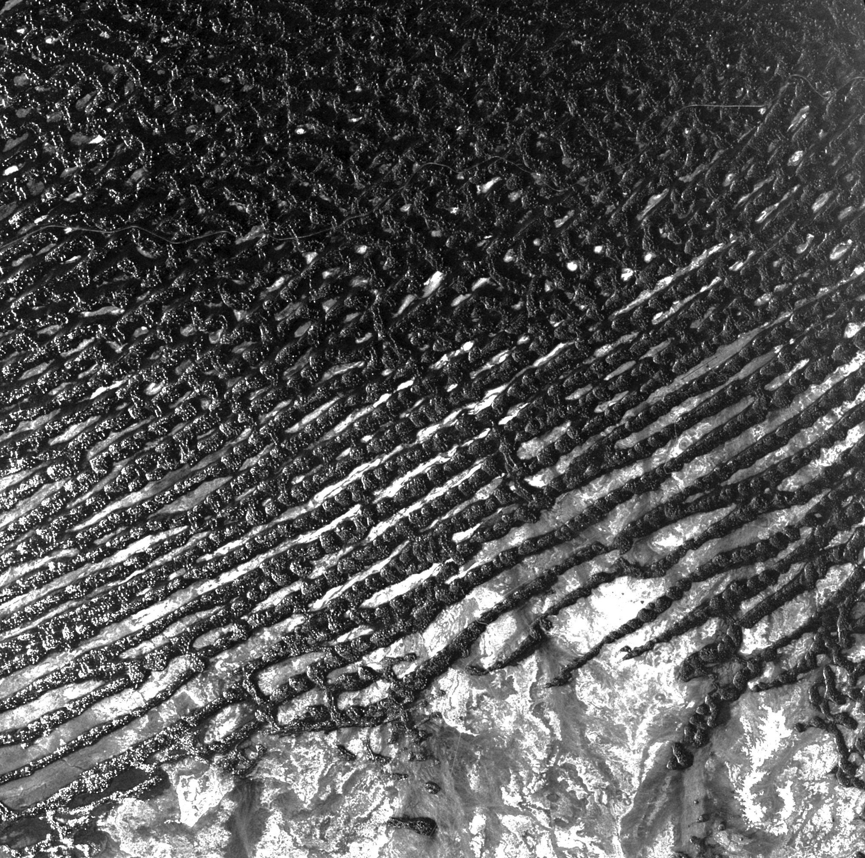
ESA radar image of the Rub' al Khali. CC BY-SA 3.0 IGO. Open the lesson without this caption; reveal it after the first words.
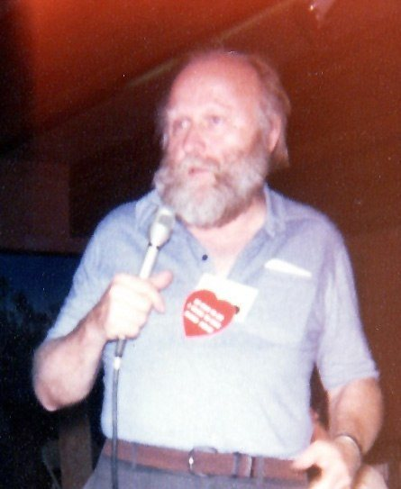
Frank Herbert, Robert E. Nylund, Octocon, October 1978. Public domain.
Look first at a radar image of a sand sea, without a caption, and say one word. Is this a place to live? (On the site, the ESA radar image of the Rub' al Khali opens the lesson; the caption is revealed afterwards.)
Listening, twice: a short context text, written for the sequence, read by the teacher. Students do not read it during the listening.
B1: tick true or false (five statements), then complete: Herbert was a ____. The idea came from ____.
B1 statements: 1. Frank Herbert was born in 1920 in Tacoma, in the state of Washington. 2. He worked as a scientist. 3. In the late 1950s he planned an article on sand dunes near Florence, Oregon. 4. Scientists there were planting grasses to stop the sand from moving. 5. His novel Dune was published in 1965.
B2: notes under three headings (the man, the origin, the world), then a 30-second oral summary.
"To the people whose labors go beyond ideas into the realm of 'real materials' ... to the dry-land ecologists."
Q1. Dedication. The American spelling "labors" is the wording of the book: leave it unchanged when you quote.
"A beginning is the time for taking the most delicate care that the balances are correct." "Arrakis, the planet known as Dune, is forever his place."
Q2. Book I, opening epigraph.
Text intelligence. The opening sentence is not the narrator. It is an extract from a book written later, inside the fiction, by a princess. The novel begins with a historian who already knows that Paul is great. What does it change to read the hero's story through someone who already admires him?
Grammar. Modals of obligation and necessity: must, have to, need to, can't. Example (already corrected): water / not waste → On Arrakis, you must not waste water.
Exercise 1. a) people / protect their water. b) children / learn to walk on sand. c) nobody / cry in public. d) travellers / wear a special suit.
Expanding your vocabulary: arid, barren, scarce, scarcity, a dune, a planet, an empire, a resource, to survive, survival, to recycle, a desert people. Language for analysis: the epigraph, the narrator, the point of view, to introduce, to foreshadow.
Flashcards. Front: scarce. Back: available in small quantities; noun: scarcity. "Water is scarce on Arrakis." Front: epigraph. Back: a short quotation at the beginning of a chapter.
Diagnostic (not graded). CO: When and where was Herbert born? What was his job? What gave him the idea? Name two elements of the world of Arrakis. CE: Who writes Q2? What is Arrakis? What does "forever his place" suggest? EOC, one minute: Would you like to live on Arrakis? Why? EE, 40 words: My first impression of Dune. Self-correction: What I understood / What I missed / My improved answer.
Written trace: "Arrakis is a desert planet where water is scarce. The novel opens with the voice of a historian, the Princess Irulan, who already presents Paul as a great man. On Arrakis, people must..."
Homework. Make four flashcards. Record a 30-second voice note: "Three things I noticed about Arrakis".

Lesson 2. The Spice: One Resource, One System
Step of the problématique: Je repère. Who needs the spice, who extracts it, who controls it?
55 minutes, timed on 52.
Stage | Time | Activity | Skill
1 | 5 min | Three voice notes heard; the class lists what we noticed. | EOC
2 | 10 min | Historical map of the medieval spice-trade routes. Who travelled? Who became rich? | CE, EOI
3 | 10 min | Listening: The spice, explained. | CO
4 | 15 min | Role play in fours: Emperor's adviser, Guild navigator, Harkonnen governor, Fremen. | EOI
5 | 8 min | A definition paragraph with relative clauses. | EE
6 | 4 min | Spiral turn 2, trace, homework. | EE

Stopping point: After stage 4.
Emergency exit (8 minutes): Listening, then one role per student, in one sentence.
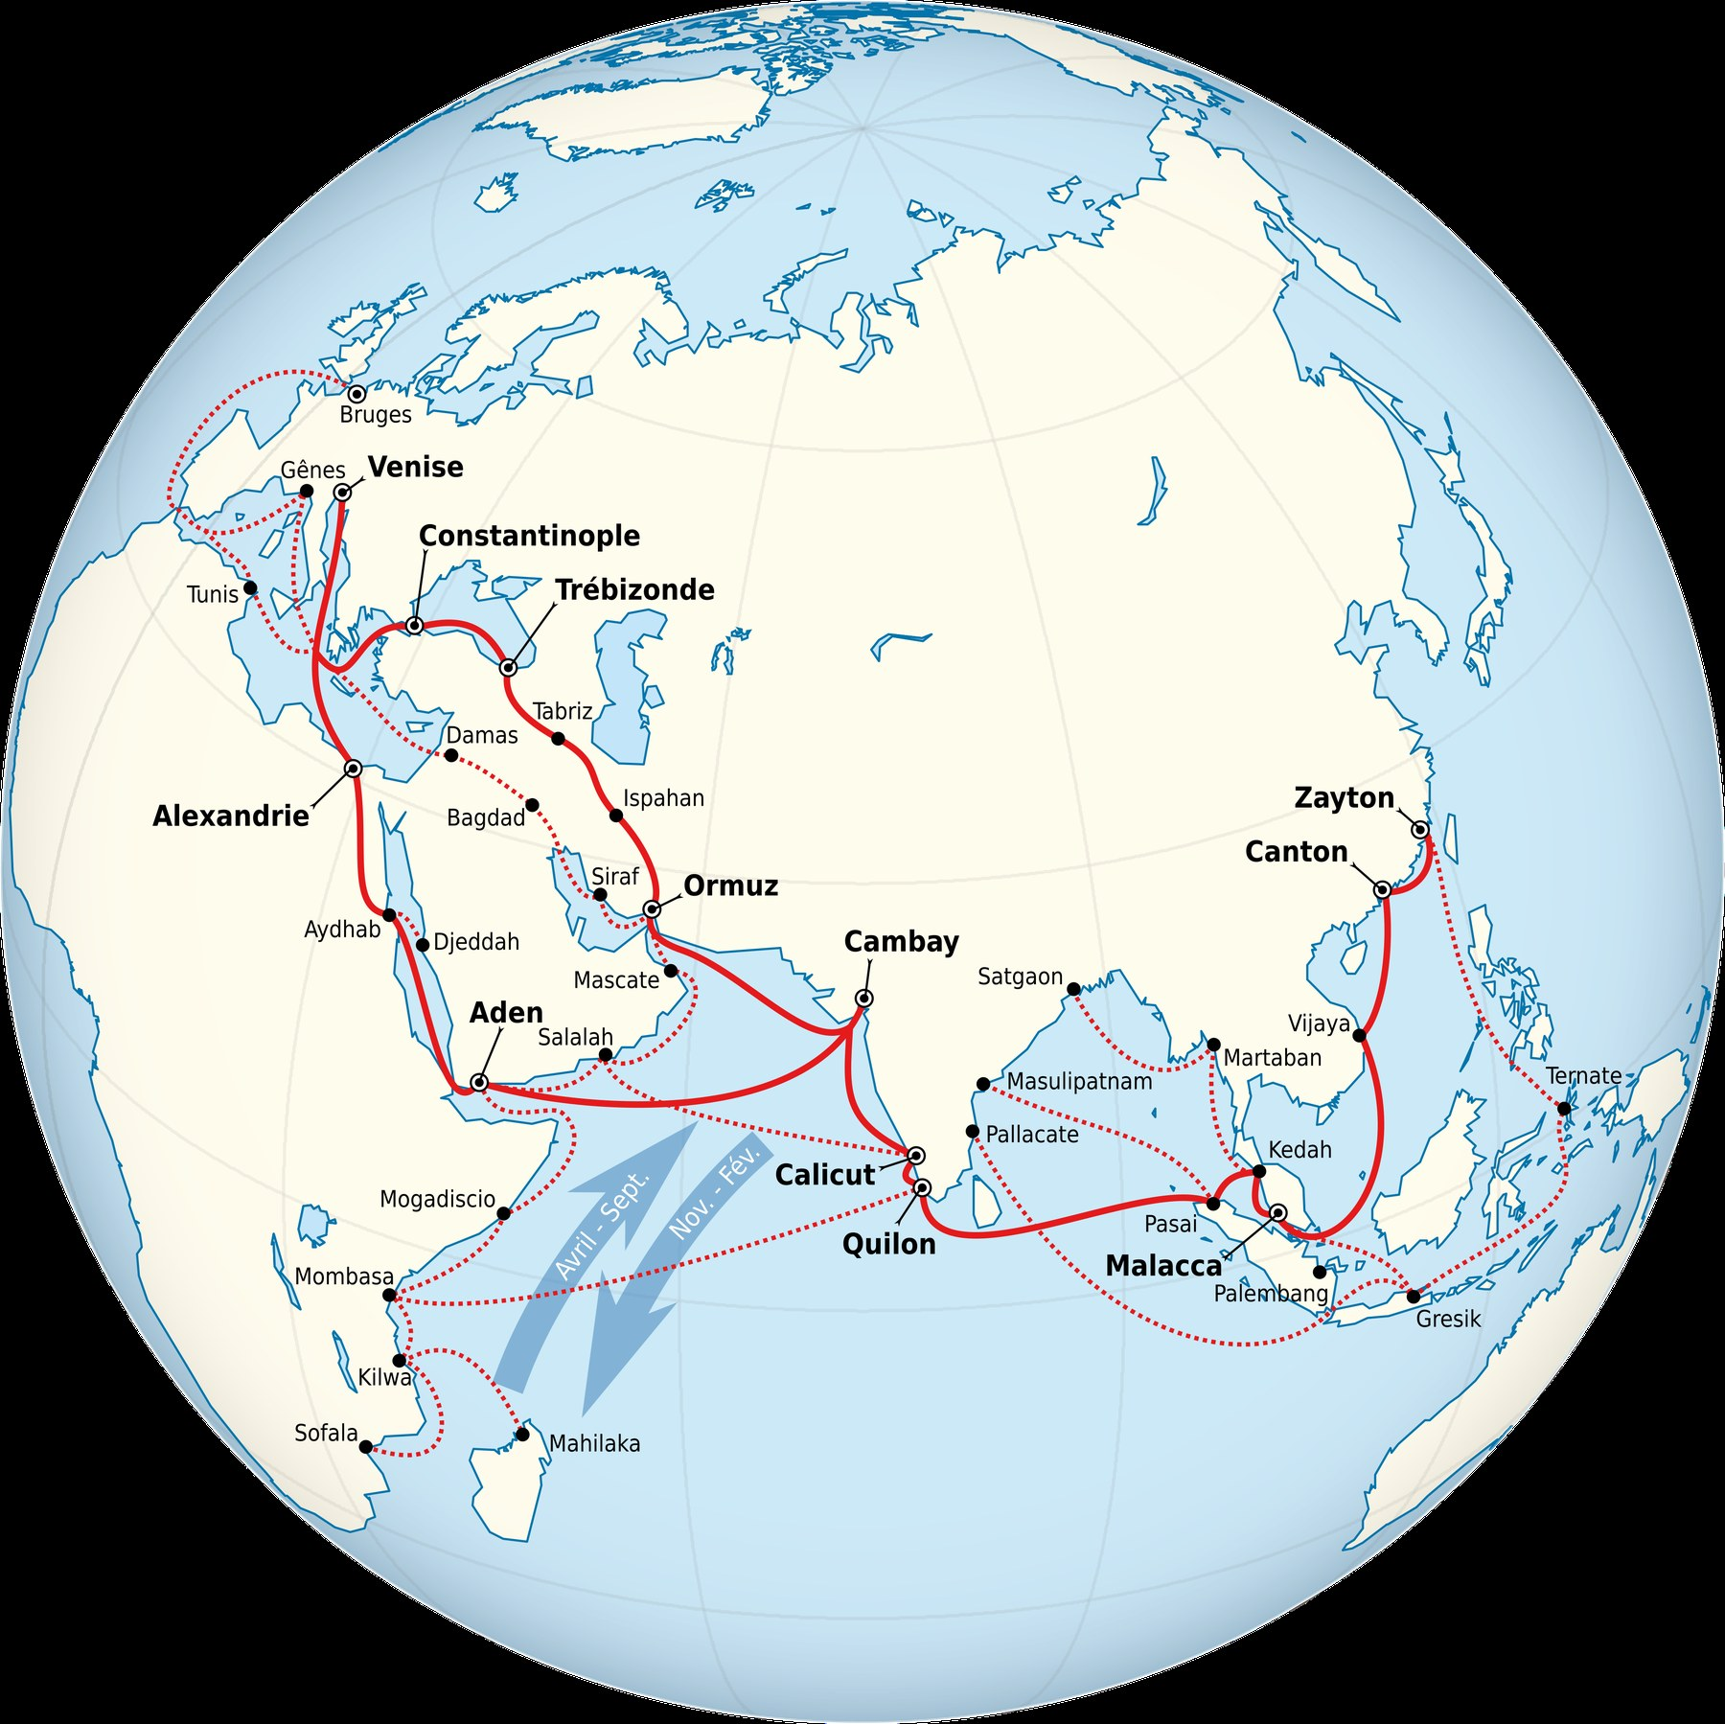
Medieval spice-trade routes. Tricholome, CC BY-SA 4.0. A historical document, not a map of Arrakis.
The map is a historical document about real trade between Asia, Africa and Europe. It is not a picture of Arrakis. Do not say "Arrakis is the Indies". Ask: what does a single, rare and distant resource do to the relations between the people who produce it and the people who consume it?
B1: complete a diagram (producers, extractors, consumers, controller, what the spice makes possible) with words from a box: Fremen, Guild navigators, noble families, the Emperor, sandworms, life, travel, the empire.
B2: in four sentences, explain why control of the spice is control of the empire, using which and so.
Role play starters: Without the spice, I... / For my people, the spice is... / Whoever controls it...
Grammar. Defining relative clauses (who, which, that, whose, where). Example: The spice is a substance. It exists only on Arrakis. → The spice is a substance which exists only on Arrakis.
Exercise 2. a) The Fremen are a people. They live in the deep desert. b) Arrakis is a planet. Water is rare there. c) The Guild is an organisation. Its navigators need the spice. d) The Harkonnens are a family. The Emperor gave them the planet.
Expanding your vocabulary: a resource, to extract, extraction, a supply, to depend on, dependence, a monopoly, a fief, a governor, profit, a trade route. Language for argument: because of, as a result, therefore, whoever controls...
Written trace: a definition paragraph (40 to 70 words) beginning "The spice is a resource which..."
Homework. Read Book I, the chapter of the crysknife (the teacher gives a two-line summary if you do not have the book). Learn six flashcards.

Lesson 3. Whose Planet? Empire and the Desert People
Step of the problématique: Je repère, then Je comprends. Who owns Arrakis: the Emperor who gives it, the family who rules it, or the people who live on it?
55 minutes, timed on 52.
Stage | Time | Activity | Skill
1 | 6 min | Flashcard duel in pairs. | EOI
2 | 10 min | A short dialogue, written for the lesson, Jessica and a Fremen housekeeper. | CO, EOC
3 | 12 min | Reading Q4: the Missionaria Protectiva. | CE
4 | 14 min | Exposés in threes, one minute each: Who owns Arrakis? | EOC
5 | 6 min | A 60-word opinion. | EE
6 | 4 min | Spiral, trace, homework. | EE

Stopping point: After stage 3.
Emergency exit (8 minutes): The dialogue, a short explanation of Q4, one sentence from each student.
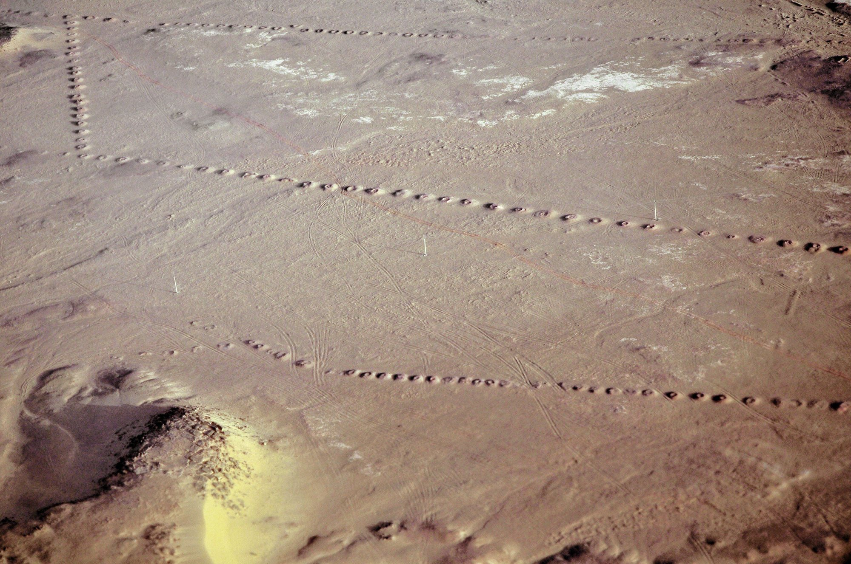
A foggara at Timimoun, Adrar, Algeria. LBM1948, 9 April 2009, CC BY-SA 4.0.
The Missionaria Protectiva is, in the novel, the Bene Gesserit order that plants protective legends on worlds such as Arrakis, so that a sister of the order can later be received and protected. In the Arrakeen scene, Jessica realises that the housekeeper's words echo a prophecy, and she decides to use it. The exact wording is to be read from the teacher's edition. The idea that matters: the religion of the people who live on Arrakis has been partly written by outsiders. This is the core of the problématique.
A historical image of a foggara (a qanat) in Algeria is used here: arid peoples have their own knowledge of water. The Fremen are not "primitive", and the offworlders' view of them is a colonial view. Who calls whom "primitive" in the novel, and why?
B1: match four sentences to four speakers (Emperor, Duke, Fremen, Bene Gesserit). 1. "I give this planet as a fief, and I can give it to someone else." 2. "I am sent to rule this land and to keep the spice moving into the empire's hands." 3. "This is our desert. We have lived here for generations." 4. "We planted a legend here, long ago, so that one of us would be safe."
B2: explain, with although and whereas, why the Fremen both believe and are manipulated.
Grammar. Concession: although, even though, whereas, however. Example: The Fremen are strong. They are used by outsiders. → Although the Fremen are strong, they are used by outsiders.
Exercise 3. a) Jessica is a foreigner. The Fremen respect her. b) The legend helps Jessica. It was invented by her order. c) The Duke wants peace. The Emperor wants him dead.
Expanding your vocabulary: to colonise, a coloniser, the colonised, to own, ownership, to rule, a native people, to exploit, a legend, to plant (an idea), to manipulate. Words for nuance: partly, to some extent, on the one hand, on the other hand.
Written trace: "The Missionaria Protectiva shows that the religion of Arrakis was partly written by outsiders. This means that..."
Homework. Oral recording, 45 seconds: "Who owns Arrakis? My view."

Lesson 4. Making a Messiah
Step of the problématique: Je comprends. How is a legend written, and who writes it?
55 minutes, timed on 52.
Stage | Time | Activity | Skill
1 | 5 min | Two homework recordings heard; the class reacts. | EOI
2 | 8 min | Reading aloud Q3 (the litany), with stress and pauses; chorus then individual. | EOC
3 | 10 min | Listening: How a prophecy works. | CO
4 | 14 min | Press conference: a Fremen witness and journalists; every student asks or answers once. | EOI
5 | 10 min | Rewriting: turn a plain event into a legend (passive, often without an agent). | EE
6 | 5 min | Spiral turn 3, homework. | EE

Stopping point: After stage 4.
Emergency exit (8 minutes): The litany read aloud, three questions and answers, one legend sentence in the passive.

Dunes and shadows at Sossusvlei. Diego Delso, delso.photo, CC BY-SA 4.0.
Q3 is a ritual sentence, short, repetitive, with a rhythm. Religious language works by repetition. Why is a sentence you repeat stronger than a sentence you understand?
B1: complete a short legend with verbs in the passive (plant, write, send, tell). B2: write a legend of 60 words, then underline every place where the agent is hidden.
Grammar. The passive used to build a myth: "It was written...", "He was sent...". This is different from the Orwell use of the passive to hide responsibility ("Mistakes were made"). Here the passive creates an invisible author. Ask, each time: by whom? Who gains from that disappearance?
Exercise 4. Example: The Bene Gesserit planted the legend. → The legend was planted (by the Bene Gesserit). a) Someone wrote the prophecy long ago. b) The Fremen will follow him. c) People are telling his story. d) They have seen the signs.
Expanding your vocabulary: a prophecy, a prophet, a messiah, a saviour, a sign, to fulfil, a believer, faith, a ritual, a litany, a myth, to worship.
Optional bridge (if the class knows the Orwell sequence, Terminale, axe Fictions et réalités): two ways of controlling language. Orwell's Newspeak reduces words; Herbert's prophecy multiplies sacred words. Is it more dangerous to take words away, or to give people the "right" words? A short question, not a second subject.
Written trace: "A messiah is made, not born. In Dune, the legend was planted by..."
"I must not fear. Fear is the mind-killer."
Q3. Book I, first chapter, the test of the gom jabbar. Read the litany, and the half page before it, in the class edition.
Homework. Revise all the flashcards for the mid-sequence assessment. Prepare a two-minute talk: "Who writes the legend of Paul? Use one quotation."

Lesson 5. Mid-Sequence Assessment
Step of the problématique: J'anticipe. If the Fremen follow the hero, what will they gain and what could they lose?
55 minutes, timed on 52.
Stage | Time | Activity | Skill
1 | 3 min | Instructions.
2 | 10 min | Compréhension de l'oral. | CO
3 | 15 min | Compréhension de l'écrit. | CE
4 | 14 min | Expression écrite. | EE
5 | 10 min | Oral: two-minute talks begin (continued in Lessons 6 and 7). | EOC, EOI

Stopping point: After stage 4.
Emergency exit (8 minutes): If time is very short: stages 2 and 4 only. Reading and talks in Lesson 6.
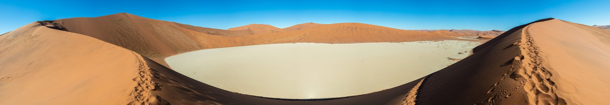
Dead Vlei, Namibia. Diego Delso, delso.photo, CC BY-SA 4.0.
This lesson is the mid-sequence assessment, out of 20 (CO 5, CE 5, EE 5, EO 5).
Part A, CO, 10 minutes. You will hear a short text three times. It was written for this assessment. It paraphrases an idea often reported from Herbert; it does not quote an interview. Questions: 1. What do many readers think? 2. What did Herbert want to show? 3. Name two things the believers gain. 4. What do they give? 5. Explain the last sentence in your own words. (LVB may answer question 5 in French if needed.)
Part B, CE, 15 minutes. Document 1 (scene summary, not a quotation): in Book I, in Arrakeen, Jessica understands that the Bene Gesserit, through the Missionaria Protectiva, planted legends on Arrakis long before her arrival, so that a sister of the order could one day be protected. The housekeeper's words echo a prophecy, and Jessica decides to use it. Document 2 is Q7.
Tasks: 1. Explain the Missionaria Protectiva in two sentences. 2. Find four pairs of opposites in Q7. 3. What do the two documents show about who writes Paul's legend?
Part C, EE, 14 minutes. B1: 80 to 100 words. B2: 120 to 150 words. "Is Paul the voice of the Fremen, or are the Fremen the voice of Paul's legend?"
Part D, EOC, two minutes, and one follow-up question: "Who writes the legend of Paul? Use one quotation." Talks continue in Lessons 6 and 7.
"warrior and mystic, ogre and saint, the fox and the innocent, chivalrous, ruthless, less than a god, more than a man"
Q7. Book III, a late epigraph by the Princess Irulan. The full epigraph is about five lines: check your edition.
Teacher grid, out of 20. CO, B1: main idea and some details; B2: all details and the implicit link between belief and loss of voice. CE, B1: explains the planted legend, finds two pairs; B2: explains the external author of the religion, four pairs, links the documents. EE content, B1: a clear opinion, one example; B2: a nuanced argument, two references, a concession. EE language, B1: modals and relatives mostly correct, five sequence words reused; B2: conditionals, passive and concession accurate, eight words reused. EO, B1: two minutes with pauses, a clear structure, one quotation; B2: fluent, structured, the quotation commented, a natural answer to a question.
Self-correction grid: Criterion / What I did / What I missed / My improved version. Rows: Content; References; Vocabulary reused; Accurate syntax.
Homework. Complete the self-correction grid. Write an improved version of your written answer.

Lesson 6. The Ecologist's Warning
Step of the problématique: J'anticipe. What does the scientist foresee, and what does he fail to foresee?
55 minutes, timed on 52.
Stage | Time | Activity | Skill
1 | 6 min | Two mid-sequence talks, continued. | EOC
2 | 8 min | Images: Banshee Hill, Oregon; a Sahel vegetation record (NASA); a satellite view of the Namib. A dune moves. What can people do? | EOI
3 | 10 min | Listening: Kynes's dream. | CO
4 | 12 min | Reading Q5, Q6 and Q9. | CE
5 | 10 min | Dilemma in fours: should the planet be made green, even if the Fremen way of life disappears? | EOI
6 | 6 min | An ecologist's note, spiral turn 4, homework. | EE

Stopping point: After stage 4.
Emergency exit (8 minutes): Listening, Q5, one sentence: "If..., then...".
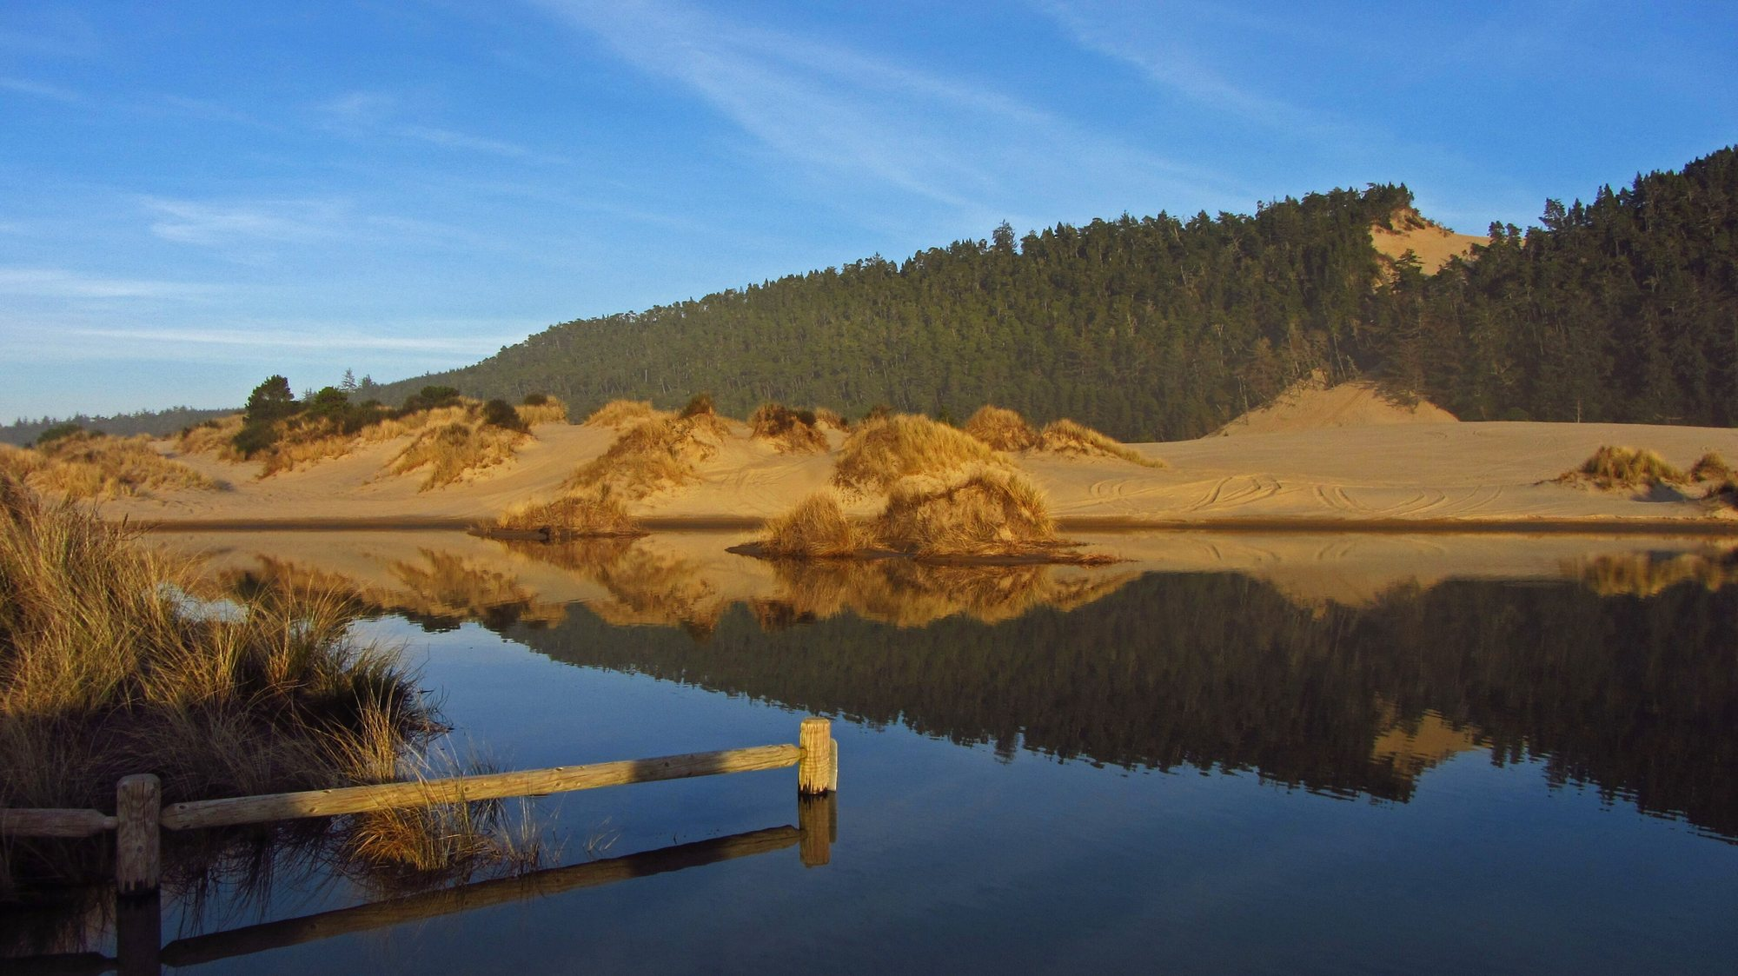
Banshee Hill, Oregon Dunes. Themom51, 21 January 2013, CC BY-SA 3.0.
Banshee Hill, in the Oregon Dunes, is near Florence, where Herbert planned an article. A light optional link to axe 6, used as biography and context, not as a substitute for Arrakis.
B1: complete "If the Fremen follow a hero, they might..." (two endings from a box, plus one personal). B2: a conditional chain of four links, ending with a consequence for the desert.
Text intelligence. Q5 is the father's voice inside the son's dying mind. The warning comes from science, not from religion, at the very moment when the religious story is winning. Q6 closes the chapter on accident and error. Why does Herbert give the strongest warning to a dying man, in what the chapter presents as a remembered lesson?
Grammar. First and second conditional; might, could, will, would. Example: If the spice disappeared, the Guild could not travel.
Exercise 5. a) the Fremen / follow Paul → the empire / fall. b) the planet / become green → the sandworms / die. c) a hero / take power → the long plan / stop.
Expanding your vocabulary: an ecologist, ecology, an ecosystem, a consequence, to foresee, to transform, terraforming, a long-term plan, irreversible, a warning, to warn against.
Written trace, 50 to 80 words: "As an ecologist, I warn that..."
"No more terrible disaster could befall your people than for them to fall into the hands of a Hero."
Q5. Book II, the chapter of Liet-Kynes dying in the desert.
"the most persistent principles of the universe were accident and error"
Q6. The same chapter, final line.
"the highest function of ecology is the understanding of consequences"
Q9. Appendix I, The Ecology of Dune. Some epigraphs give a shorter form: check your edition.
Homework. Oral recording, one minute: "A warning from Kynes to the Fremen". Learn Q5 by heart.

Lesson 7. The Hero Trap
Step of the problématique: Je trouve le sens. Is the hero the voice of the people or the voice that replaces them?
55 minutes, timed on 52.
Stage | Time | Activity | Skill
1 | 6 min | The last two-minute talks. | EOC
2 | 8 min | Listening: Q7 read aloud twice; students note pairs of opposites. | CO
3 | 10 min | Reading Q8: the threat to destroy the spice. | CE
4 | 12 min | Spiral presentations, from turn 1 to the tip, one minute per student. | EOC
5 | 10 min | Council rehearsal: questions for the final task. | EOI
6 | 6 min | Draft of the final statement, homework. | EE

Stopping point: After stage 4.
Emergency exit (8 minutes): Q7, Q8, and each student says the tip of the spiral in one sentence.
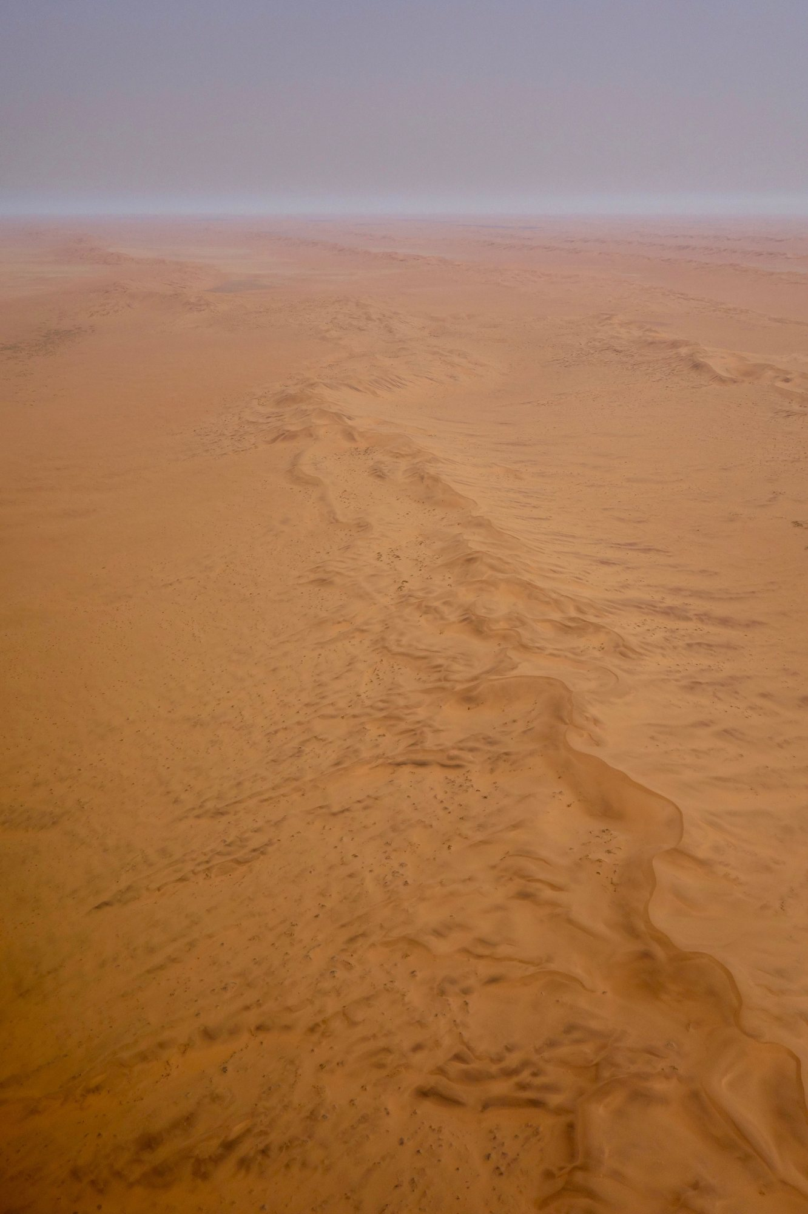
A serpentine ridge in the Namib. Sonse, 20 September 2017, CC BY 2.0.
B1: classify the words of Q7 into "positive" and "negative", then say which side wins for you. B2: comment on the effect of the antitheses in four to five sentences.
Text intelligence. Q7 is a portrait made of opposites: the historian cannot decide what Paul is. Q8 shows the liberator using the language of total control, and of the destruction of the very resource that defined the planet. Has the hero become the new owner of the spice?
The tip is a sentence the group has reached, not a sentence given in advance. A possible kind of tip (for the teacher, not to be written on the board first): "A people can be saved by the story that enslaves it."
Language for speech: Let me begin by... / I would like to stress that... / To put it simply... / I am convinced that... / To conclude...
Optional bridge: the leader as a manufactured figure. Big Brother may not even exist; Paul exists, but his legend was written before him. Does it matter whether the leader is real, if the story is what people follow?
Grammar. Comparison: as ... as, more ... than, the most, less than. Notice Q7: "less than a god, more than a man".
Exercise 6. a) the Fremen / independent / before. b) a legend / dangerous / an army. c) Kynes's plan / slow / Paul's war.
Expanding your vocabulary: a hero, heroism, a trap, to be trapped, an antithesis, to blackmail, a threat, a leader, a follower, to obey, charisma.
Written trace: the class tip, copied and signed by every group.
"warrior and mystic, ogre and saint, the fox and the innocent, chivalrous, ruthless, less than a god, more than a man"
Q7. Book III, a late epigraph by the Princess Irulan.
"The power to destroy a thing is the absolute control over it."
Q8. Book III, final chapter. Check the wording in your edition: some sources give "He who can destroy a thing has the real control of it."
Homework. Finish the draft of the final statement. Rehearse the briefing with a timer (3 to 4 minutes). Record it once.

Lesson 8. The Council of the Deep Desert
Step of the problématique: the tip. The class answers the problématique.
55 minutes, timed on 52.
Stage | Time | Activity | Skill
1 | 4 min | Instructions; roles are drawn.
2 | 30 min | The council: briefings (3 to 4 minutes), then one or two questions. | EOC, EOI
3 | 15 min | Written statement, final version. | EE
4 | 3 min | The self-correction grid is begun.

Stopping point: After stage 2.
Emergency exit (8 minutes): The written statement only, today; the briefings in the next lesson.
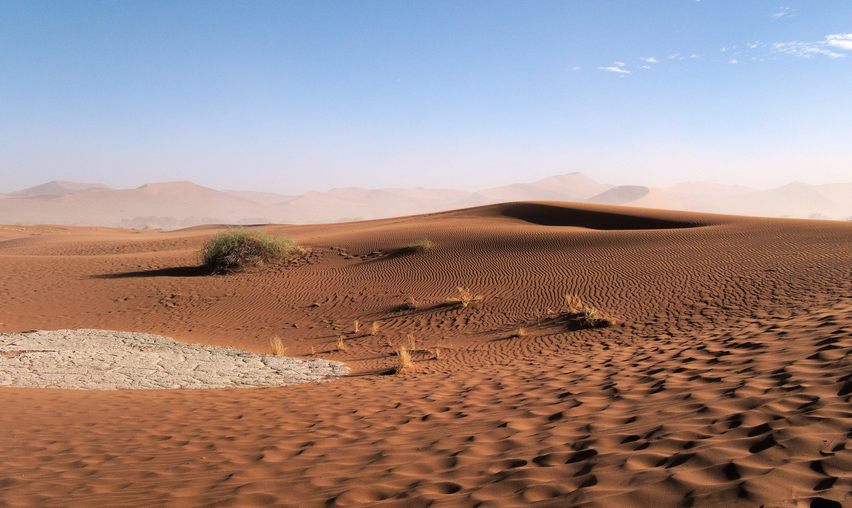
Ripples at Sossusvlei. Daniel Kraft, 21 May 2019, CC BY-SA 3.0.
This lesson is the final task and the summative assessment, out of 20 (briefing EOC 6, interaction EOI 4, written statement EE 6, language 4).
Situation. After the end of the novel, the Fremen elders of a sietch meet. You are an adviser. Choose one role: a Fremen elder; a planetologist trained by Kynes; a Fremen woman who knew Paul as Usul; a sceptical young fighter. You give a briefing: should the Fremen keep following Muad'Dib? Then you write a statement, to be kept in the sietch's records: 180 to 250 words (B1: 150 to 180).
This is not a dystopia opening page, and it is not a warning speech on the Orwell model. It is a council deliberation, inside the fiction, with a decision to take.
Requirements. Answer the problématique. Quote at least two short lines from Q1 to Q9. Use at least one conditional, one passive, and one concession.
Briefing structure (both levels): Introduction (who I am, my question) / Point 1 / Point 2 / Counter-argument (B2) / Decision / Thank you.
Guided B1 model (seven boxes). 1. Elders, I am a Fremen woman. I knew Muad'Dib when he was only Usul. (Who are you?) 2. He helped us to win, and our enemies were defeated. (What is positive? Use a passive.) 3. But the legend was written by strangers before he came. (Problem one. Use a passive.) 4. Although he is brave, he speaks for us, and we do not speak any more. (Problem two. Use a concession.) 5. Kynes's father said we must not "fall into the hands of a Hero". (A quotation.) 6. If we follow him everywhere, many young Fremen will die, and the plan to make water will stop. (A consequence. Use a conditional.) 7. So I think we must thank him, but the council must decide. (Your decision.)
Teacher grid. EOC, B1: three minutes, introduction, two points, conclusion, two quotations; B2: four minutes, a clear thesis, three points including a counter-argument, three quotations commented. EOI, B1: answers a simple question, asks for repetition if needed; B2: defends and nuances, reacts to objections, rephrases. EE, B1: a position stated, reasons, one example; B2: a position nuanced, a concession, two references, a link to today. Language: B1, six to eight sequence words, modals, relatives and conditionals generally correct; B2, ten or more words used precisely, passive, conditionals, concession and comparison accurate.
Three bridges for a later French sequence on René Barjavel's Ravage (1943), not developed here: 1. The dependence of a technical civilisation (spice / electricity). 2. The guide of a people in a hostile world, and what the guide asks in return. 3. The land that remakes its inhabitants. Is the environment a teacher or a tyrant?
Homework. Finish the self-correction grid. Rewrite your conclusion and one paragraph, following the teacher grid.

Expanding your vocabulary
The desert and nature. arid, barren, scarce, scarcity, a dune, sand, to recycle, an ecosystem, ecology, an ecologist, to transform, terraforming, irreversible.
Resource and power. a resource, to extract, a supply, to depend on, dependence, a monopoly, profit, a fief, a governor, to rule, to own, ownership.
Empire and colonialism. an empire, an emperor, to colonise, a coloniser, the colonised, a native people, to exploit.
Religion and myth. a prophecy, a prophet, a messiah, a saviour, a sign, to fulfil, faith, a believer, a ritual, a litany, a legend, a myth, to worship.
The hero. a hero, heroism, a leader, a follower, charisma, to obey, a trap, a threat, to blackmail.
Analysis. the narrator, the point of view, an epigraph, to foreshadow, an antithesis, an oxymoron, world-building, an invented word, the passive voice, the agent.
Argument and nuance. although, even though, whereas, however, on the one hand, on the other hand, to some extent, partly, as a result, therefore, I am convinced that, I would argue that, it could be said that.

Short quotations to remember
The novel remains protected. These are short lines, with references. Before class, check each line in the class edition.
- 1. "A beginning is the time for taking the most delicate care that the balances are correct." (Book I, opening epigraph)
- 2. "I must not fear. Fear is the mind-killer." (Book I, the gom jabbar)
- 3. "No more terrible disaster could befall your people than for them to fall into the hands of a Hero." (Book II, death of Liet-Kynes)
- 4. "less than a god, more than a man" (Book III, epigraph by the Princess Irulan)
- 5. "The power to destroy a thing is the absolute control over it." (Book III, final chapter)
- 6. "the highest function of ecology is the understanding of consequences" (Appendix I)

Recap
Arrakis is a desert world where water and the spice decide everything. The empire, the noble families and the Guild depend on a resource extracted from the land of the Fremen. The religion that makes Paul a messiah was partly planted by outsiders and is written down by a princess-historian. The scientist Kynes warns that a hero is the worst disaster for a people. At the end, the liberator controls the spice by threatening to destroy it. The problématique: a hero can be the voice of a people and also the voice that replaces it.

Fiche de lecture
Madame Carole Paoli Pompougnac's book-study worksheet (fiche de lecture) will be associated with this sequence, in its latest version, in pdf, docx and odt, once the model has been received.

