Anglais · CAP et baccalauréat professionnel · A2 et B1
S'exprimer sur le lieu de travail en anglais
Speaking English at work: PFMP, workshop, customers
Version adaptée dys
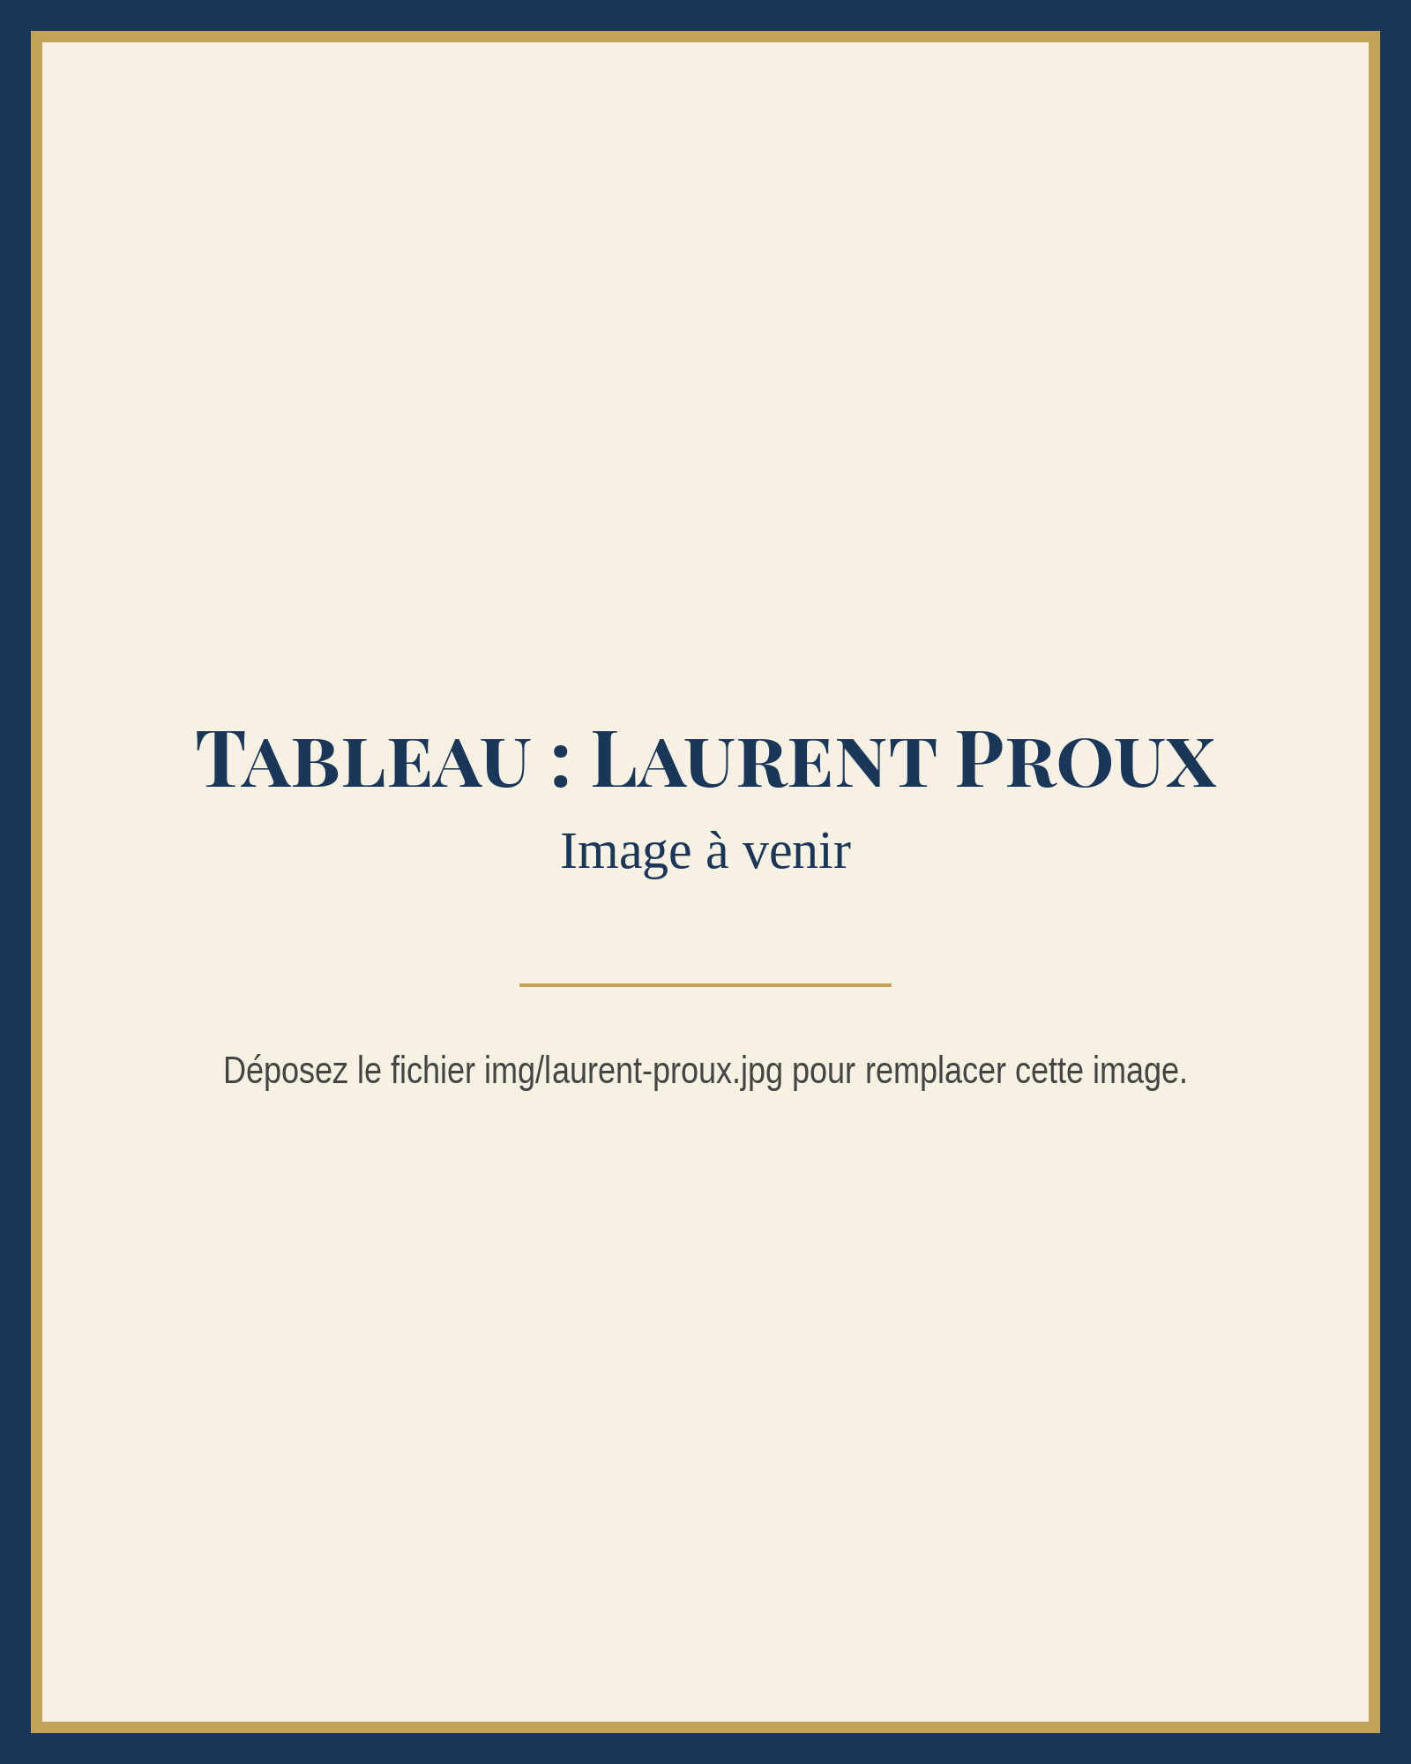
Tableau : Laurent Proux
Madame Carole Paoli Pompougnac
conçu par Madame Carole Paoli Pompougnac, mis en page par Grok
© 2026 Madame Carole Paoli Pompougnac · CC BY-NC-SA 4.0

Anglais · CAP et baccalauréat professionnel · A2 et B1
S'exprimer sur le lieu de travail en anglais
Speaking English at work: PFMP, workshop, customers
Version adaptée dys

Tableau : Laurent Proux
Madame Carole Paoli Pompougnac
conçu par Madame Carole Paoli Pompougnac, mis en page par Grok
Inclusion
Version adaptée dys
Mêmes activités, consignes allégées, étapes découpées, banque de mots visible. Chaque leçon a sa page, avec les aménagements en tête. Police Atkinson Hyperlegible, interligne large, italiques remplacées par le gras. La tâche reste la même : seul l'étayage change.
Principes pour toute la séquence
Aménagements, leçon par leçon
- Lesson 1. Looking at work
- Lesson 2. Hello, I work here
- Lesson 3. What are they doing?
- Lesson 4. Can you show me how?
- Lesson 5. Safety firstAvis de sécurité présenté en six règles courtes, numérotées, chaque modal en gras.Une carte visuelle à quatre cases : OBLIGATION (must / have to), CONSEIL (should), PERMISSION (can), INTERDICTION (can't / mustn't), avec un exemple dans chaque case.Questions de CE : 1 à 6, réponses soulignables dans le texte.Oral : cadre à trous à lire puis à dire, d'une minute au plus : Good morning, I'm... Welcome to... You must... You mustn't... You should... You can leave your bag...Travail à la maison : exercice 1 seulement, et relire le cadre à trous.
- Lesson 6. There's a problemAvant l'écoute, donner cinq mots-clés : damaged, box, order 4821, Mr Harris, replace. Lire les questions 1 à 6 à voix haute.Script écouté une troisième fois, par blocs (le problème, les actions déjà faites, la solution).Banque de verbes au past simple visible, avec l'infinitif : arrived (arrive), opened, checked, told, went (go), found (find), were (be), replaced.Un seul dialogue modèle (dialogue 5), à trous, puis lu en binôme.Note d'incident : cadre à trous A2 uniquement, déjà largement amorcé.Travail à la maison : exercices 1 (dix verbes seulement) et 2.
- Lesson 7. Customers and tutorsQuestions de CO dans l'ordre du script, avec une banque : Mrs Grant, 4702, Friday, ready, this morning, switch the machine on.Formules polies présentées en deux colonnes courtes (client / tuteur), à copier telles quelles, sans l'exercice de transformation si celui-ci est trop lourd : le proposer en défi facultatif.Oral au tuteur : cadre à trous de cinq phrases, lu puis dit.Compte rendu de PFMP : cadre A2 à trous, déjà structuré en cinq phrases à compléter. Volume visé : 60 mots. L'enseignant peut accepter une dictée à l'adulte ou un enregistrement oral transcrit, si l'écrit est un obstacle majeur, tout en gardant une trace écrite minimale.Pour la préparation de la tâche finale : une fiche unique recto, six cases, mots-clés déjà proposés à choisir et à entourer.
- Lesson 8. Welcome to the workshopCourriel A2 seulement, présenté avec des interlignes larges. Questions 1 à 6, réponses courtes, possibilité de souligner dans le texte.Écoute : donner avant le message les cinq informations à écouter (qui parle, commande 4702, problème 4821, chaussures, sac). Troisième écoute possible.Préparation : fiche à six cases déjà titrées, avec amorces écrites (Good morning, I'm... Welcome... You must... You can leave your bag... First... Then... Finally... Last week, a box arrived... We...).Oral : durée A2, partenaire bienveillant, banque de mots visible, droit de relire une amorce. L'enseignant évite la question imprévue trop éloignée, ou la pose avec un choix visuel (Did you tell your tutor, or did you call the customer first?).Autoévaluation : cases à cocher seulement, plus une phrase à trous : Today I did well when I... Next time I want to...Compte rendu écrit : accepter le cadre de la leçon 7, éventuellement dicté, sans exiger une remise en page complexe.
Document téléchargeable : voir les téléchargements (version adaptée dys, en pdf, docx et odt).
Version adaptée dys · Lesson 1
Lesson 1. Looking at work
Tableau : Laurent Proux
AMÉNAGEMENTS DE LA LESSON 1
Pour l'enseignant. Regarder le travail, découvrir l'œuvre de Laurent Proux.
Durée. 55 minutes.
Activités langagières. compréhension de l'écrit, expression orale en continu.
Objectifs. À la fin de la leçon, l'élève peut : identifier des éléments visibles dans l'œuvre (atelier scolaire, jeunes personnes et adultes, établis, cartons, grandes fenêtres) ; décrire la scène en anglais, à l'oral, avec le present continuous ; distinguer un fait visible d'une hypothèse ; copier une première trace dans le cahier.
Matériel. Reproduction projetée de l'œuvre, sans titre. Texte de lecture A2 et texte B1. Tableau pour la banque de mots. Cahiers.
Langue de la leçon. Lexique de la scène. present continuous (I can see... They are working. What are they making?). Formules d'hypothèse : I think..., Maybe..., They might be...
Phonologie. Prononciation de workshop, workbench, window, cardboard. Accent de mot sur la première syllabe de WORK-shop, WORK-bench, CAR-d-board.
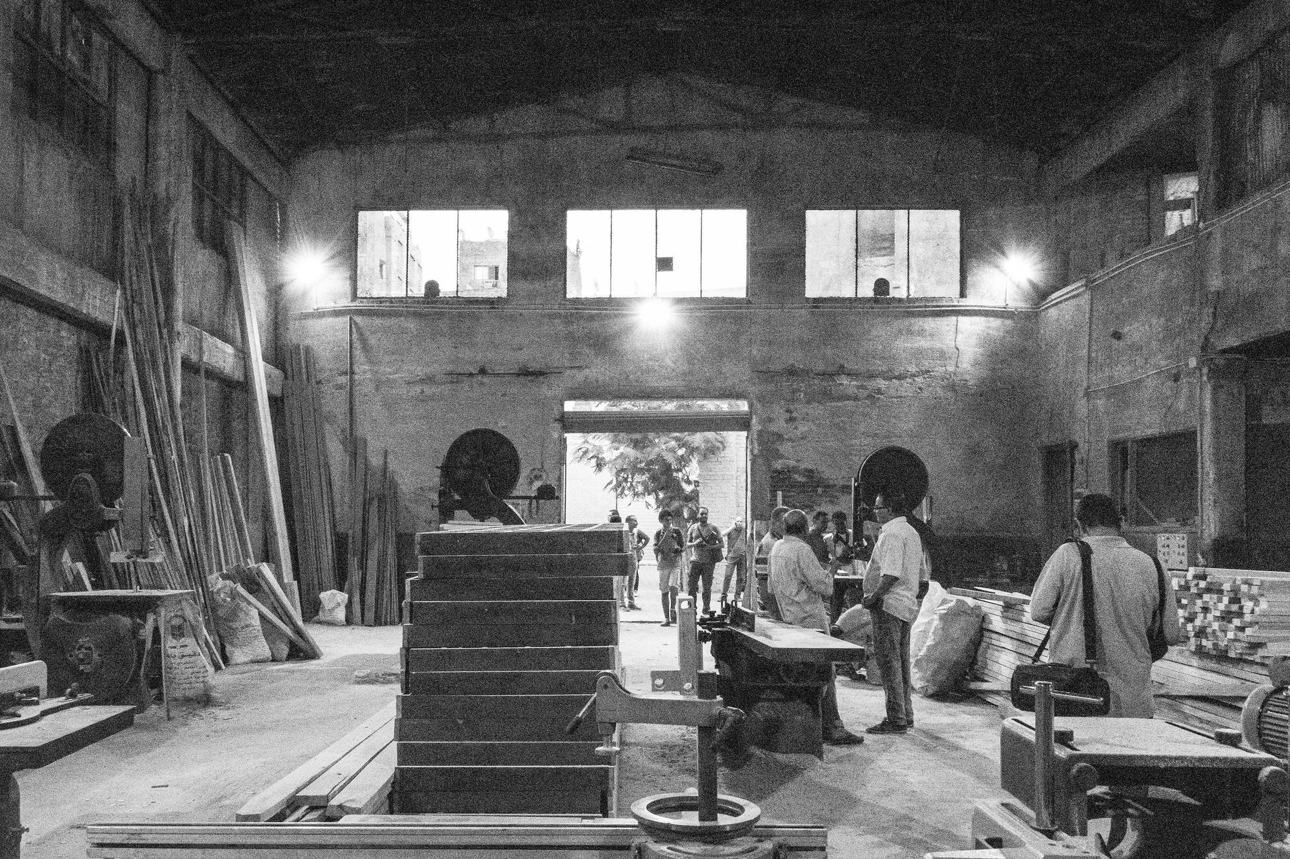
Un atelier de menuiserie, avec de grandes fenêtres, des machines et des personnes au travail. Photo : Yasser.mahmoud, CC BY-SA 4.0, Wikimedia Commons.
Amorce (5 min)
POUR LES ÉLÈVES
Look at the painting for one minute. Do not write. Then, on your own, say three words in English about what you can see. After that, tell your three words to your partner.
Recueillir quelques mots au tableau, en anglais. Ne pas corriger encore le contenu : noter fidèlement, puis faire ajuster la langue si un mot est en français (atelier devient workshop, établi devient workbench, carton devient cardboard box, fenêtre devient window).
Activité 1. Observe and describe (12 min). Expression orale en continu.
POUR LES ÉLÈVES
Work in pairs. Look at the painting again. Answer these questions in English, in full sentences.
- Where are these people?
- Who can you see: only adults, only young people, or both?
- What objects can you see?
- What is in front of the large windows?
- What are these people doing?
Then share one sentence with the class.
Activité 2. Read and understand (10 min). Compréhension de l'écrit.
POUR LES ÉLÈVES, TEXTE A2 (ENVIRON 90 MOTS)
A painting of work
Laurent Proux is a contemporary French painter. He paints the world of work. In this painting, we can see young people and adults. They are in a school workshop. They are working. There are workbenches and cardboard boxes. There are large windows. We cannot hear what these people are saying. We can only imagine their words. Look at the painting carefully. What do you think they are making? Who do you think they are?
POUR LES ÉLÈVES, TEXTE B1 (LE TEXTE A2, PLUS CE SECOND PARAGRAPHE, ENVIRON 80 MOTS DE PLUS)
A painting of work
Laurent Proux is a contemporary French painter. He paints the world of work. In this painting, we can see young people and adults. They are in a school workshop. They are working. There are workbenches and cardboard boxes. There are large windows. We cannot hear what these people are saying. We can only imagine their words. Look at the painting carefully. What do you think they are making? Who do you think they are?
Why paint a workshop today? Because work is a big part of our lives, and art can help us look at it with attention. In a school workshop, young people and adults often work side by side. The painting does not tell us the names of these people, and it does not tell us the exact object they are making. That is our task: we look, we describe what is there, and then we hypothesise. We speak as observers, not as inventors of false facts.
POUR LES ÉLÈVES, QUESTIONS (A2 : QUESTIONS 1 À 5. B1 : TOUTES LES QUESTIONS)
Read the text once. Then read it again and answer.
- Is Laurent Proux a painter of the past or a contemporary painter? Write the words from the text.
- What world does he paint?
- Where are the people in the painting?
- Name three objects or elements we can see, according to the text.
- True, false, or the text doesn't say: The painter tells us the exact words of the people in the workshop.
- (B1) What does the text ask us to do first, before we hypothesise?
- (B1) In your own words, why can a painting of a workshop be useful for us?
Activité 3. Hypothesise (12 min). Expression orale en continu, puis un échange en binôme.
POUR LES ÉLÈVES
Look at the painting. These questions have no single correct answer. Use I think..., Maybe..., They might be...
- Who are these people? Students, tutors, both?
- What are they making?
- What time of day is it? How do the large windows help you decide?
- What would two people in the painting say to each other? Prepare four short lines, in English, and be ready to say them to the class.
Activité 4. Building your vocabulary (8 min).
POUR LES ÉLÈVES
Building your vocabulary
Copy these words into your notebook. Then match each word to its meaning.
- a workshop
- a workbench
- a cardboard box
- a window
- a tutor
- an apprentice
- at the moment
- to hypothesise
Meanings:
a. a person who is learning a job b. a table where people work with their hands or with tools c. a room or building where people make or repair things d. a person who helps and guides you at work or during PFMP e. now, at this time f. a glass opening in a wall that lets light in g. to say what you imagine, when you are not sure h. a container made of thick paper, used to store or carry things
Point de langue et trace écrite (6 min).
POUR LES ÉLÈVES. TRACE POUR LE CAHIER
Present continuous, for a scene
We use the present continuous to say what is happening now, in the painting or in the workshop: subject + am / is / are + verb-ing.
- I am working in the workshop.
- He is checking the box.
- She is standing near the workbench.
- They are working in front of the large windows.
- What are they doing? They are working.
- What is he making? I think he is packing a box.
To hypothesise:
- I think they are students.
- Maybe they are preparing an order.
- They might be apprentices.
Travail à la maison (2 min pour donner la consigne).
POUR LES ÉLÈVES
Homework, Lesson 1
- Complete the sentences with the present continuous of the verb in brackets. a. The young people _______________ in the workshop. (work) b. An adult _______________ near the workbench. (stand) c. "What _______________ they _______________?" "I think they _______________ a box." (do / pack) d. We _______________ at a painting by Laurent Proux. (look)
- Write five sentences about the painting: three facts you can see, and two hypotheses with I think or Maybe.
- Learn the eight words from Building your vocabulary. You will use them again in Lesson 2.
Version adaptée dys · Lesson 2
Lesson 2. Hello, I work here
Tableau : Laurent Proux
AMÉNAGEMENTS DE LA LESSON 2
Pour l'enseignant. Saluer, se présenter, rencontrer un collègue et le tuteur.
Durée. 55 minutes.
Activités langagières. compréhension de l'oral, interaction orale.
Objectifs. À la fin de la leçon, l'élève peut : comprendre un court dialogue d'accueil sur un lieu de travail ; saluer, se présenter, présenter un camarade ; employer des formules de politesse simples ; jouer un dialogue avec un collègue, puis avec un tuteur.
Matériel. L'œuvre projetée. Script de compréhension de l'oral (voix de l'enseignant ou enregistrement). Les deux dialogues modèles. Banque de formules.
Langue de la leçon. Good morning, Hello, Hi, Nice to meet you, This is..., I am..., I work in..., I'm a PFMP student, Please, Thank you, Could you...?, See you tomorrow. Présent simple pour l'identité (I'm Samir. I work in the workshop.).
Phonologie. Intonation chaleureuse des salutations. Nice to MEET you. Forme polie Could you (/kʊd juː/).

Une apprentie mécanicienne et son tuteur consultent un manuel technique. Photo : B. A. Cornfeld, Department of Defense (États-Unis), domaine public, Wikimedia Commons.
Amorce (5 min)
POUR LES ÉLÈVES
Look at the painting. Imagine two people are talking, a young person and an adult. It is the beginning of the day. What do they say to greet each other? With your partner, say two lines.
Recueillir deux ou trois propositions. Annoncer : aujourd'hui, nous apprenons à saluer et à nous présenter au travail.
Activité 1. Listen: a first day in the workshop (12 min). Compréhension de l'oral.
POUR LES ÉLÈVES, QUESTIONS (À DONNER AVANT LA PREMIÈRE ÉCOUTE)
You will hear a conversation in a workshop. Listen twice. Then answer.
- What is the young woman's name?
- Why is she in the workshop?
- What is the tutor's name?
- Who is Karim?
- What is Karim doing at the moment?
- Where can Léa leave her bag?
- True or false: Karim works near the window.
Activité 2. Building your vocabulary (8 min).
POUR LES ÉLÈVES
Building your vocabulary
Copy these phrases. They help you greet people and introduce yourself at work.
Greetings
- Good morning. / Good afternoon. / Hello. / Hi.
- Nice to meet you. / Nice to meet you too.
- Welcome to the workshop.
Introducing yourself
- I'm Léa Morel. / My name is Léa Morel.
- I'm a PFMP student from the lycée. (PFMP: your work placement.)
- I work in the workshop. / I work at this workbench.
Introducing someone else
- This is Karim. He works here.
- Karim, this is Léa. She is with us for her PFMP.
Polite phrases
- Please. / Yes, please. / Thank you. / Thanks.
- Could you show me, please?
- Where can I leave my bag?
Leaving
- See you tomorrow. / Have a good day. / Goodbye.
Now complete the short dialogue. Use the phrases above.
A: Good morning. _______________ Léa. I'm a _______________ student. B: _______________ meet you, Léa. I'm Mr Baker, your _______________. _______________ to the workshop. A: Nice to meet you _______________. _______________ you.
Activité 3. Model dialogues, then your turn (14 min). Interaction orale.
POUR LES ÉLÈVES
Dialogue 1. With a colleague
A: Hi, I'm Léa. I'm a new PFMP student. B: Hi Léa, I'm Karim. Nice to meet you. I work at this workbench, near the window. A: Nice to meet you too. What are you doing at the moment? B: I'm preparing these cardboard boxes. Can you pass me that box, please? A: Sure. Here you are. B: Thanks.
Dialogue 2. With the tutor
Student: Good morning, Mr Baker. I'm Samir, the PFMP student from the lycée. Tutor: Good morning, Samir. Welcome. Nice to meet you. Let me show you the workshop. Student: Thank you. What should I do first? Tutor: First, leave your bag in the locker. Then come with me to the workbench. Student: All right. Where can I put my phone? Tutor: You can leave it in the locker too, please.
Your task. In pairs, choose Dialogue 1 or Dialogue 2. First, read it aloud twice (change roles the second time). Then write a short variant with your own names and your own workplace (workshop, site, shop or kitchen). Be ready to act it out.
Activité 4. Meet three people (10 min). Interaction orale.
POUR LES ÉLÈVES
Walk around the classroom (or work in a group of four). Meet three classmates. For each person, you must:
- Greet them.
- Say your name and your role (I'm a PFMP student / I work in...).
- Ask one question (What are you doing at the moment? / Where do you work? / Who is your tutor?).
- Listen to the answer and say Nice to meet you or Thank you.
You have about two minutes for each meeting. Use English only.
Trace écrite (4 min).
POUR LES ÉLÈVES. TRACE POUR LE CAHIER
At work, first contact
- Good morning. I'm Samir. I'm a PFMP student from the lycée.
- Nice to meet you. I'm Mr Baker, your tutor. Welcome to the workshop.
- This is Karim. He works at this workbench.
- What are you doing at the moment? I'm preparing these boxes.
- Where can I leave my bag? You can leave it in the locker, over there.
- Could you show me, please? Yes, of course.
- Thank you. See you tomorrow.
Travail à la maison (2 min).
POUR LES ÉLÈVES
Homework, Lesson 2
- Put the lines in the correct order to make a dialogue. Write the full dialogue in your notebook. a. Nice to meet you too. Thank you. What should I do first? b. Good morning. I'm Inès, the new PFMP student. c. First, put on your safety shoes. Then I'll show you the workshop. d. Good morning, Inès. Nice to meet you. I'm Ms Clark, your tutor. Welcome.
- Write a short dialogue (6 to 8 lines) between you and a colleague on your first day. Use at least four phrases from Building your vocabulary.
- Learn Dialogue 2. You will need it again later in the sequence.
Version adaptée dys · Lesson 3
Lesson 3. What are they doing?
Tableau : Laurent Proux
AMÉNAGEMENTS DE LA LESSON 3
Pour l'enseignant. Décrire une activité en cours, nommer outils et matériaux, rédiger une légende.
Durée. 55 minutes.
Activités langagières. expression orale en continu, expression écrite.
Objectifs. À la fin de la leçon, l'élève peut : décrire ce que font des personnes dans l'atelier, au present continuous ; utiliser un lexique d'outils et de matériaux adapté à son métier ; rédiger une légende d'œuvre en anglais, en séparant les faits visibles et les hypothèses.
Matériel. L'œuvre projetée. Banque Expanding your vocabulary (version commune et onglets métiers). Papier pour la légende, ou le cahier.
Langue de la leçon. present continuous (affirmative, négative, interrogative). Contraste bref avec le présent simple (I work in this workshop. At the moment, I am checking an order.). Lexique des outils.
Phonologie. -ing : working, checking, preparing, standing, making. Ne pas réduire they are au point de le rendre inaudible en A2 ; en B1, on peut faire entendre they're.
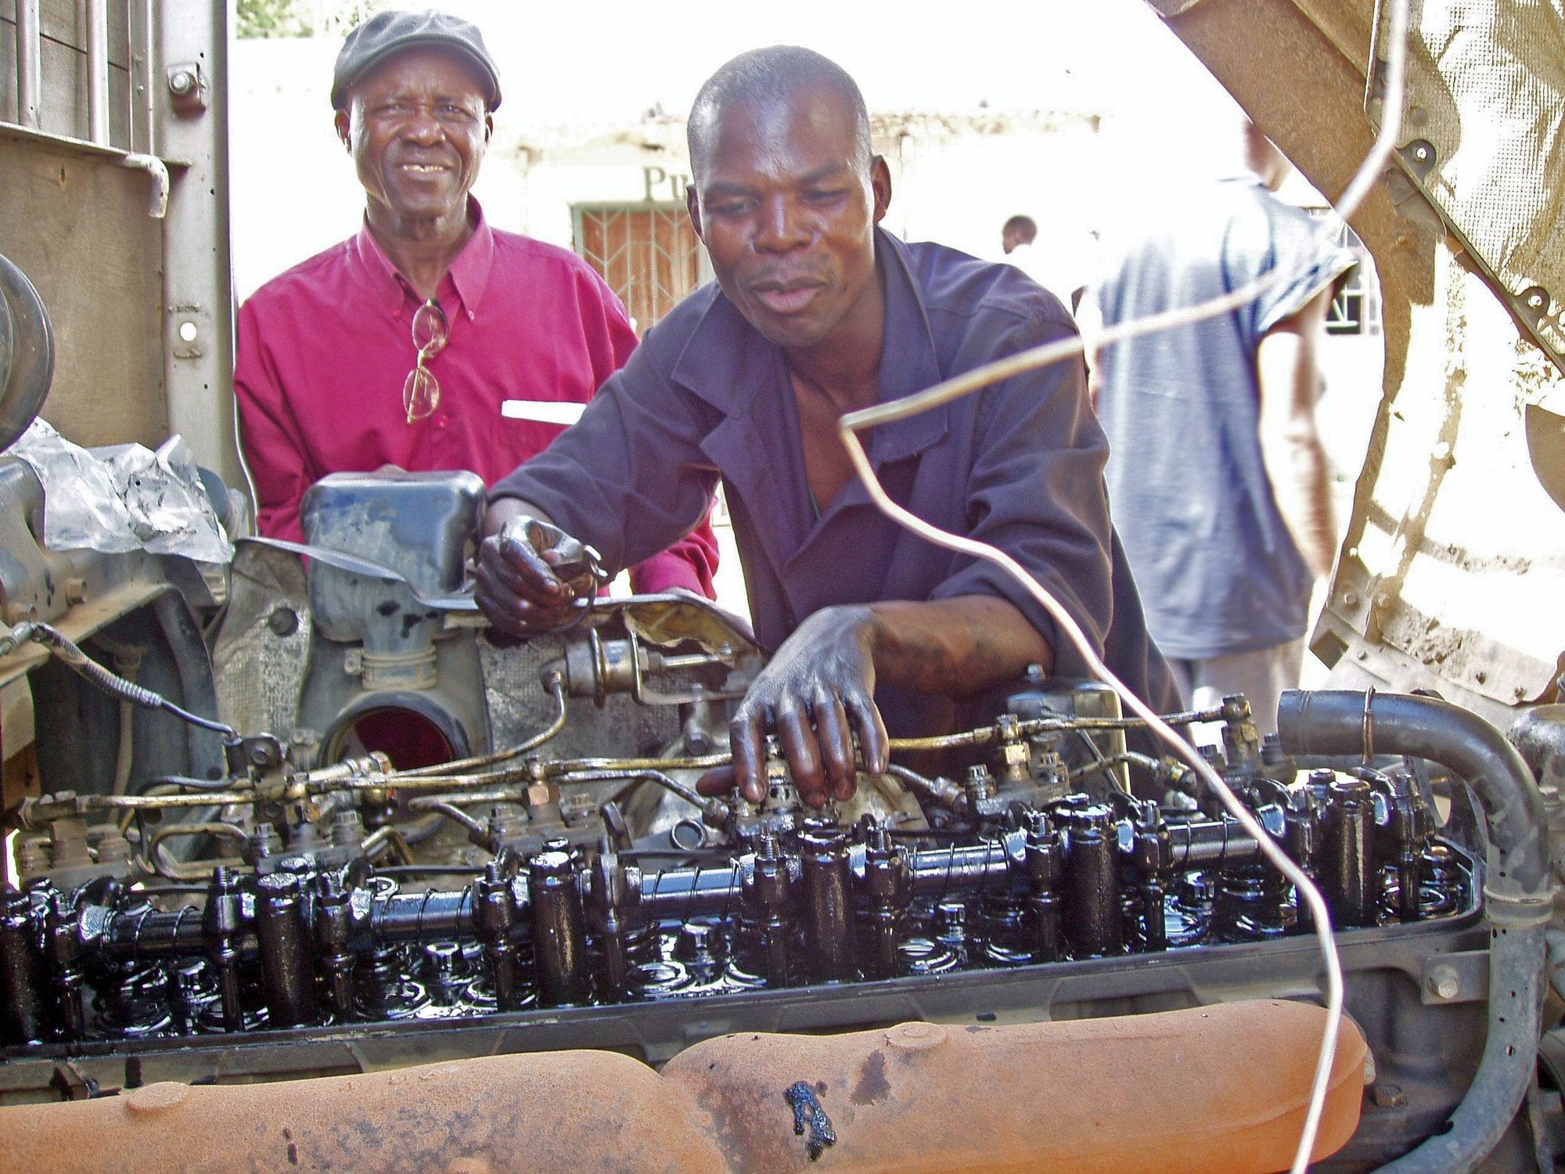
Dans un centre de formation, un élève et un formateur travaillent sur un moteur. Photo : IICD, CC BY 2.0, Wikimedia Commons.
Amorce (6 min)
POUR LES ÉLÈVES
Look at the painting. I will point to a part of the picture. Say one sentence with the present continuous, for example: They are working near the workbenches. Use I think if you are not sure.
Activité 1. Describe the scene (12 min). Expression orale en continu.
POUR LES ÉLÈVES
Prepare a short oral description of the painting (A2: 5 to 6 sentences. B1: 8 to 10 sentences). You will say it to your partner, then one or two students will say it to the class. Use this plan:
- Say the painter's name and what he paints.
- Say where the people are.
- Say who you can see.
- Name the workbenches, the cardboard boxes and the large windows.
- Say what the people are doing, with the present continuous.
- Add one hypothesis, with I think or They might be.
You may use notes (key words only).
Activité 2. Expanding your vocabulary: tools and materials (12 min).
POUR LES ÉLÈVES
Expanding your vocabulary
Common words, for every workplace
- a tool, a machine, materials, an order, a product, a task
- to check, to prepare, to make, to repair, to measure, to clean, to pack
- a pair of gloves, safety shoes, a locker
- Pass me the..., please. / I'm using a... / This is for...
Maintenance and industry
- a screwdriver, a spanner (or wrench), a pair of pliers, a spare part
- an engine, a machine, a cable, a switch, a leak
- to switch on, to switch off, to check, to replace, to assemble
Building
- a helmet, a drill, a level, a tape measure, a plan, a brick, a load
- a site, scaffolding
- to measure, to cut, to build, to carry, to check
Sales and customer service
- a customer, a counter, a shelf, stock, a receipt, an exchange, a refund
- to serve, to check an order, to pack, to exchange, to recommend
Catering
- a kitchen, a worktop, a tray, a knife, an order, an allergen
- to prepare, to cut, to cook, to serve, to clean, to check hygiene
Exercise. Complete with a word from your list.
- At the moment, I _______________ the engine. (maintenance: check)
- Can you pass me the _______________, please? (building: tape measure or drill)
- The _______________ is waiting at the counter. (sales: customer)
- I'm _______________ the order for table five. (catering: preparing or serving)
- For every workplace: This _______________ is for the delivery. Where can I put it? (cardboard box or order)
Activité 3. Write a caption (12 min). Expression écrite.
POUR LES ÉLÈVES
Write a museum caption in English for this painting by Laurent Proux. Do not invent a title.
A2. Write 50 to 60 words. Use this frame: This painting is by Laurent Proux, a contemporary French painter. In the painting, we can see... They are... There are... I think...
B1. Write 80 to 100 words. First describe what is in the painting. Then add a sentence about why this scene is interesting for students in a lycée professionnel. End with one hypothesis.
When you finish, exchange your caption with your partner. Underline one sentence you like. Correct one language detail if you can.
Activité 4. A short oral caption (8 min). Expression orale en continu.
POUR LES ÉLÈVES
Using your written caption, say it aloud to your partner, without reading every word. Look at the painting, then at your partner. Your partner listens and asks one question, for example: What do you think they are making? Then change roles.
Trace écrite (incluse dans les 5 minutes finales, avec le travail à la maison).
POUR LES ÉLÈVES. TRACE POUR LE CAHIER
Present continuous and present simple
- Every day, I work in the workshop. (present simple: a habit, a fact)
- At the moment, I am checking the order. (present continuous: now)
- In the painting, they are working in front of the large windows.
- What is she doing? She is measuring a piece.
- They are not talking to us. We can only imagine their words.
A useful frame
- This is a... / I'm using a... to... / Can you pass me the..., please?
Travail à la maison (dans les 5 minutes finales : 5 min = trace + consigne).
POUR LES ÉLÈVES
Homework, Lesson 3
- Put the verb in the present simple or the present continuous. a. Every morning, Léa _______________ at eight. (arrive) b. Look! She _______________ a cardboard box. (open) c. Karim _______________ in this workshop every day. (work) d. At the moment, the tutor _______________ the task. (explain) e. In the painting, the people _______________ in front of large windows. (work)
- Copy and improve your museum caption. Check facts and hypotheses.
- Learn ten words from Expanding your vocabulary: the common list, plus five words from your trade.
Version adaptée dys · Lesson 4
Lesson 4. Can you show me how?
Tableau : Laurent Proux
AMÉNAGEMENTS DE LA LESSON 4
Pour l'enseignant. Demander et donner des consignes, comprendre une procédure écrite.
Durée. 55 minutes.
Activités langagières. compréhension de l'écrit, interaction orale.
Objectifs. À la fin de la leçon, l'élève peut : comprendre une procédure professionnelle courte écrite en anglais ; donner une consigne claire à l'impératif ; demander une instruction de façon polie ; enchaîner les étapes avec First, then, next, finally.
Langue de la leçon. Impératif (Put on your gloves. Don't touch the machine.). Demandes : Can you show me how to... ? Could you say that again, please? What do I do first? Enchaînement : First, Then, Next, After that, Finally.
Phonologie. Impératif : attaque nette du verbe (Put, Check, Switch). Don't bien audible. Intonation montante de Can you show me how?
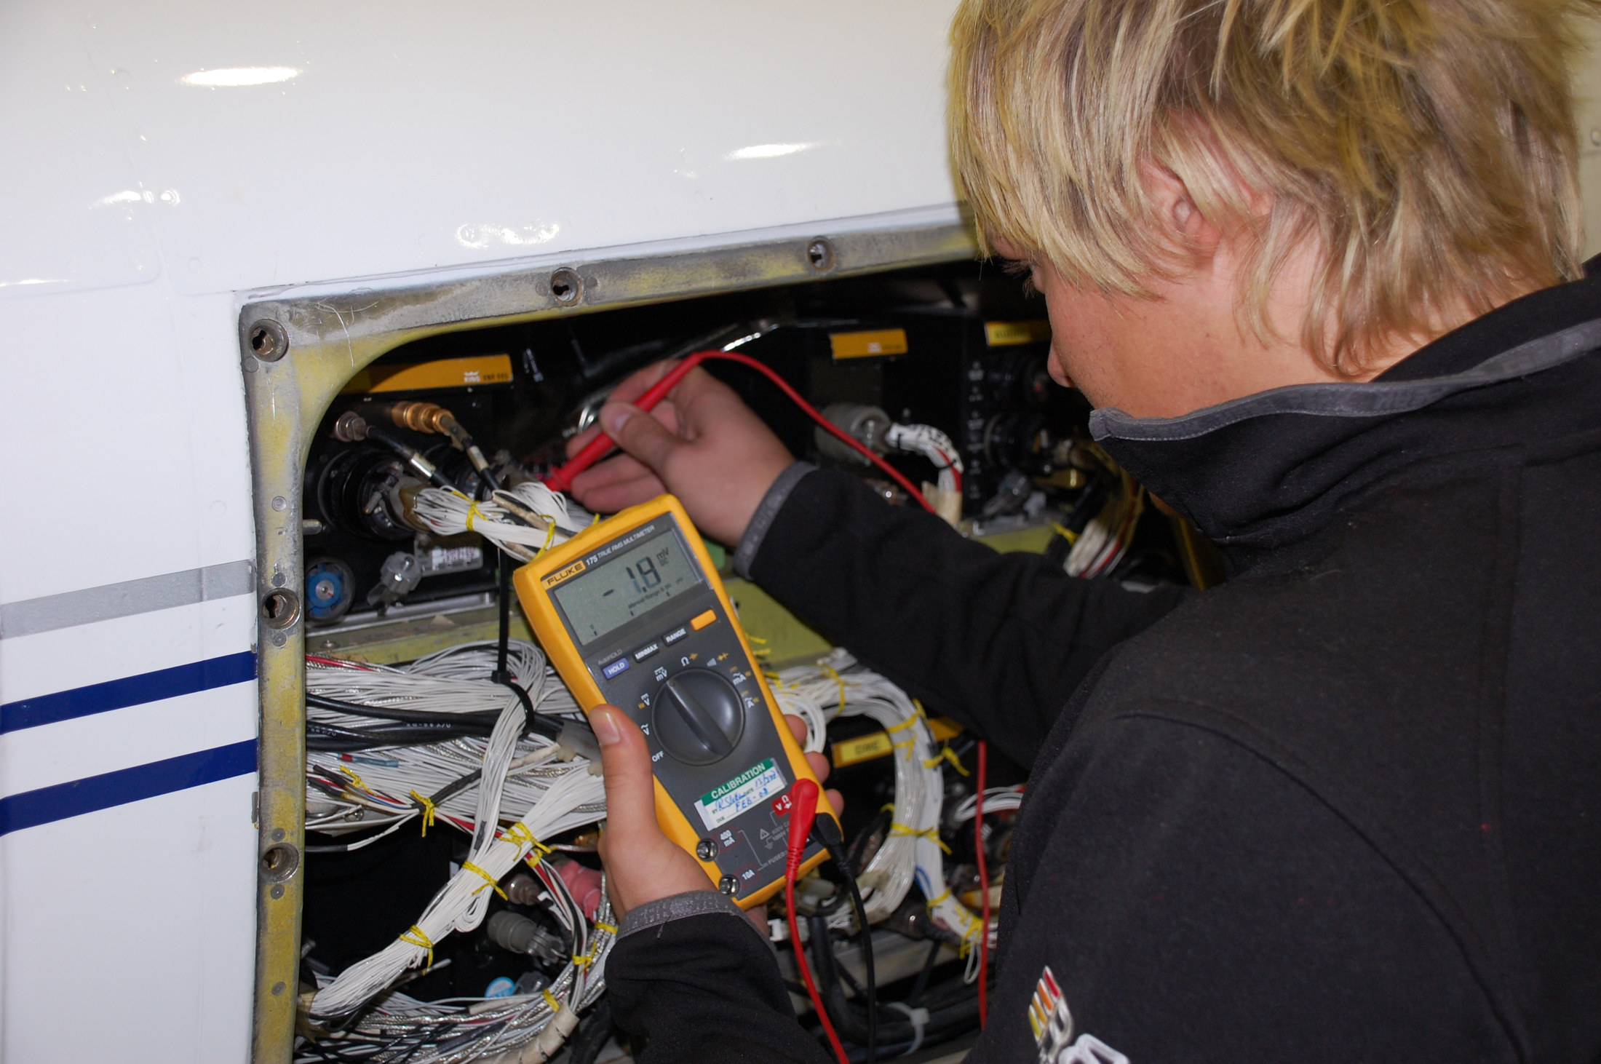
Un élève en formation d'avionique mesure un circuit avec un multimètre. Photo : Bgreiner, CC BY-SA 3.0, Wikimedia Commons.
Amorce (5 min)
POUR LES ÉLÈVES
Look at the painting. Imagine the tutor is speaking to a young person at a workbench. What is the first instruction of the day? Write one sentence, then tell your partner. Example: Put the cardboard boxes on the workbench.
Activité 1. Read a procedure (14 min). Compréhension de l'écrit.
POUR LES ÉLÈVES, TEXTE A2
How to prepare an order in the workshop
Follow these steps carefully.
First, wash your hands and put on your gloves. Then, read the order form. Check the name and the number of boxes. Next, take the right cardboard boxes and put them on the workbench. After that, pack the products and close the boxes. Finally, write the order number on each box and take them to the delivery area.
If you are not sure, ask your tutor. Do not close a box before you check the order.
POUR LES ÉLÈVES, COMPLÉMENT B1 (À AJOUTER SOUS LE TEXTE A2)
How to prepare an order in the workshop
Follow these steps carefully.
First, wash your hands and put on your gloves. Then, read the order form. Check the name and the number of boxes. Next, take the right cardboard boxes and put them on the workbench. After that, pack the products and close the boxes. Finally, write the order number on each box and take them to the delivery area.
If you are not sure, ask your tutor. Do not close a box before you check the order.
Important: if a box is damaged, do not use it. Take a new one and tell your tutor. You should also check that the workbench is clear before you start. You must not leave materials on the floor.
POUR LES ÉLÈVES, QUESTIONS
Read the procedure and answer.
- What do you do first?
- What do you check on the order form?
- Where do you put the cardboard boxes?
- What do you do finally?
- What must you do if you are not sure?
- True or false: You can close the box before you check the order.
- (B1) What do you do if a box is damaged?
- (B1) Find one rule with must not and one piece of advice with should.
Activité 2. The language of instructions (8 min).
POUR LES ÉLÈVES. TRACE POUR LE CAHIER (AMORCÉE ICI, COPIÉE PROPREMENT EN FIN DE LEÇON)
Instructions at work
To give an instruction, we often use the imperative:
- Put on your gloves.
- Check the order.
- Switch off the machine.
- Ask your tutor.
To say what not to do:
- Don't touch that.
- Do not close the box before you check.
To ask for an instruction:
- Can you show me how to do this?
- What do I do first?
- Could you say that again, please?
- Is this correct?
To order the steps:
- First, ... Then, ... Next, ... After that, ... Finally, ...
Activité 3. Give and ask for instructions (16 min). Interaction orale.
POUR LES ÉLÈVES
Dialogue 3. A colleague explains a task
A: Can you show me how to prepare this order, please? B: Yes, of course. First, put on your gloves. A: All right. What do I do next? B: Then, read the order form and check the number of boxes. A: Sorry, could you say that again, please? B: Sure. Read the order form. Check the number of boxes. Next, put the boxes on the workbench. A: OK. And finally? B: Finally, write the order number on each box. Don't close a box before you check. A: Thank you. B: You're welcome. If you're not sure, ask me or ask the tutor.
Your task.
- In pairs, read the dialogue aloud twice. Change roles.
- Then write your own version for your trade (6 to 10 lines). You must include: a polite request, at least three steps with First / Then / Finally, and one Don't....
- Act out your dialogue. Your partner may ask Could you say that again, please? You must answer patiently.
Activité 4. Une procédure en quatre étapes, à voix haute (8 min).
POUR LES ÉLÈVES
On your own, write four instructions for a simple task in your workshop (A2: use the imperative only. B1: add one warning with Don't and one polite sentence to a new colleague). Then read your four steps to your partner, without showing the paper. Your partner listens and does the actions with gestures. After that, your partner says the steps back to you.
Trace écrite et travail à la maison (4 min).
POUR LES ÉLÈVES
Homework, Lesson 4
- Rewrite these sentences as instructions, with the imperative. a. You need to put on your gloves. b. You need to switch off the machine. c. You must not leave boxes on the floor. d. You need to ask the tutor if you are not sure.
- Complete with First, Then, Next, Finally. __________, wash your hands. __________, put on your gloves. __________, take the boxes to the workbench. __________, pack the order.
- Write a short procedure (five to six lines) for a task in your PFMP workplace. Use the imperative and the sequence words.
Version adaptée dys · Lesson 5
Lesson 5. Safety first
Tableau : Laurent Proux
AMÉNAGEMENTS DE LA LESSON 5
- Avis de sécurité présenté en six règles courtes, numérotées, chaque modal en gras.
- Une carte visuelle à quatre cases : OBLIGATION (must / have to), CONSEIL (should), PERMISSION (can), INTERDICTION (can't / mustn't), avec un exemple dans chaque case.
- Questions de CE : 1 à 6, réponses soulignables dans le texte.
- Oral : cadre à trous à lire puis à dire, d'une minute au plus : Good morning, I'm... Welcome to... You must... You mustn't... You should... You can leave your bag...
- Travail à la maison : exercice 1 seulement, et relire le cadre à trous.
Pour l'enseignant. Comprendre et expliquer une règle de sécurité, employer les modaux.
Durée. 55 minutes.
Activités langagières. compréhension de l'écrit, expression orale en continu.
Objectifs. À la fin de la leçon, l'élève peut : comprendre un avis de sécurité écrit en anglais ; employer must, have to, should, can, can't dans un contexte professionnel ; présenter à l'oral, en continu, une règle de sécurité à un visiteur.
Langue de la leçon. You must wear safety glasses. You have to switch off the machine. You should ask your tutor. You can leave your bag in the locker. You can't go through this area. You mustn't run in the workshop. Nuance : must / have to (obligation), should (conseil), can / can't (permission ou capacité, interdiction pour can't et mustn't).
Phonologie. mustn't (/ˈmʌsnt/), sans faire sonner le premier t de manière lourde, mais en gardant le mot reconnaissable. have to (/hæftə/). Opposition can faible / can't plein.

Sur un chantier, deux ouvriers portent le casque, le gilet de visibilité et des chaussures de sécurité. Photo : M. Mishin, service de presse du maire et du gouvernement de Moscou, CC BY 4.0, Wikimedia Commons.
Amorce (5 min)
POUR LES ÉLÈVES
Look at the painting. This is a school workshop, with workbenches and cardboard boxes. A visitor is coming. What safety rules should these people follow? Say one rule with your partner, in English. You can start with You must... or Don't...
Activité 1. Read a safety notice (12 min). Compréhension de l'écrit.
POUR LES ÉLÈVES, TEXTE A2
Workshop safety rules
Please read these rules carefully. They are for your safety and for the safety of other people.
- You must wear safety shoes in the workshop. You must also wear gloves when you handle materials.
- You have to switch off a machine before you clean it or check it.
- You should ask your tutor if you are not sure about a task.
- You can leave your bag and your phone in the locker. You can't leave them on the workbench.
- You mustn't run in the workshop. You mustn't block the area in front of the windows or the doors.
- If you see a problem, tell your tutor immediately.
Thank you for your attention. Have a safe day.
POUR LES ÉLÈVES, COMPLÉMENT B1
Workshop safety rules
Please read these rules carefully. They are for your safety and for the safety of other people.
- You must wear safety shoes in the workshop. You must also wear gloves when you handle materials.
- You have to switch off a machine before you clean it or check it.
- You should ask your tutor if you are not sure about a task.
- You can leave your bag and your phone in the locker. You can't leave them on the workbench.
- You mustn't run in the workshop. You mustn't block the area in front of the windows or the doors.
- If you see a problem, tell your tutor immediately.
Thank you for your attention. Have a safe day.
These rules apply to everyone: young people, adults, visitors and PFMP students. If a visitor comes in, you should welcome them and explain the basic rules: safety shoes, no running, and no entry into a restricted area. You must not start an explanation near a machine that is on. Walk with the visitor, keep the workbenches clear, and never leave a cardboard box in a passageway.
POUR LES ÉLÈVES, QUESTIONS
- What must you wear in the workshop?
- When do you have to switch off a machine?
- What should you do if you are not sure?
- Where can you leave your bag? Where can't you leave it?
- Find two rules with mustn't.
- True or false: If you see a problem, you can wait until the end of the day to talk about it.
- (B1) Who do these rules apply to?
- (B1) What should you do when a visitor comes in?
Activité 2. Must, have to, should, can (12 min).
POUR LES ÉLÈVES
Expanding your vocabulary: safety
- safety shoes, safety glasses, gloves, a helmet, a locker
- a rule, a notice, a visitor, a restricted area, a passageway
- to wear, to handle, to switch off, to block, to report a problem
- immediately, carefully, basic rules, Have a safe day.
Grammar in context
- must and have to: it is necessary. You must wear safety shoes. You have to switch off the machine.
- should: it is a good idea. You should ask your tutor.
- can: it is possible or permitted. You can leave your bag in the locker.
- can't and mustn't: it is not permitted. You can't leave your bag on the workbench. You mustn't run.
Exercise. Complete with must, have to, should, can, can't or mustn't. More than one answer is sometimes possible. Be ready to explain your choice.
- You _______________ wear a helmet on the building site.
- You _______________ ask your tutor if you don't understand.
- Visitors _______________ enter this area. It is restricted.
- You _______________ leave your phone in the locker, if you wish.
- You _______________ switch off the machine before you check it. It is necessary.
- You _______________ run near the workbenches.
Activité 3. Explain a safety rule to a visitor (12 min). Expression orale en continu.
POUR LES ÉLÈVES
A visitor is in the workshop (the workshop in the painting, or your own workplace). You speak for about one minute (A2) or about two minutes (B1). Use this plan:
- Greet the visitor and introduce yourself.
- Welcome them to the workshop (or site, shop, kitchen).
- Explain two safety rules, with must / have to and mustn't or can't.
- Give one piece of advice with should.
- Say where they can leave a bag or a coat.
- (B1) Explain why one of these rules is important.
Prepare notes (key words only). Practise with your partner. Then some students will present to the class. The class listens as visitors and asks one question.
Trace écrite et travail à la maison (6 min).
POUR LES ÉLÈVES. TRACE POUR LE CAHIER
Safety at work
- You must wear safety shoes. / You have to switch off the machine.
- You should ask your tutor if you are not sure.
- You can leave your bag in the locker.
- You can't leave it on the workbench.
- You mustn't run in the workshop.
- If you see a problem, tell your tutor immediately.
POUR LES ÉLÈVES
Homework, Lesson 5
- Rewrite each idea with must, have to, should, can, can't or mustn't. a. It is necessary to wear gloves. (must) b. It is a good idea to check the order twice. (should) c. It is not permitted to use a damaged box. (mustn't) d. It is permitted to ask a colleague for help. (can) e. It is necessary to tell the tutor about a problem immediately. (have to)
- Write a short safety notice (A2: 6 lines, B1: 10 lines) for your PFMP workplace. Use at least four different modals.
- Prepare your one-minute oral from Activity 3. You will reuse it in the final task.
Version adaptée dys · Lesson 6
Lesson 6. There's a problem
Tableau : Laurent Proux
AMÉNAGEMENTS DE LA LESSON 6
- Avant l'écoute, donner cinq mots-clés : damaged, box, order 4821, Mr Harris, replace. Lire les questions 1 à 6 à voix haute.
- Script écouté une troisième fois, par blocs (le problème, les actions déjà faites, la solution).
- Banque de verbes au past simple visible, avec l'infinitif : arrived (arrive), opened, checked, told, went (go), found (find), were (be), replaced.
- Un seul dialogue modèle (dialogue 5), à trous, puis lu en binôme.
- Note d'incident : cadre à trous A2 uniquement, déjà largement amorcé.
- Travail à la maison : exercices 1 (dix verbes seulement) et 2.
Pour l'enseignant. Signaler un problème, s'excuser, raconter avec le past simple, proposer une solution.
Durée. 55 minutes.
Activités langagières. compréhension de l'oral, expression écrite, interaction orale.
Objectifs. À la fin de la leçon, l'élève peut : comprendre un court oral professionnel où quelqu'un signale un incident ; raconter un problème au past simple ; s'excuser ; proposer une solution, à un tuteur comme à un client ; rédiger une note d'incident courte.
Langue de la leçon. past simple régulier et irrégulier fréquent : arrived, damaged, checked, called, told, had, was, were, went, came, broke, found, left, said, replaced, happened. Formules : There's a problem. I'm sorry about that. I'm afraid... We can replace it. I'll check with my tutor.
Phonologie. Terminaisons du past simple : /t/ (checked, packed), /d/ (arrived, opened), /ɪd/ (wanted, needed, damaged se prononce avec /dʒd/). Faire répéter happened, damaged, replaced, told, said.
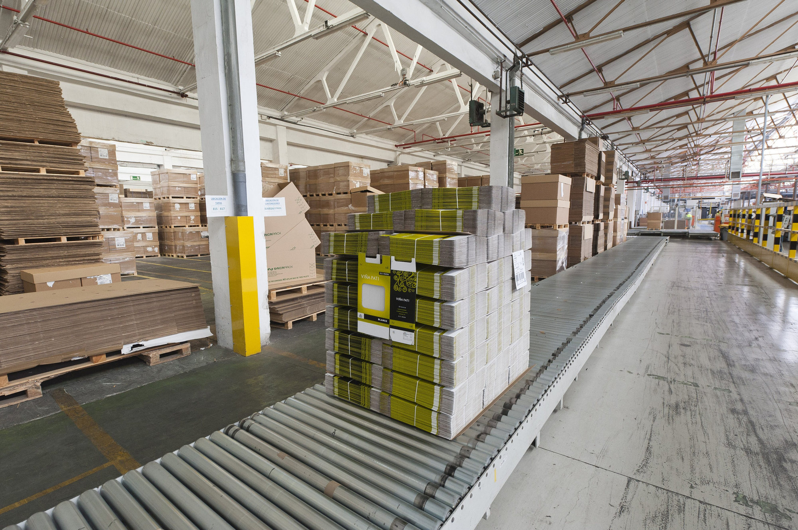
Des cartons palettisés, prêts à être expédiés, dans un entrepôt. Photo : SimónK, CC BY-SA 4.0, Wikimedia Commons.
Amorce (5 min)
POUR LES ÉLÈVES
Look at the painting, and look at the cardboard boxes. Imagine there is a problem with an order. What happened? Use the past simple, and start with I think.... Tell your partner in two sentences, for example: I think a box arrived damaged. The customer was not happy.
Activité 1. Listen: a problem in the workshop (14 min). Compréhension de l'oral.
POUR LES ÉLÈVES, QUESTIONS (A2 : 1 À 6. B1 : TOUTES)
You will hear a conversation between Léa and her tutor, Mr Baker. Listen twice and answer.
- What is the problem?
- When did the box arrive?
- What is the order number?
- Who is Mr Harris?
- What did Karim do?
- What can they do to solve the problem?
- (B1) What did Léa do before she spoke to Mr Baker?
- (B1) What should she do next time, and why?
Activité 2. Past simple and useful phrases (10 min).
POUR LES ÉLÈVES
Expanding your vocabulary: problems and solutions
- There's a problem. / I'm afraid there's a problem. / What's the matter?
- The box arrived damaged. / Two parts were broken. / The machine stopped. / The order was late. / A customer was unhappy.
- I'm sorry. / I'm sorry about that. / I apologise. / We're sorry for the delay.
- We can replace it. / We can repair it. / We can deliver it this afternoon.
- I'll check with my tutor. / I'll call the customer. / I'll do that now.
Grammar in context: past simple
To report a problem, we say what happened:
- The box arrived damaged. (regular: arrive, arrived)
- I opened it. I checked the number. I called the customer.
- Two parts were broken. Karim went to the stockroom. He found two new parts.
- I told my tutor. He said we could replace them.
Questions and negatives:
- What happened? / What did you do? / Did you check the order? Yes, I did. / No, I didn't.
- I didn't use the damaged box.
Exercise. Put the verbs in the past simple.
- The box _______________ this morning. (arrive)
- I _______________ it and I _______________ a problem. (open / find)
- Two parts _______________ broken. (be)
- Karim _______________ to the stockroom. (go)
- We _______________ the parts and we _______________ to the customer. (replace / apologise)
- _______________ you _______________ the tutor immediately? (tell)
Activité 3. Report, apologise, propose a solution (14 min). Interaction orale.
POUR LES ÉLÈVES
Dialogue 4. With the tutor
Student: Excuse me, Ms Clark. I'm afraid there's a problem. Tutor: What's the matter? Student: I checked the machine this morning and it stopped. I switched it off immediately. Tutor: Did you tell anyone? Student: I told Karim. He came and he looked at it. I think a part is broken. Tutor: All right. You did the right thing. I'll come and see. Don't switch it on. Student: Thank you.
Dialogue 5. With a customer
Customer: Good afternoon. I have a problem with my order. Student: Good afternoon. I'm sorry to hear that. How can I help you? Customer: The box arrived damaged, and two parts were broken. Student: I'm sorry about that. Could you give me the order number, please? Customer: Yes, it's 4821. Student: Thank you. We can replace the parts today, and we can deliver this afternoon. Customer: That's fine. Thank you. Student: You're welcome. I'm sorry again for the problem.
Your task. In pairs, choose one of the two dialogues. Read it twice and change roles. Then invent a new problem from your trade (a late delivery, a wrong dish, a leak, a broken tool, a wrong size). Write 6 to 8 lines: report the problem in the past simple, apologise, and propose a solution. Act it out.
Activité 4. Write a short incident note (8 min). Expression écrite.
POUR LES ÉLÈVES
Write a short incident note to your tutor, in English.
A2 (60 to 80 words). Use this frame: This morning, there was a problem. The... I... Then I... We can... I'm sorry about...
B1 (90 to 110 words). Write a complete note: what happened, when, what you did, who you told, what solution you propose, and one sentence to show you know what to do next time.
Do not invent a long story. Keep it professional and clear.
Trace écrite et travail à la maison (4 min).
POUR LES ÉLÈVES. TRACE POUR LE CAHIER
Reporting a problem
- I'm afraid there's a problem. / What's the matter?
- The box arrived damaged. I checked it. I told my tutor.
- I'm sorry about that. / I apologise.
- We can replace it today. / I'll check with my tutor.
- What happened? What did you do? Did you tell the tutor? Yes, I did.
POUR LES ÉLÈVES
Homework, Lesson 6
- Write the past simple of these verbs: arrive, open, check, tell, go, find, be, have, break, come, say, replace, happen, leave, do.
- Complete the dialogue. Customer: I have a _______________ with my order. You: I'm _______________ to hear that. How can I _______________ you? Customer: The box _______________ damaged. You: I'm sorry about that. We can _______________ it today.
- Write your own incident note (A2: 60 to 80 words, B1: 90 to 110 words) about a problem from your PFMP, real or imagined. Use the past simple, an apology, and a solution.
Version adaptée dys · Lesson 7
Lesson 7. Customers and tutors
Tableau : Laurent Proux
AMÉNAGEMENTS DE LA LESSON 7
- Questions de CO dans l'ordre du script, avec une banque : Mrs Grant, 4702, Friday, ready, this morning, switch the machine on.
- Formules polies présentées en deux colonnes courtes (client / tuteur), à copier telles quelles, sans l'exercice de transformation si celui-ci est trop lourd : le proposer en défi facultatif.
- Oral au tuteur : cadre à trous de cinq phrases, lu puis dit.
- Compte rendu de PFMP : cadre A2 à trous, déjà structuré en cinq phrases à compléter. Volume visé : 60 mots. L'enseignant peut accepter une dictée à l'adulte ou un enregistrement oral transcrit, si l'écrit est un obstacle majeur, tout en gardant une trace écrite minimale.
- Pour la préparation de la tâche finale : une fiche unique recto, six cases, mots-clés déjà proposés à choisir et à entourer.
Pour l'enseignant. Parler à un client, parler à son tuteur, rédiger le compte rendu de PFMP, préparer la tâche finale.
Durée. 55 minutes.
Activités langagières. compréhension de l'oral, expression orale en continu, expression écrite.
Objectifs. À la fin de la leçon, l'élève peut : comprendre un échange avec un client ; employer des demandes polies ; expliquer une tâche ou un produit à un client ; rendre compte oralement à un tuteur ; rédiger un court compte rendu de PFMP en anglais, qui sera la partie écrite de la tâche finale.
Langue de la leçon. Formules polies : Could you... ?, Would you mind... ?, I'd like to..., Of course, Please wait a moment, I'll check. Réemploi du past simple pour le bilan. Réemploi de tout le lexique des leçons 1 à 6.
Phonologie. Intonation polie, légèrement montante, sur Could you give me the order number, please? I'd like to (/aɪd laɪk tə/).
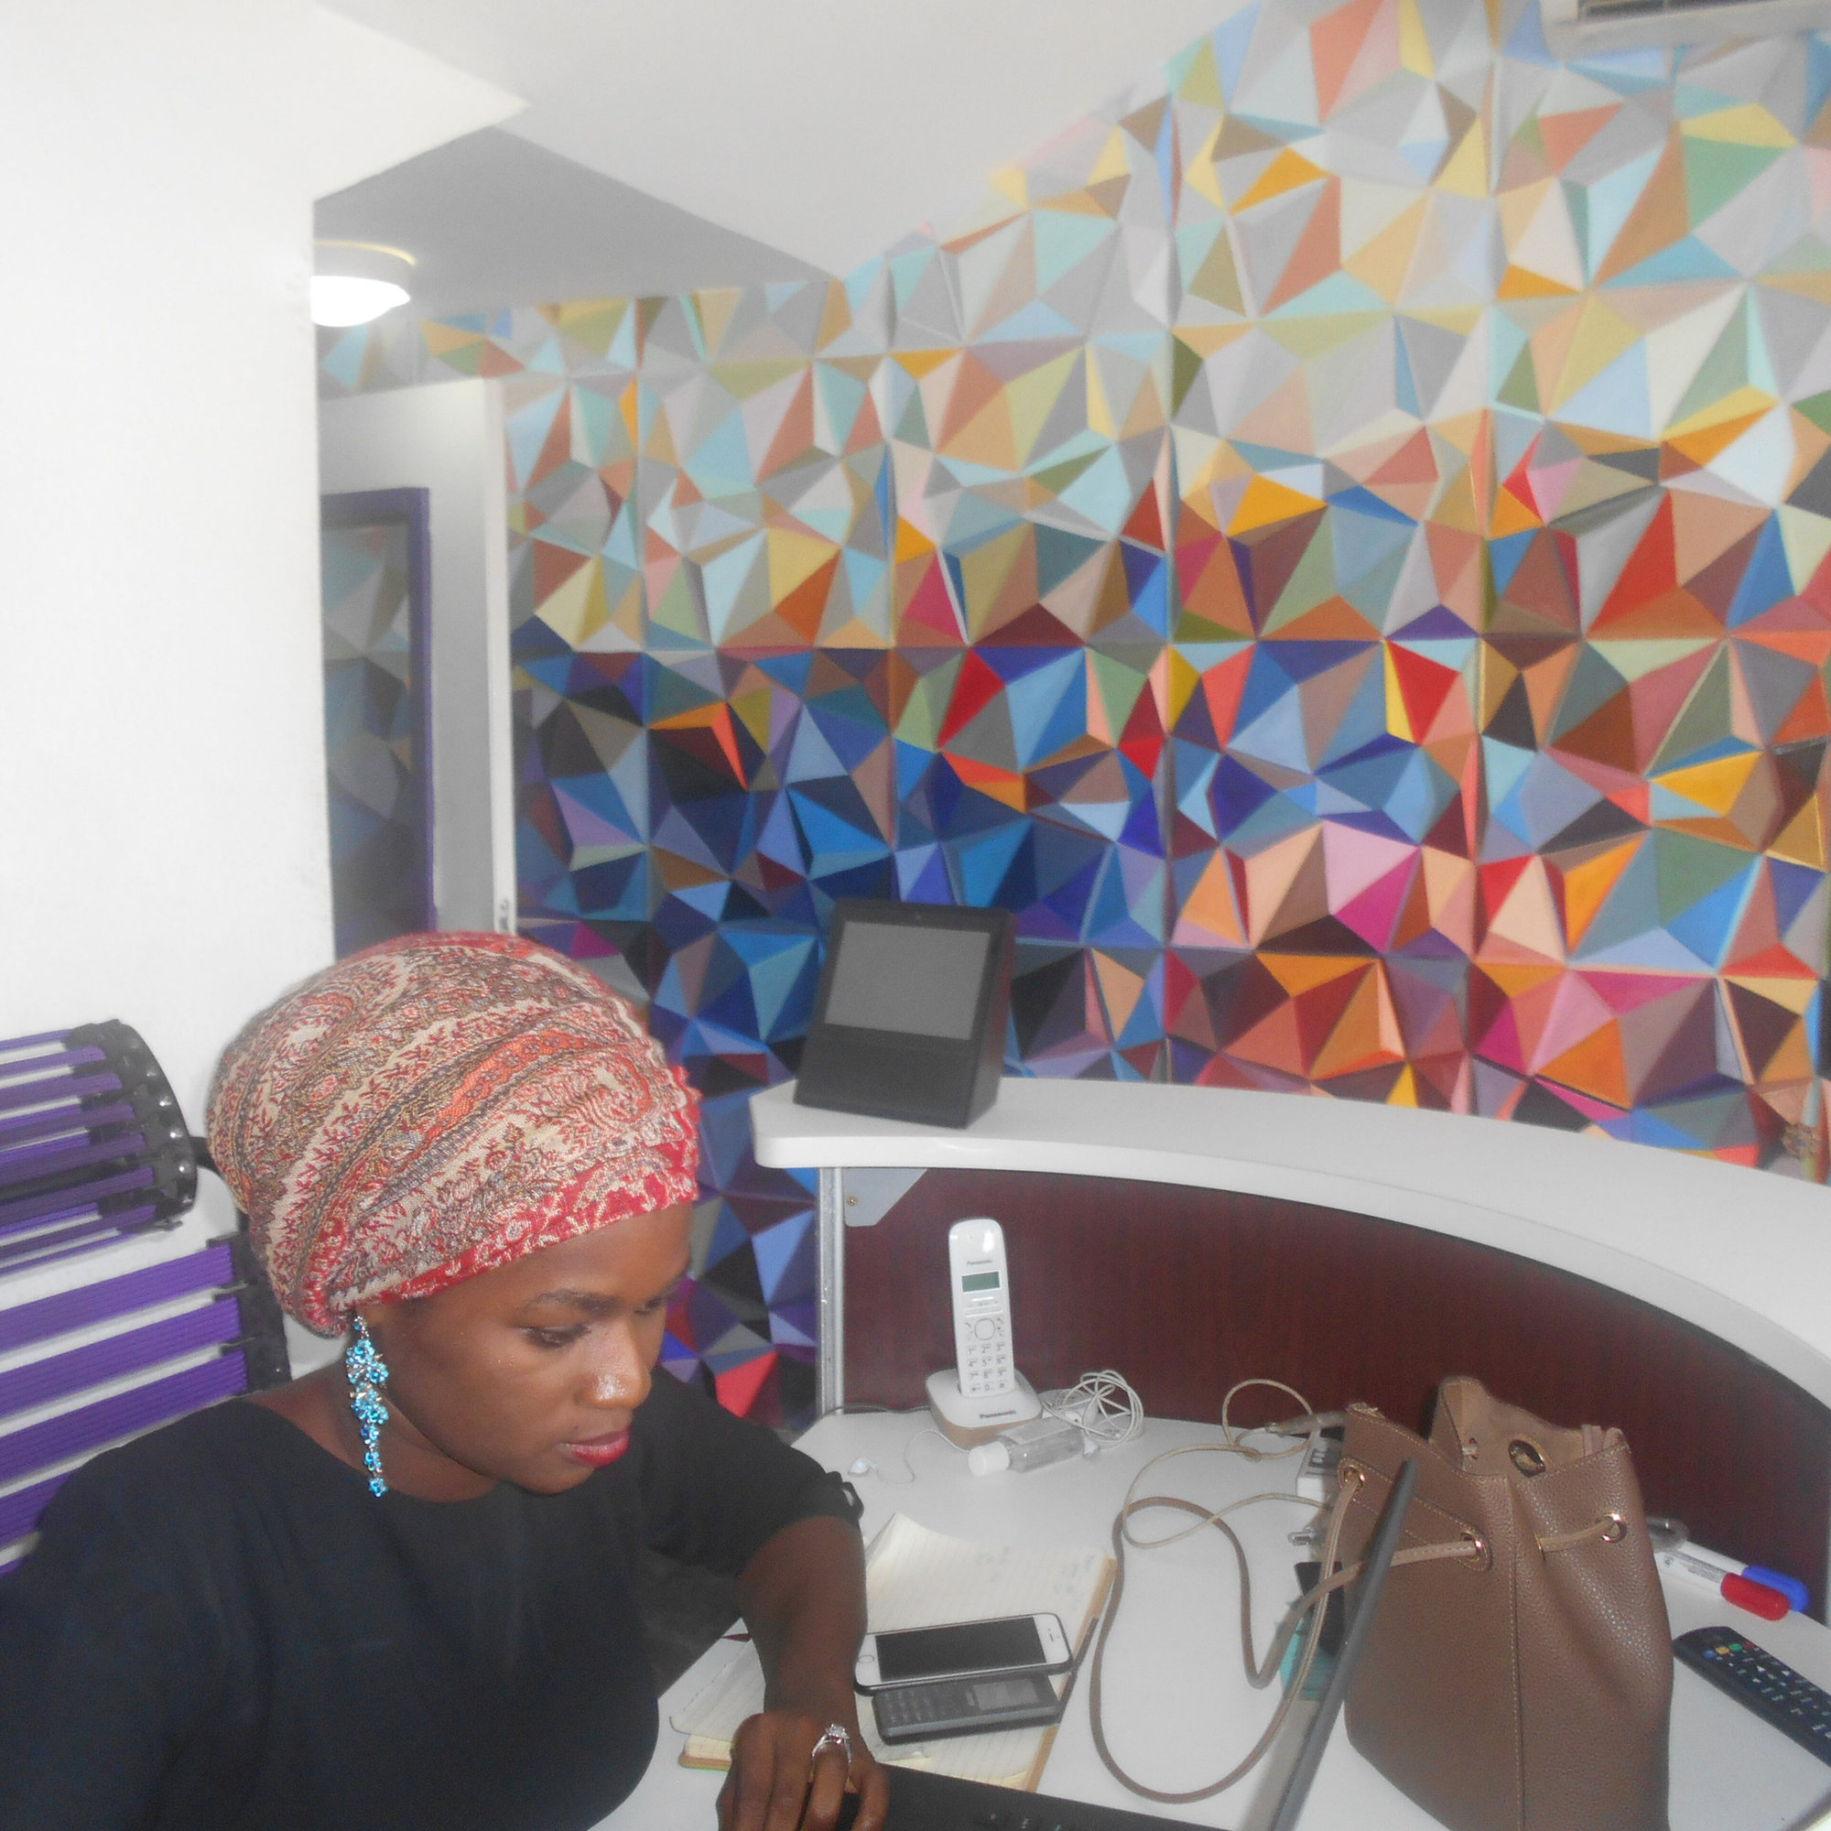
À un poste d'accueil, une professionnelle travaille, un téléphone à portée de main. Photo : Nabeelah Yousuph, CC BY-SA 4.0, Wikimedia Commons.
Amorce (4 min)
POUR LES ÉLÈVES
Look at the painting. A customer comes into this school workshop. A young person walks towards the visitor, in front of the workbenches and the cardboard boxes. What is the first thing the young person says? What is the first question the customer asks? Say two lines with your partner.
Activité 1. Listen: talking to a customer (12 min). Compréhension de l'oral.
POUR LES ÉLÈVES, QUESTIONS
Listen twice and answer.
- What does Mrs Grant want?
- What is the order number?
- When does she need the parts?
- Is the order ready?
- When did they pack the box?
- What does the student explain at the end?
- Find two polite phrases used by the student, and one used by the customer.
- (B1) Complete the safety warning the student gives about the machine.
Activité 2. Polite forms, for a customer and for a tutor (10 min).
POUR LES ÉLÈVES
Building your vocabulary: polite requests and explanations
To a customer
- Good afternoon. Welcome. How can I help you?
- I'd like to... / Could you give me..., please?
- Would you mind waiting a moment? / Please wait a moment. I'll check.
- Thank you for waiting. / I'm sorry about the delay.
- Let me explain. First... Then... You have to... You mustn't...
- You're welcome. Have a good day.
To a tutor
- Excuse me, could I ask you a question?
- Could you show me how to... ?
- This morning I checked... / I finished... / I had a problem with...
- What should I do next?
- Thank you for your help.
Exercise. Make these requests more polite.
- Give me the order number.
- Wait.
- Check this for me.
- Show me the machine.
- I want to see my order.
Activité 3. Talk to your tutor about your PFMP (12 min). Expression orale en continu.
POUR LES ÉLÈVES
Your tutor asks you about your work. Speak in continuous English for one minute (A2) or about two minutes (B1). Use this plan:
- Greet your tutor.
- Say where you work and who you work with.
- Say what you do every day (present simple) and what you did this morning or yesterday (past simple).
- Mention one problem and the solution.
- Say what you learned, or what you would like to learn next.
Useful sentences
- I work in... My tutor is...
- Every day, I check... / I prepare... / I help...
- Yesterday, I... This morning, I...
- There was a problem: ... We solved it. We...
- I learned how to... I'd like to learn how to...
Practise with your partner: one person is the student, the other is the tutor and asks two questions. Then change roles.
Activité 4. Write your PFMP report (12 min). Expression écrite. Partie écrite de la tâche finale.
POUR LES ÉLÈVES
Final written task: a short PFMP report in English
Write about your PFMP (a real PFMP, or a realistic one in your trade).
A2: 60 to 80 words. B1: 120 to 150 words.
Use this plan:
- Where you work, and who your tutor is.
- Your main tasks (present simple).
- What you did on one particular day (past simple).
- A problem and the solution.
- What you learned, and what you want to improve.
Write a first version now. Check: verbs, polite tone, clear facts. You will hand in a clean version at Lesson 8 (or at the written evaluation if your teacher organises a separate time).
Préparer la tâche finale, critères de réussite (5 min).
POUR LES ÉLÈVES
Next lesson is the final task: Welcome to the workshop.
You will welcome a visitor, in pairs. You will:
- greet and introduce yourself,
- say what is happening in the workshop,
- explain a task,
- give a safety rule,
- report a problem and a solution,
- answer the visitor's questions.
You may bring key-word notes. A2 students may keep a word bank. Learn your useful phrases tonight. Bring your PFMP report, clean and complete.
Trace pour le cahier.
Les formules polies de l'activité 2, plus le plan du compte rendu.
POUR LES ÉLÈVES
Homework, Lesson 7
- Finish a clean version of your PFMP report.
- Make these sentences polite. a. I want to see the manager. b. Give me a new box. c. Wait here.
- Prepare key-word notes (not a full text) for the final oral task, following the six-point plan.
Version adaptée dys · Lesson 8
Lesson 8. Welcome to the workshop
Tableau : Laurent Proux
AMÉNAGEMENTS DE LA LESSON 8
- Courriel A2 seulement, présenté avec des interlignes larges. Questions 1 à 6, réponses courtes, possibilité de souligner dans le texte.
- Écoute : donner avant le message les cinq informations à écouter (qui parle, commande 4702, problème 4821, chaussures, sac). Troisième écoute possible.
- Préparation : fiche à six cases déjà titrées, avec amorces écrites (Good morning, I'm... Welcome... You must... You can leave your bag... First... Then... Finally... Last week, a box arrived... We...).
- Oral : durée A2, partenaire bienveillant, banque de mots visible, droit de relire une amorce. L'enseignant évite la question imprévue trop éloignée, ou la pose avec un choix visuel (Did you tell your tutor, or did you call the customer first?).
- Autoévaluation : cases à cocher seulement, plus une phrase à trous : Today I did well when I... Next time I want to...
- Compte rendu écrit : accepter le cadre de la leçon 7, éventuellement dicté, sans exiger une remise en page complexe.
Pour l'enseignant. Tâche finale, situation professionnelle complète, évaluation.
Durée. 55 minutes.
Activités langagières. compréhension de l'écrit, compréhension de l'oral, expression orale en continu, interaction orale. L'expression écrite a été engagée à la leçon 7 et est recueillie aujourd'hui (ou dans un temps d'évaluation séparé).
Objectifs. Réaliser la tâche finale dans des conditions proches d'un CCF. Mobiliser toute la langue de la séquence. Accueillir un visiteur de manière réaliste, compréhensible et polie. Permettre une évaluation par les cinq activités langagières, à l'aide de la grille (section 8).
Matériel. L'œuvre de Laurent Proux, projetée, comme décor. Courriel du visiteur (CE). Message oral du tuteur (CO). Grille d'évaluation. Notes des élèves (mots-clés). Comptes rendus de PFMP à remettre. Salle organisée pour que les binômes puissent se préparer, puis passer.

Un menuisier au travail, sur le seuil de son atelier. Photo : RanaHafez, CC BY-SA 4.0, Wikimedia Commons.
Activité 1. Read the visitor's email (10 min). Compréhension de l'écrit, évaluée.
POUR LES ÉLÈVES, TEXTE A2
From: Alex Morgan
To: the workshop team
Subject: Visit on Friday morning
Dear team,
I am coming to your workshop on Friday morning, at ten. I am a customer from Greenfield Parts. I would like to see my order (number 4702) and to understand how you pack the boxes. I also need one safety rule, because this is my first visit.
Please meet me at the entrance. I will have a bag with me.
Thank you very much.
Kind regards, Alex Morgan
POUR LES ÉLÈVES, COMPLÉMENT B1 (UN SECOND PARAGRAPHE, À LA PLACE OU EN PLUS DE LA DERNIÈRE LIGNE A2)
From: Alex Morgan
To: the workshop team
Subject: Visit on Friday morning
Dear team,
I am coming to your workshop on Friday morning, at ten. I am a customer from Greenfield Parts. I would like to see my order (number 4702) and to understand how you pack the boxes. I also need one safety rule, because this is my first visit.
Please meet me at the entrance. I will have a bag with me.
Thank you very much.
Kind regards, Alex Morgan
I would also like a short explanation of a problem you had recently, and of the solution you found. If the order is not ready, please tell me what happened and what you can do. I may ask a few questions about your PFMP and your tasks. I look forward to meeting you.
Kind regards, Alex Morgan
POUR LES ÉLÈVES, QUESTIONS (ÉVALUÉES)
- Who is writing, and from which company?
- When is the visit?
- What is the order number?
- What two things would Alex like to see or understand?
- Why does Alex need a safety rule?
- Where should you meet Alex? What will Alex have?
- (B1) What else would Alex like you to explain?
- (B1) What should you do if the order is not ready?
Activité 2. Listen to the tutor's message (8 min). Compréhension de l'oral, évaluée.
POUR LES ÉLÈVES, QUESTIONS (ÉVALUÉES)
Listen twice. You may take notes.
- Who is speaking?
- Is order 4702 ready? When did they pack it?
- What was the problem last week? What was the order number?
- What did they do about that problem?
- Give two safety points from the message, about shoes and bags.
Activité 3. Prepare (8 min).
POUR LES ÉLÈVES
Prepare your welcome, in pairs. One of you is the student at work, the other is Alex Morgan, the visitor. You will then change roles, if time allows, or on the teacher's decision.
Use:
- the email,
- the tutor's message,
- your notes,
- the painting as the place: you are in this workshop, with workbenches, cardboard boxes and large windows.
Your plan (you must cover all six points)
- Greet Alex, introduce yourself, welcome Alex to the workshop.
- Say what people are doing in the workshop now.
- Explain how you pack the boxes, or another task from your trade (First, Then, Finally).
- Give at least one safety rule (must / can't). Say where Alex can leave the bag.
- Report the problem with order 4821 and the solution (past simple).
- Answer Alex's questions. If you don't understand, say Could you say that again, please?
A2: speak for about four minutes, together. You may use a word bank. B1: speak for five to six minutes. Be ready for an unexpected question.
Activité 4. The oral final task (22 min). Expression orale en continu et interaction orale, évaluées.
POUR LES ÉLÈVES
It is Friday morning, at ten. You are in the workshop. Alex Morgan is at the entrance. When it is your turn, perform the welcome. Be polite, clear and professional. Look at the visitor, not only at your notes. If you forget a word, explain it in another way. Good luck.
Activité 5. Brief feedback and self-assessment (7 min).
POUR LES ÉLÈVES
Self-assessment. Tick what you could do today.
- I greeted the visitor and I introduced myself.
- I used the present continuous to say what was happening.
- I explained a task with clear steps.
- I gave a safety rule with must, have to, should or can't.
- I reported a problem in the past simple, and I proposed a solution.
- I answered questions and I was polite.
- I used notes, not a full written text.
Write one thing you did well, and one thing you want to improve. Hand in your PFMP report if you have not already done so.
Travail à la maison, après la tâche finale.
POUR LES ÉLÈVES
Homework, Lesson 8
- Look at your self-assessment. Rewrite, in 6 to 8 lines, the moment of the oral that you want to improve. Write a better version, in dialogue form.
- (Optional, B1) Write a short thank-you email to Alex Morgan (60 to 80 words): thank the visitor, confirm the order is ready, and remind one safety point for a next visit.

