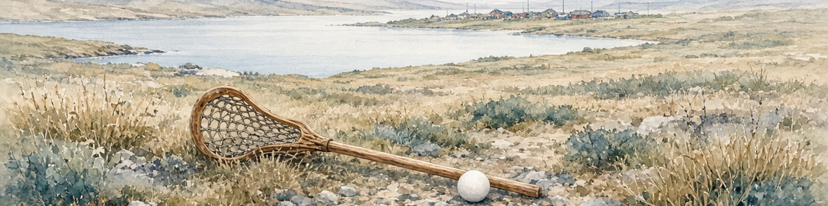

TEACHER SHEET · The Grizzlies · The Sentence I Cannot Finish Alone
Lesson 7 · Sequence: Whose Land, Whose Water? · The Grizzlies, 2018, directed by Miranda de Pencier · 52 minutes timed, 55 minutes in total
Spiral method devised by Madame Carole Paoli Pompougnac.
▪ Axes: Diversité et inclusion · Art et pouvoir · Les aires anglophones américaines  ▪ Also L’être humain et la nature, if students pick evidence about place or land | ▪ Start from their own reaction and end with a claim they can defend.  ▪ Explain one film choice: framing, sound, editing or point of view.  ▪ Listen to a classmate’s detail and adjust their reading.  ▪ Say whose view it is. Nobody speaks for Inuit people.  By the end, each student has:  ✓ a written record  ✓ spoken in each debate round  ✓ homework: a recorded conclusion (about 30 s, or 45 to 60 s on the extended route)  ✓ two flashcards  Debate motion:  ▪ In The Grizzlies, following the newcomer helps us enter the story, but can also limit whose agency we notice.
  ◆ | Classes and levels
  Class | Target and route
  Première générale, LVA | B1+ · extended route
  Première générale, LVB | B1 · extended route, supported if needed
  Bac pro | BO spécial 11 April 2019 · supported, then extended
  CFA apprentices | the route of their qualification · dys Route P
  CAP | supported route first · dys Route C
  SEGPA | dys Route S
  ► | What students do in this lesson

▼ | The spiral of questions: a thinking tool
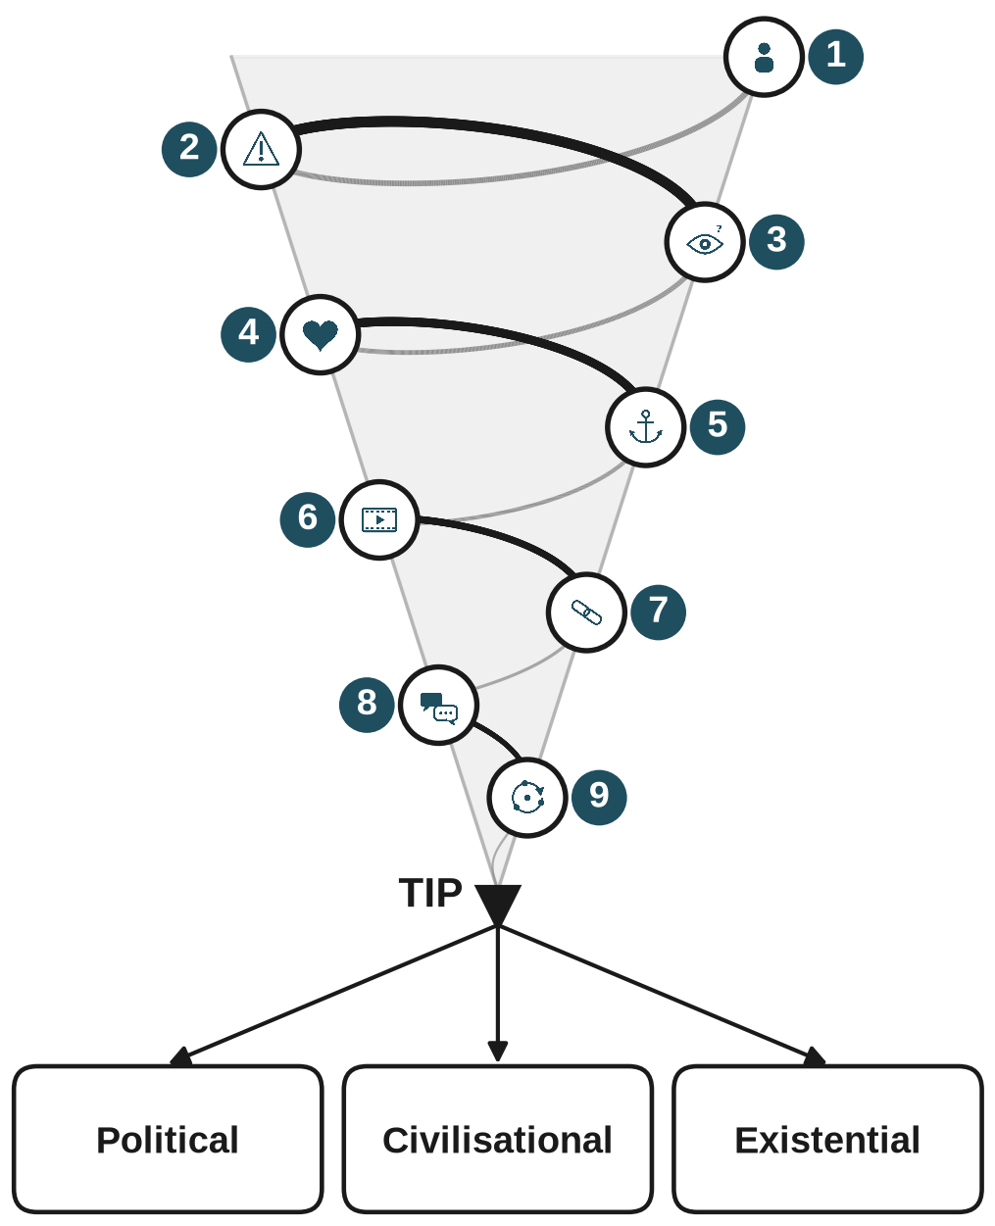  Spiral method devised by Madame Carole Paoli Pompougnac. | ▪ A way to organise your thinking: from a general question to a real problem.  ▪ Use it at the start of the study. Students begin with wide, personal questions, then look at the film’s choices, then reach the tip.  ▪ At the tip they choose one of three problems: political, civilisational or existential.  ▪ They can reuse it later with other films or texts.  ▪ The full spiral, with a question and an answer frame at each station, is in the student document. The table below gives the same nine stations.
  Turn | Type of question | Example
  Turn 1 · stages 1 to 4 | general, personal | “Who would you be?”
  Turn 2 · stages 5 to 6 | evidence, the film’s choices | “How does the film show it?”
  Turn 3 · stages 7 to 8 | testing, another viewpoint | “What if the film showed it differently?”
  Tip · stage 9 | the problem | “Whose voice and agency count?”

Station | Question | Expected answer | Reasoning | Language
 1 | Who would you be? | I would be… because… | personal reaction: choosing a way in | I would be + because
 2 | What shocks you? | The moment when… shocks me. | personal reaction | emotion adjectives: unsettled, uncomfortable, disturbed
 3 | What surprises you? | I expected…, but… | personal reaction: expectation and what I saw | I expected… / but…
 4 | What do you like? | I like the way… | personal reaction with a reason | I like the way… / I value… because…
 5 | What exactly gave you that response? | We see… / We hear… | observation | we see / we hear
 6 | How does the film show it? | The camera shows…, so I notice… | film-language analysis | the camera + verb: shows, frames, follows; so
 7 | What if the film showed it differently? | If the film showed…, I might… | testing the evidence | if + past simple, might + base verb
 8 | What did another spectator notice? | Another detail is… | testing the evidence against another viewpoint | another detail is…; supports, complicates, changes
 9 | What can you argue? What can you not claim? | I can argue…, but I cannot claim… | qualified argument | although / I can argue / I cannot claim

■ | What to prepare
Item | How many | When
Short preparation sheet (entry-position words, the four reaction frames, the neutral model) | 1 per student | the lesson before home viewing
Student document with the speaking circuit (one A4 sheet) | 1 per student | lesson 7
Two small pieces of paper: their own evidence and their partner’s detail | 2 per student | lesson 7, minutes 9 to 38
Tick grids 1 and 2 (student document, stages 5 and 8) | 1 per student | minutes 9 to 16 and 26 to 38
Picture prompts: framing, sound, editing, point of view | 1 set per group of four | minutes 9 to 21
Building your vocabulary page and the exercises with answers | 1 per student | minutes 21 to 26
Self-correction grid | 1 per student | minutes 44 to 49 and homework
Blank flashcards | 2 per student | minutes 49 to 52
Dys version, printed separately, 14 pt | as needed | lesson 7 or after an absence
A timer for the three four-minute rounds | 1 | minutes 26 to 38

▲ Before the film: watch it yourself first. Warn students about the suicide theme and emotionally charged scenes. Offer the invented scene as an alternative, with no penalty. Check that every student can watch it legally, and follow your school’s safeguarding arrangements.
▲ At home: about 8 minutes of preparation before watching, 10 to 15 minutes after. Nothing to write during the film.

9 | The 9 stages at a glance
# | Stage | When | What you do | What you can say
1 | Find your entry position | after viewing · again at min 4 to 9 | offer the five positions, ask for one limit | “What would that position not allow you to know?”
2 | Register shock | min 4 to 9 | accept one word; steer students away from judging a whole community | “Which moment? The moment when… makes me…”
3 | Register surprise | min 4 to 9 | keep surprise apart from shock | “What did you expect? What did you see?”
4 | Register liking | min 4 to 9 | ask for something precise and a reason | “I value… because…”
5 | Anchor a reaction | min 9 to 16 | check that the detail can be seen or heard: label O | “What exactly in the film gave you that response?”
6 | Find the film choice | min 9 to 16 | model one tool: label I | “How does the film make this detail available to you?”
7 | Test the connection | min 16 to 21 | give one thing to improve: label P | “Would your reaction change if the film presented the same event differently?”
8 | Another spectator’s detail | min 26 to 38, round 2 | keep time; ask for a detail, not a feeling | “Does it support, complicate or change your reading?”
9 | Close the circuit | min 26 to 44, round 3 | ask for a claim and a limit | “Remove your detail. Does your argument change?”

◷ | The 52-minute lesson
Minutes | Step | What happens
0 to 4 | Diagnostic re-entry | students point to a reaction, say it, complete “The moment when… makes me…”
4 to 9 | Rebuild the personal route | in pairs: entry, shock, surprise, liking; each picks one response
9 to 16 | Anchor and explain | evidence piece, one film tool, “The film…, so I…”; tick grid 1
16 to 21 | Midpoint check | O and I kept apart, one change of presentation tested, one thing to improve
21 to 26 | Language repair | core exercises, answers checked, one sentence improved
26 to 38 | Scaffolded debate | three four-minute rounds in groups of four, everyone speaks; tick grid 2
38 to 41 | Collective judgement | one careful sentence per group, one disagreement left open
41 to 44 | Individual assessed conclusion | recorded or written
44 | ▲ STOPPING POINT | everyone has spoken, linked a reaction to evidence and reached a conclusion
44 to 49 | Written record and self-correction | one weakness found, one corrected version
49 to 52 | Homework and flashcards | two cards, one said aloud
Exit 44 to 52 | Eight-minute emergency exit | 44 to 46 conclusion and limit · 46 to 49 written record · 49 to 51 homework and one card · 51 to 52 correct one sentence

✎ | Key vocabulary
Theme | Analysis | Grammar
newcomer · agency · initiative | foregrounds · withholds information | because · but · so
mutual support · take over | directs my attention towards | If + past simple, might + base verb
make room for · belonging | complicates my interpretation · qualifies my claim | Although…, …
unsettled · unexpected · attentive | framing · sound · editing · point of view | I can therefore argue…, but I cannot claim…

◐ | Differentiation
Supported route · A1/A2 | Extended route · B1/B1+ | Dys version
point first, then say one word | choose a more precise word | works on its own, 14 pages, Arial 14 pt
frames: “We see…”, “The film…, so…” | “If the film…, I might…”, “Although…” | one instruction per line, a worked example first
join two clauses given by you | build an explanation and add a limit | answers to check on the page
homework: about 30 seconds | homework: 45 to 60 seconds | Routes S (SEGPA), C (CAP), P (bac pro, CFA), G (lycée général)
notes and frames allowed | a competing reading, a link to the motion | a ready-made challenge after an absence

▪ Students enter a situation. They never take on someone’s identity.  ▪ They say “The film portrays [name] doing…”, never “I am [name].”  ▪ Shock is about a moment or an action, never a whole community.  ▪ Nobody has to share anything personal. “Nothing shocks me” is a fine answer.  ▪ Never ask a student to put themselves in the place of someone in a suicidal crisis.  ▪ One film does not represent every Inuit experience. | ▪ Diagnostic at minutes 0 to 4, midpoint at 16 to 21, summative out of 20 (five criteria marked 0 to 4, language included). Grids in section 12. A filled-in example is in the correction sheet.  ► 1. Use the self-correction grid. 2. Improve the conclusion. 3. Record it with notes.  ► 4. Reuse one film term and one reasoning structure. 5. State one limit. 6. Revise two flashcards.
  ▲ | Cultural care
  ✓ | Assessment
  ◎ | Homework

