Understanding meal structures related to weight and diet quality during pregnancy and postpartum

AIMS

We aim to identify and compare meal structures related to BMI (normal vs. overweight & obese), gestational weight gain (adequate vs. excessive), postpartum weight change (return to early pregnancy weight vs. not returning to early pregnancy weight 1 year after delivery), and diet quality (Q1 vs. Q4 of HEI2015) during pregnancy and postpartum using meal-specific food networks (breakfast, lunch, dinner).

HYPOTHESES

We hypothesize observing healthy foods clustering together, with stronger correlations, and higher frequency of consumption among women with a normal BMI, adequate gestational weight gain, return to early pregnancy weight, and higher diet quality, and unhealthier foods showing a similar relationship structure among women with overweight and obesity, excessive gestational weight gain, who do not return to early pregnancy weight after one year, and with lower diet quality. We expect the different meals (breakfast, lunch, dinner) to show different food groups and correlation structures.

We also hypothesize that meal food networks among women with a high-quality diet will provide useful information for generating further hypotheses for meal-specific interventions and dietary guidelines to improve quality diet among pregnant and postpartum women.

METHODS so far

Food grouping

Foods were grouped into 40 categories based on USDA’s food patterns used to compute the HEI2015 and expanded based on FNDDS food categories to provide more detailed food choices. Foods using FNDDS codes for mixed dishes were broken down into the different foods making up the mixed dish when the breakdown provided further information about the healthfulness of the food or the conceptualization of choice to consume such foods (e.g. meat, poultry, fish in gravy or sauce or creamed was separated into the animal protein component and the sauce component). FNDDS mixed dishes where the conceptualization of the choice would substantially be altered by breaking down into more foods or ingredients were left as mixed dishes and categorized based on similarity of ingredients or type of food (e.g. protein-based patties and loaves).

1. Methods to obtain networks used previously while at the German Institute of Human Nutrition (1):

Tested here so far on a few examples from PEAS:

Gaussian Graphical Models (GGMs) were used to *produce probabilistic graphs in which nodes represent variables and edges represent a relationship between the variables... A high-dimensional multivariate data set can have no or few 0 values, which would form very dense, less informative graphical representations of the networks. For this reason, regularization methods for covariance estimation are available. Regularization is achieved by choosing a penalty parameter (λ >0), which reduces the variance and helps avoid overfitting of the model (avoiding the false inclusion of edges)(2). Various methods are available for choosing the penalty parameter λ (3)**…Due to highly skewed data, the meal networks were derived through Semiparametric Gaussian Copula Graphical Models (SGCGMs), which is a nonparametric extension of GGMs. It performs the nonparanormal skeptic (Spearman/Kendall estimates preempt transformations to infer correlation) transformation in order to perform semiparametric analyses suited for highly skewed data (4, 5)…**For the analyses here presented, skeptic transformed inverse covariance matrices were estimated using the “huge” R package (6). The selection of the optimal penalization λ was performed with a tenfold cross-validated graphical lasso (glasso), which was run in R with the package “nethet” (7).*

Not yet used for PEAS but it’s a possibility:

*Communities, sets of closely related links, were detected within all identified networks to facilitate interpretation using the R package “linkcomm”, which is able to detect nested and overlapping communities in networks (8). For food groups belonging to more than one community, centrality was assessed as a measure for the importance of a node based on the number of communities it belongs to (9).*

1. Other possibility is using the Louvain algorithm for community detection on python (or R), but a regularization method needs to be defined, alternative to graphical lasso.

In addition to weighed edges (direction and strength of correlations), weighed nodes will be used to represent frequency of consumption for each food group at each meal.

CURRENT RESULTS

Breakfast food network among participants with overweight and obesity (BMI > 25) (with method a) above) during PREGNANCY, (n= 176)

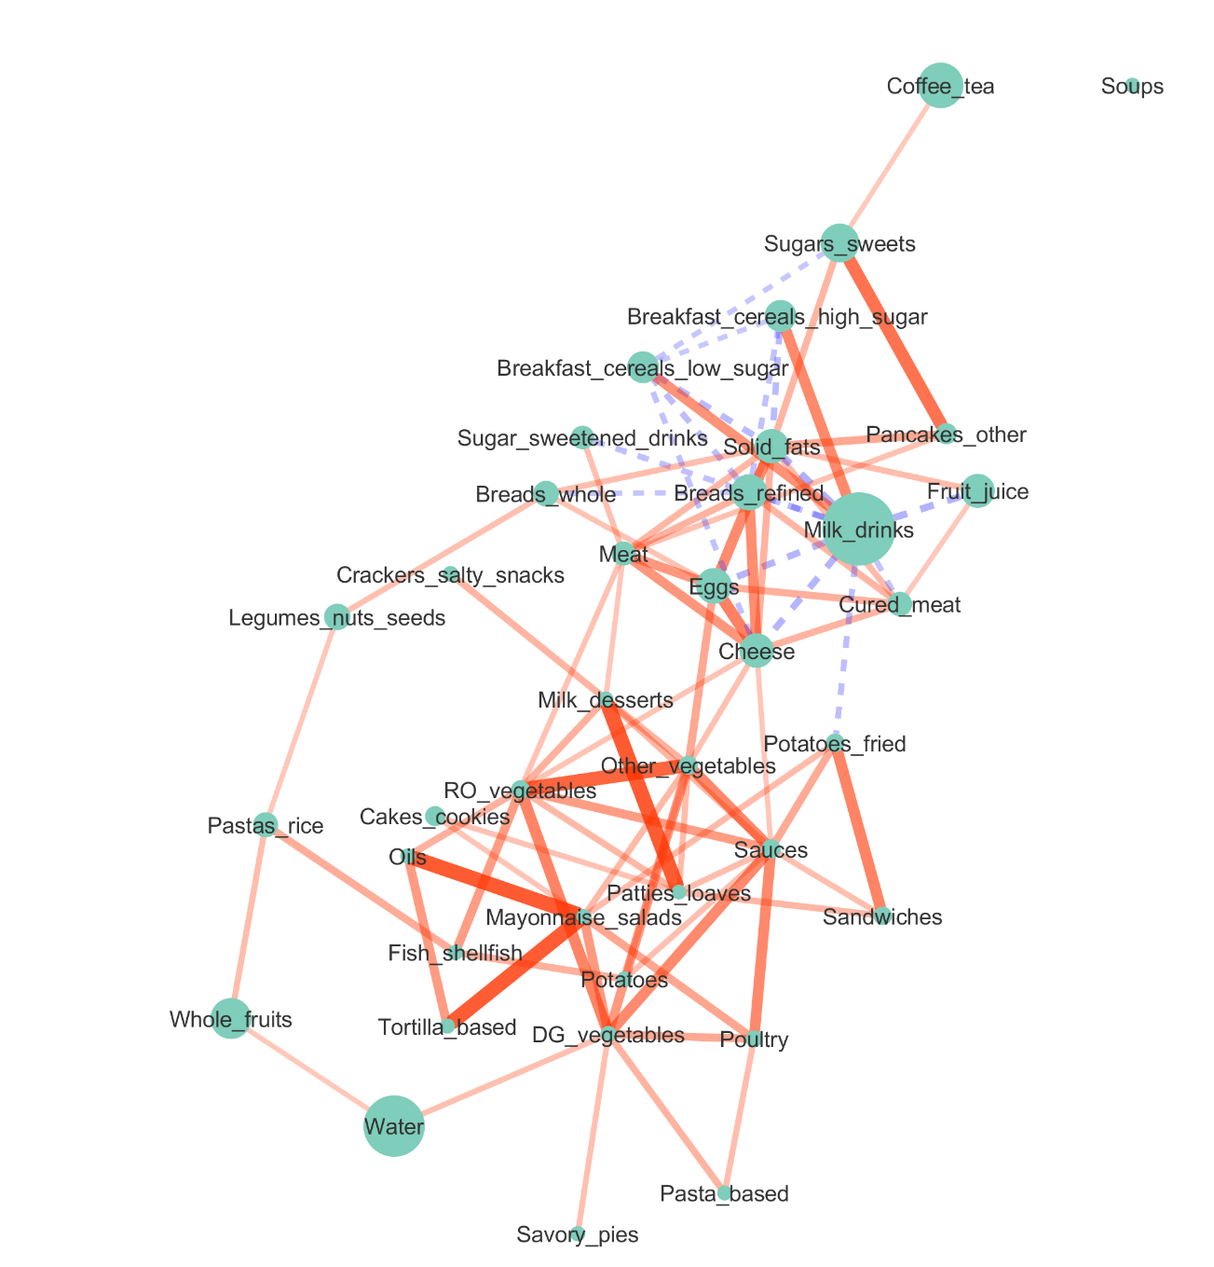

References:

1. Schwedhelm C, Knüppel S, Schwingshackl L, Boeing H, Iqbal K. Meal and habitual dietary networks identified through Semiparametric Gaussian Copula Graphical Models in a German adult population. PLOS ONE. 2018;13(8):e0202936.

2. Liu H, Han F, Yuan M, Lafferty J, Wasserman L. High-dimensional semiparametric Gaussian copula graphical models. Ann Statist. 2012;40(4):2293-326.

3. Krämer N, Schäfer J, Boulesteix A-L. Regularized estimation of large-scale gene association networks using graphical Gaussian models. BMC Bioinformatics. 2009;10(1):384.

4. Liu H, Lafferty J, Wasserman L. The nonparanormal: Semiparametric estimation of high dimensional undirected graphs. Journal of Machine Learning Research. 2009;10(Oct):2295-328.

5. Liu H, Han F, Yuan M, Lafferty J, Wasserman L. The nonparanormal skeptic. arXiv preprint arXiv:12066488. 2012.

6. Zhao T, Liu H, Roeder K, Lafferty J, Wasserman L. The huge package for high-dimensional undirected graph estimation in R. Journal of Machine Learning Research. 2012;13(Apr):1059-62.

7. Staedler N, Dondelinger F, Staedler MN. Package ‘nethet’. 2015.

8. Ahn Y-Y, Bagrow JP, Lehmann S. Link communities reveal multiscale complexity in networks. nature. 2010;466(7307):761.

9. Kalinka AT. The generation, visualization, and analysis of link communities in arbitrary networks with the R package linkcomm. Dresden: Max Planck Institute of Molecular Cell Biology and Genetics. 2014:1-16.