**Bài 1.5:**

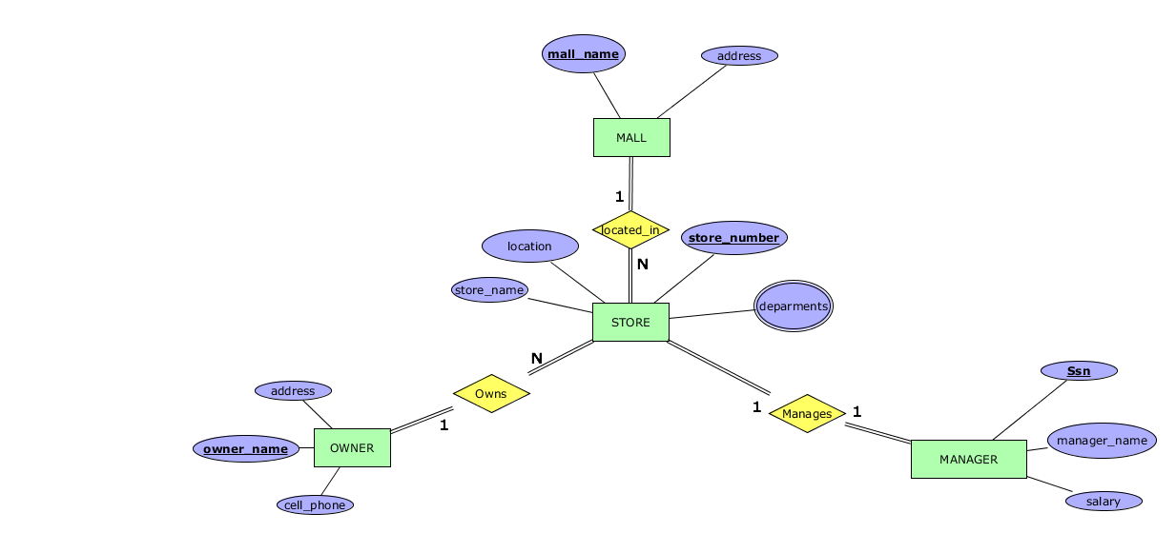

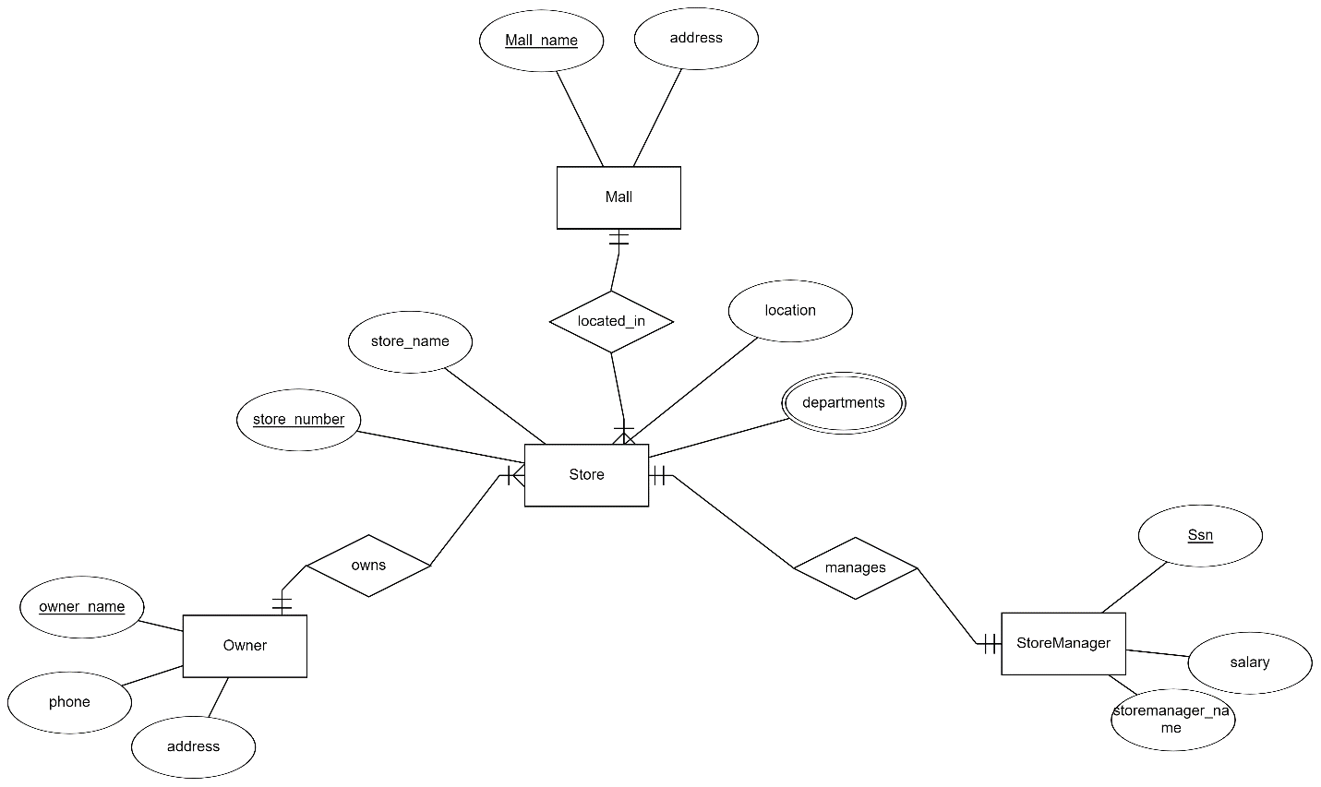

**Mapping Relationship to Relation:**

Mall(mall_name,address)

Store(store_number,store_name,owner_name(Forgeinkey),mall_name(Forgeinkey),location)

Manager(Ssn,manager_name,salary,store_number)

Owner(owner_name,address,,cell_phone)

Store_Departments(store_number,departments)