Họ tên: Trần Minh Trí

Lớp:CN22CLCF

MSSV:2251150039

Đề 2:

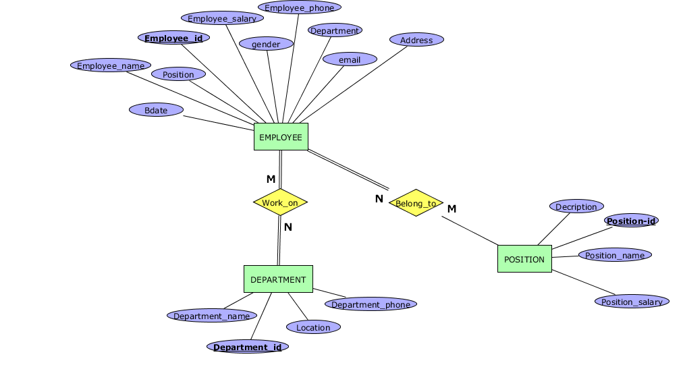

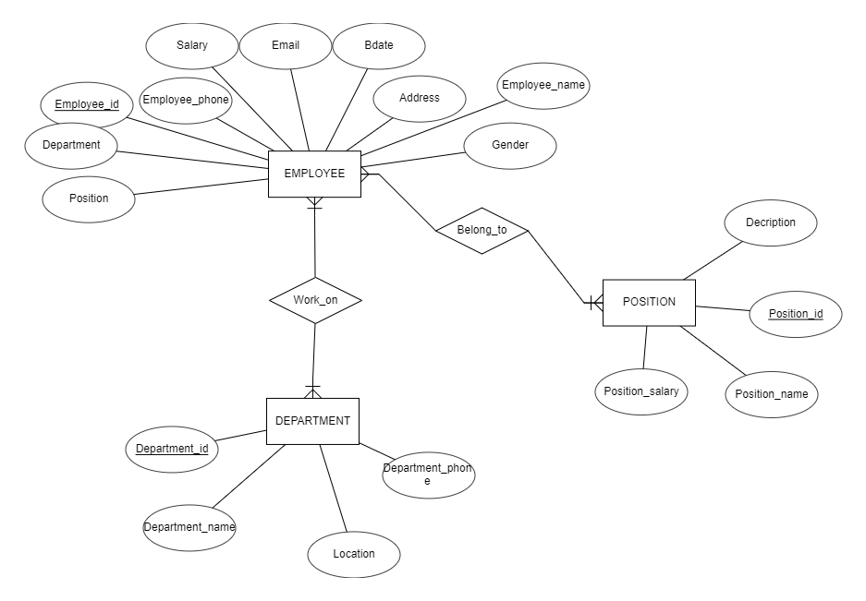

Mô hình quan hệ là:

**EMPLOYEE**( Employee_id , Employee_name , Employee_phone , Employee_salary , Email , Bdate , Address , Gender , Department_id , Position_id)

**DEPARTMENT**( Department_id , Department_name , Location , Department_phone)

**POSITION**( Position_id , Position_name , Decription , Position_salary)

**EMPLOYEE_DEPARTMENT**( Employee_id , Department_id)

**EMPLOYEE_POSITION**(Employee_id , Position_id )