

Login Depot is a CRM (Customer Relationship Management) for brokers.

This application will allow the broker to send instant quotes for his customers, manage their information, track his incomings and get a scheduled reports for his company’s progress.

Login Depot is a software made for brokers that are transporting vehicles in United States.

Login Depot will have a few main features for brokers that will help them manage their needs better.

**Quotes:**

*Once the broker enters the Pickup and Dropoff addresses in the software, it’ll get him the estimated price for the trip. Whether the information has been sent to the customer or not, the information will be automatically saved in the database for the broker use in the future and for the company’s statistics.

*The quote information will be sent to the customer by Email.

*On the quote, the broker can insert as much vehicles as needed for each customer (some customers have more than one vehicle to transport at a time).

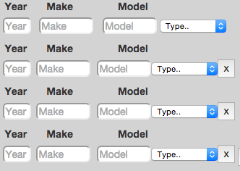

*The information that will be stored in the database for each customer is:

-name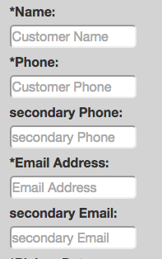

-phone

-secondary phone

-email

-secondary email

-pickup date

-pickup address (city, state, zipcode)

example: Denver, CO 80221

-dropoff address (city, state, zipcode)

example: Kirkland, WA 98034

-vehicles information (year, make, model)

example: 2005 honda accord

-vehicle condition (running, not running)

-carrier type (open, enclosed)

-vehicle extra notes

-office notes

-customer notes (will be sent to the customer by email)

-quote price

-post price (explanation on that part will come later)

**Customers Management:**

*Brokers will have the option to view all their customers in a table, sorted by name|last modified|creation date|order id|date.

*Search box will allow the company to look threw their customers.

*Once the broker clicks on a result, he’ll be directed to the customer profile page.

*The information on this page will be in a table form and will get all the records from the database based on the company unique ID.

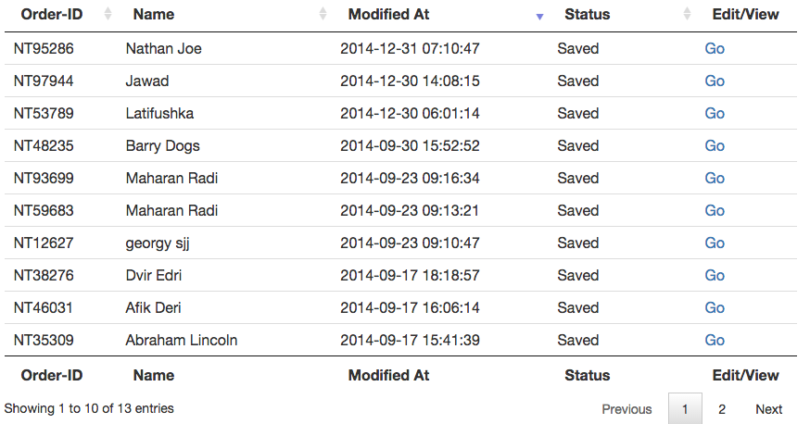

**Customer Profile Page:**

The customer profile page will show all the chosen customer information:

all the vehicles listed for him:

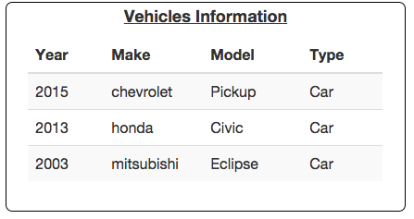

his personal information:

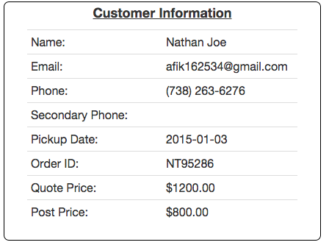

the pickup and dropoff addresess:

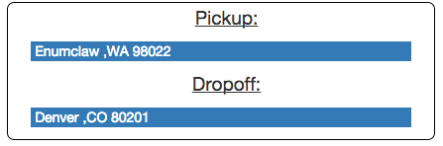

and more action buttons for handling this customer.

In this page, the broker will have the following options:

-Edit customer profile

-Add/Edit/Remove vehicles

-Delete customer

-Cancel order

-Resend quote email

-Check/Update the user status (more details on user status will come later)

-post the customer’s vehicle on a board (more details on posting boards will come later)

-add notes for the customer

-set a scheduled reminder

**New Company Sign up:**

There will be a free registration page for a new company to sign up for our service.

the company information we need in our database is:

-company name

-phone

-secondary phone

-office number

-fax number

-DOT number

-MC number

-email

-address (example: 98034 NE whitlower Ave Denver, CO 80221)

-company logo (optional)

-website

On top of that, we would like to have the option to bill our customer in the future.

we need blank fields in the database for billing address and payment information for each company and we would like to set up Authorize.net and paypal payment methods available for us once we decide to start roll it out.

keep in mind that once we decide to start charging our customers for the service, we wont have any issues with it and we can just send an email for them to update their billing information and payment method and thats it.

we also need to be able to block company’s account incase the payment wasn’t completed or payment method hasn't been updated.

**Customer sign up:**

each broker has the option to send his customers price quotes for their vehicle transportation. In order for the customer to sign up for the service, he’ll get an email with a link to “Accept the terms and conditions”. This link will get him to a signup page where he’ll need to fill out the following information:

**main contact information:**

name, phone number, secondary phone number, email, order id number.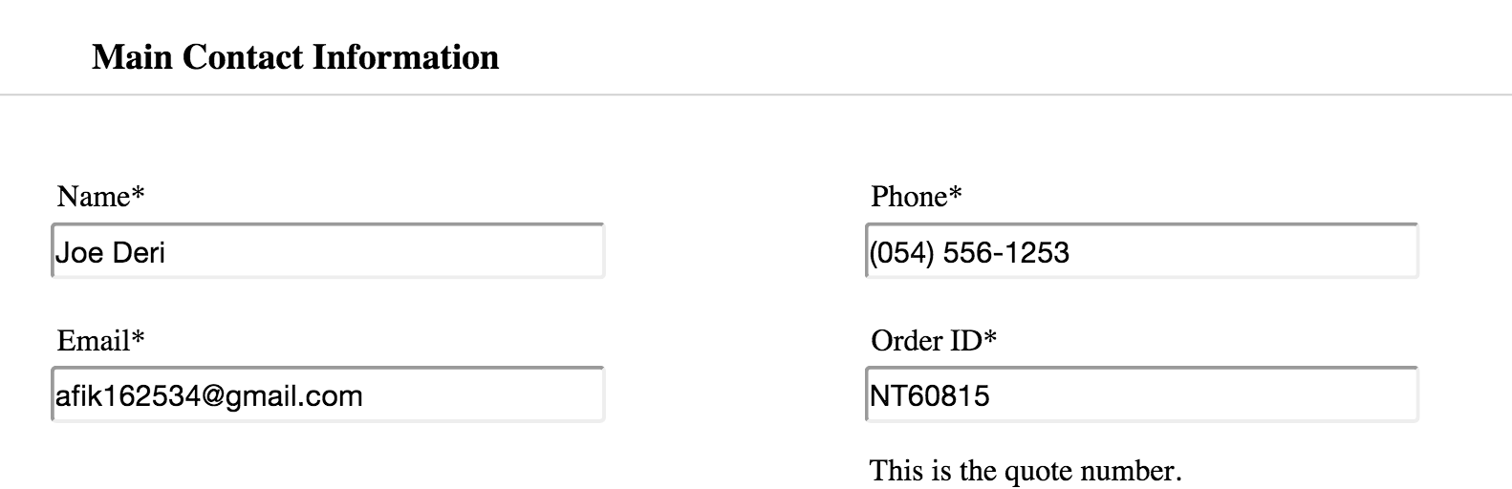

**pickup address information:**

name, phone number, secondary phone number, address, city, state, zipcode, type (residential, commercial)

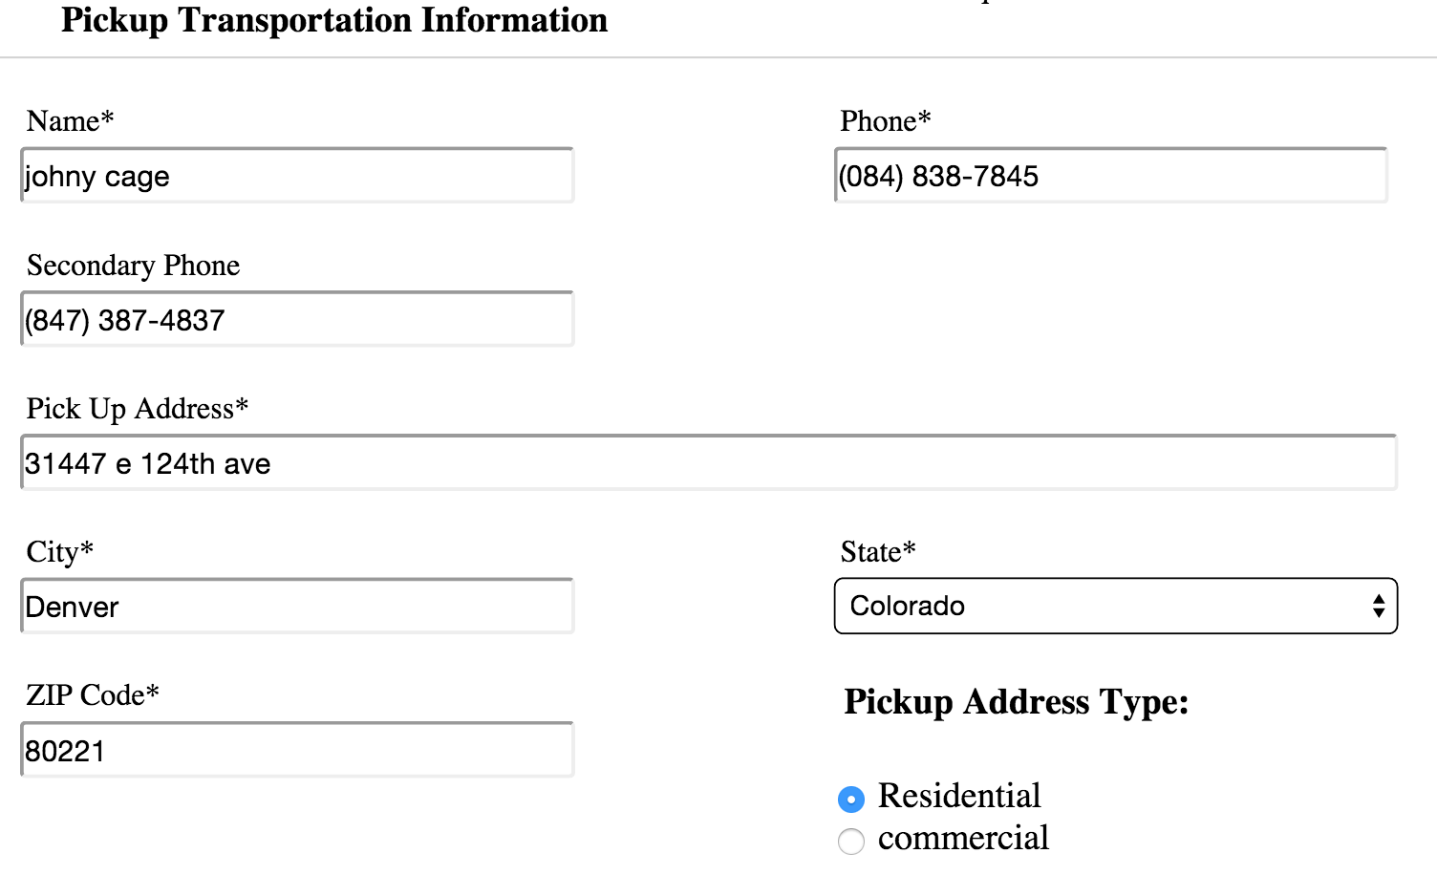

**dropoff address information:**

name, phone number, secondary phone number, address, city, state, zipcode, type (residential, commercial)

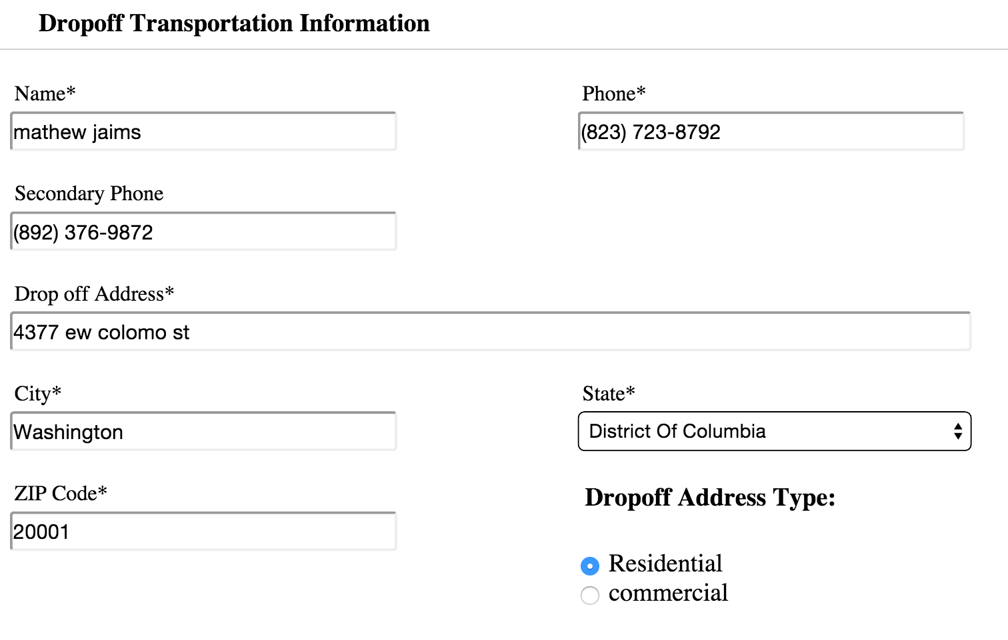

**payment information (store information only, do not chrage):**

credit card number, expiration date, cvv, name on the card, billing information.

Also in this page, the user will have to accept the company’s terms and conditions and then submit the form.

**Company Admin Panel:**

Each account will have his own option from his admin panel to :

-Users - He can add users as dispatcher (that limited to see some areas on the website like open ticket close and edit ticket , but they can’t see report or add other users and get to admin panel ) also at the same time the admin that he have full access to his account can see all the options available for him .

admin panel will include report tools that will show pie charts based on selected date range , that will bring amount of jobs that has been completed , total charges , how many orders has been canceled based on categories , user panel allowing the admin to add or disable users and choose the area that they can access in the account , on the admin panel they will be able to add their username and password for their accounts on CentralDispatch.com(posting board) , uship(another posting board) and others..- this username and password will be used to post their customer Vehicles through api system , Also they will be able to edit their automated email template that will be sent to the customer with each quote, change their billing information, account password ,auto posting setting default option

**Notifications:**

The notification area will be on the top left of the theme, presented by a drop down windows (same as facebook notifications).

This notification will show the workers of each company when:

-customer has agreed to the terms and conditions and signed up for the service.

-calendar event is coming

-important todo list is coming

-new message for this user

-notes from administrator (company’s Owner)

-General company notification

-LoginDepot newsletter notifications

**ToDo Lists:**

Pretty much self explanatory, This section will include shared ToDo list for each company between all workers (no need for separation between workers), The list will be based on time and color labels for “Important, General, etc..”.

The draggable Todo list widget frontend is already in the theme and only the backend needs to be made.

**Calendar:**

Shared calendar to each company, draggable events, scheduled events with custom emails and notifications reminders, color event label for each worker ( the calendar widget html and javascript is already functioning, we just need to add the backend to it - see theme for reference)

**Posts and Auto Posts:**

The brokers will have the option to post their customer’s vehicles on another website, this website is associated with many other drivers in united states and they will have the option to review and maybe call the broker to request that job. The posting boards websites are: CentralDispatch.com, uShip.com and a few others..

we have the api for those boards ready for our developer including a detailed documentation for how to post this job online through our system.

the meaning of “Auto Post” is for the Broker to have the option to do this post scheduled by date or by start and end date or by time (every 30 min, every hour, etc…).

for example:

My customer have a 2005 Honda Accord that he would like to transport from Denver, CO to Washington DC, Me as a broker told him that the price for that will be $800 but i would like to post it on CentralDispatch.com for $600 for other drivers to see it. once they call and ask for the job for $600 and the customer is paying $800, i made $200 profit of this deal. however, it;s not always that easy and sometime you need to raise the post price on that board to get the drivers attention and i will change it to $625, and if nobody calls for 30 minutes i’ll raise the price to $650 and so on.., The reason We’re doing an “Auto Post” system is for the broker to not have to go to CentralDispatch.com (or any other board service) and update the price menually. I will provide him with the option to select the time schedule and the amount of money that we’ll raise this job for. (raise job number NT5463 in $35 every 2 hours).

**Reports:**

Report will provide most information based on a selected period of time , admin will be able to see how many order has been created to his company with a pie charts that shows the amount of order that he have based on their order status( closed, cancel , in-progress…) .

Also he can get a report of total charges when order is closed they can enter the amount that they charge the customer and it will add this number to the report, One more report will have all the canceled orders with the reason of canceling in a pie chart.

also they can have in the report the option to see pie charts that show their advertising and when selecting one of the ads they will be able to see how many orders has been closed from this ads and their total profit from this add( please note that on the customer ticket we will add a drop menu of referral by for this part.) on the report they will see a dispatcher and admin report that will allow them to see based on each user how many order he create and their status , What is the total charge of orders that he create and also the total charge of orders that he closed.all this report and all the account databased will be able to export by the documents below .

export to: pdf, xml, csv, print

**Site Owner Panel:**

On this page the site owner (Me) will have the option to review all the companies that are currently logged in to the service, will have the option to edit their information, add\remove companies, see scheduled reports, charge their customers, send emails to customers, send notifications to each company, view and edit all sub-users for each company, adit the company gateway service (paypal, authorize.net,etc…).

This account will have a report of how many order has been created on the entire software or per account, How many new users has been created , Accounts that has been closed, enable and disable accounts ,