|  |  |  |  |
| --- | --- | --- | --- |
| 네트워크 구성 | optimizer | Learning rate | Test Accuracy |
| 1.레이어2개, ReLU | SGD | 0.001 | 0.797 |
| 2.레이어2개, ReLU | Adam | 0.001 | 0.966 |
| 3.레이어3개, ReLU | Adam | 0.001 | 0.972 |
| 4.레이어3개, Tanh | Adam | 0.001 | 0.972 |
| 5.레이어3개, Tanh, ReLU | Adam | 0.001 | 0.973 |
| 6.레이어3개, Tanh, ReLU, | Adam | 0.0001 | 0.936 |
| 7.레이어3개, Tanh, ReLU, epoch=8, | Adam | 0.0001 | 0.949 |
| 8.레이어3개, Tanh, epoch=5, batchsize = 32 | Adam | 0.0001 | 0.944 |
| 9.레이어4개, ReLU, epoch=5 batchsize = 32 | Adam | 0.001 | 0.973 |
| 10.레이어4개, ReLU, epoch=5 batchsize = 64 | Adam | 0.001 | 0.970 |
| 11.레이어4개, ReLU, epoch=20 batchsize = 64 | Adam | 0.0001 | 0.976 |

사진첨부

1.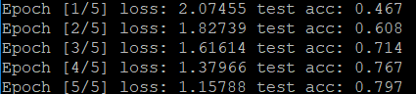

2.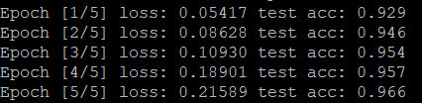

3.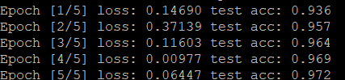

4.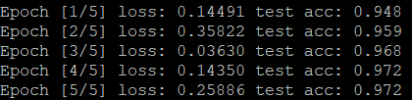

5.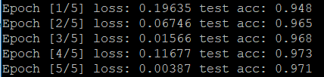

6.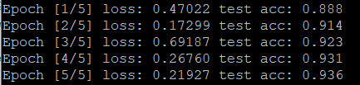

7.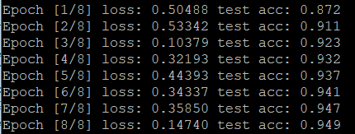

8.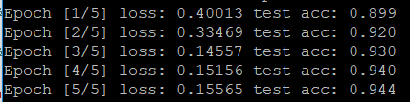

9.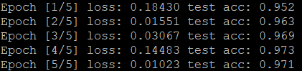

10.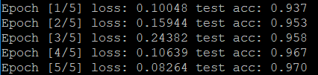

11.