|  |  |  |  |  |
| --- | --- | --- | --- | --- |
| 네트워크 구성 | optimizer | Learning rate | 채널변환 | Test Accuracy |
| 레이어4개, ReLU, BatchNorm2d, MaxPool2d | Adam | 0.001 | 3->32->64->128->16 | 0.714 |
| 레이어4개, ReLU, BatchNorm2d, MaxPool2d | SGD | 0.001 | 3->32->64->128->32 | 0.741 |
| 레이어3개, ReLU, BatchNorm2d, MaxPool2d | Adam | 0.001 | 3->32->64->128- | 0.724 |
| 레이어4개, ReLU, BatchNorm2d, MaxPool2d | Adam | 0.001 | 3->128->64->32->16 | 0.700 |
| 레이어5개, ReLU, BatchNorm2d, MaxPool2d | Adam | 0.001 | 3->32->64->128->256->32 | 0.717 |
| 레이어4개, ReLU, BatchNorm2d, MaxPool2d | Adam | 0.001 | 3->128->64->32->16 | 0.724 |
| 레이어4개, ReLU, BatchNorm2d, MaxPool2d | Adam | 0.001 | 3->32->64->128->32 | **0.769** |

1. 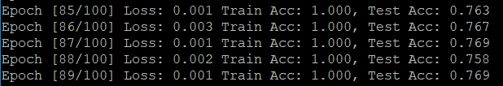
2. 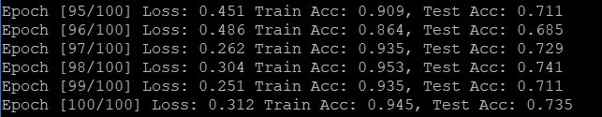
3. 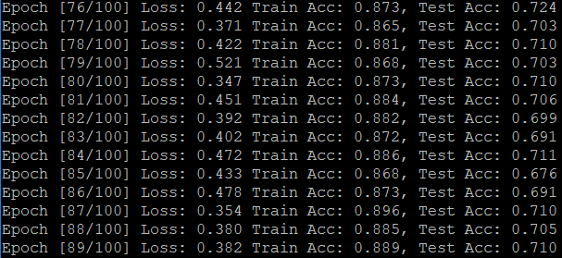
4. 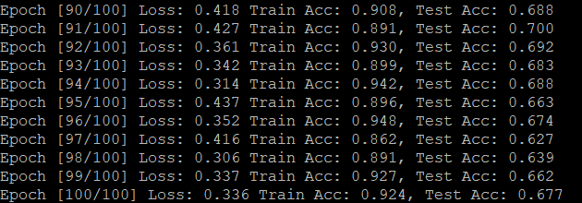
5. 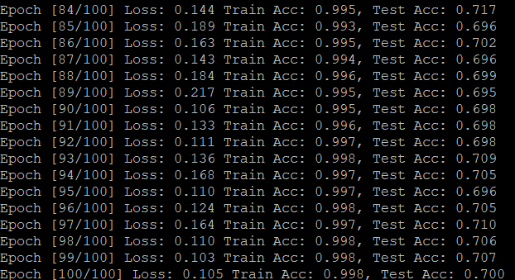
6. 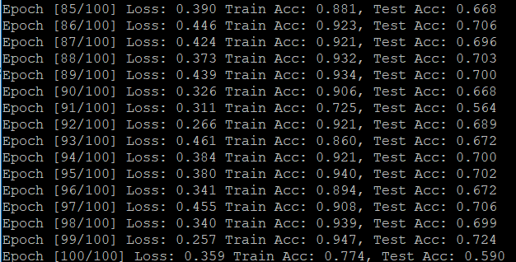
7. 