account

|  |  |  |  |  |  |  |  |
| --- | --- | --- | --- | --- | --- | --- | --- |
| aid | name | gender | phone | cid | friendlist | regid | rating |

requester

|  |  |  |  |  |  |  |  |
| --- | --- | --- | --- | --- | --- | --- | --- |
| **aid** | curpoint | start | end | time | path | carpoolpath | threshold |

receiver

|  |  |  |  |  |  |  |  |
| --- | --- | --- | --- | --- | --- | --- | --- |
| **aid** | curpoint | path | time | passenger | seat | threshold | wating |

histroy

|  |  |  |  |  |
| --- | --- | --- | --- | --- |
| hid | **did** | **pid** | distance | time |

wall

|  |  |  |  |  |  |
| --- | --- | --- | --- | --- | --- |
| wnum | **wid** | **uid** | rating | comment | time |

account(所有user)

|  |  |  |  |
| --- | --- | --- | --- |
| 名稱 | 備註 | 意思 | 範例 |
| aid | key | FBID | 860467000642654 |
| name |  | 姓名 | 胡帥 |
| gender |  | 性別 | m |
| phone | 唯一 | 電話 | 0912345678 |
| cid | 預設null | 車牌 | 082-CAR |
| friendlist |  | 朋友清單 | {"uid":"351623555004500"},{"uid":"351623555004500"} |
| regid |  | 裝置ID | APA91bHrp-_f0bSXcIq094Vf530Lhhs8uEreC-_zf6bV5Fr4VuyOe-hKcErgKal2qQWiUVlj6AnJAHHx29z-QVpVB6qtwHIVmvqpTUb9T0vZ1dp6uX8g1h09klQa_HUKJHljIrHuMgy-zjw5W88Q819XkymMqdWBeA |
| rating |  | 個人評價 | 3 |

requester(passenger)乘客

|  |  |  |  |
| --- | --- | --- | --- |
| 名稱 | 備註 | 意思 | 範例 |
| aid | 外鍵+主鍵 | FBID | 860467000642654 |
| curpoint |  | 目前位置 |  |
| start |  | 起點 |  |
| end |  | 終點 |  |
| time | 系統輸入 | 更新目前位置時間 | 20150409-xxxxxx |
| threshold | 評價門檻 |  | 3 |
| path | 乘客路徑 |  |  |
| carpoolpath | 共乘路徑 |  |  |

receiver(driver)司機

|  |  |  |  |
| --- | --- | --- | --- |
| 名稱 | 備註 | 意思 | 範例 |
| aid | 外鍵+主鍵 | FBID | 860467000642654 |
| curpoint |  | 目前位置 |  |
| time | 系統輸入 | 更新位置時間 | 20150409-xxxxxx |
| path |  | 司機路徑 |  |
| passenger |  | 乘客 | {"uid":"351623555004500"},{"uid":"351623555004500"} |
| seat |  | 共乘座位 | 4 |
| threshold | 評價門檻 |  | 3 |
| wating | 等待時間 |  | 3 |

history(共乘紀錄)

|  |  |  |  |
| --- | --- | --- | --- |
| 名稱 | 備註 | 意思 | 範例 |
| hid | 主鍵 | history編號 | 1 |
| did | 外鍵 | 司機ID | 860467000642654 |
| pid | 外鍵 | 乘客ID | {"uid":"351623555004500"},{"uid":"351623555004500"} |
| distance |  | 距離(km) | 1.6 |
| time |  | 上車時間 | 20150409-xxxxxx |

Wall(動態牆)留言+評價

|  |  |  |  |
| --- | --- | --- | --- |
| 名稱 | 備註 | 意思 | 範例 |
| wnum | 主鍵 | wall編號 | 1 |
| wid | 外鍵 | 被評價者 | 860467000642654 |
| uid | 外鍵 | 評論者 | 351623555004500 |
| rating | 預設為NULL | 評分 | 3 |
| comment |  | 留言 | 司機帥 |
| time | 系統輸入 | 留言時間 | 20150409-xxxxxx |

資料型態如下：

account

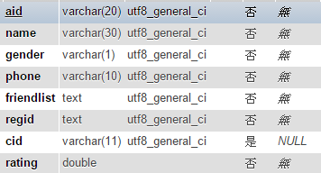

requester

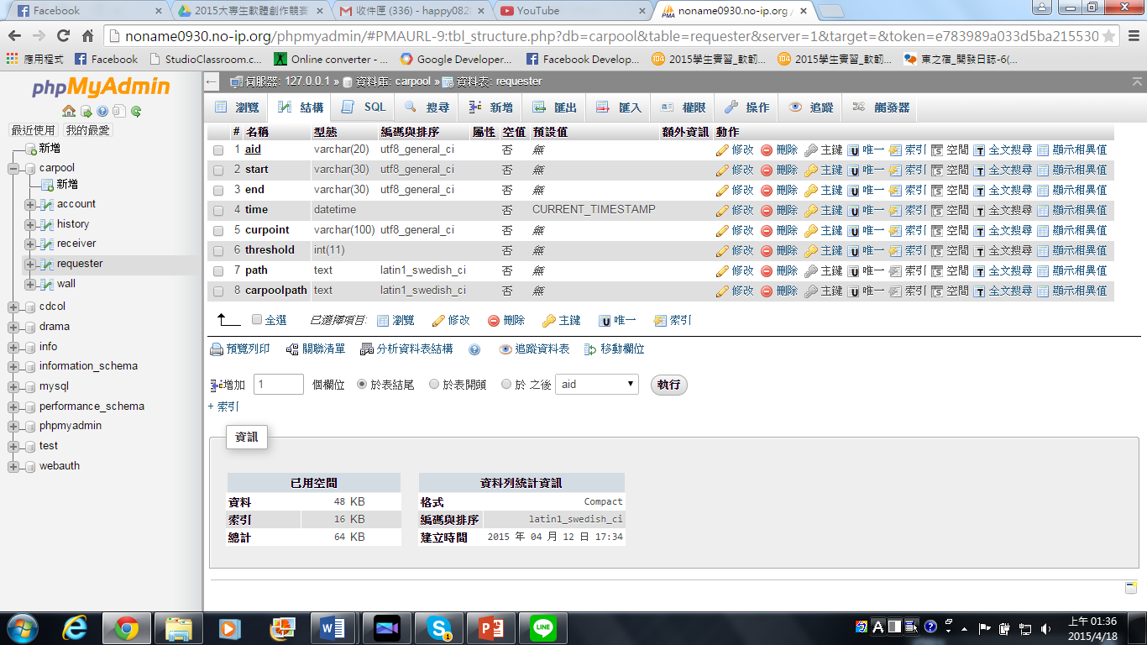

receiver

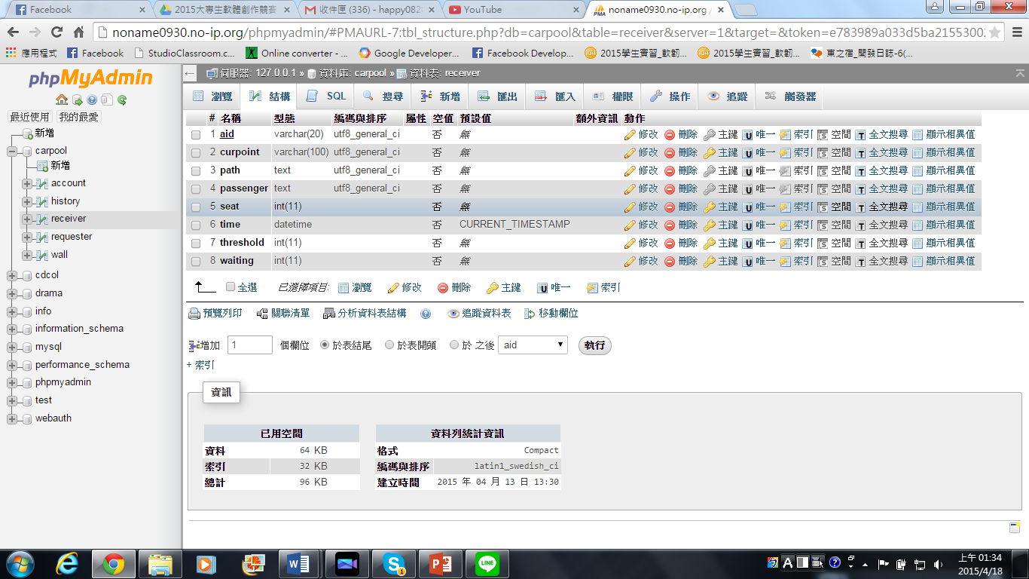

wall

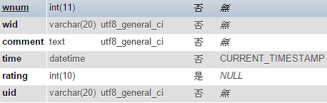

history

