**Computer Science 2**   **Lab # 05**



**Dr. Hanh Pham**

**Student Last Name: Carrasquillo Student First Name: Ariana**

**CS2 Section # 3**

**Due:** Problem A by the **end of the lab** and Problems B by the end of **Saturday** of the same week.

**TOPIC: Review of complete Java programs, standard I/O, If-Else**

**Problem B:**

**Problem Description:**

Write a program that prompts the user to enter the number of students, the students’ names, and their scores, and prints student names in **decreasing order** of their scores.

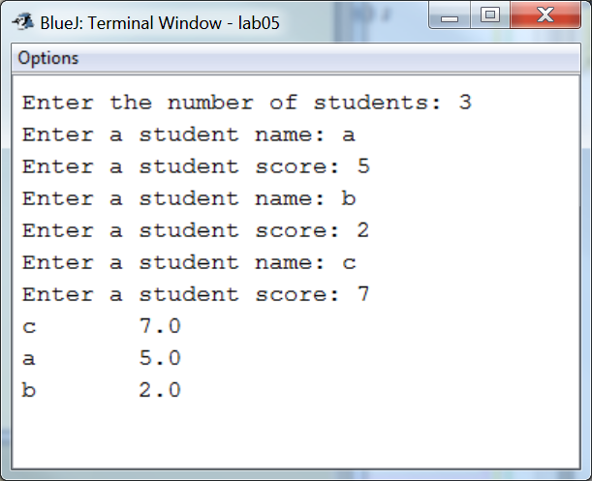

**Analysis:**

(Describe the problem including input and output in your own words. Type your answer in the following with **BLUE font color**)

|  |
| --- |
| **Ask the user for the number of students, that becomes the array length. Then individually enter each student’s name and their grades. Then display in decreasing order, highest score being the first** |

**Design:**

(Describe the major steps for solving the problem. Type your answer in the following with **BLUE font color**)

|  |
| --- |
| 1. **Create a method to sort the scores in decreasing order** 2. **In the main method create separate arrays for student name and scores** 3. **Ask for user input regarding student name and scores** 4. **Use a for loop to put the input into the separate arrays** 5. **Call method to sort the input** 6. **Display results** |

**Coding:** (Copy and Paste Source Code here. Type your answer in the following with **BLUE font color**)

|  |
| --- |
| **import java.util.*;**  **public class LabB{**  **public static void main(String[] args) {**  **Scanner input = new Scanner(System.in);**  **// Prompt the user to enter the number of students**  **System.out.print("Enter the number of students: ");**  **String[] students = new String[input.nextInt()];**  **int[] scores = new int[students.length];**  **// Prompt the user to enter each students' names and thier scores**  **System.out.println("Enter the name a score for each student:");**  **for (int i = 0; i < students.length; i++) {**  **System.out.print("Student " + (i + 1) + ": ");**  **students[i] = input.next();**  **System.out.print("Score: ");**  **scores[i] = input.nextInt();**  **}**  **// Sort student names in decreasing order of their scores**  **sortDecreasing(students, scores);**  **// Display student name in decreasing order of thier scores**  **for (int k=0; k<students.length; k++){**  **String e = students[k];**  **System.out.println(e + "\t" + scores[k]);**  **}**  **}**  **//Sorts a string and integer array in decreasing order**  **public static void sortDecreasing(String[] strs,int[] nums) {**  **for (int i = 0; i < nums.length; i++) {**  **int max = nums[i];**  **int maxIndex = i;**  **String temp;**  **// Find the minimum in the list[i..nums.length - 1]**  **for (int j = i + 1; j < nums.length; j++) {**  **if (nums[j] > max) {**  **max = nums[j];**  **maxIndex = j;**  **}**  **}**  **if (maxIndex != i) {**  **// Swap string array**  **temp = strs[i];**  **strs[i] = strs[maxIndex];**  **strs[maxIndex] = temp;**  **// Swap int array**  **nums[maxIndex] = nums[i];**  **nums[i] = max;**  **}**  **}**  **}**  **}** |

**Testing:** (Describe how you test this program. Type your answer in the following with **BLUE font color**)

|  |
| --- |
| **RUN three times, using the same input as in the sample runs:**  **Test 1:**  **Test 2:**    **Test 3:** |