Polytechnic University of the Philippines
COLLEGE OF COMPUTER AND INFORMATION SCIENCES
A. Mabini Campus, Sta. Mesa, Manila

Church-To-Go Reservation System

In partial fulfillment of the requirements for the courses:
COMP 2113 – ADVANCED PROGRAMMING
COMP 4023 – DATABASE ADMINISTRATION
INTE 3033 – DATABASE MANAGEMENT SYSTEMS 2

Carreon Jerevon C.
Del Rosario, Abigale P.
Ebrada, Jonalyn Fe D.
Ganila, Joshua J.
Inocencio, Jillmarie G.
Proponents

October 16, 2017

Executive Summary

Church is an important place for every religion; for them to share the same thoughts regarding their beliefs. It is a sacred place where we gathered together to celebrate special events of our lives. But people living in places where there are no church tends to go in other places where there are church, even though they don’t know the schedule of masses and events. And for some people who want to celebrate their special occasions in a specific church, they will go there even though it is far, just to ask questions about their inquiries/reservation of their event and that will cost them too much expense and slow processing of their reservation. We propose an application that will fasten up the church reservation process; reserving events, filling up forms in an orderly manner and giving the user free will to choose their desired date (if it is a private event) and complete the requirements needed all through this application which can be accessed online.

Table of Contents

Title Page
Executive Summary

PART I – PROJECT SPECIFICATIONS REPORT 4
1.1. INTRODUCTION 4
1.2. STATEMENT OF THE PROBLEM 4
1.3. PROJECT OBJECTIVES 4
1.3.1. General Objectives 4
1.3.2. Specific Objectives 5
1.4. SCOPE AND LIMITATION 5
1.5. PROJECT ASSUMPTIONS 5
PART II – DATABASE SPECIFICATIONS REPORT 6
2.1. BUSINESS RULES 6
2.2. ENTITY-RELATIONSHIP DIAGRAM 6
2.3. NORMALIZED RELATIONS 6
2.4. DATA DICTIONARY 7
2.5. DATABASE DIAGRAM 7
PART III – APPLICATION SPECIFICATIONS REPORT 8
3.1. APPLICATION DESCRIPTION 8
3.2. PROSPECT USERS OF THE SYSTEM 8
3.3. FEATURES SPECIFICATION 8
3.4. APPLICATION SCREENSHOTS 9

PART I – PROJECT SPECIFICATIONS REPORT

1.1. INTRODUCTION

Jesus Christ proclaimed, almost 2000 years ago, “I will build My church.” He declared that His Church would never die out promising that “the gates of Hades [the grave] shall not prevail against it” (Matthew 16:18)
Filipinos are indeed known worldwide as peoples of deep and great faith. It is the only country in Asia where majority are Catholics. Throughout the year, they manifest this kind of faith through their celebrations. Nearly every important events in our life is held at a church, like christening, baptism, and wedding. Also, we came here to say our thanks for the achievements we attain and blessings we receive. All because of the fact that our culture as Filipinos is centered on our religion and church.
Church-To-Go is a reservation system created to make special moments happen. Giving people a chance to reserve to the church in a lot more easier more way. It aims to provide an efficient and convenient way of reserving for all the individuals involved. By hosting the service online, the entire flow of the reservation system will not be greatly affected by the absence of important individuals.(Example: Suppose that the administrator of the system, whose the one that manages the approving of requests, is out of the country or sick & homebound then they can still fulfill their duties online). It also aims to prevent issues caused by human error can easily be avoided by Church-To-go, like preventing conflicting reservations. This project also aims to be extended to a bigger scope being deployed to different churches and providing uniform reservation system for the entire city.

1.2. STATEMENT OF THE PROBLEM

As far as we’ve noticed and observe in our community, not all barangay’s have their own church, because some barangay are small. For that instance, people living in places where there are no church tend to go in other places where there are church even though they don’t know the schedule of masses and events. And for some people who want to celebrate their special occasions in a specific church, they will go there even though it is far just to ask questions about their inquiries/reservation of their occasion, and that is a little bit costly for them that lead to slow reservation process.

1.3. PROJECT OBJECTIVES

1.3.1. General Objectives

The general objective of this system is to develop a Church Reservation System that aims to manage all reservations made to the church, fulfill all business rules/specifications and to offer a user-friendly interface design.

1.3.2. Specific Objectives

Specifically, the proposed system aims:
1. To help speed up the process of the church reservation.
2. To automate the manual reservation.
3. To standardize the reservation system with the list of users.
4. To reduce the amount of time to and effort consume by the customer to reserve.
5. Provide user account and user password to ensure security of stored data.
6. To lessen their expenses in making reservation.

1.4. SCOPE AND LIMITATION

The developers are in the process of creating Church-To-Go Reservation System, which is a system to allow people to reserve the church for a special occasion. The system will be available 24/7 for the convenience of the people. And this Reservation System will help the administration to find out who are the people that wants to reserve and to lessen the processing time which is a problem with both the admin and reservers. This system will only provide reservation for the people, and will not have an online payment. And when someone would like to register or sign up for an account, you will have to fill up a registration form. When you have logged in, that’s where you make a reservation and wait till the admin approved your request. But it also has its limitations. If a guest is not registered or doesn’t have an account, no possible reservations will be possible aside from viewing the site’s homepage. Also, payment through the site is not possible and should only be paid through the use of a voucher.

1.5. PROJECT ASSUMPTIONS

The following are assumptions made in our project:

- This software is for school-use only.
- People will have username and password to be able to access this site.
- Software will be dependent on access to the internet if launched.
- Software will be of great use to people in town with no churches.

PART II – DATABASE SPECIFICATIONS REPORT

2.1. BUSINESS RULES

Specify in this section, the business rules followed and automated by the application. Use the format specified below.
Rule ID | Business Rule
BR_001 | <Insert business rule here>
BR_002 | <Insert business rule here>

2.2. ENTITY-RELATIONSHIP DIAGRAM

Include the ERD here. If it will consume an entire page, place it in another page and indicate in this section that it can be seen on the next page. NOTE: Do not use the diagrams generated by the DBMS that you are using. The diagram they generate is pertaining to the tables created for the physical database. This does not reflect on the conceptual design of the database.

2.3. NORMALIZED RELATIONS

Include the Normalized Relations here. If it will consume an entire page, place it in another page and indicate in this section that it can be seen on the next page. There is no need to show each normalization step, just present the 3NF in your diagram.

2.4. DATA DICTIONARY

Include the Data Dictionary here. If it will consume an entire page, place it in another page and indicate in this section that it can be seen on the next page. Use the following format for the data dictionary. Use the formatted table for each of your database table.

Table Name: STUDENT
Table Description: Contains the records of each student.
Related Table: None
Key | Field Name | Data Type | Length | Optional | Default Value | Field Validation | Description | Sample Data
PK | StudentID | varchar | 15 | N | None | None | Unique identifier of student record. | 2011-00321-MN-0
 | LastName | varchar | 50 | N | None | None | Last name of the student | Rizal

2.5. DATABASE DIAGRAM

Include the Database Diagram here. If it will consume an entire page, place it in another page and indicate in this section that it can be seen on the next page. This is where you need to put the generated diagram of your DBMS.

PART III – APPLICATION SPECIFICATIONS REPORT

3.1. APPLICATION DESCRIPTION

Church-To-Go is a reservation system created to make special moments happen. Giving people a chance to reserve to the church in a lot more easier more way. It aims to provide an efficient and convenient way of reserving for all the individuals involved. It also aims to prevent issues caused by human error can easily be avoided by Church-To-go, like preventing conflicting reservations.

3.2. PROSPECT USERS OF THE SYSTEM

- User/Guest – they are the ones who creates an account for them to be able to reserve the church for an event they want to conduct in the church. They possibly have the biggest benefit in the creation of this reservation system. Being able to process the transactions needed for reserving the church online for special events such as weddings, baptism, etc. will help lessen the burden of having too many things to do for the preparation as well as their effort and time. If they are not near the church area, then it will save them the time needed to get back and forth to the church.

- Patron/Member of the Church – these are the people who are regularly in the church and almost always participate in the events held by the church. They will be able to see special events the church will be conducting and become able to participate, be able to see the church schedule on when the church is available for masses and such.

- Administration – it is the part of the church which handles the management side to make it an efficient organization. Acts as liaison between the priest/pastor, congregation and staff. This will make their work easier to handle. This program will be taking most of the work like getting the information and requirements needed for the reservation of an event. The admin will only have to check if the requirements passes are correct and confirming if the fee has been paid (some events doesn’t have fees). It will also help in the organization of files, make searching for certain files easier since they are sorted already.

- Priest – he is the one authorized to perform the sacred rites of a religion especially as a mediatory agent between humans and God; specifically: an Anglican, Eastern Orthodox, or Roman Catholic clergyman ranking below a bishop and above a deacon. The priest will be able to see his schedule, when he is appointed to conduct a certain ceremony and be able to get ready for it.

3.3. FEATURES SPECIFICATION

Feature ID: |  | Feat-001
Feature Name: |  | Register
Business Rule ID: |  | <Include the business rule ID/s affecting the feature>
User Story:
1. | A user must be able to create an account if he/she didn’t have one.

Feature ID: |  | Feat-002
Feature Name: |  | Log in
Business Rule ID: |  | <Include the business rule ID/s affecting the feature>
User Story:
1. | A user must be able to login in his previously created account from the Register module.
2. | A user must be able to logout his account and the account should be secured and inaccessible to others.
3. | A user must be able to edit his/her account details.

Feature ID: |  | Feat-003
Feature Name: |  | Reservation
Business Rule ID: |  | <Include the business rule ID/s affecting the feature>
User Story:
1. | A user must be able to reserve the church in her chosen date and event.
2. | A user must be able to fill up the form for her chosen event in the reservation.

Feature ID: |  | Feat-004
Feature Name: |  | Submission of Requirements
Business Rule ID: |  | <Include the business rule ID/s affecting the feature>
User Story:
1. | A user must be able to attach the required files and upload for submission.

Feature ID: |  | Feat-005
Feature Name: |  | Pending & Approved
Business Rule ID: |  | <Include the business rule ID/s affecting the feature>
User Story:
1. | A user must be able to see her previous reservation, whether it is pending or already approved.
2. | He/she must be able to edit or cancel a pending reservation.

Feature ID: |  | Feat-006
Feature Name: |  | Voucher
Business Rule ID: |  | <Include the business rule ID/s affecting the feature>
User Story:
1. | A user must be able to print the voucher derived after filling up the form for the reservation.

3.4. APPLICATION SCREENSHOTS

Form Name: | Anointment Form
Description: | If you wish to reserve a schedule for an anointment, you will have to fill-up this form.
Feature ID: | Feat-003
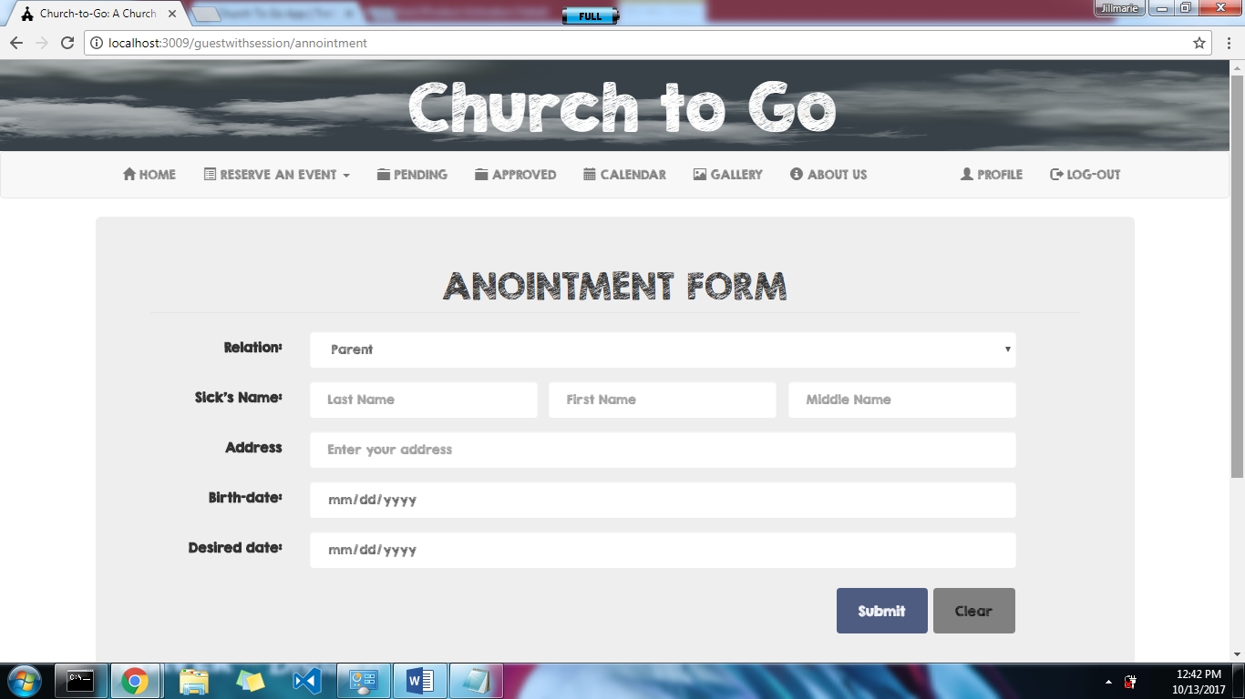

Figure 1.0. <Anointment Form>

Form Name: | Anointment Submission Requirements Form
Description: | This is where you will attach documents required to complete anointment reservation.
Feature ID: | Feat-004
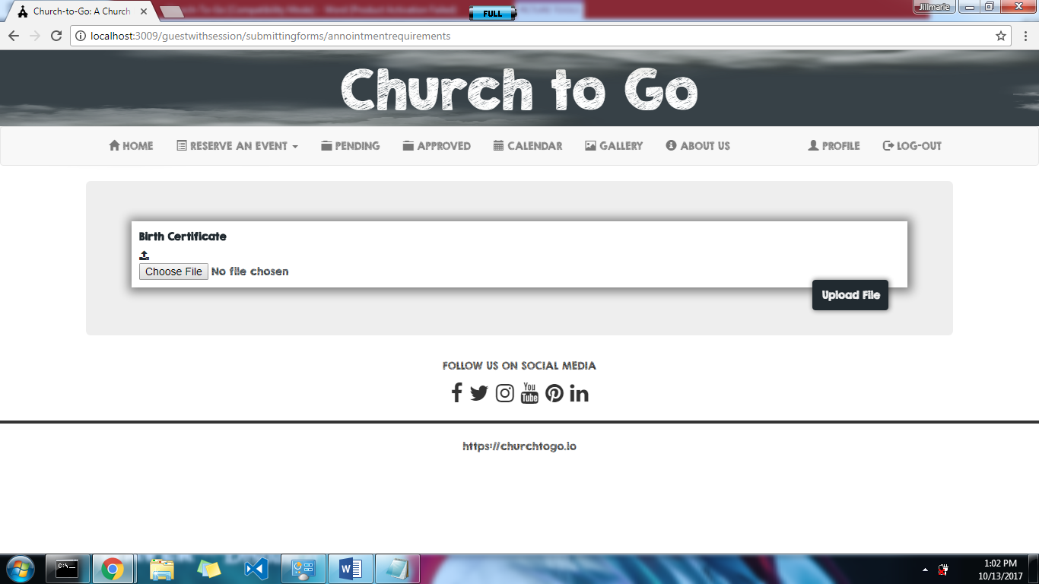

Figure 1.0. <Anointment Submission Requirements Form>

Form Name: | Baptismal Form
Description: | If you wish to reserve a schedule for a baptismal, you will have to fill-up this form.
Feature ID: | Feat-003
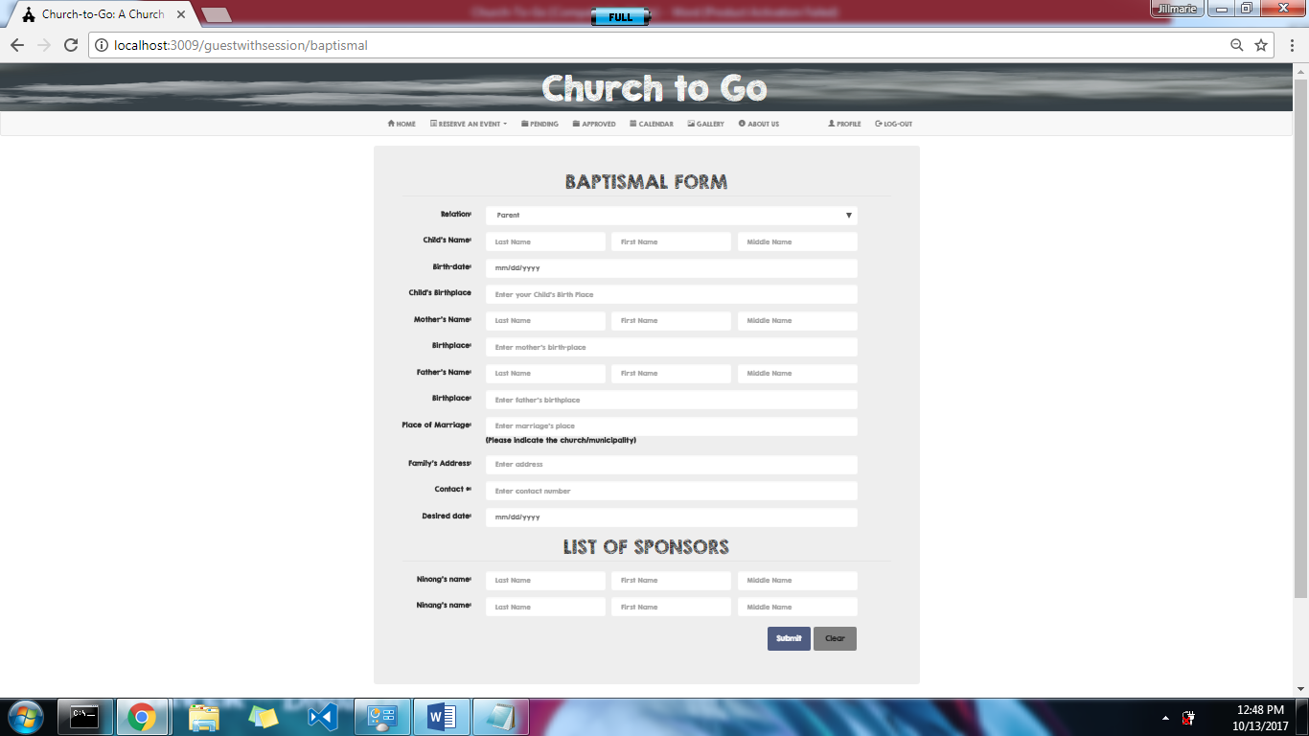

Figure 1.0. <Baptismal Form>

Form Name: | Baptismal Submission Requirements Form
Description: | This is where you will attach documents required to complete reservation.
Feature ID: | Feat-004
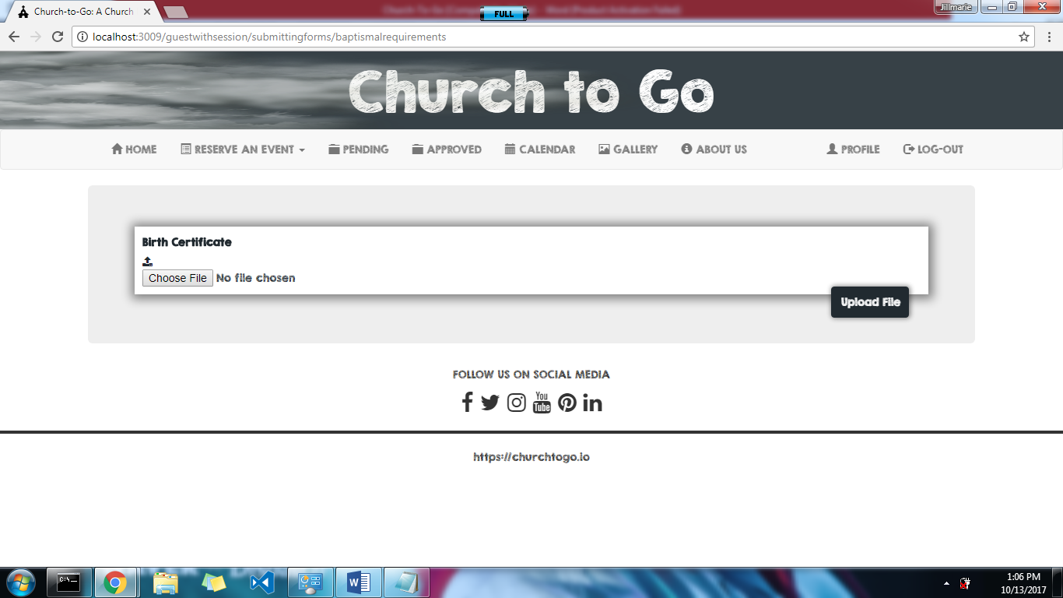

Figure 1.0. <Baptismal Submission Requirements Form>

Form Name: | Funeral Mass Form
Description: | If you wish to reserve a schedule for a funeral mass, you will have to fill-up this form.
Feature ID: | Feat-003
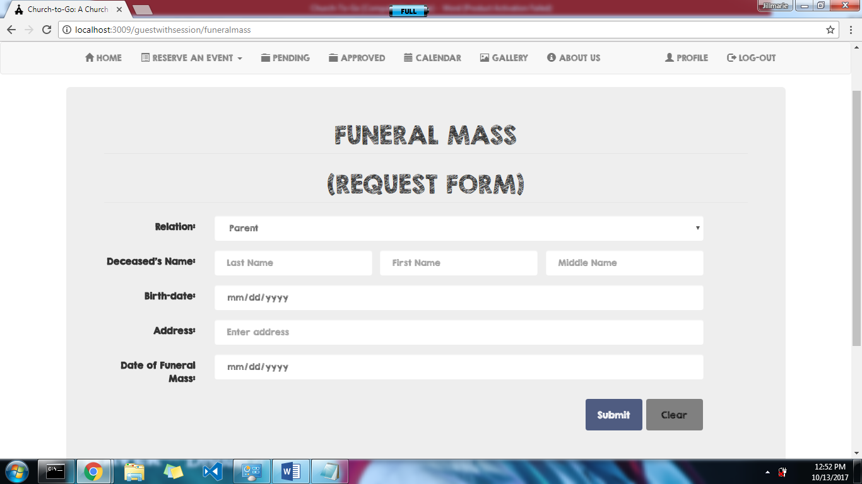

Figure 1.0. <Funeral Mass Form>

Form Name: | Funeral Mass Submission Requirements Form
Description: | This is where you will attach documents required to complete reservation.
Feature ID: | Feat-004

Figure 1.0. <Funeral Mass Submission Requirements Form>

Form Name: | Wedding Form
Description: | If you wish to reserve a schedule for a wedding, you will have to fill-up this form.
Feature ID: | Feat-003
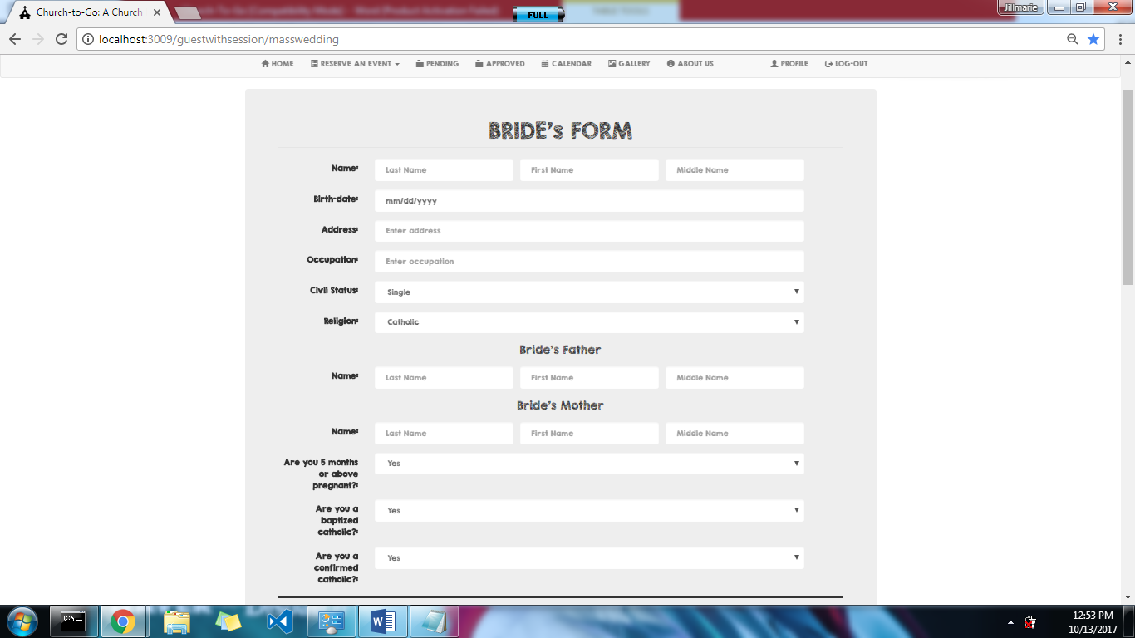

Figure 1.0. <Wedding Form – Bride’s Form>

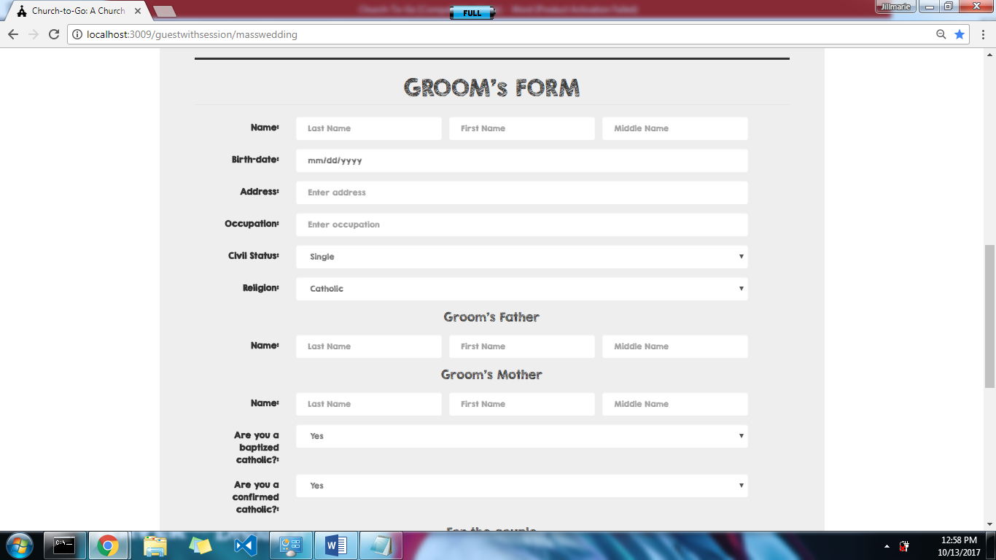

Figure 2.0. <Wedding Form – Groom’s Form>

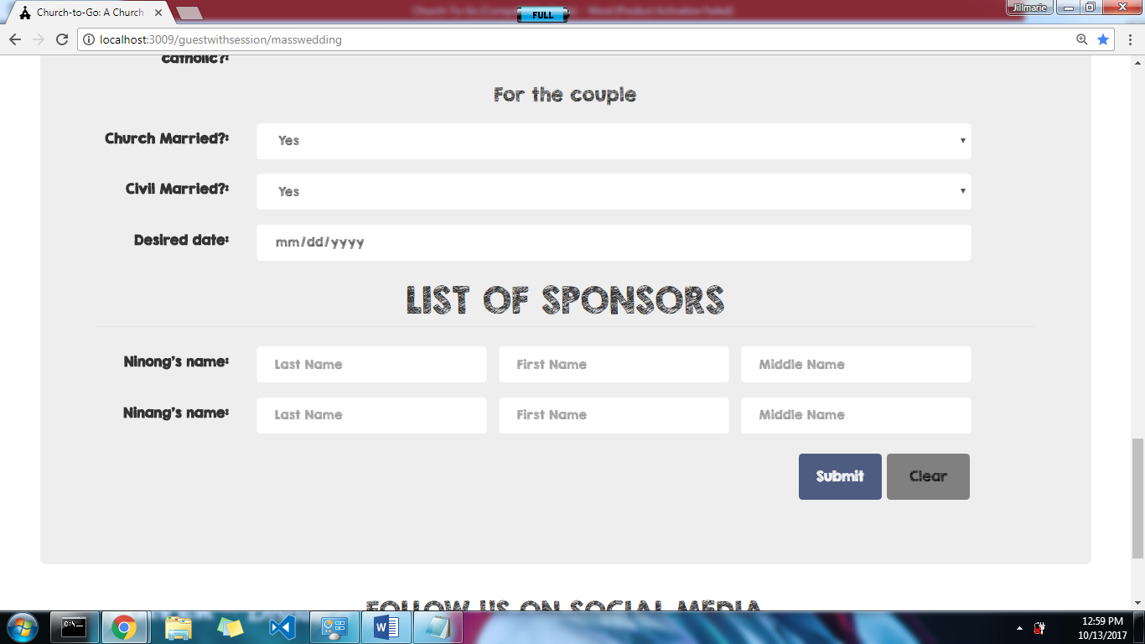

Figure 3.0. <Wedding Form – Couple’s Form>

Form Name: | Wedding Submission Requirements Form
Description: | This is where you will attach documents required to complete reservation.
Feature ID: | Feat-004
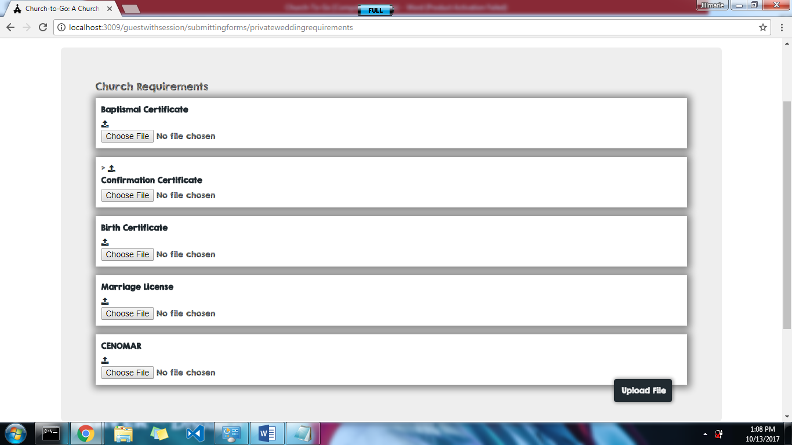

Figure 1.0. <Wedding Submission Requirements Form>

Form Name: | Registration Form
Description: | This is where a user who wants to reserve an event can create his/her account.
Feature ID: | Feat-001
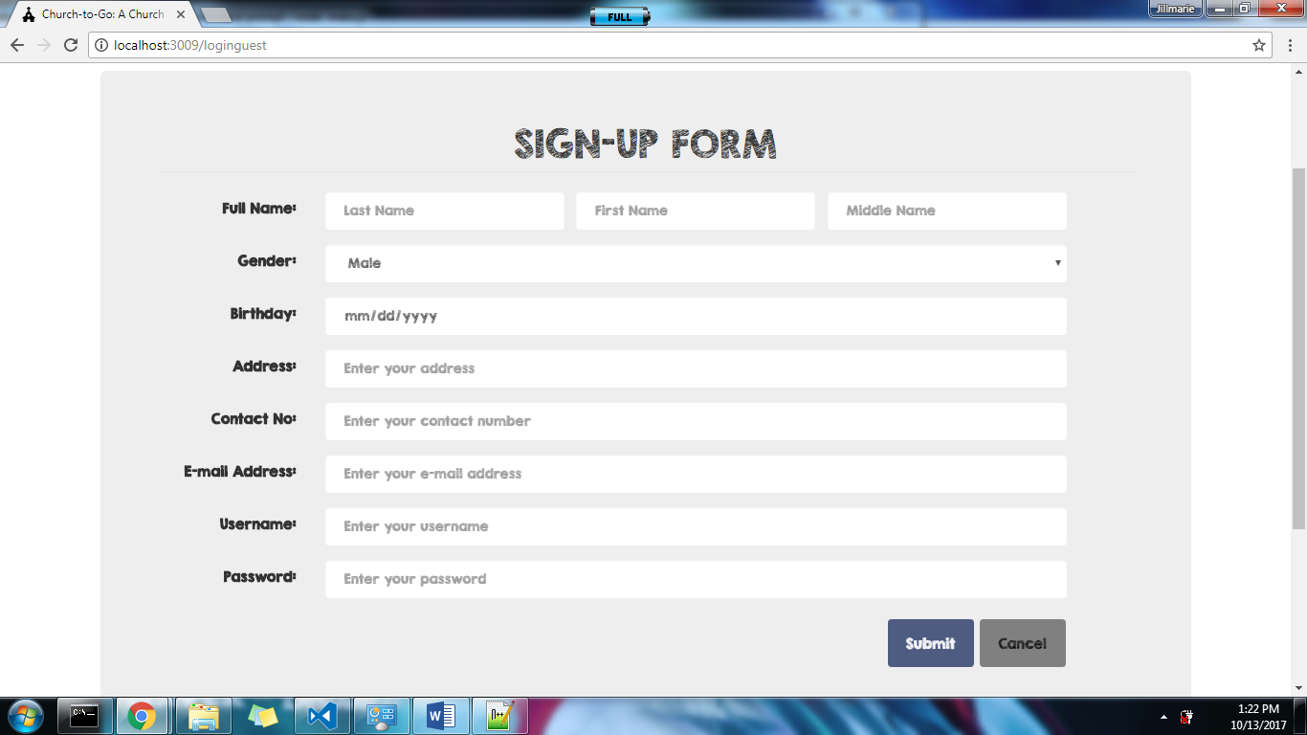

Figure 1.0. <Registration Form>

Form Name: | Login Form
Description: | This is where you enter your username and password to be able to access the site and reserve an event.
Feature ID: | Feat-001
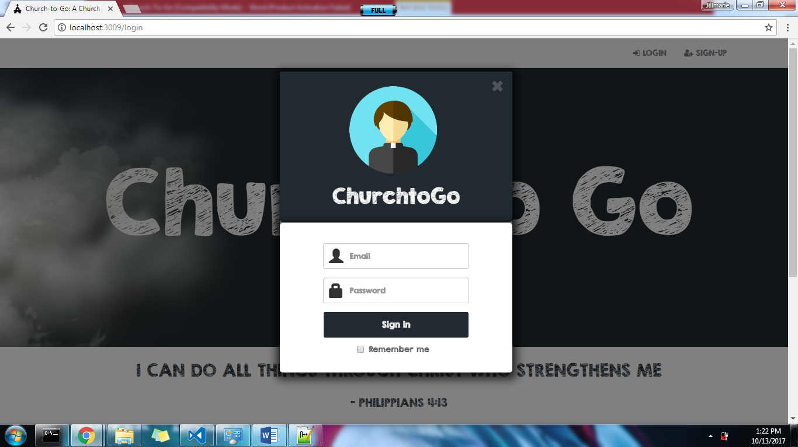

Figure 1.0. <Login Form>

Form Name: | Edit & Cancel Reservation Form
Description: | To change some details about the event, or cancel a reservation, this is the module for that.
Feature ID: | Feat-005
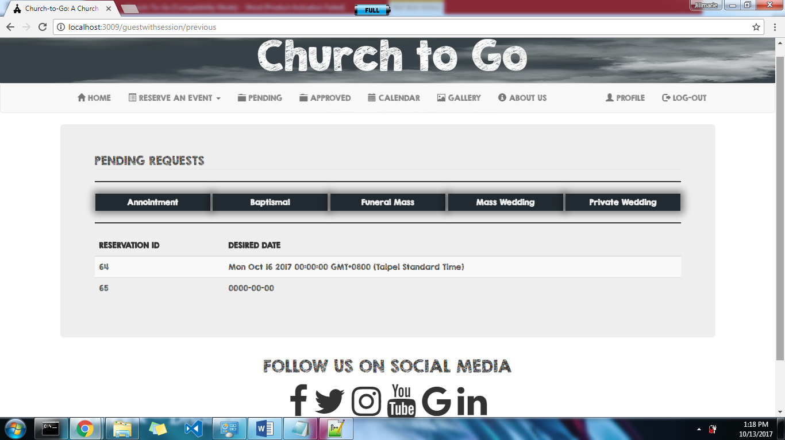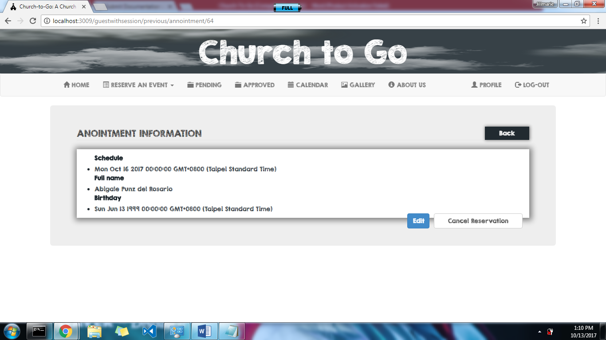

Figure 1.0. <Pending/Approved Requests Form>

Figure 2.0. <Edit/Cancel Reservation Form>
Form Name: | Profile Form
Description: | This is where you will see your profile/account details. And be able to edit if you wish.
Feature ID: | Feat-002
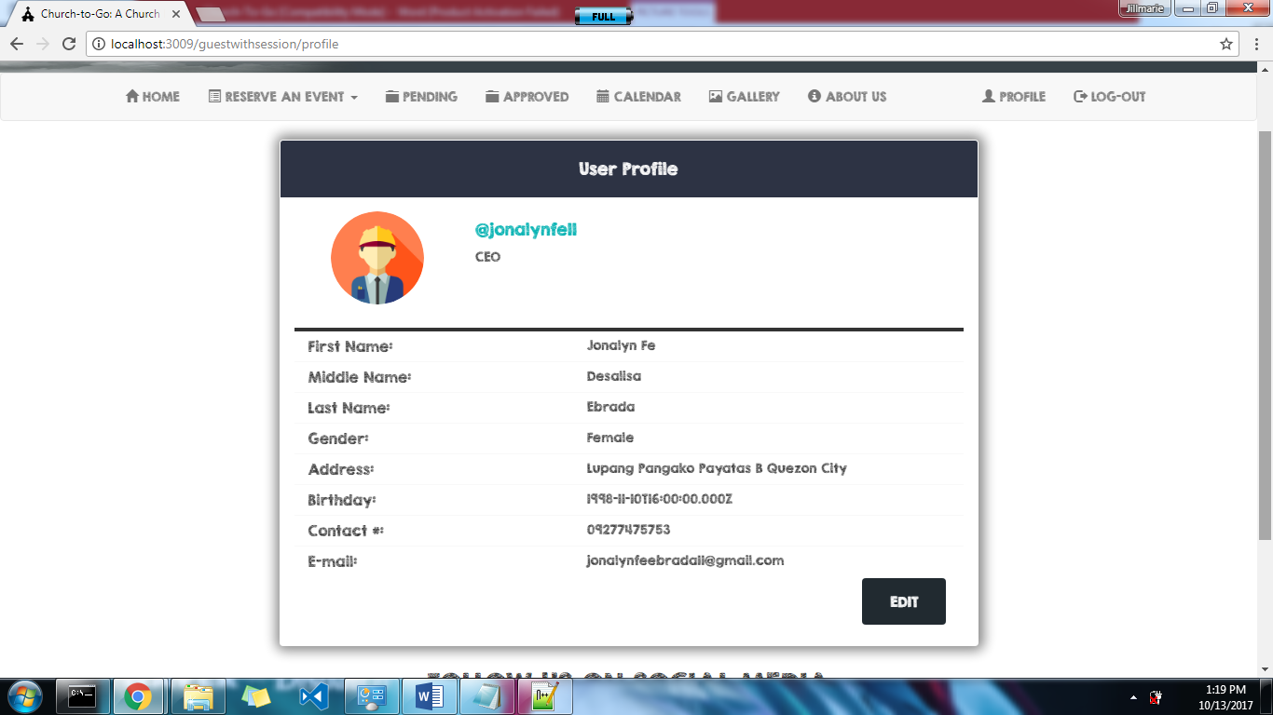

Figure 1.0. <Profile Form>
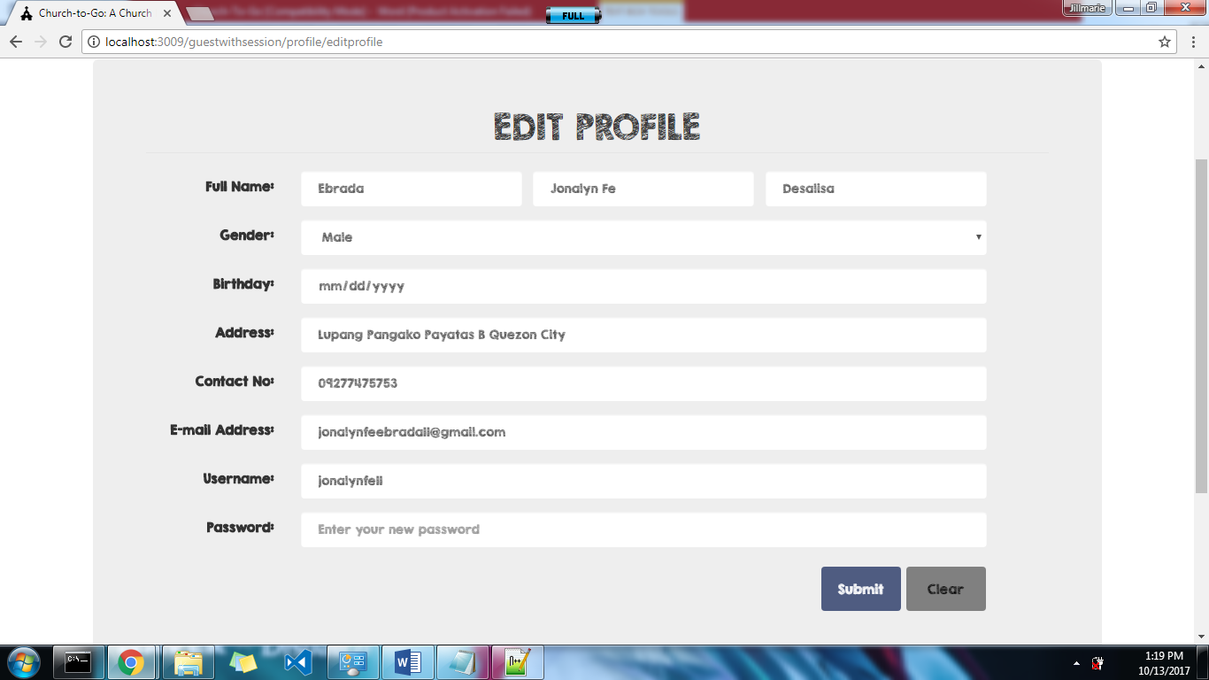

Figure 2.0. <Edit Profile Form>

Form Name: | Voucher Form
Description: | You will have to print this voucher to pay the fee required for certain event in the church itself.
Feature ID: | Feat-006
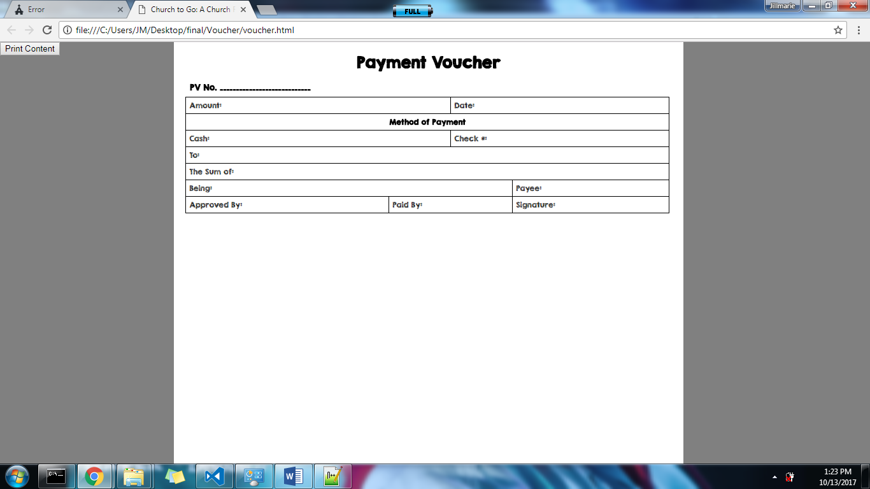

Figure 1.0. <Voucher Form>

