**Phonetics** Coursework

January 2024

(December 2024: Questions presented are my summary of the assignment.)

**Part 1**

**Q: Measure the VOT value in Language A and Language B (24 audio files each) and provide a basic analysis of their phonological categories. Compare the differences with the contrast between that of English and French.**

As shown in the tables below, Language A has three laryngeal categories for word-initial stops. They are voiceless aspirated, voiceless unaspirated, and voiced with prevoicing. The typical VOT values for each are 82ms, 11ms and -87ms. And for Language B, it has only two categories. They are voiceless unaspirated and voiced with prevoicing. For voiceless unaspirated word-initial stops, the typical value is 12ms and that of voiced ones is -45ms.

Tables of VOT values in Language A and B are as follows:

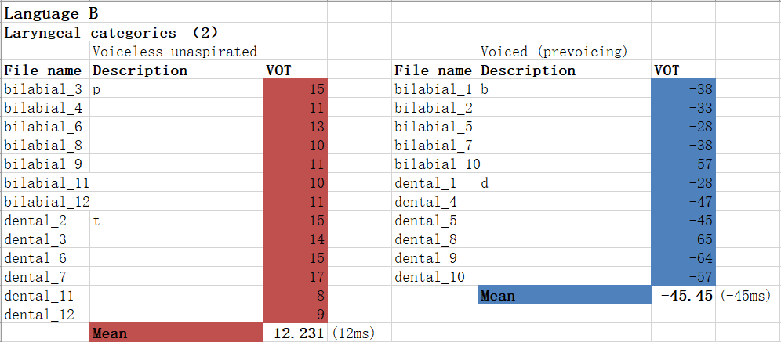

Periods of regular waveforms before the burst can be seen in the measurement of both languages. The existence of negative VOT values, together with the voicing bar, reveals that both languages have a voiced category.

As for data concerning positive VOT values, distribution is different in Language A and B. In Language B, they are consistent in terms of millisecond, ranging from 8 to 17. Therefore, the positive VOT values in B are considered to consist of one category.

In Language A however, the positive VOT values vary from 4 to 126. It is not distributed evenly within the range. The majority falls between 4 to 23, and 59 to 126. The two ranges indicate two laryngeal categories. The latter one in general is voiceless aspirated stops, as the aspiration takes longer. With the spectrogram, noise-like voices can be seen. Based on both experimental and theoretical reasons, the former should be voiceless unaspirated stops. And because the mean positive VOT value in Language B (12ms) is closer to that of voiceless unaspirated stops in Language A (11ms), the one category in Language B should also be voiceless unaspirated.

The 3 versus 2 laryngeal categories is similar to that exhibited between English and French. English has three categories like Language A, while French has two like Language B. However, strictly speaking, English has only two categories regarding word-initial stops. The other category occurs in the middle of a word, following a fricative. And because of the place restriction, in English, voiceless unaspirated word-initial stops are labeled as voiced, even though their mean VOT value (14ms) is closer to that of voiceless unaspirated ones in French (18ms), Language A (11ms), and Language B (12ms). For that reason, word-initial stops labeled as voiceless in English, are voiceless aspirated to be more specific. What’s more, in English, the mean VOT values of two voiceless categories, 14ms and 23ms, are much similar than that in Language A, 11ms and 82ms. It supports the fact that Language A has three categories of word-initial stops because the difference is much easier to perceive.

Another difference concerns prevoicing. Prevoicing in Language A takes slightly longer than in Language B, while the contrast between English and French, for word-initial stops, focuses whether there is prevoicing or not. When contrasting the four languages, French has the longest prevoicing of -158ms, while the negative VOT values for Language A and B is -87 and -45. It shows that the length of prevoicing has nothing to do with the number of its laryngeal categories. And for the four languages, there is no combination of voiced and voiceless aspirated within one language.

In conclusion, Language A has three categories while Language B has two. While in terms of number, the contrast between Language A and B is similar to that between English and French, strictly speaking the condition of one category in English is different. The difference can also be used as proof for the valid three categories in Language A.

**Part 2 Provide a tonal analysis bases on files of Language T produced by two speakers (of different regions).**

While there are differences in the two dialects of Language T, based on what they have in common, six categories of tones are concluded as follows. They are a breathy low flat (22), a high flat (44), a high rise (45), a creaky mid-low fall (32), a creaky fall followed by a mid rise (213), and a creaky fall followed by a high rise (214).

Transcriptions with phonation are listed in the table below:

The prominent similarity in both dialects is that they have two static tones (22 and 44) and one creaky mid-low falling tone (32). Between the static tones, one is rather low (22), as seen in the word *but*, while the other is relatively high (44), like in *ghost*. Because of the discrepancy in keys, they can be distinguished easily. Another common point is that for certain words, they share the same contour trend. For example, both dialects use a fall-rise tone for the word *horse*, and for the word *cheek*, they share a rising tone.

As for other categories of tones, phonation is introduced to make it easier to distinguish. And the ways of differentiating similar tones vary between the two dialects. For the fall-rise tone in the dialect of Speaker 1 (D1), there are two categories (213 and 214) that are both creaky. However, the one with a sharp rise (214) has a slightly breathy phonation at the end in the word *to draw*, compared to the other fall-rise tone (213) for the word *tomb*. Concerning the same word *tomb,* 213 in D1 shifts to a purely rising tone (23) in the dialect of Speaker 2 (D2). Consequently, there is only one fall-rise tone (213) in D2 that remains creaky. It (213) has a slightly lower ending pitch, compared to the tone used for the same word *horse* in D1 (214). It would be reasonable to suggest that as there is only one fall-rise tone (213) in D2, articulatory efforts can be lessened with a less contouring pitch between the ending point and its start.

Last, for one and only rising tone in D1, it is plainly a modal high rise (45). However, the rise in D2 (35) is more drastic, as D2 has another rising tone that is a breathy low-mid rise (23). The phonation of 23 in D2 is completely different from the creaky 213 in D1, even though they are used for the same word *tomb*. It can be argued that in D2, both the slope in 35 and the breathy phonation in 23 add to the distinctiveness between the two rising tones.

In conclusion, the two dialects of Language T exhibits similarity in the two static tones and one falling tone. And slight or significant differences lie in the other four contour tones.