Module 1: Assignment 5-Visual Studio Code

5. Modify and test code in Debug consoles.

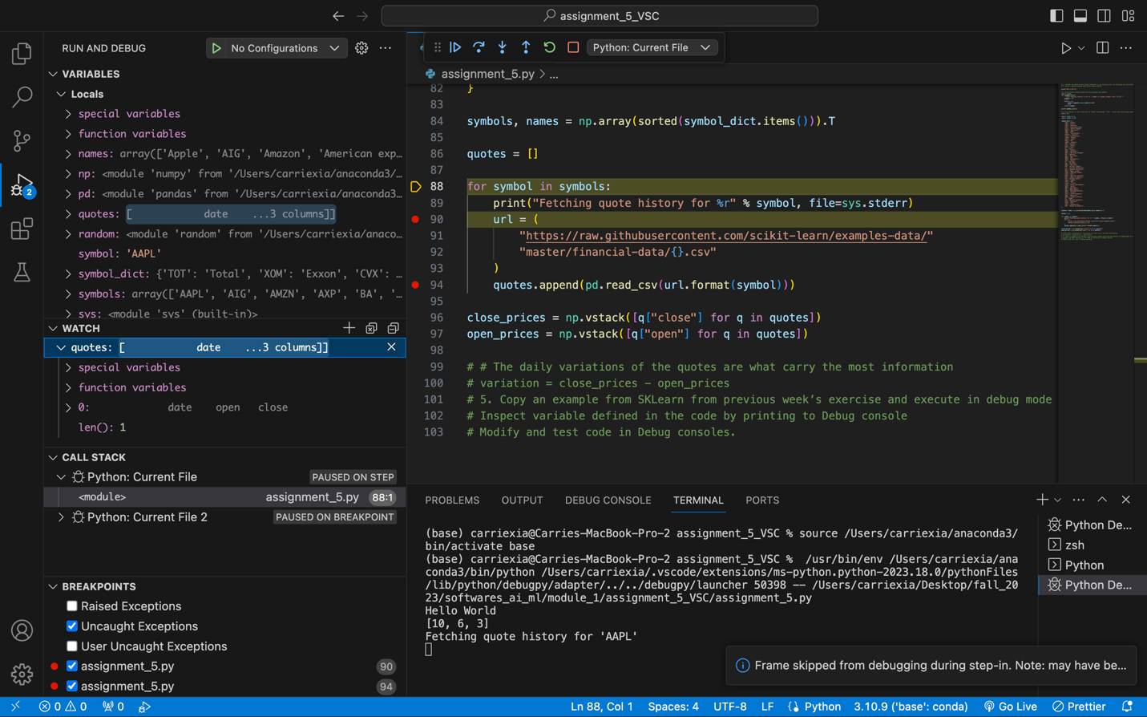

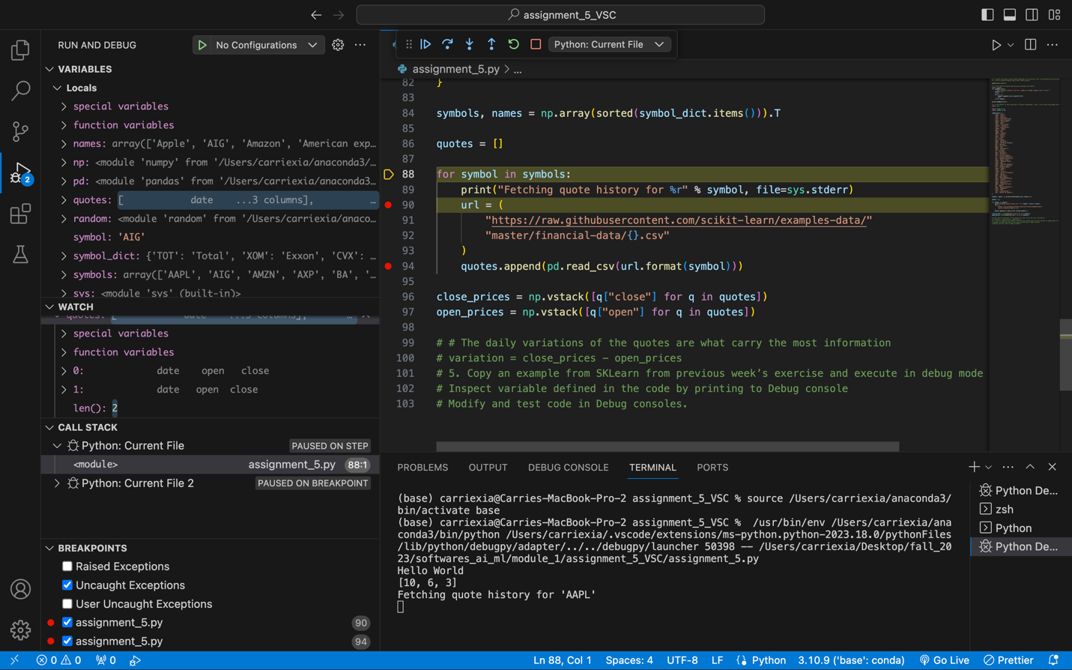

**Ungraded Exercise: Explore Visual Studio Add-Ons (Popular Extensions)**

1. Install and explore popular extensions from Visual Studio MarketPlace
2. Start a discussion on why you like the extensions you have installed
   1. TODO highlight
      1. It is very helpful highlighting what is not finish, especially when the code gets longer and takes a long time to complete

