Module 4 – Assignment 3

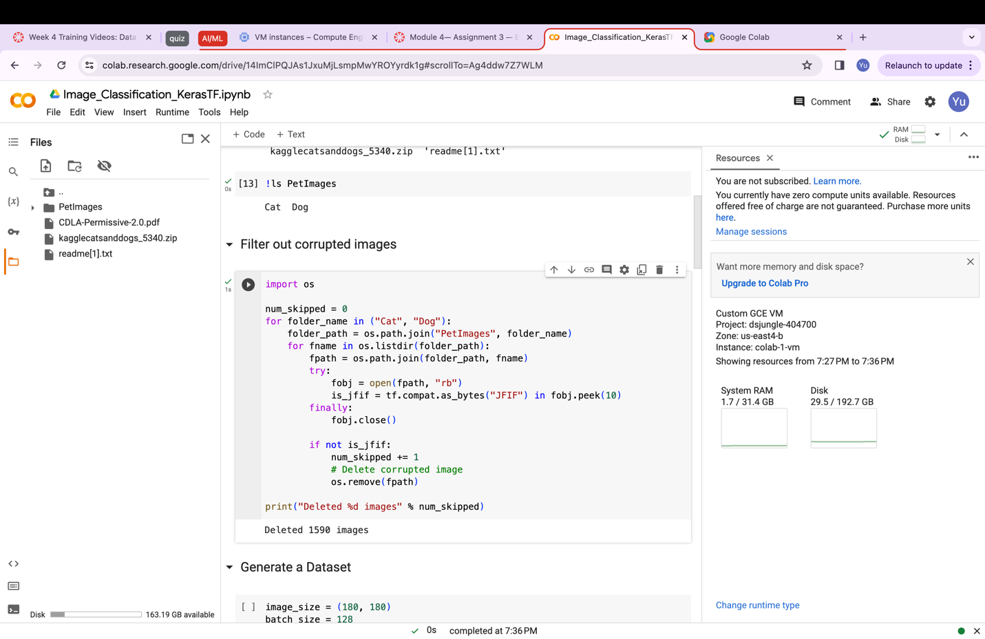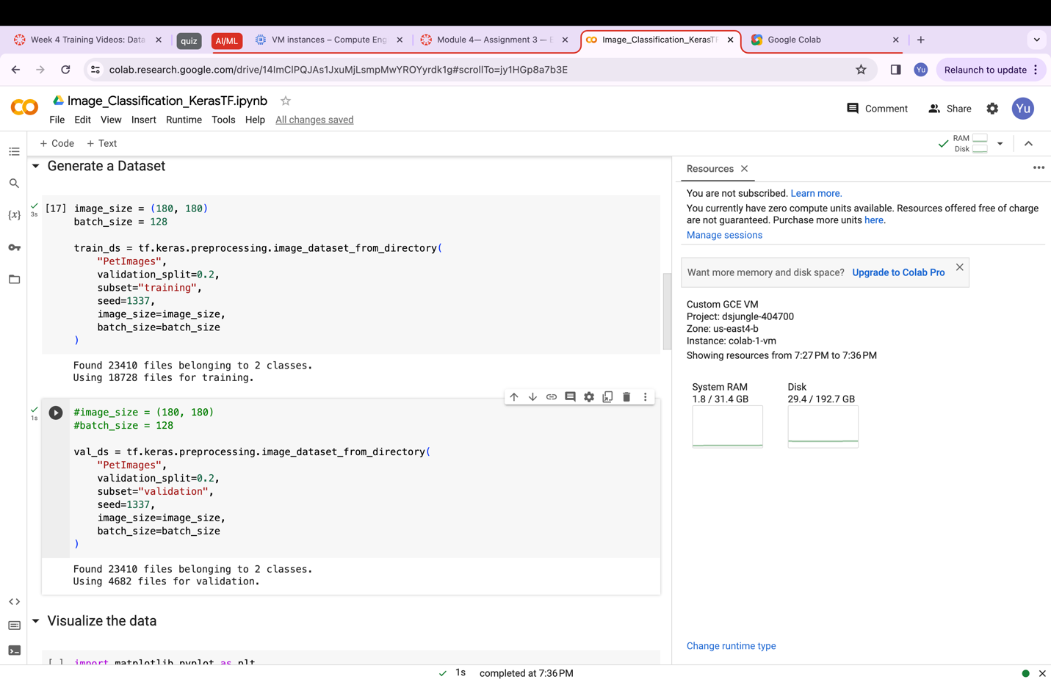

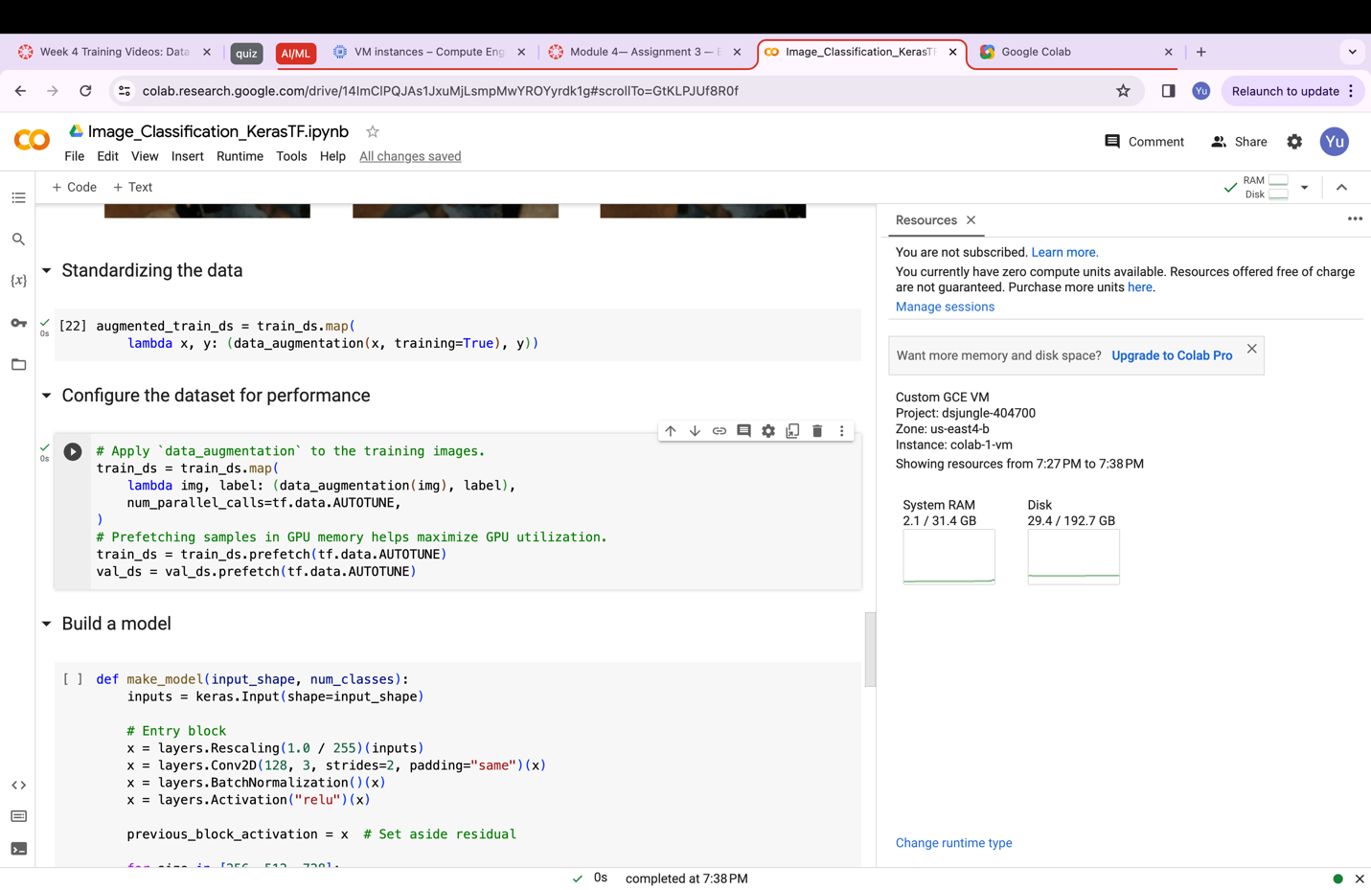

4. It took about an hour to run 1 Epoch.

