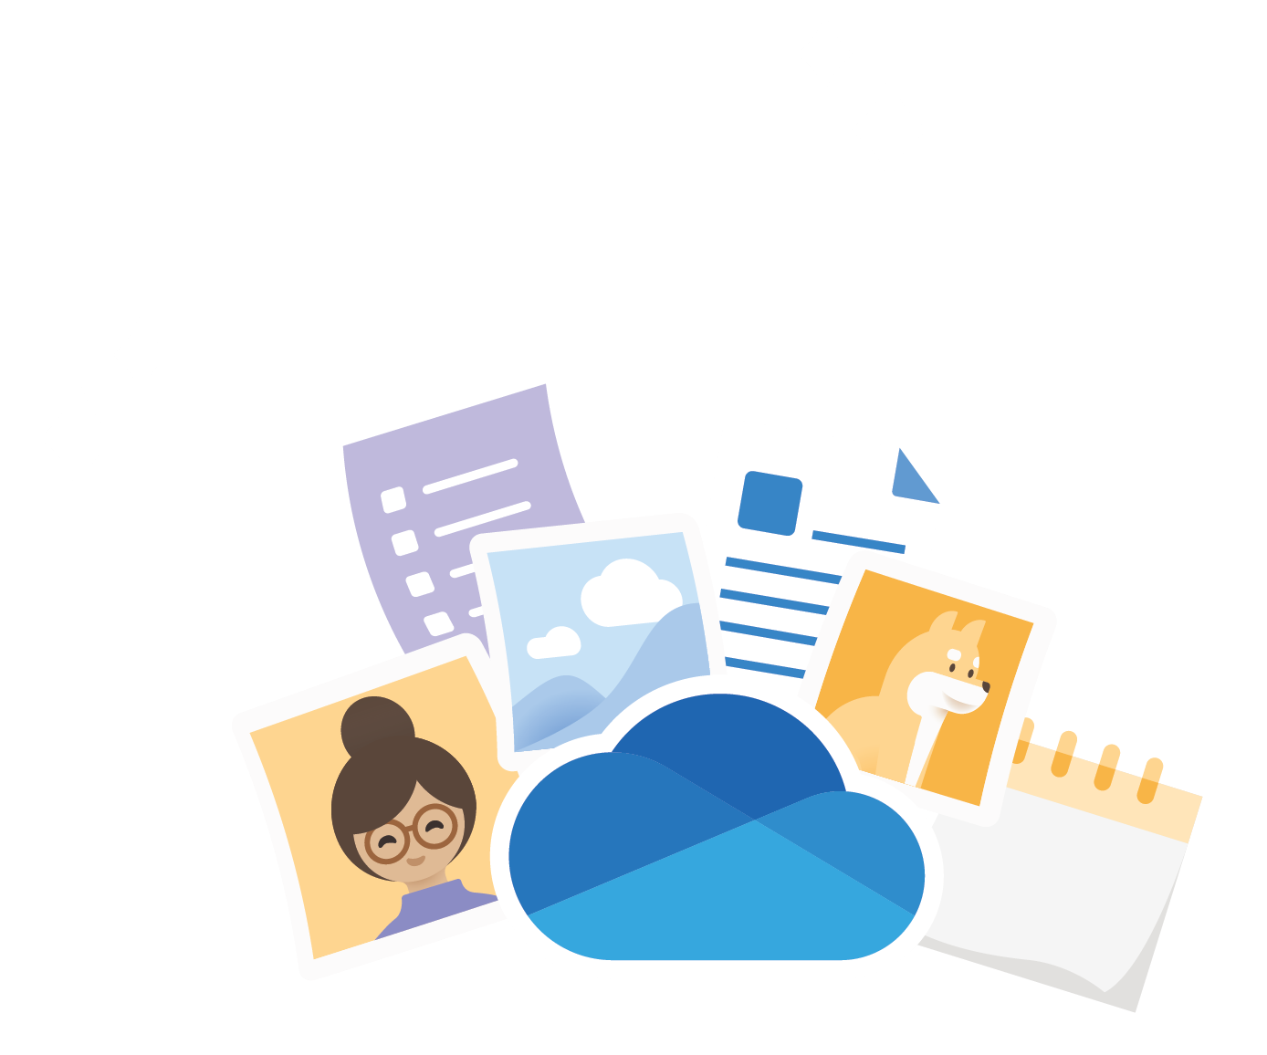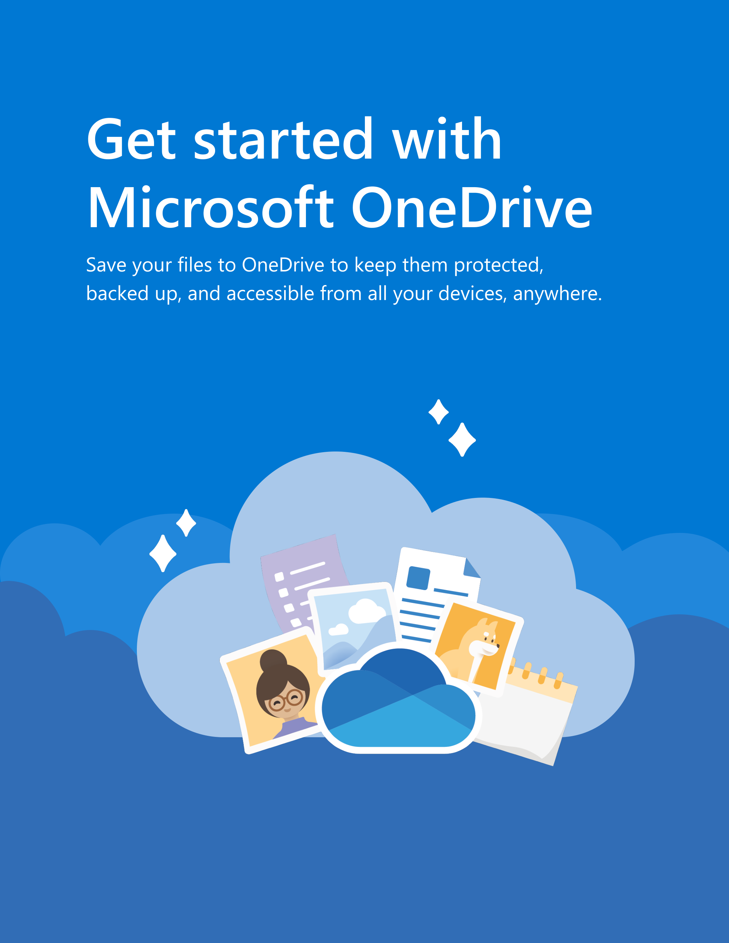

Get started with   
Microsoft OneDrive

Save your files to OneDrive to keep them protected,   
backed up, and accessible from all your devices, anywhere.

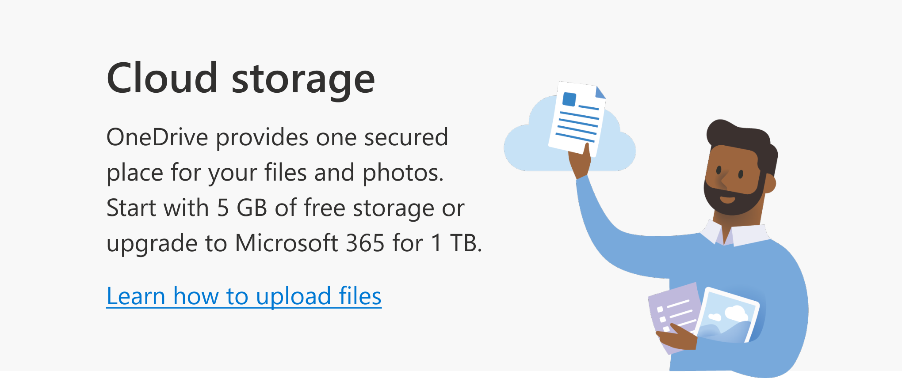

Anywhere access With [OneDrive.com](https://onedrive.com/) and the  
  
[OneDrive mobile app](https://onedrive.com/download) you can create, access and edit your files from all your devices, virtually anywhere you happen to be.

Cloud storage

OneDrive provides one secured place for your files and photos.

Start with 5 GB of free storage or upgrade to Microsoft 365 for 1 TB.

[Learn how to upload files](https://support.office.com/article/b00ad3fe-6643-4b16-9212-de00ef02b586)



PC folder backup Turn on PC folder backup to automatically back up and sync  your Desktop, Documents, and Pictures folders to OneDrive.

[How to set up PC folder backup](https://support.office.com/article/d61a7930-a6fb-4b95-b28a-6552e77c3057)

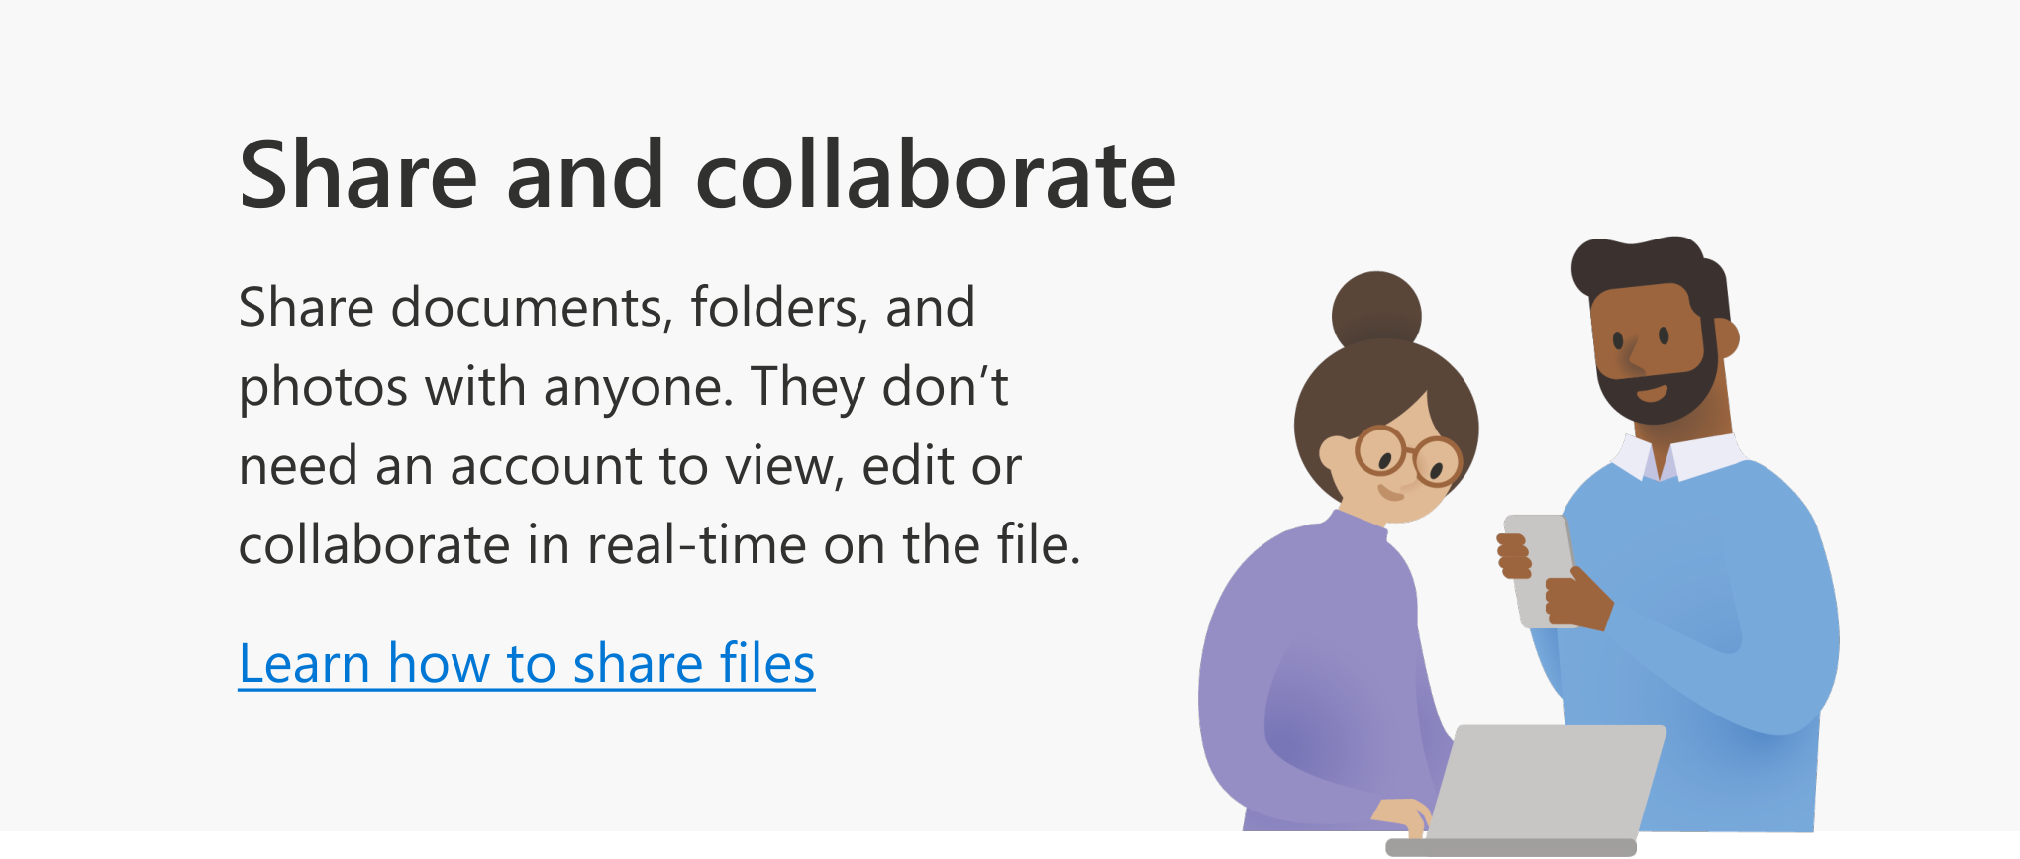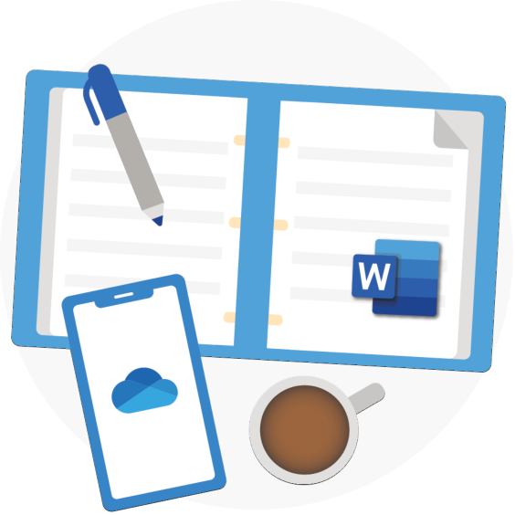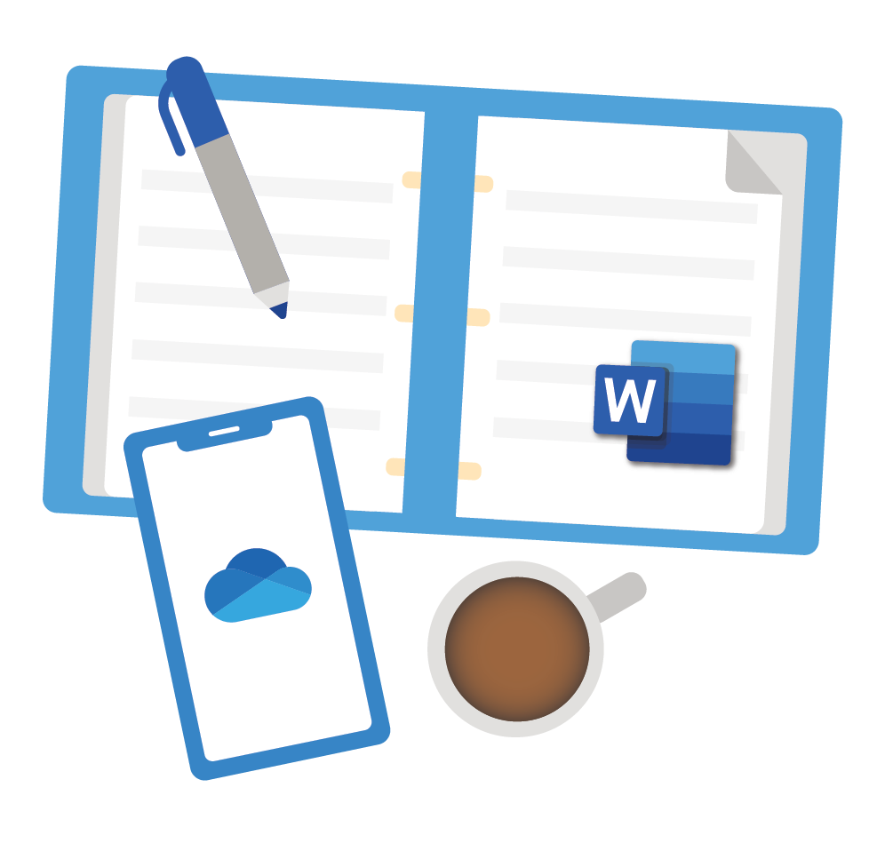

Office integration   
OneDrive works seamlessly with [Office for the web](https://products.office.com/free-office-online-for-the-web?rtc=1) . Use Word,   
PowerPoint, and Excel for free to easily create, edit, and share files.   
[Learn how to use Office for the web](https://support.office.com/article/dc62cfd4-120f-4dc8-b3a6-7aec6c26b55d)

Share and collaborate Share documents, folders, and   
photos with anyone. They don’t    
need an account to view, edit or   
collaborate in real-time on the file.

[Learn how to share files](https://support.office.com/article/9fcc2f7d-de0c-4cec-93b0-a82024800c07)

Security   
With security features like [Personal](https://support.office.com/article/6540ef37-e9bf-4121-a773-56f98dce78c4) [Vault](https://support.office.com/article/6540ef37-e9bf-4121-a773-56f98dce78c4), [Ransomware detection and](https://support.office.com/article/0d90ec50-6bfd-40f4-acc7-b8c12c73637f)   
[recovery,](https://support.office.com/article/0d90ec50-6bfd-40f4-acc7-b8c12c73637f)1 and file encryption your    
work and memories are always secured.



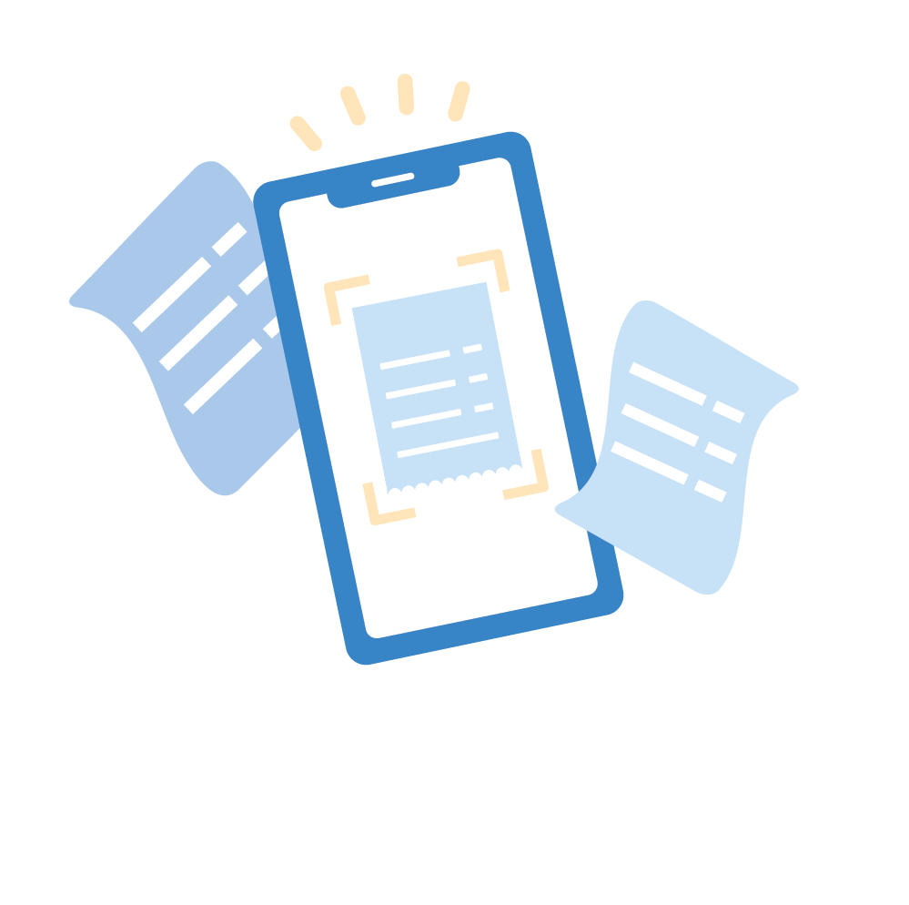

Get more features

with the mobile app

Automatic camera roll backup

Automatically back up your   
phone’s photos and videos   
so you never lose a memory.

|  |  |  |  |
| --- | --- | --- | --- |
| Learn more: | [iOS](https://support.office.com/article/74d406bb-71d0-47c0-8ab8-98679fa1b72e) | or | [Android](https://support.office.com/article/66605e54-48b8-4f55-bcff-34159702e344) |

Scan and save    
paper documents

Use your phone to scan and   
store paper documents,   
receipts or whiteboard notes   
in your OneDrive.

Learn more: [iOS](https://support.office.com/article/7b5425d5-754f-4201-b88f-13fc765d7d3a) or [Android](https://support.office.com/article/d74d52bc-dd44-4a20-babb-b75621c32da0)

For more information about OneDrive visit the [OneDrive help center](https://support.office.com/onedrive)

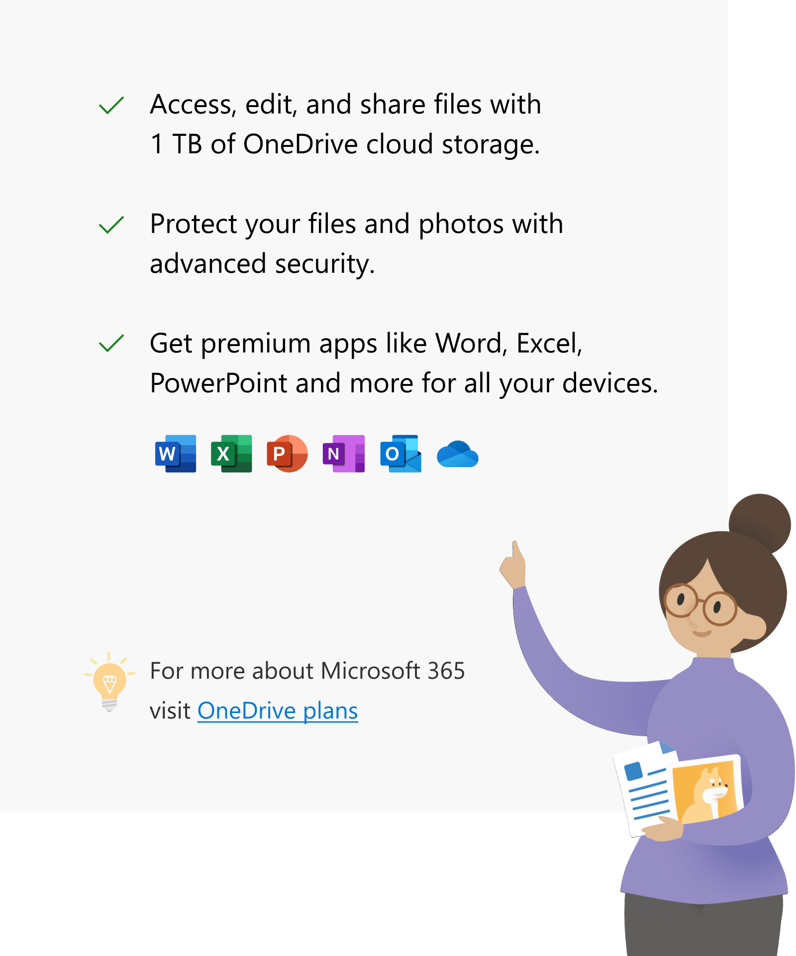



Be more creative, organized and secure with   
 Microsoft 365

Access, edit, and share files with  1 TB of OneDrive cloud storage.

Protect your files and photos with  advanced security.

Get premium apps like Word, Excel,   
PowerPoint and more for all your devices.

For more about Microsoft 365

visit [OneDrive plans](https://onedrive.live.com/about/plans/)