NAILS

The color, texture or shape changes in nails are symptoms of various diseases primarily affecting nails.

The Proposed system (NIPS-K) extracts a total of 13 features of the human nail which is a combination of Nail Color, Shape and Texture Features and then they are used for disease prediction

Longitudinal ridging is found on the nails in the shape of vertical marks or lines running from the base of the fingernail to the top.

The degree of ridging may be more severe if there is a problem during the growth phrase of the nail. Horizontal lines and marks, which are called Beau’s lines, may be a warning of a health issue.

This condition of the nail was named by a French physician, Joseph Honoré Simon **Beau**

**Conditions associated with Beau's lines include uncontrolled diabetes and peripheral vascular disease, as well as illnesses associated with a high fever, such as scarlet fever, measles, mumps and pneumonia. Beau's lines can also be a sign of zinc deficiency.**

1. **Nail clubbing is sometimes the result of low oxygen in the blood and could be a sign of various types of lung disease. Nail clubbing is also associated with inflammatory bowel disease, cardiovascular disease, liver disease and AIDS.**

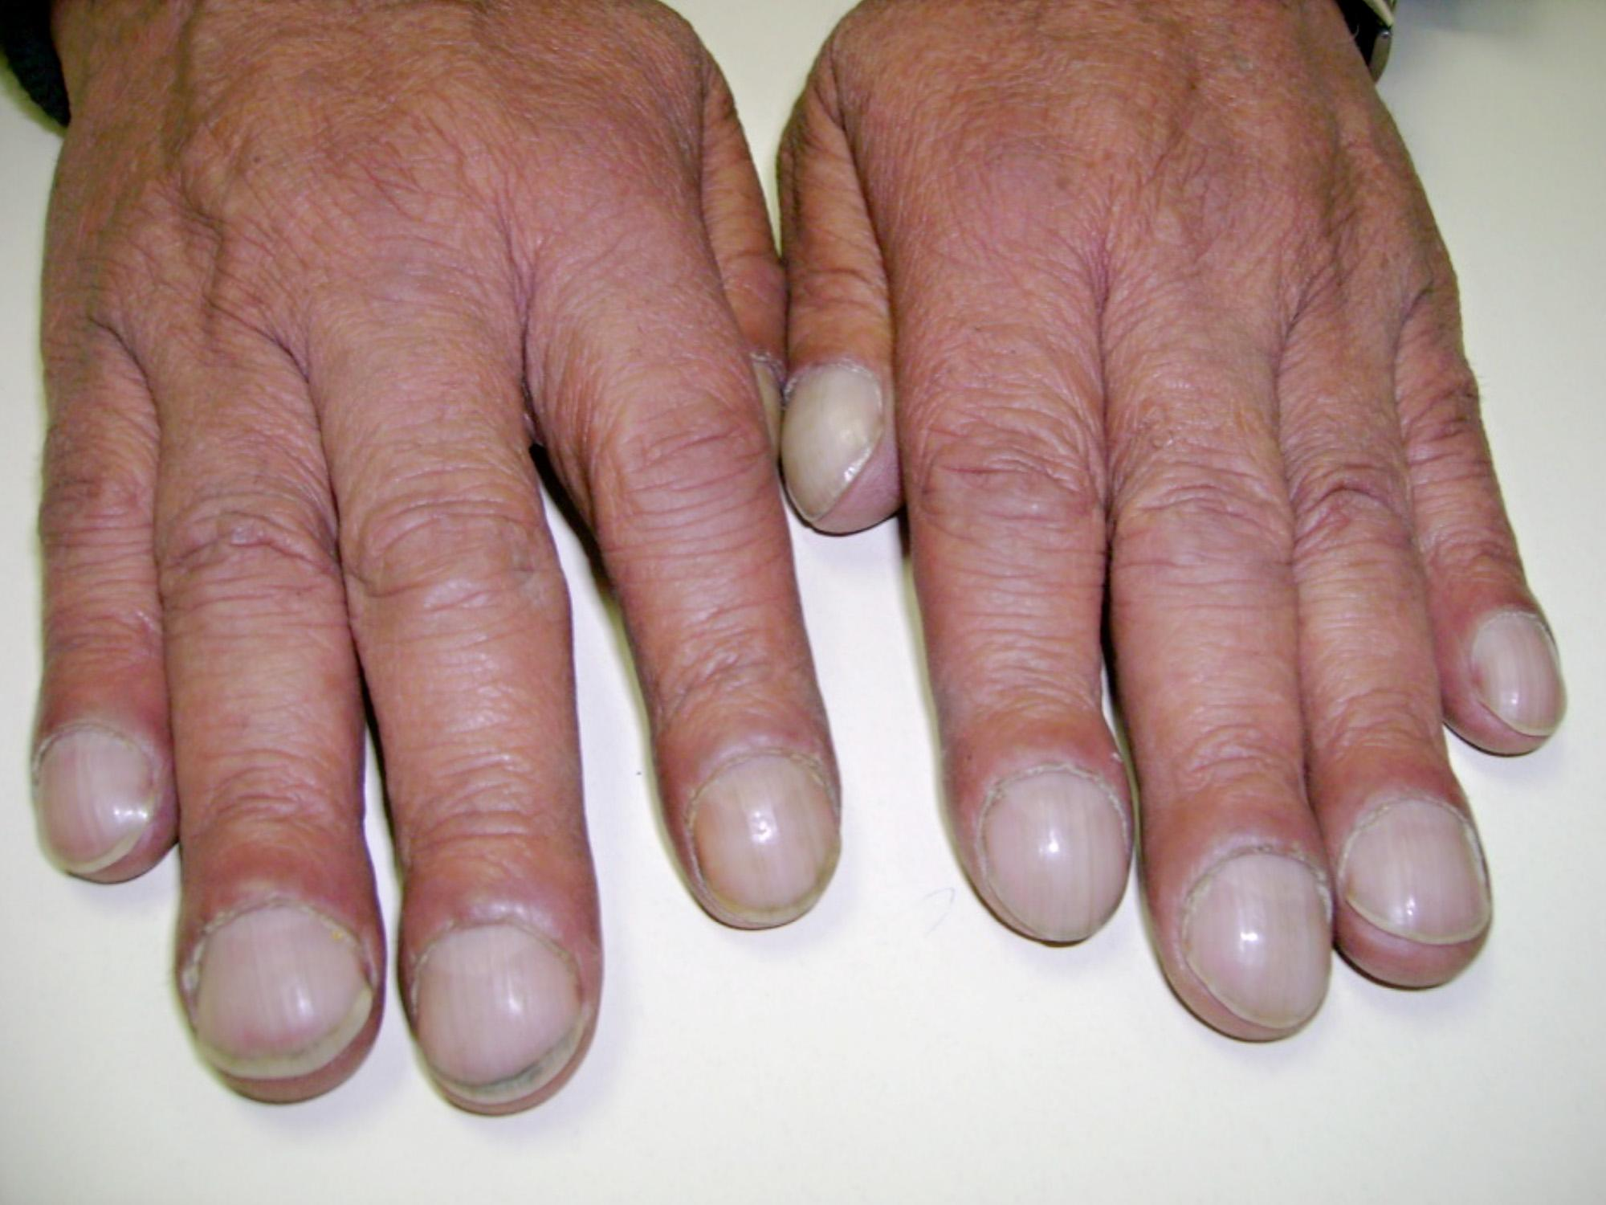

1. **Nail pitting can also be related to connective tissue disorders, such as Reiter's syndrome,and alopecia areata — an autoimmune disease that causes hair loss.**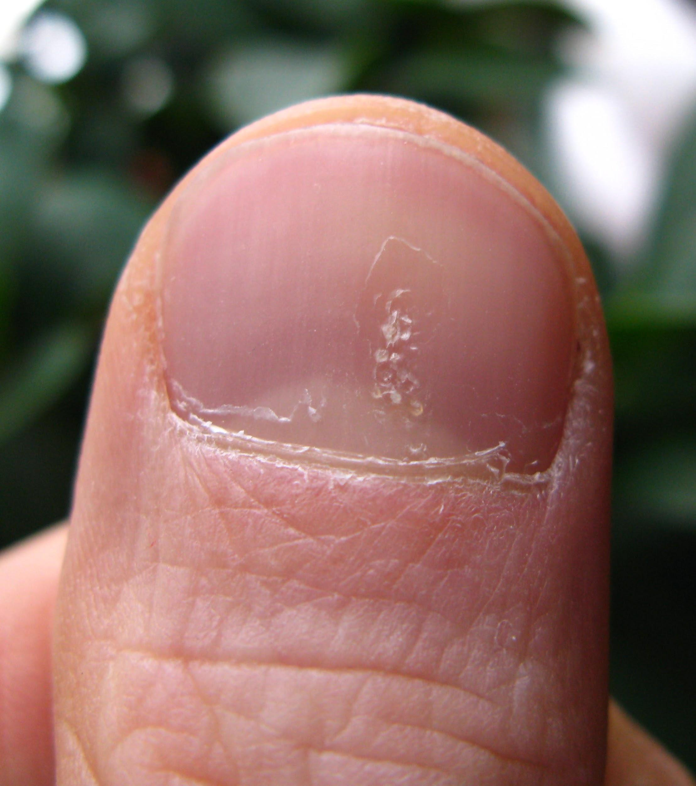
2. **spoon nails are a sign of iron deficiency anemia or a liver condition known as hemochromatosis, in which your body absorbs too much iron from the food you eat. Spoon nails can also be associated with heart disease and hypothyroidism.**

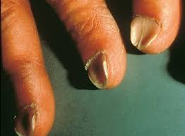

1. **Nail Separation: Thyroid disease and psoriasis — a condition characterized by scaly patches on the skin — also can cause nail separation.**

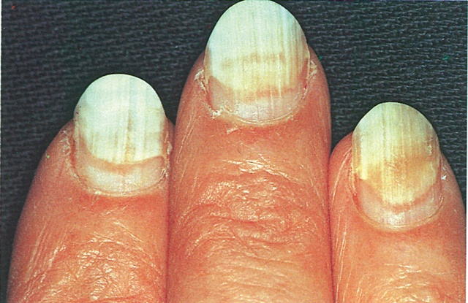

1. **Yellow nail syndrome is often a sign of respiratory disease, such as chronic bronchitis. Yellow nail syndrome can also be related to swelling of the hands (lymphedema).**

