# **MessageHub**

A program designed in C# .NET that demonstrates text communication between users and their mood at the time as well. Each person and register their own their own account. Within their account they can create a message that all the rest of the users can see. Each message has a title, body, date, time, and current ‘mood’ of the message.

## **Getting Started**

When first opening the application a user will register by clicking the link in the upper right hand corner. They will then fill out the form with name, username, and password.

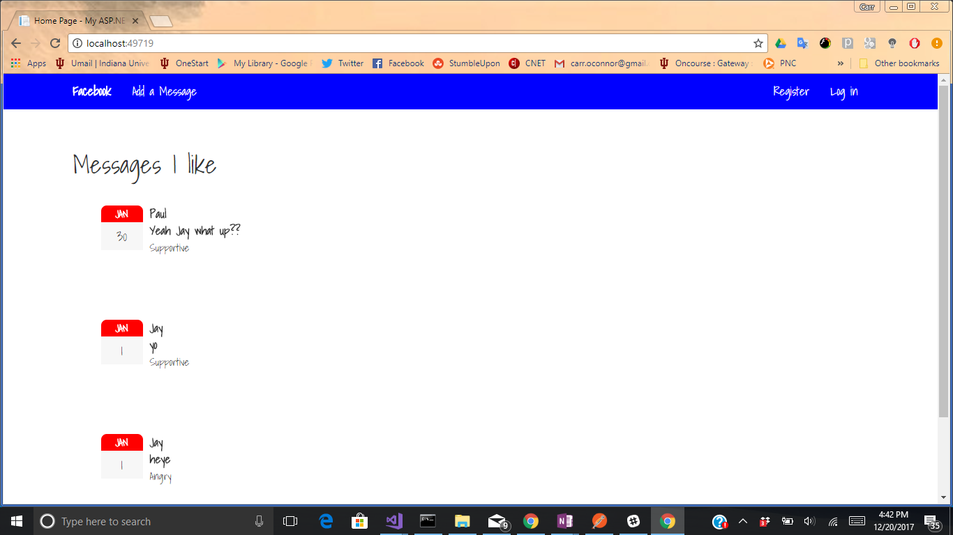

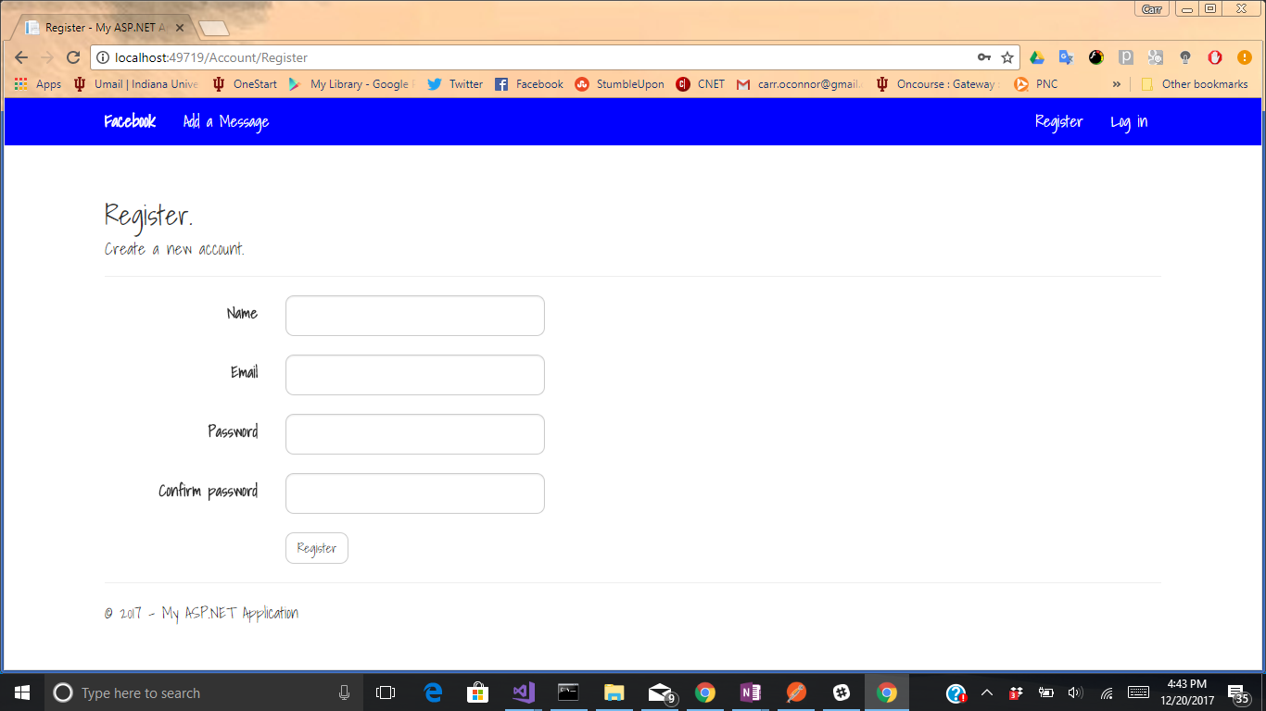

After the user is signed in all the messages from the other users will be displayed on the main page.

To create a message click the Add a Message button in the navbar then proceed to fill out the form with Title, Content, Date, Time, and Mood. After submitting the message it will post to the main page with the rest of the other users messages.

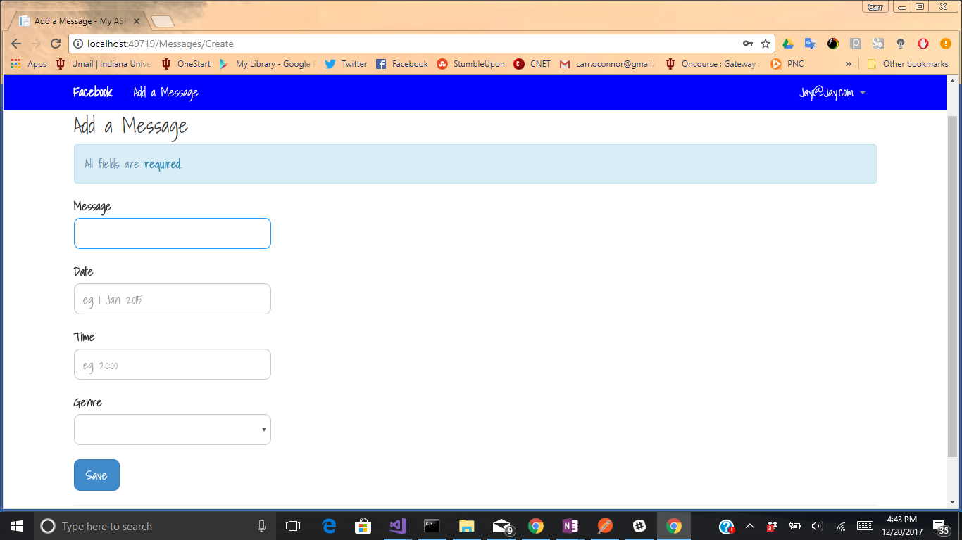

To filter to only see the messages you have posted click the dropdown in the upperright hand corner and click My Messages. This will bring you to a screen that only shows your messages.

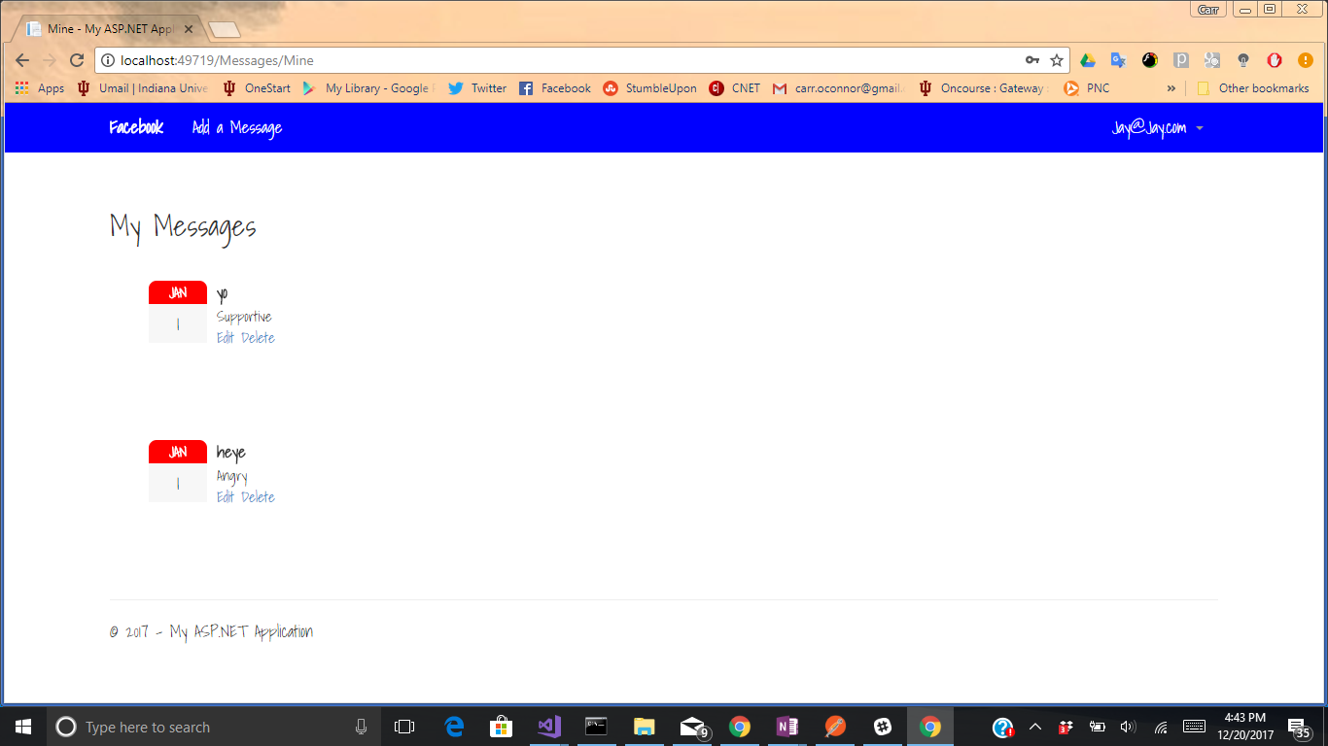

### **Installing**

A step by step series of examples that tell you have to get a development env running

Say what the step will be

Give the example

And repeat

until finished

End with an example of getting some data out of the system or using it for a little demo

## **Running the tests**

To run a test for the system go to the unit test project then within the folder you will find a Create Message test. Right click on the Method name and click run test.

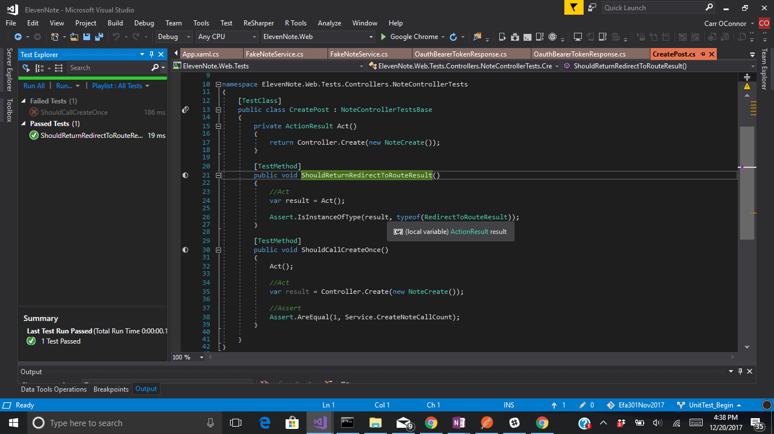

## **Deployment**

Add additional notes about how to deploy this on a live system

## **Built With**

* VisualStudio - C# .NetFrameWork
* SQL

## **Authors**

* Carr O’Connor

## **Acknowledgments**

* Special Thanks to ElevenFifty Coding Academy for teaching me these skills
* My professional mentor Chris Weiper
* Mosh Hamedani - PluralSite Author