Weekly FinTech Deals Automation Agent
Rebuild & Operations Guide
Repo: carrollr01/aboutMe · Prepared 31-Jul-2026 · Everything needed to run, maintain, or rebuild the agent
This document is self-contained: if the repository disappeared tomorrow, you could rebuild the weekly FinTech deals automation from what is written here. The one asset that cannot be reconstructed from this document is the precedent database (Finalized_Deals_History.xlsx, 650+ curated deals) — keep an independent backup of that file.

1. What the agent is
The agent is a Claude Code automation that compiles each week's global FinTech control M&A and growth equity raises (≥ $25M) into a two-tab Excel workbook matching the firm's finalized deal-database schema exactly. It is not a hosted service or a scheduled job — it is a repo-defined skill plus a durable kickoff prompt. A human pastes one prompt into a fresh Claude session; the session loads locked rules from the repo, researches the week, writes a structured JSON, and a deterministic Python builder emits the workbook.
It is the first of three workstreams in the coverage stack, and its output feeds the other two:
- Weekly deals (weekly-deals/) — this agent. Produces the weekly workbook; rows get finalized into the precedent DB.
- The Tape (tape/) — the quantitative layer: public-comps history and subsector rotation, backfilled from CapIQ.
- The Monitor (monitor/) — the narrative layer: weekly subsector briefs written in NotebookLM, grounded on the deal logs and Tape summaries.

2. Run pipeline
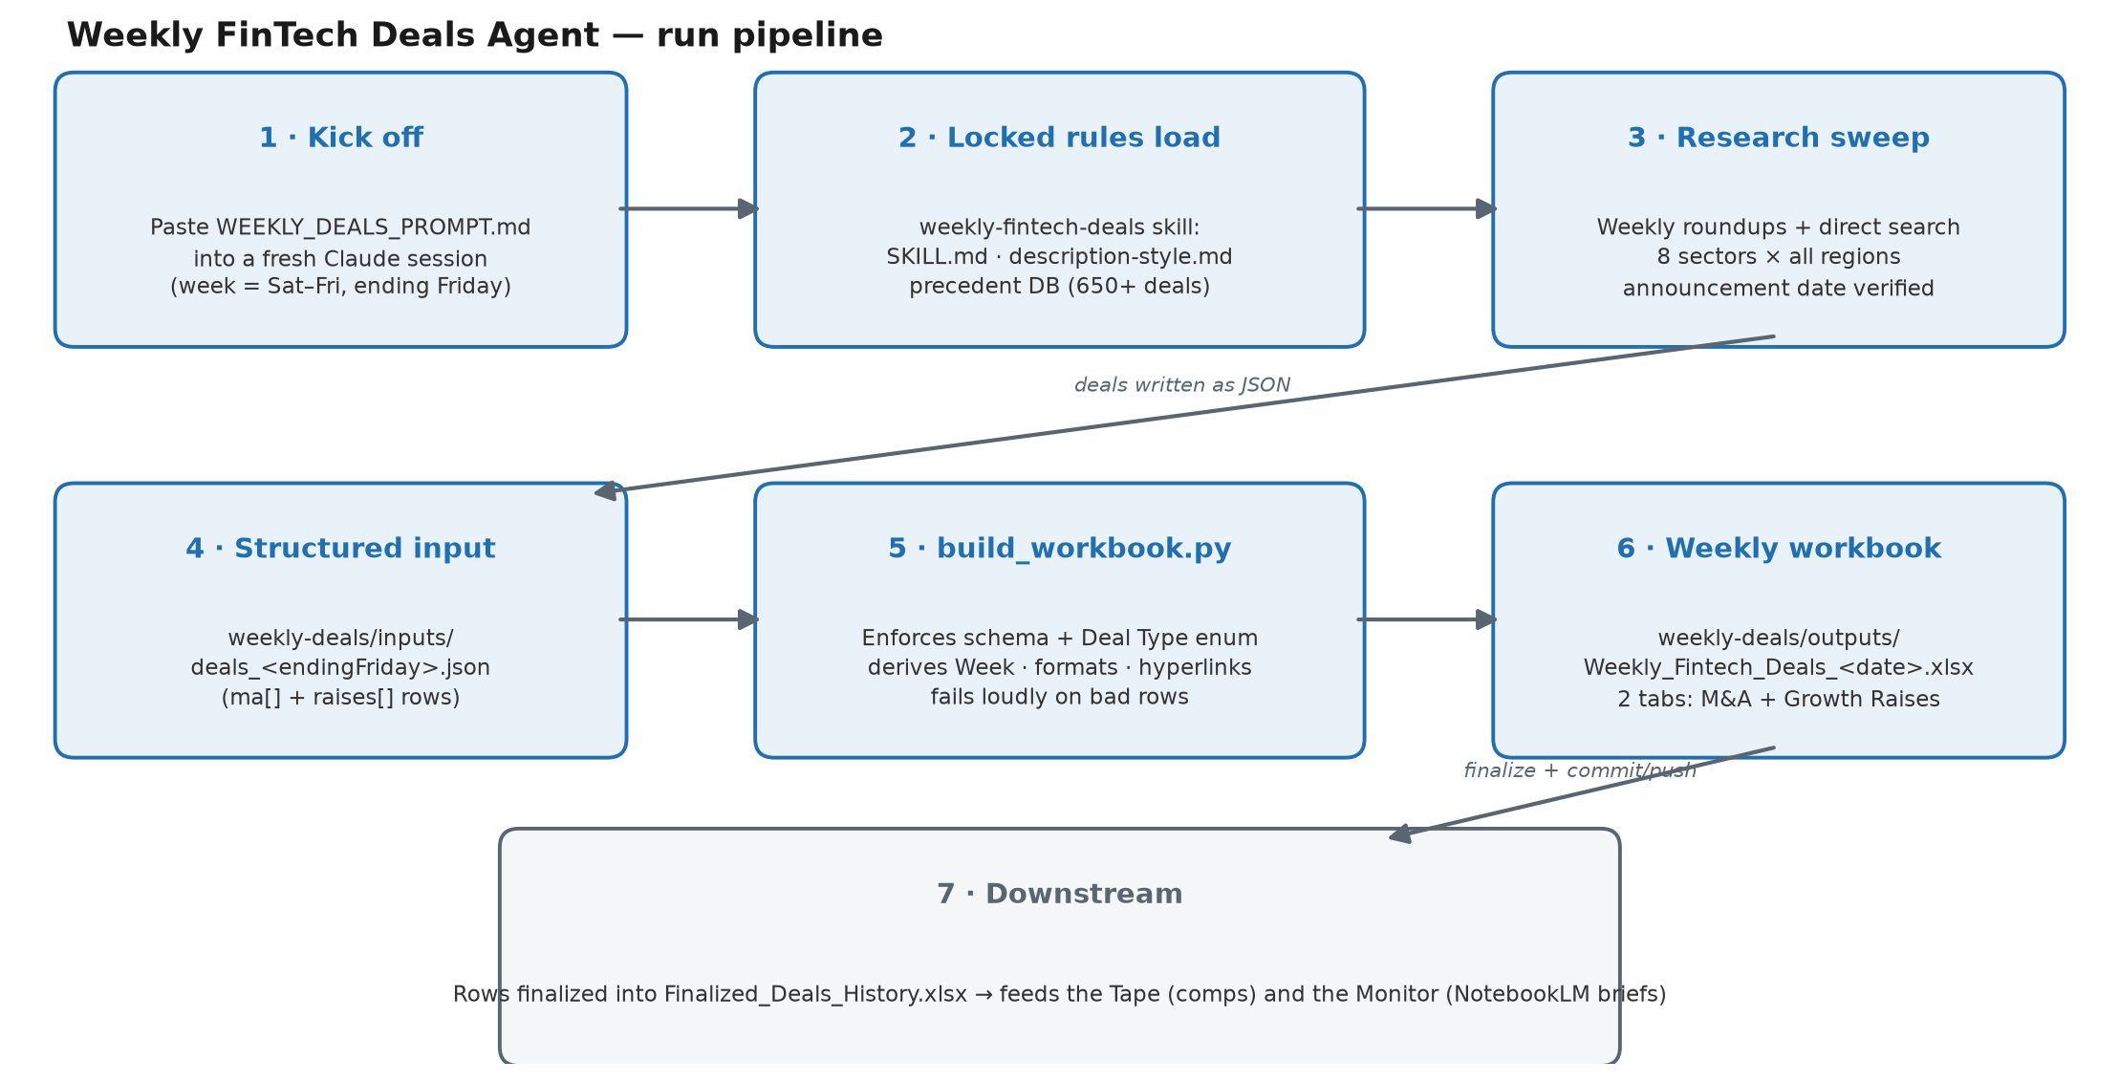
Figure: the seven-step run pipeline. This diagram is new to this document — no architecture diagram exists elsewhere in the repo.

3. Component inventory (what to restore, file by file)
Path | Role
WEEKLY_DEALS_PROMPT.md | The durable kickoff prompt pasted into a fresh session every week. Points at the skill; behavior changes belong in the skill, not here.
.claude/skills/weekly-fintech-deals/SKILL.md | The locked rules: week definition, inclusion scope, sector labels, financial conventions, exact output schema, delivery checklist.
.claude/skills/weekly-fintech-deals/description-style.md | How to write Target Description cells, derived from the owner's actual edits (before/after examples plus a tone bank).
.claude/skills/weekly-fintech-deals/build_workbook.py | Deterministic builder (Python 3 + openpyxl, ~140 lines). Reads the deals JSON, validates, formats, writes the two-tab .xlsx.
weekly-deals/Finalized_Deals_History.xlsx | Canonical precedent DB (650+ curated deals). Source of truth for schema, inclusion judgment, and description register. IRREPLACEABLE — back it up.
weekly-deals/inputs/deals_<endingFriday>.json | Per-week structured research output fed to the builder.
weekly-deals/outputs/Weekly_Fintech_Deals_<date>.xlsx | The finished weekly workbook (a _financials variant carries the multiples-enrichment pass).
archive/ | Frozen early iterations (CSV scripts). Reference only — never build on these.

Only runtime dependencies: Python 3 with openpyxl, and a Claude Code session with web search. There is no other infrastructure — no server, no database, no scheduler.

4. Running a week, step by step
- Kick off. Paste WEEKLY_DEALS_PROMPT.md into a fresh Claude Code session in the repo. The week is Saturday→Friday, named by its ending Friday (the most recent Friday that has passed). The session must state the window it is using, and work autonomously — stating assumptions instead of asking.
- Rules load. The weekly-fintech-deals skill loads SKILL.md and description-style.md; the precedent DB is the reference for anything ambiguous.
- Research. Anchor on the weekly roundups — FinTech Global, FinTech Futures ICYMI, InsurTech.ME, DealStreetAsia, Entrackr, Crunchbase, Axios Pro — then sweep all 8 sectors and all regions (US, Europe, India, MENA, Africa, SEA, East Asia, LatAm, Canada/ANZ). Crypto M&A via The Block/CoinDesk; public take-privates via SEC filings/press. The ANNOUNCEMENT date governs: verify every date against a primary source; exclude prior-week deals even when this week's roundups carry them, and exclude completions of earlier-announced deals. Prefer direct web searches; keep subagent fan-out modest (spend caps).
- Write the JSON to weekly-deals/inputs/deals_<endingFriday>.json (schema in §8).
- Build the workbook with the command below; the builder enforces the schema and fails loudly on bad rows.
python3 .claude/skills/weekly-fintech-deals/build_workbook.py \
weekly-deals/inputs/deals_<endingFriday>.json \
"weekly-deals/outputs/Weekly_Fintech_Deals_<endingFriday>.xlsx"
- Deliver. Send the file; commit and push. The summary must include counts, headliners, computed multiples, borderline calls, AND a list of notable deals excluded with the reason (out-of-window / non-fintech / not-control / below floor / no credible source) so the owner can sanity-check.

5. Inclusion rules (locked)
These were learned from the finalized DB and are deliberately rigid. Change them in SKILL.md or not at all — never improvise per run.
- FinTech only. A genuine tech / digital / money-movement / data core. The bar is low but real: exclude traditional financial services with no tech angle (traditional MGAs/underwriters/carriers, pure RIA/advisory roll-ups, IT services). Borderline targets (pawn+FX retail, HR-payroll, insurance holdco with a tech layer) are included, but the description must honestly carry both the fintech angle and the traditional business.
- Credible source required. At least one reputable outlet or primary release (wire, company newsroom, major trade press). Single-blog / unverifiable deals are dropped — this rule is why C2FO India was cut.
- Raises tab: equity rounds ≥ $25M USD. Simultaneous combined tranches (e.g. seed + Series A announced together) count as one round at the combined total. Minority / growth-equity investments belong here, never in M&A (e.g. Carbon Underwriting/FTV).
- M&A tab: control transactions only, no size floor (small tuck-ins are in). Deal Type is strictly "Strategic M&A" or "PE Buyout" — zero temperature, no other strings; the builder rejects anything else. Adjacent structures (take-private by a strategic, JV-stake-to-100%, distressed purchase, carve-out) snap to the nearest of the two, with the nuance explained in the description, not the type column. Excluded from M&A entirely: minority stakes (→ Raises), team/book/portfolio (asset) acquisitions, GP-led continuation vehicles / fund secondaries, and non-binding proposals or rumors.
- USD only. Convert at the announcement-date FX rate; note the original currency in the description or Mults Basis if material.

Sector labels (exact strings — nothing else)
Asset & Wealth Tech · Banking & Lending Tech · Capital Markets Tech · Corporate Financial Function · Financial Info & Analytics · InsurTech · Payments · Real Estate & Mortgage Tech. Crypto/digital-asset infrastructure maps into Capital Markets Tech, Payments, or Financial Info & Analytics.

6. Financials conventions
- Public targets: pull revenue/EBITDA from filings/press; compute EV/Revenue and EV/EBITDA on true enterprise value (equity value net of cash/debt). Do not default to "undisclosed".
- Private deals: compute multiples when deal value AND revenue/EBITDA are disclosed; mark bounds when revenue is a floor (">$200M").
- Always record the basis: Mults Source (outlet/filing used) and Mults Basis (e.g. "LTM FY25 rev, adj. EBITDA; EV net of $99M cash"). Numbers are honest-best-effort; these two columns exist precisely so a better source can replace them later.
- Flow metrics (TPV, volume, AUM, GWP, deposits, payroll processed) are NEVER revenue.
- Undisclosed / not-applicable = "-" (never blank). Negative EBITDA = "n.m.".

7. Output schema (builder-enforced)

Tab 1 — "All M&A (PE & Strategic)"
x | Week | Sector | Target Country | Deal Type | Date | Target | Acquirer | EV ($M) |
EV / Revenue | EV / EBITDA | Target Description | Link / Press Release |
Mults Source | Mults Basis | Public Deal | HL Deal | Seller

Tab 2 — "Growth Capital Raises"
x | Week | Sector | Target Country | Date | Target | Lead Investor(s) | Amount ($M) |
Valuation ($M) | EV / Revenue | EV / EBITDA | Target Description | Link / Press Release
- Week auto-derives from Date (the deal's ending Friday, DD-Mmm-YY). x is left empty — it is the owner's flag column.
- Meta columns (Mults Source/Basis, Public Deal Y/N, HL Deal, Seller): populate what is publicly knowable — Seller from the release, Public Deal = listed target, HL Deal only if HL is named; "-" otherwise.
- Dates DD-Mmm-YY. The link cell shows the word "Link", hyperlinked to the source. Rows are ordered sector-alphabetical, then date.
- File name Weekly_Fintech_Deals_YYYY-MM-DD.xlsx using the ending-Friday date, saved to weekly-deals/outputs/.

8. Input JSON schema
The research pass produces one JSON with two arrays. Any numeric field may be a number or "-"; missing keys default to "-".
{
"ma": [{ "sector", "country", "deal_type", // "Strategic M&A" | "PE Buyout" ONLY
"date" ("DD-Mmm-YY"), "target", "acquirer",
"ev", "ev_rev", "ev_ebitda", "description", "link",
"mults_source", "mults_basis", "public_deal", "hl_deal", "seller" }],
"raises": [{ "sector", "country", "date", "target", "lead",
"amount", "valuation", "ev_rev", "ev_ebitda", "description", "link" }]
}
Worked example row (M&A):
{ "sector": "Payments", "country": "United States",
"deal_type": "Strategic M&A", "date": "18-Jun-26",
"target": "Celero Commerce", "acquirer": "Deluxe", "ev": 625,
"description": "Integrated payment-processing and business-management platform
serving ~55,000 small and mid-sized US merchants",
"link": "https://investors.deluxe.com/..." }

9. What build_workbook.py does (rebuild spec)
If the script is lost, rebuild it to these exact behaviors (Python 3 + openpyxl):
- Validation: any M&A row whose deal_type is not exactly "Strategic M&A" or "PE Buyout" raises a ValueError naming the target — the build fails rather than emitting a bad row.
- Week derivation: parse Date as DD-Mmm-YY, roll forward to that week's Friday ((4 − weekday) mod 7 days), format DD-Mmm-YY.
- Normalization: empty/missing values become "-" for money, multiple, and meta columns (ev, ev_rev, ev_ebitda, amount, valuation, mults_source, mults_basis, public_deal, hl_deal, seller); the x column stays truly empty.
- Sorting: rows sorted by (sector, date) within each tab before writing.
- Formatting: header row filled #1F6FB2 with white bold text, height 30; thin #D0D0D0 borders; wrapped cells; freeze panes at A2; auto-filter across the used range; numeric multiples formatted 0.0"x"; link cells display "Link" in hyperlink-blue with the URL attached; fixed column widths per tab.
- CLI: build_workbook.py <deals.json> <output.xlsx>; prints "Wrote <path>: N M&A + M raises".

10. Target Description style
Full guide in description-style.md, rebuilt from the owner's actual edits against the finalized DB. Core rules:
- Product-first noun phrase: lead with what the thing IS — "Provider of…", "Developer of…", "AI-powered … platform that…", "Agentic … for …". No trailing period.
- Short wins: ~8–25 words; the owner trims aggressively. One clause is enough for well-known products; never pad to seem thorough.
- Cut client-count / geography trivia ("partnered with ~55 financial institutions across 16 countries" gets deleted). Keep a number only when it IS the point.
- Say what it converts / automates / connects — the mechanism, not the mission.
- Borderline names carry both angles — fintech lead, traditional base visible.
- Deal-structure nuance lives here when the Deal Type column can't express it (e.g. "…; was a JV between Crédit Agricole and Worldline").
Calibration example — before: "Pioneer of agentic/conversational AI for banking, partnered with ~55 financial institutions across 16 countries" → after: "Agentic/conversational AI for banking".

11. Gotchas & tribal knowledge
- Legacy inputs predate the locked enum. deals_2026-06-19.json contains "deal_type": "Take-Private" — written before commit 9262492 locked the two-value enum. Re-running today's builder on it will fail by design; snap the type to Strategic M&A / PE Buyout and carry the take-private nuance in the description.
- The precedent DB is the real spec. When SKILL.md is silent, match what Finalized_Deals_History.xlsx does. New weekly rows get finalized into it — it accumulates.
- Filenames are load-bearing. Several files are uploaded to NotebookLM/OneDrive by name; prefer moving files over renaming them. .md/.docx pairs are the same document (md = working copy, docx = share export) — keep them in sync.
- The root README.md has an encoding quirk (saved UTF-16-style, renders with spaced-out characters in some tools). Content is fine; re-save as UTF-8 if it bothers you.
- archive/ is frozen. Early CSV/script iterations superseded by the skill's builder. Never build on them.
- Exclusions are a deliverable. The weekly summary must list notable deals excluded and why — that list is how the owner audits the run.

12. Rebuild-from-zero checklist
- Restore or recreate the four agent files (§3): prompt, SKILL.md, description-style.md, build_workbook.py — the rules in §5–§10 are a complete spec for all four.
- Restore Finalized_Deals_History.xlsx from backup (cannot be recreated).
- Recreate the folder skeleton: weekly-deals/inputs/, weekly-deals/outputs/.
- Verify: run the builder against any historical inputs/deals_*.json (fixing legacy deal types) and diff the output against the matching outputs/ workbook.
- Run a live week end-to-end and have the owner review counts, borderline calls, and exclusions before trusting it unattended.

