Massachusetts Hospital Database SQL Queries

Problem #1: What is the total number of encounters per year?
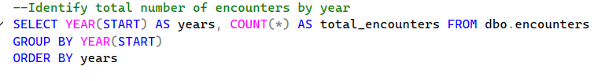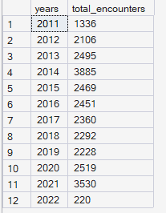
Problem #2: How many encounters had zero payer coverage each year?
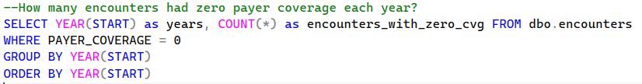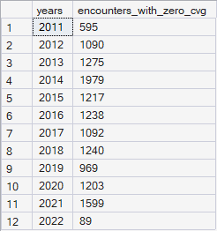
Problem #3: What are the top 10 most frequent procedures performed?
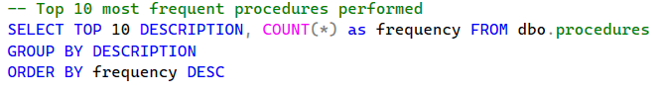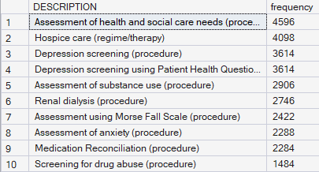

Problem #4: What is the average total claim cost for encounters broken down by payer?
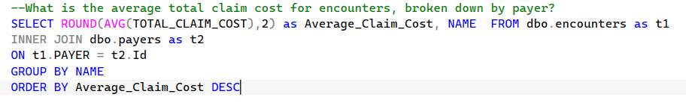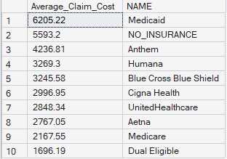

Problem #5: How many unique patient encounters took place each quarter in 2021?
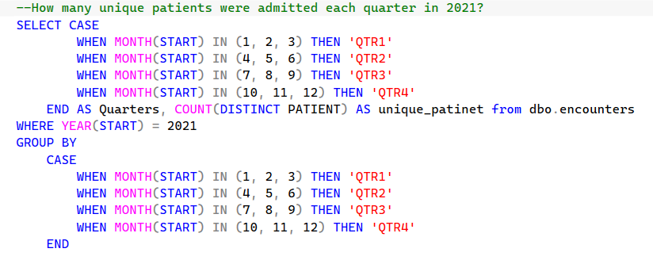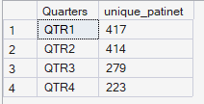

Problem #6: Which patients were diagnosed with a form of viral infection?
