Power BI

- Create a Date Table

- Create Calculated columns in Date Table
- Create relationship in data model (one to many)
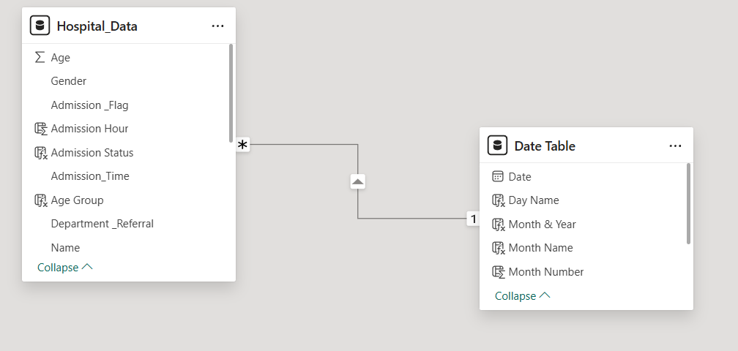

- Create Calculated Columns for Hospital Data Table
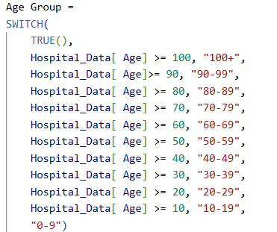
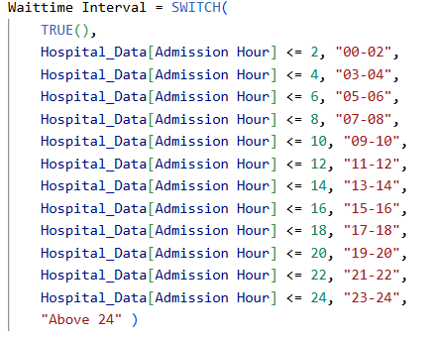

- Create Measures in Hospital Data Table

