Massachusetts Hospital SQL Query Project
Clinical Quality and Safety Question: What is the 30-day readmission rate for each year?
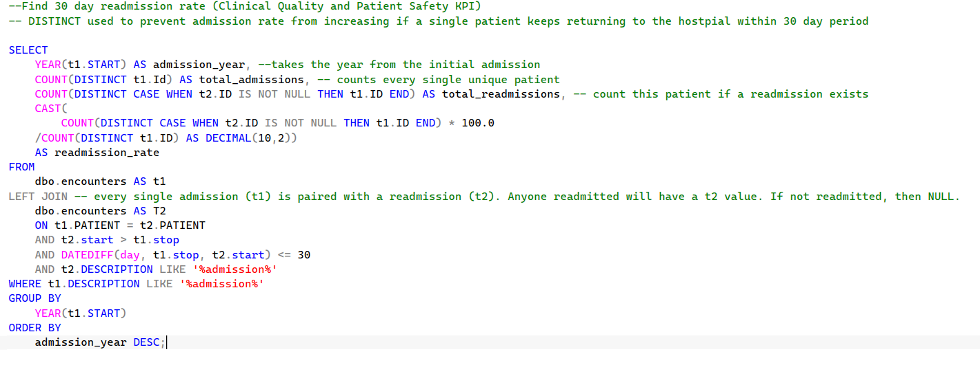
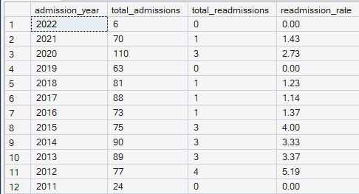
Operational Efficiency Question: What is the average length of stay?
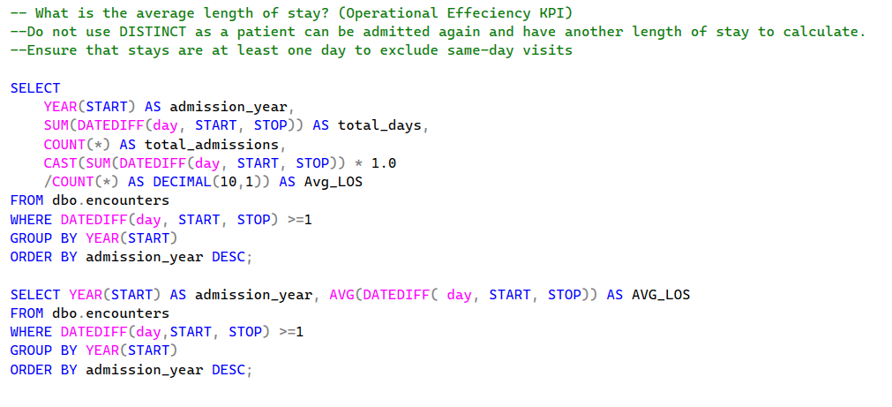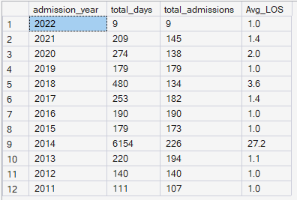
Financial/Billing Question: What is rate of zero payer coverage?


