

**Winter 2018**

**he**

T

**agle**

E

**A Publication of the Carrollton Manor Improvement Association**

**CONTENTS**

Community Meeting Update 2 Winter Tips from DNR 5

Community Picnic 3 Spring Calendar 5

CMIA Winter Reminders 4 2019 Proposed Budget 6

Holiday Information 7

__________________________________________________

**Upcoming Meeting Agenda: Tuesday, December 4 at 7:00 p.m.**

**Severna Park Baptist Church**

• 2020 CMIA-SCBD Budget Approval

• 2018 CMIA Community Activities Recap

• Community Property/Project Updates

• Community Clubhouse

• Hillbottom Beach/633 Emerson Place Property Line Fence

**Does this newsletter look weird?**

We ran into some technical difficulties putting this quarter’s edition of The Eagle together. By “technical difficulties,” we mean that the people who work on the newsletter are not very technical and had some difficulties.

Do you or someone you know (a savvy student, perhaps?) have design software, some creative ideas, and a few hours every three months to devote to making our community newsletter better?

CMIA is looking for someone who can work with Lisa Bender and Shelly DeButts to put together our next newsletter in the Spring. We’ll provide the content, you provide the layout skills (and a half decent home computer).

We’re happy to have you put your creative spin on it and make The Eagle a publication we can all be proud of!

Give Shelly a call at 205-410-4411!

**CMIA Officers**

**President** TBD

**Vice President**

Lisa Bender 410.544.4874

**Treasurer**Carolyn Rogers 410.699.5039

**Secretary**

Mike Barto 410.544.0074

**Directors-At-Large**

Bo Dant 410.544.9556

Don Price 410.647.1189

Jen Davis 443.699.5039

Russ Randle 443.994.6056

Kristen Blue 410.258.6519

**Committee Chairs**

**Pier**

Don Price 410.236.9807

**Community Properties**

Lisa Bender 410.544.4874

**Kids’ Activities**

Jen Davis 443.699.5039

Open for volunteers

**Security Patrols**

Jen Davis 443.699.5039

**Newsletter/Communication**

Shelly DeButts 205.410.4411

**Greater Severna Park Council**

Lisa Bender 410.544.4874

www.gspcouncil.org

**Severn River Association**

Lisa Bender 410.544.4874

www.severnriver.org

**Highlights from September CMIA Community Meeting**

→ **Finances**

- Carolyn presented, explained, and reviewed all CMIA financial accounts

→ **Security**

- Car break-ins have been reported in Carrollton Manor and surrounding areas.

- Drivers have been cited for running stop signs in the community

→ **Pier Report (Don)**:

- Several slips turned over to new slip holders in 2018

- Camera has been replaces

- Ramp gate lock has been repaired

→ **Area Programs (also posted to CMIA Facebook page):**

- GSPC: 2nd Tuesday of the month at Severna Park Library

- SRA: 3rd Tuesday of the month at Union Jack’s in Annapolis - Lisa reviewed past educational programs. November meeting will focus on the “State of the Severn.”

→ **Community Announcements**

- CMIA Picnic was held on Sept. 8

- CMIA Halloween Fun night and other fall events announced

- Two Board of Directors positions were open for October elections

→ **Community Concerns**

- People needed to take the lead on planning, organization, and execution of CMIA children’s and other events

- Discussion of recent Facebook posts and dialogues: this platform is meant to host respectful and informational posts only

- Discussion of Hillbottom Beach gate: policies for usage need to balance protecting the community and respecting residents use of properties realistically

- Discussion of CMIA Key Agreement form: wording and guidelines options being investigated to protect residents and the community

→ **Community Projects/Property Updates**

- Crab Away fence front to be replaced/repaired—permitting in progress

- Damaged Hillbottom Beach gate secured thanks to Bruce Redpath

- Clubhouse project is moving forward: contractor has been chosen and groundbreaking estimated around May 2019.

- AA County Pumping Station generators are being updated in the community

→ **Future Projects**

- Current focus in completion of Club House and Crab Away

- Erosion at all community beaches being watched and options being researched

- Hillbottom Beach gate upgrades

→ **New Business**

- Hillbottom Beach property line fence: 633 Emerson Place requests removing existing HillBottom property line fence. Homeowner presented his replacement option. After a long, open discussion, request was made for more specifics, details, and long-term maintenance plan.

- Crab Away: 677 Shore Rd. homeowner expressed concern about CMIA’s posting/marking of surveyed property lines. There are also concerns about runoff erosion from surrounding pavement on properties and possible cracks in storm drain pipes. Discussion held on causes and options. Curbing in front of properties proposed and discussed. Possible options need research, including contacting county.

- Bob Lindsay proposed organizing a Community Marine Flea Market—date TBA

- Jenn Campbell presented updates on GSPC/Airport Noise Committee concerning Airport GenAir pathways and increased airplane traffic noise.

Neighborhood News and Updates

Community Picnic

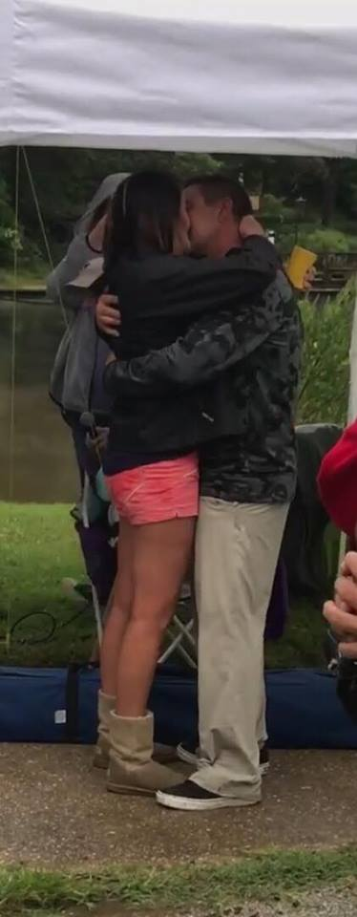

A big **THANK YOU** to all the local merchants who donated FANTASTIC items, gift cards, and services for our raffle and door prizes. Please remember the very generous contributions our community supporters when you shop. Let them know you are a CMIA resident when you buy from them.

**>Benfield Barber**

**> Froyo  
> Message Envy  
> Simple Sands  
> Mark Marsteller  
> Edgewater Restaurant**

> **Planet Fitness- Pasadena**

**> Tap House**

**> Adams Ribs  
> Bono Nation  
> Bill Bateman’s  
>Savvy Consignments  
> Village Salon  
> Szechuan  
> Park Tavern  
> Little Carmines**

**> Benfield Day Spa  
> Diane Newborough  
> Harbor Spirits  
> The Cottage  
> Mutt & Joe  
> Park Deli  
> Rivera's  
> Carolyn Rogers  
> Ledo’s Pizza of Severna Park**

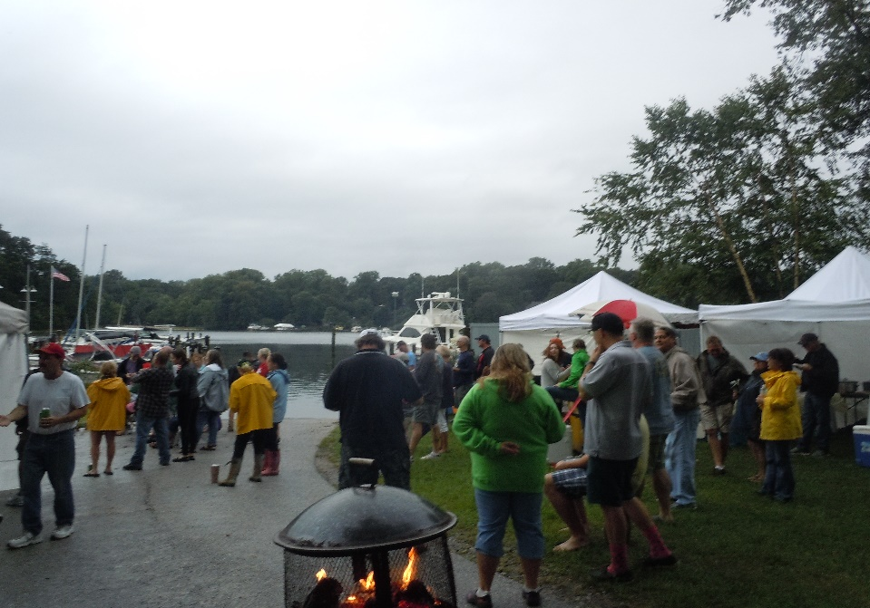

September 8 began as a gray and dreary day, but the grills were lit, the music played and friends gathered under HillBottom tents to celebrate living in Carrollton Manor. Everyone was enjoying the great food and having fun when the day became really special! Just as the sun came out, the crowd was called to the pier where Chris Rines went down on one knee and surprised his best friend Jen Gibson by asking her to marry him—right then and there! As everyone was cheering, the unforgettable wedding began. It was truly a day to remember.

**Thank You, Chris and Jen, for sharing your special day with all of us!** May all your days be filled with sun, laughter and friends.

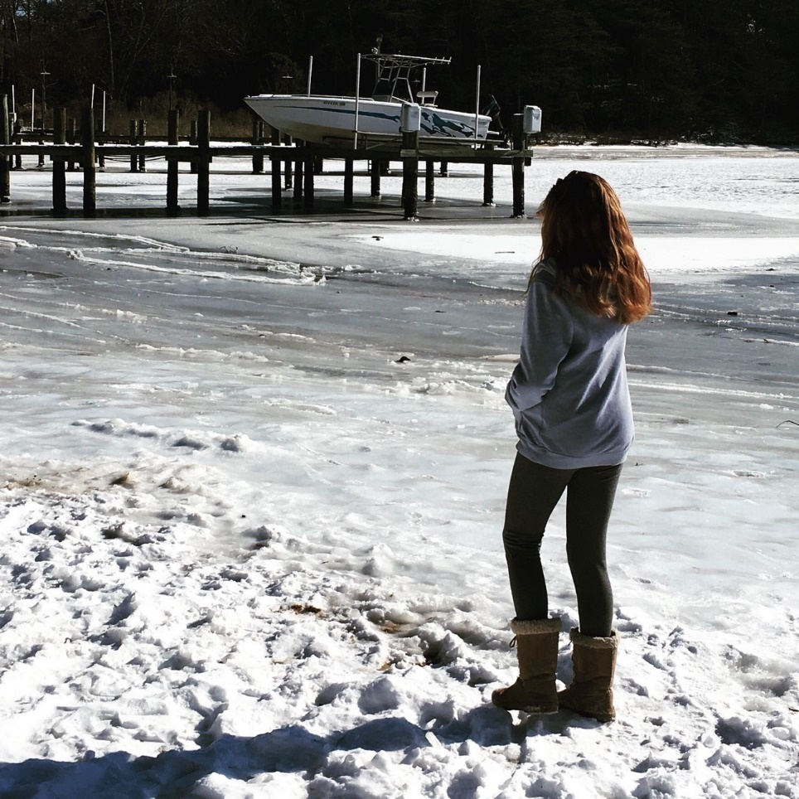

**When the snows come** Carrollton Manor becomes a winter wonderland! PLEASE continue to be a great neighbor.

* **Watch out for everyone around you**, check on your neighbors, drive very carefully through our narrow streets, and practice ‘friendly’ sense to safely get through the winter season.
* **Enjoy the snow, but stay aware**. When you shovel or blow the snow away from around your home- don’t put it in the street or block someone else’s home. Melting snow makes for dangerous ice-covered streets*. Everyone is trying to dig out. Let’s all work together !!!*
* **Move cars and trucks off the streets** if the forecast is for snow. Do not stand or park a vehicle, whether occupied or not, within 15 feet of a fire hydrant or within 20 feet of a crosswalk at an intersection. Our streets are narrow and the plows need room to get the snow cleared from the roads. If the plows can’t get through….the roads won’t be cleared!!!
* **Clean up after your pets**: Pet waste does not disappear from the winter ice and snow- it stills goes directly into the soil and waterway with the melting street runoff !!!!
* **For more information on dealing with winter**, winter emergency preparedness, and how you can help your community be prepared, visit: [**www.aacounty.org/OES/index.cfm**](http://www.aacounty.org/OES/index.cfm)**.**

During “Snow Events,” information on snow plowing and roads can be found on the AA Co. website under the “Snow Information” tab.

CMIA Winter Reminders

Winter Tips from DNR

* **Start a new family tradition** by purchasing a balled/burlapped live tree that you can plant outside after the holidays. Planting the tree will create wildlife habitat, reduce soil erosion, and reduce air pollution. Plus, **it makes a great memory as your family watches it grow!**
* When winter weather turns your driveway into a sheet of ice, consider using non-toxic de-icing techniques to thaw it out. Clean clay cat litter, sand and fireplace/stove ash are better alternatives to chemicals which will eventually wash into local waterways. Keep kitty litter in your car for emergencies.
* Each year, Americans generate **5 million tons of waste** each holiday season; wrapping paper and shopping bags make up 80% of this waste. Reduce the amount of trash that ends up in your community landfill by saving tissue paper, gift bags and boxes for reuse, and recycling torn paper and other packaging. Before you throw everything in the garbage can, take into consideration what can be recycled.
* When wrapping your holiday purchases, get creative with your packaging. **Creating your own wrapping paper** out of an outdated calendar, newspapers, or decorating paper bags can also be a fun holiday craft for all ages.
* As you begin decorating for the holidays, consider **using long-lasting LED lights** to bring spirit to your decor. A string of LED lights uses about one-tenth of the electrical current of older incandescent lights.
* When **packing lunch** for you or your family each morning, don’t miss the opportunity to reduce packaging waste. The average child annually throws away 67 pounds of lunchbox trash. Small changes such as **using a reusable insulated bag** instead of paper bags, and **utilize washable containers** instead of plastic sandwich bags to can greatly lower your waste contribution.
* New electronics and toys received over the holidays often require fresh batteries, consider switching to rechargeable batteries. Also, do not forget to **properly dispose of all used batteries.**



2019 Budget

**Carrollton Manor   
Improvement Association**

**CMIA 2019 proposed budget**

**Income**

**Tax Revenue $150.00 per house x 545 homes $81,750**

**Expenses**

AA County Administrative Expenses $2000

Administrative Expenses

Meeting $300

Office $600

PO Box $70

Storage $2000

Newsletter (Printing & Postage) $5000

Web Site $1000

Association Dues $90

Legal Assistance $2000

CPA/Accounting Firm $6000

Security $7000

Liability and D&O Insurance $4500

Treasurer's Bond $1500

**Total Administrative Expenses $32060**

**Maintenance/Community Property Expenses**

Beach Keys/Locksmith $2000

Water Testing $1000

Taxes: Real Prop, Front Foot., SWR $1000

**Utilities**

Water $100

Electric $1000

Internet $720

**Groundskeeping**

Landscaping $15400

Beautification $10000

Animal Waste Removal $2500

Sanitation $2000

Clubhouse operating Expenses $2500

**Total Maintenance $38220**

Capital Projects Carried forward from 2017/2018 $205,000

Future Projects $19769

**Total Allocated Expenses $295,049**

Have a Safe and Happy Holiday Season



**For some great ideas on fun winter activities for kids- visit some of these websites:**

* Winter Activity Guide/Nature Rocks: [www.**nature**rocks.org/**nature**-rocks-**winter**-**activity**-guide-2013-14-final](http://www.naturerocks.org/nature-rocks-winter-activity-guide-2013-14-final)
* Activity Finder from the National Wildlife Federation: [www.nwf.org/**Activity**-Finder.aspx](http://www.nwf.org/Activity-Finder.aspx)
* Archive of Outdoor Activities for Children: [www.**dnr**.maryland.gov/cin/outdoor_**activities**_**archives**.asp](http://www.dnr.maryland.gov/cin/outdoor_activities_archives.asp)

**Don’t forget our four-footed and flying friends as the weather chills!**

* Give your pets plenty of food/water, making sure the water is fresh and unfrozen. Keeping warm depletes energy. Use plastic bowls, not metal, your pet's tongue can stick and freeze to metal.
* Be careful with cars, cats and wildlife. Warm engines attract cats and small wildlife, who crawl up to get warm, so bang on your car's hood to scare them before starting your engine.
* Protect pet paws from the salt, and chemicals, used to melt snow and ice. They can irritate your pet's feet. ….. Wipe all paws before your pet licks them and irritates their mouths.
* Avoid antifreeze poisoning. Antifreeze is a deadly poison, but it has a sweet appealing taste. Wipe up spills and store antifreeze (and all household chemicals) out of reach.
* Enjoy wildlife watching! Fill bird feeders and keep water in the bird baths -- bird watching can be fun on a dreary winter day.

P.O. Box 1104

Severna Park, MD 21146

We’re on the Web!

www.carrolltonmanor.us

**About *The Eagle* mailing labels:**

CMIA gets mailing labels from the Anne Arundel County Tax Assessor. The county updates the labels once a year. If you are a resident not receiving a newsletter, please contact us at **Carri585@earthlink.net**. We will make a new address label for you for future Eagle issues. Newsletters are also available online: [www.carrolltonmanor.us](http://www.carrolltonmanor.us)**.**

**Tuesday, Dec. 4 at 7:00 p.m.**

**Severna Park Baptist Church  
Benfield Blvd.**

CMIA COMMUNITY MEETINGS