Grapa

Additional information

1. A few more details... 1
1.1. CurveSpectrum 1

A few details…
CurveSpectrum
Curve Spectrum offers functions to compute the optical absorption coefficient α from reflectance and transmittance curves of layers. The resulting curve is in units of [cm-1]. The computation of α is based on the Beer-Lambert law of an estimate of the light absorption in the layer.
Warning: The calculations presented below rely on various assumptions ans simplifications. For more accurate data treatment, various analytical approaches were developped in the literature. The use of dedicated optical modelization software is also recommended.
Beer-Lambert law
R, A and T denote the reflectance, absorptance and transmittance of the layer, and d the layer thickness.
The Beer-Lambert law describes the attenuation of a propagating beam in a medium, and is expressed as, with I0 the initial intensity and α the attenuation coefficient.
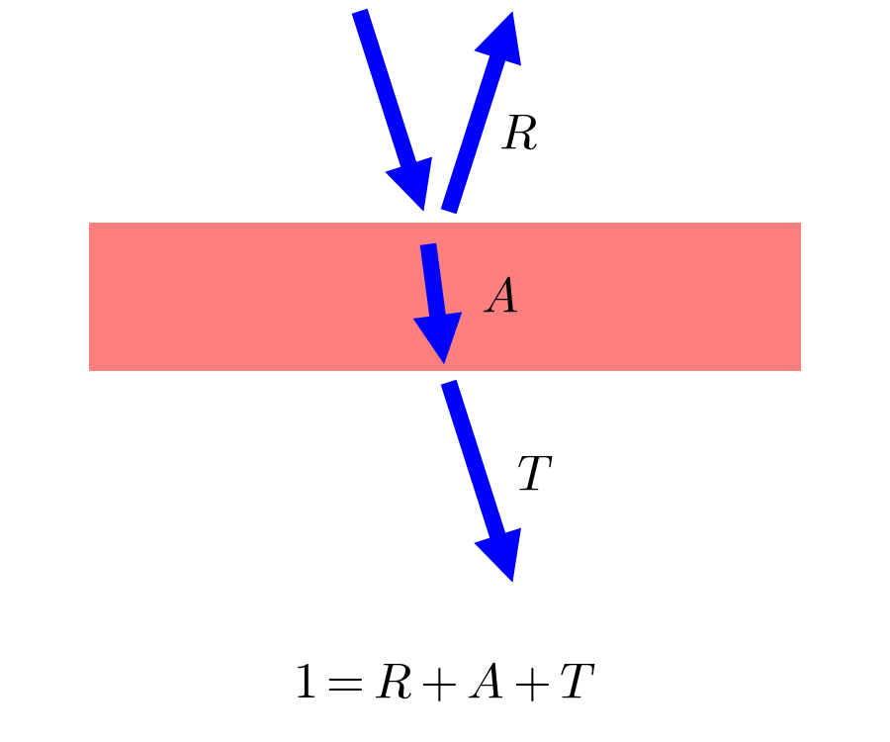
Figure 1: Schematics of the light propagation in a sample consisting of a single layer. The reflection at surfaces are negleted.
Assuming the reflection mostly takes place at the first interface (which is wrong, but here a suitably good approximation when the light absorption is more important than reflections), one obtains:

Presence of a (weakly) absorbing substrate
In real-life measurements, the layer of interest is generally on top of a substrate. The reflectance and transmittance can be characterized for both the naked substrate and the layer on substrate. On would need to perform a "virtual" measurement, where only the layer of interest would be characterized. An estimate to the optical absorption coefficient α can be obtained as follows.
Again, we assume that the reflectance only occurs at the first interface. This is mostly satisfied if the refractive index of the layer of interst is higher than that of the substrate: ZnO on soda-lime glass (SLG) for example. With a relatively low value of n around 1.5, SLG is a relatively good substrate. Conversely Si has a very high refractive index and thus large amplitude of reflection at interfaces, and will not well satisfy this hypothesis even far in the infrared.
Then, assuming that fraction of (transmitted light) over (incoming light) in the substrate are equal for both measurements :
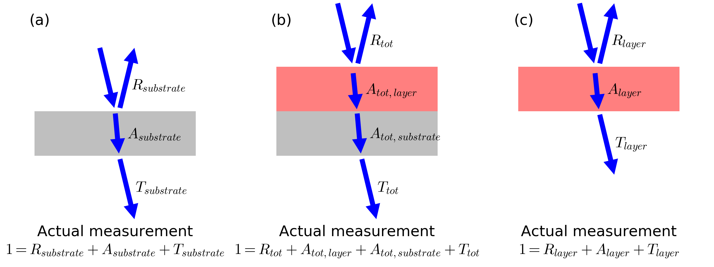
Figure 2: Schematics of light propagation in (a) a substrate, (b) a substrate covered with a layer, and (c) ideal optical measurement on a free-standing layer. The reflection at interfaces are here neglected.

Finally, assuming, and assuming ,
.
It follows that:
.
Warning: This data treatment only provides an estimation of α. For accurate results please use a more refined analytical treatment, or a dedicated optical modelization software.

