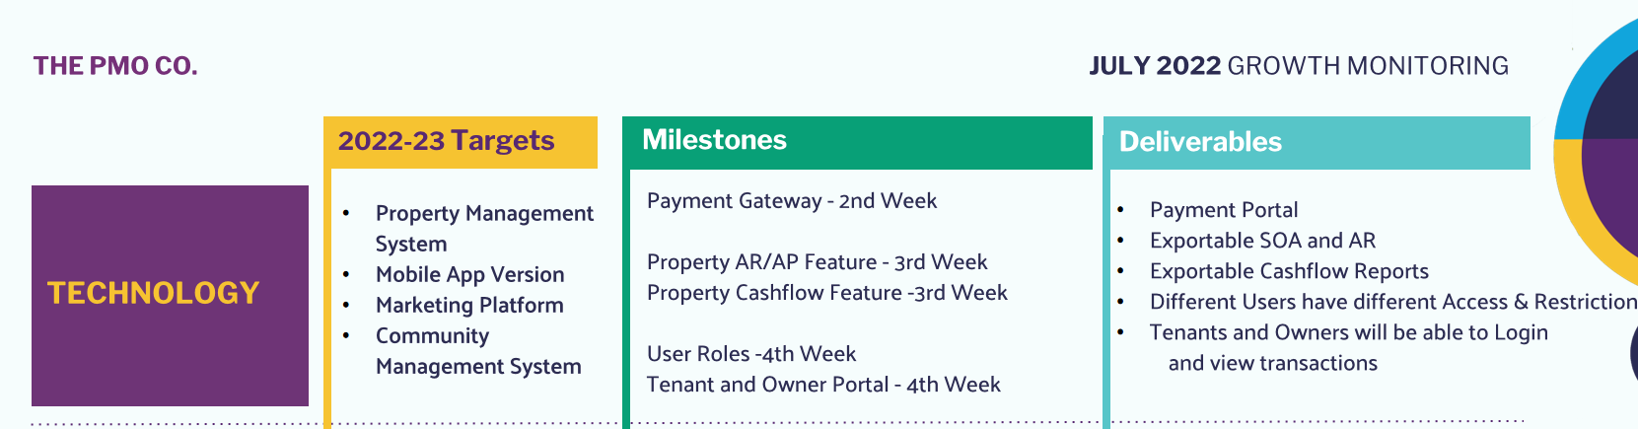

Accounting System for Rental Properties:

1. Accounts Receivables :
2. Billing Automation for RENT only. This feature is will be set on the execution of the contract.
   1. Auto create bill every month on the day of the first month of the contract up to the last day of the contract.

Example : Contract is 12 months starting 25th of July, 2022 up to 24th of July, 2023

Billing should be generated or created by the system

every 25th of the month starting July 2022 upto 25th of the month of June 2023.

* 1. Auto send to email bill of rent 5 days before due date. (# of days before due date should be set by management during execution of contract )

Example : Due date of rent is the move-in date 25th of the month.

SOA should be emailed by the system every 20th day of the month to the email of the address of the tenant.

Required fields needed for billing automation :

Name of Tenant

Unit #

Monthly Rent Amount

Due Date : ( day of the month)

Contract start: Start of bill: (day and first month of contract)

End of bill : (day and last month of contract)

1. Billing of Utilities. Manual Input only.
2. Utilities chart per property. ( create new table per month)

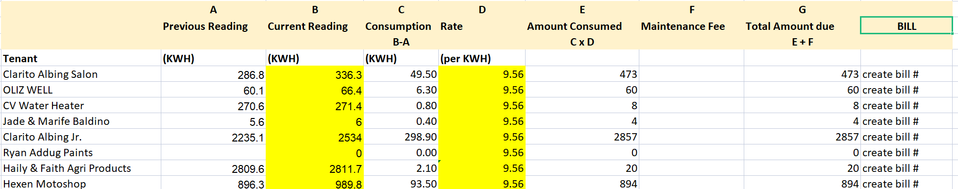

1. Create bill based on the chart
2. Add the bill # and all unpaid, and partially paid bill #s to the exportable SOA
3. Billing Reminders / Notifications. Create a notifications option for billing.
   1. Set date of notifications x number of days after due date.
   2. Notifications are billing reminders sent to tenant email address. (parang nagsset ng alarm but through email just like what we receive from digital ocean when payment is unsuccessful )
   3. Add more billing reminders / notifications until bills are paid (input dates for auto email notification).
   4. Billing reminders are set by the manager user
   5. Send a thank you email to tenants to confirm payments received.
4. Accounts Payables :
5. Add requests for payment form: Feature is available for all team users
6. Details :
   1. Particular ( dropdown, can add more particulars depending on property expenses)
   2. Description (blank, user will encode the description)
   3. Due Date ( Calendar)
   4. Pay to : (blank, user encoded)
   5. Amount Due : (blank amount, user encoded)
   6. Submit Request (a request for payment # will be created)
   7. System Forward Request to Manager
   8. Manager can see the request for payment under the Accounts Payables Menu
   9. Manager approve the RFP#
   10. Accounting Release the funds for RFP#
7. LEDGER : summary of all cash-inflows and cash-outflows
8. System automatically Records all cash-inflows in the Ledger and is displayed according to *date of payment*
9. System automatically Records all cash-outflows in the Ledger and is displayed according to *date of release of funds.*

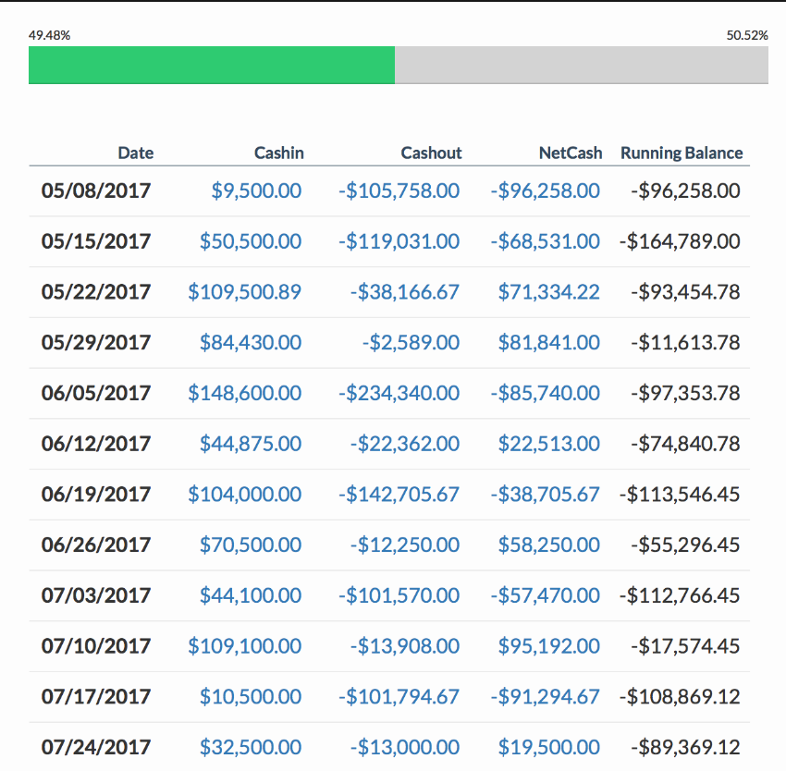

1. 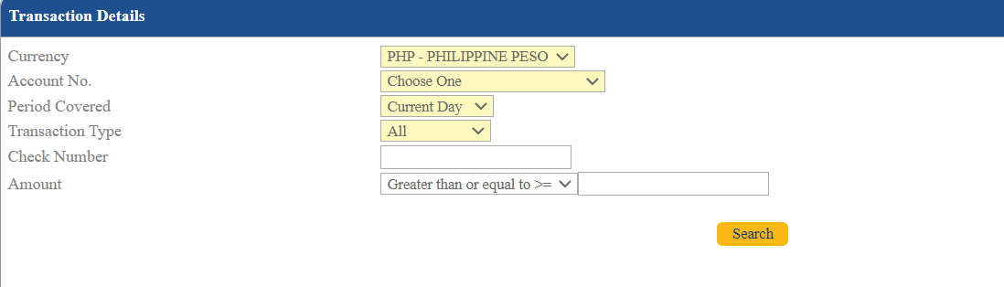Choose range of dates to display