Christian Arroyo

ET501/J1

9/26/2016

Lab#4

Mr. Lawrence

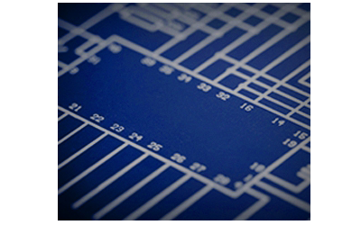

**OBJECTIVE:** To investigate the characteristics of a series DC resistive circuit.

**EQUIPMENT:**

Resistors 1-330Ω

2-220 Ω

1-470 Ω

1-100 Ω

Instruments 1- DMM or VOM

1- dc Power Supply

**RESUME OF THEORY**

In a series circuit, the current is the same through all of the circuit element. The total resistance, R, of a series is the sum of the individual resistance’s. By Ohm’s laws, the circuit current is equal to the voltage divided by the resistance.

**DIAGRAM:**

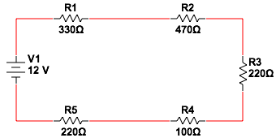

**DATA:**

|  |  |
| --- | --- |
| VOLTAGE (V) | CURRENT (mA) |
| 0 | 0 |
| 10 | 7.5 |
| 20 | 14.9 |
| 40 | 29.9 |
| 50 | 37.3 |

**GRAPH:**

|  |  |  |  |  |  |
| --- | --- | --- | --- | --- | --- |
|  |  |  |  |  |  |

**CALCULATIONS:**

$$R_{T}= R_{1}+R_{2}+R_{3}+R_{4}+R_{T}$$

$$R_{T}=330Ω+470Ω+220Ω+100Ω+220Ω$$

$$R_{T}=1340Ω$$

$$I_{T}=\frac{E_{T}}{R_{T}}$$

$$I_{T}= \frac{10V}{1340Ω}$$

$$I_{T}=7.4mA$$

**CONCLUSION:**

From the data collected we saw that in a series circuit, the total resistance RT, is the sum of the individual resistance’s. Furthermore we were able to verify Ohm’s Law, which states that the current is equal to the voltage divided by the resistance. Our calculations and graphs agreed with the theory we learned in class.