ENGLAND FEBRUARY 2026
SAINT MARY SCHOOL OF ENGLISH / CHURCHILL HOUSE OF ENGLISH . ( A tener en cuenta, todos los valores se toman al valor dólar oficial SIN LOS IMPUESTOS YA QUE ES EDUCACION; por lo que comercio exterior elimina los impuestos. Después el valor de la matricula se descuenta del valor total que restarìa por pagar hasta Nov 2025 de la forma que deseen, pueden ser cuotas ) Realizaremos reuniones previas, las necesarias para acordar detalles y que puedan sacarse todas las dudas, hay tiempo suficiente para ahorrar y decidir )

To Karina,
2026 quotes
based on Group Size: Quote 1: 12-16 students
4 weeks home stay accommodation (family /half board )
15 hours of class per week Certificate upon Course Completion
Transfers to and from airport
Transport to and from host families on arrival and departure
Introduction of Ramsgate
1 FULL day trip per week (Oxford, Cambridge, Bath, Stonehenge……)
1 HALF day trip per week ( Leeds Castle……..)
Evening activities Monday- Friday (excluding Wednesdays)
Insurance
Enrollment £300 ( USD 300)
£2399 per student

Pocket money : USD 700
We can add Paris and Scotland, or only Paris.
We can add two days in London. ( about 250 USD) in a hotel …..
Ramsgate is picturesque seaside town famous for its Royal Harbour and sandy beaches. It has relaxed pubs, bars and restaurants but also offers easy access to Canterbury and London is only a fast train ride away!
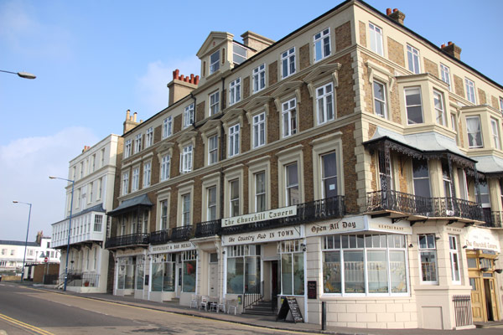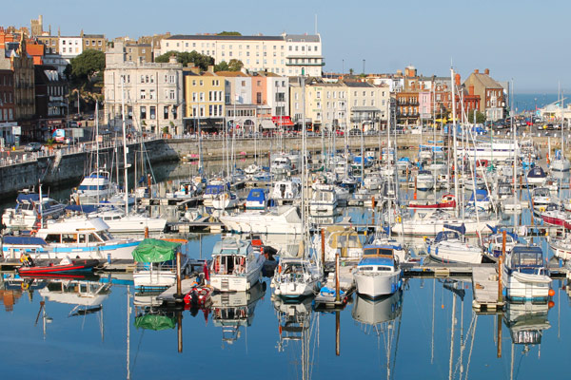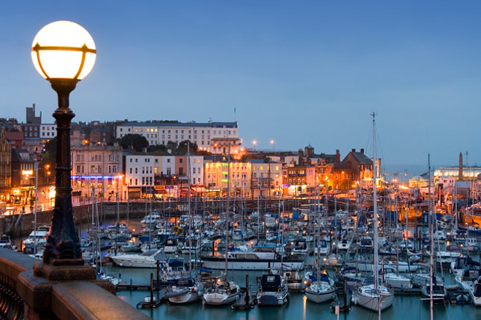

The Social Club
Our Social Club team has many years’ experience of organising leisure activities to make your free time enjoyable and rewarding and helping improve your language skills.
The aims of our social programme are to:
- Enable students to meet new people and make friends with fellow students from all over the world.
- Encourage students to practice their speaking skills in social situations.
- Provide opportunities to visit English towns and cities.
- Help understand English culture and traditions, which helps learn the language more successfully.

The Clubroom
The school has its own Clubroom with bar, disco and lounge area. There is something to enjoy most evenings, including some of the following:
- Film nights
- International party
- Quiz nights
- A weekly disco
- Karaoke nights
- Educational Talks
- Sporting events on TV such as big football matches

Accommodation
- Living in an English-speaking environment is the best way to learn and practice English.
- Whether you want private accommodation or to experience life with a British family, we have a wide range of options available. Our friendly and experienced year-round team will find the accommodation that is best for you and will ensure that you are happy and comfortable in your new home.
- 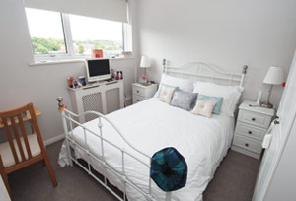

London and South of England

London
One of the world’s most visited cities, London has something for everyone: from history and culture to fine food and good times. Visit Westminster, Buckingham Palace, the Houses of Parliament and more!
There are direct trains to London from Ramsgate and many of our adult students visit London regularly. Coach trips to London are a regular part of group programmes.
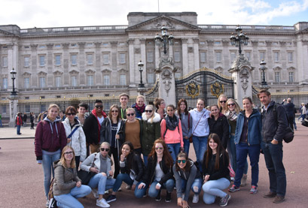

Leeds Castle
Discover almost 900 years of history and explore 500 acres of a beautiful parkland and gardens at “the loveliest Castle in the world”. Leeds Castle is considered one of the most romantic castles in England.
Leeds Castle is in the heart of Kent and is just over an hour’s coach ride from the school.
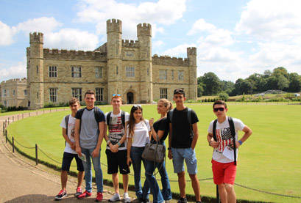

Oxford
A sightseeing tour of Oxford with the chance to see some of the colleges and buildings of Oxford University including the famous Christ Church College, Bodleian Library and Radcliffe Camera.
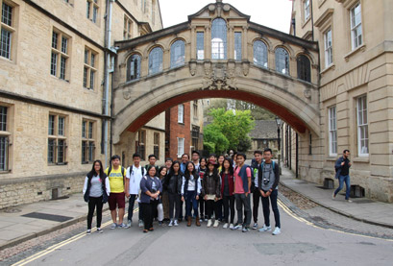

Cambridge
Cambridge is home to the world-renowned University of Cambridge, which was founded in 1209. University colleges include King’s, famed for its choir and towering Gothic chapel, and St John’s, with its 16th-century Great Gate.
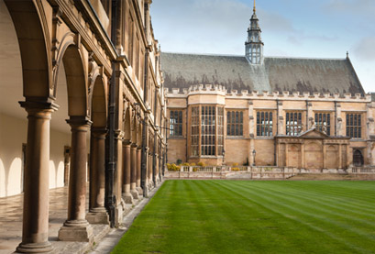

Brighton
Brighton often goes by the title ‘London by the Sea’ because of the number of London people – particularly those from the arts and music communities – who live here or visit at the weekends.
Brighton is one of our most popular summer destinations because of its ‘cool’ seaside atmosphere and shopping in the Lanes area where many of the town’s creative residents have small shops.
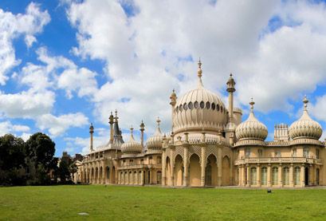

Windsor Castle
Windsor Castle is the oldest and largest inhabited castle in the world and The Queen’s favourite weekend home. No trip to Windsor could possibly be complete without a visit to amazing Windsor Castle, the family home to British kings and queens for over 1,000 years.
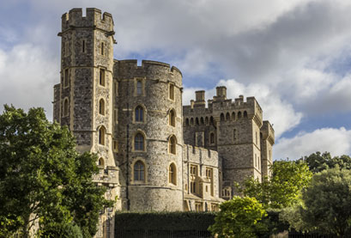

Bath and Stonehenge
Bath is a beautiful, historic city that is incredibly popular with tourists. It is recognized as a world heritage site. Stonehenge is one of England’s greatest icons. It is original purpose is unknown, and it one of mankind’s greatest mysteries.

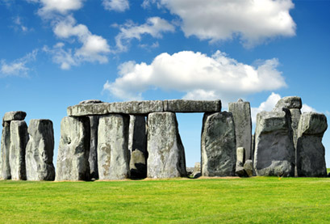

Other British Destinations THIS ACTIVITIES ARE NOT INCLUDED IN THE QUOTATION

Edinburgh, Loch Ness and the Highlands
Edinburgh is Scotland’s compact, hilly capital. It has a medieval Old Town and elegant Georgian New Town with gardens and neoclassical buildings. Loch Ness is a large, deep, freshwater loch in the Scottish Highlands.
Edinburgh makes a good destination for a weekend break, flying from one of the London airports or by train.
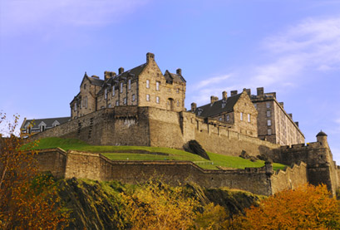

Europe

Paris
The “City of Light” is the global centre for art, fashion, culture and food. The architecture is beautiful and the history is fascinating. It’s also quite close, particularly on the fast Eurostar trains, so it is a terrific weekend break destination.
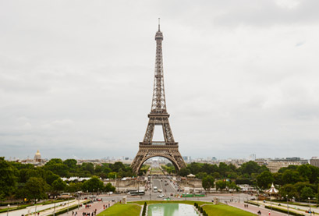

Amsterdam
Amsterdam is one of Europe’s most exciting cities, famous for its beautiful canals, art galleries and its relaxed culture. Amsterdam can be easily reached by direct Eurostar trains from London or Ebsfleet.
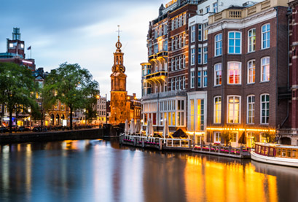

Destination:
Edinburgh N. of nights: 1
Number paying: 12
Price per person: £550
Our price includes: ❖ 1 night accommodation in a hostel (Hostelling Scotland or similar) , Students in ensuite twin rooms, Leader in single, with bed and breakfast included.
❖ Reserved seats on high speed train London to Edinburgh (return)
❖ Private transfer to/from Kings Cross St Pancras Train Station/Ramsgate on private air-conditioned coach with lap belts, reclining seats & air conditioning
❖ Entrance to Edinburgh Castle
❖ 2 Full days professional guide
❖ GTi Payment Protection guarantees 100% financial security for payments made.
❖ GTS 24-hour emergency cover, operated by experienced senior members of staff.
Destination:
Paris N. of nights: 1 Number paying: 12 Price per person: £765
Our price includes:
❖ 1 night accommodation in a 3* Hotel (Ibis or similar) , Students in ensuite twin rooms, Leader in single, with bed and breakfast included.
❖ Reserved seats on high speed train London to Paris (return)
❖ Private transfer to/from Kings Cross St Pancras Train Station/Ramsgate on private air-conditioned coach with lap belts, reclining seats & air conditioning
❖ Entrance to Eiffel Tower
❖ 2 Full days professional guide
❖ GTi Payment Protection guarantees 100% financial security for payments made.
❖ GTS 24-hour emergency cover, operated by experienced senior members of staff.
❖ Itinerary planning service, coach parking, road tolls, tax, and service charges Optionals: ● Single room supplement £77 per room, per night ● Seine River Cruise from £ 12
IMPORTANT : Paris and Scotland .
This prices are 2025 , perhaps it could be a small difference in 2026

