**Carryl Louise J. Dela Torre April 12 2021**

**Digital Image Processing**

**Exercise 1 A – Color Balancing using a Reference Chart**

Test 1: Reduce all the red tones by 50 % (cyan colored).

Result:

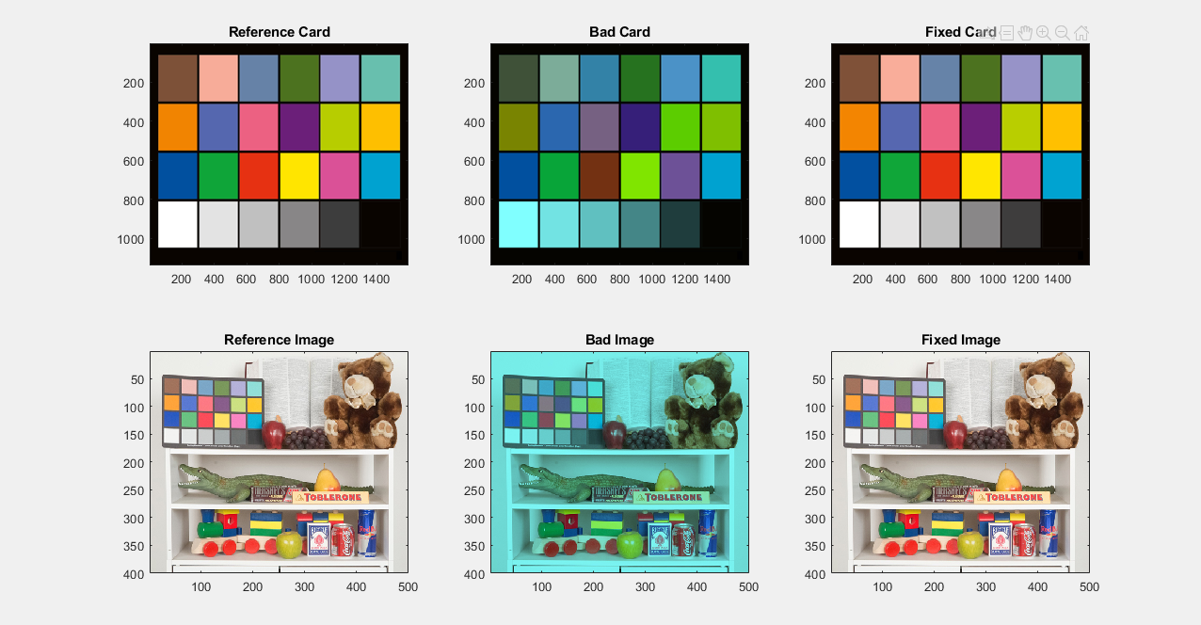

Test 2: Reduce min max range and skew colors too (coffee colored).

Result:

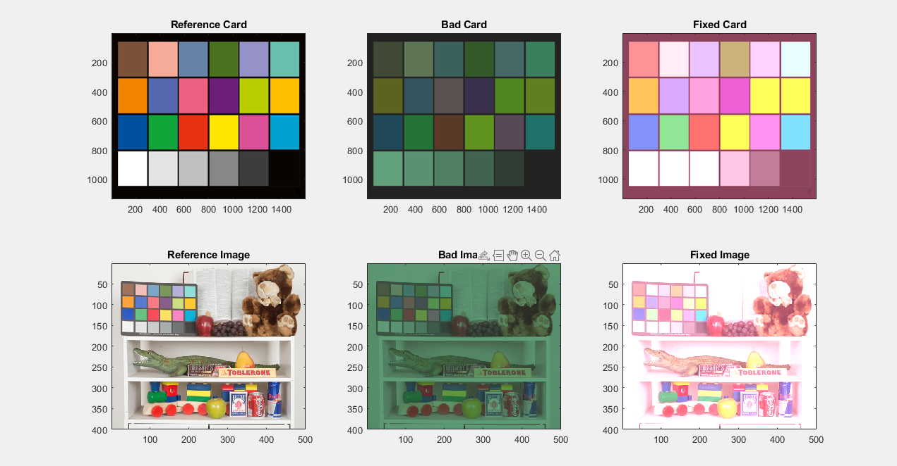

**Exercise 1B- Image Contrast Enhancement**

Test 1: Using Vintage Postcard (TIF). Damage: Image*0.8.

Result:

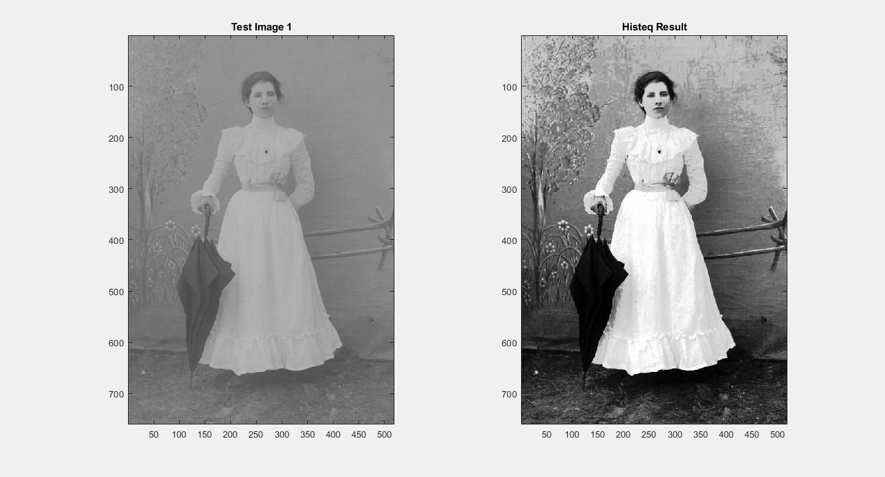

Test 2: Using Vintage Postcard (TIF). Damage: Image*0.25 + 0.25.

Result:

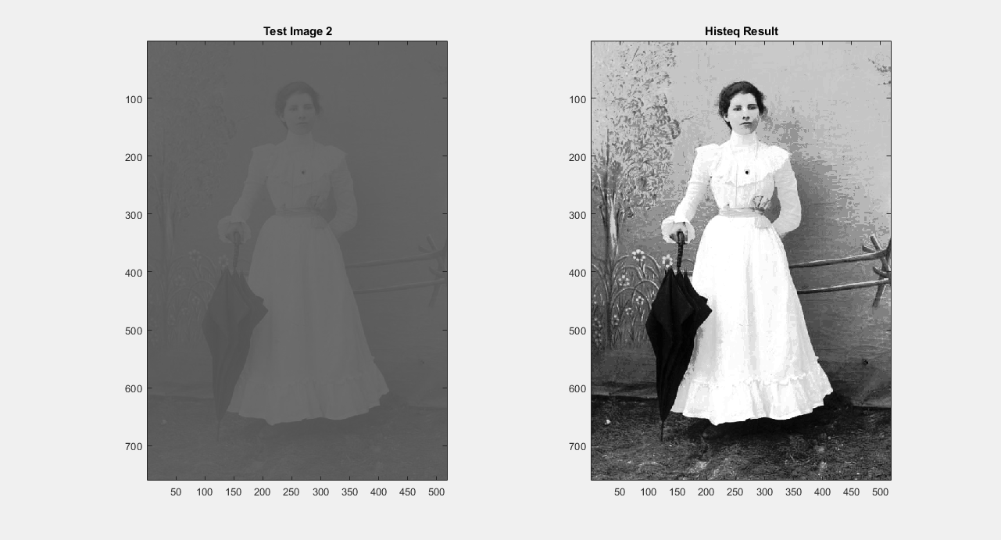

Test 3: Using Pout (TIF). Damage: Image*0.8.

Result:

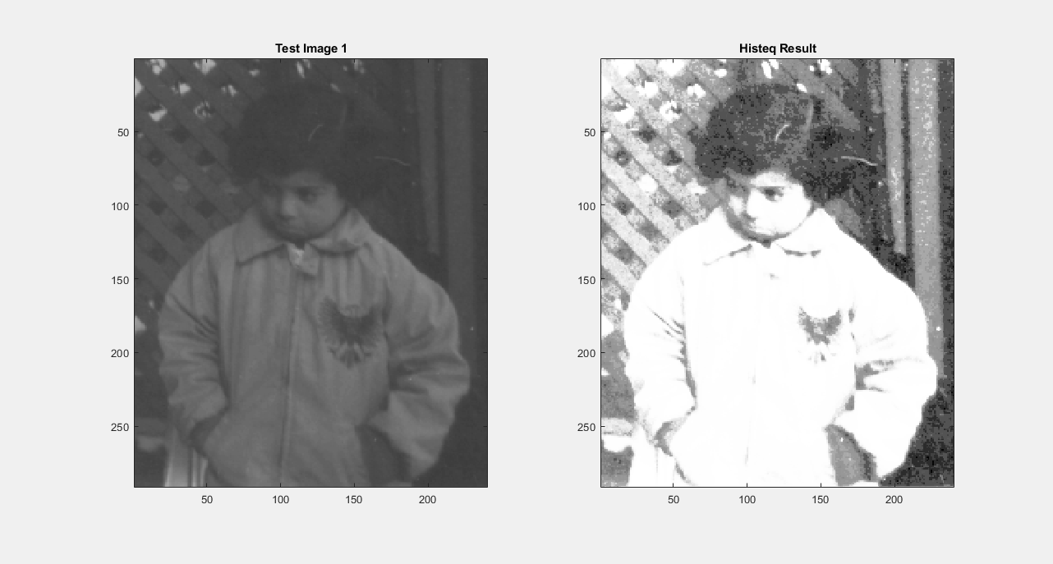

Test 4: Using Pout (TIF). Damage: Image*0.25 + 0.25.

Result:

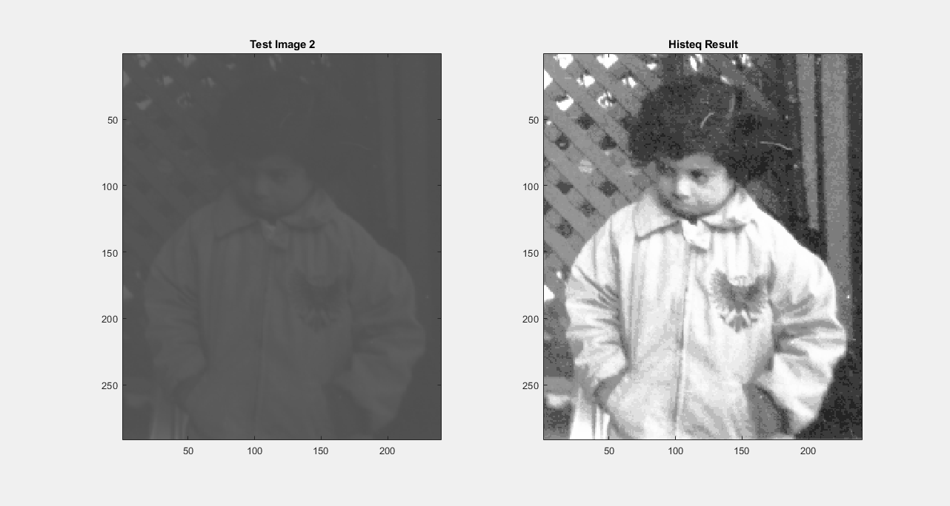

Test 5: Using Office 5 (JPG). Damage: Image*0.8.

Result:

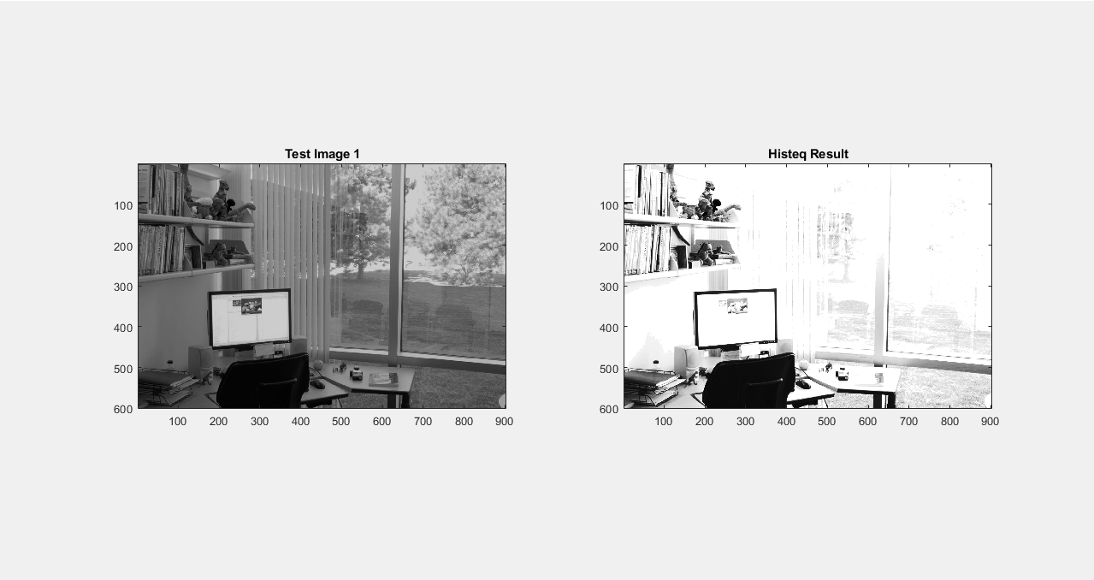

Test 6: Using Office 5 (JPG). Damage: Image*0.25 + 0.25..

Result:

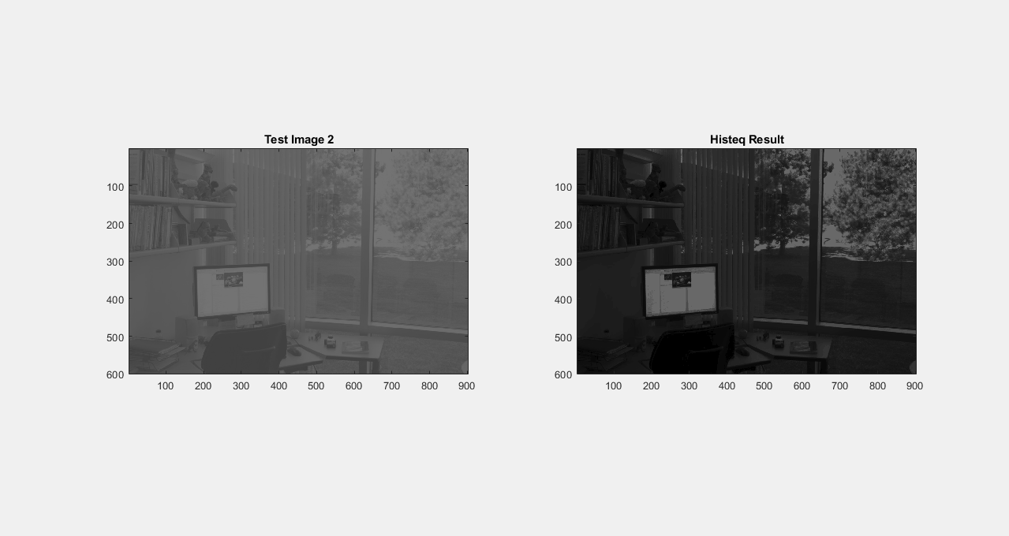

Test 7: Using Office 1 (JPG). Damage: Image*0.8.

Result:

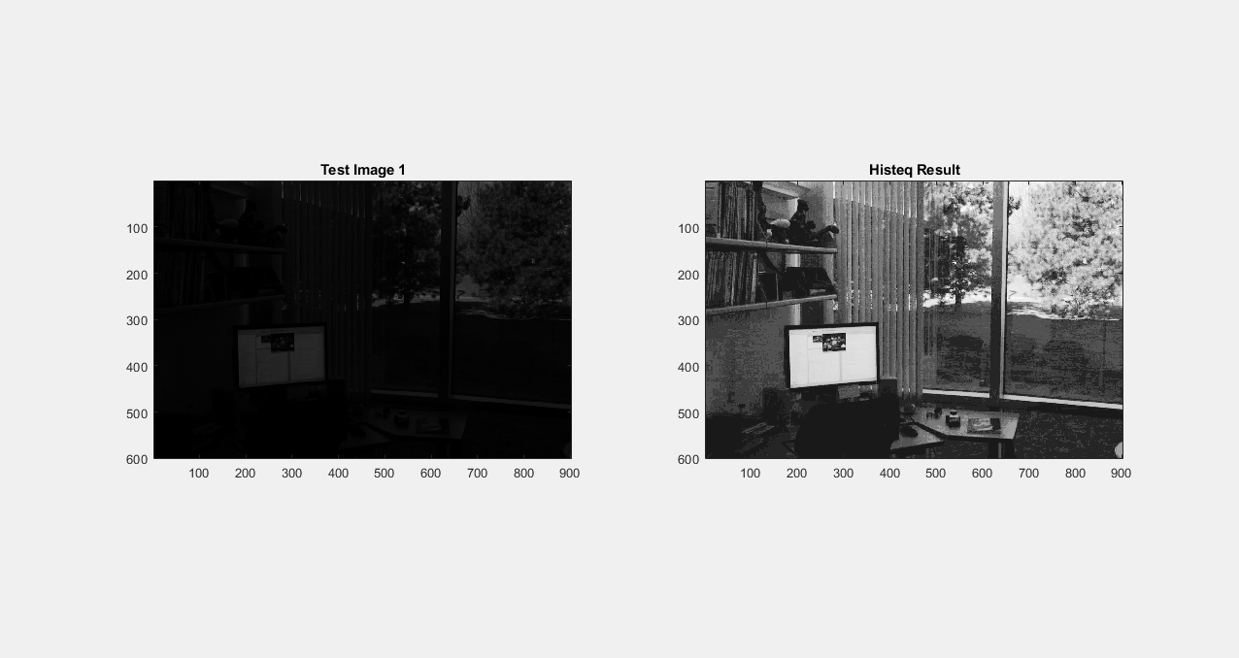

Test 8: Using Office 1 (JPG). Damage: Image*0.25 + 0.25.

Result:

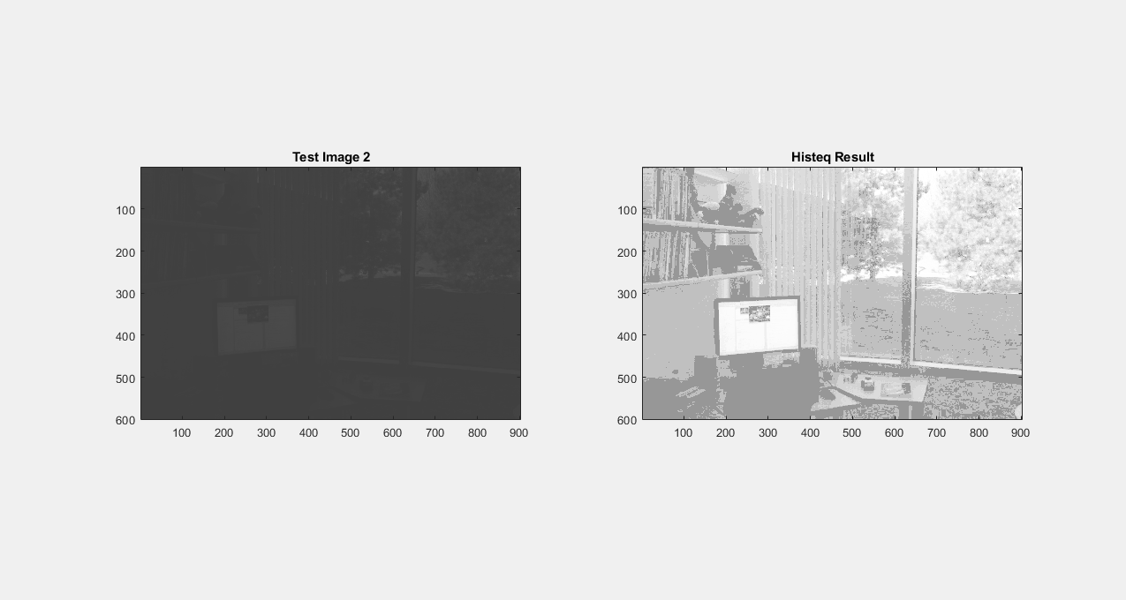

Test 9: Using Low Light (TIF). Damage: Image*0.8.

Result:

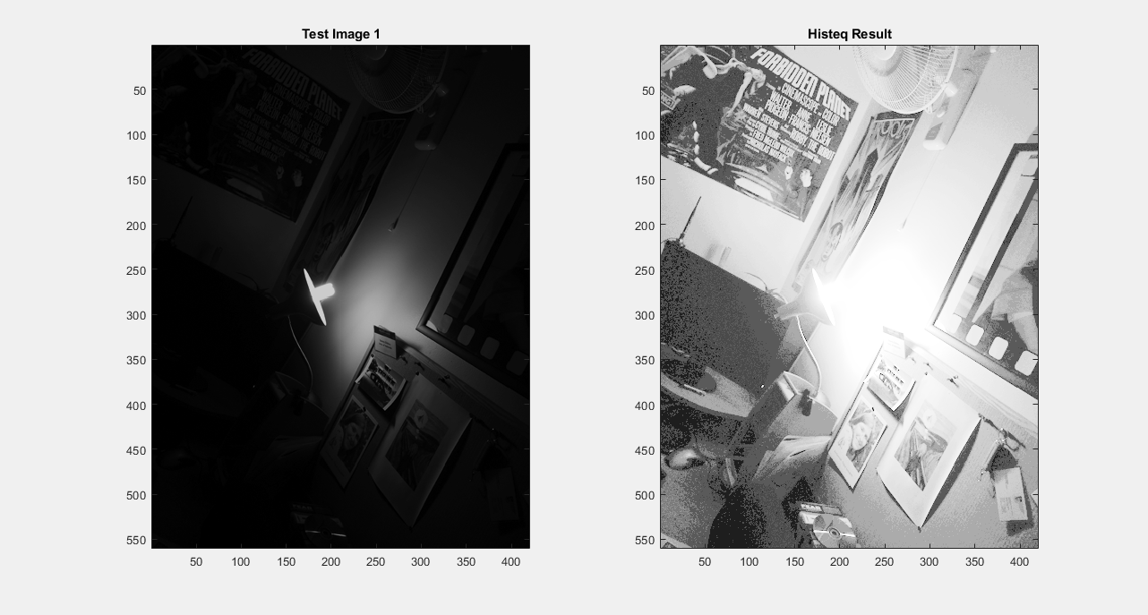

Test 10: Using Low Light (TIF). Damage: Image*0.25 + 0.25.

Result:

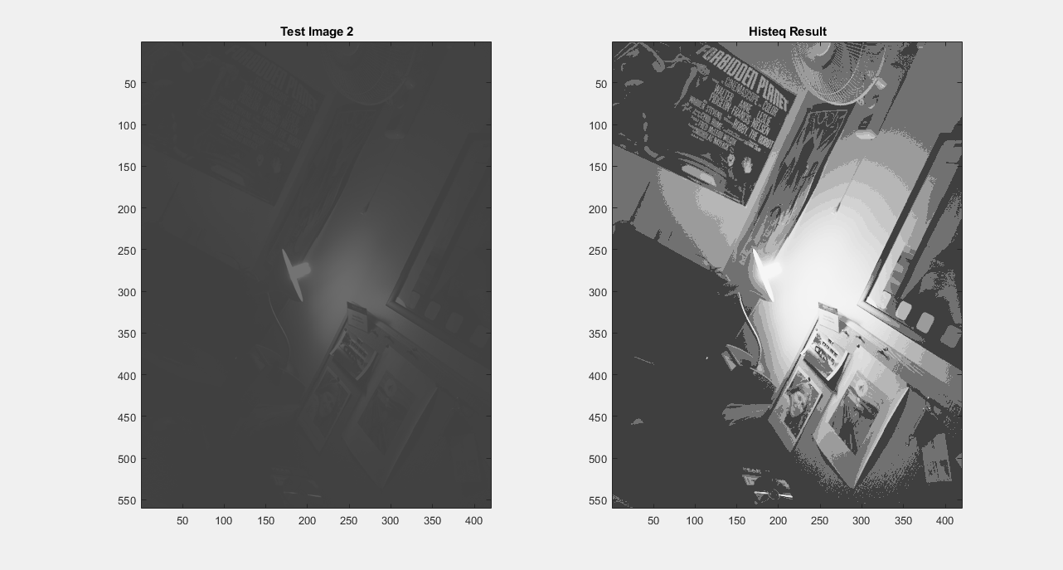

**Exercise 1C – A Simple Median Filter**

Question: Under what noise conditions does the median filter fail?

Answer: Gaussian Noise

Result:

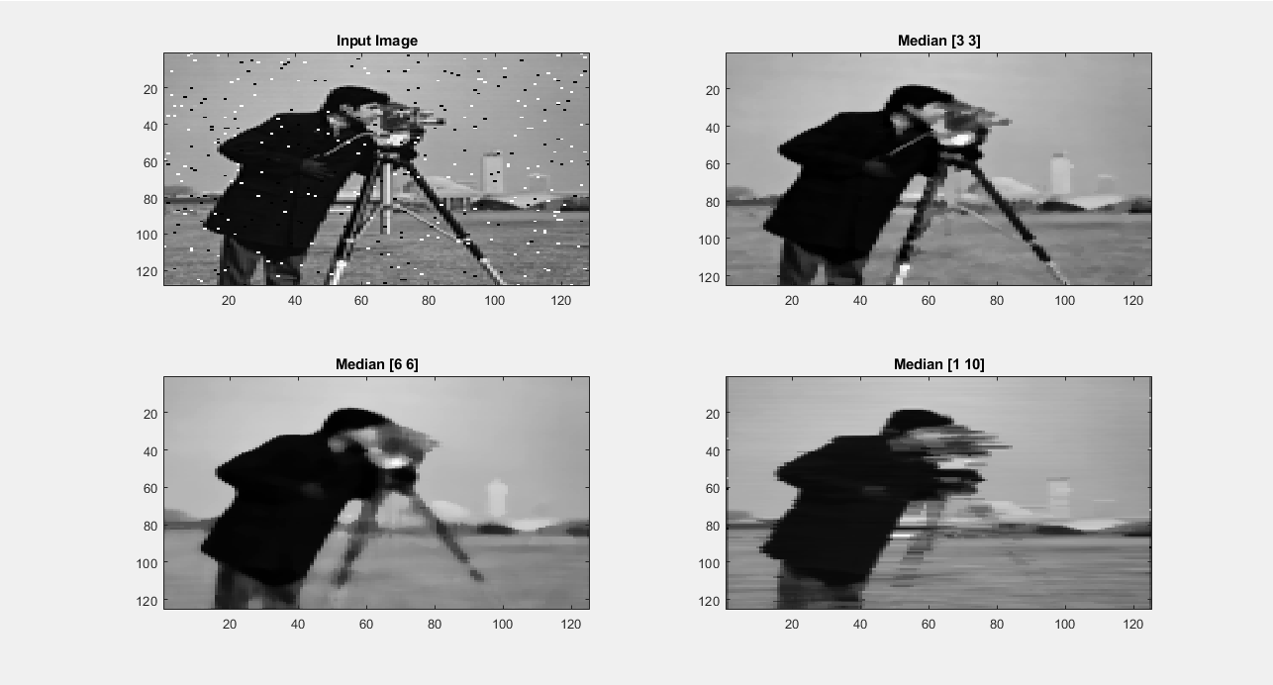

**Exercise 1D – A “Smart” Edge Preserving Noise Filter**

Test 1: Using Gantry Crane (PNG)

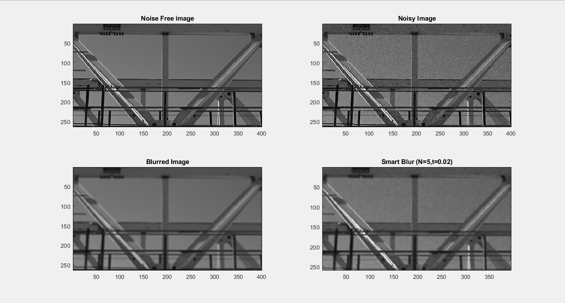

Test 2: Using Pout (TIF)

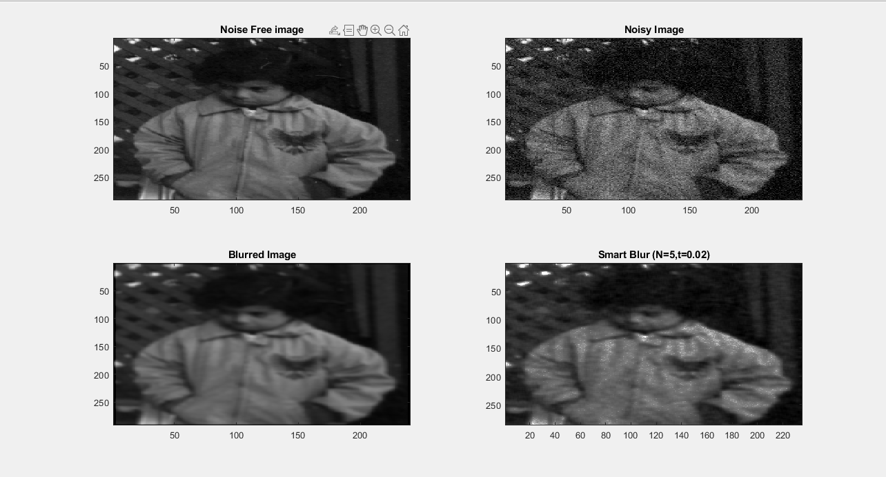

Test 2: Using Peppers (PNG).

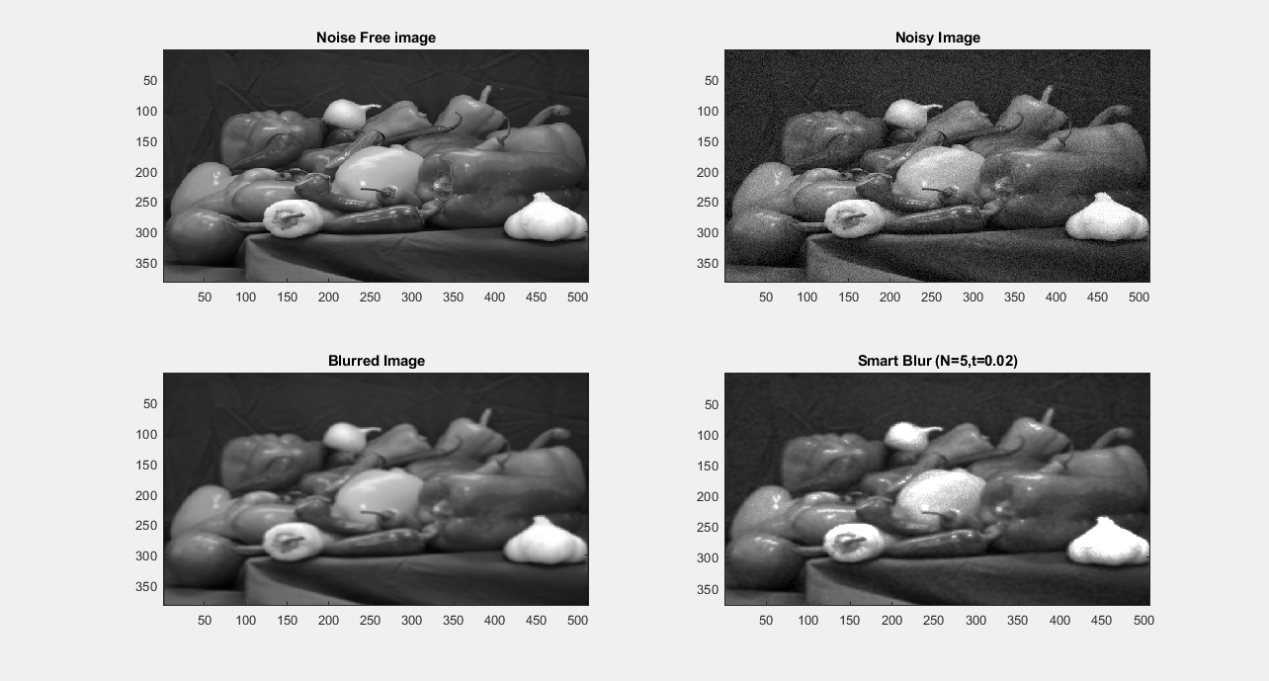

**Exercise 1E – Written Questions**

1. (1.0%) You have been given a set of imagery from a 256x256 pixel video surveillance camera to analyze. However, to work out roughly how far away objects of known size (e.g. people) are from the camera in the footage you need to determine the field of view of the sensor. Using a tape measure as a guide you are able to estimate that a doorway of 2 meters height appears to span around 32 pixels in the imagery when viewed from 10 meters away.

Q: Given the above, what is the likely field of view of the camera? (you may assume the vertical and horizontal fields of view are the same) .

FOV:

tan(θ) = = = 0.2

angle in degrees = 2 * arctan(tan(θ)) = 2 * arctan(0.2) = 22. 6 **°**

Q: How far away would a person of height 1.75 meters be if they appeared as a region of height 8 pixels in this imagery?

d = = = = 140 m

2. (1%) Carefully explain how a 'median' and an 'alpha trimmed mean' filter work and describe under what circumstances they are useful (illustrate if required).

Q: Without using a computer, what would be the result of applying a 3x3 and a 5x5 median filter to the following simple image? (you may assume that white=1, black=0 and that all values outside the image boundaries shown here are also black i.e. 0).

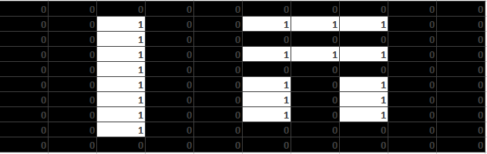

*Step 1: Applying (n x n) zero padding to the give image.*



*Step 2: Slide the filter mask to the image.*

 *Step 3: Values under that mask will be sorted. Then find the median.*

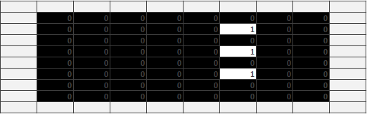*Step 4: The median value will be the new pixel value of the indicated image. Location of the pixel is based on where is the current center of the filter mask.*

*Answer: This will be the image applied with 3 x 3 median filter.*

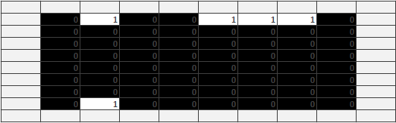

*Answer: This will be the image applied with 5x5 median filter.*

Q: Approximately, what would the result be if we instead applied a 3x3 alpha trimmed mean filter with d=3 ?

*Step 1: Calculate the value of the alpha to know how many will be trimmed from both ends of the sorted list (ascending).*

α = = = 1.5 ~ 2

Step 2: The values that is not cut out will be computed to know the new pixel value. The calculation is given below.

I(x, y) = = (total pixel value divided by 6)

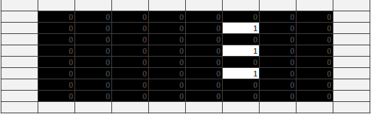

*Answer: This will be the image applied with 3x3 alpha-trimmed mean filter*