Class 04 R Intro
Malibu Slattery
Jan. 15, 2026
x<-1:50
plot(x, sin(x))
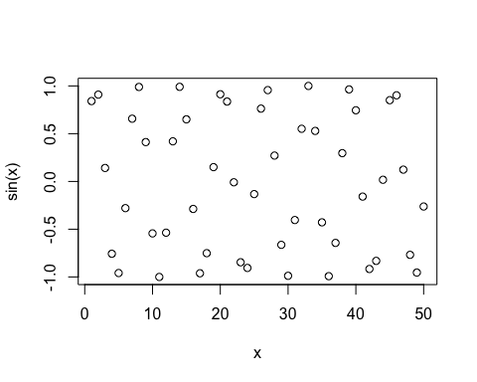
plot(x, sin(x), typ = "l", col = "darkgreen", lwd = 2)
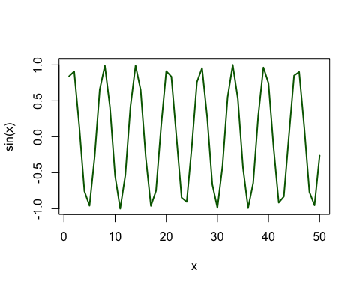
log(10,base=10)
## [1] 1

