Electric Lettuce

(A walkthrough for the website)

On clicking the link, the first page the customer would see is the home page. The home page acts as a hub and provides a path to every feature we have implemented.

Home Page:

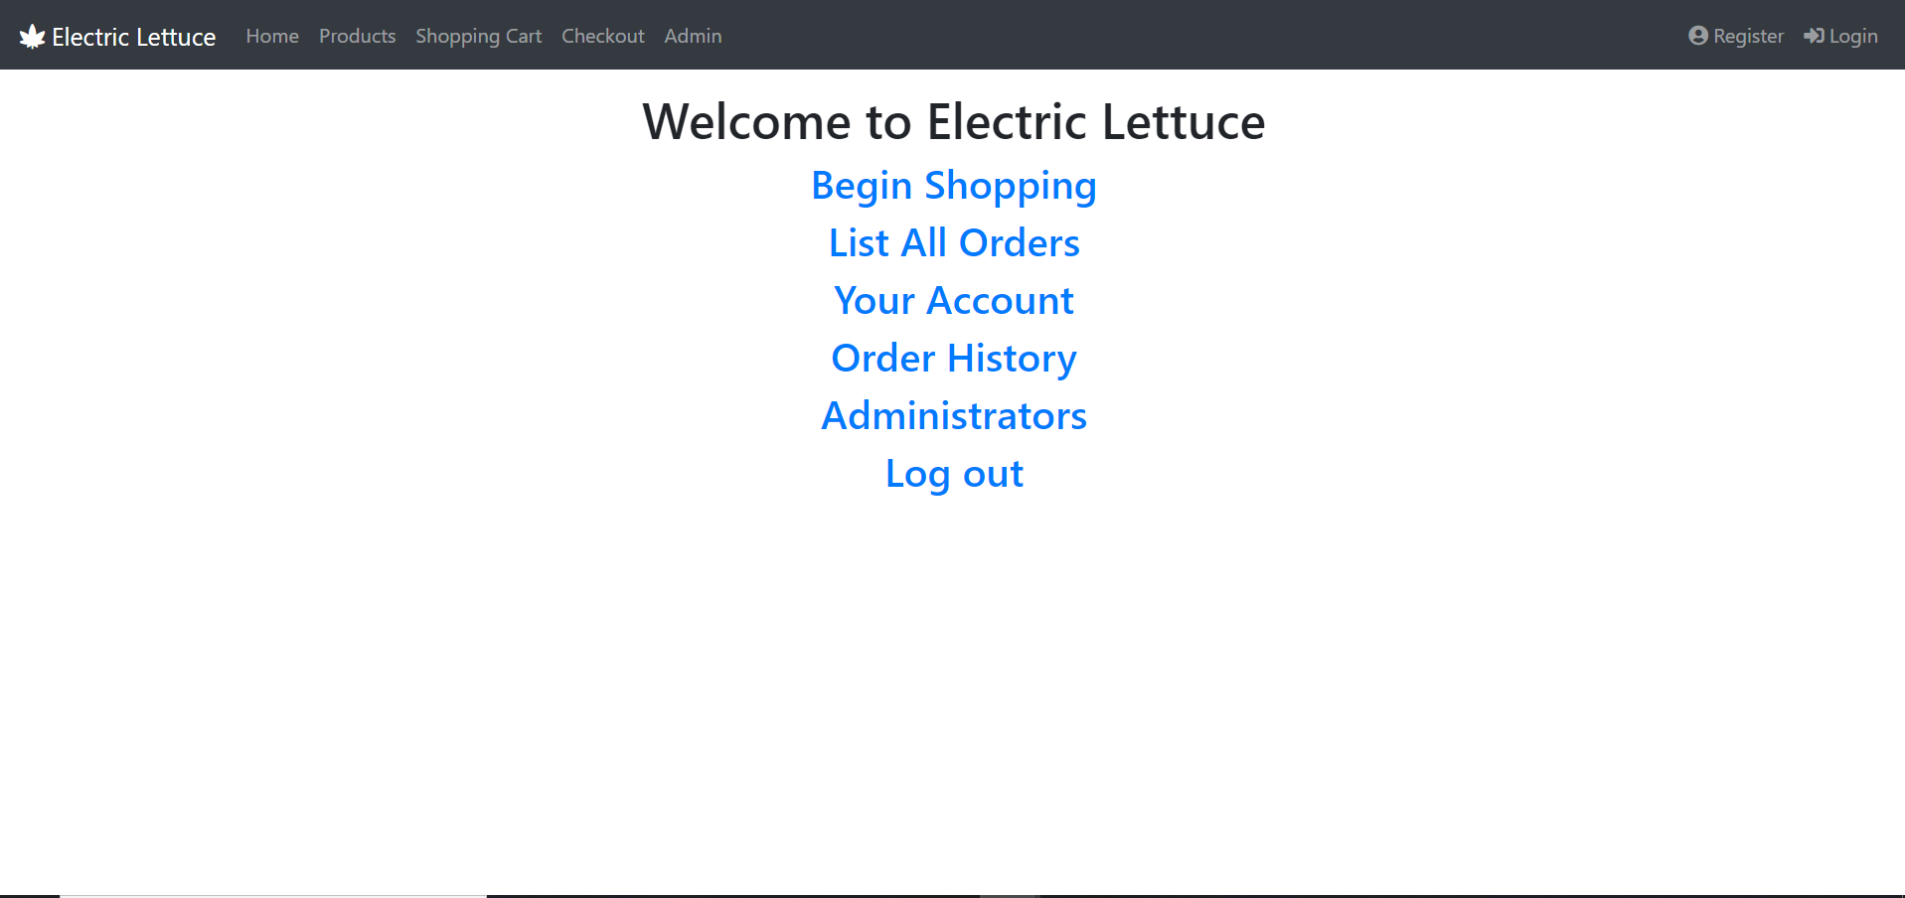

If the customer has an account already, they would click on the log in icon on the top right of the screen and enter the page seen below. This provides a form to the user to fill with their data for access to personal features.

Login page:

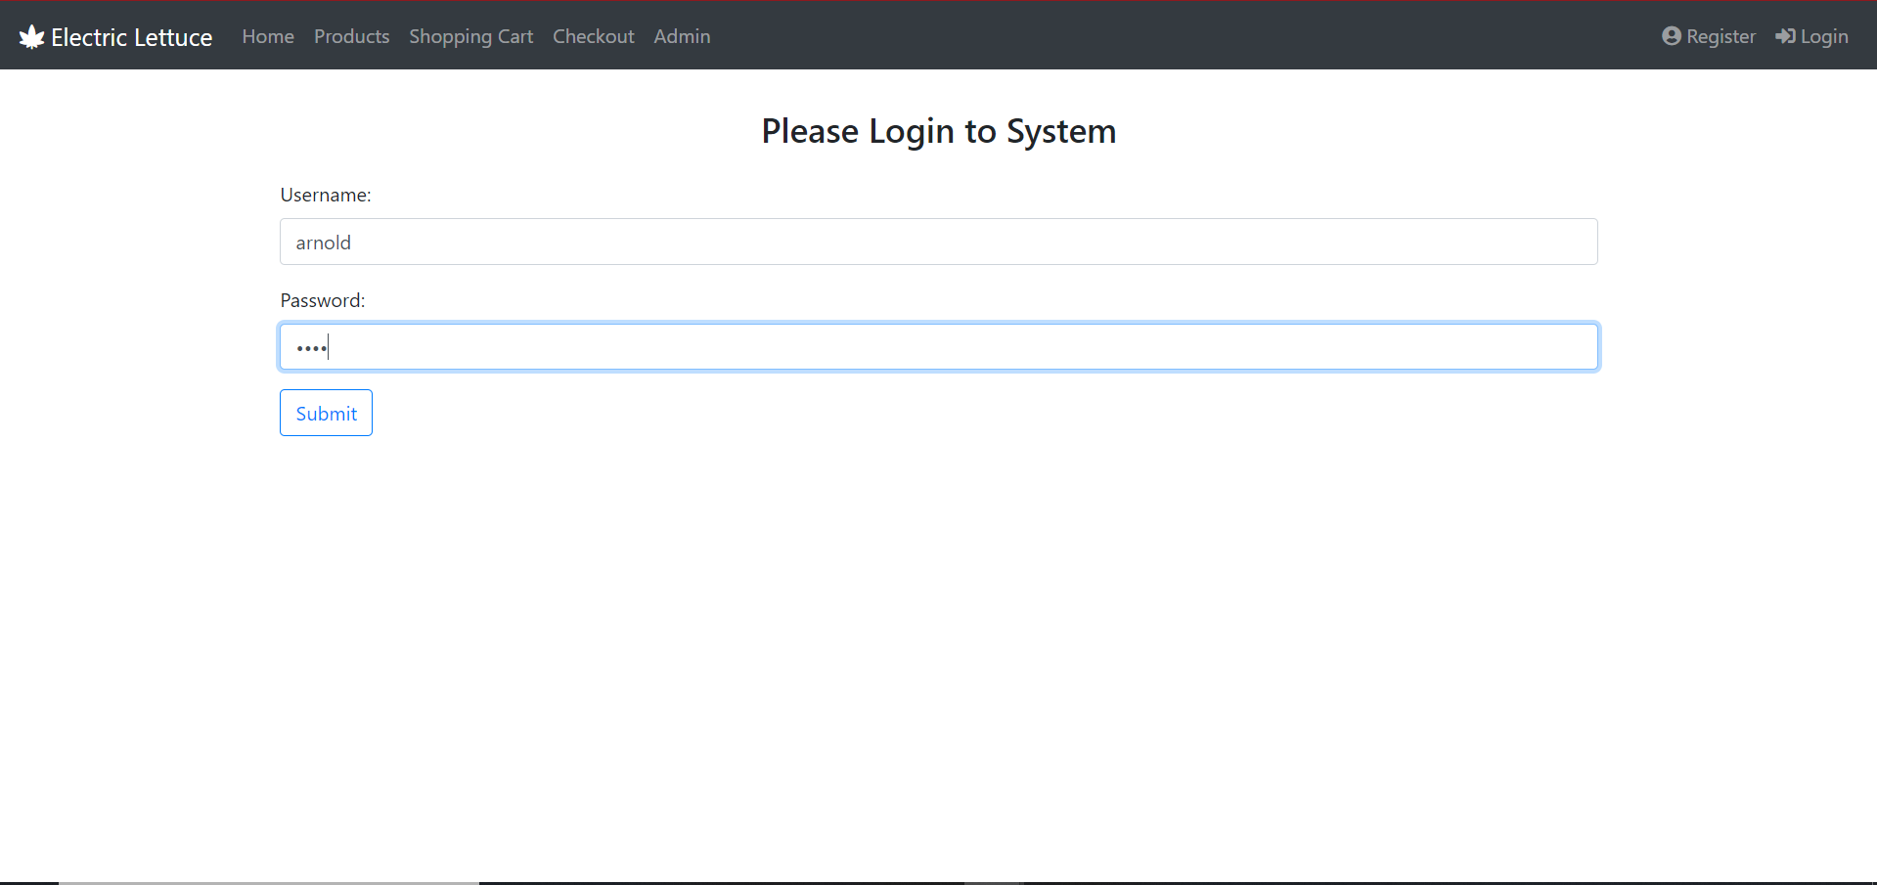

After logging in, the home page updates to show the user who they are signed is as. This helps make the website a smooth experience without any confusions.

Home page after logging in:

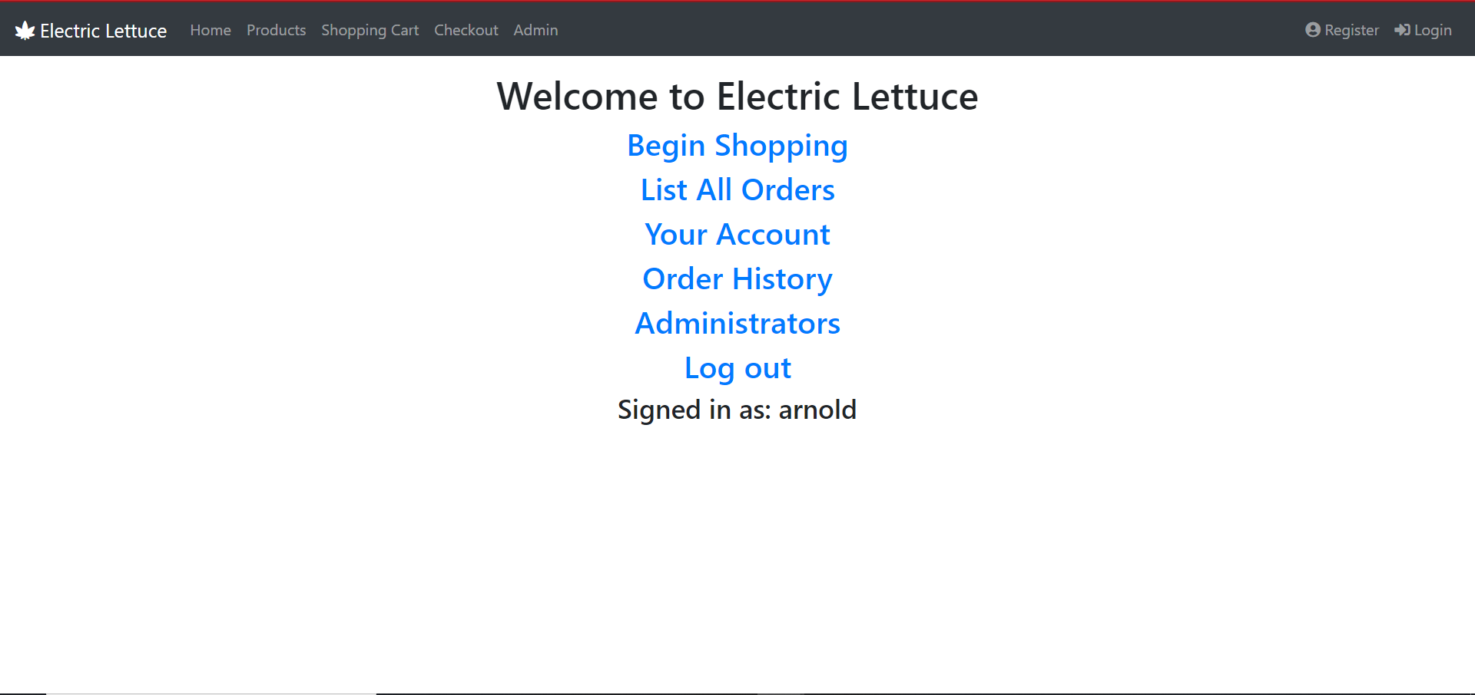

Not everyone is already a customer. Therefore, a new user who may want to set up an account with us would click the “register” icon on the top right and proceed to fill out the information to become a registered user of our website.

Register page:

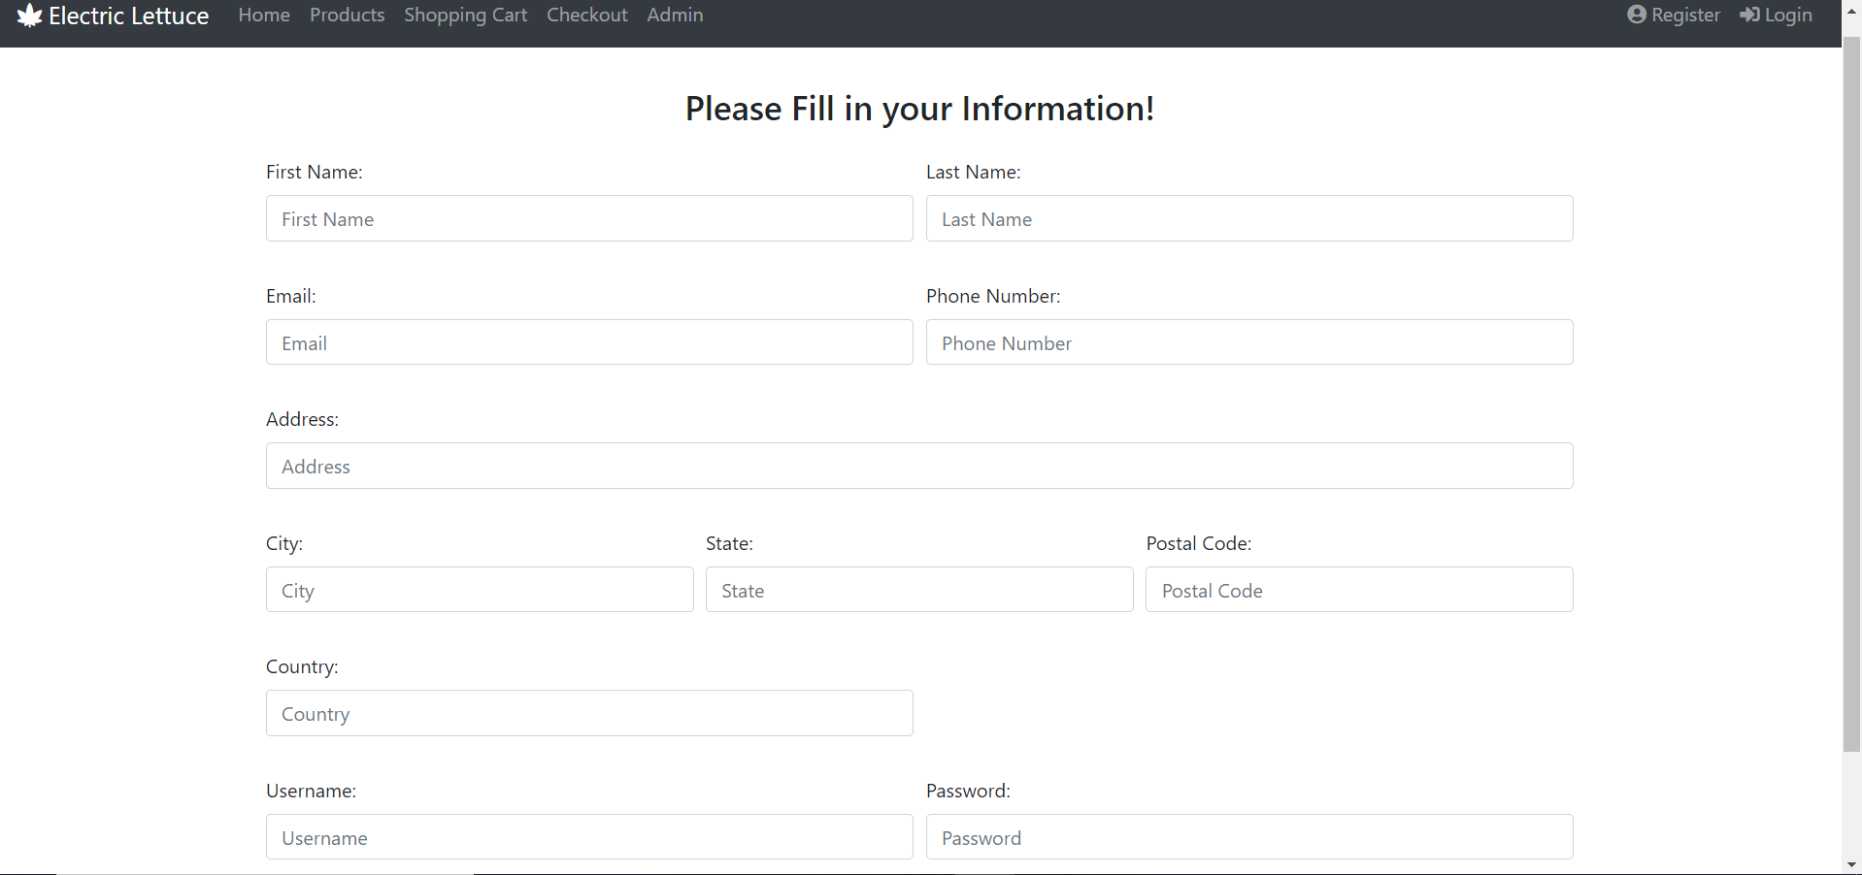

Once the user is logged in, they may proceed to the product page. This shows all the items that the company is selling along with the option to add to cart, write a review or learn more about the product itself.

Product Page:

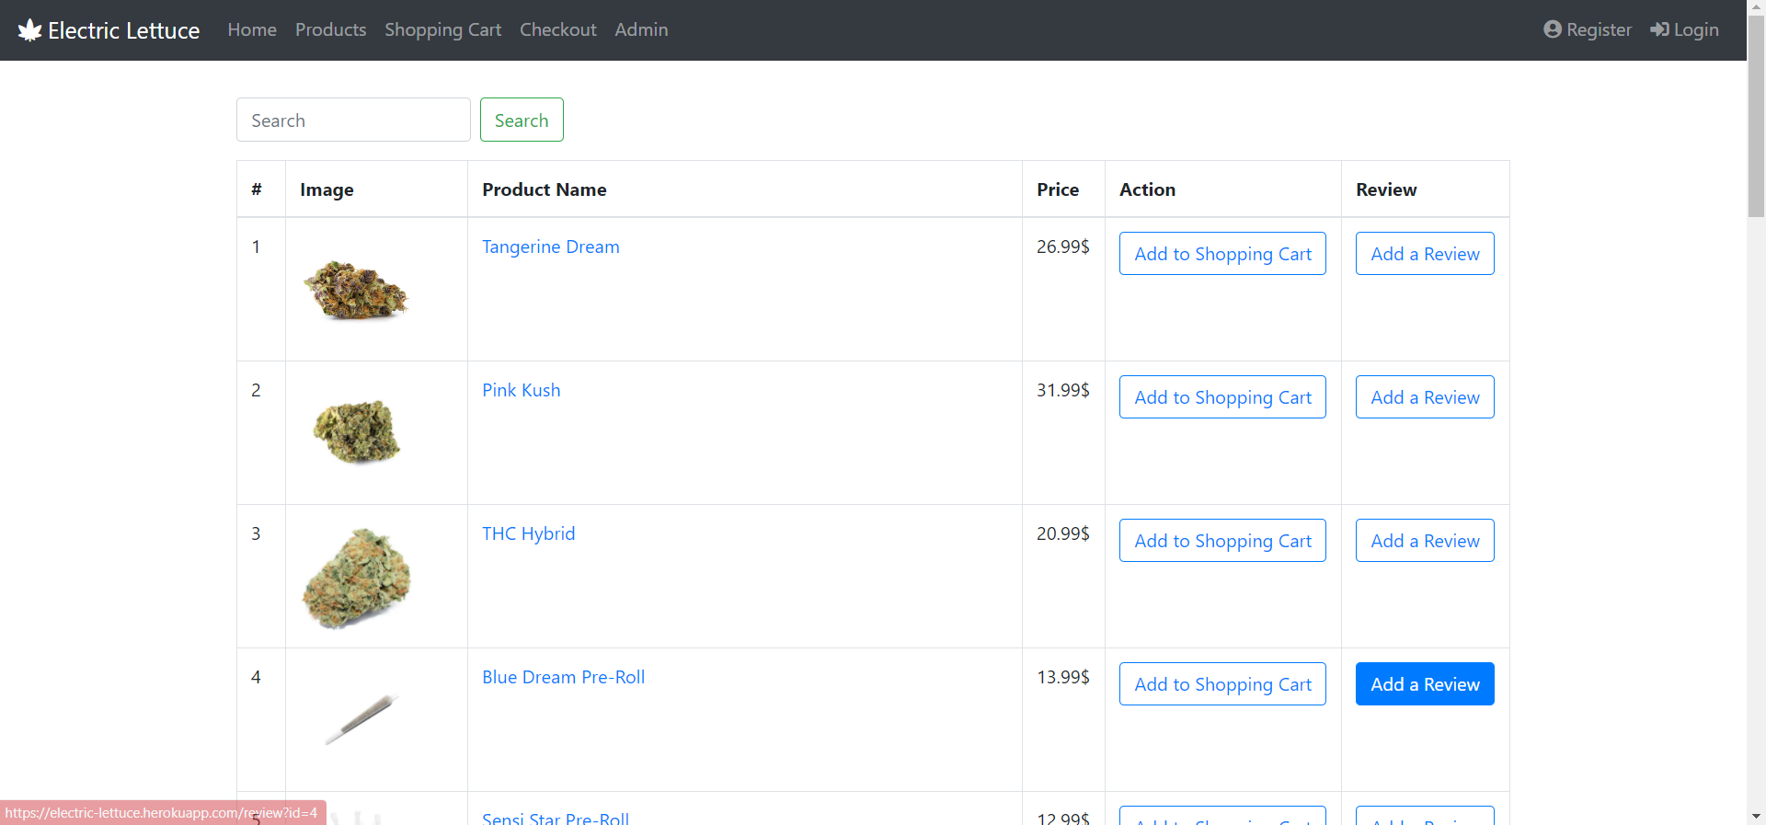

The user has the option to search for the item they want using our search bar. As seen in the screenshot below, incomplete searches return products that are closest to the customer’s input.

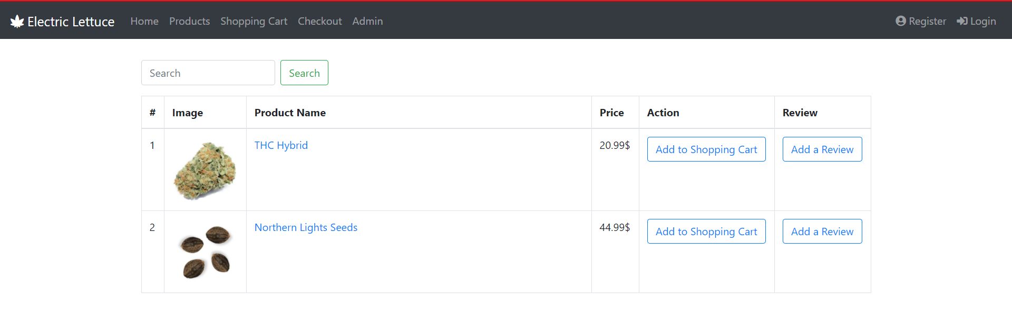

Clicking on the product that the customer wants, opens up a page with a clear image of the item. This is useful as some customers may not remember the exact name of the product therefore a picture provides clarity. A description and price complete the information provided on this page. If reviews exist for the item, they would be shown below the “continue shopping” button. This will be shown later.

Item page:

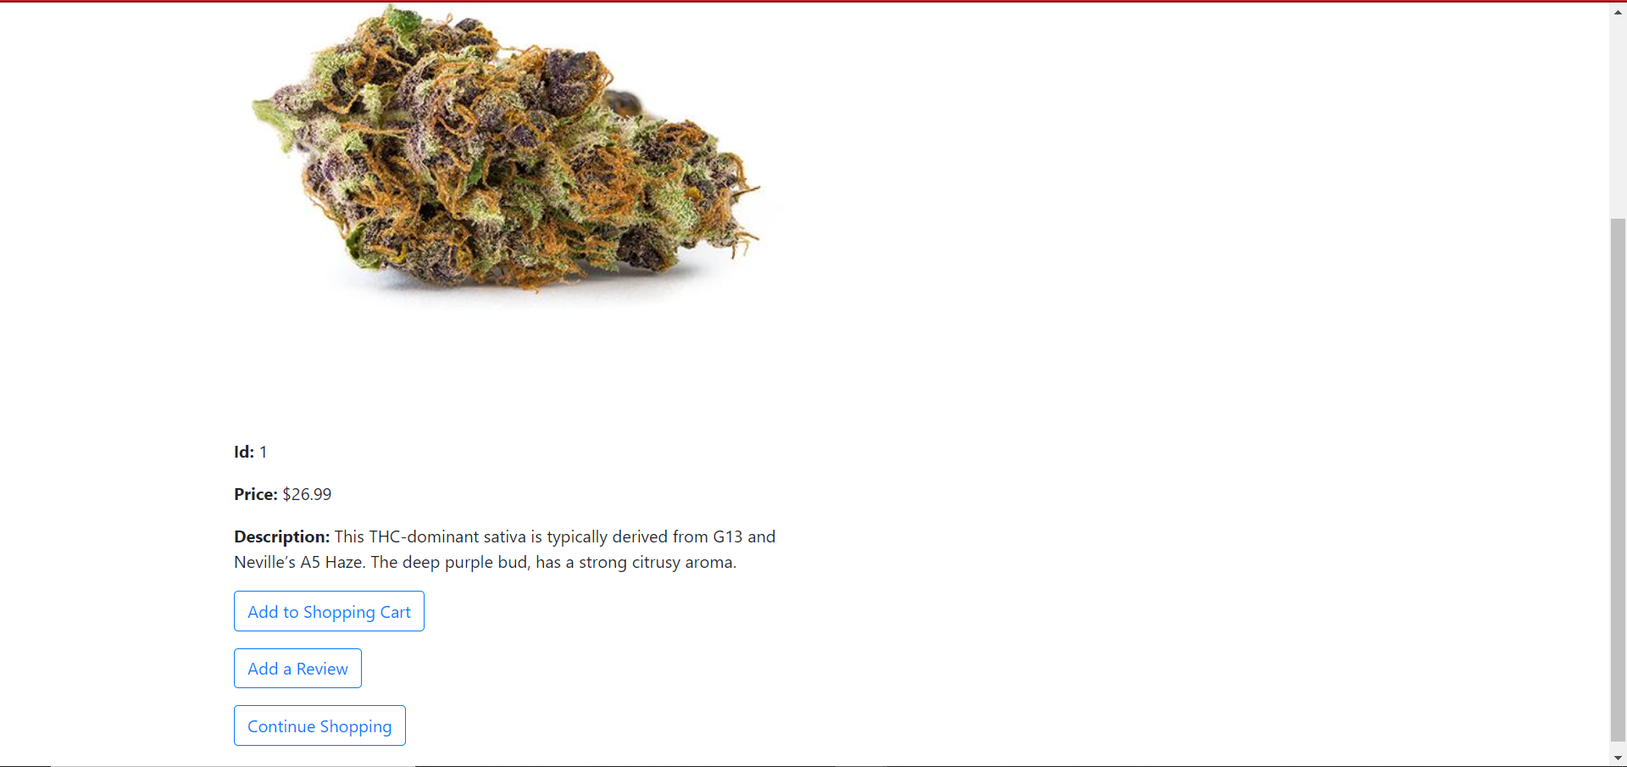

Once the customer adds the product desired, they would be redirected to the shopping cart which allows the customer to checkout or continue shopping.

Shopping cart:

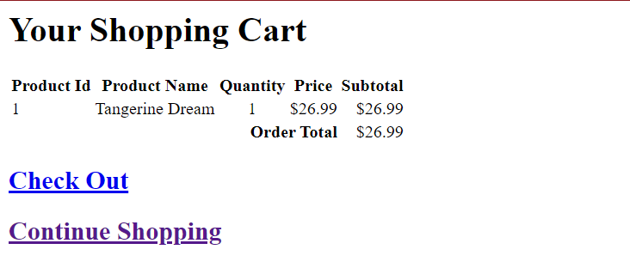

Customers can leave reviews for the products to help future customers make more informed decisions. These can be added in the format seen below and is limited to one per customer. The review shows up as stated previously.

Item review page:

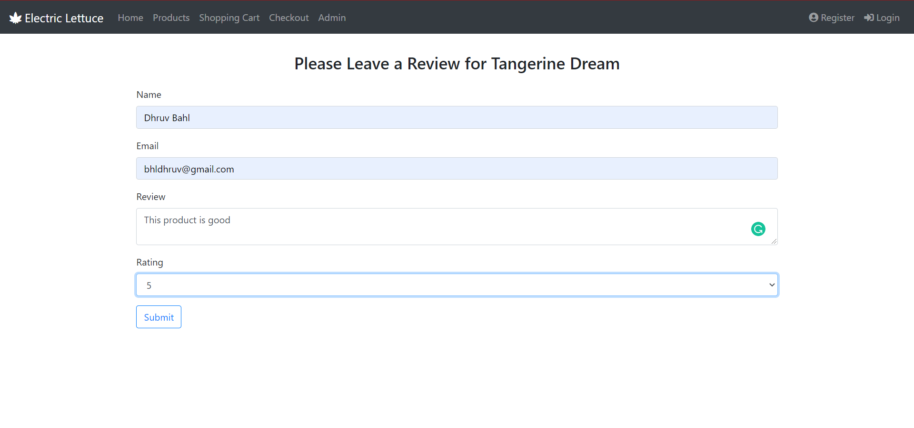

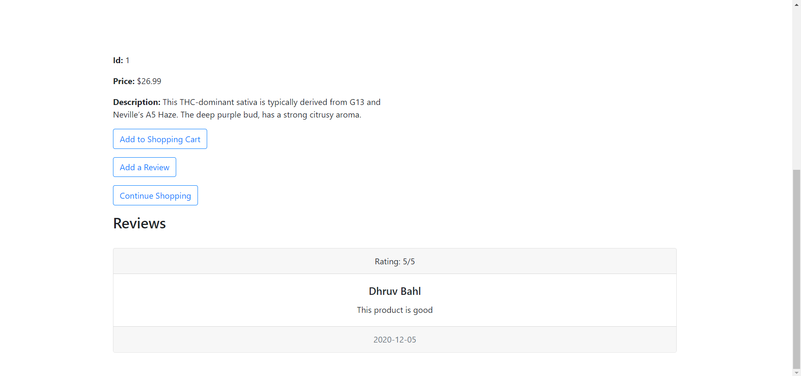

If the user decides to check out, they would be redirected to the payment page as seen below. The customer is prompted to provide their information to complete the transaction.

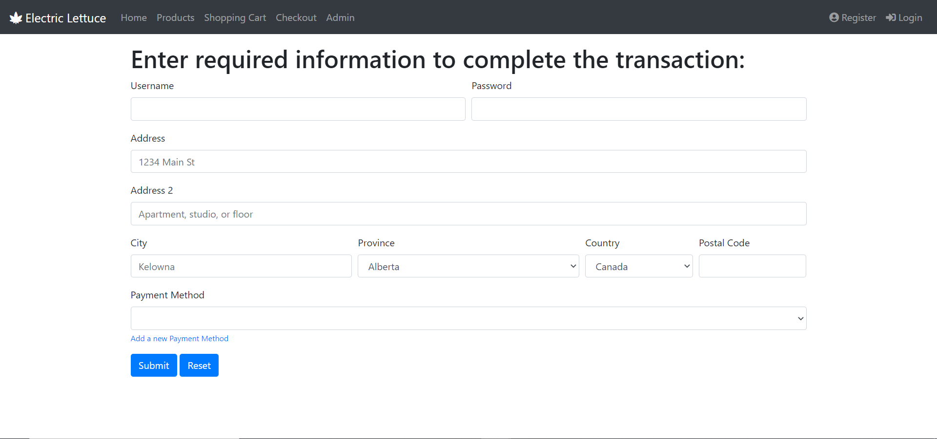

Registered customers have the option to view their personal information by logging in and checking “your account”. The screenshot below shoes an example of the customer Arnold. This can be edited as people tend to change houses and have new addresses that they want their goods to be shipped to.

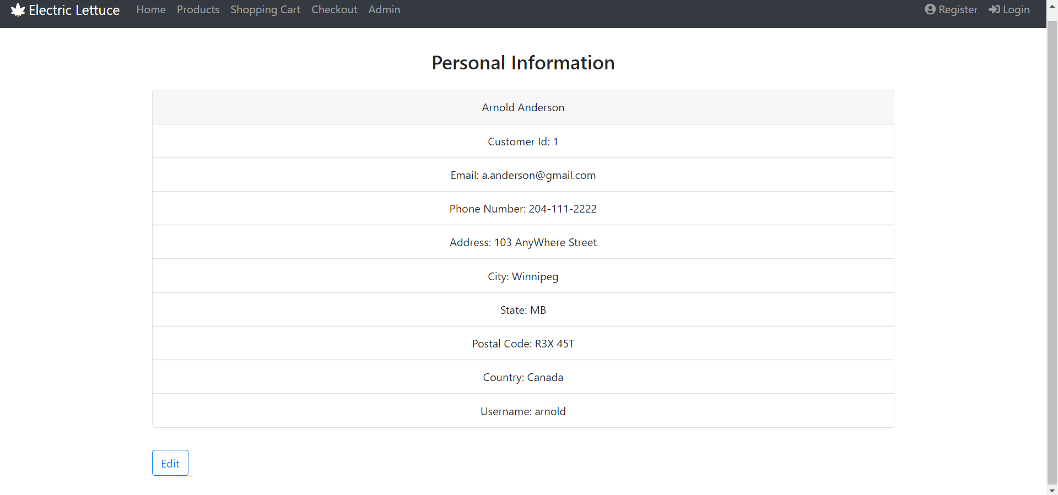

A list of all orders is available to review per customer.

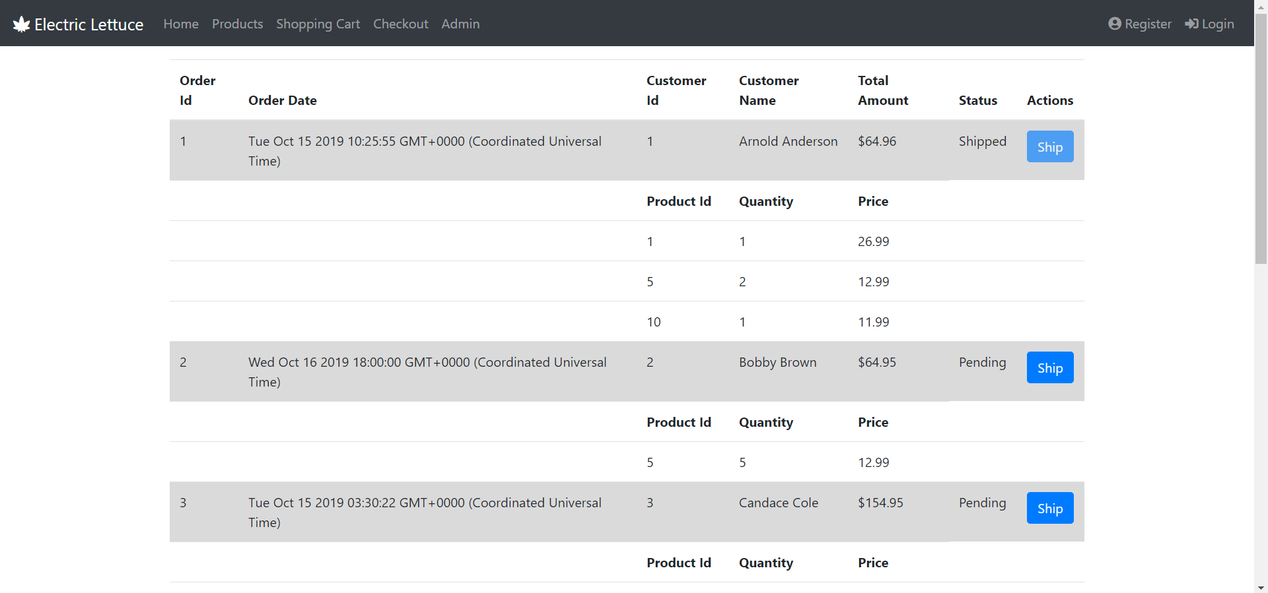

A registered customer can view their order history by logging in and clicking the “order history” link on the home page.

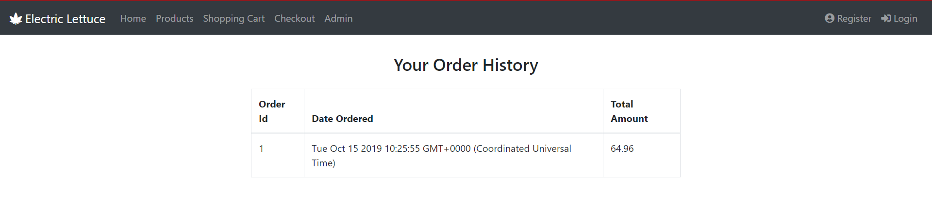

The administrator page shows crucial business data such as a graph of the sales report by year as well as one by day. These are crucial measures for businesses to understand if their growing or not.

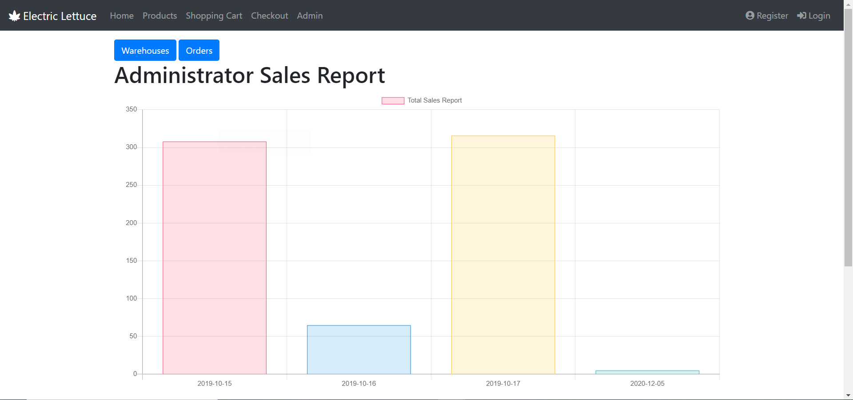

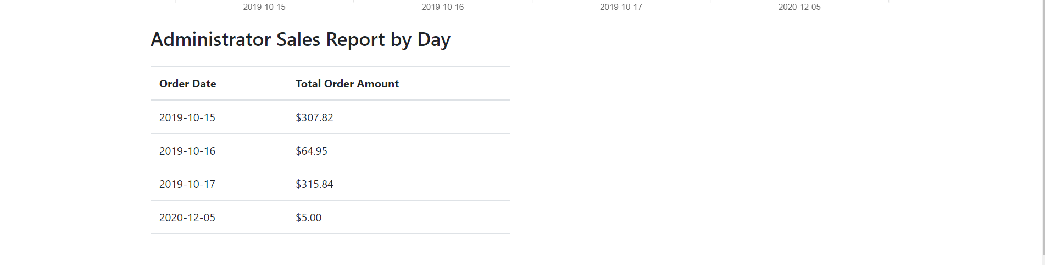

The warehouse page is part of the administrator as it allows the option to view inventory or add products.

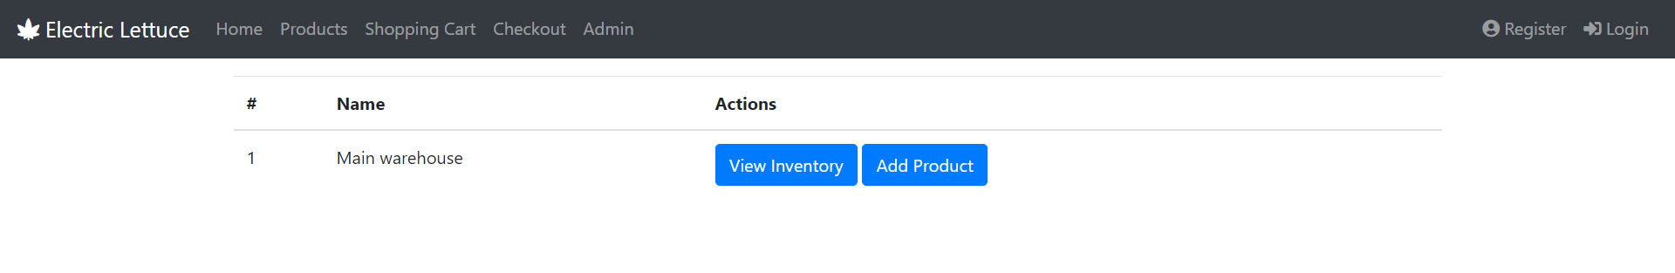

Viewing the inventory gives us the option to edit the product, view the details or delete the product itself. The product details match the details presented on the items page.

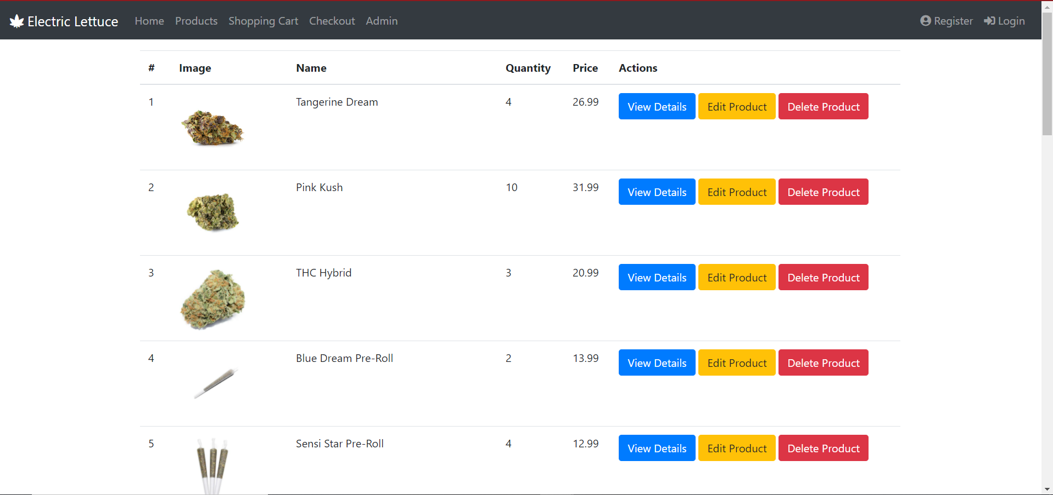

The edit product option allows us to make changes as seen below. It can update inventory quantity, price, name, description as well as a few other options as seen below. This gives us greater flexibility.

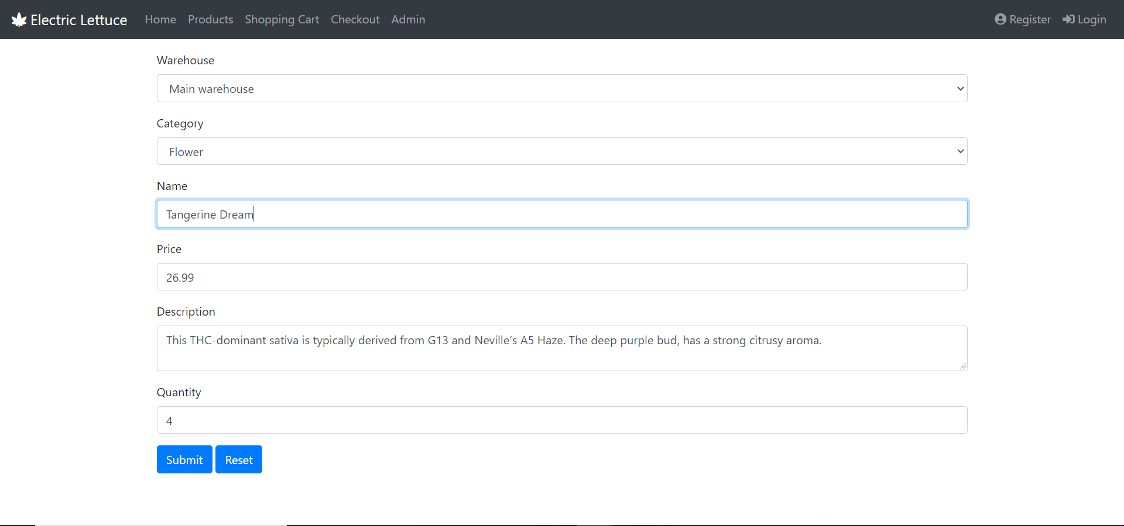

Finally, we can add new products to the warehouse too. We hope to increase the variety of goods we sell over time therefore this quick form provides the information needed to add the items into our database.

