98%
You will create an ASP.NET Core MVC Appointment Scheduling Web Application. All data should come from and work with a database. All functionality should be implemented via the web application.

Rubric
- Model Creation
  - Appointment should require:
    - Id -5pts
    - Start Date/Time includes both date and time (DateTime data type), -5pts
      - Appointments are 1 hour in duration taken on the exact hour. Example: 3/15/2025 08:00AM
    - Customer object - 10pts
  - Customer should require:
    - Id -5pts
    - Username -5pts
    - Valid Phone number -5pts
- Customer Creation - Allow new customers to be created. - 5pts
  - Enforce all validation rules set by the model - 5pts
- Appointment Creation - Any user can create an appointment and view all appointments - 10pts
- Appointment management - Create an administrative area where an administrator can edit, delete and view all appointments - 15pts
- 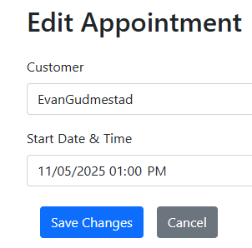
- 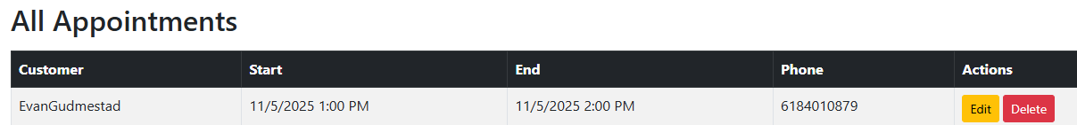
I found an odd bug where a start time was saved as 1PM but displayed as 2PM.
  - Edit/Delete/Viewing appointments should be in an Area -2pts on the “viewing” of appointments
  - Validation rules should apply to the edit appointment operation - 5pts
  - Authorization rules do not have to be defined. Authorization will be covered in Ch16
- Validate the date/time of the appointment to be in the future. - 10pts
- Validate upon appointment creation that the date/time slot is available against the current appointments. If the date and start time exists in the database, a validation error should occur. -10pts
  - This is not a range check.
  - Exact date/time should be checked
- Customize validation error messages to the user to provide meaningful information - 5pts

