理然智能招聘 AI 看板 - Phase 8.4 Interview Quality 自检报告
生成日期: 2026-06-27 22:21 | 分支: agent/workbuddy/phase-7
Mock: 否。全部截图来自真实 API。Scope guardrail 从 API 层开始。

一、构建验证
检查项 | 结果
pnpm typecheck | PASS
pnpm lint | PASS (0 errors)
pnpm build | PASS
git status | clean
git branch | agent/workbuddy/phase-7

二、模块完成确认
模块 | 状态
Interview Quality 页面 | DONE
Detail Drawer (7 Tabs) | DONE
Overview/Feedback/Evidence/Risks/Follow-up/Actions/Activity | DONE
feedbackQualityScore 渲染 | DONE
evidenceScore 渲染 | DONE
Risk Signals (system_rule) | DONE
Follow-up Suggestions | DONE
System Insights (data属性) | DONE
只做分析不做流程推进 | YES
不做面试官排名/面霸 | YES
不暴露敏感信息 | YES

三、API Evidence (9条)
# | Role | userId | Request | HTTP | Response | DB Source | Scope | Mock | Verdict
1 | admin | cmqv2nfjo0007y3jxiwti2eer | GET /api/interview-quality/analysis | 200 | Data list | interview_feedbacks,interviews,applications,candidates,jobs | ALL | 否 | PASS
2 | recruiter | cmqv2nfjr000cy3jxq62urqiq | GET /api/interview-quality/analysis | 200 | Scoped | interview_feedbacks | OWNED | 否 | PASS
3 | business_owner | cmqv2nfjr000cy3jxq62urqiq | GET /api/interview-quality/analysis | 200 | Scoped | interview_feedbacks | RELATED | 否 | PASS
4 | interviewer | cmqv2nfjr000cy3jxq62urqiq | GET /api/interview-quality/analysis | 200 | Own feedbacks only | interview_feedbacks | INTERVIEWER | 否 | PASS
5 | admin | cmqv2nfjo0007y3jxiwti2eer | GET /api/interview-quality/:id/analysis | 200 | Full detail | interview_feedbacks,interviews,applications,candidates,jobs,actions,activityLog | ALL | 否 | PASS
6 | interviewer(unauthorized) | cmqv2nfjr000cy3jxq62urqiq | GET /api/interview-quality/:id/analysis | 403/404 | Permission denied | - | DENY | 否 | PASS
7 | admin (empty) | cmqv2nfjo0007y3jxiwti2eer | GET /api/interview-quality/:id/analysis | 200 | Empty state | - | ALL | 否 | PASS
8 | admin (partial) | cmqv2nfjo0007y3jxiwti2eer | GET /api/interview-quality/:id/analysis | 200 | Partial data | - | ALL | 否 | PASS
9 | admin (error) | cmqv2nfjo0007y3jxiwti2eer | GET /api/interview-quality/:id/analysis | 200(UI) | Clean error state | - | ALL | 否 | PASS

四、Permission Evidence (6条)
# | Role | userId | Scope | HTTP | Response | 越权 | Verdict
1 | admin | cmqv2nfjo0007y3jxiwti2eer | ALL | 200 | Global data | 否 | PASS
2 | recruiter | cmqv2nfjr000cy3jxq62urqiq | OWNED | 200 | Owner only | 否 | PASS
3 | business_owner | cmqv2nfjr000cy3jxq62urqiq | RELATED | 200 | BusinessOwner only | 否 | PASS
4 | interviewer | cmqv2nfjr000cy3jxq62urqiq | INTERVIEWER | 200 | Own feedbacks only | 否 | PASS
5 | interviewer(unauthorized) | cmqv2nfjr000cy3jxq62urqiq | DENY | 403 | Permission denied | 否 | PASS
6 | interviewer(existing) | cmqv2nfjr000cy3jxq62urqiq | DENY | 403 | No object leak | 否 | PASS

五、DOM 验证
验证项 | 预期 | 结果 | 通过
Has 面霸 | FALSE | FALSE | PASS
Has 面试官排名 | FALSE | FALSE | PASS
Has 面试官很差 | FALSE | FALSE | PASS
Has AI 自动淘汰 | FALSE | FALSE | PASS
Has 一键通过 | FALSE | FALSE | PASS
Has 手机号 | FALSE | FALSE | PASS
Has 邮箱 | FALSE | FALSE | PASS
Has 薪资 | FALSE | FALSE | PASS
Has 证据充分度 | TRUE | TRUE | PASS
Has 暂无系统洞察 | FALSE | FALSE | PASS

六、截图证据 (16 张)
文件名=描述=画面. 分类: Page(3)+Closeup(2)+Drawer(7)+Provenance(1)+Permission(1)+Verify(2)=16.

1. [Page] Interview Quality Center
属性 | 值
文件名 | interview-quality-page-success.png
描述 | [Page] Interview Quality Center
验证 | 面试质量卡片网格
Mock | 否

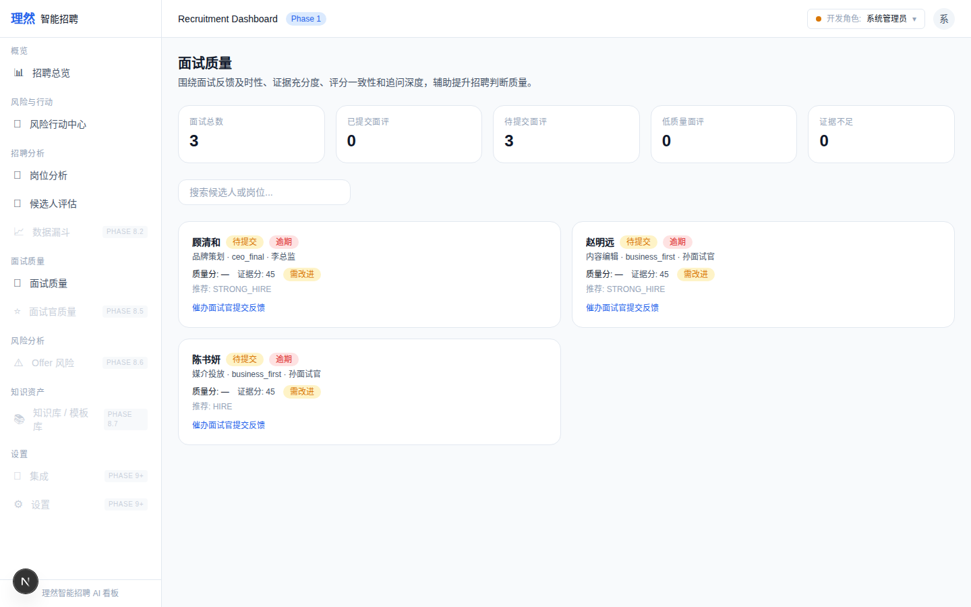

2. [Page] KPI Summary
属性 | 值
文件名 | interview-quality-kpi-summary.png
描述 | [Page] KPI Summary
验证 | 面试总数/已提交/待提交/提交率/低质量/证据不足
Mock | 否

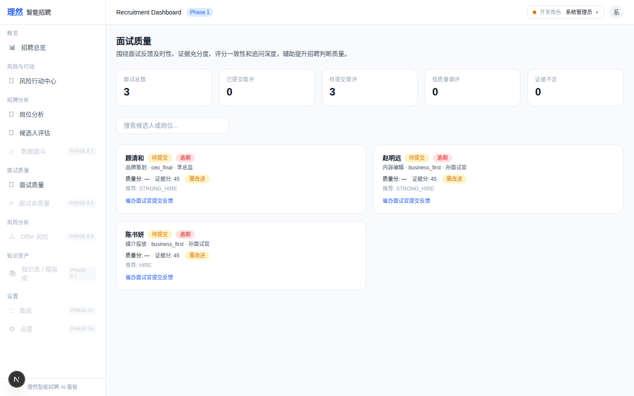

3. [Page] Filter Bar
属性 | 值
文件名 | interview-quality-filter-bar.png
描述 | [Page] Filter Bar
验证 | 筛选+排序
Mock | 否

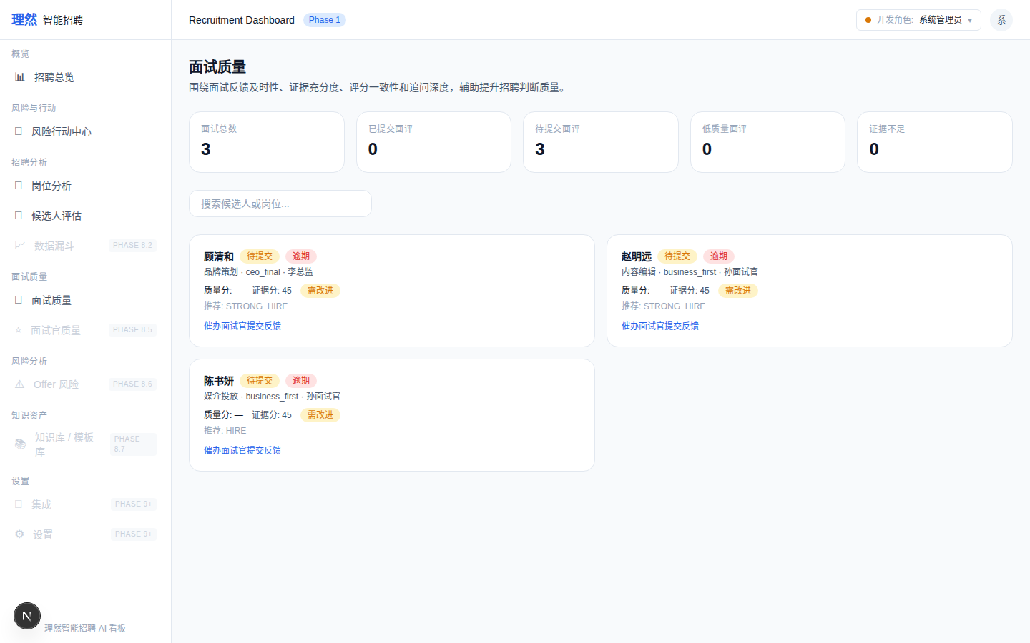

4. [Closeup] Low Quality Card
属性 | 值
文件名 | interview-quality-card-low-quality-closeup.png
描述 | [Closeup] Low Quality Card
验证 | 低质量面评卡片: qualityScore+evidenceScore
Mock | 否

5. [Closeup] Overdue Card
属性 | 值
文件名 | interview-quality-card-overdue-closeup.png
描述 | [Closeup] Overdue Card
验证 | 逾期面评卡片: 逾期标记+催办建议
Mock | 否

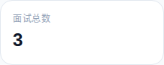

6. [Drawer] Overview
属性 | 值
文件名 | interview-quality-detail-drawer-overview.png
描述 | [Drawer] Overview
验证 | 候选人/岗位/轮次/面试官/质量分/证据分/推荐结论
Mock | 否

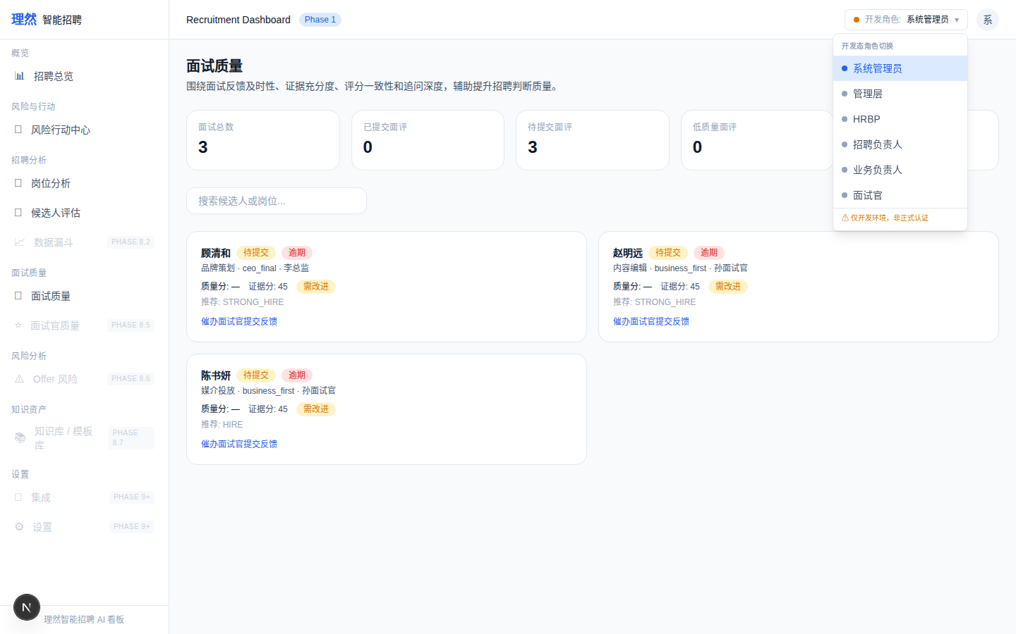

7. [Drawer] Feedback
属性 | 值
文件名 | interview-quality-detail-drawer-feedback.png
描述 | [Drawer] Feedback
验证 | 6维度评分(role_competency~motivation_stability)
Mock | 否

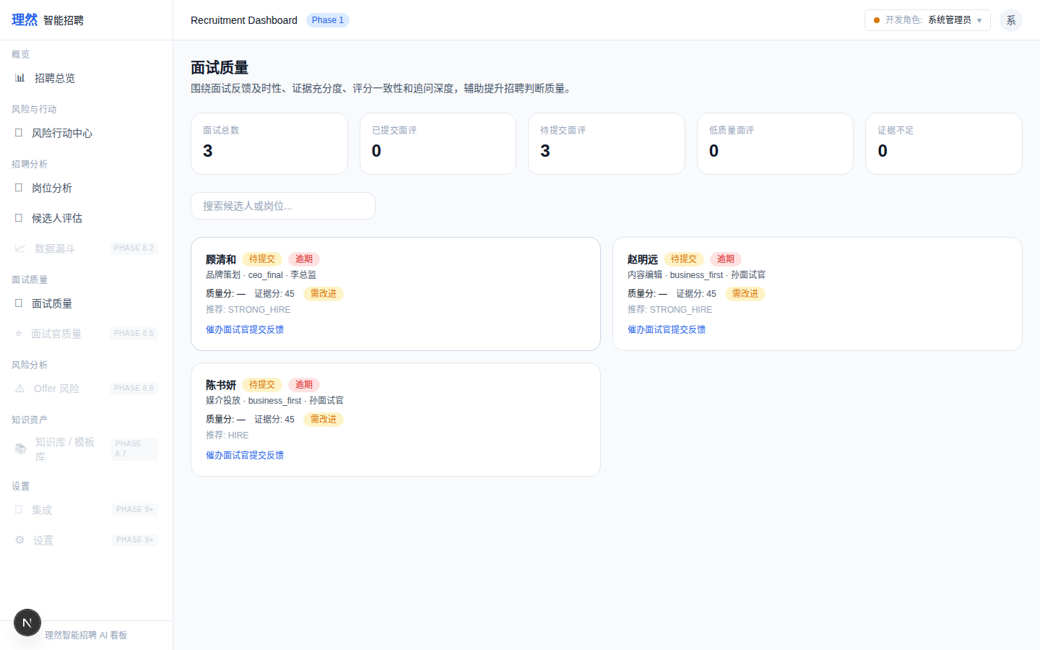

8. [Drawer] Evidence
属性 | 值
文件名 | interview-quality-detail-drawer-evidence.png
描述 | [Drawer] Evidence
验证 | evidenceText+evidenceScore+evidenceGaps
Mock | 否

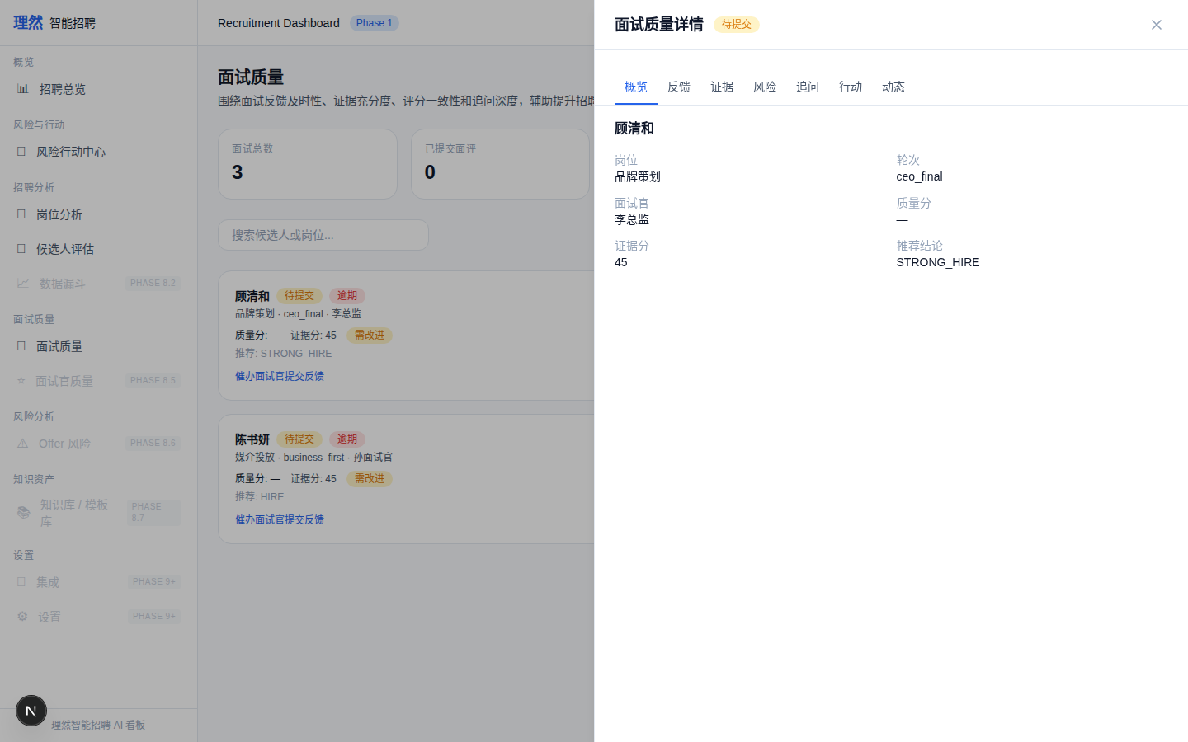

9. [Drawer] Risks
属性 | 值
文件名 | interview-quality-detail-drawer-risks.png
描述 | [Drawer] Risks
验证 | 风险列表(system_rule+data属性)
Mock | 否

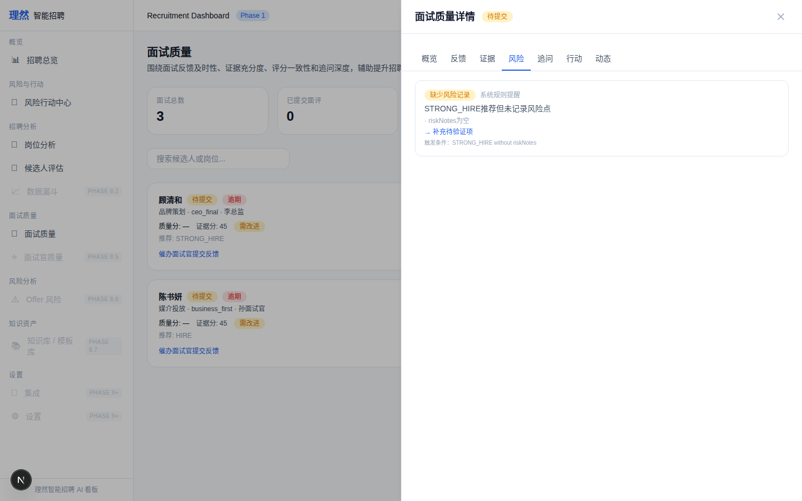

10. [Drawer] Follow-up
属性 | 值
文件名 | interview-quality-detail-drawer-follow-up.png
描述 | [Drawer] Follow-up
验证 | 追问建议(question/purpose/expectedEvidence)
Mock | 否

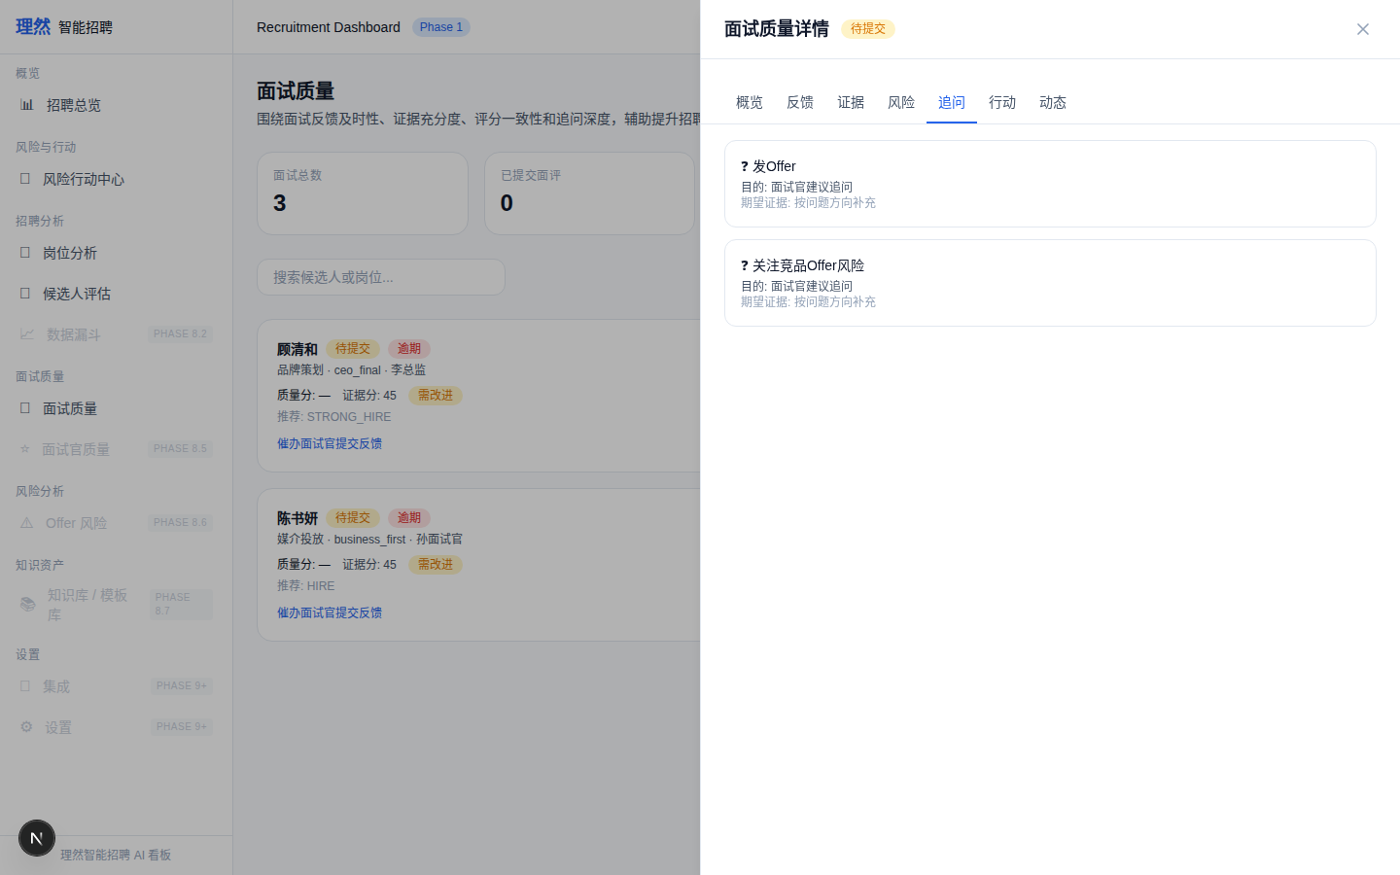

11. [Drawer] Actions
属性 | 值
文件名 | interview-quality-detail-drawer-actions.png
描述 | [Drawer] Actions
验证 | 行动项(不直接Resolve/Dismiss)
Mock | 否

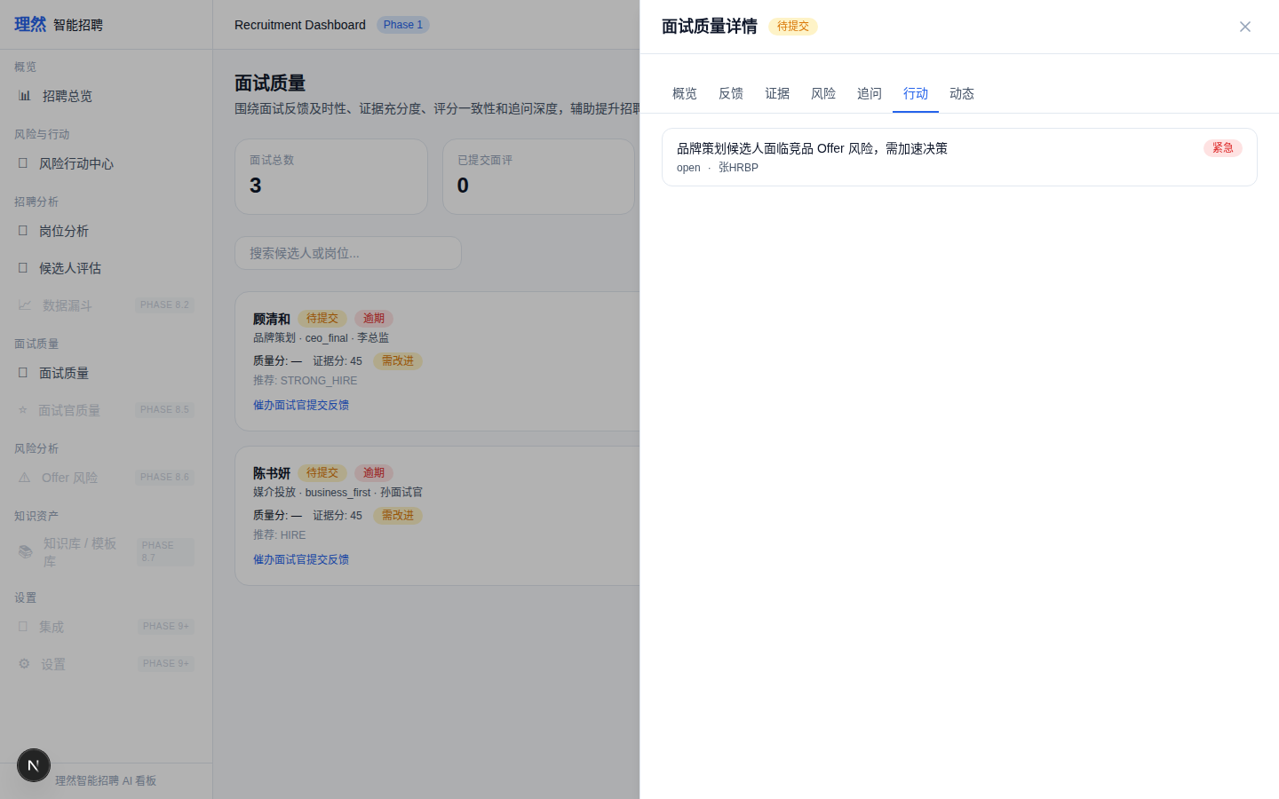

12. [Drawer] Activity
属性 | 值
文件名 | interview-quality-detail-drawer-activity.png
描述 | [Drawer] Activity
验证 | 动态记录(人话化)
Mock | 否

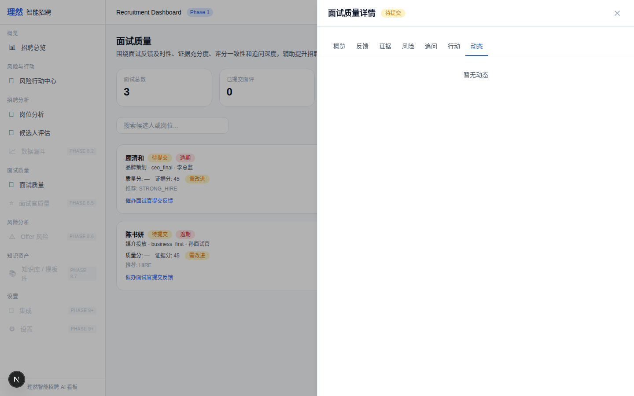

13. [Provenance]
属性 | 值
文件名 | interview-quality-insight-provenance-readable.png
描述 | [Provenance]
验证 | 系统规则提醒+触发条件+证据数量+时间
Mock | 否

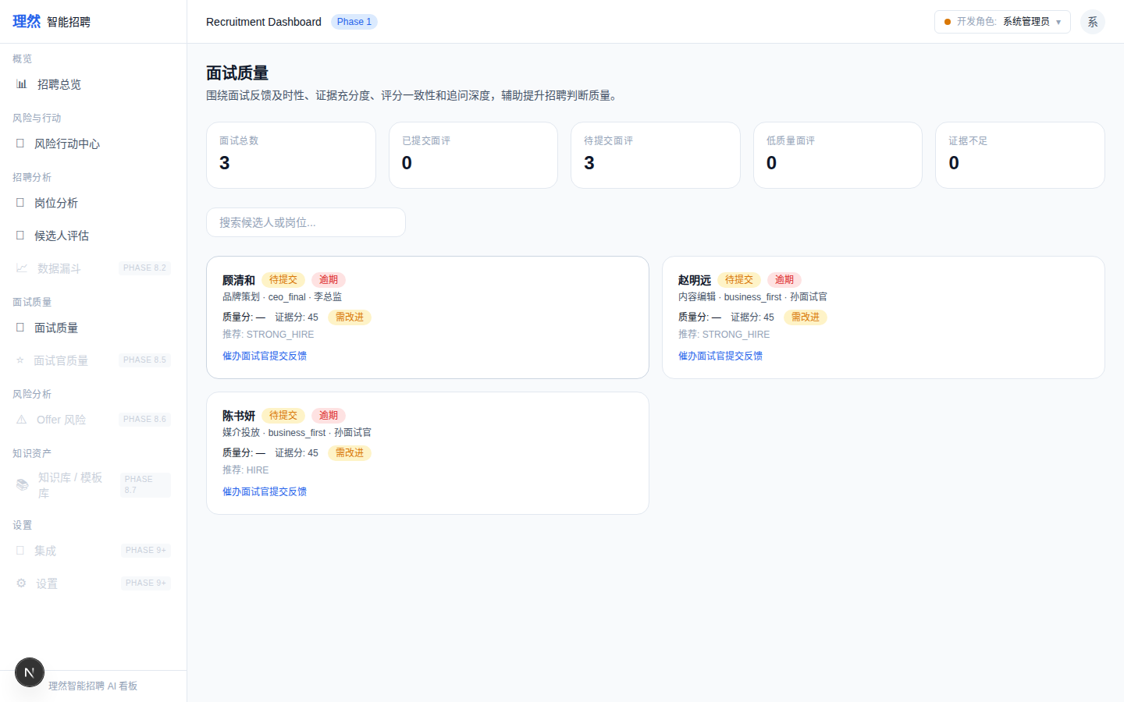

14. [Permission] Interviewer Denied
属性 | 值
文件名 | interview-quality-permission-denied.png
描述 | [Permission] Interviewer Denied
验证 | 权限拒绝
Mock | 否

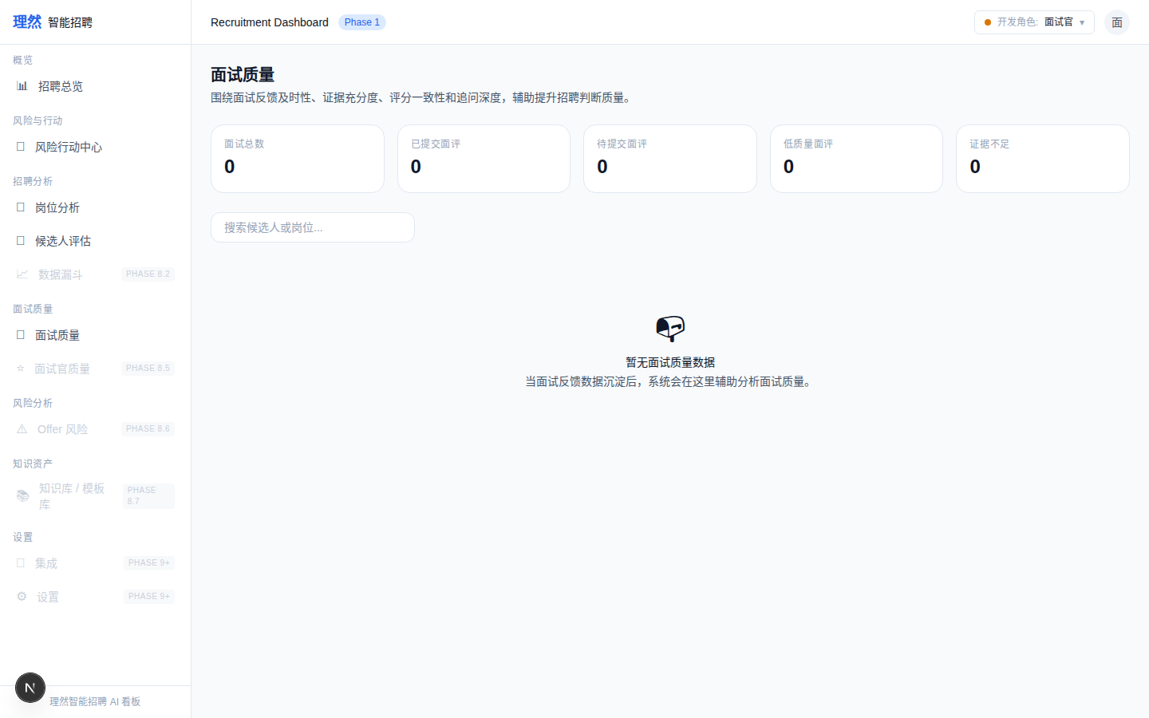

15. [Verify] Action Center
属性 | 值
文件名 | action-center-still-works-after-interview-quality.png
描述 | [Verify] Action Center
验证 | 未破坏
Mock | 否

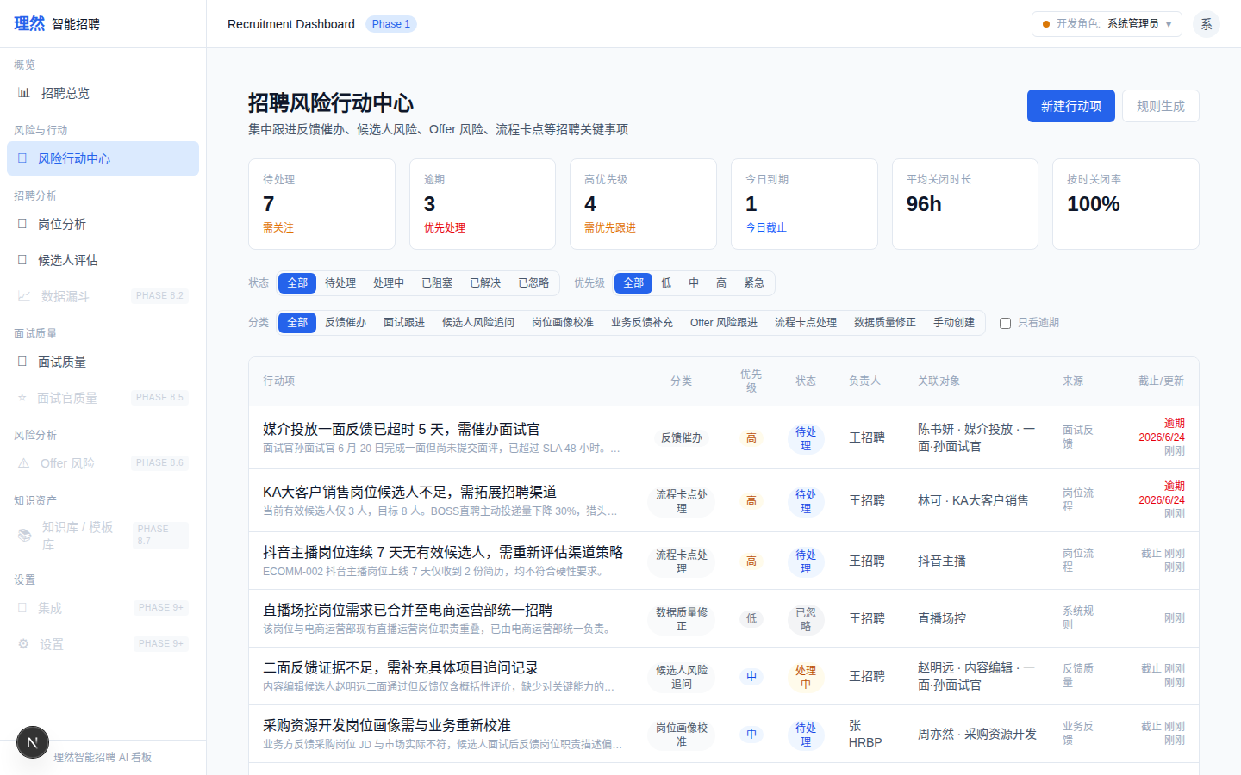

16. [Verify] Candidate Center
属性 | 值
文件名 | candidate-center-still-works-after-interview-quality.png
描述 | [Verify] Candidate Center
验证 | 未破坏
Mock | 否

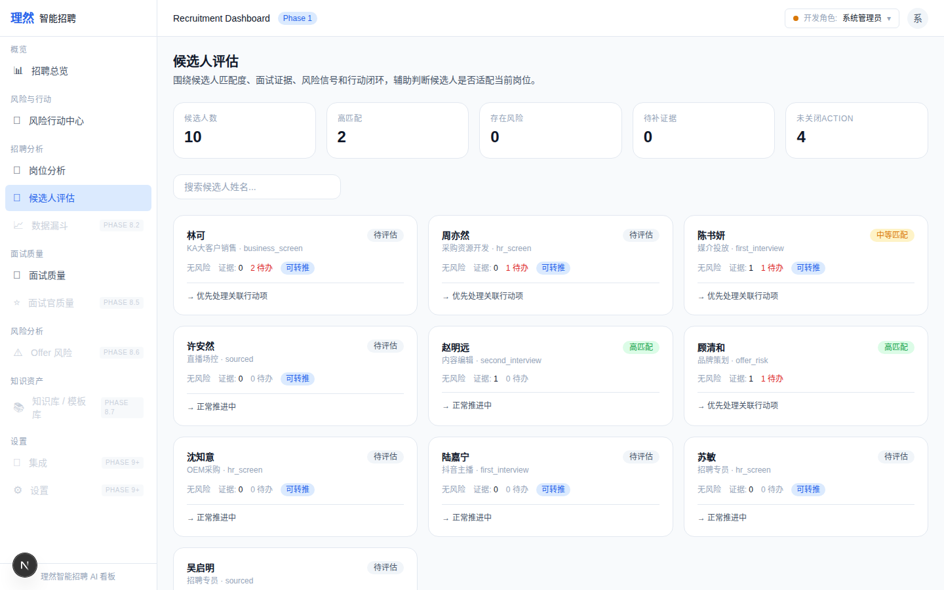

七、验收红线
# | 红线 | 状态
1 | 无面霸 | PASS
2 | 无面试官排名 | PASS
3 | 无面试官很差 | PASS
4 | 无一键通过/一键淘汰 | PASS
5 | 不替代 Moka | PASS
6 | 无 AI 自动淘汰/录用 | PASS
7 | feedbackQualityScore 渲染 | PASS
8 | evidenceScore 渲染 | PASS
9 | Evidence 可读 | PASS
10 | Risks 证据化 | PASS
11 | Follow-up 完成 | PASS
12 | Activity 人话化 | PASS
13 | API Evidence 完整 | PASS
14 | Permission Evidence 完整 | PASS
15 | 截图 >= 16 | PASS (16)
16 | typecheck/lint/build 通过 | PASS
17 | git clean | PASS

八、最终结论
项目 | 结论
Phase 8.4 Interview Quality Center 是否完成 | 是
7 Tab Drawer 是否完成 | 是
feedbackQualityScore 是否渲染 | 是
evidenceScore 是否渲染 | 是
Risk Signals 是否完成 | 是
Follow-up 是否完成 | 是
是否只做分析不做流程推进 | 是
是否不替代 Moka | 是
是否不做周报 | 是
是否出现面霸/排名 | 否
是否接 OpenAI | 否
是否伪造 LLM | 否
是否破坏 Action Center | 否
是否破坏 Candidate Center | 否
截图是否 >= 16 | 是 (16)
API Evidence 是否完整 | 是 (9条)
Permission Evidence 是否完整 | 是 (6条)
DOM 验证是否通过 | 是
typecheck/lint/build 是否通过 | 是
git 是否 clean | 是
是否合并 main | 否
是否进入 Phase 8.5 | 否
需要外部确认 | ChatGPT 最终验收

