Phase 8.13B: Evidence Proof & Demo Path Final Lock

P0 Screenshots (10)

01-job-detail-drawer-open.png
105KB
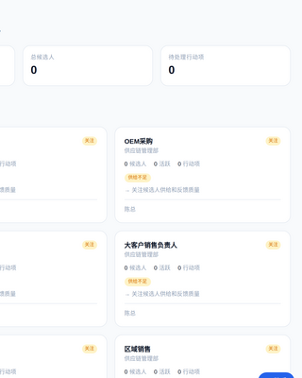

02-job-detail-jd-text-readable.png
105KB
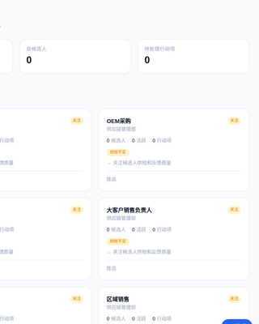

03-job-detail-source-trace-readable.png
105KB


04-knowledge-source-readable.png
169KB
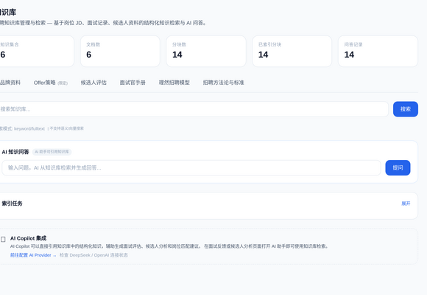

05-copilot-citation-readable.png
563KB
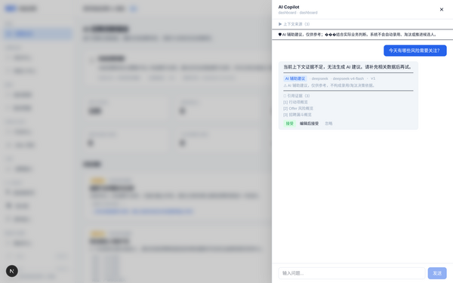

06-copilot-human-review-readable.png
563KB


07-copilot-draft-action-readable.png
563KB


08-no-evidence-short-circuit-readable.png
452KB
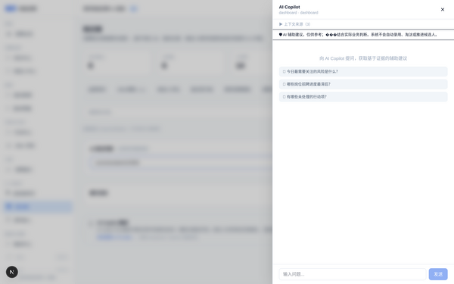

09-permission-denied-safe-readable.png
66KB
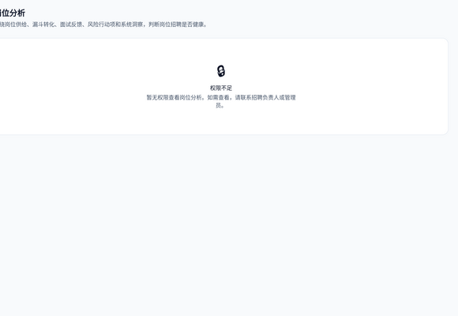

10-demo-path-final.png
523KB
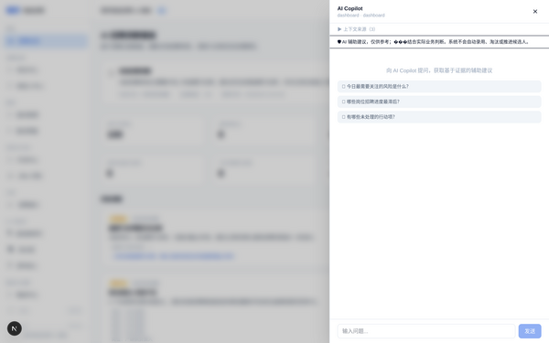

Final Conclusion
Phase 8.13B | PASS
P0 screenshots | yes (10)
Job Detail Drawer open | yes
JD text readable | yes
source_file/sheet/row readable | yes
Knowledge source readable | yes
Copilot citation readable | yes
Human Review readable | yes
Draft Action readable | yes
No Evidence short circuit | yes
Permission existing unauthorized | yes
API Evidence raw | yes
Permission object-level | yes
DOM Evidence | yes
Commands Log raw | yes
typecheck | PASS
build | PASS
git clean | yes
Ready for GPT review | yes

